

โปรเจค

Space Game

วิชา

060243103 Problem Solving in IT

จัดทำโดย

นายพันธ์วัล เมี้ยนศิริ 62-060216-2104-0
นาย ธนภัทร แสงคำพันธุ์ 62-060216-1102-8
นายศุภโชค แสงบดี 62-060216-1113-3

เสนอ
ผู้ช่วยศาสตราจารย์สมชัย เชียงพงศ์พันธุ์

ภาควิชาเทคโนโลยีสารสนเทศ
คณะเทคโนโลยีและการจัดการอุตสาหกรรม
มหาวิทยาลัยเทคโนโลยีพระจอมเกล้าพระนครเหนือ
คำนำ

โปรเจคนี้เป็นส่วนหนึ่งของวิชา Problem Solving in IT ซึ่งโปรเจคนี้มีเนื้อหาเกี่ยวกับการ สร้างและออกแบบเกมในภาษาPython ผู้จัดทำได้เลือกหัวข้อในการที่ทำโปรเจค เนื่องมาจาก เป็นเรื่องที่น่าสนใจ ผู้จัดทำจะต้องขอขอบคุณผู้ช่วยศาสตราจารย์สมชัยเชียงพงศ์พันธุ์ ผู้ให้ความรู้ และแนวทางการศึกษา เพื่อน ๆ ทุกคนที่ให้ความช่วยเหลือมาโดยตลอด ผู้จัดทำหวังว่าโปรเจคจะให้ความรู้ และเป็นประโยชน์แก่ผู้ศึกษาทุกๆท่าน

คณะผู้จัดทำ
สารบัญ
คำนำ | ก
สารบัญ | ข
ประเภท ลักษณะ และวิธีการเล่น | 1
การออกแบบตัวละคร และหน้าจอ | 2
การออกแบบ Flow การทำงานโปรแกรม | 3
ตัวอย่างหน้าจอการทำงานของเกมทั้งหมด | 13
Source Program | 16
ภาคผนวก | ค
อ้างอิง | ง

1

ประเภท ลักษณะ และวิธีการเล่น

ประเภท : Shooting
ลักษณะ : ยิงกระสุนทำลายยานคู่ต่อสู้

วิธีการเล่น: เมื่อ Run Code จะปรากฏหน้าเริ่มเกมโดยให้ผู้เล่น กด Enter เพื่อเข้าสู่เกม เมื่อกด Enter จะเข้าสู่หน้าเลือกยานโดยเกมจะสามารถเล่นได้ 2 คนเมื่อเลือกเสร็จทั้ง 2 Player แล้ว จะเข้าสู่หน้าเล่นเกมโดยฝ่าย P1 จะใช้ปุ่มลูกศร ซ้าย-ขวา ในการบังคับยาน และใช้ปุ่ม Enter ในการยิงลูกกระสุน
ส่วนฝ่าย P2 จะใช้ปุ่ม A D ในการบังคับยานซ้ายขวา และใช้ปุ่ม Space Bar ในการยิงกระสุนโดยลูกกระสุน 1 นัด ลดหัวใจ 1 ดวง โดยที่แต่ละฝ่าจะมีหัวใจคนละ 3 ดวง ฝ่ายไหนหัวใจหมดก่อนก็จะแพ้ไป2

2

การออกแบบตัวละคร และหน้าจอ

ออกแบบตัวละคร: หารูปยานอวกาศจากเนต แล้วนำมาปรับแต่งโดยใช้โปรแกรม Photoshop CS6

หน้าจอเกม: หารูปฉากหลังจากเนต แล้วนำมาปรับแต่งโดยใช้โปรแกรม Photoshop CS6 ให้มีความเข้ากันกับตัวเกม

3

การออกแบบFlow การทำงานของโปรแกรม
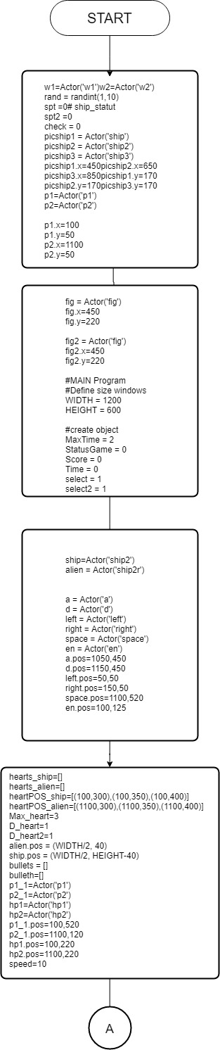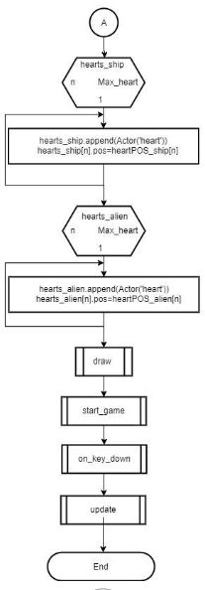

4
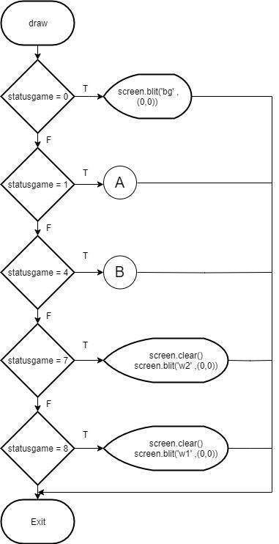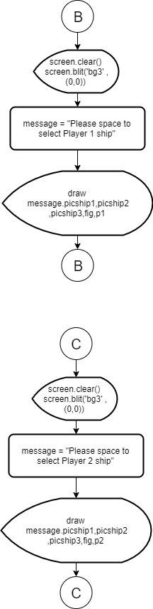

5
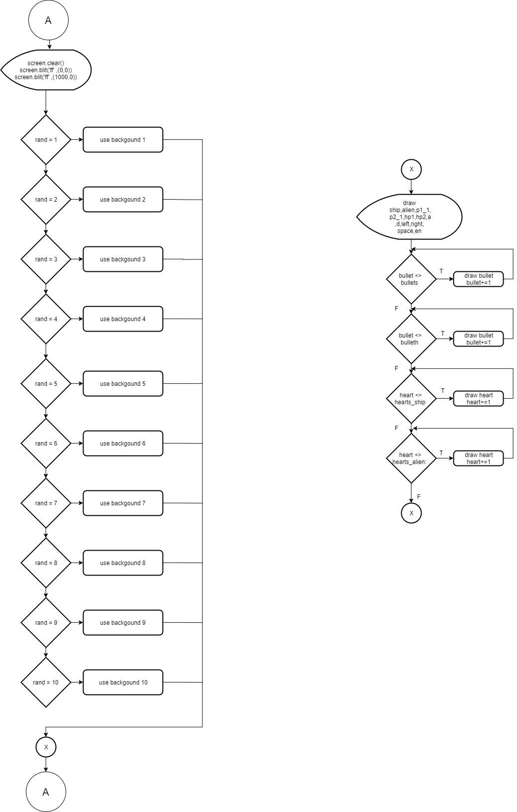

6
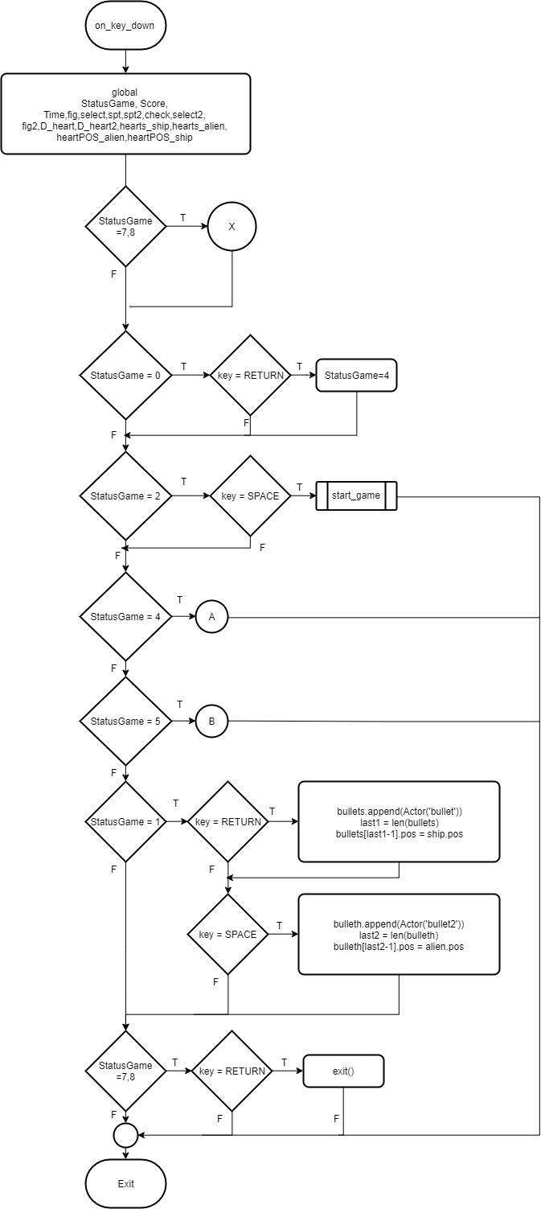

7
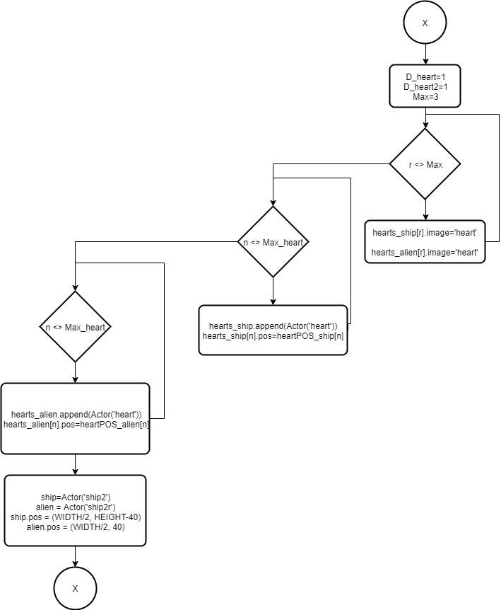

8

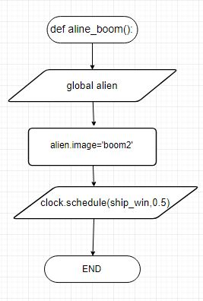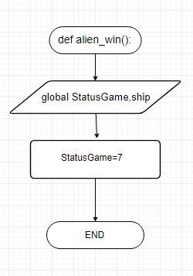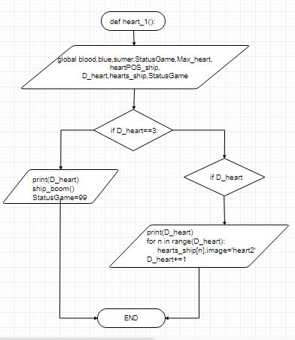

9

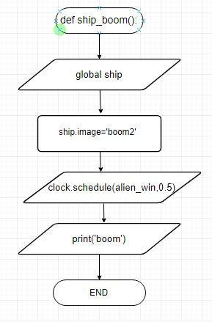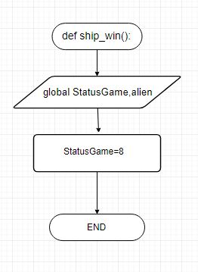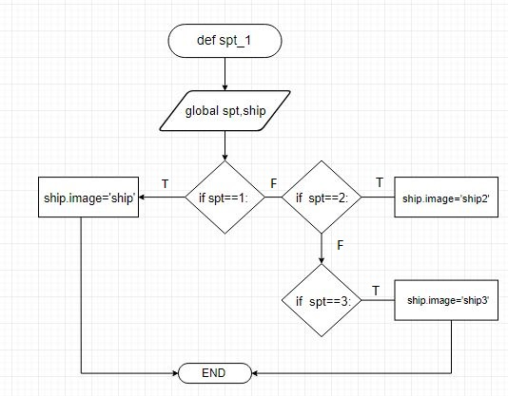

10

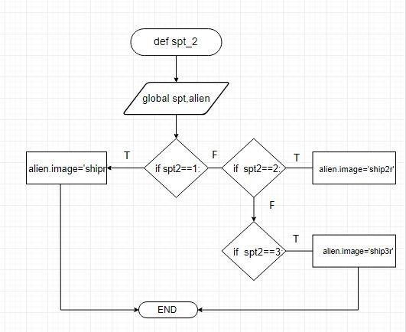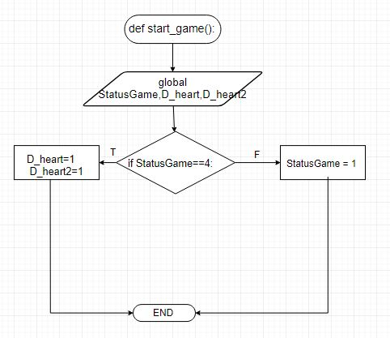

11

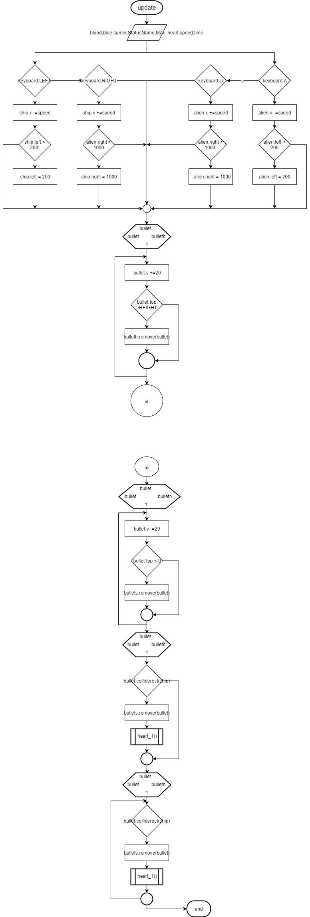

12

13

ตัวอย่างหน้าจอการทำงานของเกมทั้งหมด

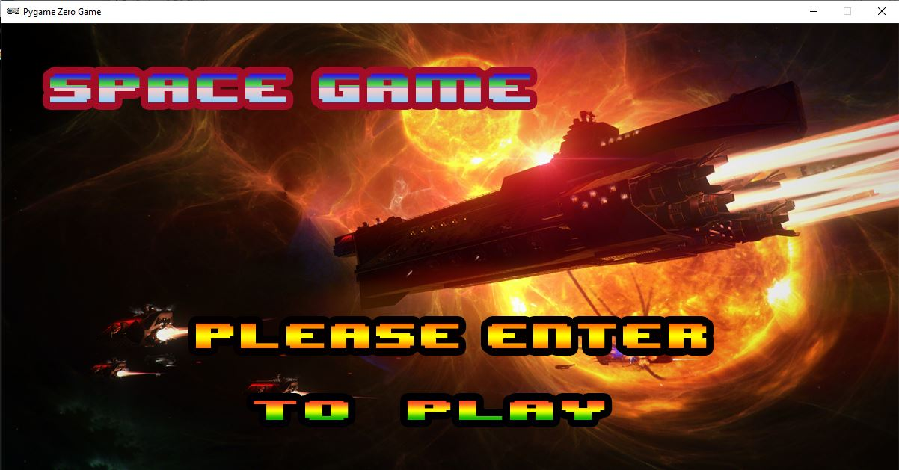
ภาพที่ 1 หน้าเริ่มเกม
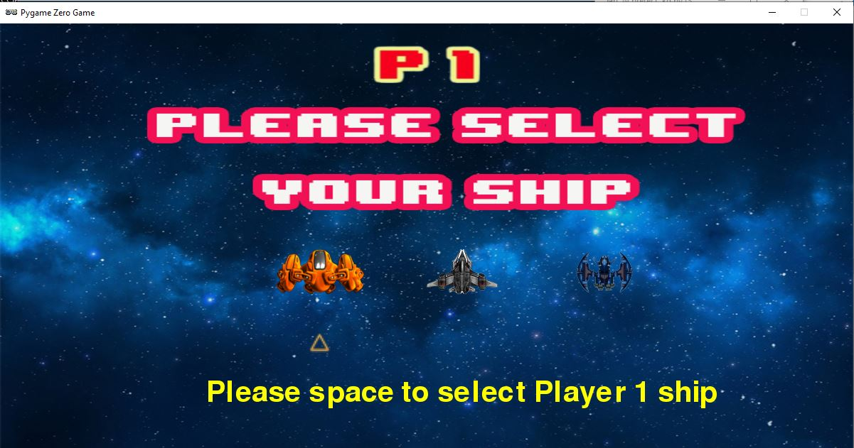
ภาพที่ 2 หน้าเลือกยาน Player1

14

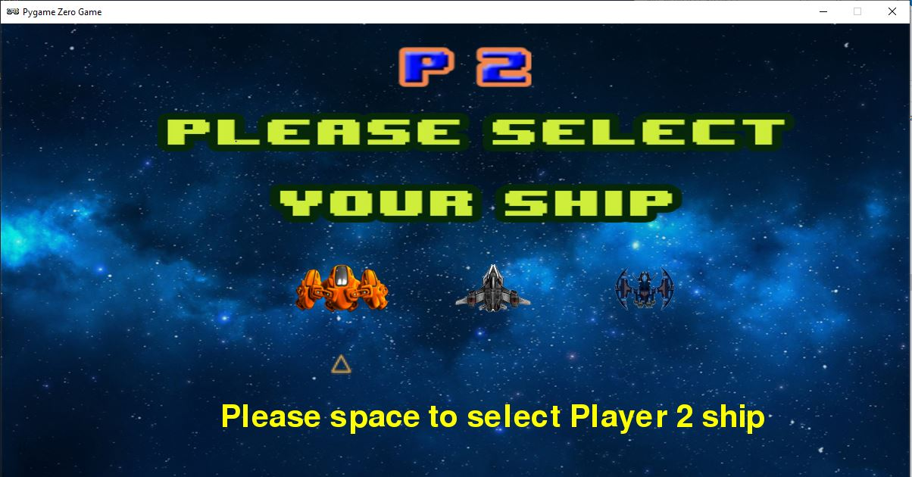
ภาพที่ 3 หน้าเลือกยาน Player2

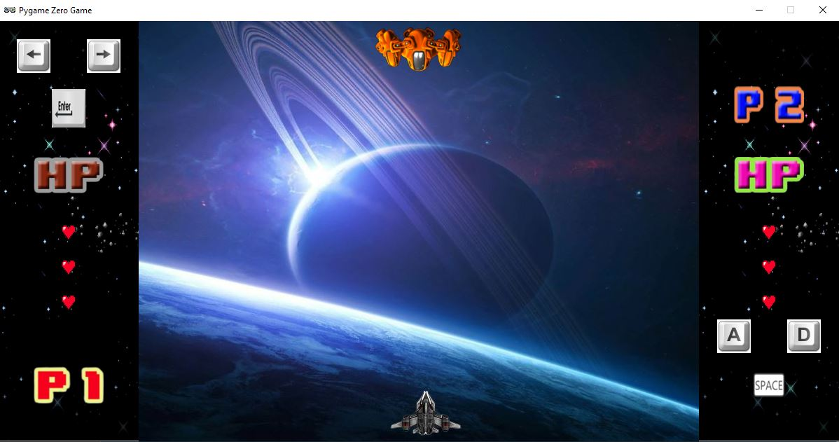ภาพที่ 4 หน้าเล่นเกม

15

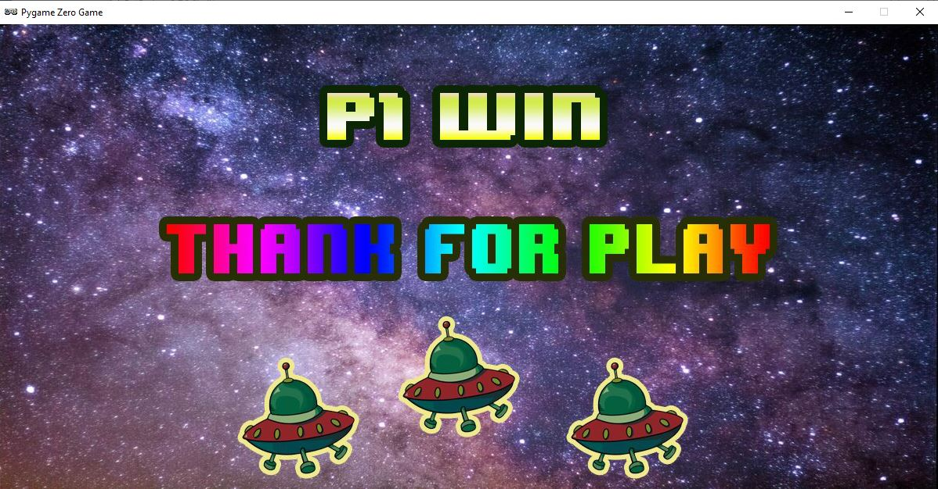ภาพที่ 5 หน้าแสดงชัยชนะของ Player 1

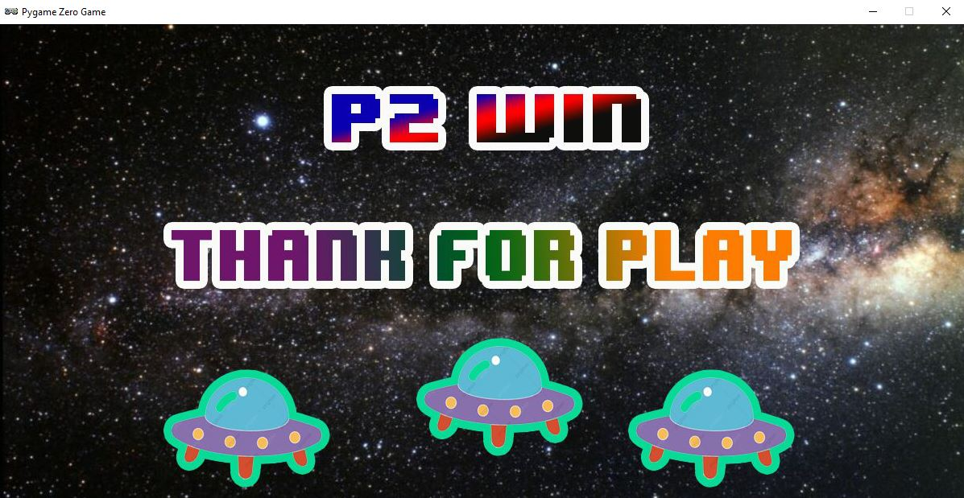ภาพที่ 6 หน้าแสดงชัยชนะของ Player

16

Source Program

import pgzrun
import os
from random import randint

def draw():
if StatusGame == 0:
screen.blit('home2' ,(0,0))
#message = "Are you ready, press Enter key to play."
#screen.draw.text(message,topleft=(350,450),fontsize=40)

elif StatusGame == 1:
screen.clear()
#screen.blit('menu2' ,(200,0))

screen.blit('ff' ,(0,0))
screen.blit('ff' ,(1000,0))
if rand == 1:
screen.blit('bbg1' , (200,0))
elif rand == 2:
screen.blit('bbg2' , (200,0))
elif rand == 3:
screen.blit('bbg3' , (200,0))
elif rand == 4:
screen.blit('bbg4' , (200,0))
elif rand == 5:
screen.blit('bbg5' , (200,0))
elif rand == 6:
screen.blit('bbg6' , (200,0))
elif rand == 7:
screen.blit('bbg7' , (200,0))
elif rand == 8:
screen.blit('bbg8' , (200,0))
elif rand == 9:
screen.blit('bbg9' , (200,0))
elif rand == 10:
screen.blit('bbg10' , (200,0))

17

ship.draw()
alien.draw()
p1_1.draw()
p2_1.draw()
hp1.draw()
hp2.draw()
a.draw()
d.draw()
left.draw()
right.draw()
space.draw()
en.draw()

for bullet in bullets:
bullet.draw()

for bullet in bulleth:
bullet.draw()

for heart in hearts_ship:
heart.draw()
for heart in hearts_alien:
heart.draw()

elif StatusGame == 4:
screen.clear()
screen.blit('sl1' ,(0,0))
message = "Please space to select Player 1 ship"
screen.draw.text(message,topleft=(290,500),fontsize=60,color='yellow')
picship1.draw()
picship2.draw()
picship3.draw()
fig.draw()

elif StatusGame == 5:
screen.clear()
screen.blit('sl2' ,(0,0))
message = "Please space to select Player 2 ship"
screen.draw.text(message,topleft=(290,500),fontsize=60,color='yellow')
18

picship1.draw()
picship2.draw()
picship3.draw()
fig2.draw()

elif StatusGame == 7:
screen.clear()
screen.blit('w2' ,(0,0))

elif StatusGame == 8:
screen.clear()
screen.blit('w1' ,(0,0))

def on_key_down(key):
global StatusGame, Score, Time,fig,select,spt,spt2,check,select2,fig2,D_heart,D_heart2,hearts_ship,hearts_alien,heartPOS_alien,heartPOS_ship,alien,ship

if StatusGame==7 or StatusGame==8:
D_heart=1
D_heart2=1
Max=3
for r in range(Max):
hearts_ship[r].image='heart'
hearts_alien[r].image='heart'
'''for n in range(D_heart):
hearts_ship[n].image='heart'
'''

for n in range(Max_heart):
hearts_ship.append(Actor('heart'))
hearts_ship[n].pos=heartPOS_ship[n]
for n in range(Max_heart):
hearts_alien.append(Actor('heart'))
hearts_alien[n].pos=heartPOS_alien[n]

ship=Actor('ship2')
alien = Actor('ship2r')
ship.pos = (WIDTH/2, HEIGHT-40)
19

alien.pos = (WIDTH/2, 40)

if StatusGame == 0:
if key == keys.RETURN:
#start_game()
StatusGame=4

elif StatusGame == 2:
if key == keys.SPACE:
start_game()

elif StatusGame == 4:
if key == key.RIGHT:
fig.x+=200
select+=1
if fig.x>850:
fig.x=850
if select>3:
select = 3
print(select)

if key == key.LEFT:
fig.x-=200
select-=1
if select<1:
select = 1
print(select)

if fig.x<450:
fig.x=450

if key == key.SPACE:
spt = select
spt_1()
print(spt)
StatusGame = 5

elif StatusGame == 5:

if key == key.RIGHT:
20

fig2.x+=200
select2 +=1
if fig2.x>850:
fig2.x=850
if select2 >3:
select2 = 3
print(select2)

if key == key.LEFT:
fig2.x-=200
select2-=1
if select2<1:
select2 = 1
if fig2.x<450:
fig2.x=450
print(select2)

if key == key.SPACE:
spt2 = select2
print(spt2)
spt_2()
StatusGame = 1

elif StatusGame==1:
if key == keys.RETURN:
bullets.append(Actor('bullet'))
last1 = len(bullets)
bullets[last1-1].pos = ship.pos
sounds.laser.play()

if key == keys.SPACE:
bulleth.append(Actor('bullet2'))
last2 = len(bulleth)
bulleth[last2-1].pos = alien.pos
sounds.laser.play()

elif StatusGame==7 or StatusGame==8:
if key == keys.RETURN:
StatusGame=4
21

#exit()

#######################################

def spt_1():
global spt,ship
if spt==1:
ship.image='ship'
elif spt==2:
ship.image='ship2'
elif spt==3:
ship.image='ship3'

def spt_2():
global spt2,alien
if spt2==1:
alien.image='shipr'
elif spt2== 2:
alien.image='ship2r'
elif spt2== 3:
alien.image='ship3r'

def update():
global blood,blue,sumer,StatusGame,Max_heart,speed,time

if keyboard.LEFT:
ship.x -=speed
if ship.left < 200:
ship.left = 200
elif keyboard.RIGHT:
ship.x +=speed
if ship.right > 1000:
ship.right = 1000

if keyboard.A:
alien.x -=speed
if alien.left < 200:
alien.left = 200
elif keyboard.D:
alien.x +=speed
22

if alien.right > 1000:
alien.right = 1000

for bullet in bullets :
bullet.y -=20
if bullet.top < 0:
bullets.remove(bullet)

for bullet in bulleth :
bullet.y +=20
if bullet.top >HEIGHT:
bulleth.remove(bullet)

#เช็คกระสุน
for bullet in bulleth:
if bullet.colliderect(ship):
bulleth.remove(bullet)

heart_1()

for bullet in bullets:
if bullet.colliderect(alien):
bullets.remove(bullet)
heart_2()

def start_game():
global StatusGame,D_heart,D_heart2
if StatusGame==4:
D_heart=1
D_heart2=1
else :
StatusGame = 1

def ship_boom():
global ship
#ship=Actor('boom2')
ship.image='boom2'
print('boom')

clock.schedule(alien_win,0.5)
23

def aline_boom():
global alien
#alien=Actor('boom2')
alien.image='boom2'
clock.schedule(ship_win,0.5)

def alien_win():
global StatusGame,ship
StatusGame=7

def ship_win():
global StatusGame,alien
StatusGame=8

def heart_1():
global blood,blue,sumer,StatusGame,Max_heart,heartPOS_ship,D_heart,hearts_ship,StatusGame
if D_heart==3:
print(D_heart)
ship_boom()
StatusGame=99

if D_heart<3:
print(D_heart)
for n in range(D_heart):
hearts_ship[n].image='heart2'
D_heart+=1

def heart_2():
global blood,blue,sumer,StatusGame,Max_heart,heartPOS_ship,D_heart2,hearts_alien,StatusGame
if D_heart2==3:
aline_boom()
StatusGame=99

if D_heart2<3:
for a in range(D_heart2):
hearts_alien[a].image='heart3'
D_heart2+=1

24

w1=Actor('w1')
w2=Actor('w2')
rand = randint(1,10)
spt =0# ship_statut
spt2 =0
check = 0
picship1 = Actor('ship')
picship2 = Actor('ship2')
picship3 = Actor('ship3')
picship1.x=450
picship2.x=650
picship3.x=850
picship1.y=350
picship2.y=350
picship3.y=350
p1=Actor('p1')
p2=Actor('p2')
p1.x=100
p1.y=50
p2.x=1100
p2.y=50
fig = Actor('fig')
fig.x=450
fig.y=450
fig2 = Actor('fig')
fig2.x=450
fig2.y=450
WIDTH = 1200
HEIGHT = 600
MaxTime = 2
StatusGame = 0
Score = 0
Time = 0
select = 1
select2 = 1
ship=Actor('ship2')
alien = Actor('ship2r')
a = Actor('a')
d = Actor('d')
left = Actor('left')
25

right = Actor('right')
space = Actor('space')
en = Actor('en')
a.pos=1050,450
d.pos=1150,450
left.pos=50,50
right.pos=150,50
space.pos=1100,520
en.pos=100,125
hearts_ship=[]
hearts_alien=[]
heartPOS_ship=[(100,300),(100,350),(100,400)]
heartPOS_alien=[(1100,300),(1100,350),(1100,400)]
Max_heart=3
D_heart=1
D_heart2=1
alien.pos = (WIDTH/2, 40)
ship.pos = (WIDTH/2, HEIGHT-40)
bullets = []
bulleth=[]
p1_1=Actor('p1')
p2_1=Actor('p2')
hp1=Actor('hp1')
hp2=Actor('hp2')
p1_1.pos=100,520
p2_1.pos=1100,120
hp1.pos=100,220
hp2.pos=1100,220
speed=10
for n in range(Max_heart):
hearts_ship.append(Actor('heart'))
hearts_ship[n].pos=heartPOS_ship[n]
for n in range(Max_heart):
hearts_alien.append(Actor('heart'))
hearts_alien[n].pos=heartPOS_alien[n]

pgzrun.go()

ภาคผนวก

ภาพตัวอย่างเมื่อรันโค้ด

ภาพตัวอย่างเมื่อจบเกม

อ้างอิง

https://github.com/StyczenB/Alien-Invasion-Game

%22%20style%3D%22endArrow%3Dnone%3Bhtml%3D1%3B%22%20edge%3D%221%22%20parent%3D%221%22%3E%3CmxGeometry%20width%3D%2250%22%20height%3D%2250%22%20relative%3D%221%22%20as%3D%22geometry%22%3E%3CmxPoint%20x%3D%22640.0000000000002%22%20y%3D%22715%22%20as%3D%22sourcePoint%22%2F%3E%3CmxPoint%20x%3D%22680.0000000000002%22%20y%3D%22715%22%20as%3D%22targetPoint%22%2F%3E%3C%2FmxGeometry%3E%3C%2FmxCell%3E%3CmxCell%20id%3D%2220%22%20value%3D%22%22%20style%3D%22endArrow%3Dnone%3Bhtml%3D1%3B%22%20edge%3D%221%22%20parent%3D%221%22%3E%3CmxGeometry%20width%3D%2250%22%20height%3D%2250%22%20relative%3D%221%22%20as%3D%22geometry%22%3E%3CmxPoint%20x%3D%22460%22%20y%3D%22565%22%20as%3D%22sourcePoint%22%2F%3E%3CmxPoint%20x%3D%22520%22%20y%3D%22565%22%20as%3D%22targetPoint%22%2F%3E%3C%2FmxGeometry%3E%3C%2FmxCell%3E%3CmxCell%20id%3D%2221%22%20value%3D%22%22%20style%3D%22endArrow%3Dnone%3Bhtml%3D1%3B%22%20edge%3D%221%22%20parent%3D%221%22%3E%3CmxGeometry%20width%3D%2250%22%20height%3D%2250%22%20relative%3D%221%22%20as%3D%22geometry%22%3E%3CmxPoint%20x%3D%22270%22%20y%3D%22564%22%20as%3D%22sourcePoint%22%2F%3E%3CmxPoint%20x%3D%22340%22%20y%3D%22564%22%20as%3D%22targetPoint%22%2F%3E%3C%2FmxGeometry%3E%3C%2FmxCell%3E%3CmxCell%20id%3D%2222%22%20value%3D%22%22%20style%3D%22endArrow%3Dnone%3Bhtml%3D1%3B%22%20edge%3D%221%22%20parent%3D%221%22%3E%3CmxGeometry%20width%3D%2250%22%20height%3D%2250%22%20relative%3D%221%22%20as%3D%22geometry%22%3E%3CmxPoint%20x%3D%22640.0000000000002%22%20y%3D%22565%22%20as%3D%22sourcePoint%22%2F%3E%3CmxPoint%20x%3D%22670.0000000000002%22%20y%3D%22565%22%20as%3D%22targetPoint%22%2F%3E%3C%2FmxGeometry%3E%3C%2FmxCell%3E%3CmxCell%20id%3D%2223%22%20value%3D%22%22%20style%3D%22endArrow%3Dnone%3Bhtml%3D1%3B%22%20edge%3D%221%22%20parent%3D%221%22%3E%3CmxGeometry%20width%3D%2250%22%20height%3D%2250%22%20relative%3D%221%22%20as%3D%22geometry%22%3E%3CmxPoint%20x%3D%22579%22%20y%3D%22620%22%20as%3D%22sourcePoint%22%2F%3E%3CmxPoint%20x%3D%22579%22%20y%3D%22660%22%20as%3D%22targetPoint%22%2F%3E%3C%2FmxGeometry%3E%3C%2FmxCell%3E%3CmxCell%20id%3D%2224%22%20value%3D%22%22%20style%3D%22endArrow%3Dnone%3Bhtml%3D1%3B%22%20edge%3D%221%22%20parent%3D%221%22%3E%3CmxGeometry%20width%3D%2250%22%20height%3D%2250%22%20relative%3D%221%22%20as%3D%22geometry%22%3E%3CmxPoint%20x%3D%22209.5%22%20y%3D%22600%22%20as%3D%22sourcePoint%22%2F%3E%3CmxPoint%20x%3D%22210%22%20y%3D%22880%22%20as%3D%22targetPoint%22%2F%3E%3C%2FmxGeometry%3E%3C%2FmxCell%3E%3CmxCell%20id%3D%2225%22%20value%3D%22%22%20style%3D%22endArrow%3Dnone%3Bhtml%3D1%3B%22%20edge%3D%221%22%20parent%3D%221%22%3E%3CmxGeometry%20width%3D%2250%22%20height%3D%2250%22%20relative%3D%221%22%20as%3D%22geometry%22%3E%3CmxPoint%20x%3D%22210%22%20y%3D%22880%22%20as%3D%22sourcePoint%22%2F%3E%3CmxPoint%20x%3D%22360%22%20y%3D%22880%22%20as%3D%22targetPoint%22%2F%3E%3C%2FmxGeometry%3E%3C%2FmxCell%3E%3C%2Froot%3E%3C%2FmxGraphModel%3E%3CmxGraphModel%3E%3Croot%3E%3CmxCell%20id%3D%220%22%2F%3E%3CmxCell%20id%3D%221%22%20parent%3D%220%22%2F%3E%3CmxCell%20id%3D%222%22%20value%3D%22global%20spt%2Cship%22%20style%3D%22shape%3Dparallelogram%3Bhtml%3D1%3BstrokeWidth%3D2%3Bperimeter%3DparallelogramPerimeter%3BwhiteSpace%3Dwrap%3Brounded%3D1%3BarcSize%3D12%3Bsize%3D0.23%3B%22%20vertex%3D%221%22%20parent%3D%221%22%3E%3CmxGeometry%20x%3D%22300%22%20y%3D%22430%22%20width%3D%22200%22%20height%3D%2260%22%20as%3D%22geometry%22%2F%3E%3C%2FmxCell%3E%3CmxCell%20id%3D%223%22%20value%3D%22%22%20style%3D%22endArrow%3Dnone%3Bhtml%3D1%3B%22%20edge%3D%221%22%20parent%3D%221%22%3E%3CmxGeometry%20width%3D%2250%22%20height%3D%2250%22%20relative%3D%221%22%20as%3D%22geometry%22%3E%3CmxPoint%20x%3D%22400%22%20y%3D%22430%22%20as%3D%22sourcePoint%22%2F%3E%3CmxPoint%20x%3D%22400%22%20y%3D%22389.9999999999999%22%20as%3D%22targetPoint%22%2F%3E%3C%2FmxGeometry%3E%3C%2FmxCell%3E%3CmxCell%20id%3D%224%22%20value%3D%22def%20spt_1%22%20style%3D%22html%3D1%3Bdashed%3D0%3Bwhitespace%3Dwrap%3Bshape%3Dmxgraph.dfd.start%22%20vertex%3D%221%22%20parent%3D%221%22%3E%3CmxGeometry%20x%3D%22315%22%20y%3D%22350%22%20width%3D%22170%22%20height%3D%2250%22%20as%3D%22geometry%22%2F%3E%3C%2FmxCell%3E%3CmxCell%20id%3D%225%22%20value%3D%22END%22%20style%3D%22html%3D1%3Bdashed%3D0%3Bwhitespace%3Dwrap%3Bshape%3Dmxgraph.dfd.start%22%20vertex%3D%221%22%20parent%3D%221%22%3E%3CmxGeometry%20x%3D%22360%22%20y%3D%22860%22%20width%3D%2280%22%20height%3D%2230%22%20as%3D%22geometry%22%2F%3E%3C%2FmxCell%3E%3CmxCell%20id%3D%226%22%20value%3D%22%22%20style%3D%22rhombus%3BwhiteSpace%3Dwrap%3Bhtml%3D1%3B%22%20vertex%3D%221%22%20parent%3D%221%22%3E%3CmxGeometry%20x%3D%22340%22%20y%3D%22510%22%20width%3D%22120%22%20height%3D%22110%22%20as%3D%22geometry%22%2F%3E%3C%2FmxCell%3E%3CmxCell%20id%3D%227%22%20value%3D%22if%20spt%3D%3D1%3A%22%20style%3D%22text%3Bhtml%3D1%3B%22%20vertex%3D%221%22%20parent%3D%221%22%3E%3CmxGeometry%20x%3D%22370%22%20y%3D%22550%22%20width%3D%2270%22%20height%3D%2230%22%20as%3D%22geometry%22%2F%3E%3C%2FmxCell%3E%3CmxCell%20id%3D%228%22%20value%3D%22%22%20style%3D%22endArrow%3Dnone%3Bhtml%3D1%3B%22%20edge%3D%221%22%20parent%3D%221%22%3E%3CmxGeometry%20width%3D%2250%22%20height%3D%2250%22%20relative%3D%221%22%20as%3D%22geometry%22%3E%3CmxPoint%20x%3D%22400%22%20y%3D%22510%22%20as%3D%22sourcePoint%22%2F%3E%3CmxPoint%20x%3D%22400%22%20y%3D%22490%22%20as%3D%22targetPoint%22%2F%3E%3C%2FmxGeometry%3E%3C%2FmxCell%3E%3CmxCell%20id%3D%229%22%20value%3D%22%22%20style%3D%22rhombus%3BwhiteSpace%3Dwrap%3Bhtml%3D1%3B%22%20vertex%3D%221%22%20parent%3D%221%22%3E%3CmxGeometry%20x%3D%22520%22%20y%3D%22510%22%20width%3D%22120%22%20height%3D%22110%22%20as%3D%22geometry%22%2F%3E%3C%2FmxCell%3E%3CmxCell%20id%3D%2210%22%20value%3D%22%22%20style%3D%22rounded%3D0%3BwhiteSpace%3Dwrap%3Bhtml%3D1%3B%22%20vertex%3D%221%22%20parent%3D%221%22%3E%3CmxGeometry%20x%3D%22150%22%20y%3D%22540%22%20width%3D%22120%22%20height%3D%2260%22%20as%3D%22geometry%22%2F%3E%3C%2FmxCell%3E%3CmxCell%20id%3D%2211%22%20value%3D%22ship.image%3D'ship'%22%20style%3D%22text%3Bhtml%3D1%3B%22%20vertex%3D%221%22%20parent%3D%221%22%3E%3CmxGeometry%20x%3D%22160%22%20y%3D%22555%22%20width%3D%22120%22%20height%3D%2230%22%20as%3D%22geometry%22%2F%3E%3C%2FmxCell%3E%3CmxCell%20id%3D%2212%22%20value%3D%22if%C2%A0%20spt%3D%3D2%3A%22%20style%3D%22text%3Bhtml%3D1%3B%22%20vertex%3D%221%22%20parent%3D%221%22%3E%3CmxGeometry%20x%3D%22550%22%20y%3D%22550%22%20width%3D%2280%22%20height%3D%2230%22%20as%3D%22geometry%22%2F%3E%3C%2FmxCell%3E%3CmxCell%20id%3D%2213%22%20value%3D%22%22%20style%3D%22rounded%3D0%3BwhiteSpace%3Dwrap%3Bhtml%3D1%3B%22%20vertex%3D%221%22%20parent%3D%221%22%3E%3CmxGeometry%20x%3D%22670%22%20y%3D%22530%22%20width%3D%22120%22%20height%3D%2260%22%20as%3D%22geometry%22%2F%3E%3C%2FmxCell%3E%3CmxCell%20id%3D%2214%22%20value%3D%22ship.image%3D'ship2'%22%20style%3D%22text%3Bhtml%3D1%3B%22%20vertex%3D%221%22%20parent%3D%221%22%3E%3CmxGeometry%20x%3D%22680%22%20y%3D%22545%22%20width%3D%22120%22%20height%3D%2230%22%20as%3D%22geometry%22%2F%3E%3C%2FmxCell%3E%3CmxCell%20id%3D%2215%22%20value%3D%22%22%20style%3D%22rhombus%3BwhiteSpace%3Dwrap%3Bhtml%3D1%3B%22%20vertex%3D%221%22%20parent%3D%221%22%3E%3CmxGeometry%20x%3D%22520%22%20y%3D%22660%22%20width%3D%22120%22%20height%3D%22110%22%20as%3D%22geometry%22%2F%3E%3C%2FmxCell%3E%3CmxCell%20id%3D%2216%22%20value%3D%22if%26amp%3Bnbsp%3B%20spt%3D%3D3%3A%22%20style%3D%22text%3Bhtml%3D1%3B%22%20vertex%3D%221%22%20parent%3D%221%22%3E%3CmxGeometry%20x%3D%22550%22%20y%3D%22690%22%20width%3D%2280%22%20height%3D%2230%22%20as%3D%22geometry%22%2F%3E%3C%2FmxCell%3E%3CmxCell%20id%3D%2217%22%20value%3D%22%22%20style%3D%22rounded%3D0%3BwhiteSpace%3Dwrap%3Bhtml%3D1%3B%22%20vertex%3D%221%22%20parent%3D%221%22%3E%3CmxGeometry%20x%3D%22680%22%20y%3D%22685%22%20width%3D%22120%22%20height%3D%2260%22%20as%3D%22geometry%22%2F%3E%3C%2FmxCell%3E%3CmxCell%20id%3D%2218%22%20value%3D%22ship.image%3D'ship3'%22%20style%3D%22text%3Bhtml%3D1%3B%22%20vertex%3D%221%22%20parent%3D%221%22%3E%3CmxGeometry%20x%3D%22690%22%20y%3D%22700%22%20width%3D%22120%22%20height%3D%2230%22%20as%3D%22geometry%22%2F%3E%3C%2FmxCell%3E%3CmxCell%20id%3D%2219%22%20value%3D%22%22%20style%3D%22endArrow%3Dnone%3Bhtml%3D1%3B%22%20edge%3D%221%22%20parent%3D%221%22%3E%3CmxGeometry%20width%3D%2250%22%20height%3D%2250%22%20relative%3D%221%22%20as%3D%22geometry%22%3E%3CmxPoint%20x%3D%22640.0000000000002%22%20y%3D%22715%22%20as%3D%22sourcePoint%22%2F%3E%3CmxPoint%20x%3D%22680.0000000000002%22%20y%3D%22715%22%20as%3D%22targetPoint%22%2F%3E%3C%2FmxGeometry%3E%3C%2FmxCell%3E%3CmxCell%20id%3D%2220%22%20value%3D%22%22%20style%3D%22endArrow%3Dnone%3Bhtml%3D1%3B%22%20edge%3D%221%22%20parent%3D%221%22%3E%3CmxGeometry%20width%3D%2250%22%20height%3D%2250%22%20relative%3D%221%22%20as%3D%22geometry%22%3E%3CmxPoint%20x%3D%22460%22%20y%3D%22565%22%20as%3D%22sourcePoint%22%2F%3E%3CmxPoint%20x%3D%22520%22%20y%3D%22565%22%20as%3D%22targetPoint%22%2F%3E%3C%2FmxGeometry%3E%3C%2FmxCell%3E%3CmxCell%20id%3D%2221%22%20value%3D%22%22%20style%3D%22endArrow%3Dnone%3Bhtml%3D1%3B%22%20edge%3D%221%22%20parent%3D%221%22%3E%3CmxGeometry%20width%3D%2250%22%20height%3D%2250%22%20relative%3D%221%22%20as%3D%22geometry%22%3E%3CmxPoint%20x%3D%22270%22%20y%3D%22564%22%20as%3D%22sourcePoint%22%2F%3E%3CmxPoint%20x%3D%22340%22%20y%3D%22564%22%20as%3D%22targetPoint%22%2F%3E%3C%2FmxGeometry%3E%3C%2FmxCell%3E%3CmxCell%20id%3D%2222%22%20value%3D%22%22%20style%3D%22endArrow%3Dnone%3Bhtml%3D1%3B%22%20edge%3D%221%22%20parent%3D%221%22%3E%3CmxGeometry%20width%3D%2250%22%20height%3D%2250%22%20relative%3D%221%22%20as%3D%22geometry%22%3E%3CmxPoint%20x%3D%22640.0000000000002%22%20y%3D%22565%22%20as%3D%22sourcePoint%22%2F%3E%3CmxPoint%20x%3D%22670.0000000000002%22%20y%3D%22565%22%20as%3D%22targetPoint%22%2F%3E%3C%2FmxGeometry%3E%3C%2FmxCell%3E%3CmxCell%20id%3D%2223%22%20value%3D%22%22%20style%3D%22endArrow%3Dnone%3Bhtml%3D1%3B%22%20edge%3D%221%22%20parent%3D%221%22%3E%3CmxGeometry%20width%3D%2250%22%20height%3D%2250%22%20relative%3D%221%22%20as%3D%22geometry%22%3E%3CmxPoint%20x%3D%22579%22%20y%3D%22620%22%20as%3D%22sourcePoint%22%2F%3E%3CmxPoint%20x%3D%22579%22%20y%3D%22660%22%20as%3D%22targetPoint%22%2F%3E%3C%2FmxGeometry%3E%3C%2FmxCell%3E%3CmxCell%20id%3D%2224%22%20value%3D%22%22%20style%3D%22endArrow%3Dnone%3Bhtml%3D1%3B%22%20edge%3D%221%22%20parent%3D%221%22%3E%3CmxGeometry%20width%3D%2250%22%20height%3D%2250%22%20relative%3D%221%22%20as%3D%22geometry%22%3E%3CmxPoint%20x%3D%22209.5%22%20y%3D%22600%22%20as%3D%22sourcePoint%22%2F%3E%3CmxPoint%20x%3D%22210%22%20y%3D%22880%22%20as%3D%22targetPoint%22%2F%3E%3C%2FmxGeometry%3E%3C%2FmxCell%3E%3CmxCell%20id%3D%2225%22%20value%3D%22%22%20style%3D%22endArrow%3Dnone%3Bhtml%3D1%3B%22%20edge%3D%221%22%20parent%3D%221%22%3E%3CmxGeometry%20width%3D%2250%22%20height%3D%2250%22%20relative%3D%221%22%20as%3D%22geometry%22%3E%3CmxPoint%20x%3D%22210%22%20y%3D%22880%22%20as%3D%22sourcePoint%22%2F%3E%3CmxPoint%20x%3D%22360%22%20y%3D%22880%22%20as%3D%22targetPoint%22%2F%3E%3C%2FmxGeometry%3E%3C%2FmxCell%3E%3C%2Froot%3E%3C%2FmxGraphModel%3E%3CmxGraphModel%3E%3Croot%3E%3CmxCell%20id%3D%220%22%2F%3E%3CmxCell%20id%3D%221%22%20parent%3D%220%22%2F%3E%3CmxCell%20id%3D%222%22%20value%3D%22global%20spt%2Cship%22%20style%3D%22shape%3Dparallelogram%3Bhtml%3D1%3BstrokeWidth%3D2%3Bperimeter%3DparallelogramPerimeter%3BwhiteSpace%3Dwrap%3Brounded%3D1%3BarcSize%3D12%3Bsize%3D0.23%3B%22%20vertex%3D%221%22%20parent%3D%221%22%3E%3CmxGeometry%20x%3D%22300%22%20y%3D%22430%22%20width%3D%22200%22%20height%3D%2260%22%20as%3D%22geometry%22%2F%3E%3C%2FmxCell%3E%3CmxCell%20id%3D%223%22%20value%3D%22%22%20style%3D%22endArrow%3Dnone%3Bhtml%3D1%3B%22%20edge%3D%221%22%20parent%3D%221%22%3E%3CmxGeometry%20width%3D%2250%22%20height%3D%2250%22%20relative%3D%221%22%20as%3D%22geometry%22%3E%3CmxPoint%20x%3D%22400%22%20y%3D%22430%22%20as%3D%22sourcePoint%22%2F%3E%3CmxPoint%20x%3D%22400%22%20y%3D%22389.9999999999999%22%20as%3D%22targetPoint%22%2F%3E%3C%2FmxGeometry%3E%3C%2FmxCell%3E%3CmxCell%20id%3D%224%22%20value%3D%22def%20spt_1%22%20style%3D%22html%3D1%3Bdashed%3D0%3Bwhitespace%3Dwrap%3Bshape%3Dmxgraph.dfd.start%22%20vertex%3D%221%22%20parent%3D%221%22%3E%3CmxGeometry%20x%3D%22315%22%20y%3D%22350%22%20width%3D%22170%22%20height%3D%2250%22%20as%3D%22geometry%22%2F%3E%3C%2FmxCell%3E%3CmxCell%20id%3D%225%22%20value%3D%22END%22%20style%3D%22html%3D1%3Bdashed%3D0%3Bwhitespace%3Dwrap%3Bshape%3Dmxgraph.dfd.start%22%20vertex%3D%221%22%20parent%3D%221%22%3E%3CmxGeometry%20x%3D%22360%22%20y%3D%22860%22%20width%3D%2280%22%20height%3D%2230%22%20as%3D%22geometry%22%2F%3E%3C%2FmxCell%3E%3CmxCell%20id%3D%226%22%20value%3D%22%22%20style%3D%22rhombus%3BwhiteSpace%3Dwrap%3Bhtml%3D1%3B%22%20vertex%3D%221%22%20parent%3D%221%22%3E%3CmxGeometry%20x%3D%22340%22%20y%3D%22510%22%20width%3D%22120%22%20height%3D%22110%22%20as%3D%22geometry%22%2F%3E%3C%2FmxCell%3E%3CmxCell%20id%3D%227%22%20value%3D%22if%20spt%3D%3D1%3A%22%20style%3D%22text%3Bhtml%3D1%3B%22%20vertex%3D%221%22%20parent%3D%221%22%3E%3CmxGeometry%20x%3D%22370%22%20y%3D%22550%22%20width%3D%2270%22%20height%3D%2230%22%20as%3D%22geometry%22%2F%3E%3C%2FmxCell%3E%3CmxCell%20id%3D%228%22%20value%3D%22%22%20style%3D%22endArrow%3Dnone%3Bhtml%3D1%3B%22%20edge%3D%221%22%20parent%3D%221%22%3E%3CmxGeometry%20width%3D%2250%22%20height%3D%2250%22%20relative%3D%221%22%20as%3D%22geometry%22%3E%3CmxPoint%20x%3D%22400%22%20y%3D%22510%22%20as%3D%22sourcePoint%22%2F%3E%3CmxPoint%20x%3D%22400%22%20y%3D%22490%22%20as%3D%22targetPoint%22%2F%3E%3C%2FmxGeometry%3E%3C%2FmxCell%3E%3CmxCell%20id%3D%229%22%20value%3D%22%22%20style%3D%22rhombus%3BwhiteSpace%3Dwrap%3Bhtml%3D1%3B%22%20vertex%3D%221%22%20parent%3D%221%22%3E%3CmxGeometry%20x%3D%22520%22%20y%3D%22510%22%20width%3D%22120%22%20height%3D%22110%22%20as%3D%22geometry%22%2F%3E%3C%2FmxCell%3E%3CmxCell%20id%3D%2210%22%20value%3D%22%22%20style%3D%22rounded%3D0%3BwhiteSpace%3Dwrap%3Bhtml%3D1%3B%22%20vertex%3D%221%22%20parent%3D%221%22%3E%3CmxGeometry%20x%3D%22150%22%20y%3D%22540%22%20width%3D%22120%22%20height%3D%2260%22%20as%3D%22geometry%22%2F%3E%3C%2FmxCell%3E%3CmxCell%20id%3D%2211%22%20value%3D%22ship.image%3D'ship'%22%20style%3D%22text%3Bhtml%3D1%3B%22%20vertex%3D%221%22%20parent%3D%221%22%3E%3CmxGeometry%20x%3D%22160%22%20y%3D%22555%22%20width%3D%22120%22%20height%3D%2230%22%20as%3D%22geometry%22%2F%3E%3C%2FmxCell%3E%3CmxCell%20id%3D%2212%22%20value%3D%22if%C2%A0%20spt%3D%3D2%3A%22%20style%3D%22text%3Bhtml%3D1%3B%22%20vertex%3D%221%22%20parent%3D%221%22%3E%3CmxGeometry%20x%3D%22550%22%20y%3D%22550%22%20width%3D%2280%22%20height%3D%2230%22%20as%3D%22geometry%22%2F%3E%3C%2FmxCell%3E%3CmxCell%20id%3D%2213%22%20value%3D%22%22%20style%3D%22rounded%3D0%3BwhiteSpace%3Dwrap%3Bhtml%3D1%3B%22%20vertex%3D%221%22%20parent%3D%221%22%3E%3CmxGeometry%20x%3D%22670%22%20y%3D%22530%22%20width%3D%22120%22%20height%3D%2260%22%20as%3D%22geometry%22%2F%3E%3C%2FmxCell%3E%3CmxCell%20id%3D%2214%22%20value%3D%22ship.image%3D'ship2'%22%20style%3D%22text%3Bhtml%3D1%3B%22%20vertex%3D%221%22%20parent%3D%221%22%3E%3CmxGeometry%20x%3D%22680%22%20y%3D%22545%22%20width%3D%22120%22%20height%3D%2230%22%20as%3D%22geometry%22%2F%3E%3C%2FmxCell%3E%3CmxCell%20id%3D%2215%22%20value%3D%22%22%20style%3D%22rhombus%3BwhiteSpace%3Dwrap%3Bhtml%3D1%3B%22%20vertex%3D%221%22%20parent%3D%221%22%3E%3CmxGeometry%20x%3D%22520%22%20y%3D%22660%22%20width%3D%22120%22%20height%3D%22110%22%20as%3D%22geometry%22%2F%3E%3C%2FmxCell%3E%3CmxCell%20id%3D%2216%22%20value%3D%22if%26amp%3Bnbsp%3B%20spt%3D%3D3%3A%22%20style%3D%22text%3Bhtml%3D1%3B%22%20vertex%3D%221%22%20parent%3D%221%22%3E%3CmxGeometry%20x%3D%22550%22%20y%3D%22690%22%20width%3D%2280%22%20height%3D%2230%22%20as%3D%22geometry%22%2F%3E%3C%2FmxCell%3E%3CmxCell%20id%3D%2217%22%20value%3D%22%22%20style%3D%22rounded%3D0%3BwhiteSpace%3Dwrap%3Bhtml%3D1%3B%22%20vertex%3D%221%22%20parent%3D%221%22%3E%3CmxGeometry%20x%3D%22680%22%20y%3D%22685%22%20width%3D%22120%22%20height%3D%2260%22%20as%3D%22geometry%22%2F%3E%3C%2FmxCell%3E%3CmxCell%20id%3D%2218%22%20value%3D%22ship.image%3D'ship3'%22%20style%3D%22text%3Bhtml%3D1%3B%22%20vertex%3D%221%22%20parent%3D%221%22%3E%3CmxGeometry%20x%3D%22690%22%20y%3D%22700%22%20width%3D%22120%22%20height%3D%2230%22%20as%3D%22geometry%22%2F%3E%3C%2FmxCell%3E%3CmxCell%20id%3D%2219%22%20value%3D%22%22%20style%3D%22endArrow%3Dnone%3Bhtml%3D1%3B%22%20edge%3D%221%22%20parent%3D%221%22%3E%3CmxGeometry%20width%3D%2250%22%20height%3D%2250%22%20relative%3D%221%22%20as%3D%22geometry%22%3E%3CmxPoint%20x%3D%22640.0000000000002%22%20y%3D%22715%22%20as%3D%22sourcePoint%22%2F%3E%3CmxPoint%20x%3D%22680.0000000000002%22%20y%3D%22715%22%20as%3D%22targetPoint%22%2F%3E%3C%2FmxGeometry%3E%3C%2FmxCell%3E%3CmxCell%20id%3D%2220%22%20value%3D%22%22%20style%3D%22endArrow%3Dnone%3Bhtml%3D1%3B%22%20edge%3D%221%22%20parent%3D%221%22%3E%3CmxGeometry%20width%3D%2250%22%20height%3D%2250%22%20relative%3D%221%22%20as%3D%22geometry%22%3E%3CmxPoint%20x%3D%22460%22%20y%3D%22565%22%20as%3D%22sourcePoint%22%2F%3E%3CmxPoint%20x%3D%22520%22%20y%3D%22565%22%20as%3D%22targetPoint%22%2F%3E%3C%2FmxGeometry%3E%3C%2FmxCell%3E%3CmxCell%20id%3D%2221%22%20value%3D%22%22%20style%3D%22endArrow%3Dnone%3Bhtml%3D1%3B%22%20edge%3D%221%22%20parent%3D%221%22%3E%3CmxGeometry%20width%3D%2250%22%20height%3D%2250%22%20relative%3D%221%22%20as%3D%22geometry%22%3E%3CmxPoint%20x%3D%22270%22%20y%3D%22564%22%20as%3D%22sourcePoint%22%2F%3E%3CmxPoint%20x%3D%22340%22%20y%3D%22564%22%20as%3D%22targetPoint%22%2F%3E%3C%2FmxGeometry%3E%3C%2FmxCell%3E%3CmxCell%20id%3D%2222%22%20value%3D%22%22%20style%3D%22endArrow%3Dnone%3Bhtml%3D1%3B%22%20edge%3D%221%22%20parent%3D%221%22%3E%3CmxGeometry%20width%3D%2250%22%20height%3D%2250%22%20relative%3D%221%22%20as%3D%22geometry%22%3E%3CmxPoint%20x%3D%22640.0000000000002%22%20y%3D%22565%22%20as%3D%22sourcePoint%22%2F%3E%3CmxPoint%20x%3D%22670.0000000000002%22%20y%3D%22565%22%20as%3D%22targetPoint%22%2F%3E%3C%2FmxGeometry%3E%3C%2FmxCell%3E%3CmxCell%20id%3D%2223%22%20value%3D%22%22%20style%3D%22endArrow%3Dnone%3Bhtml%3D1%3B%22%20edge%3D%221%22%20parent%3D%221%22%3E%3CmxGeometry%20width%3D%2250%22%20height%3D%2250%22%20relative%3D%221%22%20as%3D%22geometry%22%3E%3CmxPoint%20x%3D%22579%22%20y%3D%22620%22%20as%3D%22sourcePoint%22%2F%3E%3CmxPoint%20x%3D%22579%22%20y%3D%22660%22%20as%3D%22targetPoint%22%2F%3E%3C%2FmxGeometry%3E%3C%2FmxCell%3E%3CmxCell%20id%3D%2224%22%20value%3D%22%22%20style%3D%22endArrow%3Dnone%3Bhtml%3D1%3B%22%20edge%3D%221%22%20parent%3D%221%22%3E%3CmxGeometry%20width%3D%2250%22%20height%3D%2250%22%20relative%3D%221%22%20as%3D%22geometry%22%3E%3CmxPoint%20x%3D%22209.5%22%20y%3D%22600%22%20as%3D%22sourcePoint%22%2F%3E%3CmxPoint%20x%3D%22210%22%20y%3D%22880%22%20as%3D%22targetPoint%22%2F%3E%3C%2FmxGeometry%3E%3C%2FmxCell%3E%3CmxCell%20id%3D%2225%22%20value%3D%22%22%20style%3D%22endArrow%3Dnone%3Bhtml%3D1%3B%22%20edge%3D%221%22%20parent%3D%221%22%3E%3CmxGeometry%20width%3D%2250%22%20height%3D%2250%22%20relative%3D%221%22%20as%3D%22geometry%22%3E%3CmxPoint%20x%3D%22210%22%20y%3D%22880%22%20as%3D%22sourcePoint%22%2F%3E%3CmxPoint%20x%3D%22360%22%20y%3D%22880%22%20as%3D%22targetPoint%22%2F%3E%3C%2FmxGeometry%3E%3C%2FmxCell%3E%3C%2Froot%3E%3C%2FmxGraphModel%
%3CmxGraphModel%3E%3Croot%3E%3CmxCell%20id%3D%220%22%2F%3E%3CmxCell%20id%3D%221%22%20parent%3D%220%22%2F%3E%3CmxCell%20id%3D%222%22%20value%3D%22global%20spt%2Cship%22%20style%3D%22shape%3Dparallelogram%3Bhtml%3D1%3BstrokeWidth%3D2%3Bperimeter%3DparallelogramPerimeter%3BwhiteSpace%3Dwrap%3Brounded%3D1%3BarcSize%3D12%3Bsize%3D0.23%3B%22%20vertex%3D%221%22%20parent%3D%221%22%3E%3CmxGeometry%20x%3D%22300%22%20y%3D%22430%22%20width%3D%22200%22%20height%3D%2260%22%20as%3D%22geometry%22%2F%3E%3C%2FmxCell%3E%3CmxCell%20id%3D%223%22%20value%3D%22%22%20style%3D%22endArrow%3Dnone%3Bhtml%3D1%3B%22%20edge%3D%221%22%20parent%3D%221%22%3E%3CmxGeometry%20width%3D%2250%22%20height%3D%2250%22%20relative%3D%221%22%20as%3D%22geometry%22%3E%3CmxPoint%20x%3D%22400%22%20y%3D%22430%22%20as%3D%22sourcePoint%22%2F%3E%3CmxPoint%20x%3D%22400%22%20y%3D%22389.9999999999999%22%20as%3D%22targetPoint%22%2F%3E%3C%2FmxGeometry%3E%3C%2FmxCell%3E%3CmxCell%20id%3D%224%22%20value%3D%22def%20spt_1%22%20style%3D%22html%3D1%3Bdashed%3D0%3Bwhitespace%3Dwrap%3Bshape%3Dmxgraph.dfd.start%22%20vertex%3D%221%22%20parent%3D%221%22%3E%3CmxGeometry%20x%3D%22315%22%20y%3D%22350%22%20width%3D%22170%22%20height%3D%2250%22%20as%3D%22geometry%22%2F%3E%3C%2FmxCell%3E%3CmxCell%20id%3D%225%22%20value%3D%22END%22%20style%3D%22html%3D1%3Bdashed%3D0%3Bwhitespace%3Dwrap%3Bshape%3Dmxgraph.dfd.start%22%20vertex%3D%221%22%20parent%3D%221%22%3E%3CmxGeometry%20x%3D%22360%22%20y%3D%22860%22%20width%3D%2280%22%20height%3D%2230%22%20as%3D%22geometry%22%2F%3E%3C%2FmxCell%3E%3CmxCell%20id%3D%226%22%20value%3D%22%22%20style%3D%22rhombus%3BwhiteSpace%3Dwrap%3Bhtml%3D1%3B%22%20vertex%3D%221%22%20parent%3D%221%22%3E%3CmxGeometry%20x%3D%22340%22%20y%3D%22510%22%20width%3D%22120%22%20height%3D%22110%22%20as%3D%22geometry%22%2F%3E%3C%2FmxCell%3E%3CmxCell%20id%3D%227%22%20value%3D%22if%20spt%3D%3D1%3A%22%20style%3D%22text%3Bhtml%3D1%3B%22%20vertex%3D%221%22%20parent%3D%221%22%3E%3CmxGeometry%20x%3D%22370%22%20y%3D%22550%22%20width%3D%2270%22%20height%3D%2230%22%20as%3D%22geometry%22%2F%3E%3C%2FmxCell%3E%3CmxCell%20id%3D%228%22%20value%3D%22%22%20style%3D%22endArrow%3Dnone%3Bhtml%3D1%3B%22%20edge%3D%221%22%20parent%3D%221%22%3E%3CmxGeometry%20width%3D%2250%22%20height%3D%2250%22%20relative%3D%221%22%20as%3D%22geometry%22%3E%3CmxPoint%20x%3D%22400%22%20y%3D%22510%22%20as%3D%22sourcePoint%22%2F%3E%3CmxPoint%20x%3D%22400%22%20y%3D%22490%22%20as%3D%22targetPoint%22%2F%3E%3C%2FmxGeometry%3E%3C%2FmxCell%3E%3CmxCell%20id%3D%229%22%20value%3D%22%22%20style%3D%22rhombus%3BwhiteSpace%3Dwrap%3Bhtml%3D1%3B%22%20vertex%3D%221%22%20parent%3D%221%22%3E%3CmxGeometry%20x%3D%22520%22%20y%3D%22510%22%20width%3D%22120%22%20height%3D%22110%22%20as%3D%22geometry%22%2F%3E%3C%2FmxCell%3E%3CmxCell%20id%3D%2210%22%20value%3D%22%22%20style%3D%22rounded%3D0%3BwhiteSpace%3Dwrap%3Bhtml%3D1%3B%22%20vertex%3D%221%22%20parent%3D%221%22%3E%3CmxGeometry%20x%3D%22150%22%20y%3D%22540%22%20width%3D%22120%22%20height%3D%2260%22%20as%3D%22geometry%22%2F%3E%3C%2FmxCell%3E%3CmxCell%20id%3D%2211%22%20value%3D%22ship.image%3D'ship'%22%20style%3D%22text%3Bhtml%3D1%3B%22%20vertex%3D%221%22%20parent%3D%221%22%3E%3CmxGeometry%20x%3D%22160%22%20y%3D%22555%22%20width%3D%22120%22%20height%3D%2230%22%20as%3D%22geometry%22%2F%3E%3C%2FmxCell%3E%3CmxCell%20id%3D%2212%22%20value%3D%22if%C2%A0%20spt%3D%3D2%3A%22%20style%3D%22text%3Bhtml%3D1%3B%22%20vertex%3D%221%22%20parent%3D%221%22%3E%3CmxGeometry%20x%3D%22550%22%20y%3D%22550%22%20width%3D%2280%22%20height%3D%2230%22%20as%3D%22geometry%22%2F%3E%3C%2FmxCell%3E%3CmxCell%20id%3D%2213%22%20value%3D%22%22%20style%3D%22rounded%3D0%3BwhiteSpace%3Dwrap%3Bhtml%3D1%3B%22%20vertex%3D%221%22%20parent%3D%221%22%3E%3CmxGeometry%20x%3D%22670%22%20y%3D%22530%22%20width%3D%22120%22%20height%3D%2260%22%20as%3D%22geometry%22%2F%3E%3C%2FmxCell%3E%3CmxCell%20id%3D%2214%22%20value%3D%22ship.image%3D'ship2'%22%20style%3D%22text%3Bhtml%3D1%3B%22%20vertex%3D%221%22%20parent%3D%221%22%3E%3CmxGeometry%20x%3D%22680%22%20y%3D%22545%22%20width%3D%22120%22%20height%3D%2230%22%20as%3D%22geometry%22%2F%3E%3C%2FmxCell%3E%3CmxCell%20id%3D%2215%22%20value%3D%22%22%20style%3D%22rhombus%3BwhiteSpace%3Dwrap%3Bhtml%3D1%3B%22%20vertex%3D%221%22%20parent%3D%221%22%3E%3CmxGeometry%20x%3D%22520%22%20y%3D%22660%22%20width%3D%22120%22%20height%3D%22110%22%20as%3D%22geometry%22%2F%3E%3C%2FmxCell%3E%3CmxCell%20id%3D%2216%22%20value%3D%22if%26amp%3Bnbsp%3B%20spt%3D%3D3%3A%22%20style%3D%22text%3Bhtml%3D1%3B%22%20vertex%3D%221%22%20parent%3D%221%22%3E%3CmxGeometry%20x%3D%22550%22%20y%3D%22690%22%20width%3D%2280%22%20height%3D%2230%22%20as%3D%22geometry%22%2F%3E%3C%2FmxCell%3E%3CmxCell%20id%3D%2217%22%20value%3D%22%22%20style%3D%22rounded%3D0%3BwhiteSpace%3Dwrap%3Bhtml%3D1%3B%22%20vertex%3D%221%22%20parent%3D%221%22%3E%3CmxGeometry%20x%3D%22680%22%20y%3D%22685%22%20width%3D%22120%22%20height%3D%2260%22%20as%3D%22geometry%22%2F%3E%3C%2FmxCell%3E%3CmxCell%20id%3D%2218%22%20value%3D%22ship.image%3D'ship3'%22%20style%3D%22text%3Bhtml%3D1%3B%22%20vertex%3D%221%22%20parent%3D%221%22%3E%3CmxGeometry%20x%3D%22690%22%20y%3D%22700%22%20width%3D%22120%22%20height%3D%2230%22%20as%3D%22geometry%22%2F%3E%3C%2FmxCell%3E%3CmxCell%20id%3D%2219%22%20value%3D%22%22%20style%3D%22endArrow%3Dnone%3Bhtml%3D1%3B%22%20edge%3D%221%22%20parent%3D%221%22%3E%3CmxGeometry%20width%3D%2250%22%20height%3D%2250%22%20relative%3D%221%22%20as%3D%22geometry%22%3E%3CmxPoint%20x%3D%22640.0000000000002%22%20y%3D%22715%22%20as%3D%22sourcePoint%22%2F%3E%3CmxPoint%20x%3D%22680.0000000000002%22%20y%3D%22715%22%20as%3D%22targetPoint%22%2F%3E%3C%2FmxGeometry%3E%3C%2FmxCell%3E%3CmxCell%20id%3D%2220%22%20value%3D%22%22%20style%3D%22endArrow%3Dnone%3Bhtml%3D1%3B%22%20edge%3D%221%22%20parent%3D%221%22%3E%3CmxGeometry%20width%3D%2250%22%20height%3D%2250%22%20relative%3D%221%22%20as%3D%22geometry%22%3E%3CmxPoint%20x%3D%22460%22%20y%3D%22565%22%20as%3D%22sourcePoint%22%2F%3E%3CmxPoint%20x%3D%22520%22%20y%3D%22565%22%20as%3D%22targetPoint%22%2F%3E%3C%2FmxGeometry%3E%3C%2FmxCell%3E%3CmxCell%20id%3D%2221%22%20value%3D%22%22%20style%3D%22endArrow%3Dnone%3Bhtml%3D1%3B%22%20edge%3D%221%22%20parent%3D%221%22%3E%3CmxGeometry%20width%3D%2250%22%20height%3D%2250%22%20relative%3D%221%22%20as%3D%22geometry%22%3E%3CmxPoint%20x%3D%22270%22%20y%3D%22564%22%20as%3D%22sourcePoint%22%2F%3E%3CmxPoint%20x%3D%22340%22%20y%3D%22564%22%20as%3D%22targetPoint%22%2F%3E%3C%2FmxGeometry%3E%3C%2FmxCell%3E%3CmxCell%20id%3D%2222%22%20value%3D%22%22%20style%3D%22endArrow%3Dnone%3Bhtml%3D1%3B%22%20edge%3D%221%22%20parent%3D%221%22%3E%3CmxGeometry%20width%3D%2250%22%20height%3D%2250%22%20relative%3D%221%22%20as%3D%22geometry%22%3E%3CmxPoint%20x%3D%22640.0000000000002%22%20y%3D%22565%22%20as%3D%22sourcePoint%22%2F%3E%3CmxPoint%20x%3D%22670.0000000000002%22%20y%3D%22565%22%20as%3D%22targetPoint%22%2F%3E%3C%2FmxGeometry%3E%3C%2FmxCell%3E%3CmxCell%20id%3D%2223%22%20value%3D%22%22%20style%3D%22endArrow%3Dnone%3Bhtml%3D1%3B%22%20edge%3D%221%22%20parent%3D%221%22%3E%3CmxGeometry%20width%3D%2250%22%20height%3D%2250%22%20relative%3D%221%22%20as%3D%22geometry%22%3E%3CmxPoint%20x%3D%22579%22%20y%3D%22620%22%20as%3D%22sourcePoint%22%2F%3E%3CmxPoint%20x%3D%22579%22%20y%3D%22660%22%20as%3D%22targetPoint%22%2F%3E%3C%2FmxGeometry%3E%3C%2FmxCell%3E%3CmxCell%20id%3D%2224%22%20value%3D%22%22%20style%3D%22endArrow%3Dnone%3Bhtml%3D1%3B%22%20edge%3D%221%22%20parent%3D%221%22%3E%3CmxGeometry%20width%3D%2250%22%20height%3D%2250%22%20relative%3D%221%22%20as%3D%22geometry%22%3E%3CmxPoint%20x%3D%22209.5%22%20y%3D%22600%22%20as%3D%22sourcePoint%22%2F%3E%3CmxPoint%20x%3D%22210%22%20y%3D%22880%22%20as%3D%22targetPoint%22%2F%3E%3C%2FmxGeometry%3E%3C%2FmxCell%3E%3CmxCell%20id%3D%2225%22%20value%3D%22%22%20style%3D%22endArrow%3Dnone%3Bhtml%3D1%3B%22%20edge%3D%221%22%20parent%3D%221%22%3E%3CmxGeometry%20width%3D%2250%22%20height%3D%2250%22%20relative%3D%221%22%20as%3D%22geometry%22%3E%3CmxPoint%20x%3D%22210%22%20y%3D%22880%22%20as%3D%22sourcePoint%22%2F%3E%3CmxPoint%20x%3D%22360%22%20y%3D%22880%22%20as%3D%22targetPF%3E%3C%2FmxGeometry%3E%3C%2FmxCell%3E%3C%2Froot%3E%3C%2FmxGraphModel%3E

