
SMARTBRACKET™ BRACKET COMPARISON

Review of Bracket Prediction Comparison from March Madness 2025

Dan Lipsy
President & COO
Supported Intelligence LLC
May 15, 2025

SI technical paper 2025-1

Table of Contents
Table of Contents 2
Executive Summary 3
1. Introduction 4
2. Background 5
3. Methodology 6
3.1 Data Collection 7
3.2 Analysis Techniques 7
4. Findings and Results 8
5. Discussion 9
6. Implications and Applications 9
7. Conclusion 10
8. References 10
9. Appendices 10
Appendix A – SmartBracket™ user interface 10
Appendix B – Historical SmartBracket™ performance 12
Appendix C – Prompts and Strategies used for LLM Brackets 14
Appendix D – Anomalies encountered working with the various LLM models 15

Executive Summary
Supported Intelligence invented, developed, and brought to market a unique, useful, and now-patented decision intelligence technology. The Rapid Recursive® system and method allows for the fast composition and solution of a large class of sequential decision problems, including those in personal finance, business management, investment analysis, risk mitigation, and strategic planning. These problems involve a series of events, in which new information is created and additional costs or benefits incurred at each stage, and where the potential number of outcomes is extremely large. The subject in these decision problems desires to maximize the total value of their investment, opportunity, or work effort against a backdrop of uncertainty.
This technology originated in the field of Control Theory, and elements of it were first outlined in the late 1950s. However, both technical and computational obstacles, including the “curse of dimensionality,” prevented it from achieving widespread use. A handful of known uses since then include the guidance system used for the Apollo missions in the 1960s and 1970s, and the use of Reinforcement Learning within machine learning models in the last several years.
Supported Intelligence pioneered multiple innovations that represent a breakthrough in the usability of this class of decision models. These include the technology covered by our patents for the composition of problems involving multi-dimensional information, and the identification of likely paths forward. Other innovations are part of the trade secrets and practices developed by the company, patent applications, or both. These innovations and this IP have been patented in the US (#9798700, #10460249, #10546248), Japan (#6284472) and Korea (#10-2082522) and pending elsewhere.
Using this unique technology, Supported Intelligence LLC has sought to apply this to well-known arenas, including business decision-making and valuation and risk minimization, military strategy and tactical planning, impactful consumer decision-making, gaming prediction and betting lines, and more. One application we’ve had since 2015 was SmartBracket™, a straightforward user-friendly bracket prediction tool that enables a user to create an excellent bracket for their tournament or office pool in a few minutes or less. We share more detail on the user interface and capabilities in Appendix A. Recently, with the rising popularity of ChatGPT, we have begun comparing it alongside Generative AI bracket predictions, which also can be achieved in a few minutes or less. We have had a strong performance in the past few years, as detailed in Appendix B. This year, with several new widely available models, we compared AI bracket predictions with SmartBracket™ in 2025 above and beyond the benchmark comparisons we had done in the past.
As we looked back on 2024, we have seen evidence of our system's resilience against tournament upsets and its adaptability to changing dynamics over the years. As generative AI solutions entered the prediction space with considerable fanfare, their performance was underwhelming by comparison, as evidenced in 2024 when a ChatGPT bracket finished at 45.7th percentile while SmartBracket™ had a stellar 97th percentile placement.
Once again, in 2025, we saw a very strong showing with brackets using SmartBracket™ technology, a strong competitor to carefully crafted prompts and evaluations needed to build LLM bracket predictions that we also included (see Appendix C for the prompts used). In some cases, we had anomalies in the results that required a response to build a proper bracket. See Appendix D for detail on this.
This paper examines in further detail the inputs we used for the Generative AI brackets and some detail around our decision intelligence approach when addressing the complex problem of tournament prediction.
As we navigate the evolving landscape of sports predictive analytics, SmartBracket™ has consistently demonstrated superior performance compared to both traditional methods and emerging Generative AI competitors. Our historical data spanning nine tournaments (2016-2024) shows SmartBracket™ maintaining performance in the upper echelons of bracket competitions, with an average finishing position near the 90th percentile across the ESPN Tournament Challenge, the leader in bracket tracking (with over 24 million brackets submitted in 2025).

1. Introduction
When researchers and practitioners have sought to validate a complex model or system or predictive formula, one popular route has been to seek to apply the model or system or formula to the single-elimination NCAA March Madness tournament, which has 9.2 quintillion “coin-flip” possibilities. The structure of the single elimination game is such that 64 teams must play in round 1 (based on ranking/seed coming into the tournament), with the half of the teams who lose being eliminated, followed by 32 teams in round 2, recursively until there is a final game with the remaining two teams that have not been eliminated playing to determine a winner.
This tournament, which has been ongoing since March 1939, has led to many approaches, which have gained in popularity from these early days of the tournament, as people sought to predict the future, determining future winners and losers and often placing bets on the outcome:
1) Expert picks – former players and scouts as well as sports commentators and media figures have felt they hold a special understanding of which teams are on a hot streak and which are unpredictable and will fade out in the tournament, based on various factors such as coach longevity, player cohesion, depth of bench, injury reports, stats on 2-point and 3-point averages, team versatility, team morale (scandals/school spirit) and even more esoteric details like mascot and the teams’ geographic location and/or climate/weather. This has continued to grow so that today, so there are myriad celebrity and expert brackets who seek to use insights/experience as a tilt alongside team stats.
2) Chalk – many would default to higher seed advancing, going based on the notion that the seed rank was sufficient to predict even single-game outcomes.
3) Betting line – back in the early days, betting pools and gambling outfits (with organized crime roots) often sought to influence scores by bribing players. Later, as that was cleaned up a bit more, bracket betting became more popular, but NCAA took a hard anti-gambling approach, although there continued to be illegal or untraced betting, which continued to manifest in point-shaving schemes. Recently, NCAA has embraced betting on many levels, leading to ESPNBet.com, BetMGM, DraftKings and other betting sites that provide a “bet with the bookies” approach for picking a bracket today.
4) More recently, as detailed to some degree in the Moneyball book written by Michael Lewis and popularized in the movie by the same name, there have been various sports stats afficionados like Nate Silver, KenPom, and others who have taken a statistics-based approach and sought various team and individual stats, metrics, and measurements, where correlation may imply causation.
5) Most recently, Generative AI, which has taken in many historical sources and using advanced statistical modeling and large language models (LLMs), has sought to pull recent sports stories and stats and past measurable performance to synthesize a bracket prediction, if prompted accordingly. This can incorporate a mix (albeit fairly randomized without clear trust or recentness ranking) of articles from ESPN, Substack, blogs, news sites and a mix of stats on each team (some old, some current) to predict the winners of the March Madness tournament. The “ChatGPT bracket,” per se, does not exist as a single bracket, as one run with the same user prompt and follow-up dialog can differ in results from another run with the same prompt. Further, due to the problem of hallucination, LLM models do not always have current stats or team rankings and do not natively understand logical contractions, and thus can predict that teams that didn’t qualify in the tournament would advance in tournament or teams that were eliminated could show up in later rounds.

2. Background
Supported Intelligence has developed novel and patented technology that can provide superior sequential decision modeling that incorporates multiple dimensions and inputs. We have treated this tournament as one would a recursive decision, determining probabilities and rewards for each team’s match-up, and providing an optimal path that maximizes the overall rewards, thus selecting the best teams at each decision point (Round of 64, Round of 32, Sweet Sixteen, Elite Eight, Final Four, Final).
Since 2016, we have measured our predictive algorithm using two inputs and our modeling against all other approaches, focusing in recent years on beating the baseline expert predictions, crowd favorites and lately LLM-based predictions. Therefore, in the past few years, we have compared SmartBracket™ next to Generative AI bracket predictions, with all the buzz that has surrounded LLM’s potential predictive capabilities. This year, we wanted to formalize a competition with AI bracket predictions in 2025 above and beyond the benchmark comparisons we had done in the past.
We have run SmartBracket™ every year since 2015, with paying customers every year since 2016, except for 2020 when the tournament was canceled due to COVID. We have marketed and sold this as a better bracket that could help you win in your group or office pool, without established gaming/gambling ties. Customers have requested a refund for around 0.6% of transactions, based on sales data, indicating that almost all were satisfied with its performance in the past 10 years that it’s been operating.

3. Methodology
We sent the word out and had some SmartBracket™ users added their bracket (based on variations built on our SmartBracket™ model) to a group called AI-Generated Brackets. These were the brackets that joined that group:
- 3-question SmartBracket™ brackets
  - SmartBracket™ user P’s SmartBracket v Midwest came in #2 of 25 in the AI bracket competition at 92.4 percentile
  - SmartBracket™ user M’s SmartBracket came in #5 of 25 in the AI bracket competition at 83.8 percentile
  - SmartBracket™ user P’s SmartBracket vs Mich came in #6 of 25 in the AI bracket competition at 81.4 percentile
  - SmartBracket™ user P’s SmartBracket vs Nat'l came in #6 of 25 in the AI bracket competition at 81.4 percentile
  - SmartBracket™ user D’s 3-Q-MW-SmartBracket came in #9 of 25 in the AI bracket competition at 77.7 percentile
- 1-question SmartBracket™ brackets
  - SmartBracket™ 1-click SmartBracket came in #17 of 25 in the AI bracket competition at 68.8 percentile
We added some brackets to the AI-Generated Brackets to serve as benchmark predictions, for comparison basis. These included:
- ESPNBet.com – betting favorites (with any gaps filled in favoring top seeds) - link
- ESPN Fan Favorites – weighted based on top choice favorites from ESPN’s basketball fans
- Chalk top seed – weighted based on seed, where higher seed teams were always assumed to beat lower seed teams.
- Favorite MSU – hat-tip to our location in East Lansing, with choices weighted based on the local die-hard fans that are assuming Michigan State will go all the way and win the final.
- ESPN Analytics – weighted based on ESPN experts providing their own “Moneyball-style” data analysis on team performance.
- ESPN “Smart Bracket” – uses ESPN’s own secret analysis, which they call “Smart Bracket” (no relation to SmartBracket™
For the Generative AI (GPT/LLM models), we tried to use similar prompts to get similar starting points for each model, although some of the models didn’t have current news and needed the bracket ordering and team seed and 64-game line-up. For more detail on the prompt(s) used to complete these brackets, take a look at Appendix C. For anomalies we found along the way to building each bracket, please see Appendix D.

3.1 Data Collection
For a benchmark bracket, these often could be generated for someone using ESPN’s 1-click bracket interface, which provided several autofill options, while other brackets had to be entered manually in ESPN’s Tournament Challenge app/website by looking up the details from an article or the betting line at a point in time. All brackets were created/submitted before the deadline of ~12:15 PM on March 20. This was the deadline ESPN enforces, before the first game of the March Madness tournament begins.
Note that ESPN had a bracket called “Smart Bracket” which is confusing as it is so similar to our SmartBracket™ name. However, it has had underwhelming performance these past few years, particularly in comparison with the SmartBracket™ that has been built by Supported Intelligence.
For a Generative AI model, we had to prompt our way to a complete bracket and then manually click into the ESPN Tournament 2025 and build the bracket from there. We worked with 12 different Generative AI models to build a bracket, realizing that others may have used the same model with similar or quite different prompts and have had varying results, by the nature of the fuzzy logic and non-deterministic nature of a Generative AI model.
We don’t really have to do any additional data collection for this study as the bracket selections are immortalized (for ~3 years) by ESPN, for later review and analysis.

3.2 Analysis Techniques
This one is predetermined by ESPN, which has adopted the standard scoring system. ESPN determines in advance the total points each round will earn, if you predict the match-up correctly:
Round Scores
Max Score: 1610
Round of 64: 320 potential points (10 points per game predicted correctly)
Round of 32: 320 potential points (20 points per game predicted correctly)
Sweet 16: 320 potential points (40 points per game predicted correctly)
Elite 8: 320 potential points (80 points per game predicted correctly)
Final Four: 320 potential points (160 points per game predicted correctly)
National Championship: 320 potential points (320 points if predicted correctly)

4. Findings and Results
Here is the list of all the brackets ordered from top to bottom (in descending order by total points):
RANK Brackets PTS PCT NCG F4 E8 S16
1 AI- Claude Sonnet Bracket 1610 98.4 320 320 240 280
2 P SmartBracket v Mid 1420 92.4 320 160 240 200
3 AI - Grok3 Bracket 1280 85.1 0 160 320 320
4 AI - Perplexity Deep 1270 84.5 0 160 320 320
5 M SmartBracket 1260 83.8 0 160 320 280
6 P SmartBracket v Mich 1240 81.4 0 160 320 280
6 P SmartBracket vs Nat'l 1240 81.4 0 160 320 280
8 AI - Sesame Bracket 1230 80.8 0 160 320 240
9 D-3-Q-MW-SmartBracket 1180 77.7 0 160 320 240
10 AI - ChatGPT 4.5 Bracket 1150 75.9 0 160 240 320
11 AI - Llama bracket 1130 74.1 0 160 240 280
12 AI - Gemini DeepResearch 1120 73.4 0 160 320 240
13 Benchmark: Fan favorites 1090 71.1 0 160 240 240
13 Benchmark: ESPNBet|Chalk 1090 71.1 0 0 320 280
13 AI - Copilot Bracket 1090 71.1 0 0 320 280
13 Benchmark: Chalk top seed 1090 71.1 0 0 320 280
17 SmartBracket 1-click 1080 68.8 0 0 320 280
17 AI - Qwen2.5 Max Bracket 1080 68.8 0 0 320 280
19 Benchmark: Favorite MSU 1010 62.7 0 0 240 280
20 AI - Llama 3.1 “Smarter” 960 57.7 0 0 240 240
21 AI- Deepseek R1 900 51 0 0 240 200
22 ESPN “Smart Bracket” 860 46.1 0 160 160 160
RANK Brackets PTS PCT NCG F4 E8 S16
23 AI - O3 Mini 820 41.2 0 0 80 240
24 Benchmark: ESPN Analytics 800 38.7 0 0 80 240
25 D-RandomPicks 400 9.2 0 0 0 120

5. Discussion
This year, we expected a relatively strong showing from at least some of the Generative AI (LLM) models, particularly with 12 different ones competing. Each model was given the opportunity to predict using a Nate Silver / KenPom / Moneyball (Sabermetrics) approach. They weren’t given direct access to a downloaded dataset from Nate Silver or KenPom, however.
In our competition in 2025, the group results highlight an extreme variance in performance, with the lowest performing Generative AI solution (Open AI ChatGPT O3 Mini) at 41.2th percentile finish while top performer Claude Sonnet 3.7 bracket was at 98.4th percentile. Taking the 12 Generative AI brackets as a cohort, the average Generative AI bracket came in at 71.8% while the 6 SmartBracket™ brackets averaged at 80.9%, representing an average 10% improved performance going with SmartBracket™.
A Generative AI bracket (Claude Sonnet 3.7) did end up taking the first place finish in this AI bracket competition with a very impressive outcome of 1610 points or 98.4 percentile. The top SmartBracket™ bracket came in 2nd place at 1420 points or 92.4 percentile. Grok 3, a very new model introduced in 2025 by xAI, which is Elon Musk’s AI company that has recently combined with Twitter/X, posted a particularly strong showing and took 3rd place (85.1 percentile). Perplexity’s DeepResearch bracket with 92 input sources had a strong showing in 4th place (84.5 percentile), very closely followed by a SmartBracket™ bracket in 5th place (83.8 percentile). Two more SmartBracket™ brackets were in 6th place (at 81.4 percentile), followed closely by the voice-enabled Sesame bracket in 8th place (at 80.8 percentile).
Overall, we come away impressed with Claude’s latest Sonnet model and xAI’s latest Grok 3 model as well as Perplexity’s DeepResearch in giving a pretty strong performance. That being said, SmartBracket™ has the longer track record of consistently strong performance and did not underwhelm this year.

6. Implications and Applications
We believe other single-elimination games could be predicted in similar ways, but we have not seen the full extent of (sequential) business decision problems that Rapid Recursive® can solve in superior ways to current legacy models.
Unlike with Generative AI applications, our underlying technology, the Rapid Recursive® toolbox and data platform, can provide a deterministic solution and recommendation. We believe the full extent of unique and valuable business applications are only starting to surface and welcome comparisons with existing models and approaches as we have done in this exercise.
We believe that the Rapid Recursive® toolbox and data platform will provide ease of mind compared with alternative solutions that can lead to many potential negative outcomes (particularly if these are based on hallucinations). In a March 2025 study, recent AI searches have confidently cited nonexistent news according to a study published by Columbia Journalism Review. Consequently, we see the need to differentiate Rapid Recursive® from these alternative AI models to make it clear that we have a proprietary, unique and superior AI solution.

7. References
All references are hyperlinked in their appropriate places.
For further study and review, please reference these resources to learn more about Rapid Recursive®: https://supportedintelligence.com/resources

8. Appendices

Appendix A – SmartBracket™ user interface
- SmartBracket™ has a 1-click bracket with no questions or user inputs. This is the most straightforward to build but not quite as powerful as other options. We had a bracket that included this version and try to have one every year that is the 1-click bracket, without any questions or user inputs:
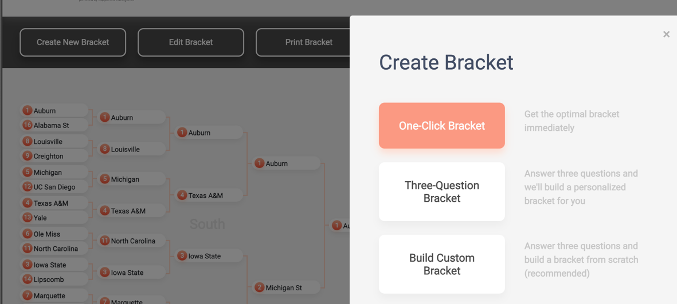
- SmartBracket™ also has a 3-question bracket, which asks these questions:
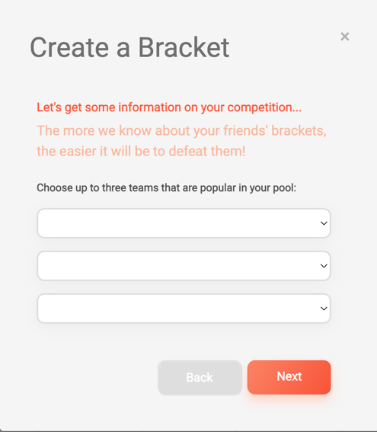

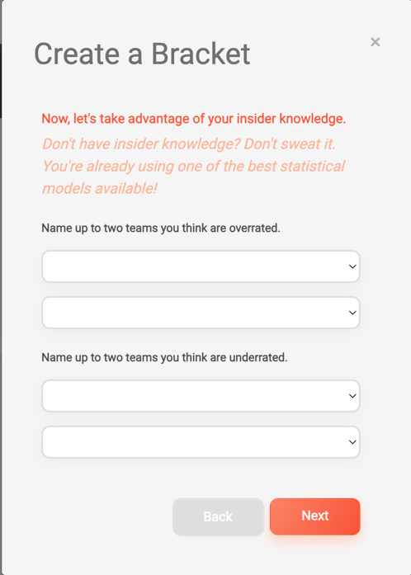
- SmartBracket™ additionally has a “Build Custom Bracket”, which asks the user the 3 questions and then immediately allows further editing/overriding of existing bracket selections. It also allows the user to fill in the bracket with optimal choices and then customize individual selections thereafter:
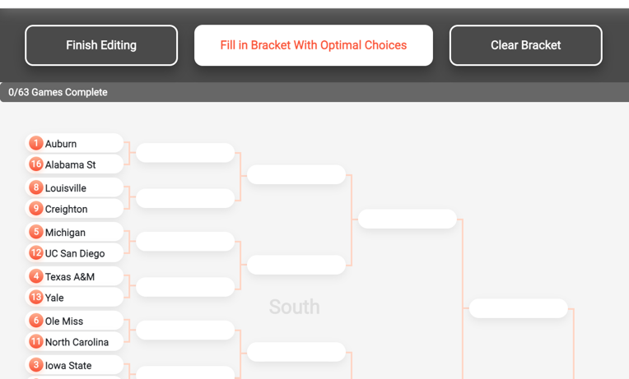

Appendix B – Historical SmartBracket™ performance
We have included the 2025 results here, but are sharing a synopsis with links for users to review/explore further:
2025 – 92nd percentile
The 2025 3-click SmartBracket™ achieved an impressive 92.4% performance, continuing our strong track record of bracket predictions outperforming several AI brackets and fan favorites.
2024 – 97th percentile
In 2024, the SmartBracket™ national bracket finished at 97% on ESPN's Tournament Challenge, while a ChatGPT-generated bracket ranked at 45.7%.
2023 – 83rd percentile
In 2023, the SmartBracket™ 1-click bracket scored an impressive 83.2%, while the 3-question Midwest themed bracket came even stronger at 88.4%!
2022 – Between 84-86% percentile
In 2022, the SmartBracket™ 3-question bracket again came in strong! Depending on the tilt (local or national favorites), SmartBracket™ came in between 84-86% at the final ESPN Tournament Challenge!

2021 – 87th percentile
For 2021, we had another 3-question bracket that clocked in at the 87th percentile on ESPN's Tournament challenge! Meanwhile the ESPN Fan Recommendations only clocked in at 21st percentile.
2019-2020 – 91st percentile
For 2019, SmartBracket™'s 3-question bracket had another stellar performance, at the 91st percentile on ESPN's Tournament challenge!
For 2020, SmartBracket™'s interface went through a significant update. However, the tournament cancellation meant it couldn't be put to use in the tournament. However, we were able to apply all the work to the 2021 tournament!
2018 – 96th percentile
SmartBracket™'s One-Click Bracket finished in the 96th percentile.
Over 43% of survey responders reported finishing third or better in their pools.
2017 – 88.4th percentile
SmartBracket™'s example 3-question bracket was perfect after day 1; ranked in the 98.5th percentile in the finals, picking both finalists; and finished the tournament in the 88.4th percentile.
SmartBracket™ was listed in the leading business publication in America as one of the Best Ways To Win Your NCAA Tournament Office Pool for the second year running.
2016 – 95th percentile
60% of SmartBracket™ survey respondents reported finishing third or better in their pools in 2016, while more than 35% won their pool.
The national SmartBracket™ finished in the 95th percentile in both the Yahoo! and ESPN bracket competitions in 2016, ahead of more than 12 million other brackets.
The leading business publication in America named SmartBracket™ as the Best Way to Pick a Winning Tournament Bracket!

Appendix C – Prompts and Strategies used for LLM Brackets
We tried to use similar prompts to the following for our bracket predictions, with any variations recorded in each section – both the user prompt and unexpected challenges we encountered when building the bracket.
The prompt used is similar to the following:
I want you to analyze today's data on the NCAA March Madness tournament and outlay and build me a bracket, including each division's outcomes, elite eight, final four, final match-up and final score. Use "moneyball" style analysis of the historical team match-ups, coaches' performances, recent past performance, latest injuries, upsets, betting odds and more related stats like KenPom to come up with your decision and show your work on any upsets or unusual picks.
For the AI (GPT-style) brackets, sometimes we had to navigate missing predictions, stopping short of predicting the winner of the Final 4 or championship game. Some also had inconsistencies, like including teams not playing in the tournament or predicting a later match-up with a team that had lost an earlier match-up.
One other prompt was even better in getting most/all of the data for the AI, based on a suggested prompt:
I want you to analyze today's data on the NCAA March Madness tournament and outlay and build me a bracket, including each division's outcomes, elite eight, final four, final match-up and final score. Use "moneyball" style analysis of the historical team match-ups, coaches' performances, recent past performance, latest injuries, upsets, betting odds and more related stats like KenPom to come up with your decision and show your work on any upsets or unusual picks. I need a full bracket based on today's 64 teams (including play-in)!!
(1) Search for the official list of the 64 teams participating in the 2025 NCAA Men's Basketball Tournament, including the play-in games, as of March 17, 2025.
(2) For each first-round matchup, find the historical head-to-head records between the two teams.
(3) For each coach in every matchup, research their NCAA Tournament performance history, including win-loss records and notable achievements.
(4) Analyze the recent performance of each team in their last 5-10 games, including conference tournament results, as of March 17, 2025.
(5) Find reports on any recent injuries to key players for each team as of March 17, 2025.
(6) Collect the latest betting odds for each first-round game as of March 17, 2025.
(7) Find the current KenPom rankings and relevant statistics (e.g., adjusted offensive efficiency, adjusted defensive efficiency) for all 64 teams.
(8) Based on the analysis of historical matchups, coaching performance, recent form, injuries, betting odds, and KenPom statistics, predict the winner for each game in the bracket, progressing through all rounds to determine the Elite Eight, Final Four, and the final championship matchup, including a predicted final score. Document the rationale behind any predicted upsets or unusual picks in each round

Appendix D – Anomalies encountered working with the various LLM models
In more detail, here were the inputs/findings that were used to build these brackets:
- Claude Sonnet Bracket, Sonnet 3.7 Reasoning model, built by Anthropic and available through Perplexity.ai – link to prompt and results:
  - Everything came back to complete the bracket after the first prompt
  - Results: 98.4 percentile (#1 of 25 in AI bracket competition) - link to bracket on ESPN
- Grok 3, the reasoning model built by xAI – link to prompt and results – in order to build a complete bracket, we found the following anomalies and missing data:
  - Anomaly and missing data: “I need you to tell me Wisconsin vs. Montana and Saint Mary's vs. Vanderbilt too. Also, you had BYU win so I need to know how BYU vs. Wisconsin ends up and who wins after that winner goes vs. Alabama. Also, Gonzaga plays Georgia, not Montana. Who wins there? Also, Texas Tech (3) plays UNC Wilmington. Who wins? How about the winner of that and Missouri (6)? Kansas plays St Johns in 2nd round - who wins? Tennessee (2) and Wofford (15) play - who wins? HOw about UCLA (7) vs. Utah State (10)? Who wins when these two winners play one another? How about that winner vs. Illionois? Kentucky (3) plays Troy (14)...who wins? How about that vs. Illinois (6)?”
  - Missing data: “That leaves us with a match-up - Texas Tech (3) vs. Kansas (7) and Kentucky (3) vs. Tennessee (2). The winner of this plays Houston (1). Also, the winner of Texas Tech v. Kansas plays Florida (1). Who wins that? Then, the winner of these two play together to get to final 4 - who are they?”
  - Results: 85.1 percentile (#3 of 25 in AI bracket competition) - link to bracket on ESPN
- Perplexity Deep Research, the Perplexity reasoning model available in March 2025, built by Perplexity.ai – link to prompt and results – in order to build a complete bracket, we missed the following data:
  - Link to bracket on ESPN
  - Missing data: “I think you are missing some games. Who wins between Iowa State (3) and Lipscomb (14)? How about Memphis (5) vs. Colorado St (12)? How about Maryland (4) vs. Grand Canyon (13)? Between the winners of these two games, who comes out on top in the next round? How about Kansas (7) vs. Arkansas (10)? How about Miss. State (8) vs. Baylor (9)? Oregon (5) vs. Liberty (12)? BYU (6) vs. VCU (11)? Saint Mary's (7) vs. Vanderbilt (10)?Gonzaga (8) v. Georgia (9)? Clemson (5) vs. McNeese (12)? Illinois (6) vs. TEX/XAV (11)? UCLA (7) vs. Utah State (10)? Tenessee (2) vs. Wofford (15)? Who are the ones you'd say advance to sweet 16 and beyond?”
  - Results: 84.5 percentile (#4 of 25 in AI bracket competition) - link to bracket on ESPN
- Sesame, the AI voice persona model built by Sesame AI Inc, built a bracket in the course of a conversation we had with the Miles persona. A link to a recording of the conversation is here.
  - Results: 80.8 percentile (#8 of 25 in AI bracket competition) - link to bracket on ESPN
- GPT 4.5, the reasoning model built by OpenAI and available through Perplexity.ai – link to prompt and results:
  - Missing result: when pulling up the result, the GPT 4.5 reasoning data is no longer available. Therefore, checking the work is not possible due to aging of the share/query.
  - Anomly: “Close, but based on the match-up the final four has Florida vs. Auburn and Duke vs. Tennessee. Please provide final four match up, results, and final game matchup and final score”
  - Results: 75.9 percentile (#10 of 25 in AI bracket competition) - link to bracket on ESPN
- Llama 3.2, the reasoning model built by Meta, link to prompt and results (the pinned prompt):
  - Everything came back to complete the bracket.
  - Results: 74.1 percentile (#11 of 25 in AI bracket competition) - link to bracket on ESPN
- Gemini Deep Research, the reasoning model built by Google – link to prompt and results – in order to build a complete bracket, we found the following anomalies and missing data:
  - Anomaly: “Unfortunately you botched the final part - You had Houston beating Gonzaga and then playing in later rounds and beating Tennessee. Then you have them playing Duke in the final! Right now Auburn and Florida are in final four from your research but you need Duke to play either Houston or Gonzaga in Final Four and then from that we need a champion from Auburn v Florida vs. Houston/Gonzaga v. Duke”
  - Results: 73.4 percentile (#12 of 25 in AI bracket competition) - link to bracket on ESPN
- Copilot, the reasoning model built as part of Microsoft Bing using a customized version of ChatGPT – link to prompt and results – in order to build a complete bracket, we found the following anomalies and missing data:
  - Anomaly: “There's a problem - in Final Four Auburn doesn't play Michigan State. They play in Elite 8. However, based on ranking, Florida and Uconn play and Nemphis and Maryland and Missouri and Texas Tech. One of these makes it to Final Four. Tell me how the West region goes.”
  - Anomaly: “How about Arizon and Oregon in the East line-up? Then the winner plays Duke which you have going through to final four.”
  - Anomaly: “Sorry, you don't realize? Mississippi St and Baylor play in East region as well as Oregon and Arizona. I need to see how this shakes out!”
  - Missing data: after several prompts, we had to keep pushing Bing Copilot to complete the bracket.
  - Results: 71.1 percentile (#13 of 25 in AI bracket competition) - link to bracket on ESPN
- Qwen 2.5 Max, the reasoning model built by Alibaba Cloud, link to prompt and results – in order to build a complete bracket, we found the following anomalies and missing data:
  - Missing data: “There is a bit of a challenge here. Do you know the current 2025 March madness line-up? You have Kansas beating Virginia in Final Four, but Virginia is not even in the tournament. You need to build a bracket that is built on real 64 teams!”
  - Results: 68.8 percentile (#17 of 25 in AI bracket competition) - link to bracket on ESPN
- Llama 3.1 “Smarter”, the reasoning model built by Meta, link to prompt and results (the unpinned prompt)
  - No real-time search led to wrong teams selected: “Sorry, if you can't do a realtime search for this info. I'll help you: all teams are listed below. Please now do your analysis and predict the tournament that follows - assuming adjacent teams will play each other to start”
  - Missing data: “Can you continue with the East and West regions based on what I shared?”
  - Missing data: “Yes, so we have to complete the midwest line-up to the final four and then get the match up of all those playing in final four and all the way to the final! Pick me a winner and give final score!”
  - Wrong region: “While Houston is south it's not playing in south region this year. We do need to complete sweet 16 and later for south between Auburn, Louisville, Michigan, Texas A&M, Ole Miss, Iowa State, Marquette, Michigan St.”
  - Missing data: “OK yes, I need to know if Michigan St or Auburn win, and then predict for me the final 4 and above with your selections Florida, Duke, Tenessee and the winner”
  - Missing data: “Sorry Duke vs Tennessee is final four. Duek [sic] still has to play Auburn vs. Florida. HOw [sic] does this end up?”
  - Missing data: “So now we have Auburn vs. Florida. Who wins this? Then the winner faces Duke in the final. What's the score. You already said Duke wins”
  - Final Note: User error in filling out the final championship – we entered Auburn for winning final rather than Duke. Neither team won in Final Four, so no impact on points.
  - Results: 57.7 percentile (#20 of 25 in AI bracket competition) - link to bracket on ESPN
- DeepSeek R1, the reasoning model built by DeepSeek Inc., available through Perplexity.ai – link to prompt and results
  - Everything came back to complete the bracket after the first prompt
  - Results: 51 percentile (#21 of 25 in AI bracket competition) - link to bracket on ESPN
- O3 Mini, the reasoning model built by OpenAI and available through Perplexity.ai – link to prompt and results:
  - Missing data: “Please provide the West and Midwest line-up in a similar way. Also, I want to know who wins in the final-four matchup, and who's the overall champion with a projected score.”
  - Missing data: some of the analysis didn’t complete fully, so we had to prompt again.
  - Results: 41.2 percentile (#23 of 25 in AI bracket competition) - link to bracket on ESPN

