FE5209 FINANCIAL ECONOMETRICS · GROUP PROJECT
AlgoGoneCrazy
Three-asset algorithmic portfolio: performance evaluation report

Evaluation period: 1 Oct 2026 00:00 → 20 Oct 2026 23:30 UTC (20 days, 960 thirty-minute marks)
Capital: USD 500,000 starting equity, no top-ups
Sleeves: SPY · Momentum | ES3 (STI ETF) · Mean reversion | BTCUSDT · ML + voting
Team: Aishee Sengupta · Kshemasanta Pinn · Suppanat Poo-im · Tsai Yi-Kai · Pranav Ananth Hari

Net P&L  +$7,084  passive −$3,311 | Total return  +1.42%  passive −0.66% | Max drawdown  −0.43%  passive −5.04% | Sharpe (ann.)  4.62  passive −0.99 | Win rate  42% of 24  profit factor 4.29 | Costs  $2,794  28% of gross P&L
Passive mix = the same 1 Oct sleeve weights (SPY 33.8%, STI 10%, BTC 51.2%, cash 5%) held without trading or costs. Annualised ratios extrapolate a 20-day window and are indicative only.

Contents

Right-click the table of contents and choose "Update Field" after editing to refresh page numbers.

1. Executive summary
Over the 20-day live test the portfolio returned +1.42% (+$7,084 net of $2,794 in transaction costs), while a passive mix of the same assets at the same 1 October weights lost 0.66% (−$3,311). The gap of about 2.1 percentage points is an exact, realised figure, not an estimate. Risk was cut even more sharply than return was improved: the worst peak-to-trough fall was −0.43% against −5.04% for the passive mix, and annualised volatility was 4.7% against 15.4%.
Every sleeve beat buy-and-hold of its own asset on sleeve capital: SPY +1.17% vs +0.61%, STI +0.83% vs −5.03%, and BTC +1.83% vs −0.71%. BTC was the engine, supplying 66% of portfolio P&L for 65% of portfolio risk, which shows the inverse-volatility sizing put risk where the profit came from.
The result is encouraging but not conclusive. Two days (1 and 5 Oct) made $7,318, more than the whole window; the other 18 days netted −$234. The annualised Sharpe of 4.62 has a 95% band of −3.9 to +13.1, and a bootstrap gives about an 87% probability that the true Sharpe is above zero, short of the usual 95% bar.
Table 1. Headline results versus the passive benchmark
Metric | Portfolio | Passive mix (same weights) | Difference
Initial equity | $500,000 | $500,000 | –
Final equity | $507,084 | $496,689 | +$10,396
Net P&L | +$7,084 | −$3,311 | +$10,396
Total return | +1.42% | −0.66% | +2.08 pp
Max drawdown | −0.43% | −5.04% | 4.61 pp shallower
Annual volatility | 4.68% | 15.35% | ≈ one-third
Sharpe ratio* | 4.62 | −0.99 | +5.61
Orders / completed trades | 57 / 24 | – / –
Transaction costs | $2,794 | $0
* Annualised from 20 UTC daily returns (partial final day excluded, 365-day basis, U.S. Treasury 3M risk-free rate).

Verdict at a glance
Dimension | Verdict
Value added | Yes: +1.42% vs −0.66% passive, and all three strategies beat their own asset
Risk control | Strong: about a twelfth of the passive drawdown and a third of the volatility, from light exposure and cash discipline
Quality of edge | Concentrated: the BTC model signals and two days drove nearly all profit
What to improve | Remove or shrink the BTC daily fallback rule; cut trading frequency to reduce the 28% cost drag
Confidence | Encouraging, not conclusive: about 87% probability of a positive Sharpe; a longer test is needed

2. Portfolio set-up and evaluation conventions

2.1 Strategy sleeves
Table 2. Instruments, strategies and decision rules
Sleeve | Instrument | Strategy and rule | Direction | Decision
SPY | SPDR S&P 500 ETF (NYSE, USD) | Momentum: EMA(8) > EMA(16) on 2h bars and 8-bar return > +0.25% to enter; exit when the return ≤ 0% | Long / cash | Every 2 h
STI | SPDR STI ETF, ES3 (SGX, SGD) | Mean reversion: 16-bar z-score ≤ −1.25 to enter, exit at ≥ +0.25 after 4–20 bars, 4-bar cooldown | Long / cash | Every 2 h
BTC | BTC/USDT (Binance, 24/7) | Two LightGBM models (p_up + p_down > 0.35 gate) plus a 4-indicator vote (|score| ≥ 2); max hold 12 bars; 10% daily fallback at 20:00 UTC if no entry | Long / short | Every 30 min

2.2 Position sizing
Sleeve budgets were fixed on 1 October by capped inverse volatility of each strategy's after-cost returns over the prior 60 days (5% volatility floor), scaled to a 95% gross target with 5% strategic cash. STI is capped at 10% because its validation evidence rests on only 6 rolling windows; SPY and BTC are capped at 75%. When at least two sleeves are active, idle capital may scale active targets up to 2× within the caps, which is why SPY orders (8) exceed its round trips (2).
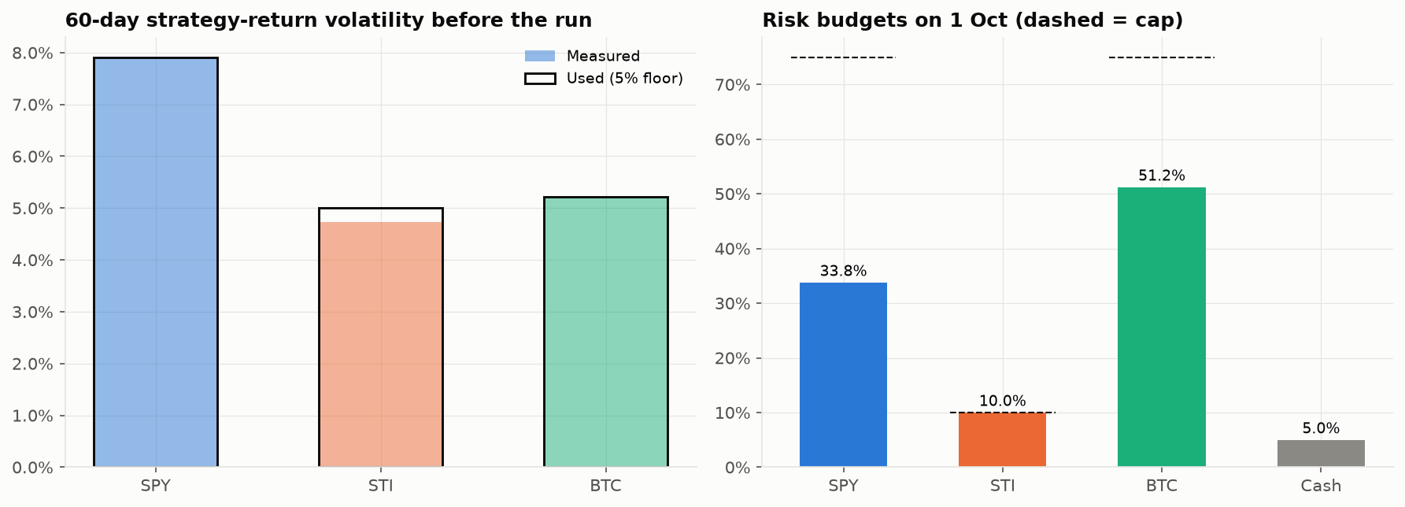
Figure 1. Pre-run 60-day strategy volatility (left) and the resulting 1 Oct risk budgets: SPY 33.8%, STI 10.0% (at cap), BTC 51.2%, cash 5.0%.

2.3 Evaluation conventions
- Execution at the next eligible bar open; valuation at raw closes, converted point-in-time to USD (SGD→USD with a 1-day lag).
- Commissions: SPY USD 0.0035/share (IBKR Pro Tiered), ES3 0.08% with SGD 2.50 minimum (IBKR), BTC 0.10% taker fee (Binance). Slippage, funding and cash interest assumed zero.
- Risk metrics use UTC daily returns with the partial final day excluded, 365-day annualisation, CAGR on elapsed calendar time, and the U.S. Treasury 3-month yield (average 4.23%) as the risk-free rate. Drawdowns use the intraday equity curve.
- Sleeve returns are measured on sleeve capital (1 Oct risk weight × $500,000). Buy-and-hold benchmarks are frictionless positions entered at each asset's first open in the window.

3. Market context during the test window
October was a difficult month to simply hold these assets. The STI ETF fell about 5%, BTC drifted down 0.7% with sharp intraday swings, and SPY gained only 0.6%. Realised daily volatility ranged from 10.5% (SPY) to 25.6% (BTC). SPY and BTC moved together (daily correlation 0.56), while STI was almost independent of SPY (0.01), which is consistent with running each sleeve on its own signal.
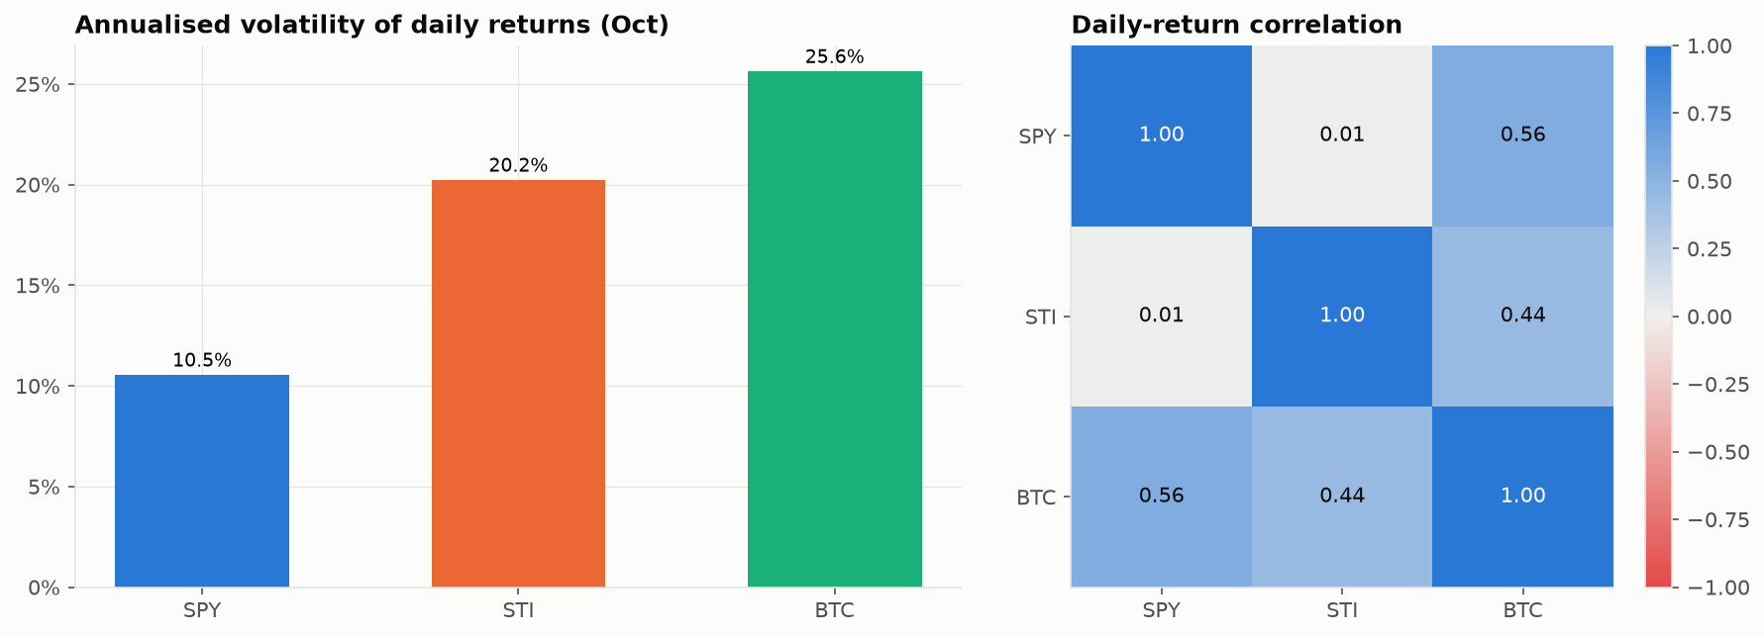
Figure 2. Annualised volatility of daily asset returns in October (left) and the daily-return correlation matrix (right).

4. Portfolio-level performance

4.1 Scorecard
Table 4 is the master scorecard used in the presentation. Sleeve columns are measured on sleeve capital; the passive mix holds the 1 October weights without costs.
Table 3. Scorecard: portfolio, sleeves and passive mix (1–20 Oct 2026)
Metric | Portfolio | SPY | STI | BTC | Passive mix
RETURN
Net P&L | +$7,084 | +$1,972 | +$414 | +$4,699 | −$3,311
Total return | +1.42% | +1.17% | +0.83% | +1.83% | −0.66%
Annual return* | +29.3% | +23.6% | +16.2% | +39.3% | −11.4%
RISK
Annual volatility | 4.7% | 6.9% | 8.4% | 6.4% | 15.4%
Max drawdown | −0.43% | −1.11% | −2.10% | −0.87% | −5.04%
RISK-ADJUSTED
Sharpe ratio* | 4.62 | 2.50 | 1.33 | 4.54 | −0.99
Sortino ratio* | 15.6 | 5.94 | 2.20 | 28.0 | −1.23
Calmar ratio* | 67.5 | 21.2 | 7.73 | 45.1 | −2.27
TRADING
Completed trades | 24 | 2 | 3 | 19 | –
Win rate | 42% | 50% | 33% | 42% | –
Profit factor | 4.29 | 5.90 | 2.41 | 4.22 | –
Avg holding (hours) | 26.8 | 118 | 97.3 | 6.0 | –
Transaction costs | $2,794 | $8 | $243 | $2,543 | $0
* Annualised from 20 days, so indicative only. Sleeves measured on sleeve capital: SPY $168,887, STI $50,000, BTC $256,113.

4.2 Equity curve against benchmarks
The portfolio built most of its gain in the first week and then held it, finishing at +1.42%. The passive mix peaked early, then slid with STI's 8 Oct gap-down and BTC's mid-month weakness to finish at −0.66%; an equal-weight buy-and-hold did worse still at −1.71%. The dotted line shows the portfolio before costs (+1.98%), so costs consumed about 0.56 pp of return.
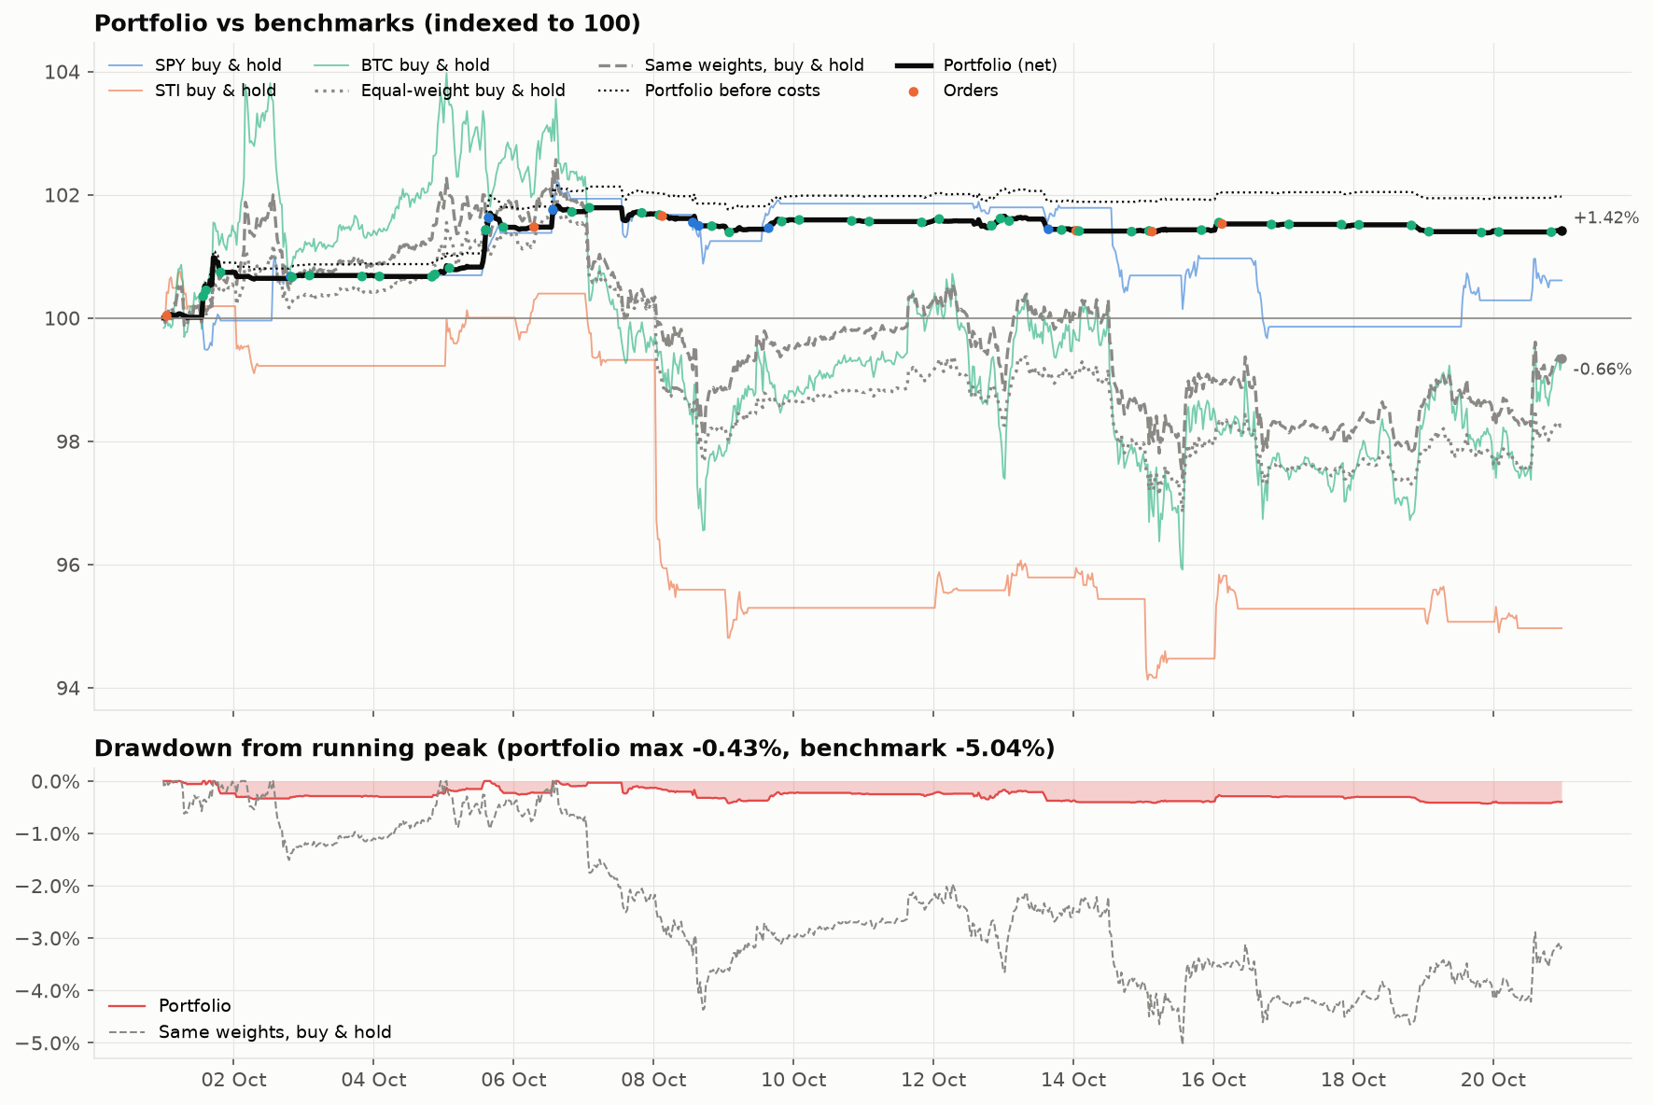
Figure 3. Portfolio (net and before costs) against buy-and-hold benchmarks, indexed to 100, with orders marked (top); drawdown from running peak, portfolio −0.43% vs same-weights benchmark −5.04% (bottom).

4.3 Strategy versus buy-and-hold
On all three dimensions the strategy layer beats holding: higher return, lower volatility and shallower drawdowns, at both portfolio and sleeve level. The largest risk reductions are in STI (drawdown −2.10% vs −6.59%) and BTC (−0.87% vs −7.75%).
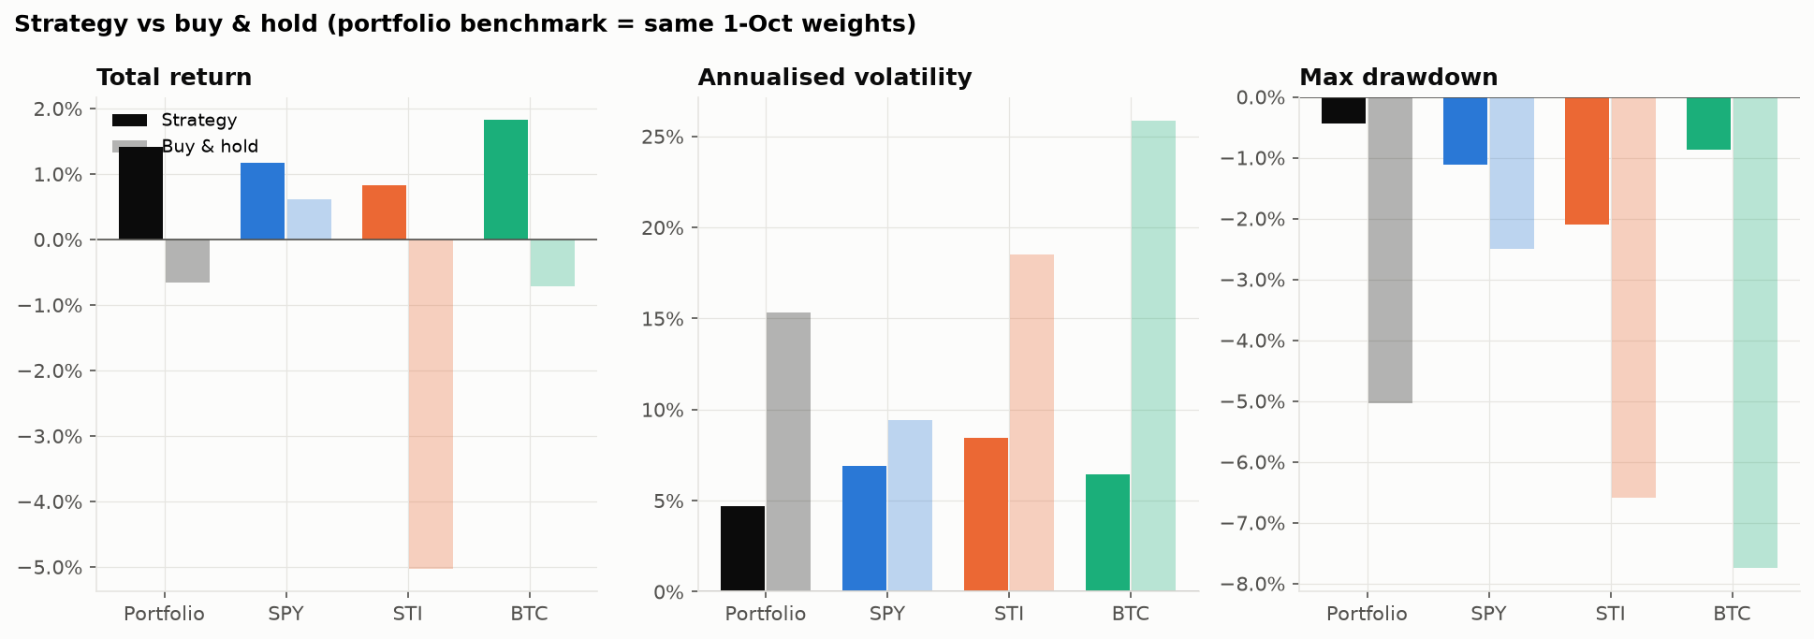
Figure 4. Total return, annualised volatility and maximum drawdown: strategy (solid) vs buy-and-hold (light) for the portfolio and each sleeve.

4.4 Return distribution
The window had 10 up days and 10 down days, but the up days were much larger. Non-zero 30-minute returns are strongly right-skewed (skew 4.87, excess kurtosis 40.2): the strategy spends most bars flat or near zero and earns in a few large moves, the typical profile of signal-driven trading that cuts losers and lets winners run.
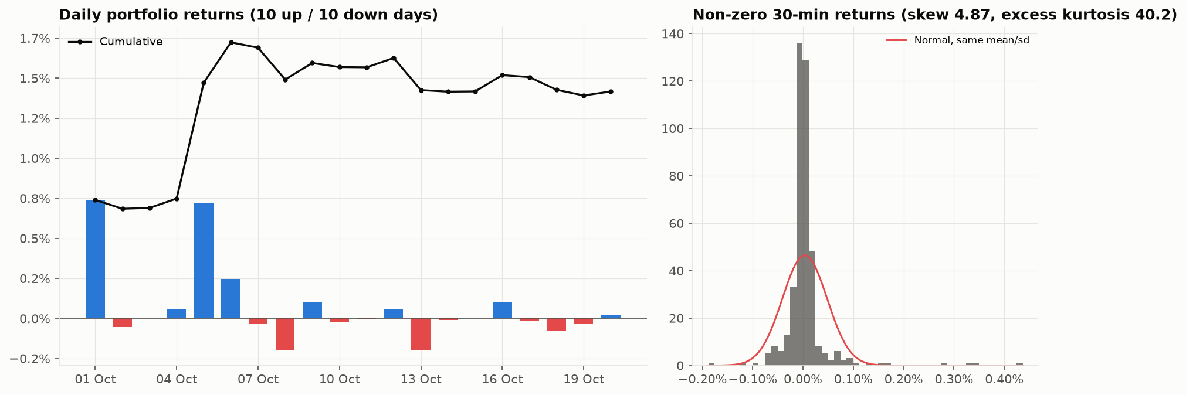
Figure 5. Daily portfolio returns with cumulative return (left) and histogram of non-zero 30-minute returns against a normal curve (right).

4.5 Exposure
Protection came from being lightly invested and stepping aside, not from hedging. Average gross exposure was 38% and average cash 65%; some position was open 77% of the time. Exposure was highest from 3–13 Oct while SPY's momentum signal was on, then fell to near zero for the last week as SPY and STI went to cash and BTC traded only small fallback positions.
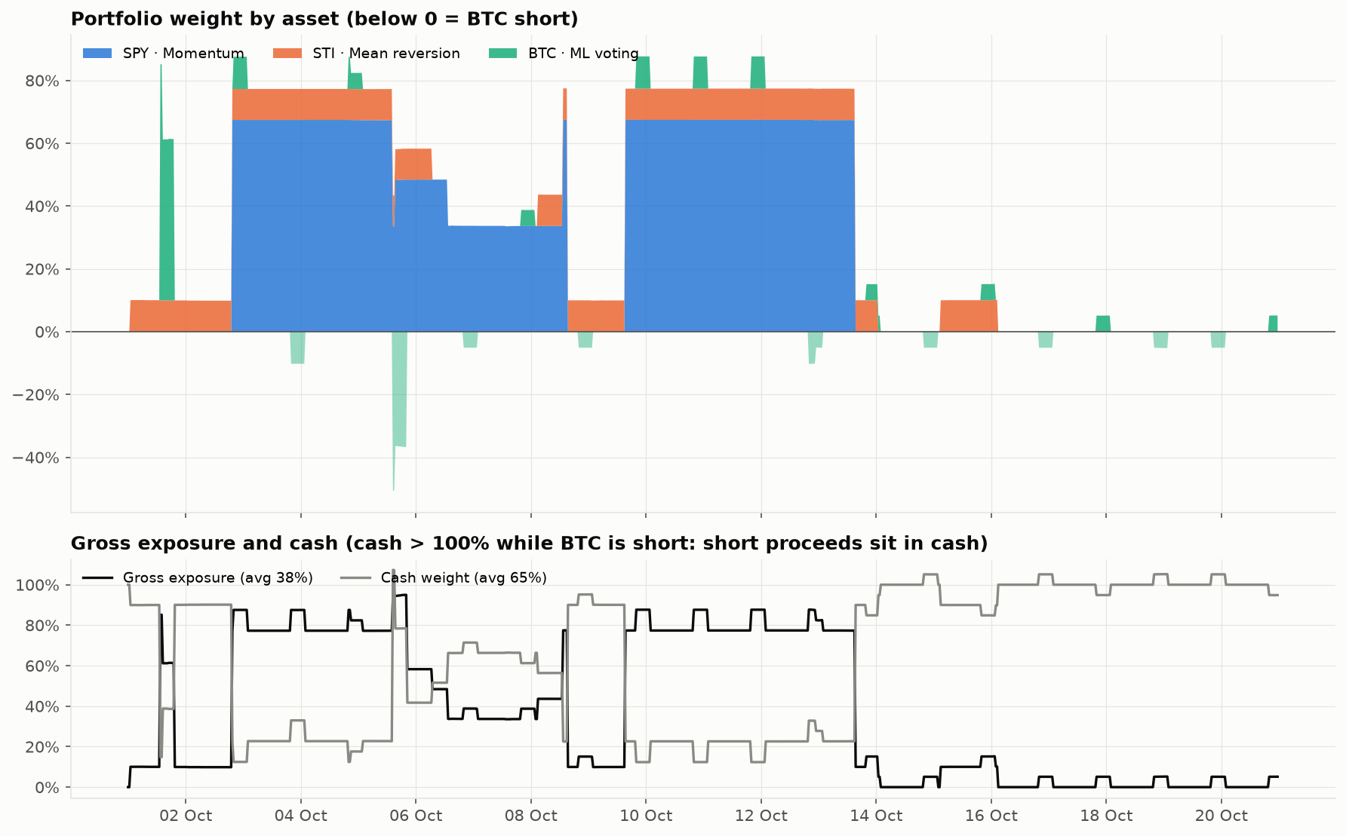
Figure 6. Portfolio weight by asset, with BTC shorts below zero (top); gross exposure and cash weight (bottom).

4.6 How far to trust the ratios
The window gives 960 thirty-minute observations for measuring risk, so volatility and drawdown are well measured. It gives only 20 daily returns for estimating mean return, so return-based ratios carry wide sampling error. The Sharpe ratio settled at 4.62 but its 95% band (Lo, 2002) still spans −3.9 to +13.1; a bootstrap of daily excess returns (20,000 resamples) puts the probability of a positive true Sharpe at about 87%.
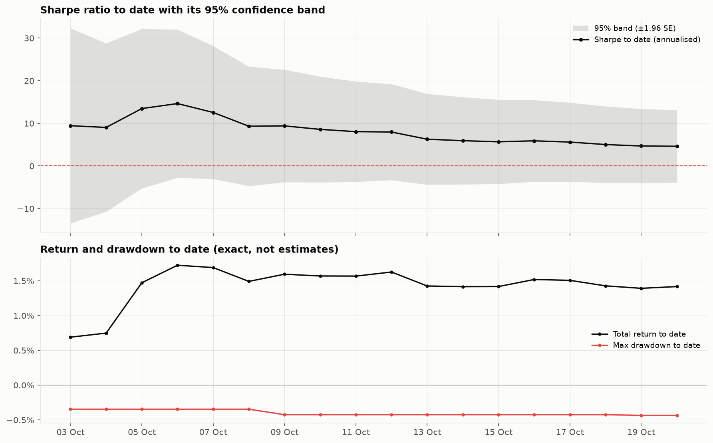
Figure 7. Annualised Sharpe ratio to date with its 95% confidence band (top); total return and maximum drawdown to date, which are exact rather than estimated (bottom).
Return concentration is the main caveat. The best two days, 1 Oct (+0.74%) and 5 Oct (+0.72%), produced $7,318 between them. Removing them turns the window return to −0.05%; removing the best three gives −0.29%.
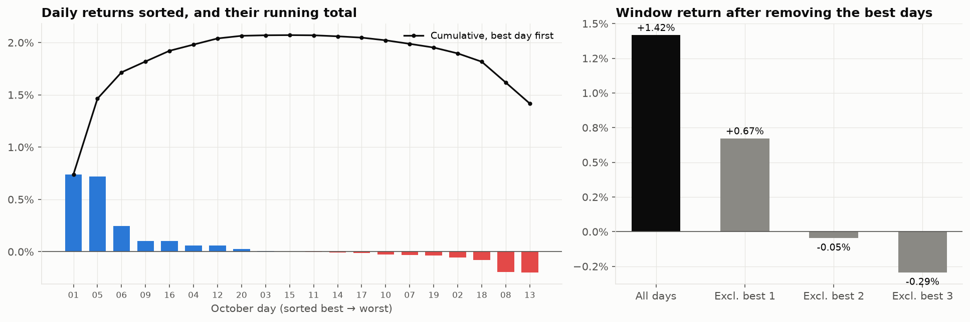
Figure 8. Daily returns sorted best to worst with their running total (left); window return after excluding the best one, two and three days (right).

5. Per-asset (sleeve) performance

5.1 Contribution to P&L
Gross of costs, BTC made $7,242, SPY $1,980 and STI $657. After $2,794 of costs the sleeves contributed $4,699 (BTC), $1,972 (SPY) and $414 (STI), which sum exactly to the $7,084 portfolio result. BTC contributed +0.94% of portfolio return, SPY +0.39% and STI +0.08%.
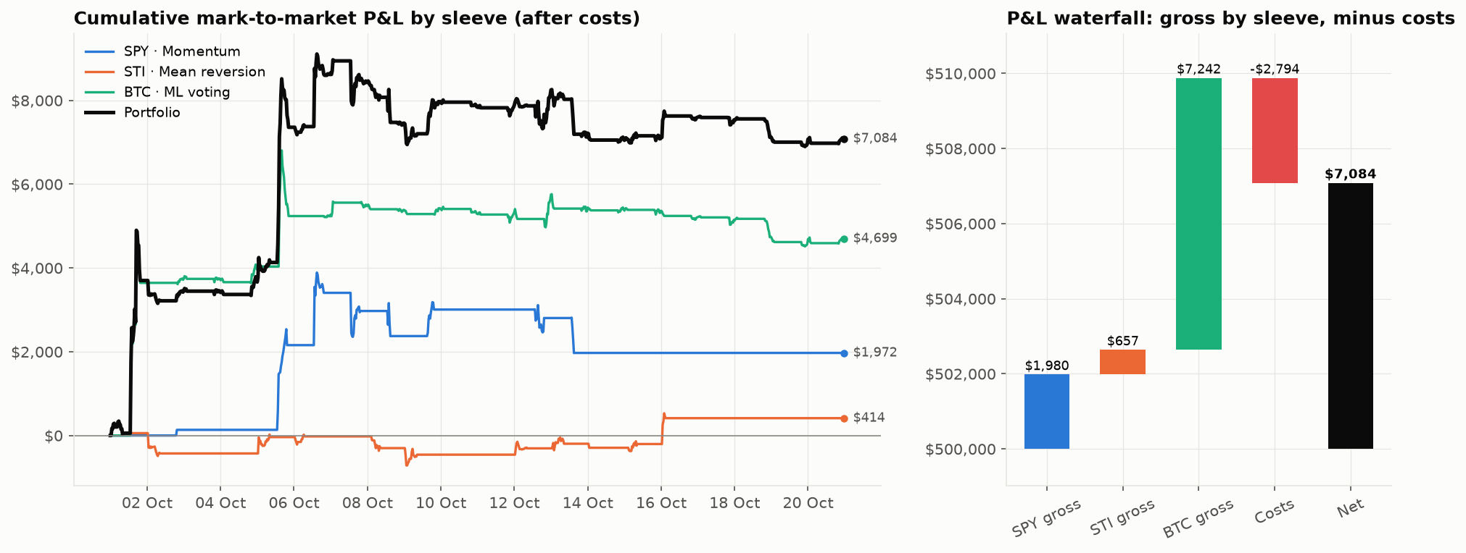
Figure 9. Cumulative mark-to-market P&L by sleeve after costs (left) and P&L waterfall from gross sleeve P&L to net (right).
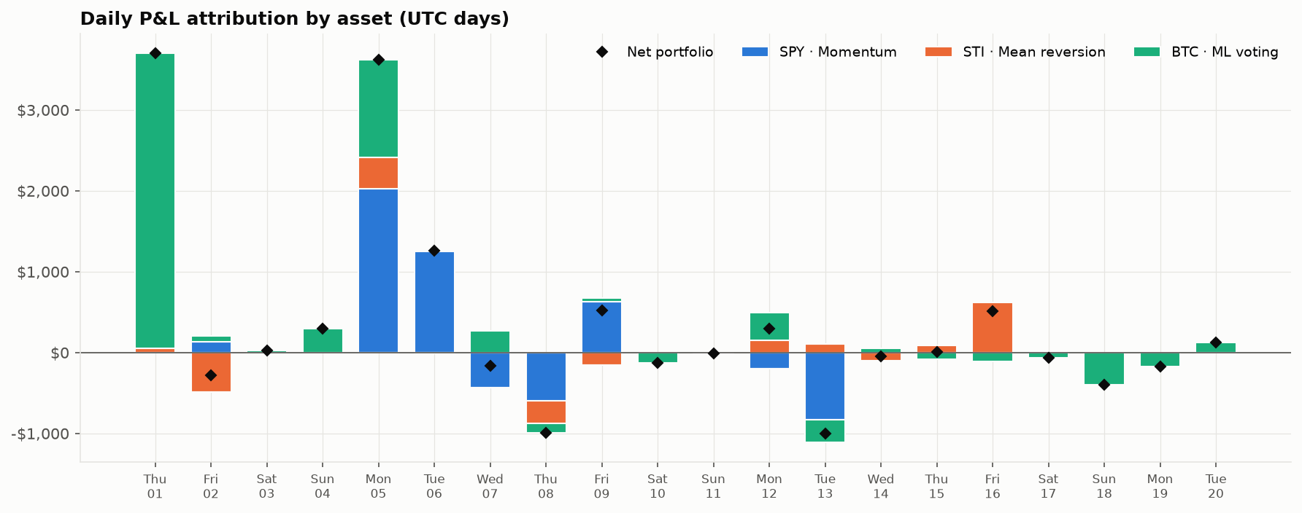
Figure 10. Daily P&L attribution by sleeve (UTC days), with net portfolio P&L marked. BTC drove 1 Oct; SPY and BTC drove 5 Oct; STI's rebound drove 16 Oct.

5.2 Per-asset scorecard
Table 4. Per-asset scorecard
Metric | SPY · Momentum | STI · Mean reversion | BTC · ML voting
PROFIT AND CAPITAL
Net P&L (USD) | +$1,972 | +$414 | +$4,699
Gross P&L before costs (USD) | +$1,980 | +$657 | +$7,242
Transaction costs (USD) | $8 | $243 | $2,543
Sleeve capital (USD) | $168,887 | $50,000 | $256,113
Contribution to portfolio return | +0.39% | +0.08% | +0.94%
Share of P&L / share of risk | 28% / 30% | 6% / 5% | 66% / 65%
STRATEGY VS BUY & HOLD
Return on sleeve | +1.17% | +0.83% | +1.83%
Buy & hold return | +0.61% | −5.03% | −0.71%
Excess vs buy & hold | +0.56 pp | +5.86 pp | +2.55 pp
RISK
Annual volatility (sleeve) | 6.89% | 8.43% | 6.45%
Max drawdown (sleeve) | −1.11% | −2.10% | −0.87%
Sharpe / Sortino* | 2.50 / 5.94 | 1.33 / 2.20 | 4.54 / 28.0
Longest drawdown (days) | 14.3 | 14.8 | 15.3
TRADING ACTIVITY
Time in market | 49% | 61% | 25%
Orders / round trips | 8 / 2 | 6 / 3 | 43 / 19
Win rate | 50% | 33% | 42%
Profit factor | 5.90 | 2.41 | 4.22
Avg holding (hours) | 118.0 | 97.3 | 6.0
Profit per trade (USD) | $986 | $138 | $242
Cost (bps of traded notional) | 0.05 | 8.0 | 10.0
* Annualised from 20 days. Sleeve capital = 1 Oct risk weight × $500,000. Risk share = covariance contribution of 30-minute sleeve P&L to portfolio variance.
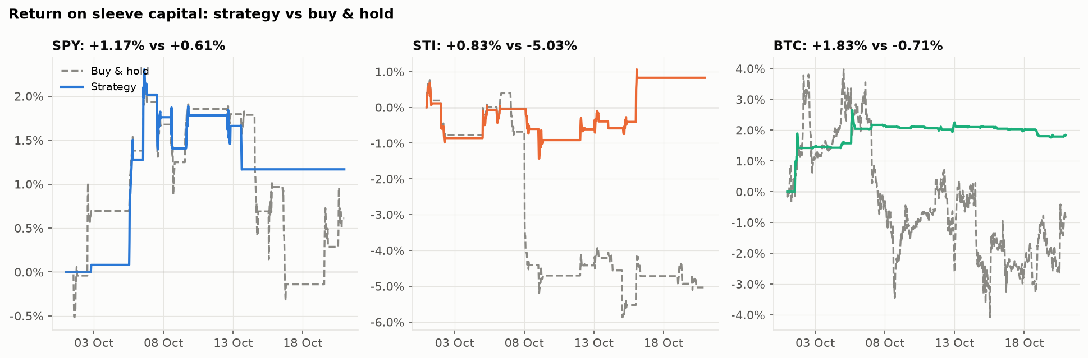
Figure 11. Return on sleeve capital: strategy (solid) vs buy-and-hold of the same capital (dashed), after costs.

5.3 SPY · Momentum
The momentum filter went long on 2 Oct once the 8-bar return cleared +0.25%, rode the rise to 8 Oct (+$2,374), re-entered on 9 Oct and exited on 13 Oct (−$402) as the trailing return turned negative, before SPY's roughly 2% slide into 16 Oct. It then stayed in cash for the rest of the window. Costs were only $8 on $1.86m traded, so the result is almost entirely timing. Position size was adjusted four times by the portfolio's active-capital scaling.
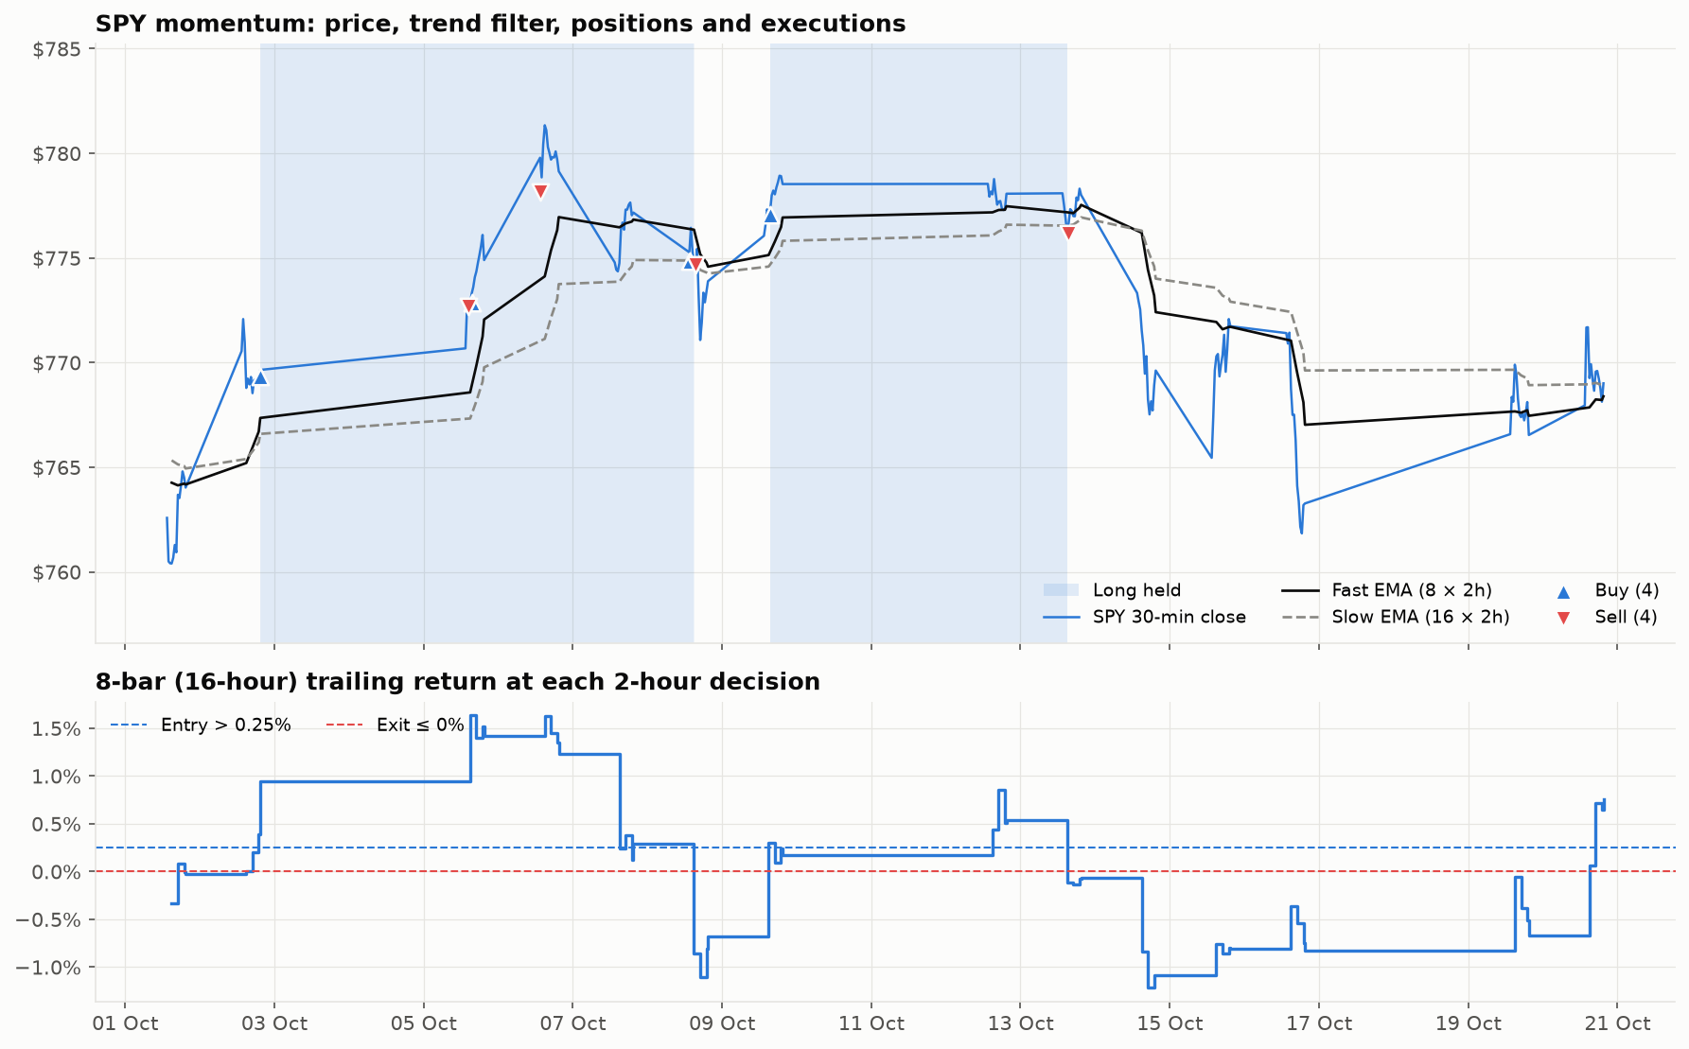
Figure 12. SPY price with fast/slow EMAs, long periods shaded and executions marked (top); 8-bar trailing return at each 2-hour decision against the entry (+0.25%) and exit (0%) thresholds (bottom).
Table 5. SPY completed trades
Trade | Entry → exit (UTC) | Held | Qty | Return | Net P&L
Long | 2 Oct 19:30 → 8 Oct 15:30 | 5.8 d | 760 | +0.40% | +$2,374
Long | 9 Oct 15:30 → 13 Oct 15:30 | 4.0 d | 440 | −0.12% | −$402

5.4 STI (ES3) · Mean reversion
The rule bought three dips. The 1 Oct entry was flat after costs (−$21). The 8 Oct entry bought into STI's sharp gap-down, but the 10% cap kept the loss to $272. The 15 Oct entry caught a 1.6% one-day rebound and made $707, covering both losses. While the ETF fell 5.03%, the sleeve returned +0.83%, the largest excess return of any sleeve (+5.86 pp). Costs of $243 at 0.08% per fill took 37% of gross profit.
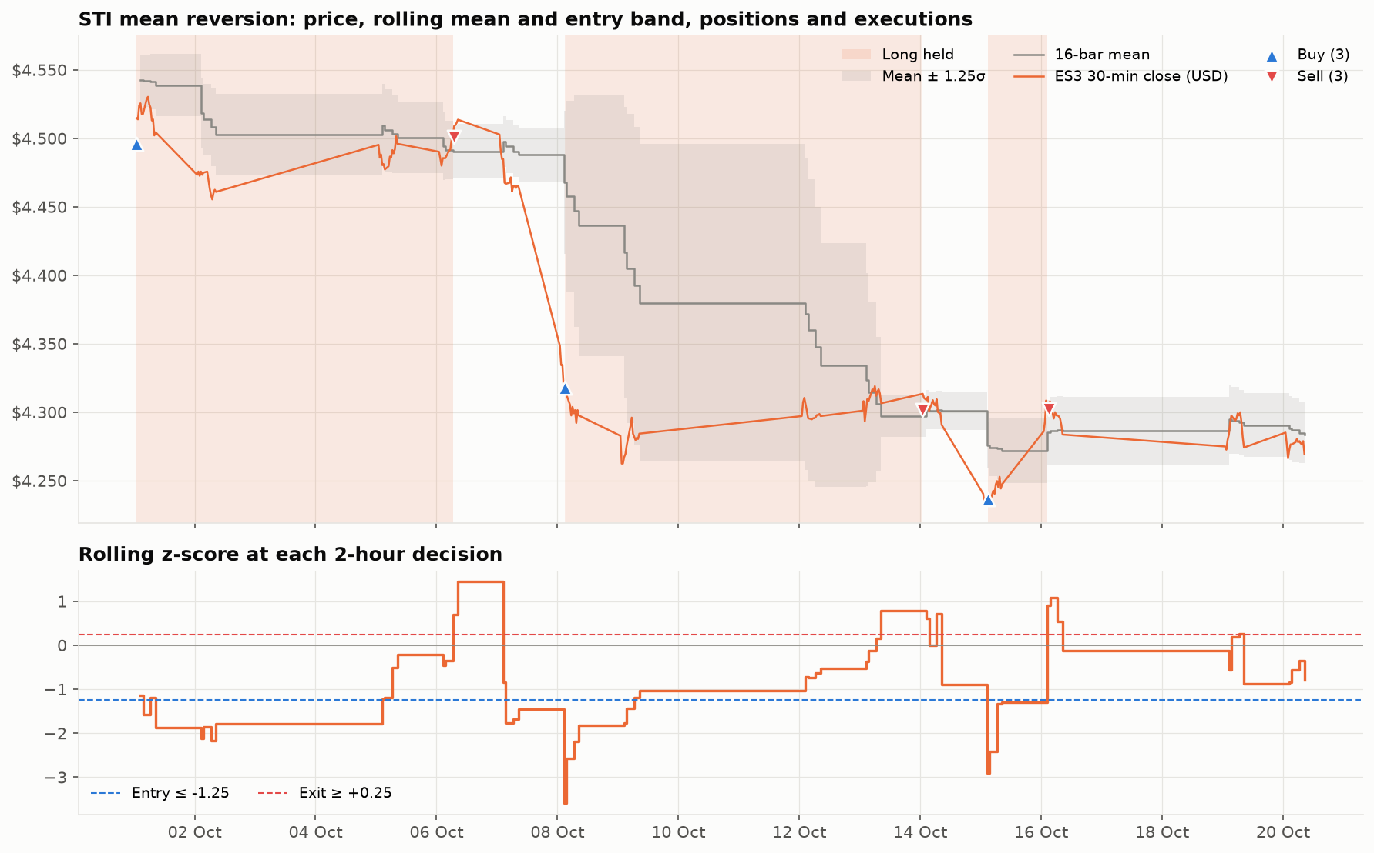
Figure 13. ES3 price (USD) with the 16-bar mean and ±1.25σ band, long periods shaded and executions marked (top); rolling z-score at each 2-hour decision with entry (−1.25) and exit (+0.25) thresholds (bottom).
Table 6. STI completed trades
Trade | Entry → exit (UTC) | Held | Qty | Return | Net P&L
Long | 1 Oct 01:00 → 6 Oct 07:00 | 5.3 d | 11,121 | −0.04% | −$21
Long | 8 Oct 03:00 → 14 Oct 01:00 | 5.9 d | 11,773 | −0.53% | −$272
Long | 15 Oct 03:00 → 16 Oct 03:00 | 1.0 d | 11,969 | +1.39% | +$707

5.5 BTC · ML voting
BTC is the only sleeve that can short and the most active, with 19 round trips of 6 hours each. The ML volatility gauge (p_up + p_down) crossed 0.35 only a handful of times; when it did and the indicator vote agreed, the sleeve took a full position. Those two model-plus-vote trades, a long on 1 Oct (+$3,644) and a short on 5 Oct (+$1,205), made $4,849 net and both won.
The other 17 trades came from the daily fallback rule, which opens a 10% position at 20:00 UTC in the direction of the vote when no full entry occurred that day. These won 35% of the time and lost $257 net after $1,246 of fees. The model has an edge in this sample; the fallback does not, and it generates nearly half of BTC's costs.
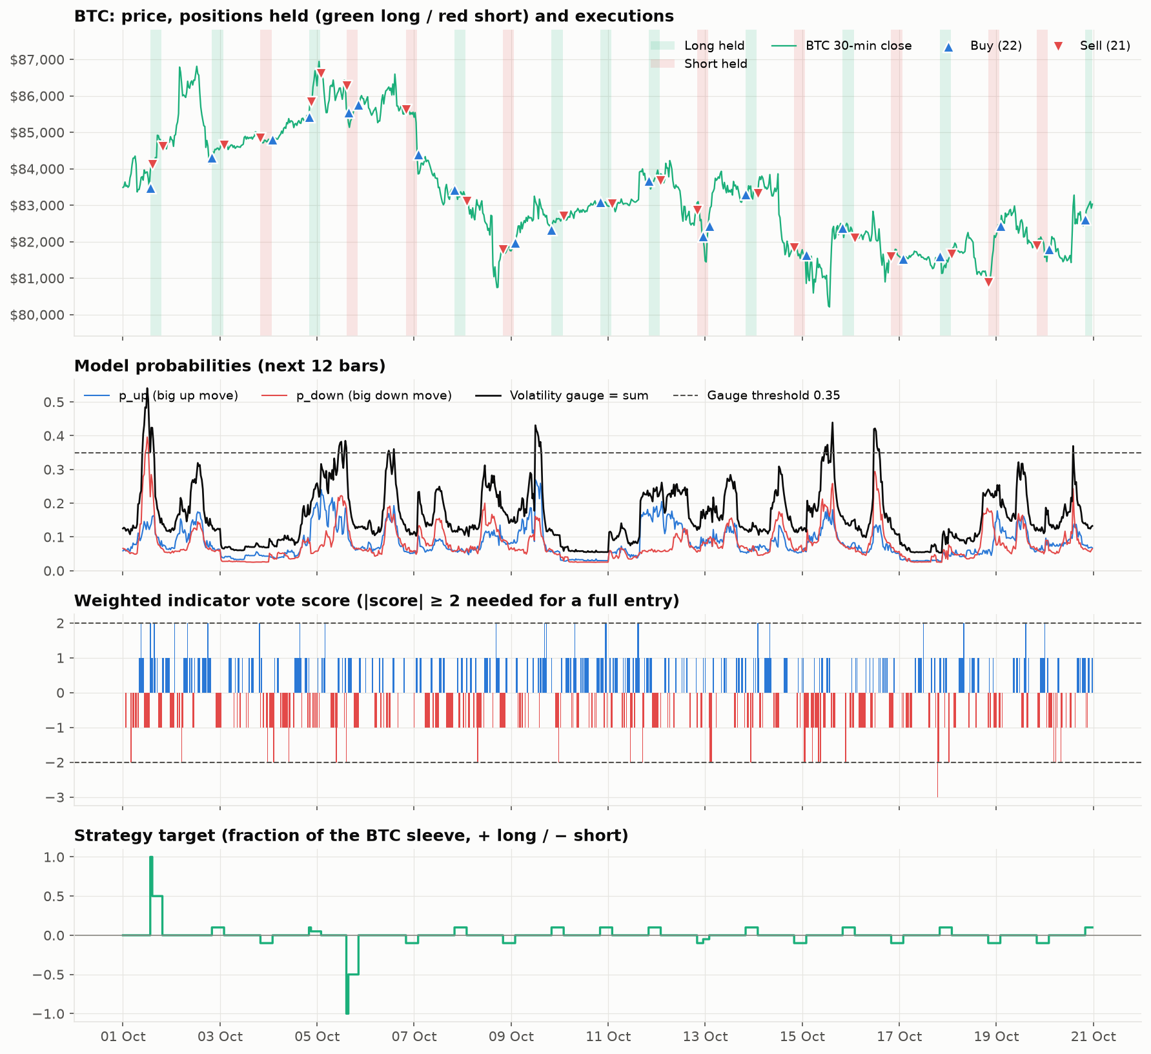
Figure 14. BTC price with long (green) and short (red) holding periods and executions; LightGBM probabilities and the 0.35 volatility gauge; weighted indicator vote score; and executed target as a fraction of the BTC sleeve.
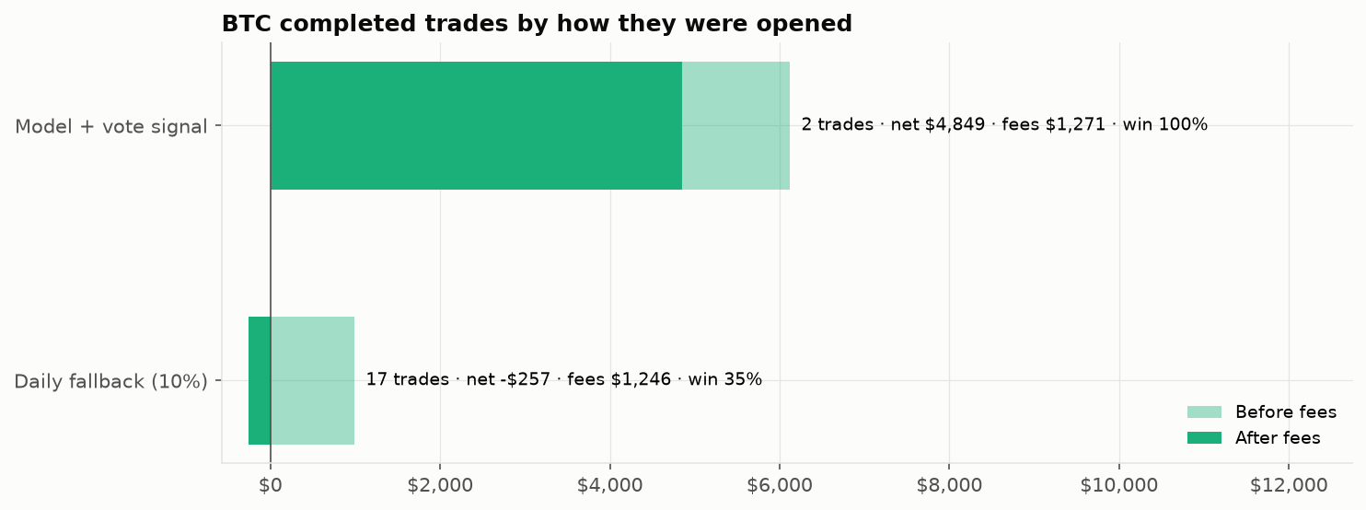
Figure 15. BTC completed trades by how they were opened: model + vote signal (2 trades, net $4,849, 100% win) vs daily fallback (17 trades, net −$257, 35% win).

5.6 Risk allocation and diversification
SPY used 77% of average deployed capital but only 30% of risk, because its low-volatility exposure was large and long-lived. BTC used 7% of capital but 65% of risk, and earned 66% of the P&L. Each sleeve's P&L share is within two points of its risk share, so the sizing rule allocated risk efficiently.
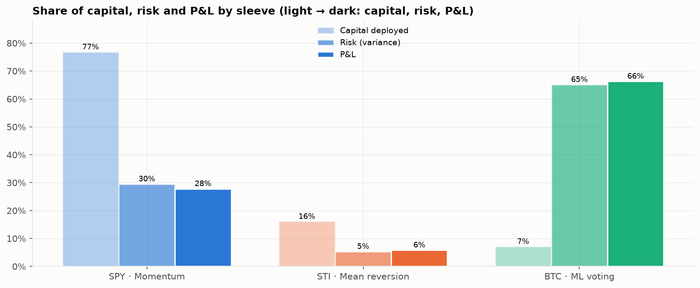
Figure 16. Share of average capital deployed, portfolio risk (variance contribution) and P&L by sleeve.
All three strategy sleeves sit up and to the left of their buy-and-hold counterparts, and the portfolio sits furthest left of all (lowest volatility) with a positive return. Sleeve daily returns are positively but imperfectly correlated (STI–SPY 0.26, STI–BTC 0.28), so combining them lowered portfolio volatility below any single sleeve.
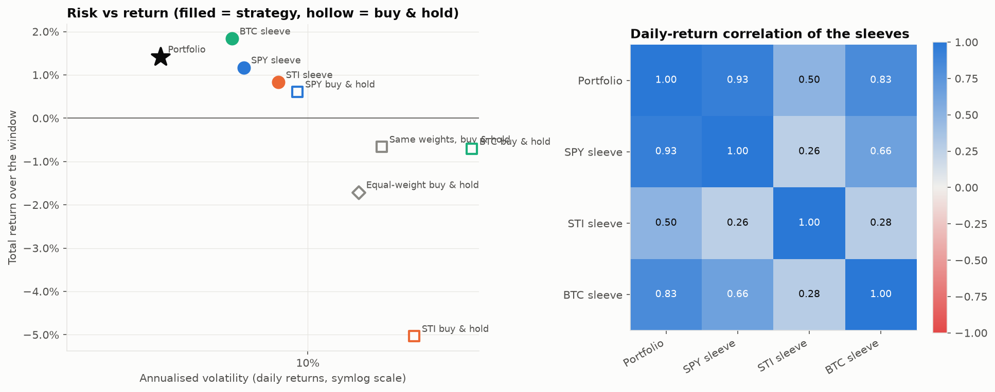
Figure 17. Risk vs return of the portfolio, strategy sleeves (filled) and buy-and-hold (hollow) (left); daily-return correlation of the sleeves (right).

6. Trades and transaction costs

6.1 Completed trades
The portfolio completed 24 round trips with a 41.7% win rate and a profit factor of 4.29: winning trades made about 4.3 times what losing trades lost. Average profit per trade was $291 and average holding period 26.8 hours, a blend of multi-day SPY and STI holds and 6-hour BTC trades.
Table 7. Largest winning and losing trades
Asset | Side | Entry (UTC) | Held | Gross P&L | Costs | Net P&L
BTC | Long | 1 Oct 13:30 | 6 h | +$4,399 | $754 | +$3,644
SPY | Long | 2 Oct 19:30 | 5.8 d | +$2,379 | $5 | +$2,374
BTC | Short | 5 Oct 14:30 | 6 h | +$1,721 | $516 | +$1,205
STI | Long | 15 Oct 03:00 | 1.0 d | +$789 | $82 | +$707
BTC | Short | 18 Oct 20:00 | 6 h | −$503 | $52 | −$555
SPY | Long | 9 Oct 15:30 | 4.0 d | −$399 | $3 | −$402
STI | Long | 8 Oct 03:00 | 5.9 d | −$191 | $81 | −$272

6.2 Transaction costs
Costs totalled $2,794, equal to 28% of gross P&L, 0.56% of starting capital and 5.9 bps of the $4.70m traded notional. 91% of costs came from BTC: each trade is cheap at 10 bps, but 43 orders made them material. SPY's per-share commission cost only 0.05 bps on $1.86m traded. Fewer, more selective BTC trades, in particular dropping the fallback rule, would lift the net result most.
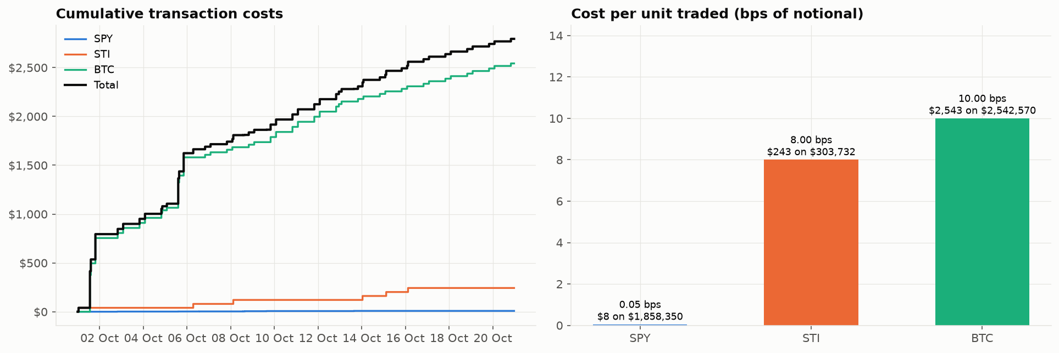
Figure 18. Cumulative transaction costs by sleeve (left) and cost per unit traded in bps of notional (right).

7. Key findings and conclusions
Table 8. Key performance metrics and what they mean
Metric | Value | What the result means
HEADLINE
Total return | +1.42% (passive −0.66%) | The ~2.1 pp gap is the value the signals added; an exact figure, not an estimate.
Max drawdown | −0.43% (passive −5.04%) | Roughly a twelfth of the passive loss: the strongest result in the project.
Annual volatility | 4.7% (passive 15.4%) | About one-third of passive volatility, measured on 960 thirty-minute marks, so reliable.
Excess vs buy & hold | +0.56 / +5.86 / +2.55 pp | All three strategies beat their own asset; STI stands out by staying in cash while the ETF fell ~5%.
DRIVERS
Time in market | 77% (cash 65%, gross 38%) | Usually active but at modest size; protection came from light exposure, not hedging.
Profit factor | 4.29 (win 42%, 24 trades) | Winners ~4.3× losers: cut losers quickly, let winners run.
BTC model vs fallback | +$4,849 vs −$257 | The 2 model+vote trades carried BTC; the 17 fallback trades lost money after fees.
Cost drag | $2,794 (28% of gross) | 91% from BTC; trade frequency, not per-trade cost, is the issue.
CONFIDENCE
Sharpe ratio | 4.62 (95% band −3.9 to +13.1) | Based on 20 daily returns; the band includes zero.
P(true Sharpe > 0) | 87% (bootstrap) | Encouraging but below the 95% usually needed for significance.
Return excl. best 2 days | −0.05% | Two days made the whole return; the main caveat.
BTC risk vs P&L share | 65% / 66% | Profit share matched risk share: sizing allocated risk efficiently.

Recommendations
- Remove or shrink the BTC daily fallback. It produced 17 of 19 BTC trades, lost $257 net and generated $1,246 of fees.
- Reduce trading frequency. Cutting low-conviction BTC trades is the most direct way to lower the 28% cost drag.
- Extend the test. A longer live window is needed before the risk-adjusted edge can be called statistically significant, particularly for STI, whose rule rests on few signals.
Overall: the portfolio added about 2 percentage points over a passive mix with roughly a tenth of the drawdown, and every strategy contributed, but the gain came from a few large trades and 20 days is too short to call it proven skill.

Appendix A. Full metric comparison
Table 9. Portfolio, benchmarks and sleeves on a common metric set
Series | Total return | Ann. return | Ann. vol | Sharpe | Sortino | Max DD | Calmar | Net P&L
Portfolio | +1.42% | +29.3% | 4.68% | 4.62 | 15.60 | −0.43% | 67.5 | +$7,084
Portfolio before costs | +1.98% | +42.9% | 5.33% | 5.95 | 25.26 | −0.38% | 111.7 | +$9,878
Same weights, B&H | −0.66% | −11.4% | 15.35% | −0.99 | −1.23 | −5.04% | −2.27 | −$3,311
Equal-weight B&H | −1.71% | −27.0% | 13.42% | −2.59 | −2.93 | −5.07% | −5.33 | −$8,562
SPY B&H | +0.61% | +11.7% | 9.42% | 0.78 | 1.05 | −2.50% | 4.70 | +$3,048
STI B&H | −5.03% | −61.0% | 18.53% | −5.21 | −5.38 | −6.59% | −9.27 | −$25,174
BTC B&H | −0.71% | −12.2% | 25.88% | −0.54 | −0.72 | −7.75% | −1.58 | −$3,560
SPY sleeve | +1.17% | +23.6% | 6.89% | 2.50 | 5.94 | −1.11% | 21.2 | +$1,972
STI sleeve | +0.83% | +16.2% | 8.43% | 1.33 | 2.20 | −2.10% | 7.73 | +$414
BTC sleeve | +1.83% | +39.3% | 6.45% | 4.54 | 27.97 | −0.87% | 45.1 | +$4,699
Asset buy-and-hold rows are on $500,000 of capital; sleeve rows on sleeve capital. Ratios annualised from 20 days.

Drawdown pattern
Metric | Portfolio | SPY | STI | BTC
Drawdowns ≥ 0.1% | 3 | 3 | 3 | 4
Drawdowns ≥ 0.25% | 3 | 1 | 1 | 2
Drawdowns ≥ 1% | 0 | 1 | 1 | 0
Longest drawdown (days) | 14.3 | 14.3 | 14.8 | 15.3

Appendix B. Metric definitions
- Total return: Change in equity over the window divided by starting capital ($500,000, or sleeve capital for sleeves).
- Annual return: Total return compounded to a year on elapsed calendar time (CAGR, 365 days). Indicative for a 20-day window.
- Annual volatility: Standard deviation of UTC daily returns × √365, partial final day excluded.
- Sharpe ratio: (Annualised mean daily return − risk-free rate) / annual volatility; risk-free = U.S. Treasury 3M yield. 95% band from Lo (2002).
- Sortino ratio: As Sharpe, but dividing by downside deviation only.
- Max drawdown: Largest fall from a running equity peak to a later trough, on the intraday (30-minute) equity curve.
- Calmar ratio: Annual return divided by the absolute maximum drawdown.
- Win rate / profit factor: Share of completed round trips with positive net P&L / gross profit of winners divided by gross loss of losers.
- Risk share: Each sleeve's covariance contribution of 30-minute P&L to total portfolio P&L variance.
- Excess vs buy & hold: Sleeve return on sleeve capital minus the frictionless return of holding the same asset with the same capital.
Source: frozen simulation outputs in results/portfolio_simulation and charts in results/eda_notebook, generated by portfolio_performance_evaluation.ipynb (simulation run 23 Oct 2026, 04:01 UTC).

