Luo et al, 2019 [14], designed a discrete Fourier transform (DFT) and support vector regression (SVR) based machine learning model to predict the road traffic flow during the holidays in Jiangsu Province, China, on Tomb-sweeping Day and National Day from 2011 to 2015. With proper training, the model outperformed other ML models – like ARIMA, SVR and EMD-SVR. The model works as follows:

1. With DFT, the traffic flow time series are transformed from the time to the frequency domain, and the trend is extracted through setting the appropriate threshold.
2. Besides the holiday natural traffic growth, the model retains the change of the trend component (TC). Thus, the TC is predicted by extreme extrapolation of the historical trend.
3. For the residual, the fluctuation and burst are defined at first. The mean and variance of the fluctuation are stable, but the burst has great randomness.
4. With SVR, the residual is predicted with its burst preprocessed.
5. The final prediction result can be obtained by combining the trend with residual prediction result. Their approach is summarized below.

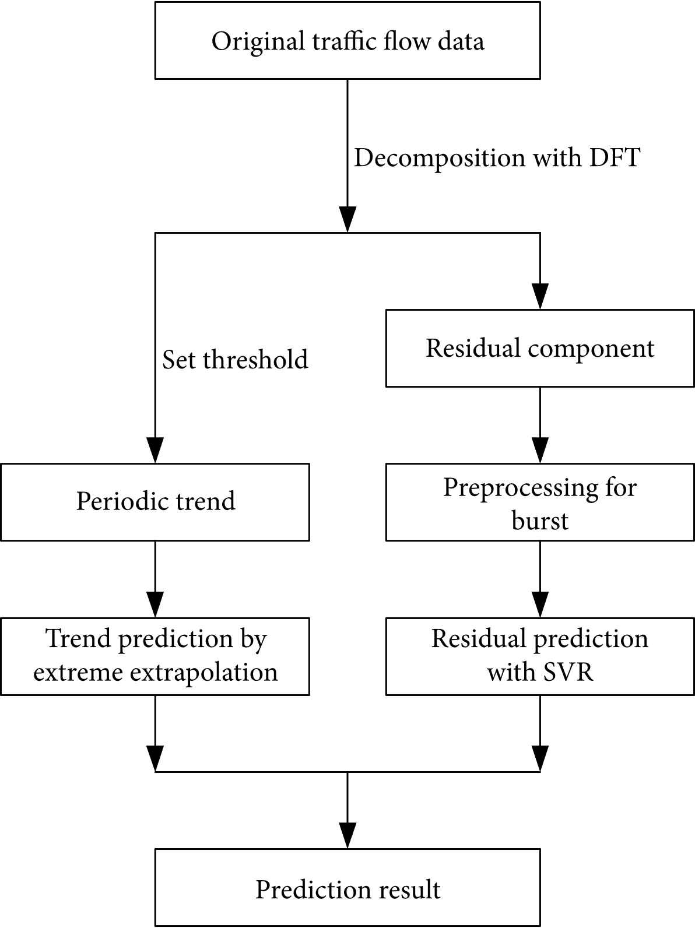

Pan et al, 2019 [15], designed the ST-MetaNet to predict the urban traffic in Los Angeles using the METR-LA dataset, and achieved the MAE score of 16.9 and the RMSE of 34.0, outperforming several state-of-the-art models. The model works as follows:  
 1. The RNN captures the sequence of historical urban traffic. 2. The Meta-Knowledge Learner (MK-L), containing 2 FCNs - each for nodes (GPS coordinates) and edges (distance between the nodes), the MK is used to learn the weight of the GAT and RNN. 3. The GAT captures diverse spatial correlations by individually broadcasting locations’ hidden states along edges. And 4. The RNN capture diverse temporal correlations associated with the geographical information of locations.

