**Ihere m2 Manual & Specification**

|  |
| --- |
| **iHere series JTAG interface board** |
| **WISOL** |
| **January 2, 2018** |

Contents

Revision history 2

Overview 2

Appearance 3

Block Diagram 4

Pin description 4

Schematics 5

Connection example 6

iHere to Jtag 7

iHere to PC (for PC tool) 7

IET20RCx to Jtag 8

IET20RCx to PC (for WiFi F/W download) 9

Copyright WISOL | All Rights Reserved | [www.wisol.co.kr](http://www.wisol.co.kr)

# Revision history

|  |  |  |  |
| --- | --- | --- | --- |
| **Date** | **Version** | **Name** | **Description** |
| Nov.28,2017 | 0.1 | Kidae Kim | First release product description for iHere interface |
| Jan.02,2018 | 0.2 | Kidae Kim | Added Block diagram and schematics |
|  |  |  |  |
|  |  |  |  |
|  |  |  |  |
|  |  |  |  |
|  |  |  |  |
|  |  |  |  |
|  |  |  |  |
|  |  |  |  |

# Overview

* Connect iHere to Jtag
* Connect iHere to PC
* Connect M2(=IET20RCx) to Jtag
* UART to USB Bridge   
   - iHere M2 WIFI Firmware Download

# Appearance

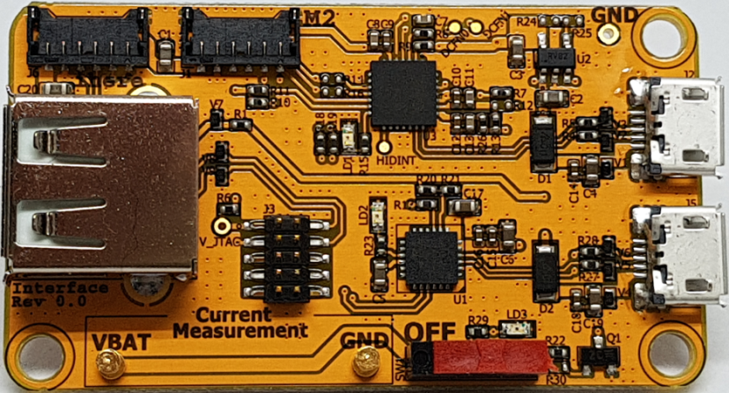



# Block Diagram



# Pin description

|  |  |  |  |  |  |
| --- | --- | --- | --- | --- | --- |
| **J1** , 1.2mm pitch Wafer Connector for M2 | | | **J6** , 1.2mm pitch Wafer Connector for iHere | | |
| NO. | Pin Name | Description | NO. | Pin Name | Description |
| 1 | I2C0_SCL_DBG | for PC TOOL | 1 | I2C0_SCL_DBG | for PC TOOL |
| 2 | I2C0_SDA_DBG | 2 | I2C0_SDA_DBG |
| 3 | UART0_TX_WIFI | for WIFI FIRMWARE DOWNLOAD | 3 | SWDCLK | for JTAG Debugging |
| 4 | UART0_RX_WIFI | 4 | SWDIO |
| 5 | Ground | Ground | 5 | Ground | Ground |
| 6 | VBAT | M2 power input 3.3V | 6 | VBAT | iHere power input 3.3V |

|  |  |  |  |  |  |
| --- | --- | --- | --- | --- | --- |
| **J3** , 1.25mm pitch 5x2 Dual row header for JTAG | | | **J4** , USB Type A for M2 | | |
| NO. | Pin Name | Description | NO. | Pin Name | Description |
| 1 | V_JTAG | JTAG power input 3.3V | 1 | VUSB | M2 power input 5.0V |
| 2 | SWDIO | for JTAG Debugging | 2 | SWDCLK | for JTAG Debugging |
| 3 | Ground | Ground | 3 | SWDIO |
| 4 | SWDCLK | for JTAG Debugging | 4 | Ground | Ground |
| 5~10 | NC |  |  |  |  |

# Schematics





# Connection example

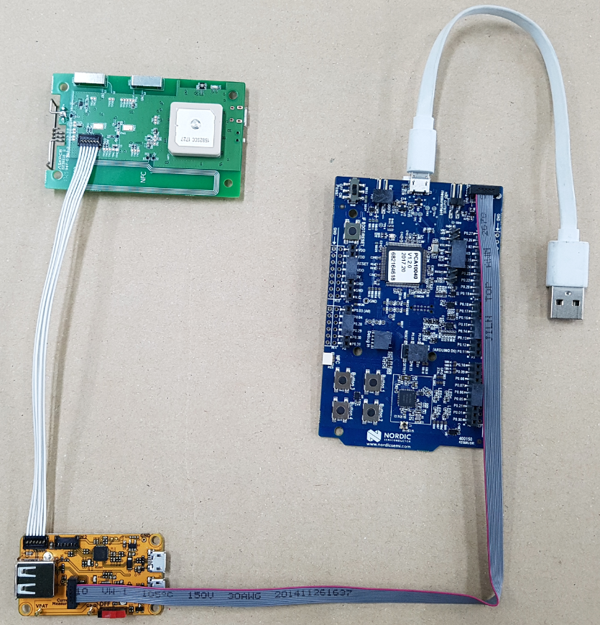

# iHere to Jtag



# iHere to PC (for PC tool)



# IET20RCx to Jtag



# IET20RCx to PC (for WiFi F/W download)





**\*Green pads are ground**

**\*When the download is completed, it is necessary to remove the jump.**