**REPORT LAB 03**

1. Update use-case diagram and class diagram

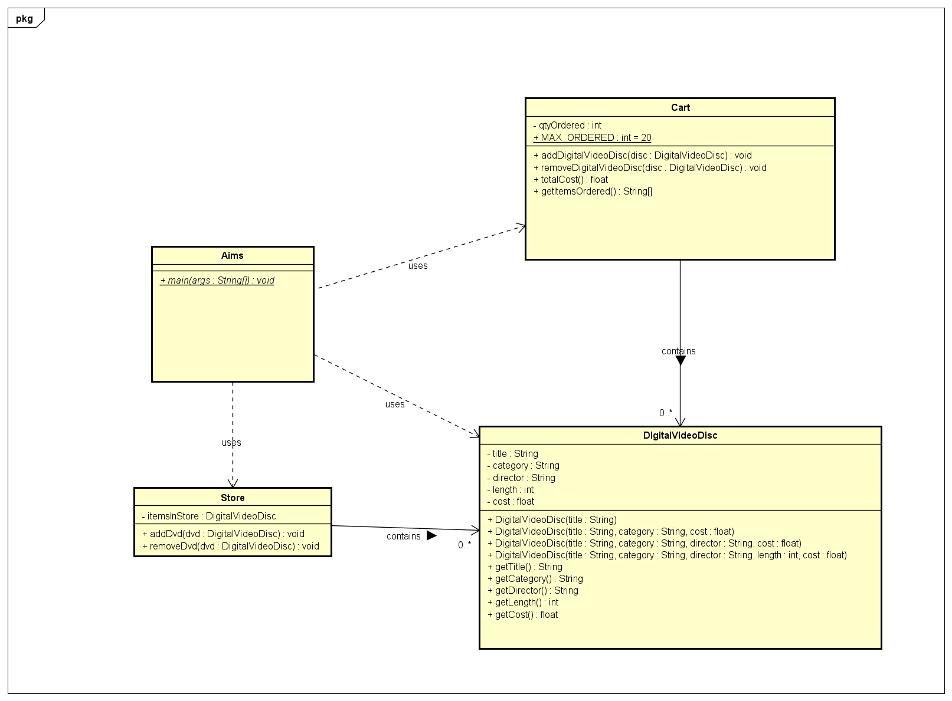

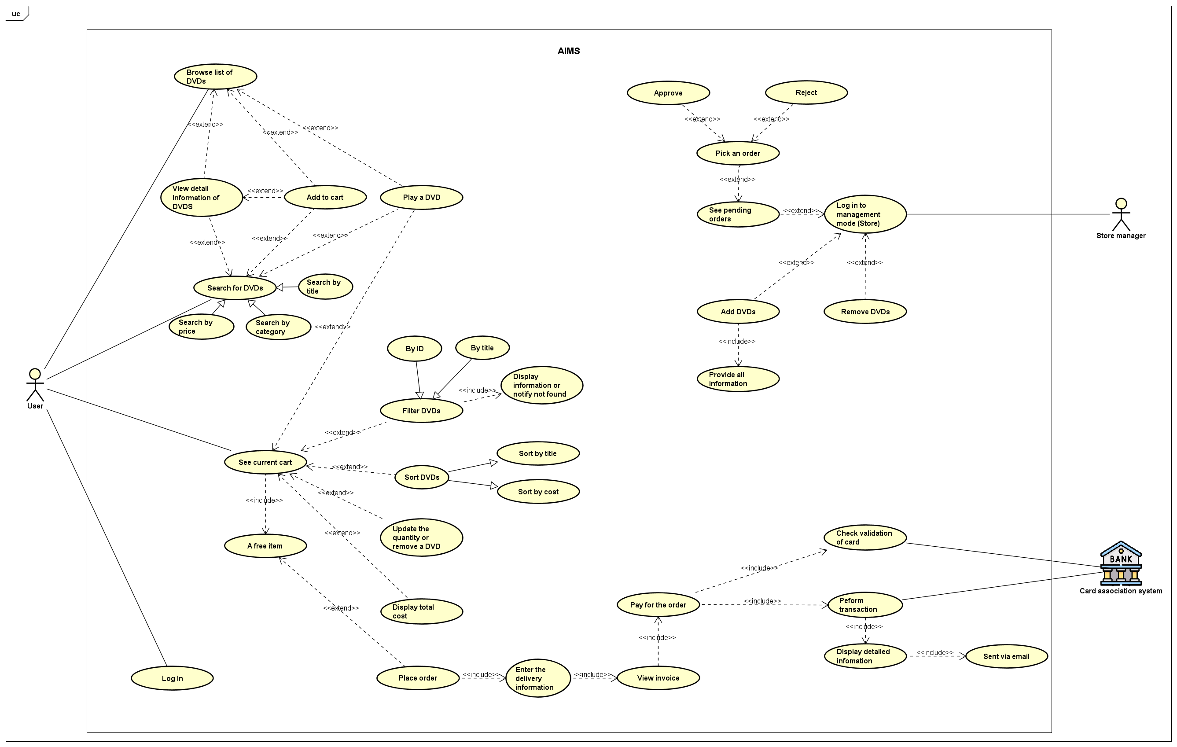

2. Working with method overloading

- *Try to add a method addDigitalVideoDisc which allows to pass an arbitrary number of arguments for dvd. Compare to an array parameter. What do you prefer in this case?*

+ I think I prefer the array parameter way as I can easily get the number of DVD I need to add to the cart to validate while it will be harder to handle if we just pass an arbitrary number of DVD.

3. Passing parameter

* ***Is JAVA a Pass by Value or a Pass by Reference programming language?***
  + Java Pass by Value. For example, if we pass an object into a method in Java ( swap(DVD dvd1, DVD dvd2) ) then in the method swap only recieve the address value point to the dvd1 Object and dvd2 object in the memory so if we try to swap by Obj tmp = dvd1; dvd1 = dvd2; dvd2 = tmp then it won't work. Because it is only dvd1 and dvd2 in the method change value for each other which does not affect original 2 objects.
* After the call of **swap(jungleDVD, cinderellaDVD)** why does the title of these two objects still remain?
  + As i said earlier, o1 and o2 are just local variables of method swap so swap value of o1 and o2 does not affect the value of original objects which are jungleDVD and cinderellaDVD. So the value of jungleDVD and cinderellaDVD still remain
* After the call of **changeTitle(jungleDVD, cinderellaDVD.getTitle())** why is the title of the JungleDVD changed?
  + In changeTitle, we have passed down the address of jungleDVD object so when we modify the title of dvd ( which is the jungleDVD object) it also changes the title of jungleDVD because both point to the same Object.

4. Debugging Java in Eclipse

Result:

5. Classifier Member and Instance Member

6. Open the **Cart** class

- Write a **toString()** method for the **DigitalVideoDisc** class. What should be the return type of this method?

+ The method should return a String.

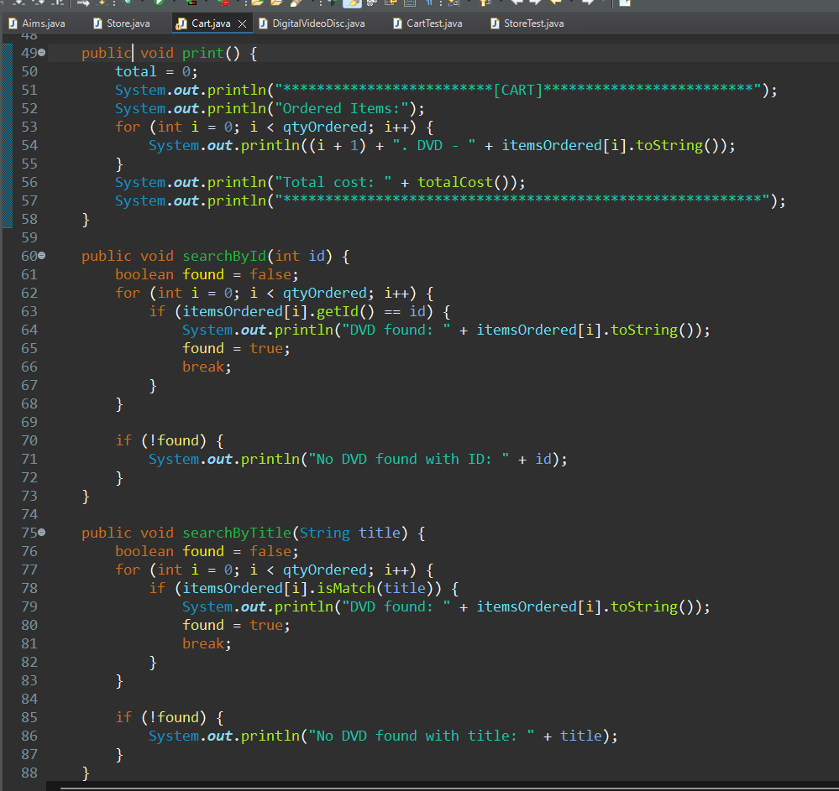

7. Implement the **Store** class

**9. String, StringBuilder and StringBuffer**

String concatenation

* Very slow. Take so much time to read the file\

Using stringBuffer & string Builder:

* Much faster and more efficient
* The only thing stringBuffer differs from stringBuilder is about thread safety. Usually I think stringBuilder is the go to unless we need to care about thread safety.
* Although it still reach the limit but it is because the file I create is too big ( ~ 4GB )
* Definitely better than string concatenation.