Postman Collection is included for testing

Hosted on google cloud (https://orbitass-447000.el.r.appspot.com/health)

1. Api 1 (Get user by Id)

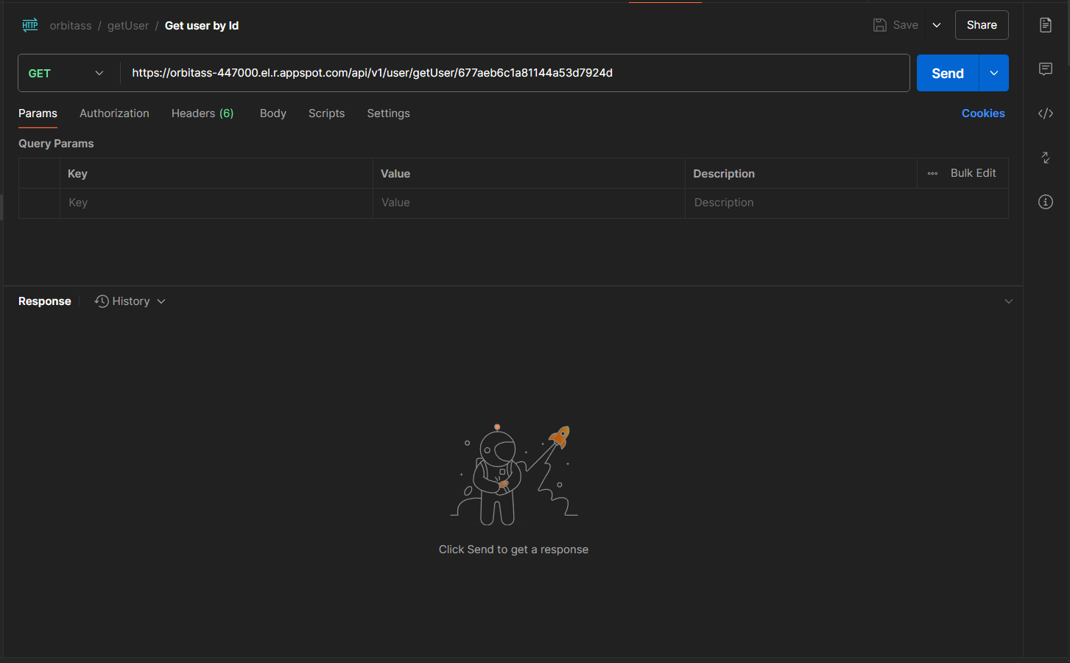

1. Api 2 (Get transaction detail by userId with filters)

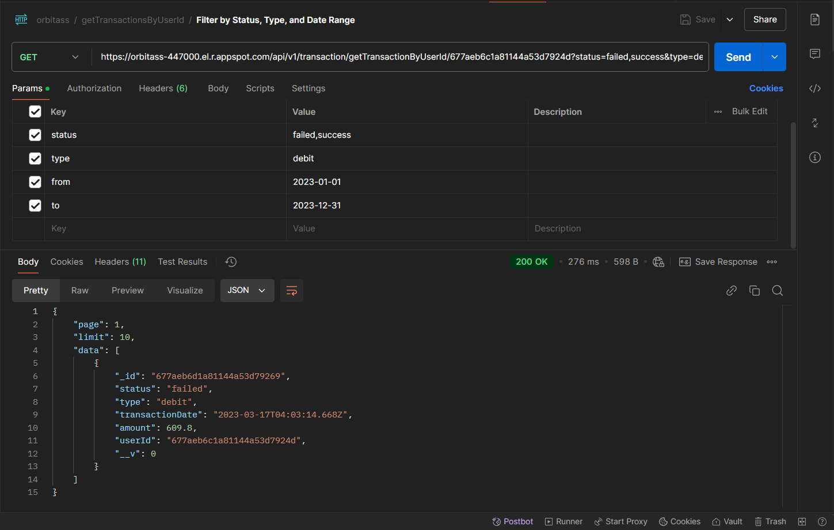

1. Api 3 (Get All transaction with filters)

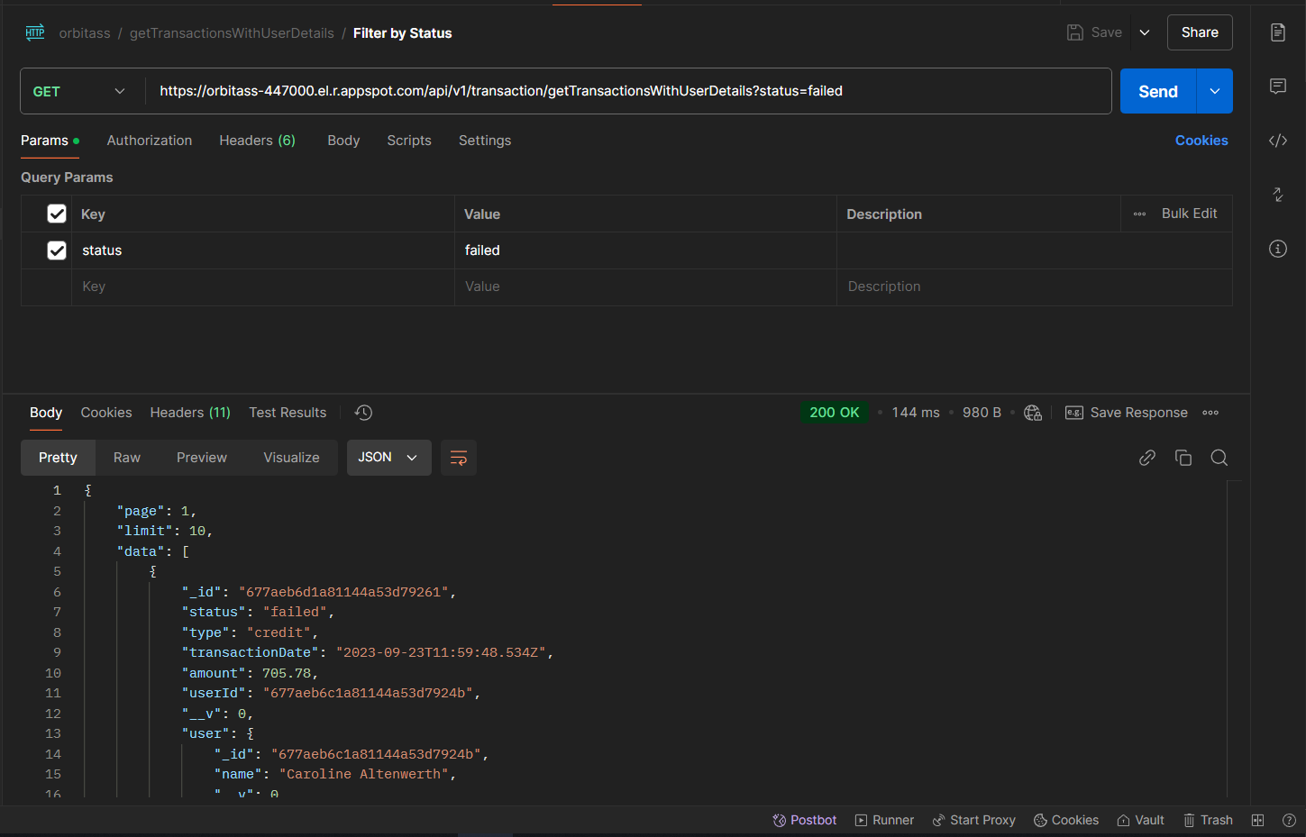

1. Api 4 (Health check)

