# Git

Git is a modern and widely used **distributed version control** system in the world. It is developed to manage projects with high speed and efficiency. The version control system allows us to monitor and work together with our team members at the same workspace.

## What is Git?

**Git** is an **open-source distributed version control system**. It is designed to handle minor to major projects with high speed and efficiency. It is developed to co-ordinate the work among the developers. The version control allows us to track and work together with our team members at the same workspace.

## Features of Git

Some remarkable features of Git are as follows:

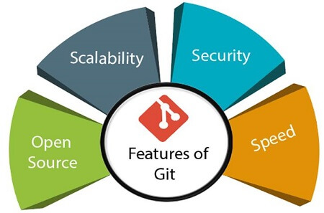

* **Open Source**Git is an **open-source tool**. It is released under the **GPL** (General Public License) license.
* **Scalable**Git is **scalable**, which means when the number of users increases, the Git can easily handle such situations.
* **Distributed**One of Git's great features is that it is **distributed**. Distributed means that instead of switching the project to another machine, we can create a "clone" of the entire repository. Also, instead of just having one central repository that you send changes to, every user has their own repository that contains the entire commit history of the project. We do not need to connect to the remote repository; the change is just stored on our local repository. If necessary, we can push these changes to a remote repository.

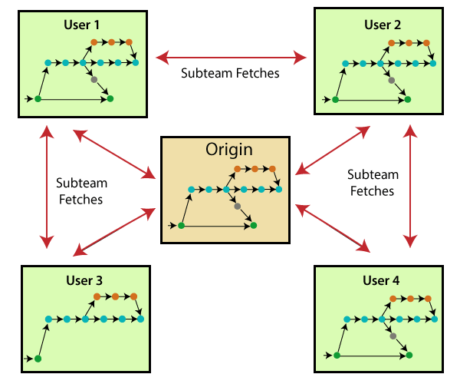

**Branching and Merging**

**Branching and merging** are the **great feature**s of Git, which makes it different from the other SCM tools. Git allows the **creation of multiple branches** without affecting each other. We can perform tasks like **creation**, **deletion**, and **merging** on branches, and these tasks take a few seconds only. Below are some features that can be achieved by branching:

* We can **create a separate branch** for a new module of the project, commit and delete it whenever we want.
* We can have a **production branch**, which always has what goes into production and can be merged for testing in the test branch.
* We can create a **demo branch** for the experiment and check if it is working. We can also remove it if needed.
* **Staging Area**The **Staging area** is also a **unique functionality** of Git. It can be considered as a **preview of our next commit**, moreover, an **intermediate area** where commits can be formatted and reviewed before completion. When you make a commit, Git takes changes that are in the staging area and make them as a new commit. We are allowed to add and remove changes from the staging area. The staging area can be considered as a place where Git stores the changes.  
  Although, Git doesn't have a dedicated staging directory where it can store some objects representing file changes (blobs). Instead of this, it uses a file called index.

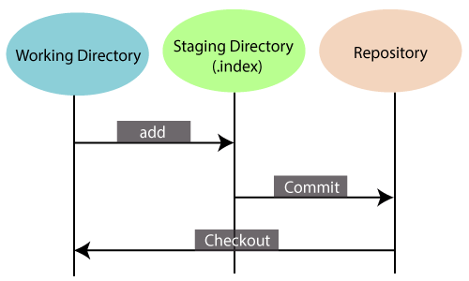

* Another feature of Git that makes it apart from other SCM tools is that **it is possible to quickly stage some of our files and commit them without committing other modified files in our working directory.Maintain the clean history**Git facilitates with Git Rebase; It is one of the most helpful features of Git. It fetches the latest commits from the master branch and puts our code on top of that. Thus, it maintains a clean history of the project.

## Benefits of Git

A version control application allows us to **keep track** of all the changes that we make in the files of our project. Every time we make changes in files of an existing project, we can push those changes to a repository. Other developers are allowed to pull your changes from the repository and continue to work with the updates that you added to the project files.

Some **significant benefits** of using Git are as follows:

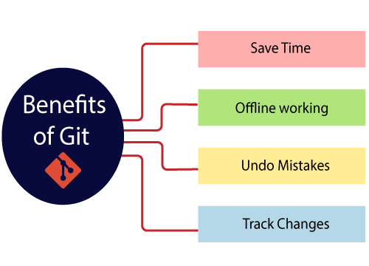

# What is GitHub?

GitHub is a Git repository hosting service. GitHub also facilitates with many of its features, such as access control and collaboration. It provides a Web-based graphical interface.

GitHub is an American company. It hosts source code of your project in the form of different programming languages and keeps track of the various changes made by programmers.

It offers both **distributed version control and source code management (SCM)** functionality of Git. It also facilitates with some collaboration features such as bug tracking, feature requests, task management for every project.