**ASSIGNMENT 1**

* All information for customers who live in 'New York'.

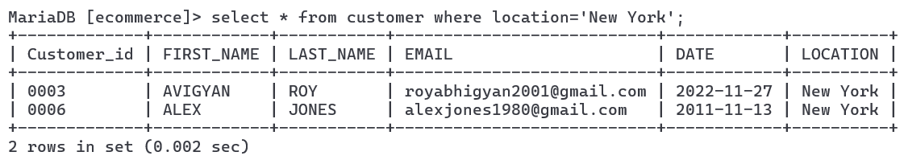

* The first_name, last_name, and email of all customers whose last name starts with the letter 'S'.

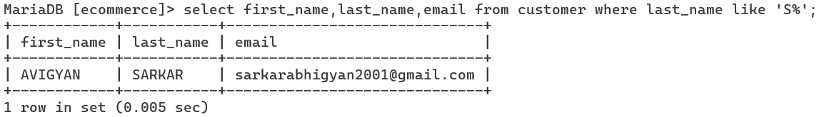

* A list of all customers, ordered by the date they joined (join_date) from newest to oldest.

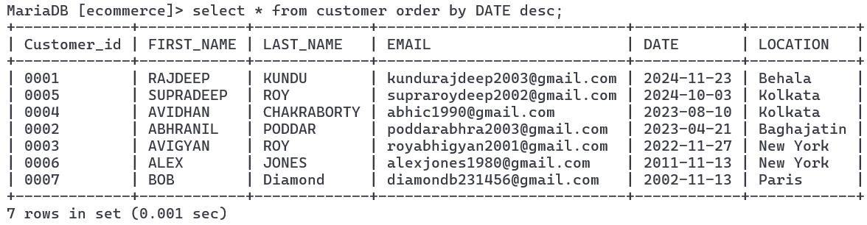

* The top 5 customers who joined most recently.

