UNIVERSITÀ DEGLI STUDI DI MESSINA
Department of Mathematics and Computer Science,
Physical Sciences and Earth Sciences
Subject: Software Engineering
RideNDrive
A Commuter Carpooling Platform
Project Report — Scrum Development Process with DevOps Practices
Student:
Mohammad Haroon (560824)
Supervisor:
Prof. Salvatore Distefano
Version 2.0 — July 2026
Repository: https://github.com/SupraflyX/RideNDrive

Table of Contents

1. Introduction
RideNDrive is a modular commuter carpooling platform: it connects drivers who are already making a journey with passengers travelling along a compatible route, computes an optimal pickup/drop-off sequence for every shared trip, prices each seat dynamically, and lets participants build trust through a time-decaying reputation system. The system was developed as the examination project for the Software Engineering course (Prof. Salvatore Distefano), with a nominal individual effort of about 100 hours.
Commuting costs and vehicular emissions keep rising while most private cars travel with empty seats. Ride-hailing is too expensive for daily commuting and public transport rarely offers point-to-point flexibility. RideNDrive addresses this gap with constraint-aware ride matching: a driver publishes a trip with an explicit detour budget and stop limit, passengers request rides inside pickup time windows, and the platform decides — algorithmically — whether and in which order everyone can be served.

1.1 Purpose and structure of this document
This report documents the complete software development process of RideNDrive. Following the adopted process model (Scrum with DevOps practices, justified in Section 2), the document is organized around the three Scrum phases taught in the course: outline planning and architectural design (Section 3), a series of sprint cycles (Section 6), and project closure (Section 9). Requirements are uniquely identified (FR-x / NFR-x, Section 4), expressed as user stories with acceptance criteria, prioritized with the MoSCoW notation in the Product Backlog (Section 5), and referenced by identifier throughout every sprint, diagram, and test description. Complex functionality is specified algorithmically with UML activity, sequence, and state diagrams.

1.2 Reading conventions
- FR-n / NFR-n — unique identifiers of functional / non-functional requirements (Section 4);
- PB-n — Product Backlog item identifier (Section 5), each tracing to one or more FR/NFR;
- Sprint n — two-week sprint cycles numbered 1–7 (Section 6), each closed by review, retrospective, burndown and burnup charts;
- Figure n — all figures are listed in the Table of Figures at the end of the document.

2. Software Development Process Selection

2.1 Plan-driven versus agile processes
Every software process arranges the four basic activities — specification, development, validation and evolution — differently. In a plan-driven process (e.g. the waterfall model) all activities are planned in advance and progress is measured against that plan; separate, distinct phases of specification and development make change expensive: the main drawback of the waterfall model is precisely the difficulty of accommodating change after the process is underway. In agile processes, planning is incremental, specification, development and validation are interleaved, and it is easier to change the process to reflect changing requirements. In practice most processes blend both approaches.
RideNDrive is a one-developer, ~100-hour project whose requirements were expected to evolve (and did evolve — Sprint 7 exists precisely because supervisor feedback changed the backlog). A plan-driven model would have frozen requirements that were still being discovered; an agile, incremental model lets each two-week cycle deliver a working, testable increment of the system. Agile was therefore selected.

2.2 Why Scrum among the agile methods
Among the agile methods considered — Extreme Programming (XP), Kanban, Scrumban and Scrum — Scrum was selected because its focus is on managing iterative development rather than prescribing specific engineering practices, which leaves room to combine it with the DevOps engineering practices described in Section 2.4. Scrum defines exactly the artifacts the project needed for control and transparency: a single prioritized Product Backlog owned by the Product Owner role, sprint backlogs with measurable sprint goals, and burndown/burnup charts to track progress. XP practices were not discarded entirely: test-first development of the service layer and continuous integration — both XP-inspired — are used throughout.
Scrum structures the project in three phases. The initial outline planning phase establishes the general objectives and designs the software architecture (Section 3). This is followed by a series of sprint cycles, each developing an increment of the system (Section 6). The project closure phase wraps up the project, completes documentation, and assesses lessons learned (Section 9).

2.3 Adapting Scrum to a single-developer team
Scrum nominally distributes responsibility over a Product Owner (build the right thing), a Scrum Master (build it fast) and a cross-functional Team (build things right). This project was carried out by one student; the colleagues originally considered for a group were engaged in other examinations, so the adaptation below was applied honestly rather than simulating a fictitious team:
- Product Owner — the course project guidelines and the supervisor act as the customer voice. The backlog was derived from those requirements, and supervisor feedback (June 2026) entered the backlog exactly as a Product Owner re-prioritization would (it produced Sprint 7);
- Scrum Master — ceremony discipline was self-managed: every sprint began with a written sprint plan (goal + selected stories), and ended with a review against the sprint goal and a written retrospective, all reproduced in Section 6;
- Team — the developer covers design, implementation and testing. The loss of peer review is compensated by automation: every push triggers the CI pipeline, which rebuilds the system and executes the entire regression suite (98 automated tests), acting as an always-on integration reviewer.
Daily stand-ups degenerate in a team of one; they were replaced by a short written log at the start of each working session (what was done, what is next, impediments), which served the same inspect-and-adapt purpose.

2.4 The DevOps dimension
DevOps complements Scrum: Scrum organizes the work, DevOps automates the engineering flow from commit to running system. Of the DevOps practice areas — infrastructure automation, configuration management, deployment automation, log management and monitoring — the project implements the first four:
- Continuous Integration — a GitHub Actions pipeline builds the system with Maven on JDK 17, runs all 98 JUnit tests on every push and pull request, and publishes the JaCoCo coverage report and the application jar as build artifacts;
- Deployment automation — a multi-stage Dockerfile produces a reproducible runtime image (non-root user, JRE-only final stage); docker compose brings up the application together with a health-checked MySQL 8 instance in one command;
- Configuration management — all environment-specific values (database URL and credentials, Google Maps API key) are externalized to environment variables following the 12-factor principle; no secret is committed to version control;
- Log management — the application emits structured startup, SQL and workflow logs (e.g. the reputation workflow trace), captured by the container runtime.

2.5 How the process was adhered to
Eight sprints were executed between 16 March and 5 July 2026: seven two-week cycles and a final one-week cycle (Sprint 8), with a pause between 8 and 14 June for the first report submission and the examination session. Sprint length and load were not uniform — capacity followed reality (course load, exams, supervisor feedback), and Section 9.1 shows the resulting velocity variance, including one sprint that missed its goal. Each sprint is documented in Section 6 with the five-part structure Planning – Implementation – Testing – Review – Retrospective, its user stories (with acceptance criteria and FR references), completed backlog items, and burndown/burnup charts. A Definition of Ready (story has an ID, a user-story sentence, acceptance criteria, an estimate in story points and no unresolved dependency) and a Definition of Done (code merged to main, all tests green in CI, coverage not reduced, documentation updated) were enforced from Sprint 1.

3. Outline Planning and Architectural Design

3.1 Vision and scope
The outline planning phase (Scrum phase 1) fixed the product vision: a web platform where drivers publish trips with explicit constraints (maximum stops, maximum detour minutes), passengers request rides within pickup time windows, and the system computes feasible, optimal shared routes, prices seats dynamically, processes simulated payments, and maintains trust through ratings, reputation tiers, booking lifecycle management and notifications. Out of scope: real payment processing, mobile native clients, and live GPS tracking (declared Won't-have in the MoSCoW backlog).

3.2 Conceptual architecture
A three-tier layered architecture in MVC style was chosen during outline planning: a Vanilla JavaScript single-page application (View), Spring REST controllers (Controller), a Service layer holding all business logic — routing, pricing, reputation, booking lifecycle, notifications — and a Repository layer abstracting MySQL 8 persistence behind Spring Data JPA. The layering enforces separation of concerns: no controller touches a repository directly, and the algorithmic services are independent of both the web and persistence layers, which is what makes them unit-testable with mocked collaborators.

Figure 1 — Layered (three-tier MVC) architecture of RideNDrive
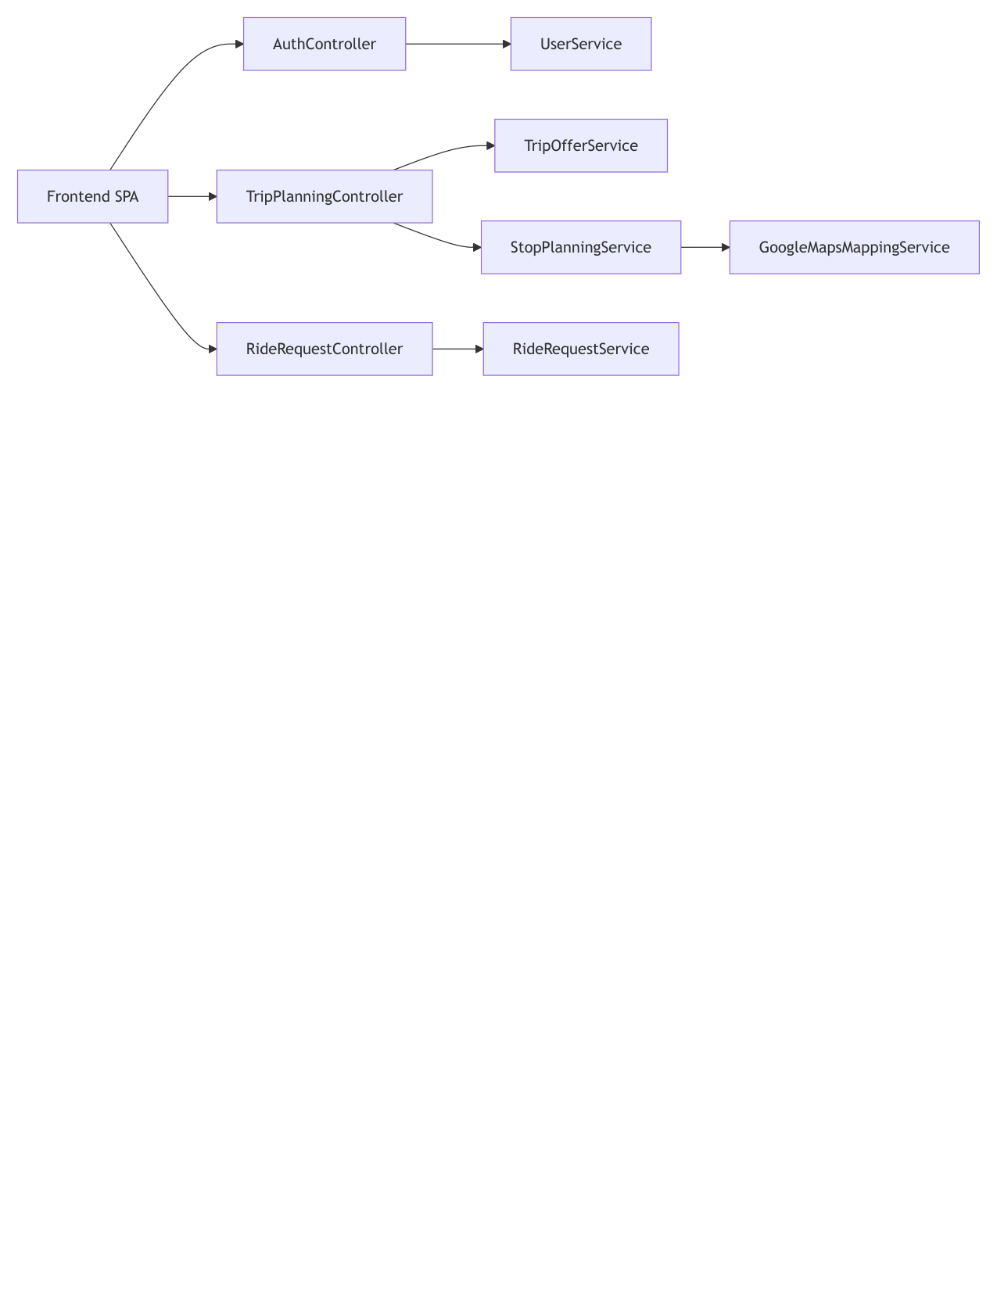
Figure 2 — UML component diagram — modules and their provided/required interfaces

3.3 Technology mapping and justification
Concern | Technology | Justification
Backend framework | Spring Boot 3.2.5 (Java 17) | Mature DI container, embedded server, first-class testing support
Persistence | MySQL 8.0 + Spring Data JPA (Hibernate) | Relational model fits users/trips/requests; repository abstraction
Frontend | Vanilla HTML/CSS/JS SPA | Zero build tooling, framework-independent demonstration of MVC view layer
Security | jBCrypt (salted hashing) | Industry-standard adaptive password hashing
External services | Google Maps Distance Matrix API | Real travel times/distances; local approximation fallback for robustness
Build & dependencies | Maven 3.9 | Reproducible builds, single command CI entry point
Testing | JUnit 5, Spring Boot Test, Mockito, H2 | Unit + integration testing with in-memory database profile
Quality | JaCoCo | Line/branch coverage measurement, published as CI artifact
CI/CD | GitHub Actions | Native to the repository host; matrix of build→test→coverage→Docker
Deployment | Docker + docker compose | Reproducible one-command environment (Infrastructure as Code)

3.4 Development tools
IntelliJ IDEA / VS Code as IDEs; Git for version control with GitHub as the remote; XAMPP for local MySQL administration during development; Postman and the browser developer tools for exploratory API testing; Graphviz and Matplotlib for the UML/state diagrams and the Scrum charts included in this report.

4. Software Requirements Analysis
Requirements were elicited from the course project guidelines, an inspection of comparable carpooling products (BlaBlaCar for long-distance, corporate shuttle tools for fixed routes) and supervisor feedback. Functional user requirements are given as user stories; each is refined by a system-level description and verifiable acceptance criteria, is uniquely identified, and is referenced by identifier in the Product Backlog (Section 5), the sprints (Section 6) and the test suite (Section 8). Non-functional requirements are stated with measurable metrics wherever possible.

4.1 Functional requirements

FR-1: Passenger Registration
User story. As a commuter, I want to register a passenger account with a username and password so that I can request rides.
Description. The system creates a PASSENGER account with a unique (case-insensitive) username; the password is salted-BCrypt-hashed before storage; the new profile starts at reputation 5.0, STANDARD tier.
Acceptance criteria:
  - Duplicate usernames are refused with a clear error.
  - The stored password is a BCrypt hash, never plaintext.
  - Successful registration returns the profile without any credential material.
Priority (MoSCoW): Must have | Implemented in: Sprint 5

FR-2: Driver Registration with Vehicle
User story. As a car owner, I want to register as a driver together with my vehicle (make, model, seating capacity) so that I can publish trips.
Description. Driver registration additionally validates and persists exactly one vehicle with capacity 1–8; the vehicle capacity later bounds the matching algorithm (FR-7).
Acceptance criteria:
  - Vehicle capacity outside 1–8 is rejected.
  - Driver and vehicle are created atomically.
  - Registration fails if any vehicle field is missing.
Priority (MoSCoW): Must have | Implemented in: Sprint 5

FR-3: Authentication
User story. As a registered user, I want to log in with my username and password so that I can access my role-specific dashboard.
Description. Login verifies the password against the stored BCrypt hash and returns the profile (id, name, role, reputation, tier). Unknown users and wrong passwords produce distinct, non-leaking error responses (404 / 401).
Acceptance criteria:
  - Correct credentials return HTTP 200 with the profile.
  - A wrong password returns HTTP 401 without revealing which field was wrong.
  - Passwords never appear in any API response (write-only fields).
Priority (MoSCoW): Must have | Implemented in: Sprint 5

FR-4: Profile and Account Management
User story. As a user, I want to update my profile and delete my account so that I control my data.
Description. Profile updates re-hash a changed password; account deletion cascades over all dependent entities (ratings given/received, vehicles, trip offers, ride requests) in a single transaction.
Acceptance criteria:
  - Password change invalidates the old password immediately.
  - After deletion, no orphan rows referencing the user remain.
  - Deletion of a non-existent user returns HTTP 404.
Priority (MoSCoW): Should have | Implemented in: Sprint 1 / Sprint 5

FR-5: Trip Offer Management
User story. As a driver, I want to publish, edit and remove trip offers with origin, destination, departure time, maximum stops and maximum detour minutes so that the matcher can respect my constraints.
Description. Full CRUD over trip offers; maxStops and maxDetourMinutes parameterize the DFS search (FR-7); departure times must not lie in the past (bean validation at persistence).
Acceptance criteria:
  - A trip with negative constraints is rejected.
  - Editing a trip preserves already-linked bookings.
  - Removing a trip removes its dependent ride links.
Priority (MoSCoW): Must have | Implemented in: Sprint 1

FR-6: Ride Request Management
User story. As a passenger, I want to create, edit and remove ride requests with origin, destination and a pickup time window so that drivers can find me.
Description. Full CRUD over ride requests; every new request starts in booking state PENDING (FR-12); the pickup window [start, end] is enforced by the matcher.
Acceptance criteria:
  - A request with an inverted time window is rejected.
  - New requests default to status PENDING.
  - The request appears immediately in the passenger dashboard.
Priority (MoSCoW): Must have | Implemented in: Sprint 1

FR-7: Intelligent Route Matching
User story. As a driver, I want the system to compute whether pending requests fit my trip and in which pickup/drop-off order, so that I never exceed my declared detour budget or capacity.
Description. A depth-first search over all pickup/drop-off interleavings with five pruning constraints: (1) drop-off only after its pickup; (2) vehicle capacity never exceeded; (3) driver's maximum stop count respected; (4) passenger pickup time windows respected (early arrival waits); (5) a detour lower bound prunes branches that cannot meet the budget. Among feasible sequences the search maximizes requests served, then minimizes total travel time. Worst-case complexity O((2n)!), made practical by pruning — specified algorithmically in Figure 9.
Acceptance criteria:
  - For a trip with two compatible requests, a feasible 4-stop sequence is returned.
  - No returned sequence violates capacity, windows, stop or detour limits.
  - If nothing fits, the result is explicitly marked infeasible with a reason.
Priority (MoSCoW): Must have | Implemented in: Sprint 2

FR-8: Seat Booking with Payment Simulation
User story. As a passenger, I want to book a seat on a matched trip and see the fare and payment outcome so that my place is secured.
Description. Booking re-validates routing feasibility, computes the fare through the pricing engine (FR-9), verifies identity and processes a simulated payment; on success the booking is CONFIRMED and the driver is notified (FR-13); on payment hold it remains PENDING.
Acceptance criteria:
  - Booking an infeasible request is rolled back (no orphan request persists).
  - A successful booking returns routing, per-passenger pricing breakdown and payment status.
  - Double-booking the same trip by the same passenger is refused.
Priority (MoSCoW): Must have | Implemented in: Sprint 2 / Sprint 6

FR-9: Dynamic Pricing
User story. As a platform operator, I want fares computed from a base rate plus contextual policies so that pricing stays fair and explainable.
Description. Base fare = €2.00 + €0.50/km, then an ordered chain of pricing policies (Chain of Responsibility over Strategy implementations): rush-hour surcharge, late-night fee, same-destination-zone discount, long-distance discount. Every applied policy is recorded in an audit list returned with the result — specified algorithmically in Figure 13.
Acceptance criteria:
  - A 08:00 weekday ride includes the rush-hour surcharge in the audit list.
  - A 01:00 ride applies the late-night fee.
  - Fares are rounded to 2 decimals and never negative.
Priority (MoSCoW): Must have | Implemented in: Sprint 3

FR-10: Ratings
User story. As a participant, I want to rate my counterpart 1–5 after a ride so that reliable behaviour is visible.
Description. Ratings (reviewer, reviewee, score, type) are persisted and immediately propagated to the reputation workflow (FR-11) and the notification centre (FR-13).
Acceptance criteria:
  - Submitting a rating updates the reviewee's reputation in the same transaction.
  - The reviewee receives a rating notification.
  - Only counterparts from COMPLETED bookings are offered for rating (eligibility rule, added in Sprint 7).
  - Ratings are visible in the user directory averages.
Priority (MoSCoW): Must have | Implemented in: Sprint 4

FR-11: Reputation and Incentive Tiers
User story. As a user, I want a reputation score with visible tiers so that good behaviour is rewarded.
Description. A five-step workflow recalculates the rolling average on every rating event, applies a time-decay penalty (0.01/day beyond 30 days of inactivity, capped at 1.0), maps the score to a tier (STANDARD < 4.0 ≤ SILVER < 4.5 ≤ GOLD < 4.8 ≤ PREMIUM_PRICING) and persists the update — specified in Figure 16.
Acceptance criteria:
  - A 5-star rating raises the rolling average correctly.
  - 31 days of inactivity reduce the effective score by 0.01.
  - Score 4.9 maps to PREMIUM_PRICING tier.
Priority (MoSCoW): Should have | Implemented in: Sprint 4

FR-12: Booking Lifecycle Management
User story. As a driver I want to confirm or decline pending bookings, and as a passenger I want to withdraw mine, so that both sides control their commitments until the trip is completed.
Description. Every booking follows the finite state machine PENDING → {CONFIRMED, REJECTED, CANCELLED}, CONFIRMED → {CANCELLED, COMPLETED}; terminal states admit no transition. The transition relation is an explicit guard table (State pattern); illegal transitions surface as HTTP 409. Completing a trip transitions all its CONFIRMED bookings to COMPLETED and invites passengers to rate the driver — specified in Figures 28 and 29.
Acceptance criteria:
  - Confirming a PENDING booking succeeds and notifies the passenger.
  - Confirming an already-confirmed booking returns HTTP 409 with a descriptive error.
  - Trip completion closes every CONFIRMED booking on that trip.
  - The UI shows per-booking status badges and role-appropriate actions.
Priority (MoSCoW): Must have (added after supervisor feedback) | Implemented in: Sprint 7

FR-13: In-App Notification Centre
User story. As a user, I want an inbox with unread count so that I notice booking and rating events without polling other pages.
Description. Domain services publish notifications (Observer pattern) on booking transitions, new bookings and new ratings. Endpoints provide the inbox (newest first), the unread count, mark-read and mark-all-read. The SPA shows a bell with an unread badge, polls every 30 s, and renders the panel — specified in Figure 29.
Acceptance criteria:
  - Confirming a booking creates a BOOKING notification for the passenger.
  - A new rating creates a RATING notification for the reviewee.
  - Mark-all-read sets the unread count to zero.
Priority (MoSCoW): Should have (added after supervisor feedback) | Implemented in: Sprint 7

FR-14: Trip Search for Passengers
User story. As a passenger, I want to search published trips by origin, destination and date and see only trips that can actually accommodate me, so that I do not request infeasible rides.
Description. Search filters published offers by route and date, then runs the matcher (FR-7) per candidate to verify feasibility before presenting it; offers whose planning raises a Maps API error are skipped, not fatal.
Acceptance criteria:
  - A search returns only feasible offers for the passenger's window.
  - Missing search parameters return HTTP 400.
  - An unknown passenger id returns HTTP 400.
Priority (MoSCoW): Must have | Implemented in: Sprint 2

4.2 Non-functional requirements
ID | Category | Requirement and metric
NFR-1 | Performance | Route matching for a trip with up to 4 concurrent requests (8 stops) completes in < 2 s on commodity hardware, thanks to the five pruning constraints.
NFR-2 | Security | Passwords stored only as salted BCrypt hashes; credential material never serialized into responses; all secrets (DB password, Maps API key) injected via environment variables, none committed to the repository.
NFR-3 | Maintainability | Strict layering (Controller→Service→Repository), 10 documented design patterns, JavaDoc on every service; adding a pricing policy requires no change to the engine (open/closed).
NFR-4 | Testability | Every service unit-testable with mocked collaborators; a dedicated H2 in-memory test profile allows the full integration suite to run with zero external dependencies; line coverage ≥ 80 % (JaCoCo, currently 84 %).
NFR-5 | Reliability / Robustness | Loss of the Google Maps API degrades gracefully to a deterministic local distance approximation; invalid input never crashes the matcher (explicit infeasible result).
NFR-6 | Portability | The complete system (app + MySQL 8) starts with a single docker compose up on any Docker host; no host-specific configuration required.
NFR-7 | Usability | Single-page application: every user goal (publish, search, book, rate, manage bookings, read notifications) reachable without a full page reload; booking states always visible as coloured badges.
NFR-8 | Auditability | Every pricing result carries the list of applied policies; every notification is persisted with a timestamp, forming a per-user event trail.

4.3 Actors and use cases
Two human actors (Passenger, Driver) and one external system actor (Google Maps API) interact with the platform. The use case view and the domain entity-relationship model are given below; both were produced during outline planning and refined during the sprints.
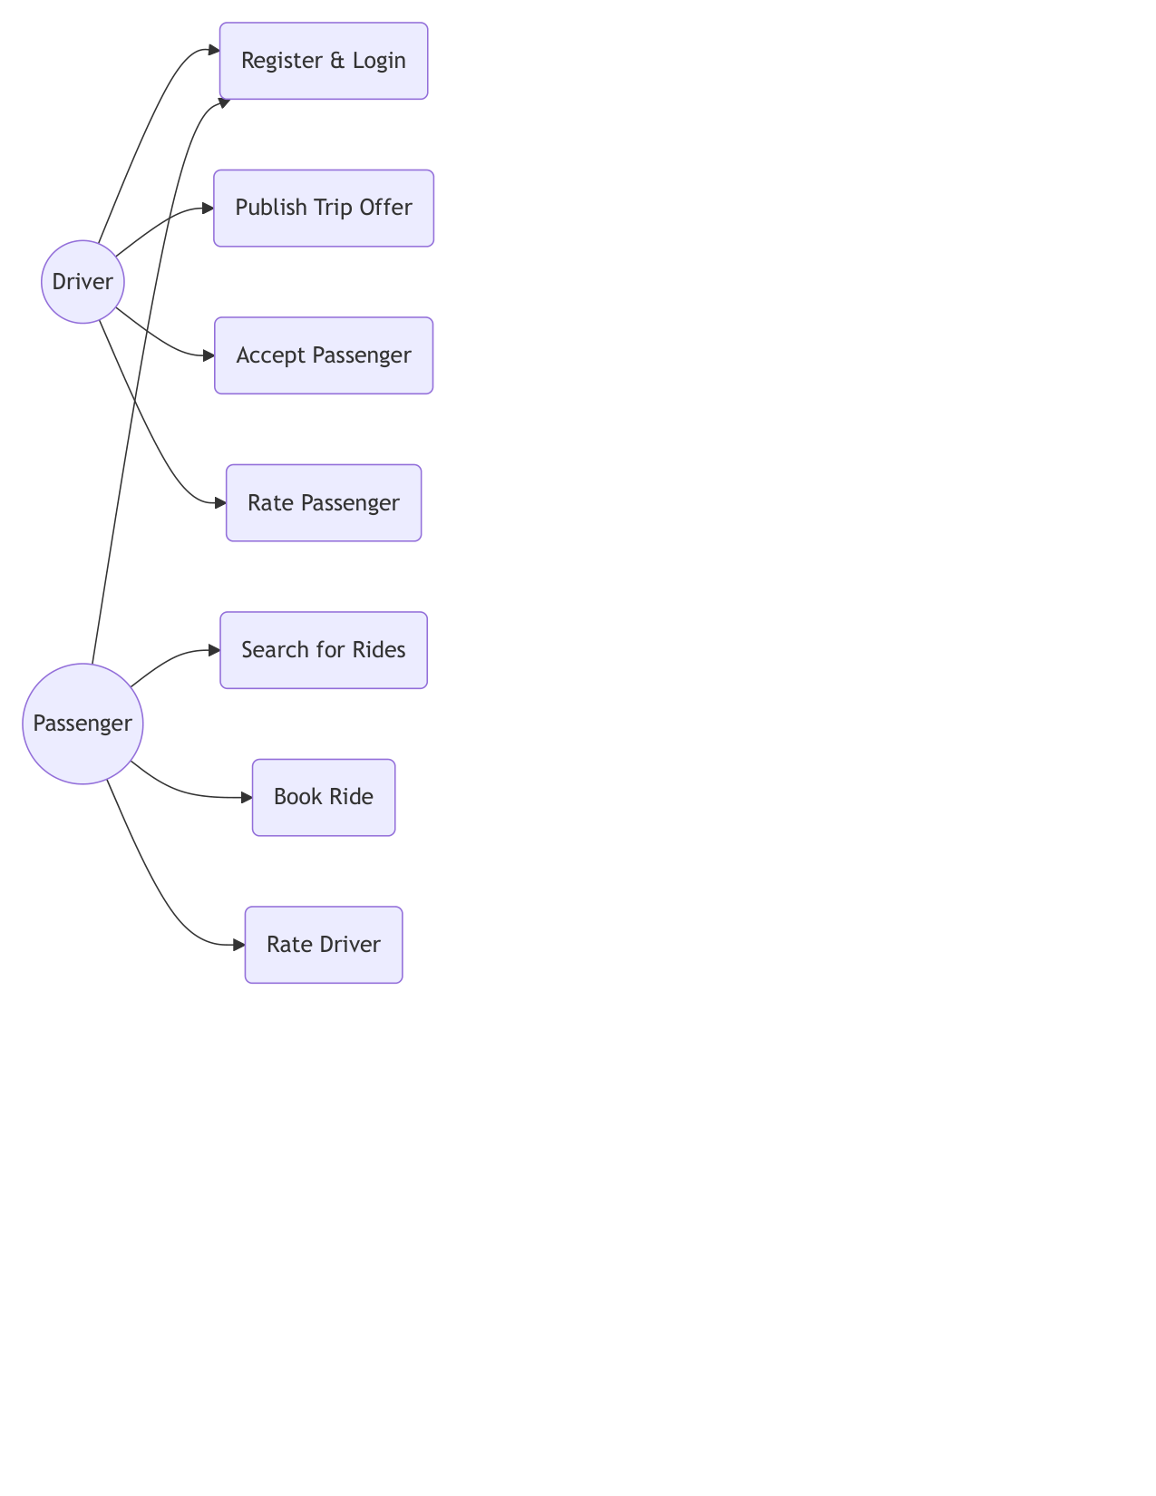
Figure 3 — Use case diagram — Passenger, Driver and external Maps API
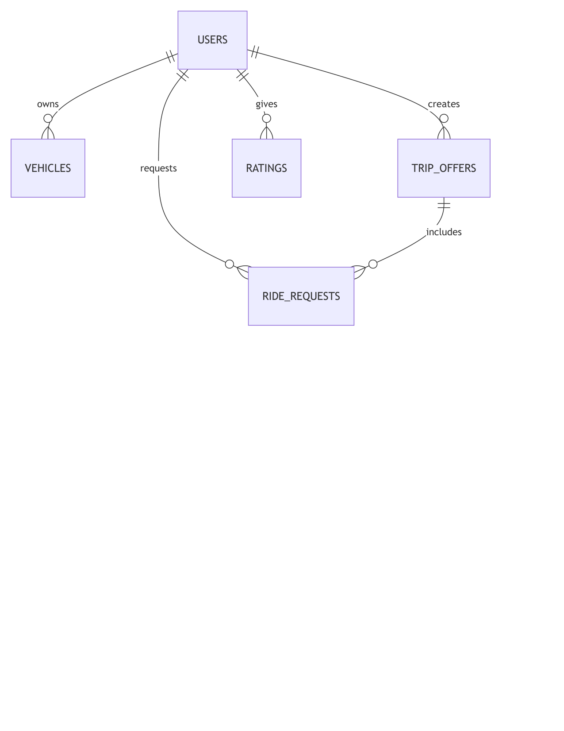
Figure 4 — Entity–relationship model of the persistent domain

5. Product Backlog and Refinement
The Product Backlog is the single prioritized list of everything the product needs. Items are ordered by business value and risk, estimated in story points (SP, modified-Fibonacci), prioritized with the MoSCoW notation, and each traces to the requirement(s) it realizes. The backlog was revised continuously: supervisor feedback in June 2026 added PB-13–PB-15 and the subsequent UI critique produced PB-16–PB-17 — exactly the constant revision the Scrum Product Backlog is meant to absorb. PB-8 shows a carry-over: it was planned in Sprint 4 and finished in Sprint 5.
ID | Backlog item | Realizes | MoSCoW | SP | Sprint
PB-1 | Domain model, repositories and CRUD APIs for users, vehicles, trips, requests, ratings | FR-4, FR-5, FR-6 | Must | 13 | 1
PB-2 | Constraint-based DFS stop-sequencing algorithm with pruning | FR-7 | Must | 13 | 2
PB-3 | Trip search returning only feasible offers | FR-14 | Must | 8 | 2
PB-4 | Seat booking flow with routing re-validation and payment simulation | FR-8 | Must | 5 | 2
PB-5 | Pricing engine: policy chain over strategy implementations + audit trail | FR-9 | Must | 13 | 3
PB-6 | Pricing policies: rush-hour, late-night, same-zone discount, long-distance discount | FR-9 | Must | 6 | 3
PB-7 | Rating submission and propagation | FR-10 | Must | 5 | 4
PB-8 | Reputation workflow with time decay and incentive tiers | FR-11 | Should | 7 | 4 → 5 (2 SP carried)
PB-9 | Registration (passenger / driver+vehicle) and BCrypt login | FR-1, FR-2, FR-3 | Must | 10 | 5
PB-10 | Single-page application dashboards for both roles | NFR-7 | Must | 14 | 5
PB-11 | Integration test suite on H2 profile + JaCoCo ≥ 80 % | NFR-4 | Must | 10 | 6
PB-12 | CI pipeline on GitHub Actions | NFR-2, NFR-4 | Must | 7 | 6
PB-13 | Booking lifecycle state machine (confirm/decline/withdraw/complete) end-to-end | FR-12 | Must | 10 | 7
PB-14 | In-app notification centre (backend + SPA bell/panel) | FR-13 | Should | 8 | 7
PB-15 | DevOps & security hardening: Docker/compose, secret externalization, hash-disclosure fix, CI artifacts | NFR-2, NFR-6 | Must | 5 | 7
PB-16 | UX & quality hardening: rating eligibility from completed trips, toast/confirm dialogs, loading states, standardized JSON errors | FR-10, NFR-7 | Must | 5 | 8
PB-17 | UI redesign: search-first information architecture, ride cards, role landings, dashboard removal, mobile layout | NFR-7 | Must | 9 | 8
PB-18 | Live GPS tracking, native mobile clients, real payment provider | — | Won't (v2 roadmap) | — | —

5.1 Definition of Ready and Definition of Done
- Definition of Ready — the story has a unique ID, a user-story sentence, acceptance criteria, a story-point estimate, and no unresolved external dependency;
- Definition of Done — code merged to main; all automated tests green in CI; coverage not reduced; API/README documentation updated; the increment is demonstrable from the UI or the API.
Refinement happened at the start of every sprint: the top backlog items were re-estimated, split when larger than 13 SP (PB-1 was deliberately kept whole as the foundational walking skeleton), and their acceptance criteria sharpened into the sprint-level user stories reported in Section 6.

6. Sprint Development
Eight sprints were executed — seven two-week cycles and one final one-week cycle. Velocity was deliberately not forced to look uniform: Sprint 1 was slow (framework learning curve), Sprint 2 was the heaviest (the matching algorithm), Sprint 4 collided with the examination period and missed its goal by 2 SP (carried into Sprint 5 — the only goal miss of the project), and Sprint 8 was a short, intense redesign cycle. Every sprint below follows the same structure: Planning (sprint goal and user stories with acceptance criteria and requirement traces), Implementation (completed backlog items, achievements, challenges), Testing, Review and Retrospective, closed by the sprint's burndown and burnup charts. Story points use the modified-Fibonacci scale; charts plot the 10 working days of each sprint.

Sprint 1 — Walking Skeleton: Domain Model and CRUD Services (16–29 Mar 2026)

Planning
Sprint goal. Stand up the layered architecture end-to-end: JPA domain model, repositories, services and REST CRUD for every core entity, so that all later sprints extend a working vertical slice.
User story US-1.1 — Manage trip offers. As a driver, I want to create, read, update and delete my trip offers so that my planned journeys are visible to the platform.
Acceptance criteria (traces to FR-5):
  - POST/GET/PUT/DELETE /api/trips behave per contract.
  - Negative maxStops or maxDetourMinutes are rejected.
  - Unknown ids return HTTP 404.
User story US-1.2 — Manage ride requests. As a passenger, I want to create, read, update and delete my ride requests so that drivers can consider me.
Acceptance criteria (traces to FR-6):
  - CRUD over /api/ride-requests works.
  - Time-window validation enforced.
  - Requests link optionally to a trip offer.
User story US-1.3 — Account deletion cascade. As a user, I want deleting my account to remove all my dependent data so that no orphans remain.
Acceptance criteria (traces to FR-4):
  - Ratings, vehicles, offers and requests of the user are removed transactionally.
  - Deletion is atomic (all-or-nothing).

Implementation
Completed backlog items:
- PB-1 — entities User, Vehicle, TripOffer, RideRequest, Rating with validation metadata; five Spring Data repositories; service layer; CRUD controllers; cascading account deletion.
Major achievements:
- Layered architecture proven end-to-end (walking skeleton) with MySQL schema auto-generated from JPA metadata.
- Transactional cascade deletion implemented and covered by tests (Figure 6).
- Repository pattern isolates persistence — later sprints never wrote SQL.
Challenges and impediments:
- Bidirectional TripOffer↔RideRequest association caused JSON serialization cycles; resolved with @JsonIgnore on the owning side (an early lesson that DTO boundaries matter).
- MySQL reserved keywords forced explicit table naming conventions.

Testing
- Context-load smoke test plus repository round-trip checks on H2.
- Manual API verification with Postman for every endpoint (happy + 404 paths).

Review
- Increment demonstrated: all core entities creatable and queryable through the API.
- 13/13 SP delivered — slower than hoped: the first week was dominated by the Spring Boot/JPA learning curve, which the retrospective priced into later planning.

Retrospective
What went well:
- Vertical-slice approach removed integration risk immediately.
- Bean-validation-first modelling caught bad input at the boundary.
What to improve:
- Start automated integration tests earlier instead of relying on Postman (adopted in Sprint 2).
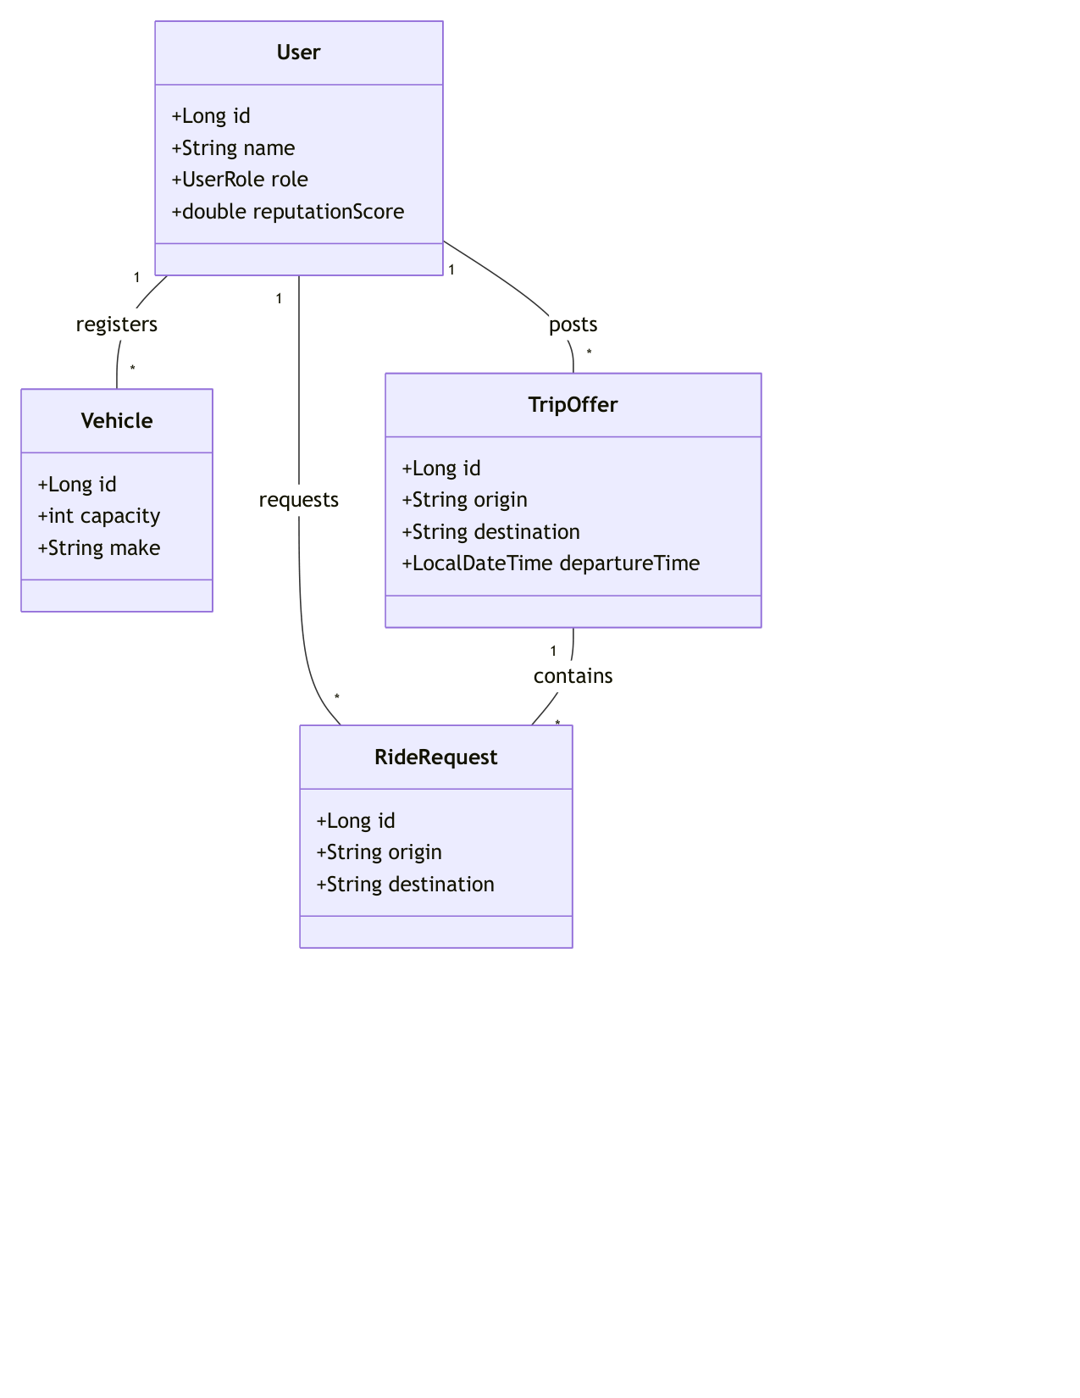
Figure 5 — UML class diagram — persistent domain model
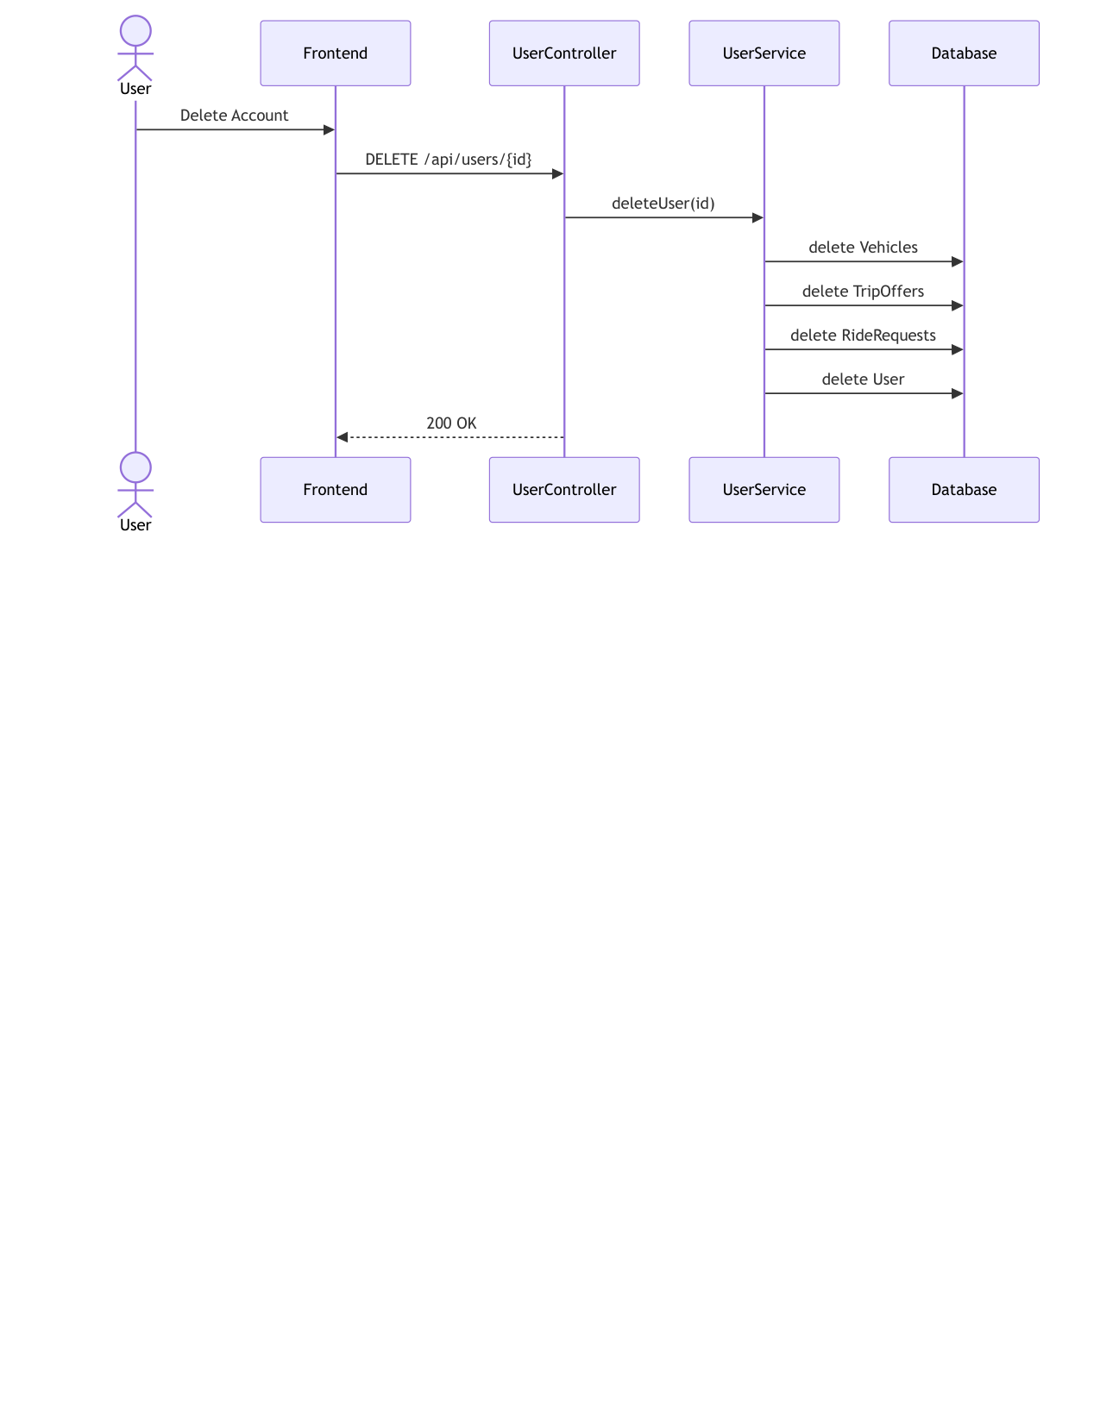
Figure 6 — Activity diagram — cascading account deletion (FR-4)
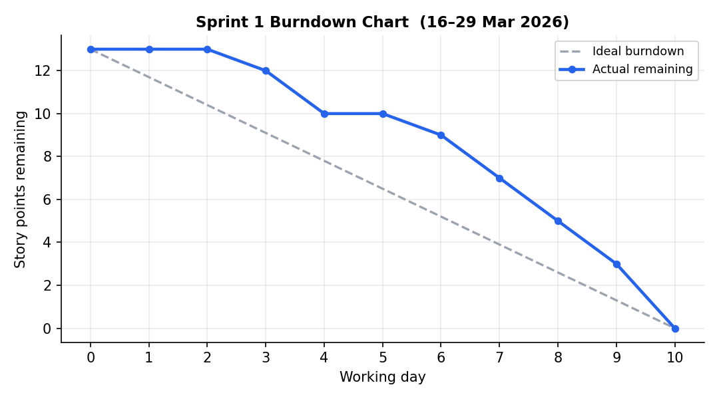
Figure 7 — Sprint 1 burndown chart
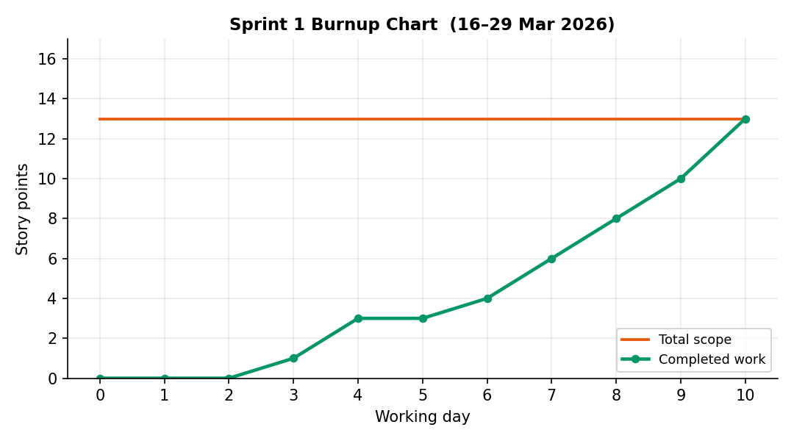
Figure 8 — Sprint 1 burnup chart

Sprint 2 — Intelligent Route Matching (DFS) and Booking (30 Mar – 12 Apr 2026)

Planning
Sprint goal. Deliver the algorithmic heart of the product: constraint-based stop sequencing, feasibility-aware trip search, and the seat-booking flow.
User story US-2.1 — Optimal stop sequencing. As a driver, I want the system to compute the best pickup/drop-off order for the passengers I take, so that my detour budget and capacity are never violated.
Acceptance criteria (traces to FR-7, NFR-1, NFR-5):
  - All five pruning constraints enforced (ordering, capacity, stop limit, time windows, detour lower bound).
  - Result maximizes served requests, then minimizes total time.
  - Infeasible inputs yield an explicit infeasible result, never an exception.
User story US-2.2 — Feasibility-aware search. As a passenger, I want search results to contain only trips that can actually take me, so that I never request impossible rides.
Acceptance criteria (traces to FR-14):
  - Search runs the matcher per candidate offer.
  - Offers failing the Maps API are skipped, not fatal.
  - Missing parameters → HTTP 400.
User story US-2.3 — Book a seat. As a passenger, I want to book a seat on a feasible trip and see fare and payment outcome, so that my place is secured.
Acceptance criteria (traces to FR-8):
  - Booking re-validates routing before persisting.
  - Infeasible booking rolls back cleanly.
  - Duplicate booking on the same trip is refused.

Implementation
Completed backlog items:
- PB-2 DFS matcher with SearchContext and backtracking; PB-3 search-matches endpoint; PB-4 book-passenger flow with payment simulation (identity check + transfer).
Major achievements:
- Worst-case O((2n)!) search made practical: the five constraints prune the tree so aggressively that 4-request instances plan in milliseconds (NFR-1).
- Mapping integration behind an interface with a deterministic local fallback (NFR-5) — the algorithm is testable with a mocked MappingService.
- Search→match→book demonstrated end-to-end from the API.
Challenges and impediments:
- Detour accounting: the naive check compared only elapsed time; the fix introduced the destination lower bound (constraint 5), which both corrected results and accelerated pruning.
- Waiting semantics at early arrivals (driver waits until window start) required careful time arithmetic to keep the detour honest.

Testing
- First unit suite: StopPlanningServiceTest with mocked mapping — feasibility, capacity, ordering, window and detour cases (5 tests).
- Booking flow exercised via Postman scenarios that later became integration tests.

Review
- Increment demonstrated live: two passengers matched onto one trip with a correct 4-stop sequence.
- 26/26 SP delivered (scope grew +2 SP on day 3 when US-2.2 gained the skip-on-API-error criterion).

Retrospective
What went well:
- Interface-first design of MappingService paid off immediately in testability.
What to improve:
- Algorithmic code needs activity-diagram documentation while fresh (done: Figure 9) rather than after the fact.
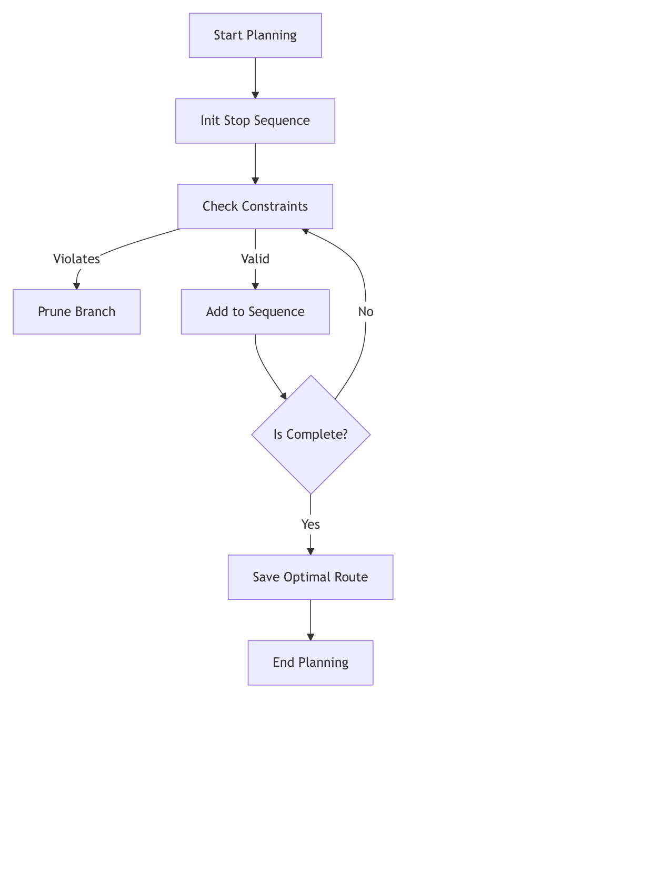
Figure 9 — Activity diagram — DFS stop-sequencing with pruning constraints (FR-7)
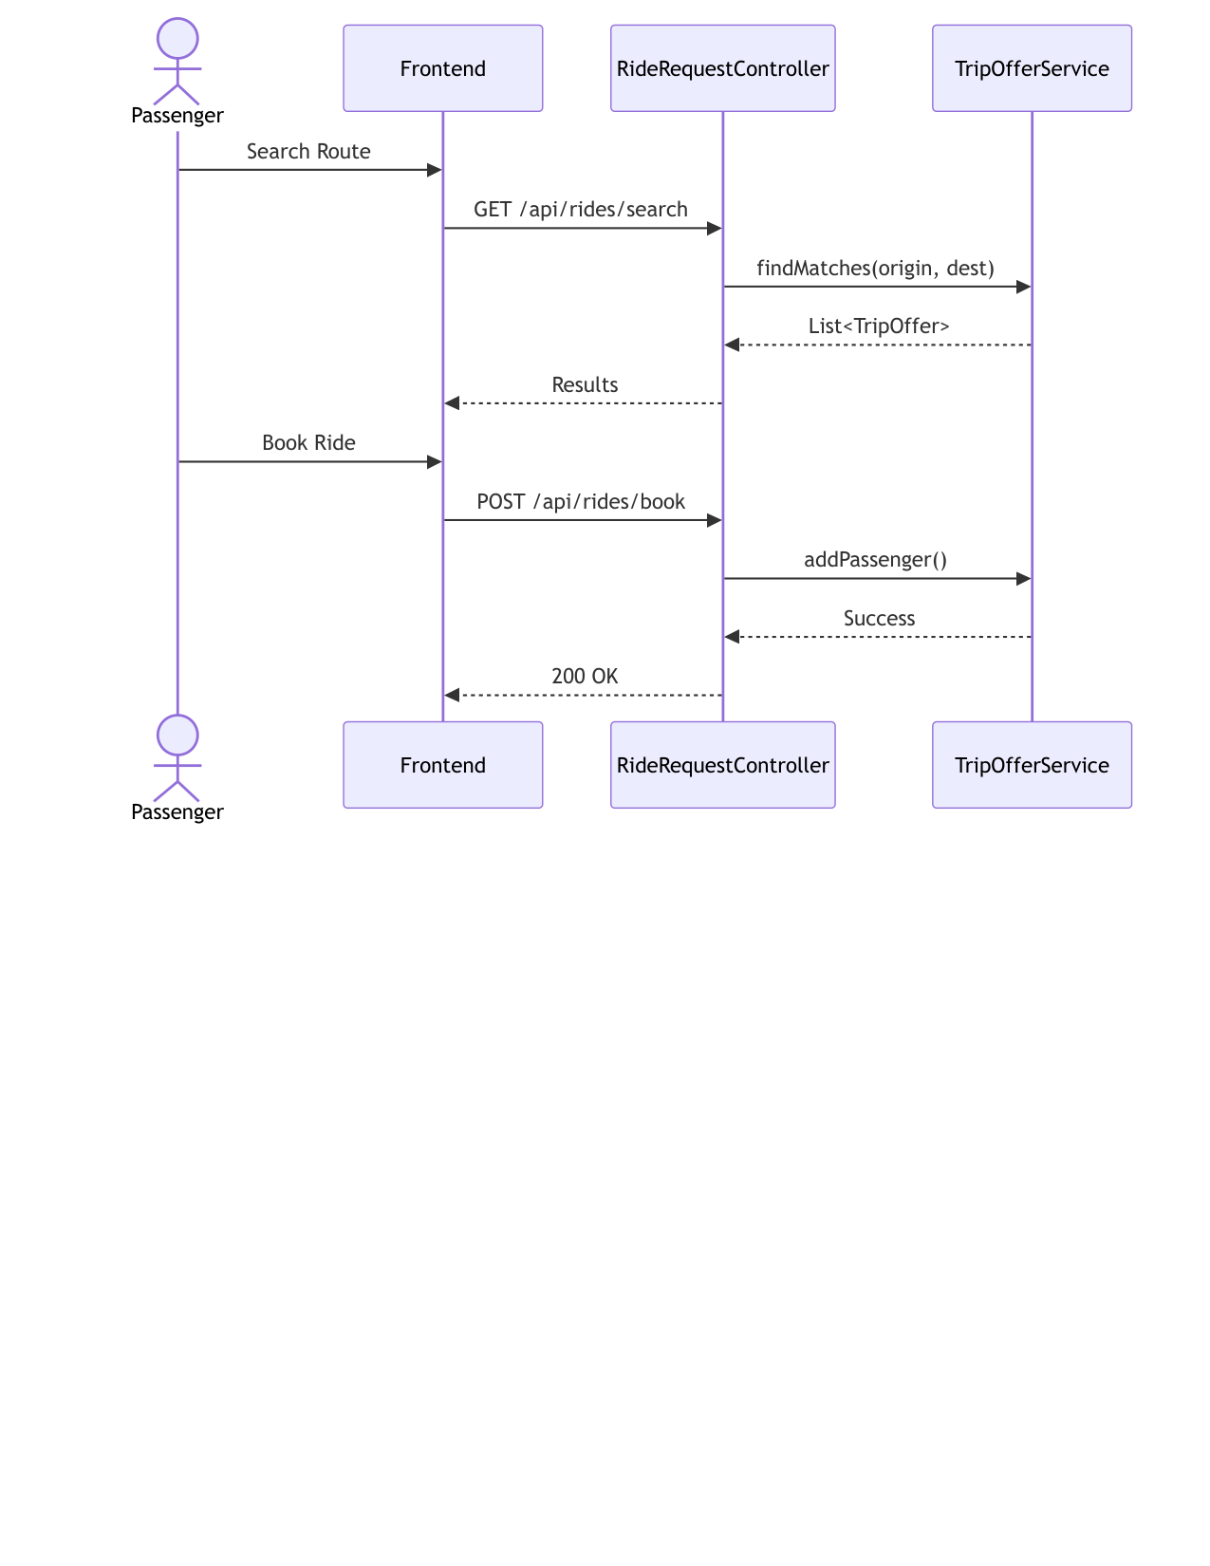
Figure 10 — Sequence diagram — search and book ride flow (FR-14, FR-8)
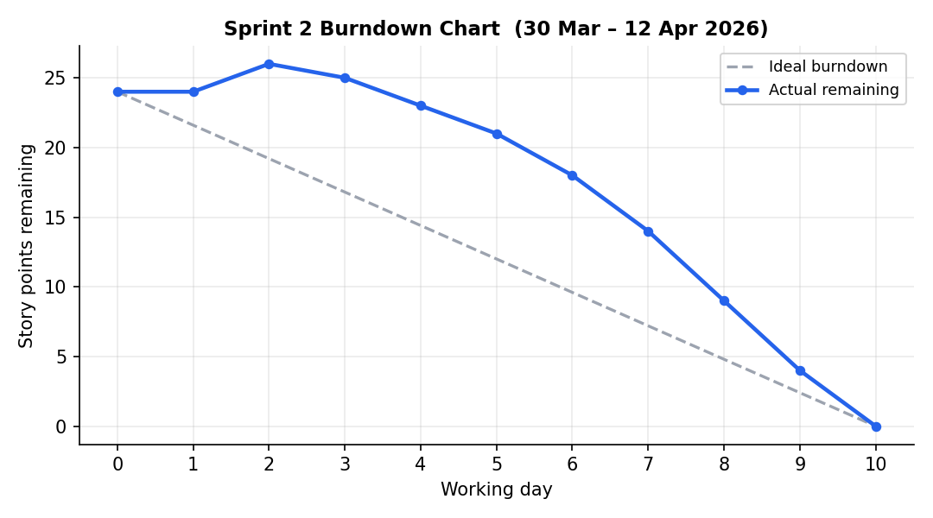
Figure 11 — Sprint 2 burndown chart
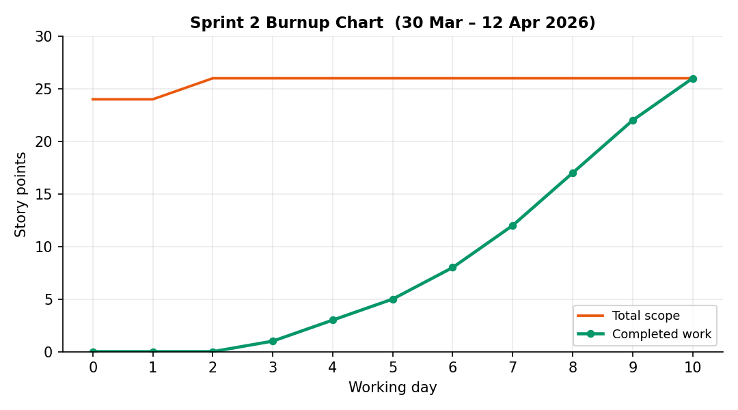
Figure 12 — Sprint 2 burnup chart

Sprint 3 — Dynamic Pricing Engine (13–26 Apr 2026)

Planning
Sprint goal. Price every seat through an extensible, auditable policy pipeline.
User story US-3.1 — Base fare and policy chain. As a platform operator, I want fares to start from a transparent base and pass through prioritized pricing policies, so that pricing is fair, explainable and extensible.
Acceptance criteria (traces to FR-9, NFR-3, NFR-8):
  - Base fare €2.00 + €0.50/km.
  - Policies execute in priority order; each applied policy is recorded in the audit list.
  - Adding a policy requires zero changes to the engine (open/closed).
User story US-3.2 — Contextual policies. As a commuter, I want predictable surcharges and discounts (rush hour, late night, same zone, long distance), so that prices match circumstances.
Acceptance criteria (traces to FR-9):
  - Weekday 07–09/17–19 adds the rush-hour surcharge.
  - 00–05 adds the late-night fee.
  - Same destination zone and long distances apply discounts.

Implementation
Completed backlog items:
- PB-5 PricingEngine (Chain of Responsibility, priority-sorted via Spring-injected strategy list); PB-6 four concrete PricingPolicy strategies.
Major achievements:
- Two GoF patterns composed cleanly: Strategy for interchangeable rules, Chain of Responsibility for their pipeline; Spring DI discovers all policies at runtime (Factory-Method flavour).
- Audit list turns every fare into an explainable object (NFR-8) — later reused directly by the UI.
Challenges and impediments:
- Rounding: applying rounding per-policy accumulated cent drift; moved to a single terminal rounding step.
- Policy ordering mattered more than expected (discount-after-surcharge vs before); made explicit with integer priorities.

Testing
- PricingEngineTest: 5 unit tests covering each policy trigger and the neutral case, all with deterministic LocalDateTime fixtures.

Review
- Increment demonstrated: identical route priced at 12:00 vs 08:00 vs 01:00 shows the audit trail differences.
- 19/19 SP delivered.

Retrospective
What went well:
- Pattern-driven design made the sprint almost friction-free.
What to improve:
- Property-based tests (never-negative fares) would strengthen confidence (picked up in Sprint 6 review).

Figure 13 — Activity diagram — pricing policy chain (FR-9)
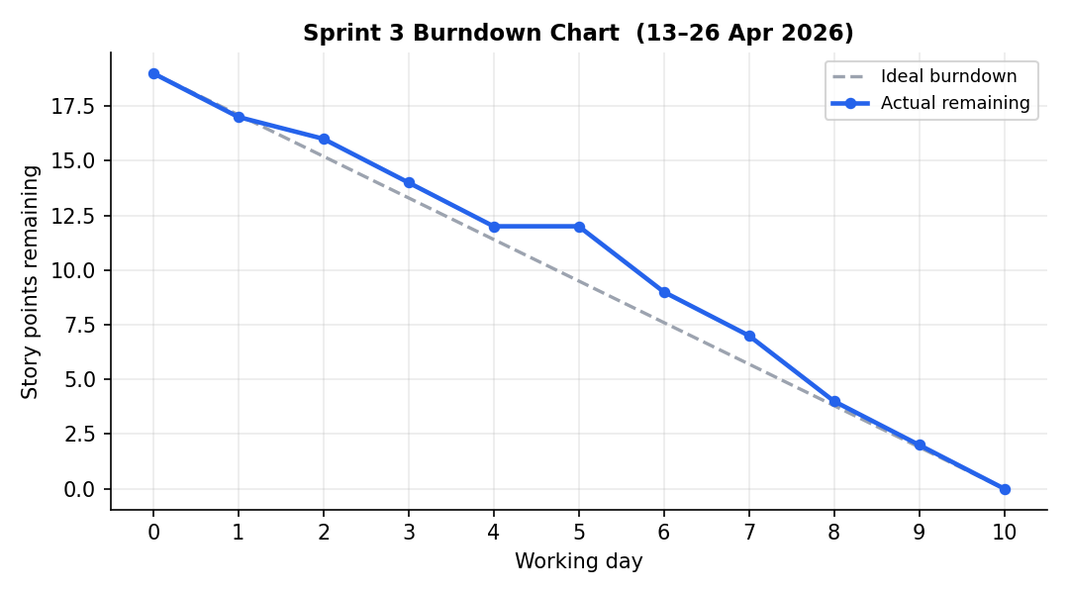
Figure 14 — Sprint 3 burndown chart
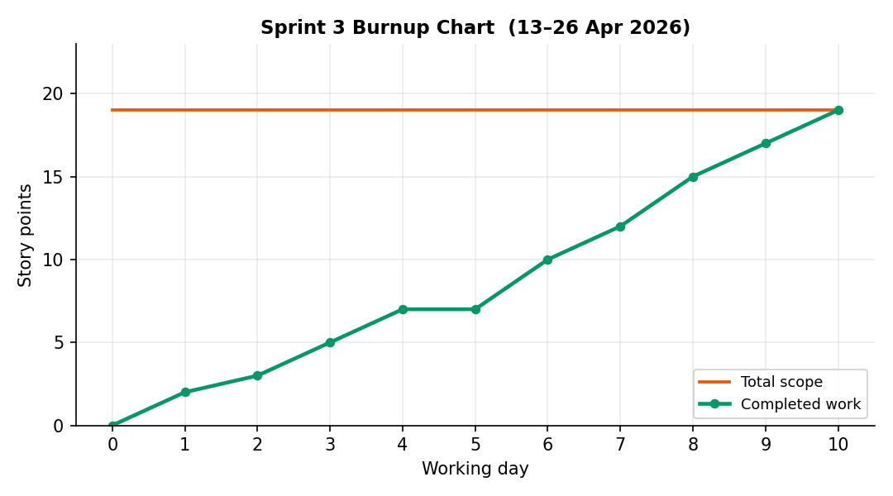
Figure 15 — Sprint 3 burnup chart

Sprint 4 — Ratings, Reputation and Incentive Tiers (27 Apr – 10 May 2026)

Planning
Sprint goal. Close the trust loop: ratings feed a decaying reputation score mapped to visible incentive tiers.
User story US-4.1 — Rate a counterpart. As a participant, I want to rate my counterpart after a ride, so that reliability is visible to everyone.
Acceptance criteria (traces to FR-10):
  - POST /api/ratings persists and propagates in one transaction.
  - Score bounds 1–5 enforced.
User story US-4.2 — Reputation workflow. As a user, I want my reputation to reflect recent behaviour, decaying with inactivity, so that scores stay meaningful.
Acceptance criteria (traces to FR-11):
  - Rolling average recomputed on every rating event.
  - 0.01/day decay beyond 30 days inactivity, capped at 1.0.
  - Tier thresholds 4.0/4.5/4.8 mapped correctly.

Implementation
Completed backlog items:
- PB-7 rating submission with event propagation (Observer); PB-8 five-step ReputationService workflow with tier mapping.
Major achievements:
- Event-driven propagation kept RatingService and ReputationService decoupled (@Lazy breaking the DI cycle).
- Deterministic, unit-tested tier boundaries; workflow trace logged for auditability.
Challenges and impediments:
- Time-based logic vs deterministic tests: decay depends on now; solved by testing the decay function directly with crafted lastActiveDate values.
- Circular service dependency surfaced Spring initialization order issues; resolved with lazy injection.

Testing
- ReputationServiceTest: 5 unit tests (average, decay boundary, cap, tier mapping, null lastActive).

Review
- Increment demonstrated: rating a driver updates score and tier immediately in the directory.
- 10/12 SP delivered — the sprint goal was NOT met: the examination period cut capacity mid-sprint, and the tier-mapping story (2 SP) was carried into Sprint 5.

Retrospective
What went well:
- Observer separation later made the Sprint 7 notification hook a one-line addition.
What to improve:
- System.out workflow logging should move to a logging framework (noted for hardening).
- Planning ignored the known exam calendar — capacity must reflect it (applied from Sprint 5 on).
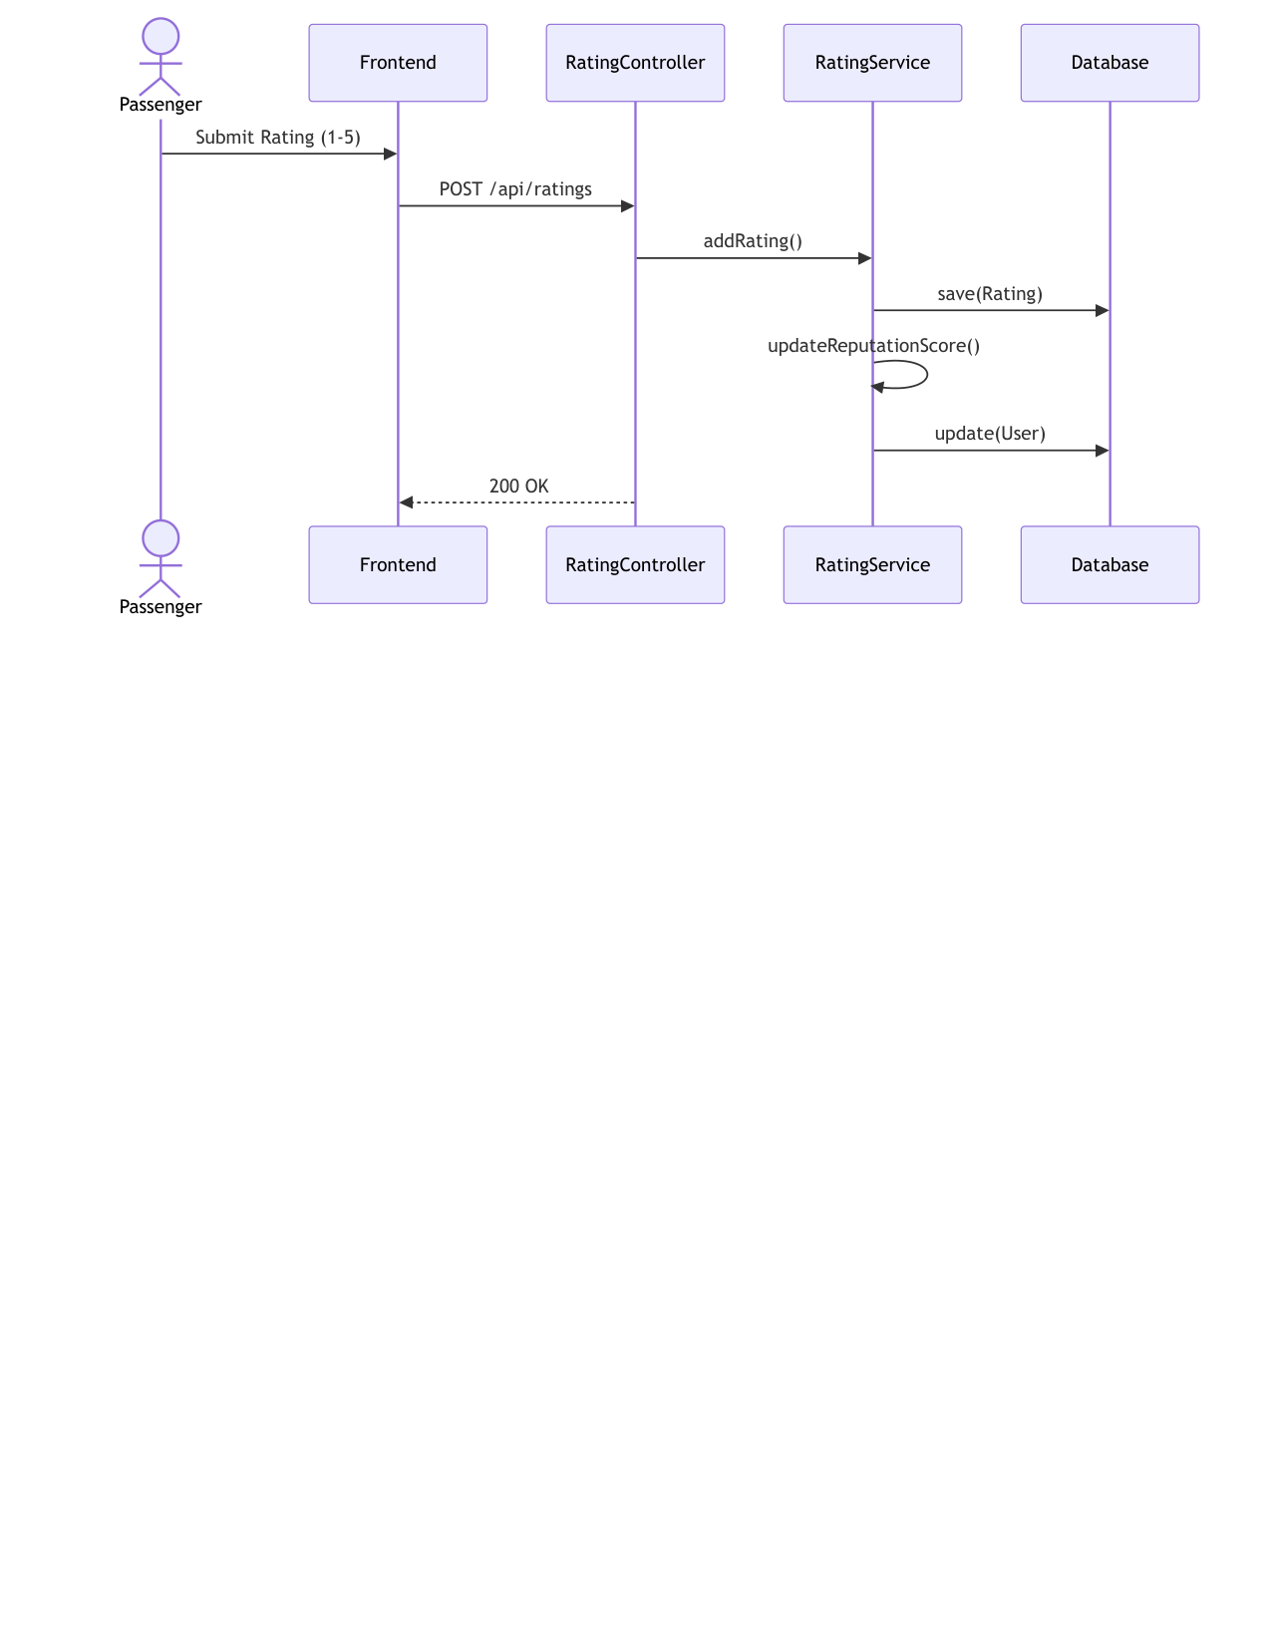
Figure 16 — Sequence/activity view — rating and reputation update (FR-10, FR-11)
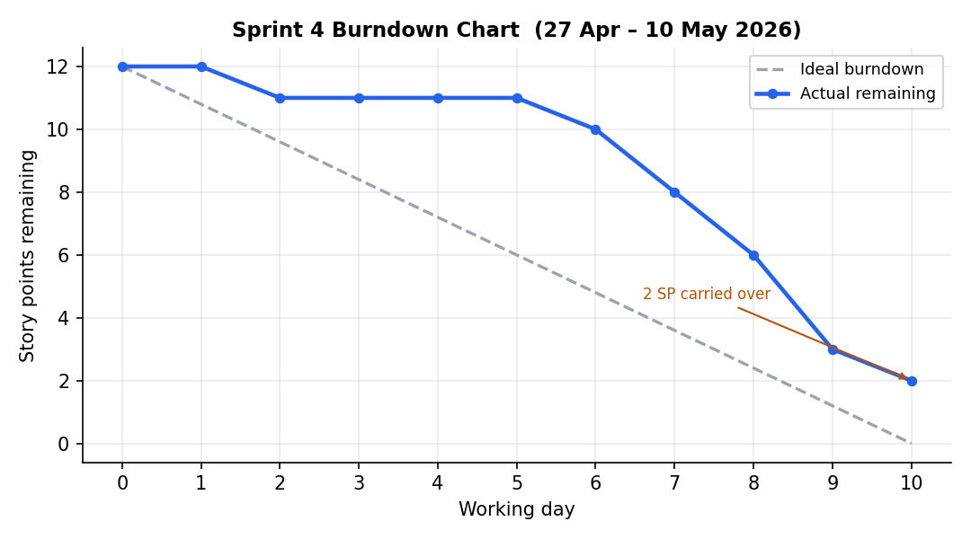
Figure 17 — Sprint 4 burndown chart
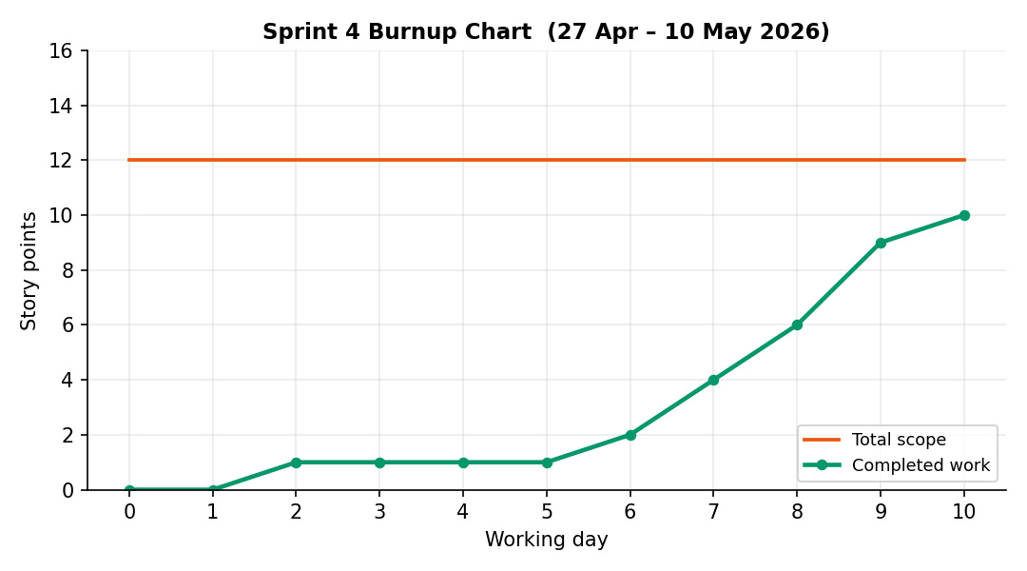
Figure 18 — Sprint 4 burnup chart

Sprint 5 — Authentication and Single-Page Application (11–24 May 2026)

Planning
Sprint goal. Give the platform real users and a complete UI: salted-hash authentication, role registration, and dashboards for both roles.
User story US-5.1 — Register and log in. As a commuter or car owner, I want to register (with my vehicle, if driving) and log in securely, so that I can use my role's dashboard.
Acceptance criteria (traces to FR-1, FR-2, FR-3, NFR-2):
  - BCrypt with per-user salt; no plaintext at rest.
  - Driver registration validates capacity 1–8 and creates user+vehicle atomically.
  - Distinct 404/401 error paths without credential leakage.
User story US-5.2 — Role dashboards. As a user, I want a dashboard tailored to my role, so that every goal is reachable without page reloads.
Acceptance criteria (traces to NFR-7):
  - Passenger: search, book, manage bookings, rate.
  - Driver: publish trips, manage rides/requests, directory, rate.
  - Session survives refresh; logout clears it.

Implementation
Completed backlog items:
- PB-9 auth endpoints with jBCrypt; PB-10 full SPA (index.html/css/js): auth screens, role navigation, dashboards, tables, modals, planner view.
Major achievements:
- Security baseline reached (NFR-2): hashing + validation on both endpoints and entities.
- SPA delivered with zero frameworks — a deliberate MVC-view demonstration (~2 100 lines of JS).
Challenges and impediments:
- Session handling without a session framework: settled on localStorage profile + server-side verification per sensitive call, accepting course-scope limits (full Spring Security noted as roadmap).
- Keeping the SPA maintainable required disciplined function-per-view structure.

Testing
- Auth happy/negative paths automated (register duplicates, wrong password, missing fields).
- Cross-browser manual pass of every view (Chrome/Edge).

Review
- Increment demonstrated: full user journey from registration to booking in the browser.
- 26/26 SP delivered, including the 2 SP tier-mapping story carried over from Sprint 4.

Retrospective
What went well:
- Early validation annotations from Sprint 1 caught most bad input for free in the UI flows.
What to improve:
- UI code volume justifies at least smoke-level automated UI checks (accepted as debt, documented).
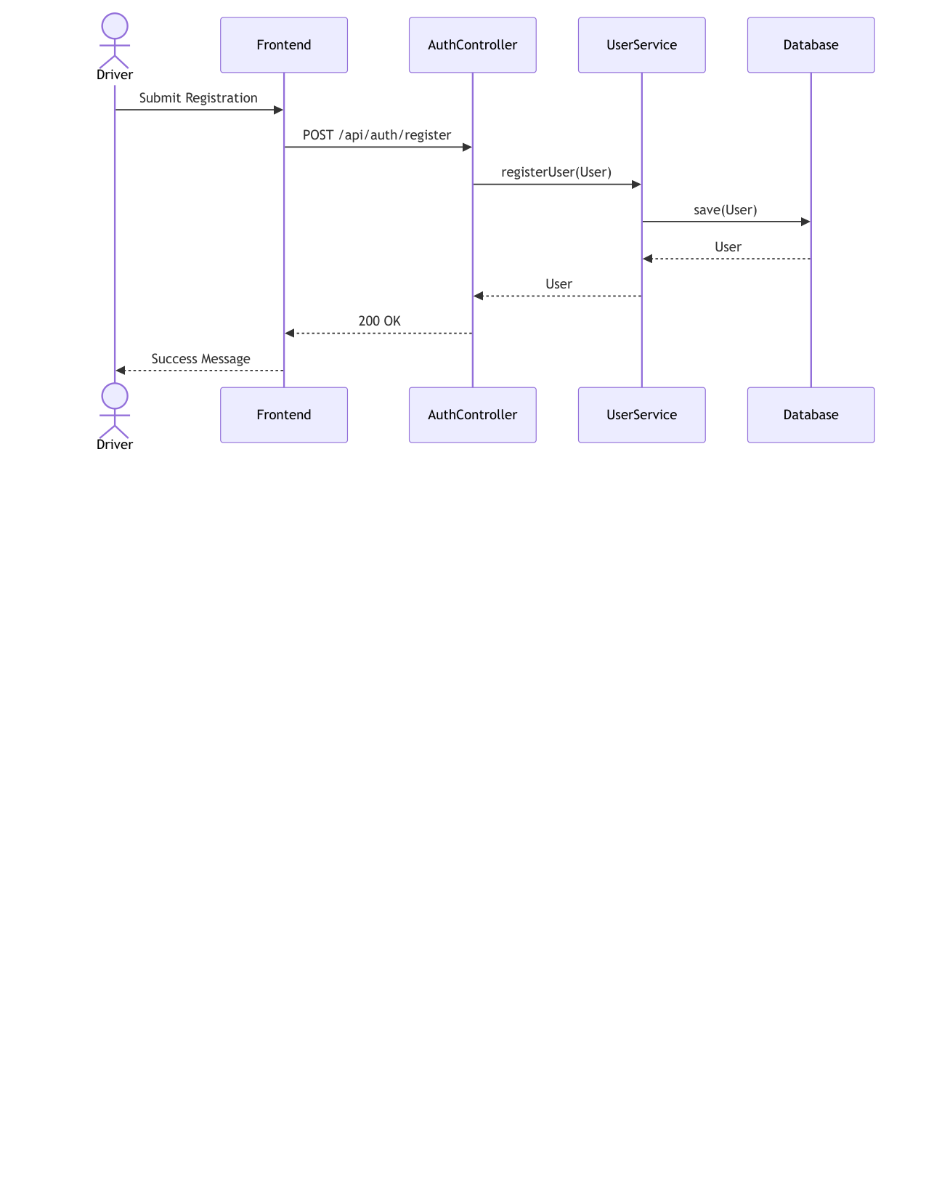
Figure 19 — Sequence diagram — user registration (FR-1, FR-2)
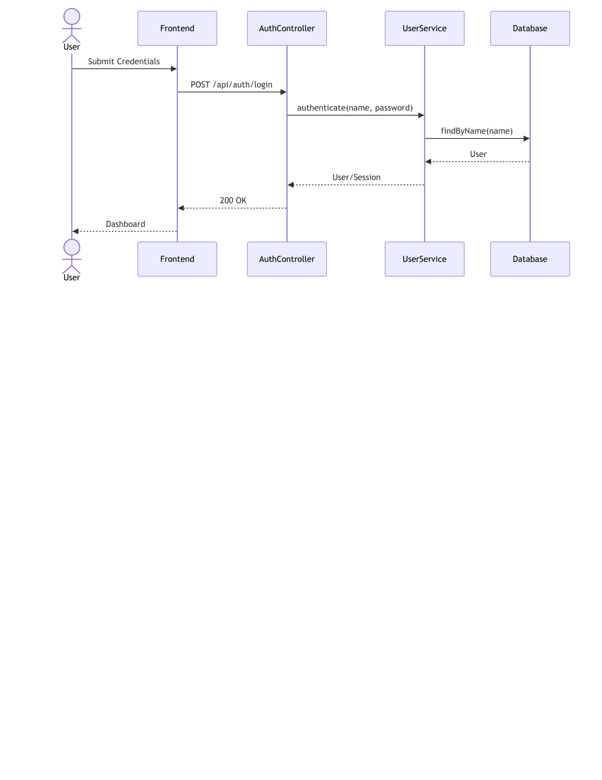
Figure 20 — Sequence diagram — login with BCrypt verification (FR-3)
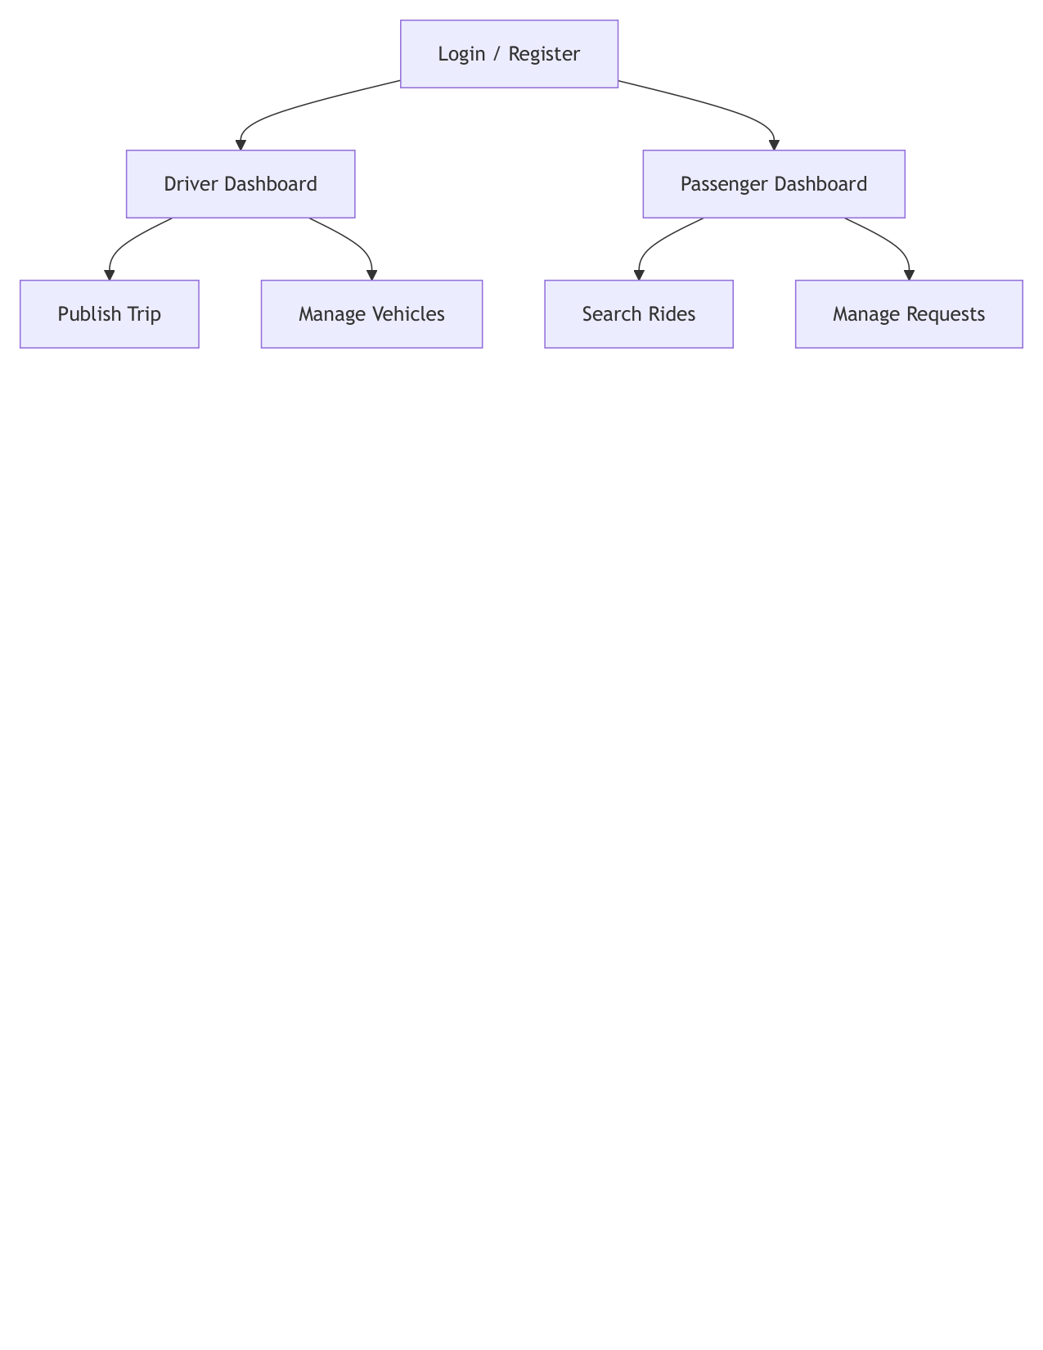
Figure 21 — UI flow of the single-page application (NFR-7)
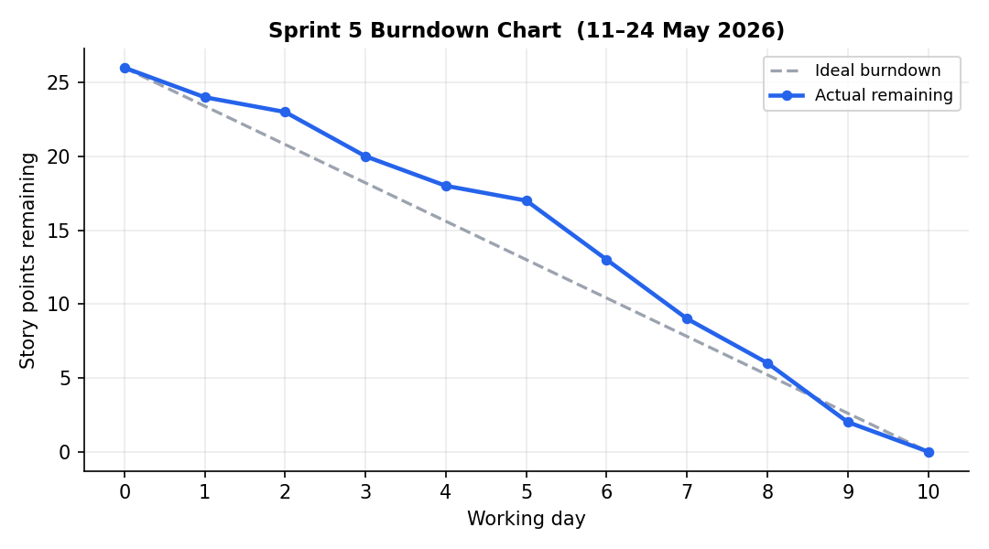
Figure 22 — Sprint 5 burndown chart
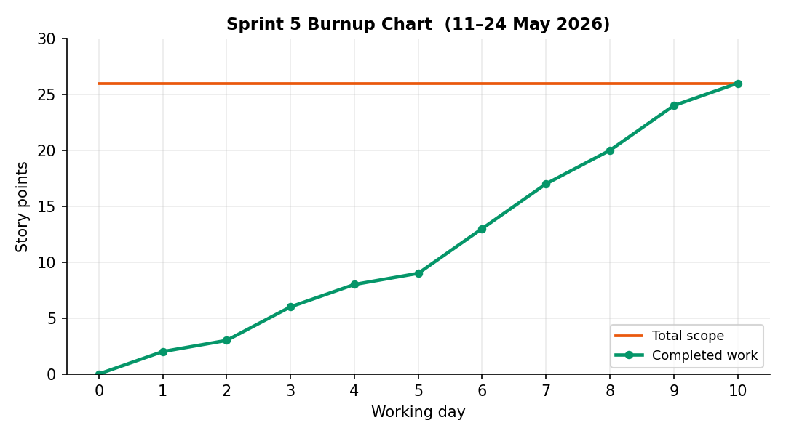
Figure 23 — Sprint 5 burnup chart

Sprint 6 — Quality Hardening, CI/CD and Coverage (25 May – 7 Jun 2026)

Planning
Sprint goal. Turn correctness into a machine-checked property: integration suite on an isolated profile, coverage measurement, and a CI pipeline gating every push.
User story US-6.1 — Integration regression suite. As the developer, I want an end-to-end suite exercising every endpoint including error branches, so that regressions are caught automatically.
Acceptance criteria (traces to NFR-4):
  - Dedicated H2 test profile, zero external dependencies.
  - Happy paths + validation/error branches for every controller.
  - Suite runs headless via mvn test.
User story US-6.2 — Continuous integration. As the developer, I want every push built and tested automatically, so that main is always releasable.
Acceptance criteria (traces to NFR-4, NFR-2):
  - GitHub Actions workflow: JDK 17 build, full test run, JaCoCo report.
  - Failing tests block the merge mindset (red pipeline = stop).

Implementation
Completed backlog items:
- PB-11 IntegrationCoverageTest (60 ordered tests over TestRestTemplate) + service unit suites; PB-12 GitHub Actions pipeline; JaCoCo 84 % line coverage.
Major achievements:
- 76 automated tests at sprint close; coverage 84 % exceeded the NFR-4 target.
- Mockito SpyBean fault injection proved the Maps-API failure path (NFR-5) without network access.
- CI became the de-facto reviewer for a solo developer (Section 2.3).
Challenges and impediments:
- Ordered integration tests share state by design (registration → trip → booking chain); documented the tradeoff explicitly.
- ByteBuddy/JDK compatibility for mocking needed the experimental flag on newer JDKs.

Testing
- This sprint is testing: suite composition, coverage measurement, CI wiring; JaCoCo HTML reports reviewed per package.

Review
- Increment: green pipeline badge on the repository; coverage artifact per build.
- 17/17 SP delivered; first report (v1) compiled and submitted alongside.

Retrospective
What went well:
- Fault injection via spies found dead error-handling code that manual testing never reached.
What to improve:
- The v1 report documented the product but not the process — corrected by restructuring this document around the SDP (v2).
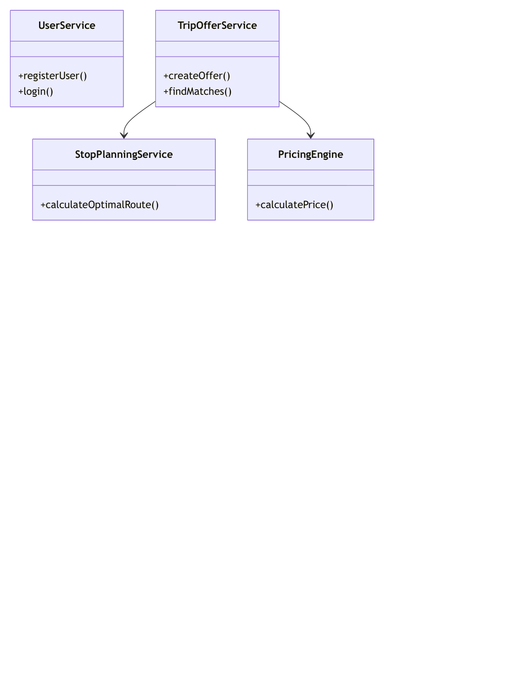
Figure 24 — Service-layer class diagram at the end of Sprint 6
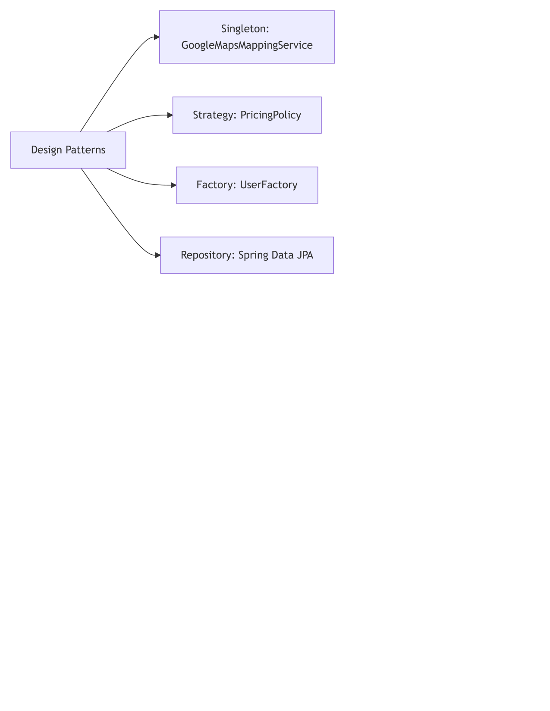
Figure 25 — Design patterns summary after Sprint 6
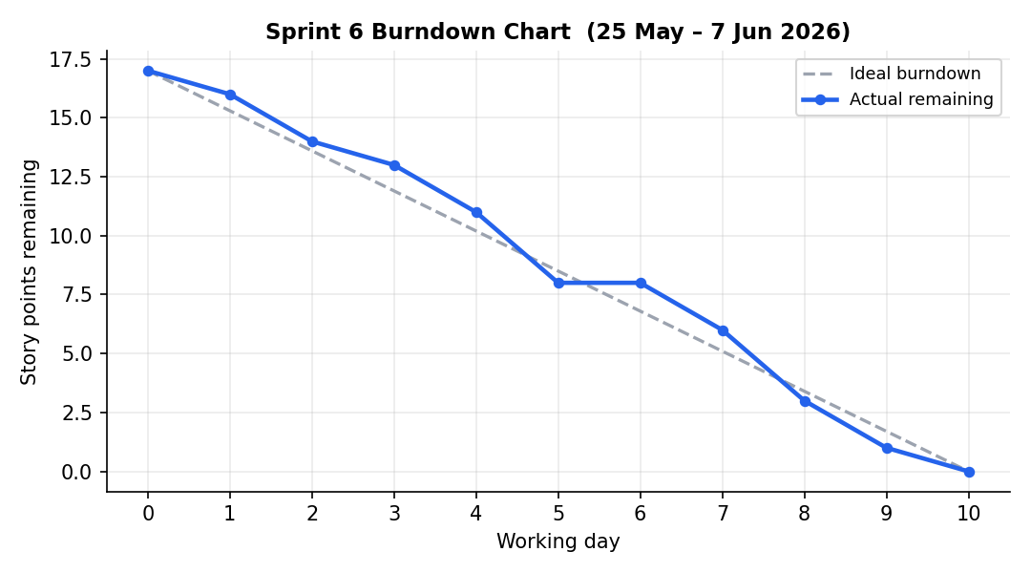
Figure 26 — Sprint 6 burndown chart
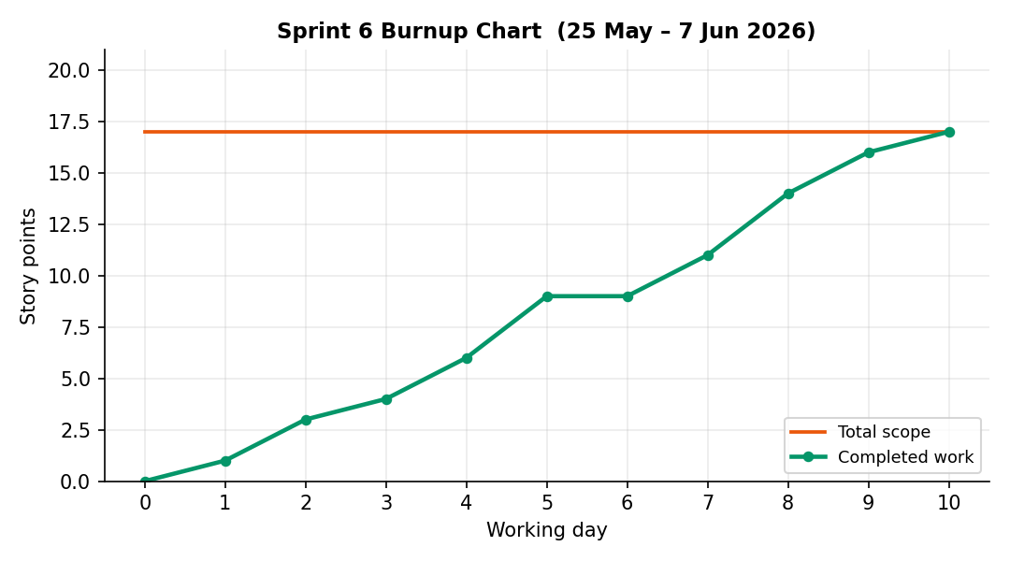
Figure 27 — Sprint 6 burnup chart

Sprint 7 — Revision Sprint: Booking Lifecycle, Notifications, DevOps and Security Hardening (15–28 Jun 2026)

Planning
Sprint goal. Absorb supervisor feedback as a Product Owner re-prioritization: extend the product with booking lifecycle management and a notification centre, harden the delivery pipeline (containerization, secret management, disclosure fixes), and raise the UI to production quality.
User story US-7.1 — Booking lifecycle control. As a driver I want to confirm or decline pending bookings, and as a passenger withdraw mine, so that commitments are explicit until trip completion.
Acceptance criteria (traces to FR-12):
  - Guarded FSM: PENDING→{CONFIRMED,REJECTED,CANCELLED}, CONFIRMED→{CANCELLED,COMPLETED}; terminal states frozen.
  - Illegal transitions → HTTP 409 with a descriptive body.
  - Trip completion closes all CONFIRMED bookings and requests ratings.
  - Status badges and role-appropriate actions in both dashboards.
User story US-7.2 — Notification centre. As a user, I want an unread-badge inbox fed by booking and rating events, so that I notice what concerns me immediately.
Acceptance criteria (traces to FR-13):
  - Observer hooks on booking transitions, new bookings, new ratings.
  - Inbox, unread-count, mark-read, mark-all-read endpoints.
  - SPA bell with 30 s polling and panel rendering.
User story US-7.3 — DevOps & security hardening. As the developer, I want reproducible containerized deployment and zero secrets in the repository, so that the system is portable and safe to publish.
Acceptance criteria (traces to NFR-2, NFR-6):
  - Multi-stage Dockerfile (non-root runtime) + compose with health-checked MySQL.
  - All secrets via environment variables; committed API key revoked and externalized.
  - Password hashes never serialized (write-only property).
  - CI extended: coverage + jar artifacts, Docker image build stage.

Implementation
Completed backlog items:
- PB-13 BookingStatus enum, BookingLifecycleService (explicit guard table), BookingController, SPA status badges and actions; PB-14 Notification entity/repository/service/controller + bell/panel UI; PB-15 Dockerfile, docker-compose, .env.example, externalized configuration, hash-disclosure fix, upgraded workflow.
Major achievements:
- State + Observer patterns added (10 patterns total) with formal transition relation — see Figures 28–29.
- 19 new automated tests (state-machine legality incl. 409 paths, notification flows, runtime-config endpoint) — suite at 95 tests.
- Three latent defects found and fixed during hardening: a UTF-16-encoded CSS tail silently breaking dashboard styles; date-rotted test fixtures (hardcoded June 2026 dates violating @FutureOrPresent after June 20); BCrypt hashes exposed by user-listing endpoints.
Challenges and impediments:
- Retrofitting lifecycle status onto existing bookings without breaking the Sprint 2 flow: solved by defaulting new requests to PENDING and auto-confirming paid bookings.
- MySQL reserves READ: the notification read flag maps to column is_read.

Testing
- BookingLifecycleIntegrationTest: 18 ordered tests — every legal transition, every illegal transition class (409), trip completion, inbox lifecycle, rating-notification propagation; plus a direct guard-table unit check and a runtime-config check.
- Full regression: 95/95 green locally and in CI.

Review
- Increment demonstrated: confirm/decline/withdraw/complete round-trip with live badge updates and notifications.
- 23/23 SP delivered (scope +2 SP on day 4 after refining US-7.3 with the disclosure fix).

Retrospective
What went well:
- Feedback-to-backlog conversion worked exactly as Scrum intends; the layered architecture absorbed two new subsystems without touching the matcher or pricing code.
What to improve:
- Time-dependent test data must always be generated relative to now — adopted as a standing rule.
- Next iteration: Spring Security session management and WebSocket push instead of polling (roadmap).
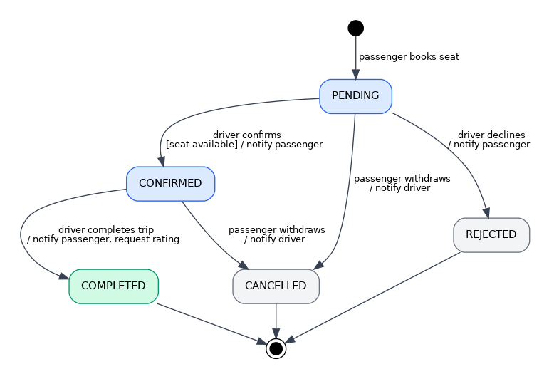
Figure 28 — UML state diagram — booking lifecycle FSM (FR-12)
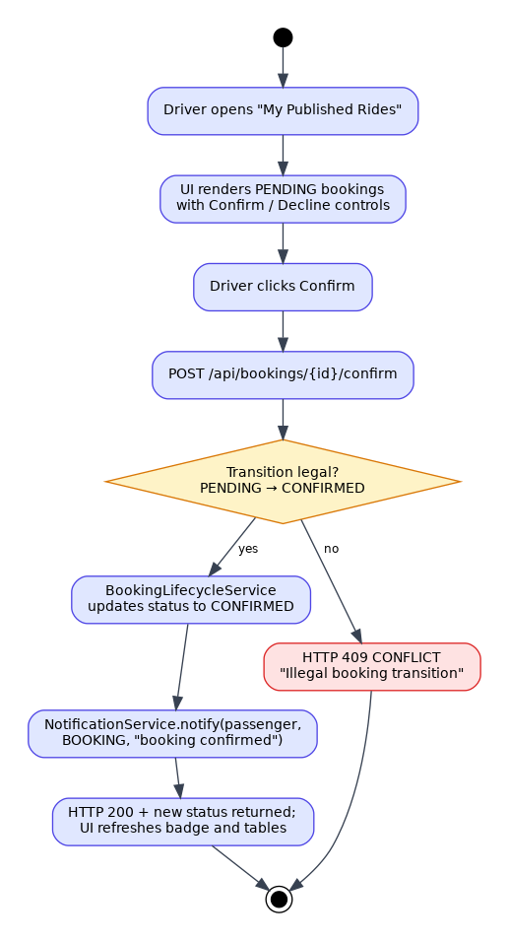
Figure 29 — Activity diagram — booking confirmation with notification (FR-12, FR-13)
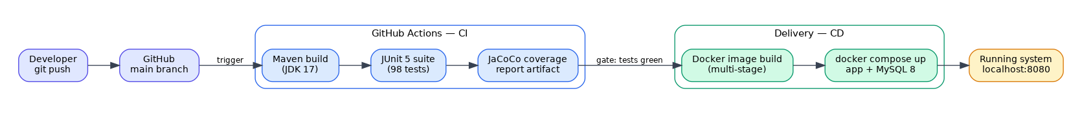
Figure 30 — DevOps delivery pipeline — commit to running system (NFR-6)
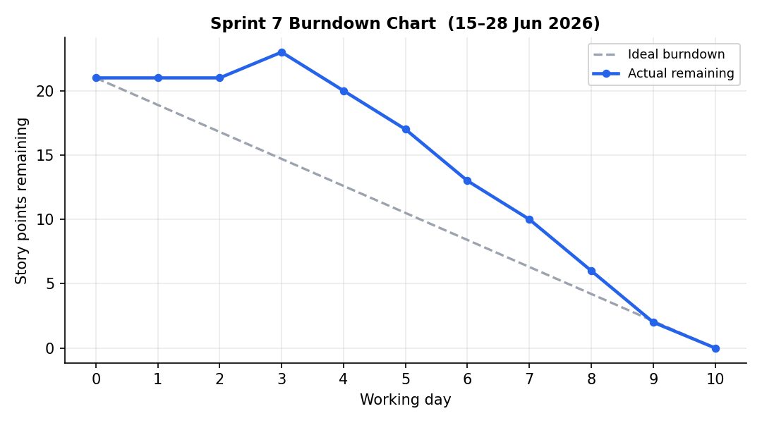
Figure 31 — Sprint 7 burndown chart
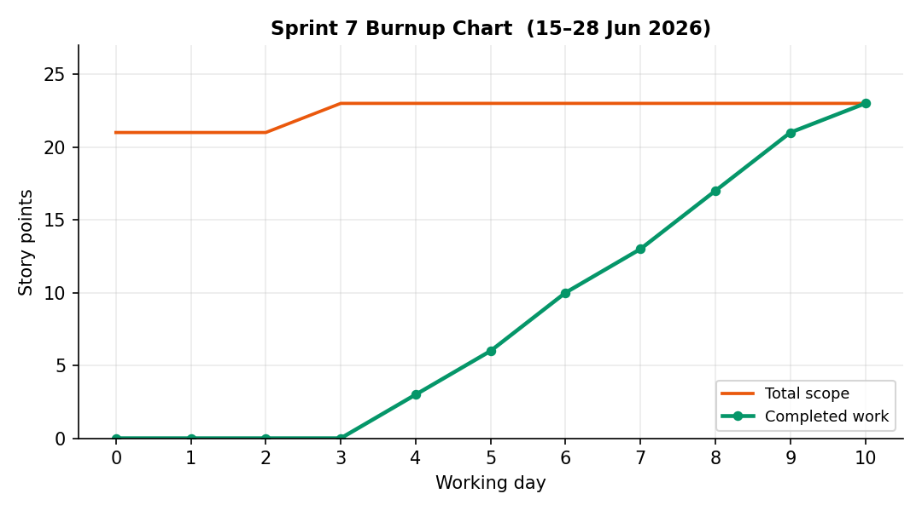
Figure 32 — Sprint 7 burnup chart

Sprint 8 — UI Redesign: Search-First Information Architecture and UX Hardening (29 Jun – 5 Jul 2026 (one-week sprint))

Planning
Sprint goal. Replace the generic dashboard-centred interface with a task-centred one — passengers land on search, drivers land on their trips — and raise interaction quality to production level.
User story US-8.1 — Task-centred redesign. As a user, I want the app to open on the thing I came to do, so that no clicks are wasted on decorative screens.
Acceptance criteria (traces to NFR-7):
  - Passengers land on Find a Ride (search-first hero); drivers land on My Trips.
  - The two dashboard-home views are removed entirely.
  - Bookings, trips, search results and open requests render as ride cards with route, time, constraints and status chips.
  - Driver decisions (confirm/decline/complete) happen inline on the trip card.
  - Community and Profile are shared views; branding is consistent (RideNDrive everywhere).
User story US-8.2 — UX & rating integrity. As a user, I want a polished, responsive interface and to rate only people I actually rode with, so that the platform feels trustworthy on any device.
Acceptance criteria (traces to FR-10, NFR-7):
  - Rating dropdowns offer only counterparts from COMPLETED bookings (eligibility endpoint).
  - No native browser dialogs: styled toasts and a promise-based confirm modal everywhere.
  - Buttons show loading state and block double submits on slow calls.
  - Layout usable at phone width: off-canvas sidebar, adaptive grids, scroll-safe tables.
  - Notifications show relative timestamps and click through to the related view.

Implementation
Completed backlog items:
- PB-16 rating-eligibility endpoint backed by derived queries + UI wiring; toast/confirm/loading primitives replacing 36 native dialogs; centralized JSON error handling (@RestControllerAdvice); API-key log masking; PB-17 full HTML/CSS rebuild on a token-based design system, card renderers for trips/bookings/requests, role-specific landing views, removal of both dashboard homes.
Major achievements:
- Rating integrity closed end-to-end: eligibility is a database-answered rule, enforced in the UI and verified by tests (FR-10).
- Interface rebuilt without adding any framework — still vanilla HTML/CSS/JS, now ~530 lines of structure and a 570-line design system (was ~600/1300 with dead styles).
- The redesign touched zero backend contracts: the API surface, and therefore all existing tests, remained untouched by the UI rebuild.
- 3 new eligibility tests — suite at 98 tests, all green.
Challenges and impediments:
- Preserving every JavaScript-referenced element ID across a full HTML rewrite required an explicit ID contract inventory first — the redesign was executed against that checklist.
- A one-week sprint forced ruthless scope discipline: visual polish beyond the design tokens was explicitly declared out of scope.

Testing
- 3 new integration tests for the eligibility rule (passenger side, driver side, empty case) — full suite 98/98 green.
- Manual regression walk of every user journey on desktop and phone-width viewports; UI-flow verified against Figure 33.

Review
- Increment demonstrated: both role journeys end-to-end in the redesigned UI, including inline booking decisions and eligibility-filtered rating.
- 14/14 SP delivered in five working days.

Retrospective
What went well:
- The ID-contract inventory made a risky rewrite mechanical.
- Backend/frontend separation paid off exactly as the architecture promised: a full UI replacement with zero backend edits.
What to improve:
- UI work of this size deserves its own automated smoke tests (declared as v2 roadmap debt).
- Design tokens should have existed from Sprint 5 — retrofitting them cost extra effort.
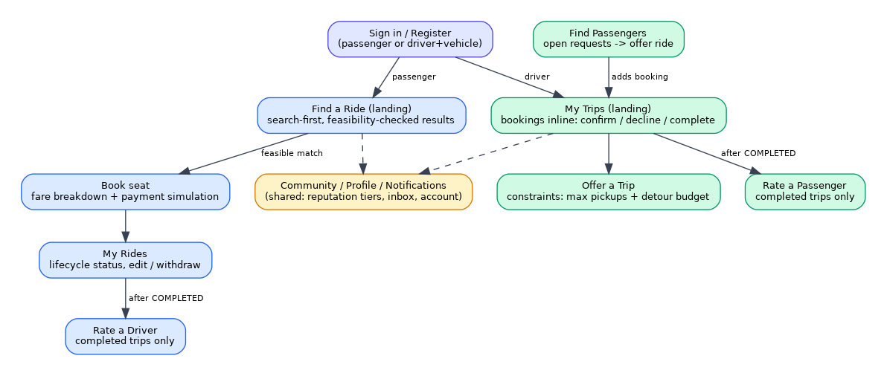
Figure 33 — Redesigned UI flow — task-centred navigation after Sprint 8 (NFR-7)
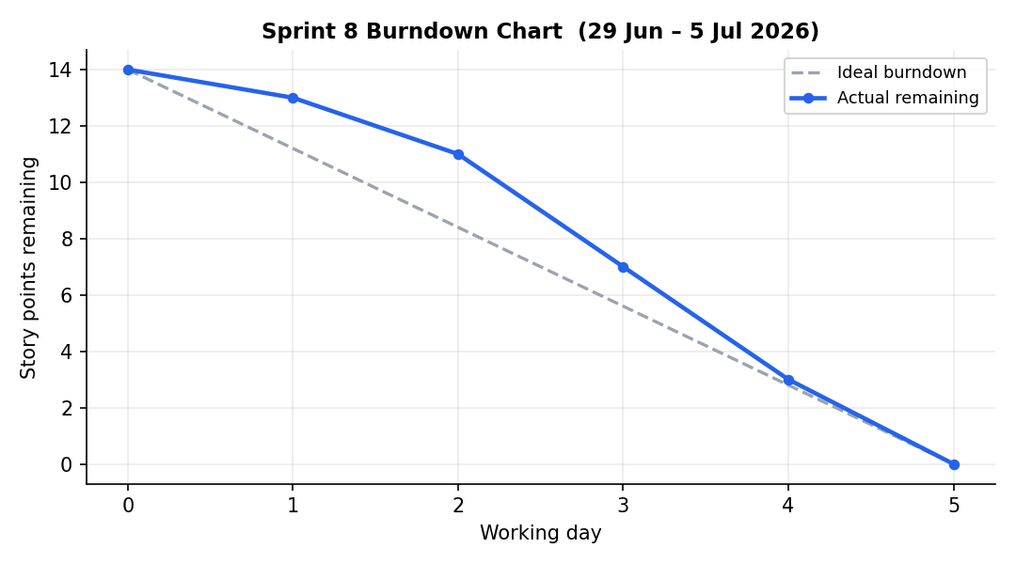
Figure 34 — Sprint 8 burndown chart
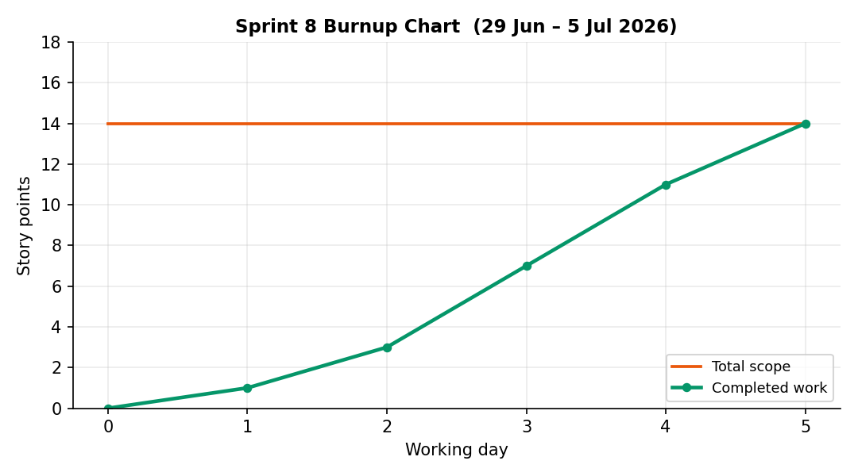
Figure 35 — Sprint 8 burnup chart

7. Software Architecture

7.1 Architectural style and components
The system realizes a client–server, three-tier layered architecture in MVC style. The client is the SPA (View); the server exposes stateless JSON/REST connectors through seven controllers (Auth, User, Vehicle, TripOffer, RideRequest, TripPlanning, Booking, Notification — the routing/pricing orchestration lives in TripPlanningController); the Service layer contains all business logic; the Repository layer abstracts persistence. External connectors: the Google Maps Distance Matrix API behind the MappingService interface (Singleton service, Primary implementation with graceful fallback) and a simulated PaymentService behind an equivalent interface.
Benefits obtained from the style: independent evolvability of the layers (the Sprint 7 subsystems touched no algorithmic code), unit-testability of the core (mocked interfaces), and replaceability of external services. Accepted trade-offs: an in-process monolith (adequate at course scale) and HTTP polling instead of push for notifications.

7.2 Design patterns
# | Pattern | Where | Purpose
1 | Strategy | PricingPolicy implementations | Interchangeable pricing rules
2 | Chain of Responsibility | PricingEngine | Priority-ordered policy pipeline
3 | Repository | Spring Data interfaces | Persistence abstraction
4 | MVC | SPA / Controllers / Model | Web-layer separation
5 | Dependency Injection | Spring IoC everywhere | Loose coupling, testability
6 | DTO | PricingResult, StopSequenceResult | Decouple API shapes from entities
7 | Factory | User creation flows | Role-specific construction
8 | Singleton | GoogleMapsMappingService | Single stateful API client
9 | State | BookingLifecycleService guard table | Formal booking FSM (FR-12)
10 | Observer | NotificationService hooks; rating→reputation propagation | Event-driven decoupling (FR-10/11/13)

7.3 Deployment view
Two deployment configurations exist. Development: Spring Boot embedded server + local MySQL (XAMPP). Production-like: two containers orchestrated by docker compose — the application image (built by the multi-stage Dockerfile, running as a non-root user on a JRE-only base) and mysql:8.0 with a named volume and a health check that gates application startup. Configuration enters exclusively through environment variables (12-factor); the same image runs unchanged in both configurations (NFR-6).

8. Verification and Validation

8.1 Test strategy
Three complementary levels, all executed by mvn test and by CI on every push: unit tests of the algorithmic services with mocked collaborators (matching, pricing, reputation — 15 tests); an ordered end-to-end integration suite driving the real HTTP stack against the H2 profile (60 tests covering every endpoint's happy and error branches, including fault injection of Maps API failures via a Mockito spy); and the Sprint 7 lifecycle/notification/eligibility suite (22 tests) verifying the full state machine — every legal transition, every illegal-transition class as HTTP 409, trip completion semantics, and Observer propagation into the inbox. One context smoke test completes the 98.

8.2 Results and coverage
- 98 automated tests, all green (local and CI); JaCoCo line coverage 84 %, above the ≥ 80 % target of NFR-4;
- requirement coverage: every FR is exercised by at least one named test scenario; the FSM guard table of FR-12 is additionally verified exhaustively at unit level;
- defects found by verification during Sprint 7 hardening: (D1) dashboard CSS silently unparsed due to a UTF-16-encoded file tail — fixed and visually re-verified; (D2) integration fixtures with hardcoded June 2026 dates began violating @FutureOrPresent at persistence after 20 June — replaced by now-relative dates (standing rule adopted); (D3) BCrypt password hashes serialized by user-listing endpoints — fixed with a write-only JSON property and re-tested.

8.3 Validation against user needs
Each sprint review demonstrated the increment against its sprint goal from the user's perspective (Section 6). Final validation walked the complete passenger and driver journeys: register → search (only feasible trips shown) → book (fare with audit trail, payment simulation) → driver confirm → trip completion → rating → reputation/tier update → notifications at every step.

9. Project Closure

9.1 Velocity and delivery
148 story points were delivered over eight sprints (average velocity ≈ 18.5 SP/sprint, ranging from 10 to 26). Velocity was deliberately not smoothed: Sprint 1 paid the framework learning curve, Sprint 2 was the heaviest cycle, and Sprint 4 — colliding with the examination period — is the one sprint whose goal was missed (2 SP carried into Sprint 5 and delivered there). The two scope adjustments (Sprints 2 and 7) were absorbed within their sprints. Total effort tracked ≈ 100 hours, matching the course's individual budget.
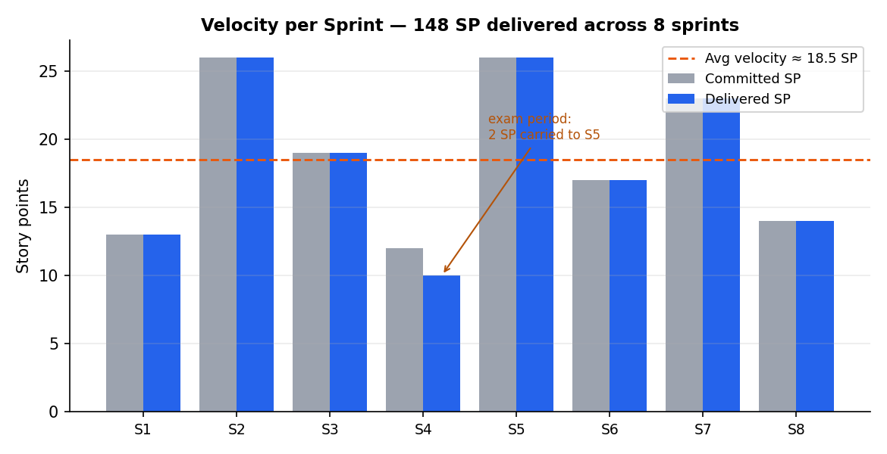
Figure 36 — Velocity per sprint — committed vs delivered story points

9.2 Risk assessment (retrospective)
Risk (identified at outline planning) | Mitigation applied | Outcome
Combinatorial explosion makes matching unusable | Five pruning constraints; lower-bound cut; feasibility-first design | Millisecond planning at course scale (NFR-1 met)
External Maps API unavailability breaks demos/tests | Interface + deterministic local fallback; spy-injected fault tests | Zero external dependency in CI; graceful degradation proven
Solo development loses peer review | CI as automated reviewer; DoD with coverage gate; written ceremonies | 3 latent defects still slipped until Sprint 7 hardening — process improved (D1–D3)
Secrets leakage in a public repository | Externalized configuration; .env excluded; key revocation procedure | Leaked key revoked and externalized in Sprint 7; repository clean
Schedule pressure around the exam session | Two-week cadence with an explicit pause; capacity-aware planning after Sprint 4 | 7 of 8 sprint goals met at first attempt; Sprint 4's 2 SP remainder was delivered in Sprint 5

9.3 Lessons learned
- Organizing work by process (backlog → sprint → increment) produced better engineering than organizing by component: every piece of code exists because a story with acceptance criteria demanded it;
- automation substitutes surprisingly well for a missing team — but only for what it checks: the three D-defects were exactly in the gaps (encoding, time-dependence, serialization) the pipeline did not yet gate;
- interface-first design of external dependencies (maps, payments) is what made 95-test automation possible without any network access;
- supervisor feedback handled as backlog re-prioritization (not as rework) turned criticism into a productive, well-scoped sprint.

9.4 Roadmap (v2)
- Spring Security with server-side sessions/JWT, replacing the course-scope localStorage session;
- WebSocket push for notifications, replacing 30 s polling;
- real payment provider integration behind the existing PaymentService interface;
- live GPS tracking and native mobile clients (declared Won't-have for v1);
- monitoring/alerting to complete the DevOps practice areas (metrics endpoint + dashboards).

9.5 Conclusion
RideNDrive delivers its vision — constraint-aware commuter carpooling with explainable pricing and a working trust loop — through a disciplined Scrum process augmented with DevOps automation: 8 documented sprints, 17 delivered backlog items, 14 uniquely identified functional requirements traced from user story to test, 10 design patterns, 98 automated tests at 84 % coverage, and a one-command containerized deployment. The process, not only the product, is the deliverable of this course — and this report documents both.

Table of Figures
Figure 1 — Layered (three-tier MVC) architecture of RideNDrive
Figure 2 — UML component diagram — modules and their provided/required interfaces
Figure 3 — Use case diagram — Passenger, Driver and external Maps API
Figure 4 — Entity–relationship model of the persistent domain
Figure 5 — UML class diagram — persistent domain model
Figure 6 — Activity diagram — cascading account deletion (FR-4)
Figure 7 — Sprint 1 burndown chart
Figure 8 — Sprint 1 burnup chart
Figure 9 — Activity diagram — DFS stop-sequencing with pruning constraints (FR-7)
Figure 10 — Sequence diagram — search and book ride flow (FR-14, FR-8)
Figure 11 — Sprint 2 burndown chart
Figure 12 — Sprint 2 burnup chart
Figure 13 — Activity diagram — pricing policy chain (FR-9)
Figure 14 — Sprint 3 burndown chart
Figure 15 — Sprint 3 burnup chart
Figure 16 — Sequence/activity view — rating and reputation update (FR-10, FR-11)
Figure 17 — Sprint 4 burndown chart
Figure 18 — Sprint 4 burnup chart
Figure 19 — Sequence diagram — user registration (FR-1, FR-2)
Figure 20 — Sequence diagram — login with BCrypt verification (FR-3)
Figure 21 — UI flow of the single-page application (NFR-7)
Figure 22 — Sprint 5 burndown chart
Figure 23 — Sprint 5 burnup chart
Figure 24 — Service-layer class diagram at the end of Sprint 6
Figure 25 — Design patterns summary after Sprint 6
Figure 26 — Sprint 6 burndown chart
Figure 27 — Sprint 6 burnup chart
Figure 28 — UML state diagram — booking lifecycle FSM (FR-12)
Figure 29 — Activity diagram — booking confirmation with notification (FR-12, FR-13)
Figure 30 — DevOps delivery pipeline — commit to running system (NFR-6)
Figure 31 — Sprint 7 burndown chart
Figure 32 — Sprint 7 burnup chart
Figure 33 — Redesigned UI flow — task-centred navigation after Sprint 8 (NFR-7)
Figure 34 — Sprint 8 burndown chart
Figure 35 — Sprint 8 burnup chart
Figure 36 — Velocity per sprint — committed vs delivered story points

