**PIZZA SALES SQL QUERIES**

# **KPIs:**

**We need to analyse key indicators for our pizza sales data to gain insights into our business performance, for which we want to calculate the following metrics:**

* 1. ***Total Revenue:***

**QUERY:**

**SELECT SUM(TOTAL_PRICE)**

**AS TOTAL_REVENUE**

**FROM pizza_sales;**

**OUTPUT:**



* 1. ***Average Order Value (Rounded to 2 figures):***

**QUERY:**

**SELECT ROUND(SUM(TOTAL_PRICE)/COUNT(DISTINCT(ORDER_ID)),2)**

**AS AVERAGE_ORDER_VALUE**

**FROM pizza_sales;**

**OUTPUT:**



* 1. ***Total Pizzas Sold:***

**QUERY:**

**SELECT COUNT(DISTINCT(PIZZA_ID))**

**AS TOTAL_PIZZAS_SOLD**

**FROM pizza_sales;**

**OUTPUT:**



* 1. ***Total Orders:***

**QUERY:**

**SELECT COUNT(UNIQUE(ORDER_ID))**

**AS TOTAL_ORDERS**

**FROM pizza_sales;**

**OUTPUT:**



* 1. ***Average Pizzas Per Order:***

**QUERY:**

**SELECT ROUND(COUNT(UNIQUE(PIZZA_ID))/COUNT(UNIQUE(ORDER_ID)),2)**

**AS AVG_PIZZAS_PER_ORDER**

**FROM pizza_sales;**

**OUTPUT:**



# **Chart Requirements for Trend Analysis:**

**We would like to visualise various aspects of our pizza sales data to gain insights and understand key trends. We have identified the following requirements for creating charts:**

* 1. ***Daily Trend for Total Orders:* Create a bar chart that displays the daily trend of total orders over a specific time period. This chart will help us identify any patterns or fluctuations in order volumes on a daily basis.**

**QUERY:**

**SELECT TO_CHAR(ORDER_DATE, 'Day') AS Weekday, COUNT(UNIQUE(PIZZA_ID)) AS Orders**

**FROM pizza_sales**

**GROUP BY TO_CHAR(ORDER_DATE, 'Day');**

**OUTPUT:**

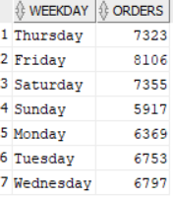

* 1. ***Hourly Trend for Total Orders:* Create a line chart that illustrates the hourly trend of total orders throughout the day. This chart will allow us to identify peak hours or periods of high order activity.**

**QUERY:**

**SELECT SELECT EXTRACT(Hour from ORDER_TIME) AS Hour, COUNT(UNIQUE(PIZZA_ID)) AS Orders**

**FROM pizza_sales**

**GROUP BY EXTRACT(Hour from ORDER_TIME);**

**OUTPUT:**

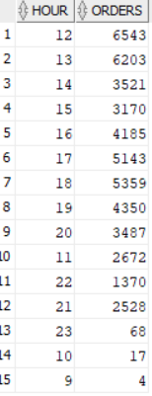

* 1. ***Percentage of Sales by Pizza Category:* Create a pie chart that shows the distribution of sales across different pizza categories. This chart will provide insights into the popularity of various pizza categories and their contribution to overall sales.**

**QUERY:**

**SELECT Pizza_Category AS Category, SUM(Total_Price) AS Total_Sale,**

**ROUND(COUNT(Pizza_category)*100/(SELECT COUNT(Pizza_Category) FROM pizza_sales),2) AS Total_Share_Of_Orders,**

**ROUND(SUM(Total_Price)*100/(SELECT SUM(Total_Price) FROM pizza_sales),2) AS Total_Share_Of_Revenue**

**FROM pizza_sales**

**GROUP BY Pizza_category;**

**OUTPUT:**

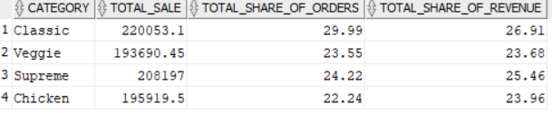

* 1. ***Percentage of Sales by Pizza Size:* Generate a pie chart that represents the percentage of sales attributed to different pizza sizes. This chart will help us understand customer preferences for pizza sizes and their Impact on sales.**

**QUERY:**

**SELECT Pizza_Size AS Pizza_Size,**

**ROUND(COUNT(Pizza_size)*100/(SELECT COUNT(Pizza_size) FROM pizza_sales),2) AS Total_Share**

**FROM pizza_sales**

**GROUP BY Pizza_size;**

**OUTPUT:**

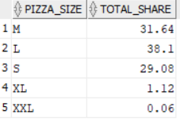

* 1. ***Total Pizzas Sold by Pizza Category:* Create a funnel chart that presents the total number of pizzas sold for each pizza category. This chart will allow us to compare the sales performance of different pizza categories.**

**QUERY:**

**SELECT Pizza_Category AS Category, SUM(Quantity) AS Total_Units**

**FROM pizza_sales**

**GROUP BY Pizza_category;**

**OUTPUT:**

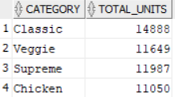

* 1. ***Top 5 Best Sellers by Total Pizzas Sold:* Create a bar chart highlighting the top 5 best-selling pizzas based on the total number of pizzas sold. This chart will help us Identify the most popular pizza options.**

**QUERY:**

**SELECT Pizza_Name AS Name, Sum(Quantity) AS Total_Units**

**FROM pizza_sales**

**GROUP BY Pizza_Name**

**ORDER BY Sum(Quantity) DESC**

**FETCH NEXT 5 ROWS ONLY;**

**OUTPUT:**

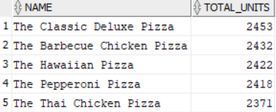

* 1. ***Bottom 5 Best Sellers by Total Pizzas Sold:* Create a bar chart showcasing the bottom 5 worst-selling pizzas based on the total number of pizzas sold. This chart will enable us to identify underperforming or less popular pizza options.**

**QUERY:**

**SELECT Pizza_Name AS Name, Sum(Quantity) AS Total_Units**

**FROM pizza_sales**

**GROUP BY Pizza_Name**

**ORDER BY Sum(Quantity) ASC**

**FETCH NEXT 5 ROWS ONLY;**

**OUTPUT:**

