1. Use a python code to display the following star pattern using the for loop

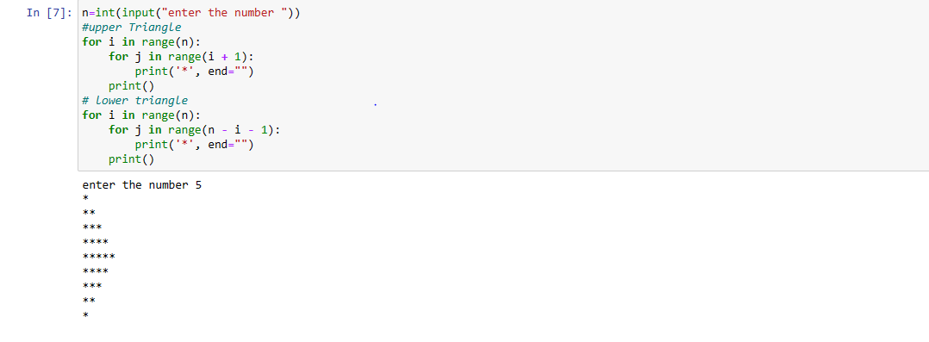

2. Use looping to output the elements from a provided list present at odd indexes. my_list = [10, 20, 30, 40, 50, 60, 70, 80, 90, 100]

3. Write a code that appends the type of elements from a given list. Input x = [23, ‘Python’, 23.98] Expected output [23, 'Python', 23.98] [<class ‘int’>,<class ‘str’><class ‘float’> ]

4. Write a function that takes a list and returns a new list with unique items of the first list. Sample List: [1,2,3,3,3,3,4,5] Unique List: [1, 2, 3, 4, 5]

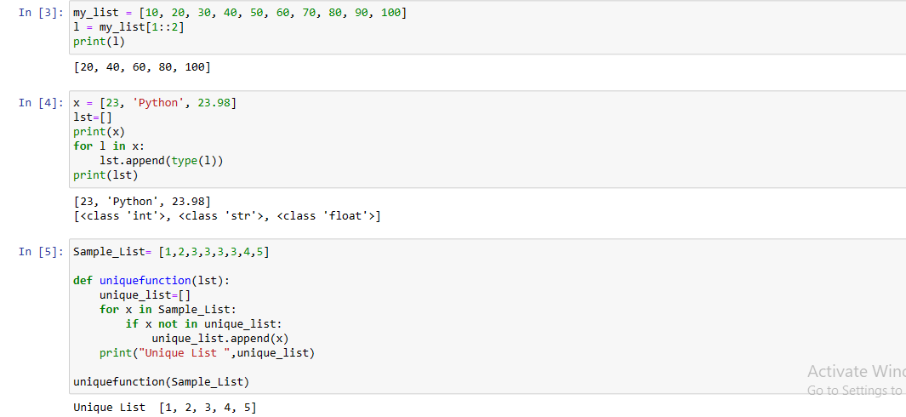

5. Write a function that accepts a string and calculate the number of upper-case letters and lower-case letters. Input String: 'The quick Brow Fox' Expected Output: No. of Upper-case characters: 3 No. of Lower-case Characters: 12

