COMPREHENSIVE DATA ANALYSIS REPORT USING R
Heart Disease Dataset
Week 4 – Final Report
Submitted By:
P. Suprathik Sai
SASTRA University
August 2026

Description
This final report integrates the data cleaning, preprocessing, exploratory analysis, visualization, statistical analysis, and predictive modeling carried out across the previous three weeks using the Heart Disease dataset and the R programming language. The purpose of the final report is to present the complete analytical workflow as one connected study rather than as separate weekly activities. The report therefore begins with the original dataset and follows the progression from data quality checks to exploratory findings, graphical analysis, formal statistical testing, and predictive modeling.
The data preparation stage focused on checking missing values and duplicate observations, examining outliers, standardizing cholesterol values, and converting selected coded variables into factors. Exploratory analysis then summarized the cleaned data using descriptive statistics, frequency tables, and grouped calculations. Visualization was used to communicate distributions, category frequencies, relationships, and unusual values. The report includes the actual graphs produced in the Week 2 analysis, including the age histogram, sex bar chart, target pie chart, age-versus-cholesterol scatter plot, cholesterol box plot, ordered-age line chart, and grouped cholesterol visualization.
The statistical stage used hypothesis testing, Pearson correlation, and the Shapiro-Wilk normality test. Predictive modeling was treated as a binary classification problem, with logistic regression used as an interpretable baseline classifier. The model was evaluated using a train-test split, five-fold cross-validation, a confusion matrix, accuracy, sensitivity, specificity, and balanced accuracy. The final discussion explains what these results mean, identifies strengths and limitations, and recommends possible improvements.
The report also documents challenges and lessons learned from the project. The final objective is to show how a data-driven workflow can turn raw patient records into interpretable evidence while keeping the limitations of the analysis clear. The model is presented as an academic predictive-analysis exercise and not as a clinical diagnostic tool.

Table of Contents
1. Introduction
2. Dataset Overview and Identification
3. Integrated Data Preparation and Cleaning
4. Exploratory Data Analysis
5. Data Visualization
6. Statistical Analysis
7. Predictive Modeling
8. Model Evaluation and Diagnostics
9. Integrated Results and Discussion
10. Practical Implications and Impact
11. Challenges Encountered
12. Lessons Learned
13. Recommendations and Future Work
14. Conclusion
15. References
Appendix A – R Code Summary
Appendix B – GitHub Project Submission

1. Introduction
Data analysis is useful for turning large collections of observations into information that can be interpreted and used for further investigation. In this project, the Heart Disease dataset was analyzed using R from the initial data-quality stage through statistical analysis and predictive modeling. The final report brings the three previous weeks together so that each stage supports the next.
The analysis first establishes that the dataset is suitable for analysis and classification. It then cleans and transforms the data, examines important distributions and relationships, creates visualizations, performs statistical tests, and develops a logistic regression model. The final stage evaluates the model and discusses what can and cannot be concluded from the results.

2. Dataset Overview and Identification
The Heart Disease dataset is a publicly available dataset containing patient-related variables and a binary target representing heart disease status. The variables used throughout the project include age, sex, chest pain type (cp), resting blood pressure (trestbps), cholesterol (chol), fasting blood sugar (fbs), resting ECG (restecg), maximum heart rate (thalach), exercise-induced angina (exang), ST depression (oldpeak), slope, ca, thal, and target.
Dataset source: https://www.kaggle.com/datasets/johnsmith88/heart-disease-dataset
str(heart)
summary(heart)
dim(heart)
names(heart)
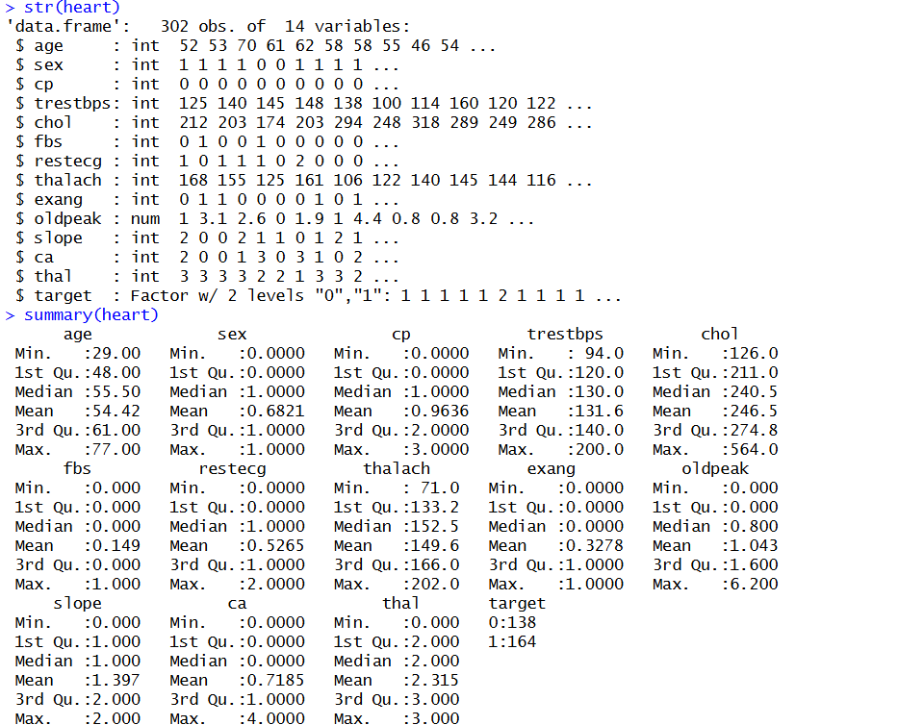
Figure 1. Dataset structure and descriptive summary from the Week 3 report.
The Week 3 output shows the cleaned dataset with 302 observations and 14 variables. The variables include both numeric measurements and coded categorical information, making the dataset appropriate for exploratory analysis and binary classification.

3. Integrated Data Preparation and Cleaning
The first stage of the project concentrated on data quality. Missing values were checked with colSums(is.na()), and the Week 1 output showed zero missing values across the variables. Duplicate records were then checked using duplicated(). The original dataset contained 723 duplicate rows. The duplicate observations were removed using unique(), leaving a cleaned dataset used in the later analysis.
colSums(is.na(heart))
sum(duplicated(heart))
heart <- unique(heart)
dim(heart)
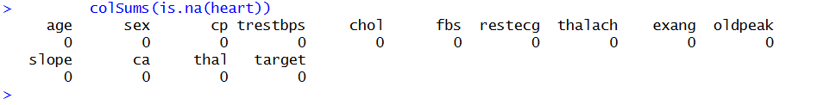
Figure 2. Missing-value check showing zero missing values.
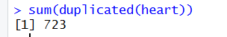
Figure 3. Duplicate-row count showing 723 duplicate records.
The Week 1 report also examined outliers using box plots for age, cholesterol, and resting blood pressure. Cholesterol showed several unusually high observations, while the age distribution did not show the same level of extreme values.
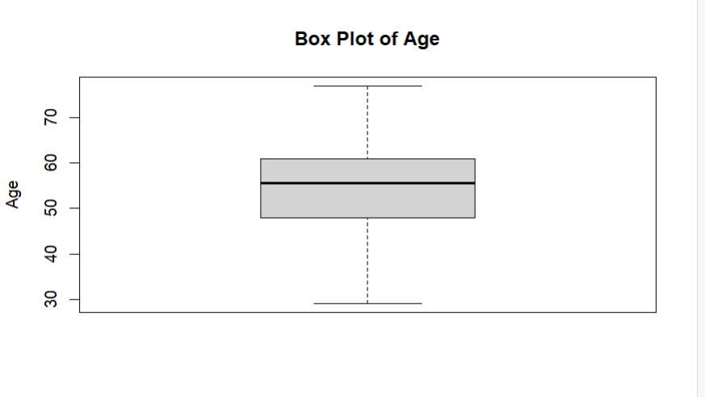
Figure 4. Box plot of age.
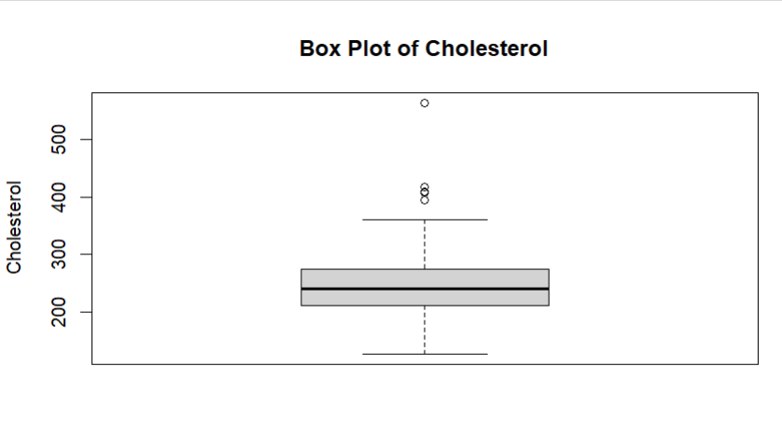
Figure 5. Box plot of cholesterol, showing high-value outliers.
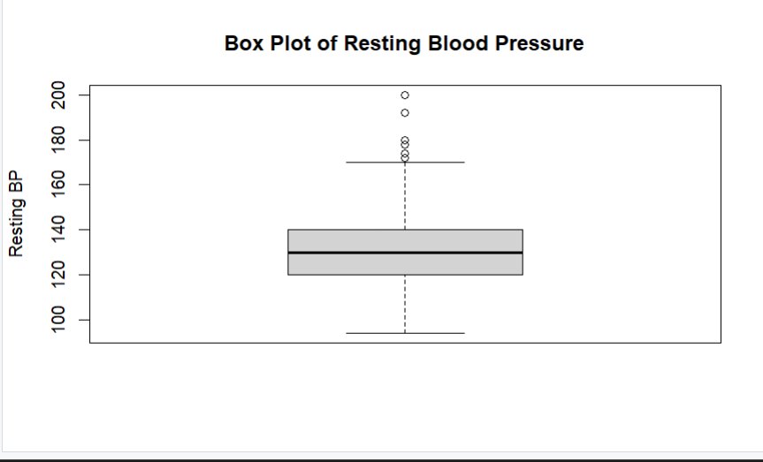
Figure 6. Box plot of resting blood pressure.
For transformation, cholesterol was standardized using scale(), and selected coded variables were converted to factors. These steps make the data more appropriate for statistical analysis and for interpreting categorical variables correctly in R.
heart$chol_normalized <- scale(heart$chol)
heart$sex <- as.factor(heart$sex)
heart$cp <- as.factor(heart$cp)
heart$target <- as.factor(heart$target)

4. Exploratory Data Analysis
Exploratory Data Analysis was used to understand the cleaned dataset before statistical testing and modeling. The summary output gives the minimum, quartiles, median, mean, and maximum for numerical variables. The cleaned data show an average age of about 54 years, average cholesterol of about 246 mg/dL, and average resting blood pressure of about 131 mmHg.
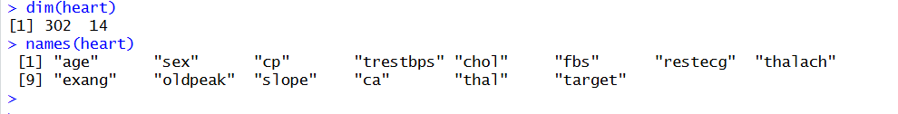
Figure 7. Summary statistics from the cleaned dataset.
Frequency tables were also used to examine the sex and target categories. The Week 1 output contains 96 observations in sex category 0 and 206 in category 1, while the target table contains 138 observations in category 0 and 164 in category 1.
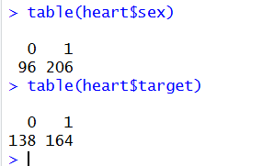
Figure 8. Frequency tables for sex and target.
Grouped analysis was used to compare average age by sex and average cholesterol by target group. The Week 1 aggregate output shows average age values of approximately 55.68 and 53.83 for the two sex categories, and average cholesterol values of approximately 251.09 and 242.64 for the two target groups.
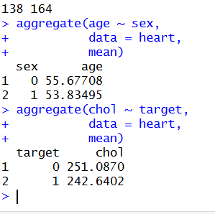
Figure 9. Aggregate calculations for age by sex and cholesterol by target.

5. Data Visualization
Visualization was a major part of Week 2. Different graph types were selected according to the type of variable and the question being examined. The actual graphs from the Week 2 report are included below.

5.1 Histogram – Age Distribution
Purpose: To understand how patient ages are distributed across intervals and identify where observations are concentrated.
hist(heart$age,
main = "Age Distribution",
xlab = "Age",
ylab = "Frequency")
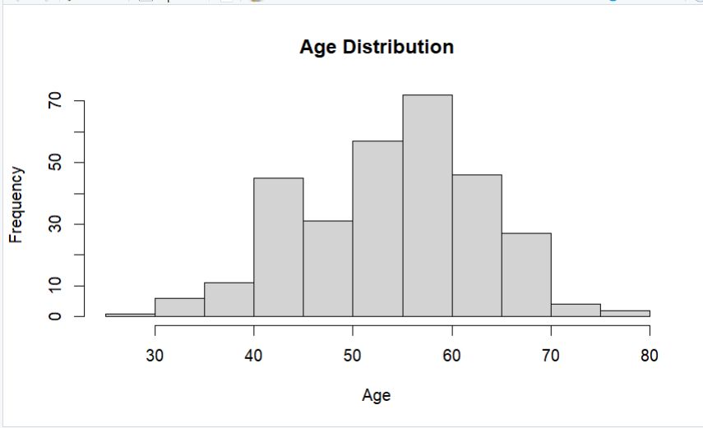
Figure 10. Age distribution histogram.
Interpretation: The observations are concentrated mainly in the middle-age range, with fewer observations at the youngest and oldest ages.

5.2 Bar Chart – Sex Distribution
Purpose: To compare the number of patients in each sex category.
barplot(table(heart$sex),
main = "Gender Distribution",
xlab = "Sex",
ylab = "Number of Patients")
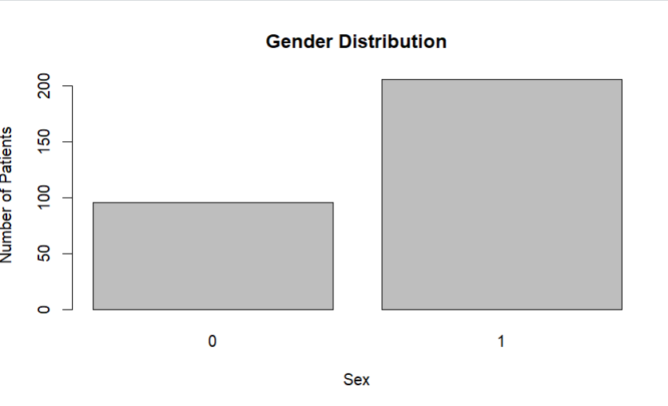
Figure 11. Sex-category bar chart.
Interpretation: The graph makes the difference between the two sex categories easy to compare and shows more observations in category 1.

5.3 Pie Chart – Heart Disease Distribution
Purpose: To show the relative proportion of the two heart disease outcome categories.
pie(table(heart$target),
main = "Heart Disease Distribution")
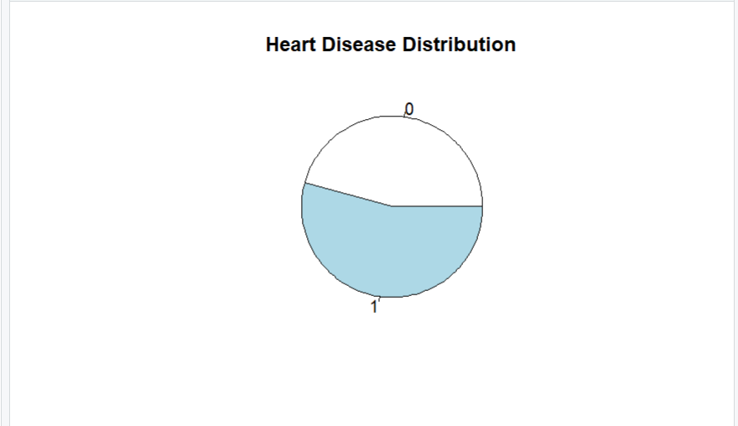
Figure 12. Target-category pie chart.
Interpretation: The pie chart provides a quick visual comparison of the proportions of target categories 0 and 1.

5.4 Scatter Plot – Age vs Cholesterol
Purpose: To visually examine whether age and cholesterol have an obvious linear relationship.
plot(heart$age, heart$chol,
main = "Age vs Cholesterol",
xlab = "Age",
ylab = "Cholesterol")
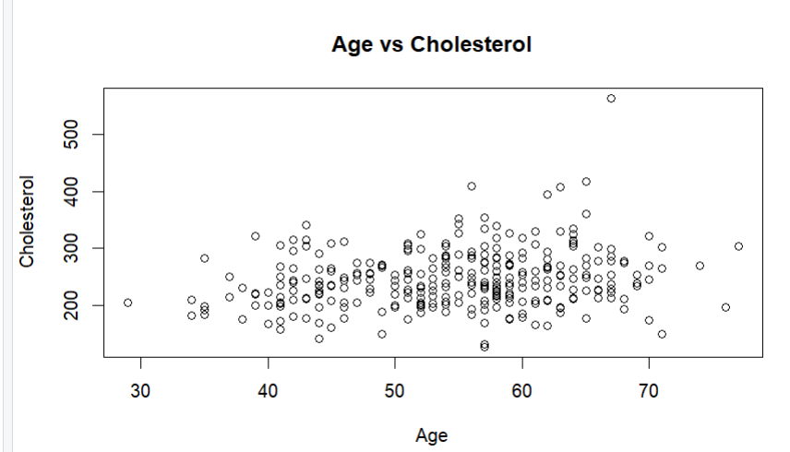
Figure 13. Scatter plot of age versus cholesterol.
Interpretation: The points are widely scattered rather than forming a clear straight-line pattern. The graph therefore does not suggest a strong linear relationship between age and cholesterol.

5.5 Box Plot – Cholesterol Distribution
Purpose: To examine the spread of cholesterol values and identify unusually high or low observations.
boxplot(heart$chol,
main = "Cholesterol Distribution",
ylab = "Cholesterol")
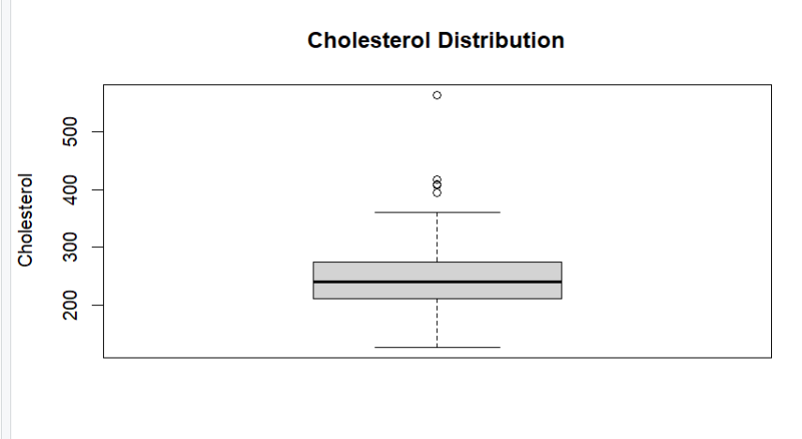
Figure 14. Cholesterol box plot.
Interpretation: The box plot shows the median, middle 50 percent, overall spread, and possible outliers. Several high cholesterol observations lie beyond the main distribution.

5.6 Line Chart – Ordered Age Values
Purpose: To show how age values change when observations are arranged from the lowest to the highest age.
ordered_age <- sort(heart$age)
plot(ordered_age,
type = "l",
main = "Ordered Age Values",
xlab = "Observation Order",
ylab = "Age")
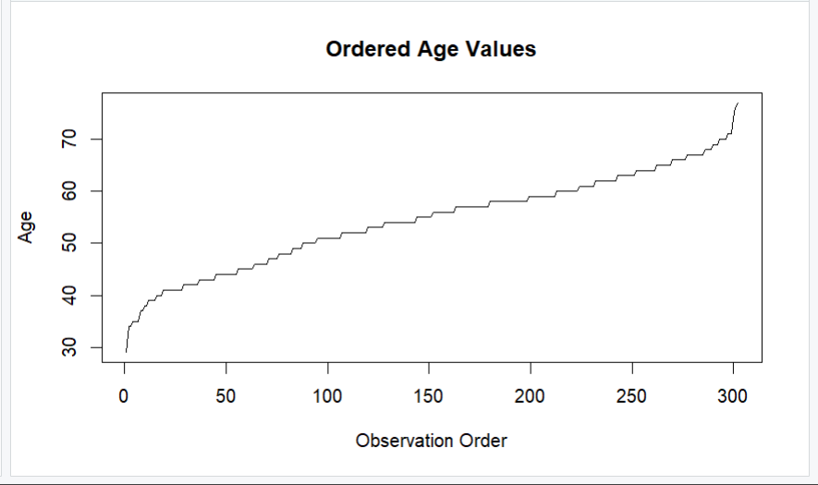
Figure 15. Line chart of ordered age values.
Interpretation: The line rises as the sorted observations move from younger to older patients. Because the observations are ordered rather than time-based, this is not a time-series trend.

5.7 Grouped Visualization – Cholesterol by Heart Disease Status
Purpose: To compare cholesterol distributions between the two target groups using ggplot2.
library(ggplot2)
ggplot(heart, aes(x = target, y = chol)) +
geom_boxplot()
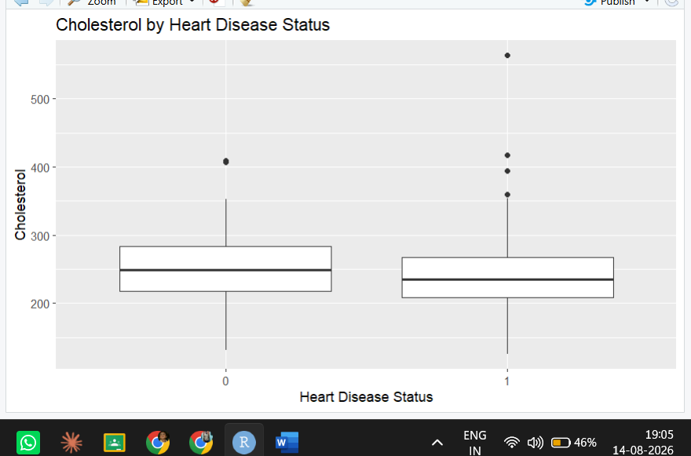
Figure 16. ggplot2 box plot comparing cholesterol by heart disease status.
Interpretation: The grouped box plot allows the distributions of cholesterol in the two target categories to be compared while also showing possible high-value observations.

6. Statistical Analysis

6.1 Hypothesis Testing
A two-sample t-test was used to investigate whether the mean age differs between the two heart disease outcome groups. The null hypothesis states that the mean age is the same for the two target groups, while the alternative hypothesis states that the means are different. The significance level was set at 0.05.
t.test(age ~ target, data = heart)
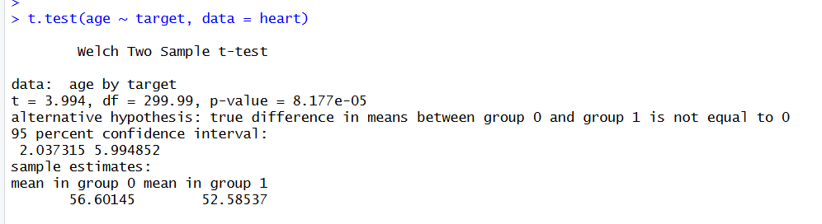
Figure 17. Two-sample t-test output.
The p-value was 8.177e-05, which is less than 0.05. Therefore, the null hypothesis was rejected. The Week 3 report gives mean ages of approximately 56.60 years for group 0 and 52.59 years for group 1, providing statistical evidence that the mean age differs between the two outcome groups.

6.2 Correlation Analysis
Pearson correlation was used to measure the direction and strength of linear relationships among numerical variables. Values close to +1 indicate strong positive relationships, values close to -1 indicate strong negative relationships, and values near zero indicate weak linear relationships. Correlation describes association and does not by itself establish causation.
numeric_data <- heart[sapply(heart, is.numeric)]
cor(numeric_data)
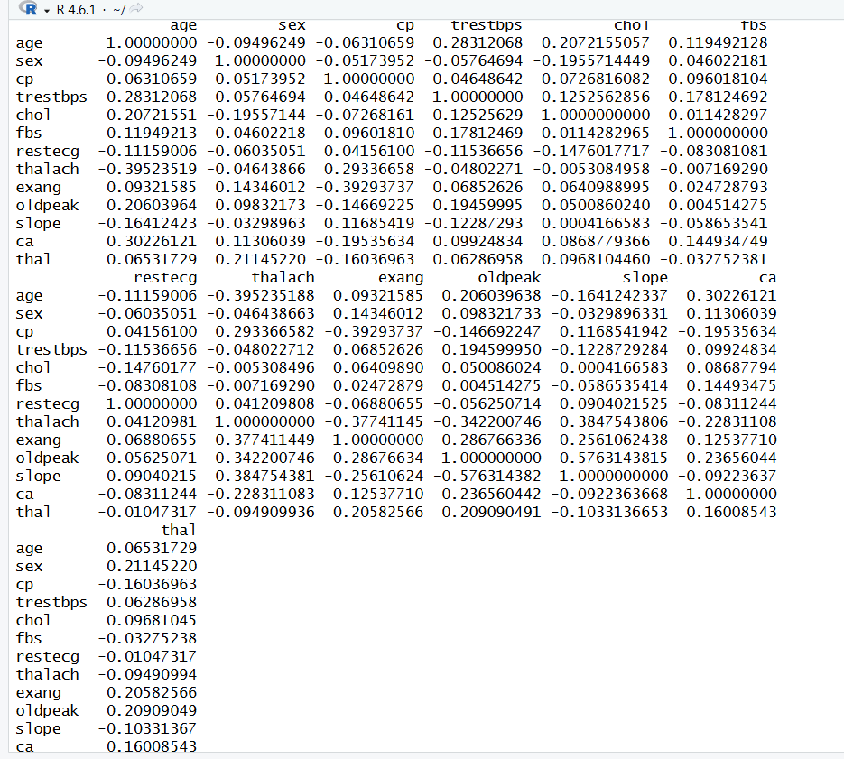
Figure 18. Pearson correlation matrix.
The matrix shows that many relationships are weak to moderate. The analysis is therefore useful for identifying potentially related variables, but correlation alone is not sufficient to claim that one variable causes another.

6.3 Normality Testing
The Shapiro-Wilk test and a Q-Q plot were used to examine whether the age variable follows a normal distribution. The null hypothesis states that age follows a normal distribution.
shapiro.test(heart$age)
qqnorm(heart$age)
qqline(heart$age)
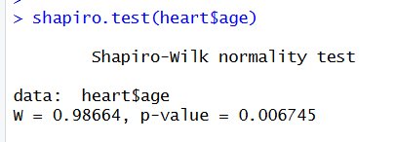
Figure 19. Shapiro-Wilk normality test output.
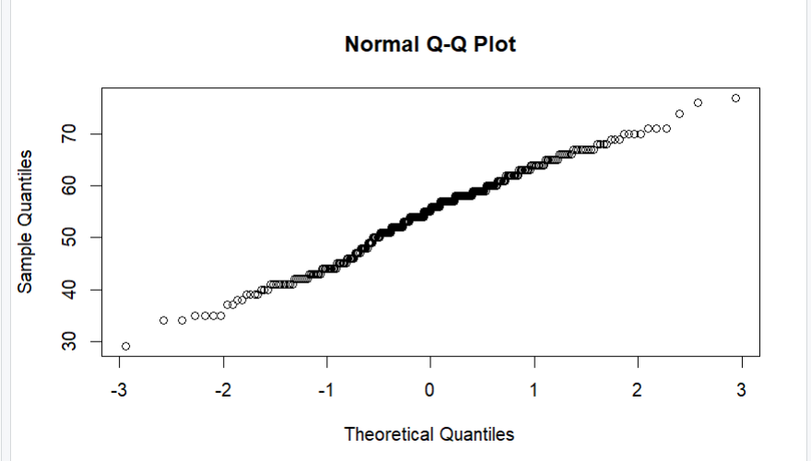
Figure 20. Normal Q-Q plot for age.
The Shapiro-Wilk p-value was 0.006745, which is less than 0.05. Therefore, the null hypothesis was rejected, indicating that age does not follow a normal distribution according to the test. The Q-Q plot provides a visual assessment alongside the formal test.

7. Predictive Modeling
The predictive task was treated as binary classification because the target variable contains two outcome categories. Logistic regression was selected as the baseline model because it is appropriate for a binary outcome and is relatively easy to interpret.
heart$target <- as.factor(heart$target)

7.1 Train-Test Split
set.seed(123)
index <- sample(seq_len(nrow(heart)), size = 0.8*nrow(heart))
train <- heart[index, ]
test <- heart[-index, ]
dim(train)
dim(test)
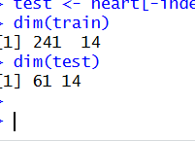
Figure 21. Train-test split output showing 241 training observations and 61 test observations.
The cleaned data were divided into training and testing portions. The training set was used to fit the model, while the test set was held out for evaluation on unseen observations.

7.2 Logistic Regression Model
model <- glm(target ~ age + sex + cp + trestbps + chol + thalach + exang,
data = train, family = binomial)
summary(model)
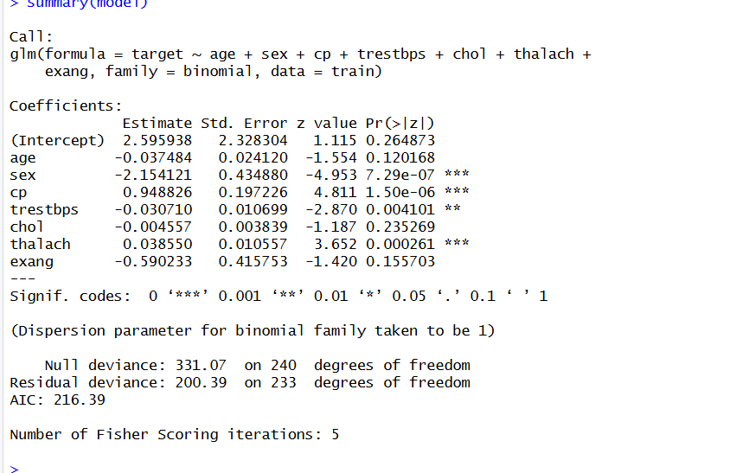
Figure 22. Logistic regression model summary.
The model summary provides coefficient estimates, standard errors, and p-values for the selected predictors. These results can be used to examine the contribution of predictors to the estimated outcome probability.

7.3 Five-Fold Cross-Validation
Five-fold cross-validation was used to obtain a more stable estimate of model performance. The training data were divided into five folds, with each fold used for validation while the remaining folds were used for training.
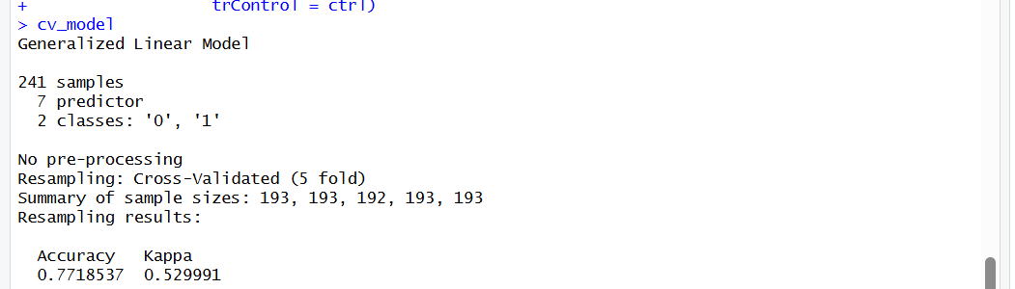
Figure 23. Five-fold cross-validation output.
The Week 3 result reports approximately 77.19% cross-validation accuracy and a Kappa value of approximately 0.53.

8. Model Evaluation and Diagnostics
Predictions on the held-out test data were evaluated using a confusion matrix and standard classification metrics. The test accuracy was approximately 72.13%. Sensitivity was 80.00%, specificity was 64.52%, and balanced accuracy was 72.26%. These values indicate moderate overall classification performance, with higher sensitivity than specificity.
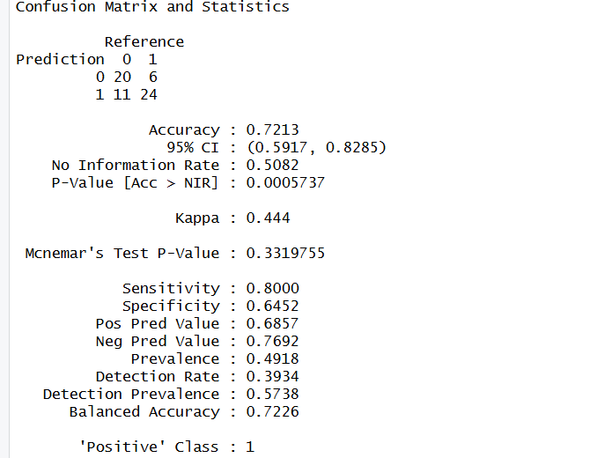
Figure 24. Confusion matrix and classification statistics.
The confusion matrix makes it possible to see correct and incorrect classifications directly. In this analysis, the model identified a relatively high proportion of positive cases, but some negative cases were incorrectly classified as positive.
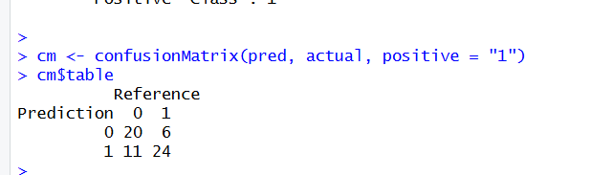
Figure 25. Confusion matrix table.
Model diagnostics were also examined using residual and influence plots. These plots help identify systematic patterns, unusual residual behavior, non-constant variability, and potentially influential observations.
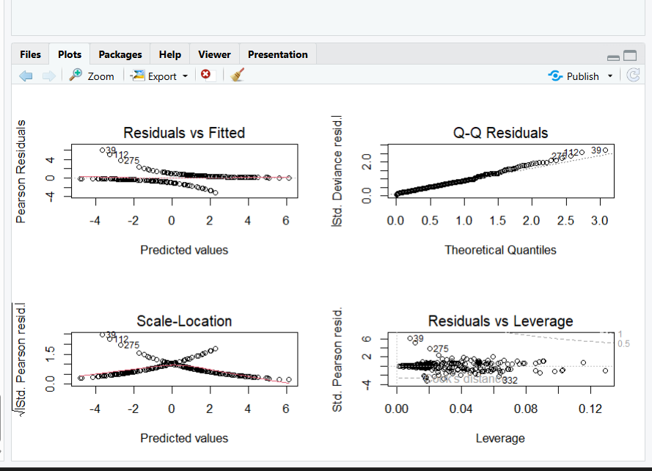
Figure 26. Logistic regression diagnostic plots.

9. Integrated Results and Discussion
When the three weeks of work are considered together, the analysis follows a logical progression. The original dataset was first checked for data-quality issues. Missing-value analysis found no missing values, while the duplicate check identified 723 repeated rows. After duplicate removal, the cleaned dataset contained 302 observations and 14 variables. Outlier analysis showed several unusually high cholesterol values, which were retained as observations rather than automatically deleted.
The visualization stage showed that patient ages were concentrated around the middle-age range, the dataset had more observations in sex category 1, and the two target categories were present in substantial proportions. The scatter plot of age versus cholesterol did not show a strong straight-line pattern. The cholesterol box plot and grouped box plot highlighted high-value cholesterol observations.
The statistical analysis added formal evidence to the exploratory findings. The t-test found a statistically significant difference in mean age between the two target groups. The correlation matrix showed a mixture of weak and moderate linear associations, while the Shapiro-Wilk test indicated that age was not normally distributed.
Finally, logistic regression provided an interpretable baseline classifier. Five-fold cross-validation produced approximately 77.19% accuracy, while the held-out test set produced approximately 72.13% accuracy. The difference between these values also demonstrates why performance should be checked using more than one evaluation procedure.

10. Practical Implications and Impact
The project demonstrates how a structured data-analysis process can help analysts identify patterns in patient data and evaluate whether a predictive model can classify outcomes. Visualization makes distributions and unusual observations easier to communicate, while statistical tests provide formal evidence for selected comparisons. Classification metrics then show how well a model performs on unseen observations.
Because this is an academic analysis of a publicly available dataset, the logistic regression model should not be treated as a clinical diagnostic tool. A real healthcare application would require appropriate clinical variables, larger and independently collected datasets, careful validation, and expert oversight. The practical value of this project is therefore in demonstrating the analytical workflow and the importance of evaluating model limitations.

11. Challenges Encountered
- Handling a dataset with a large number of duplicate observations.
- Distinguishing numerical variables from categorical variables stored as numeric codes.
- Identifying and interpreting outliers without automatically removing valid observations.
- Selecting appropriate graphs for different variable types and analytical questions.
- Understanding the difference between correlation and causation.
- Interpreting p-values, normality tests, and hypothesis decisions.
- Understanding classification metrics such as sensitivity, specificity, and balanced accuracy.
- Interpreting model diagnostics and recognizing that a baseline model can be improved.

12. Lessons Learned
The project provided practical experience with the full R data-analysis workflow. The main lessons were that data should be cleaned before analysis, visualizations should be chosen according to the question being asked, and statistical conclusions should be supported by appropriate tests. The project also showed that model performance cannot be described using accuracy alone. Sensitivity, specificity, balanced accuracy, the confusion matrix, and cross-validation provide a broader view of classification quality.

13. Recommendations and Future Work
- Compare logistic regression with decision trees, random forests, and other classification algorithms.
- Perform feature selection to investigate whether removing weak predictors improves the model.
- Use repeated or stratified cross-validation for more robust performance estimates.
- Tune model parameters for algorithms that support hyperparameter optimization.
- Investigate class balance and apply suitable resampling methods if required.
- Validate promising models using a larger independent dataset.

14. Conclusion
This final report integrated the data cleaning, preprocessing, exploratory analysis, visualization, statistical testing, and predictive modeling completed across the previous three weeks. The Heart Disease dataset was checked for missing values and duplicates, transformed for analysis, and explored using descriptive statistics and visualizations. Statistical tests provided evidence about differences between target groups, relationships among numerical variables, and the distribution of age.
A logistic regression model was then developed as a baseline binary classifier. Cross-validation and test-set evaluation showed moderate performance, with stronger sensitivity than specificity. Overall, the project demonstrates the importance of combining data preparation, visualization, statistical reasoning, and predictive model evaluation rather than relying on a single analytical technique. Future work can improve the analysis by comparing alternative models, selecting features, using stronger validation, and testing performance on independent data.

15. References
1. Kaggle – Heart Disease Dataset: https://www.kaggle.com/datasets/johnsmith88/heart-disease-dataset
2. R Documentation – Statistical Tests and Generalized Linear Models.
3. caret package documentation – Model Training and Classification in R.

Appendix A – R Code Summary
The following are the principal R commands used across the project:
heart <- read.csv("heart.csv")
head(heart)
str(heart)
summary(heart)
dim(heart)
names(heart)
colSums(is.na(heart))
sum(duplicated(heart))
heart <- unique(heart)
boxplot(heart$age)
boxplot(heart$chol)
boxplot(heart$trestbps)
heart$chol_normalized <- scale(heart$chol)
heart$sex <- as.factor(heart$sex)
heart$cp <- as.factor(heart$cp)
heart$target <- as.factor(heart$target)
hist(heart$age)
barplot(table(heart$sex))
pie(table(heart$target))
plot(heart$age, heart$chol)
boxplot(heart$chol)
ordered_age <- sort(heart$age)
plot(ordered_age, type = "l")
numeric_data <- heart[sapply(heart, is.numeric)]
cor(numeric_data)
t.test(age ~ target, data = heart)
shapiro.test(heart$age)
set.seed(123)
index <- sample(seq_len(nrow(heart)), size = 0.8*nrow(heart))
train <- heart[index, ]
test <- heart[-index, ]
model <- glm(target ~ age + sex + cp + trestbps + chol + thalach + exang,
data = train, family = binomial)

Appendix B – GitHub Project Submission
For GitHub submission, the project repository should contain the R scripts used for the analysis, the final Week 4 report, and the graph files used in the report. A README file should briefly explain the project, dataset source, analysis stages, and file organization. The raw heart.csv file should only be uploaded if redistribution is permitted by the dataset license or by the course instructions.
Suggested repository structure:
Heart-Disease-Analysis/
├── README.md
├── R_Code/
│ ├── Week1_Data_Cleaning.R
│ ├── Week2_Visualization.R
│ └── Week3_Statistical_Modeling.R
├── Report/
│ └── Week4_Final_Report.docx
└── Graphs/
├── age_histogram.png
├── sex_barplot.png
├── target_piechart.png
├── age_chol_scatterplot.png
├── cholesterol_boxplot.png
└── grouped_cholesterol.png
GitHub repository link: https://github.com/Suprathik2007

