**WEEK – 2 (PL/SQL programming)**

**HANDS – ON**

**Exercise 1:** Control Structures

**SCENARIO -1 : -**

-- Create MYCUSTOMER table

CREATE TABLE MYCUSTOMER(

    CUSTOMER_ID NUMBER PRIMARY KEY,

    NAME VARCHAR2(100),

    AGE NUMBER CHECK (AGE >= 0)

);

-- Create LOANS table

CREATE TABLE MYLOANS (

    LOAN_ID NUMBER PRIMARY KEY,

    CUSTOMER_ID NUMBER,

    INTEREST_RATE NUMBER(5,2),

    FOREIGN KEY (CUSTOMER_ID) REFERENCES MYCUSTOMER(CUSTOMER_ID)

);

-- Inserting the  sample customer data

INSERT INTO MYCUSTOMER (CUSTOMER_ID, NAME, AGE) VALUES (1, 'Jhonny Depp', 65);

INSERT INTO MYCUSTOMER (CUSTOMER_ID, NAME, AGE) VALUES (2, 'Adam Smith', 45);

INSERT INTO MYCUSTOMER (CUSTOMER_ID, NAME, AGE) VALUES (3, 'Ayan Das', 70);

INSERT INTO MYCUSTOMER (CUSTOMER_ID, NAME, AGE) VALUES (4, 'Ritesh Singh', 20);

INSERT INTO MYCUSTOMER (CUSTOMER_ID, NAME, AGE) VALUES (5, 'Abhay Keshri', 71);

COMMIT;

SELECT * FROM MYCUSTOMER;

-- Inserting sample loan data (linked to customer IDs)

INSERT INTO MYLOANS (LOAN_ID, CUSTOMER_ID, INTEREST_RATE) VALUES (101, 1, 8.5);

INSERT INTO MYLOANS (LOAN_ID, CUSTOMER_ID, INTEREST_RATE) VALUES (102, 2, 9.0);

INSERT INTO MYLOANS (LOAN_ID, CUSTOMER_ID, INTEREST_RATE) VALUES (103, 3, 7.5);

INSERT INTO MYLOANS (LOAN_ID, CUSTOMER_ID, INTEREST_RATE) VALUES (104, 4, 4.5);

INSERT INTO MYLOANS (LOAN_ID, CUSTOMER_ID, INTEREST_RATE) VALUES (105, 5, 6.0);

COMMIT;

SELECT * FROM MYLOANS;

BEGIN

        FOR rec IN (

        SELECT l.LOAN_ID, l.INTEREST_RATE

        FROM MYLOANS l

        JOIN MYCUSTOMER c ON l.CUSTOMER_ID = c.CUSTOMER_ID

        WHERE c.AGE > 60

    )

    LOOP

          UPDATE MYLOANS

        SET INTEREST_RATE = rec.INTEREST_RATE + 1

        WHERE LOAN_ID = rec.LOAN_ID;

    END LOOP;

COMMIT;

END;

/

SELECT * FROM MYLOANS;

**OUTPUT**

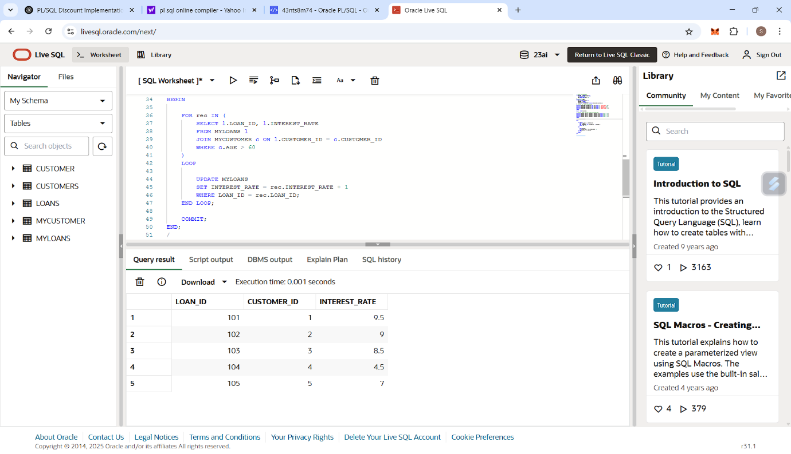

**SCENARIO – 2 :-**

ALTER TABLE MYCUSTOMER ADD (

    BALANCE NUMBER(10, 2),

    ISVIP CHAR(1) DEFAULT 'N'

);

UPDATE MYCUSTOMER SET BALANCE = 12000 WHERE CUSTOMER_ID = 1;

UPDATE MYCUSTOMER SET BALANCE = 8500 WHERE CUSTOMER_ID = 2;

UPDATE MYCUSTOMER SET BALANCE = 15000 WHERE CUSTOMER_ID = 3;

UPDATE MYCUSTOMER SET BALANCE = 25000 WHERE CUSTOMER_ID = 4;

UPDATE MYCUSTOMER SET BALANCE = 9000 WHERE CUSTOMER_ID = 5;

COMMIT;

BEGIN

    FOR cust IN (

        SELECT CUSTOMER_ID, BALANCE FROM MYCUSTOMER

        WHERE BALANCE > 10000

    )

    LOOP

        UPDATE MYCUSTOMER

        SET ISVIP = 'Y'

        WHERE CUSTOMER_ID = cust.CUSTOMER_ID;

    END LOOP;

COMMIT;

END;

/

SELECT CUSTOMER_ID, NAME, AGE, BALANCE, ISVIP FROM MYCUSTOMER;

**OUTPUT**

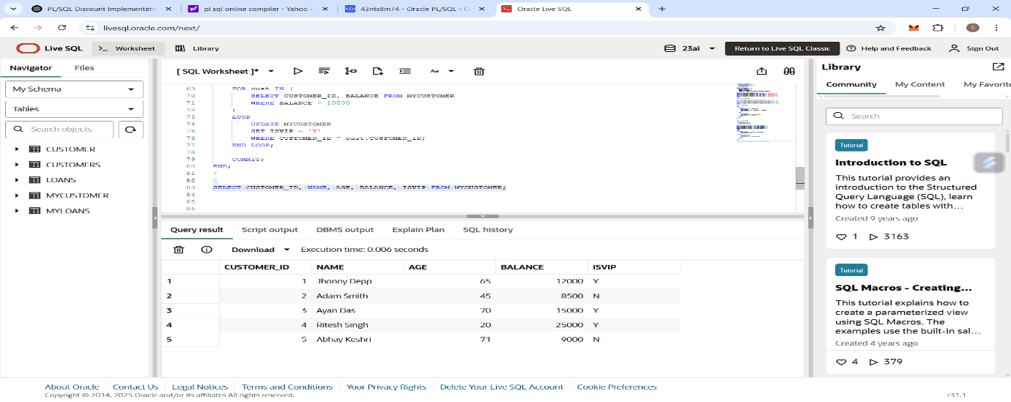

**SCENARIO – 3 :-**

ALTER TABLE MYLOANS ADD (

    DUE_DATE DATE

);

UPDATE MYLOANS SET DUE_DATE = SYSDATE + 10 WHERE LOAN_ID = 101;

UPDATE MYLOANS SET DUE_DATE = SYSDATE + 40 WHERE LOAN_ID = 102;

UPDATE MYLOANS SET DUE_DATE = SYSDATE + 25 WHERE LOAN_ID = 103;

UPDATE MYLOANS SET DUE_DATE = SYSDATE + 35 WHERE LOAN_ID = 104;

UPDATE MYLOANS SET DUE_DATE = SYSDATE + 20 WHERE LOAN_ID = 105;

COMMIT;

BEGIN

   FOR rec IN (

        SELECT l.LOAN_ID, c.NAME, l.DUE_DATE

        FROM MYLOANS l

        JOIN MYCUSTOMER c ON l.CUSTOMER_ID = c.CUSTOMER_ID

        WHERE l.DUE_DATE BETWEEN SYSDATE AND SYSDATE + 30

    )

    LOOP

    DBMS_OUTPUT.PUT_LINE('Reminder: Dear ' || rec.NAME ||

                             ', your loan (ID: ' || rec.LOAN_ID ||

                             ') is due on ' || TO_CHAR(rec.DUE_DATE, 'DD-Mon-YYYY'));

    END LOOP;

END;

/

**OUTPUT**

