**Week – 7**

**REACT HANDS ON**

**9. ReactJS-HOL**

**CODE :**

1. **ListofPlayers.js**

import React from "react";

const ListofPlayers = () => {

const players = [

{ name: "Virat Kohli", score: 95 },

{ name: "Rohit Sharma", score: 88 },

{ name: "KL Rahul", score: 60 },

{ name: "Shreyas Iyer", score: 45 },

{ name: "Hardik Pandya", score: 75 },

{ name: "Ravindra Jadeja", score: 68 },

{ name: "Rishabh Pant", score: 80 },

{ name: "Bhuvneshwar Kumar", score: 50 },

{ name: "Mohammed Shami", score: 72 },

{ name: "Jasprit Bumrah", score: 65 },

{ name: "Yuzvendra Chahal", score: 40 }

];

const filteredPlayers = players.filter(player => player.score < 70);

return (

<div>

<h2>List of All Players</h2>

<ul>

{players.map((player, index) => (

<li key={index}>{player.name} - Score: {player.score}</li>

))}

</ul>

<h2>Players with Score Below 70</h2>

<ul>

{filteredPlayers.map((player, index) => (

<li key={index}>{player.name} - Score: {player.score}</li>

))}

</ul>

</div>

);

};

export default ListofPlayers;

1. **IndianPlayers.js**

import React from "react";

const IndianPlayers = () => {

const players = [

"Virat", "Rohit", "Rahul", "Iyer", "Pandya",

"Jadeja", "Pant", "Kumar", "Shami", "Bumrah", "Chahal"

];

const oddPlayers = players.filter((_, index) => index % 2 !== 0);

const evenPlayers = players.filter((_, index) => index % 2 === 0);

const T20players = ["Virat", "Rohit", "Rahul"];

const RanjiTrophyPlayers = ["Pujara", "Rahane", "Ashwin"];

const mergedPlayers = [...T20players, ...RanjiTrophyPlayers];

return (

<div>

<h2>Odd Team Players</h2>

<ul>

{oddPlayers.map((player, index) => (

<li key={index}>{player}</li>

))}

</ul>

<h2>Even Team Players</h2>

<ul>

{evenPlayers.map((player, index) => (

<li key={index}>{player}</li>

))}

</ul>

<h2>Merged Players (T20 + Ranji Trophy)</h2>

<ul>

{mergedPlayers.map((player, index) => (

<li key={index}>{player}</li>

))}

</ul>

</div>

);

};

export default IndianPlayers;

1. **App.js**

import logo from './logo.svg';

import './App.css';

import React from "react";

import ListofPlayers from "./components/ListofPlayers";

import IndianPlayers from "./components/IndianPlayers";

function App() {

const flag = false; // Change to true to see the other component

return (

<div className="App">

<h1>Cricket App</h1>

{flag ? <ListofPlayers /> : <IndianPlayers />}

</div>

);

}

export default App;

1. **App.css**

.App {

text-align: center;

font-family: Arial, sans-serif;

margin-top: 20px;

}

h2 {

color: #1e90ff;

}

ul {

list-style: none;

padding: 0;

}

.App-logo {

height: 40vmin;

pointer-events: none;

}

@media (prefers-reduced-motion: no-preference) {

.App-logo {

animation: App-logo-spin infinite 20s linear;

}

}

.App-header {

background-color: #282c34;

min-height: 100vh;

display: flex;

flex-direction: column;

align-items: center;

justify-content: center;

font-size: calc(10px + 2vmin);

color: white;

}

.App-link {

color: #61dafb;

}

@keyframes App-logo-spin {

from {

transform: rotate(0deg);

}

to {

transform: rotate(360deg);

}

}

**OUTPUT**

**When flag is false**

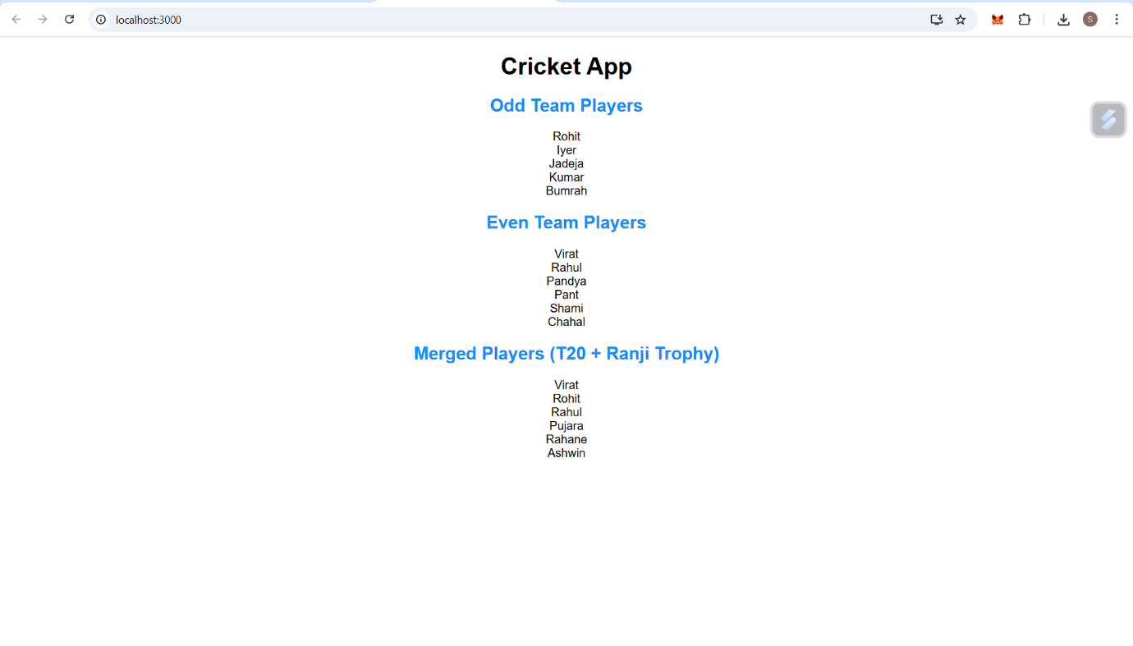

**When flag is true**

