**WEEK – 8**

**HANDS ON**

**2.Git-HOL**

**Explain gitignore :**

It is a **special text file** used in Git to **tell Git which files or folders to ignore** in our repository.

**CODE and OUTPUT:**

**.gitignore file added in my github repository named gitignorePrac(helps in ignoring unwanted files)**

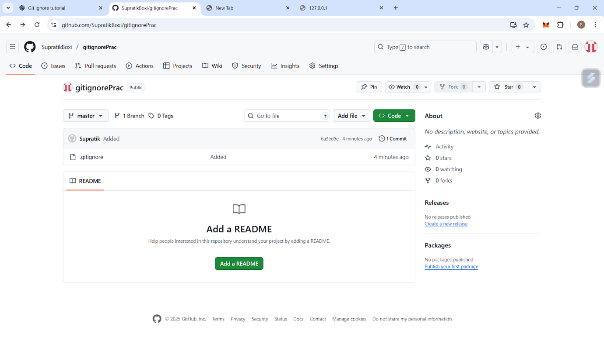

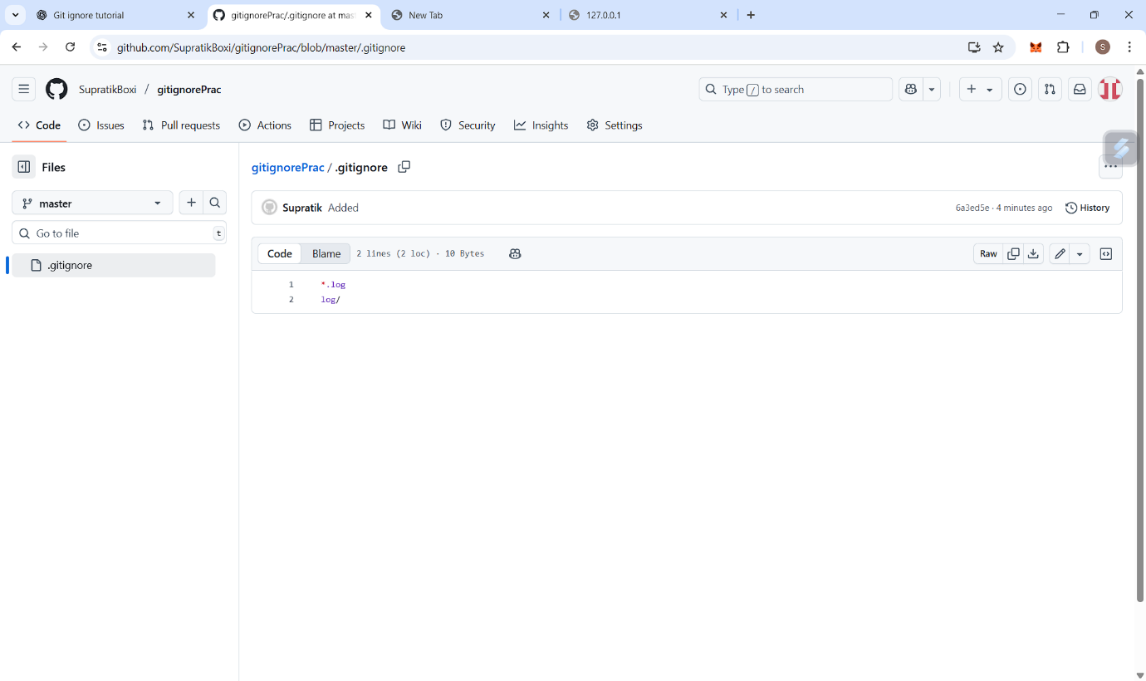

**Git bash commands**

