**Week – 8**

**HANDS ON**

**3.Git-HOL**

**CODE along with OUTPUT :**

**Firstly I have committed README.md into the project then created the new branch and then further proceeded with the assignment as it was mentioned accordingly :**

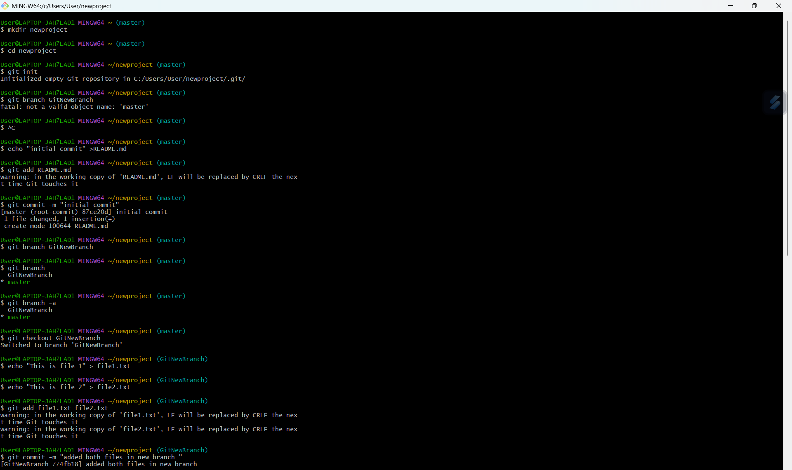

**Here I have used checkout command to switch to master and used mergetool to compare changes between branches :**

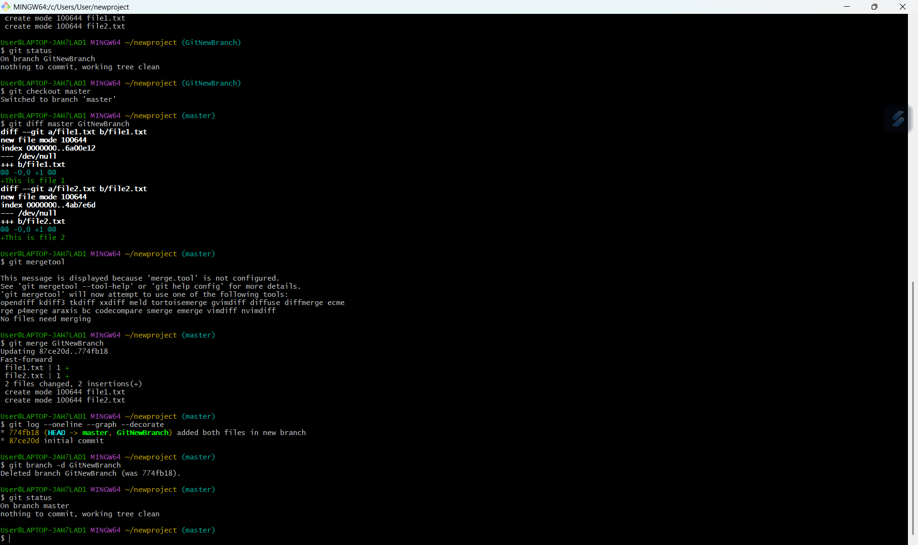

**At the end I have deleted the branch and checked the status :**

