**Week – 8**

**HANDS ON**

**5.Git-HOL**

**CODE WITH OUTPUT :**

Here I have written all the necessary commands that were required to complete the assignment. I Have switched the branch name from master to GIT-T03-HOL_002.

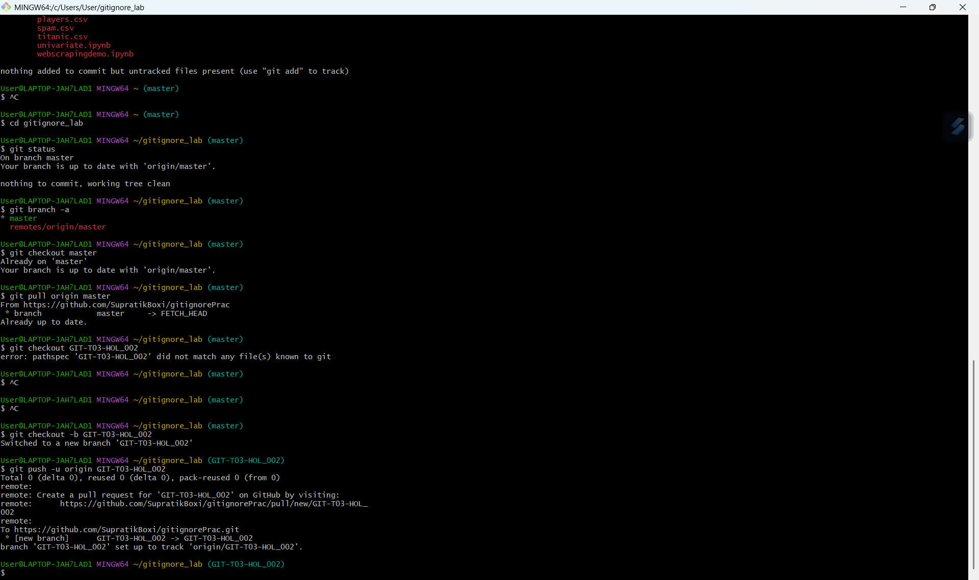

**New branch is added in github as GIT-T03-HOL_002 :**

