QUARY AND OUTPUT LIST

-- 1. Total number of cars in the dataset
SELECT COUNT(*) AS total_cars FROM bmw_cars;
OUTPUT:-
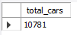
-- 2. Display top 10 most expensive cars
SELECT model, year, price
FROM bmw_cars
ORDER BY price DESC
LIMIT 10;
OUTPUT:-
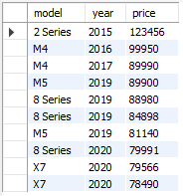
-- 3. Find the average price per model
SELECT model, ROUND(AVG(price),2) AS avg_price
FROM bmw_cars
GROUP BY model
ORDER BY avg_price DESC;
OUTPUT:-
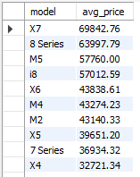
-- 4. Count total cars grouped by fuel type
SELECT fuelType, COUNT(*) AS total
FROM bmw_cars
GROUP BY fuelType
ORDER BY total DESC;
OUTPUT:-
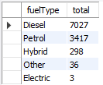
-- 5. Calculate average mileage per year
SELECT year, ROUND(AVG(mileage),2) AS avg_mileage
FROM bmw_cars
GROUP BY year
ORDER BY year DESC;
OUTPUT:-
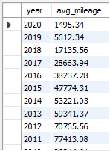
-- 6. Compare each model’s price to the highest priced model in the same year
SELECT
a.model AS model_name,
a.year,
a.price AS model_price,
b.model AS top_model_same_year,
b.price AS top_price_same_year
FROM bmw_cars a
JOIN (
SELECT
year,
MAX(price) AS max_price
FROM bmw_cars
GROUP BY year
) AS max_table
ON a.year = max_table.year
JOIN bmw_cars b
ON b.year = max_table.year
AND b.price = max_table.max_price
ORDER BY a.year DESC, a.price DESC;
OUTPUT:-
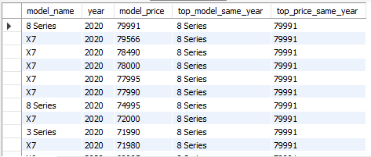
-- 7. Rank models by price within each year
SELECT model,
year,
price,
RANK() OVER (PARTITION BY year ORDER BY price DESC) AS price_rank
FROM bmw_cars
ORDER BY year DESC, price_rank;
OUTPUT:-
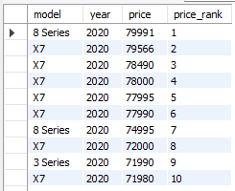

-- 8. Calculate running total of cars over the years
SELECT year,
COUNT(*) AS total_per_year,
SUM(COUNT(*)) OVER (ORDER BY year) AS running_total
FROM bmw_cars
GROUP BY year
ORDER BY year;
OUTPUT:-
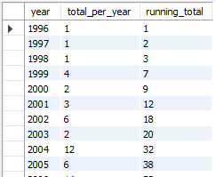

-- 9. Find average price per model and compare with overall average
SELECT model,
ROUND(AVG(price),2) AS model_avg_price,
ROUND(AVG(AVG(price)) OVER (),2) AS overall_avg_price,
ROUND(AVG(price) - AVG(AVG(price)) OVER (),2) AS difference_from_overall
FROM bmw_cars
GROUP BY model
ORDER BY model_avg_price DESC;
OUTPUT:-
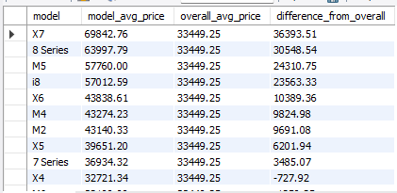

-- 10. Get top 5 most expensive cars per fuel type
SELECT model,
fuelType,
price,
rnk
FROM (
SELECT model,
fuelType,
price,
RANK() OVER (PARTITION BY fuelType ORDER BY price DESC) AS rnk
FROM bmw_cars
) AS ranked
WHERE rnk <= 5
ORDER BY fuelType, rnk;
OUTPUT:-
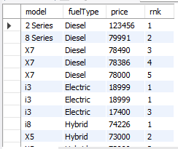

-- 11. Check how average price varies with engine size bucket
SELECT engine_bucket,
ROUND(AVG(price), 2) AS avg_price
FROM (
SELECT CONCAT(FLOOR(engineSize), 'L') AS engine_bucket,
price
FROM bmw_cars
) AS t
GROUP BY engine_bucket
ORDER BY CAST(REPLACE(engine_bucket, 'L', '') AS UNSIGNED);
OUTPUT:-
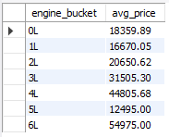

-- 12. Top 10 most fuel-efficient models
SELECT model,
fuelType,
mpg
FROM bmw_cars
ORDER BY mpg DESC
LIMIT 10;
OUTPUT:-
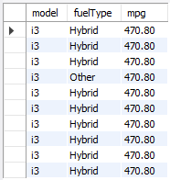

-- 13. Compare average price across transmission types per fuel type
SELECT fuelType,
transmission,
ROUND(AVG(price), 2) AS avg_price
FROM bmw_cars
GROUP BY fuelType, transmission
ORDER BY fuelType, avg_price DESC;
OUTPUT:-
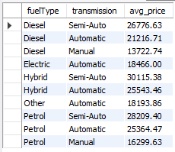

-- 14. Models priced above the yearly average
SELECT model,
year,
price,
ROUND(year_avg, 2) AS avg_price_of_year
FROM (
SELECT model,
year,
price,
AVG(price) OVER (PARTITION BY year) AS year_avg
FROM bmw_cars
) AS t
WHERE price > year_avg
ORDER BY year DESC, price DESC;
OUTPUT:-
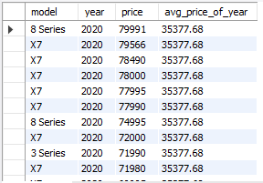

-- 15. Price distribution per year
SELECT year,
MIN(price) AS min_price,
MAX(price) AS max_price,
ROUND(AVG(price), 2) AS avg_price
FROM bmw_cars
GROUP BY year
ORDER BY year DESC;
OUTPUT:-
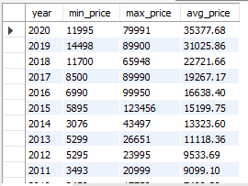

-- 16. Outlier detection: cars priced 1.5x above yearly average
SELECT model,
year,
price,
ROUND(year_avg, 2) AS avg_price_of_year
FROM (
SELECT model,
year,
price,
AVG(price) OVER (PARTITION BY year) AS year_avg
FROM bmw_cars
) AS t
WHERE price > 1.5 * year_avg
ORDER BY year DESC, price DESC;
OUTPUT:-
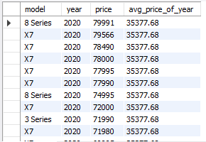

Key Insights & Recommendations
🔍 Key Insights
- BMW dataset shows a diverse range of models across multiple years, with increasing listings in recent years.
- Premium models (M-series, X-series) command the highest average prices, while entry models remain budget-friendly.
- Petrol cars dominate, but diesel and hybrid variants show strong fuel efficiency.
- Larger engines (3.0L+) and automatic transmissions are associated with higher prices.
- Average prices have risen over the years; some models remain priced well above yearly averages, showing strong market demand.
- Outlier cars priced 1.5× above yearly averages are performance or luxury editions.

💡 Recommendations
- Pricing: Use yearly and model-wise averages to set competitive resale prices and identify over/underpriced cars.
- Inventory Focus: Prioritize high-demand models (e.g., M-series, X5) and expand hybrid/electric stock.
- Marketing: Promote fuel-efficient diesel/hybrid models and premium performance models for niche buyers.
- Data Strategy: Track price vs. mileage and engine size trends for smarter forecasting.
- Future Work: Add depreciation and regional analysis to refine pricing insights.

