Aim

A client using a wireless device wants to communicate to the server located in an unknown location.Demonstrate the concept with relevant protocol communication.

Procedure

1)Firstly create a extension file in cocalc by name netwok.c.

2)Then create two new files by name server.c and client.c

3)Then in next step create two new term files by naming client.term and server.term.

4)Then type the code on client and server side then run the output in the server.

Server code:-

#include<sys/types.h>  
#include<sys/socket.h>  
#include<netinet/in.h>  
#include<unistd.h>  
#include<netdb.h>  
#include<stdio.h>  
#include<string.h>  
#include<arpa/inet.h>  
#define MAXLINE 1024  
int main(int argc,char **argv)  
{  
int sockfd;  
int n;  
socklen_t len;  
char msg[1024];  
struct sockaddr_in servaddr,cliaddr;  
sockfd=socket(AF_INET,SOCK_DGRAM,0);  
bzero(&servaddr,sizeof(servaddr));  
servaddr.sin_family=AF_INET;  
servaddr.sin_addr.s_addr=INADDR_ANY;  
servaddr.sin_port=htons(5035);  
printf("\n\n Binded");  
bind(sockfd,(struct sockaddr*)&servaddr,sizeof(servaddr));  
printf("\n\n Listening...");  
for(;;)  
{  
      printf("\n ");  
     len=sizeof(cliaddr);  
     n=recvfrom(sockfd,msg,MAXLINE,0,(struct sockaddr*)&cliaddr,&len);  
     printf("\n Client's Message : %s\n",msg);  
     if(n<6)  
        perror("send error");  
     sendto(sockfd,msg,n,0,(struct sockaddr*)&cliaddr,len);  
}  
return 0;   
}

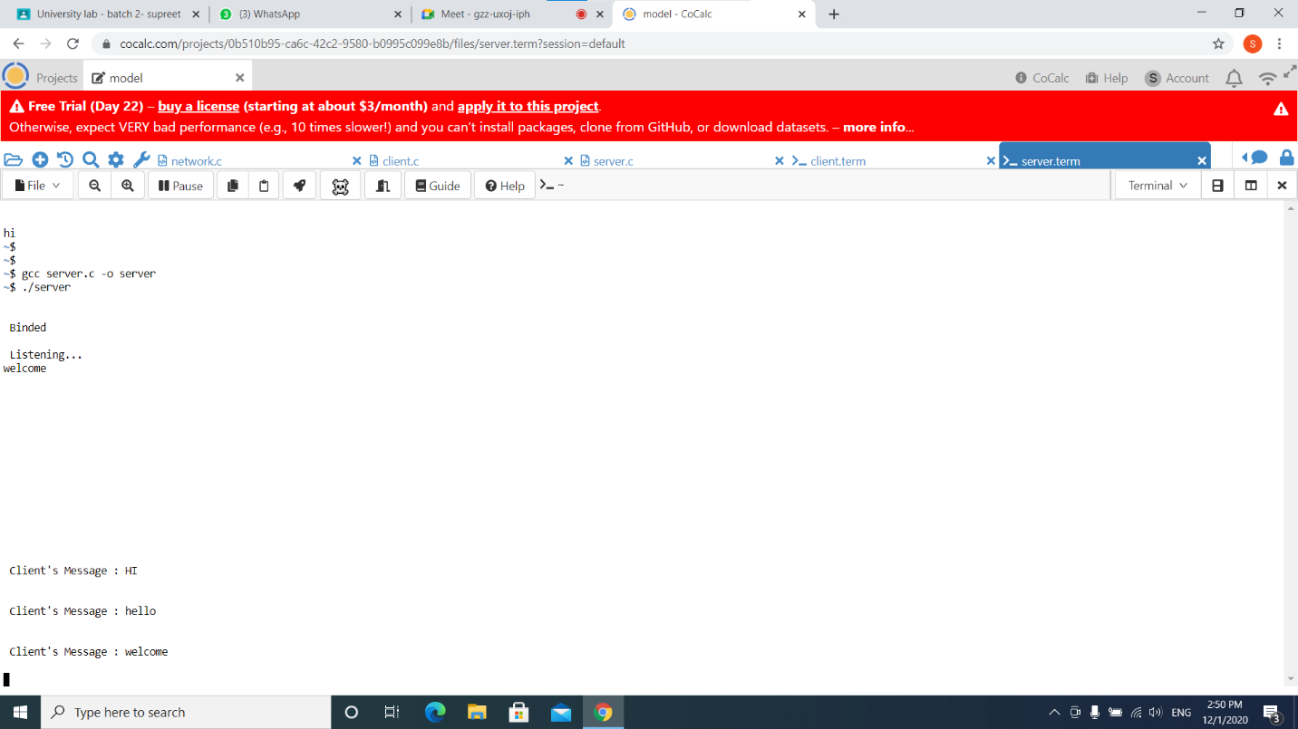

Client code :-

#include<sys/types.h>  
#include<sys/socket.h>  
#include<netinet/in.h>  
#include<string.h>  
#include<arpa/inet.h>  
#include<string.h>  
#include<arpa/inet.h>  
#include<stdio.h>  
#define MAXLINE 1024  
int main(int argc,char* argv[])  
{  
int sockfd;  
int n;  
socklen_t len;  
char sendline[1024],recvline[1024];  
struct sockaddr_in servaddr;  
strcpy(sendline,"");  
printf("\n Enter the message : ");  
scanf("%s",sendline);  
sockfd=socket(AF_INET,SOCK_DGRAM,0);  
bzero(&servaddr,sizeof(servaddr));  
servaddr.sin_family=AF_INET;  
servaddr.sin_addr.s_addr=inet_addr("127.0.0.1");  
servaddr.sin_port=htons(5035);  
connect(sockfd,(struct sockaddr*)&servaddr,sizeof(servaddr));  
len=sizeof(servaddr);  
sendto(sockfd,sendline,MAXLINE,0,(struct sockaddr*)&servaddr,len);  
n=recvfrom(sockfd,recvline,MAXLINE,0,NULL,NULL);  
recvline[n]=0;  
printf("\n Server's Echo : %s\n\n",recvline);  
return 0;  
}

