**Matlab Simulation**

**20171157**

**Harsh Sharma**

**Ans 4_1**

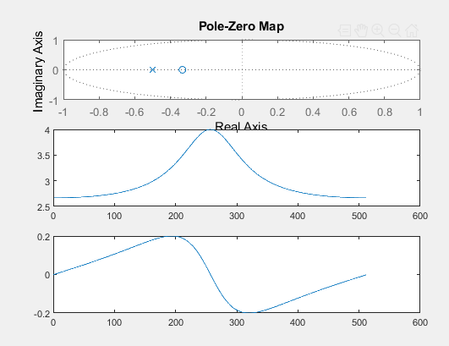

Image of part 1

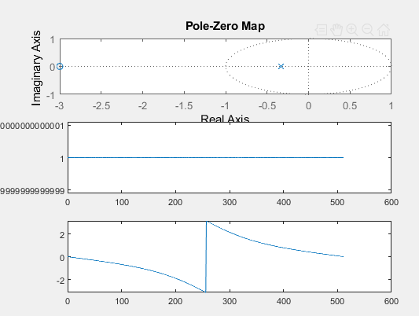

Image of part 2

As we can see that the system is causal, so ROC contains the unit circle and all poles are lying inside the unit circle that means, system is stable.

And as we know that if all the zeros lie inside the circle then it is minimum phase system and if all zeros lie outside, then it is maximum phased system.

Here as we can see that for the first part all zeros lie inside the circle that means it is minimum phase system and for the 2nd one, all zeros lie outside the circle that means it is maximum phased system.

2nd and 3rd graph in the above 2 images is the magnitude and phase response of h(n).

**Ans 5**

Given, x(n) = e^(-0.5n) for 0<n<1000,

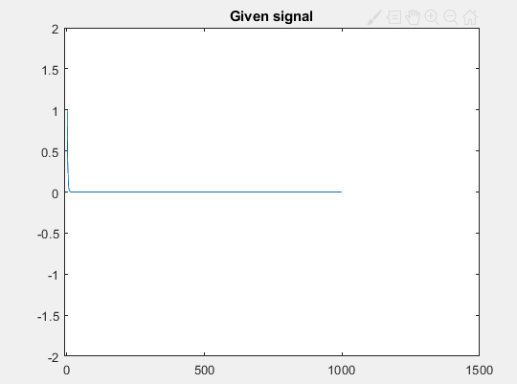

When x(n) passes through H1(z) then the magnitude and phase response of the output is shown below:

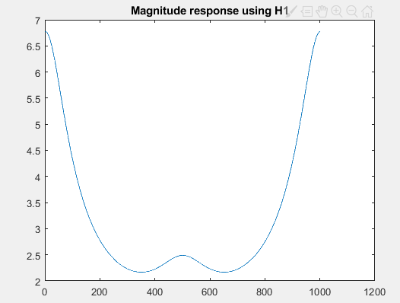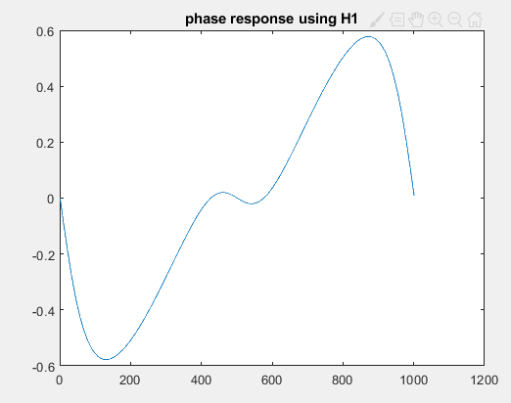

When x(n) passes through H2(z) then the magnitude and phase response of the output is shown below: 