BIG DATA LAB
(Learning Activity-2)

SUPREETHA G S
1NT19IS166
C-2 BATCH

SET-2

Download the Sales dataset from the Link, And build a Hadoop mapreduce program for the following.
Link: https://tinyurl.com/3tvbj4sj

Queries

Use the Hadoop MapReduce programming framework to come up with a Program which will take the data from the .csv file and computes the following.

1. Count the number of transactions done by each country

CODE
package my.la2.pack;

import java.io.IOException;
import java.util.Iterator;

import org.apache.hadoop.fs.Path;
import org.apache.hadoop.io.IntWritable;
import org.apache.hadoop.io.LongWritable;
import org.apache.hadoop.io.Text;
import org.apache.hadoop.mapred.FileInputFormat;
import org.apache.hadoop.mapred.FileOutputFormat;
import org.apache.hadoop.mapred.JobClient;
import org.apache.hadoop.mapred.JobConf;
import org.apache.hadoop.mapred.MapReduceBase;
import org.apache.hadoop.mapred.Mapper;
import org.apache.hadoop.mapred.OutputCollector;
import org.apache.hadoop.mapred.Reducer;
import org.apache.hadoop.mapred.Reporter;
import org.apache.hadoop.mapred.TextOutputFormat;

public class la2q1 {
public static class Map extends MapReduceBase implements Mapper<LongWritable, Text,Text , IntWritable>{
private final static IntWritable one = new IntWritable (1);

@Override
public void map(LongWritable key, Text value, OutputCollector<Text, IntWritable> out, Reporter report)
throws IOException {
// TODO Auto-generated method stub
String valueString = value.toString ();
String [] data = valueString.split(",");
out.collect( new Text(data[6]),one);

}
}

public static class Reduce extends MapReduceBase implements Reducer < Text , IntWritable , Text , IntWritable >{

@Override
public void reduce(Text key, Iterator<IntWritable> values, OutputCollector<Text, IntWritable> out,
Reporter report) throws IOException {
// TODO Auto-generated method stub
Text mykey = key;
int frequency = 0;
while (values.hasNext()){
IntWritable value = (IntWritable)values.next();
frequency += value.get();
}
out.collect(mykey,new IntWritable(frequency));
}
}

public static void main(String[] args) throws IOException {
// TODO Auto-generated method stub
JobConf conf = new JobConf(la2q1.class);
conf.setJobName("la2q1");
conf.setOutputKeyClass(Text.class);
conf.setOutputValueClass(IntWritable.class);
conf.setMapperClass(Map.class);
conf.setCombinerClass(Reduce.class);;
conf.setReducerClass(Reduce.class);
conf.setOutputFormat(TextOutputFormat.class);
conf.setOutputFormat(TextOutputFormat.class);
FileInputFormat.setInputPaths(conf, new Path(args[0]));
FileOutputFormat.setOutputPath(conf , new Path(args[1]));
JobClient.runJob(conf);

}
}
OUTPUT

cd $HADOOP_HOME/sbin
hdfs dfs -mkdir -p ~/supreetha

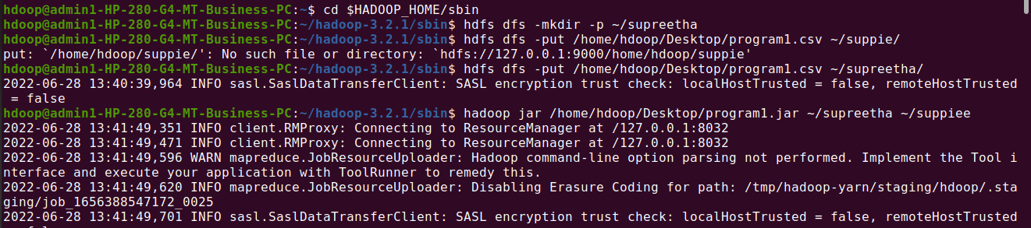

hdfs dfs -put /home/hdoop/Desktop/program1.csv ~/supreetha/
hadoop jar /home/hdoop/Desktop/program1.jar ~/supreetha ~/suppiee

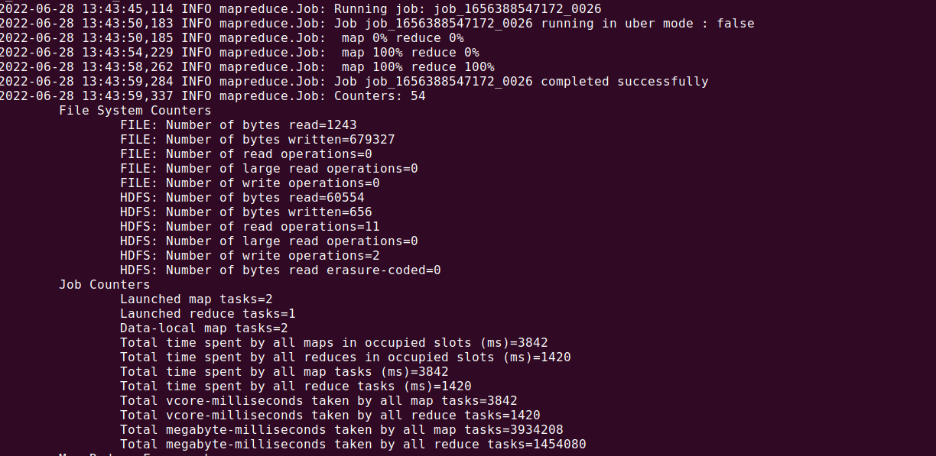

hdfs dfs -ls ~/suppiee
hdfs dfs -cat ~/suppiee/part*

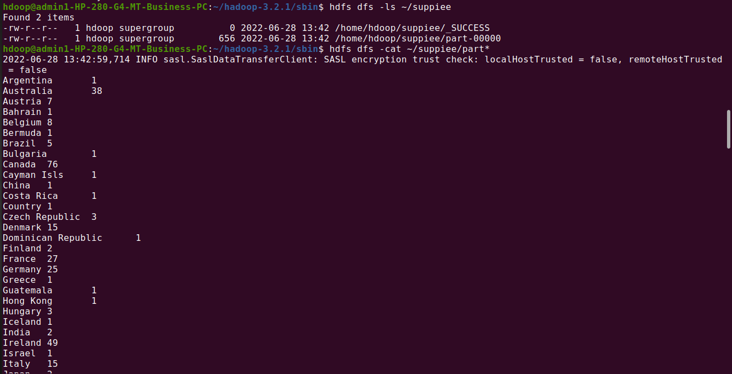

2. Find the cumulative amount of transactions done by each country

CODE
package my.la21.pack;

import java.io.IOException;
import java.util.Iterator;

import org.apache.hadoop.fs.Path;
import org.apache.hadoop.io.IntWritable;
import org.apache.hadoop.io.LongWritable;
import org.apache.hadoop.io.Text;
import org.apache.hadoop.mapred.FileInputFormat;
import org.apache.hadoop.mapred.FileOutputFormat;
import org.apache.hadoop.mapred.JobClient;
import org.apache.hadoop.mapred.JobConf;
import org.apache.hadoop.mapred.MapReduceBase;
import org.apache.hadoop.mapred.Mapper;
import org.apache.hadoop.mapred.OutputCollector;
import org.apache.hadoop.mapred.Reducer;
import org.apache.hadoop.mapred.Reporter;
import org.apache.hadoop.mapred.TextOutputFormat;

public class la2q2 {
public static class Map extends MapReduceBase implements Mapper<LongWritable, Text,Text , IntWritable>{
@Override
public void map(LongWritable key, Text value, OutputCollector<Text, IntWritable> out, Reporter report)
throws IOException {
// TODO Auto-generated method stub
String valueString = value.toString();
String[] data = valueString.split(",");
out.collect(new Text(data[6]),
new IntWritable(Integer.parseInt(data [1])));
}
}

public static class Reduce extends MapReduceBase implements Reducer < Text , IntWritable , Text , IntWritable >{
@Override
public void reduce(Text key, Iterator<IntWritable> values, OutputCollector<Text, IntWritable> out,
Reporter report) throws IOException {
// TODO Auto-generated method stub
Text mykey = key;
int tcount = 0;
while(values.hasNext()) {
IntWritable value = (IntWritable)values.next();
tcount += value.get();
}
out.collect(mykey , new IntWritable(tcount));
}
}

public static void main(String[] args) throws IOException {
// TODO Auto-generated method stub
JobConf conf = new JobConf(la2q2.class);
conf.setJobName("la2q2");
conf.setOutputKeyClass(Text.class);
conf.setOutputValueClass(IntWritable.class);
conf.setMapperClass(Map.class);
conf.setCombinerClass(Reduce.class);;
conf.setReducerClass(Reduce.class);
conf.setOutputFormat(TextOutputFormat.class);
conf.setOutputFormat(TextOutputFormat.class);
FileInputFormat.setInputPaths(conf, new Path(args[0]));
FileOutputFormat.setOutputPath(conf , new Path(args[1]));
JobClient.runJob(conf);

}
}

OUTPUT

cd $HADOOP_HOME/sbin
hdfs dfs -mkdir -p ~/suppie
hdfs dfs -put /home/hdoop/Desktop/salesd.csv ~/suppie/

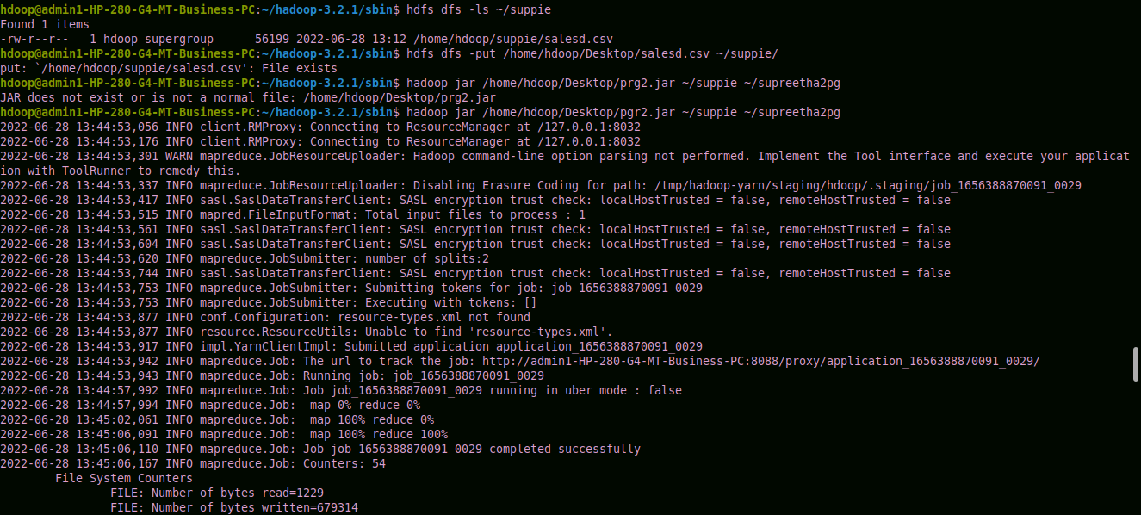

hadoop jar /home/hdoop/Desktop/pgr2.jar ~/suppie ~/supreetha2pg

hdfs dfs -cat ~/supreetha2pg/part-00000

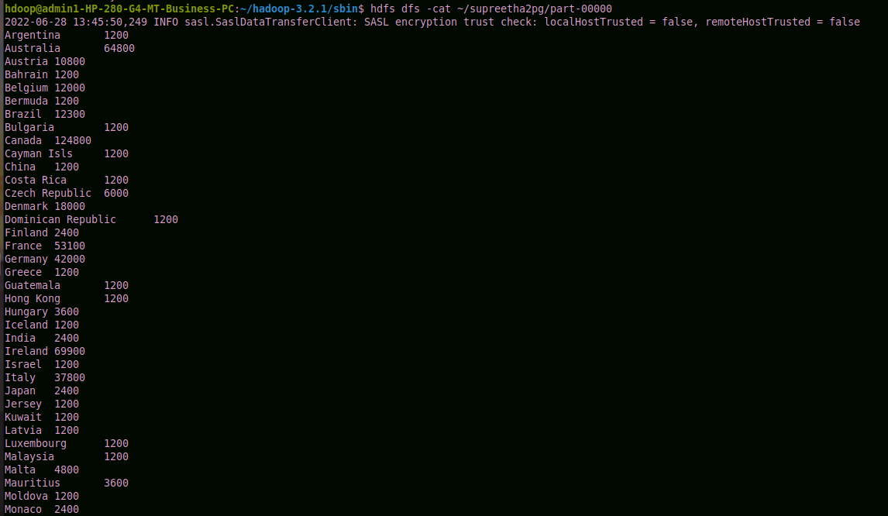

3. Count how many transactions done using Master, VISA, Diners, Amex

CODE
package my.la22.pack;

import java.io.IOException;
import java.util.Iterator;

import org.apache.hadoop.fs.Path;
import org.apache.hadoop.io.IntWritable;
import org.apache.hadoop.io.LongWritable;
import org.apache.hadoop.io.Text;
import org.apache.hadoop.mapred.FileInputFormat;
import org.apache.hadoop.mapred.FileOutputFormat;
import org.apache.hadoop.mapred.JobClient;
import org.apache.hadoop.mapred.JobConf;
import org.apache.hadoop.mapred.MapReduceBase;
import org.apache.hadoop.mapred.Mapper;
import org.apache.hadoop.mapred.OutputCollector;
import org.apache.hadoop.mapred.Reducer;
import org.apache.hadoop.mapred.Reporter;
import org.apache.hadoop.mapred.TextOutputFormat;

public class la2q3 {
public static class Map extends MapReduceBase implements Mapper<LongWritable, Text,Text , IntWritable>{
private final static IntWritable one = new IntWritable (1);

@Override
public void map(LongWritable key, Text value, OutputCollector<Text, IntWritable> out, Reporter report)
throws IOException {
// TODO Auto-generated method stub
String valueString = value.toString ();
String [] data = valueString.split(",");
out.collect( new Text(data[2]),one);

}
}

public static class Reduce extends MapReduceBase implements Reducer < Text , IntWritable , Text , IntWritable >{

@Override
public void reduce(Text key, Iterator<IntWritable> values, OutputCollector<Text, IntWritable> out,
Reporter report) throws IOException {
// TODO Auto-generated method stub
Text mykey = key;
int frequency = 0;
while (values.hasNext()){
IntWritable value = (IntWritable)values.next();
frequency += value.get();
}
out.collect(mykey,new IntWritable(frequency));
}
}

public static void main(String[] args) throws IOException {
// TODO Auto-generated method stub
JobConf conf = new JobConf(la2q3.class);
conf.setJobName("la2q3");
conf.setOutputKeyClass(Text.class);
conf.setOutputValueClass(IntWritable.class);
conf.setMapperClass(Map.class);
conf.setCombinerClass(Reduce.class);;
conf.setReducerClass(Reduce.class);
conf.setOutputFormat(TextOutputFormat.class);
conf.setOutputFormat(TextOutputFormat.class);
FileInputFormat.setInputPaths(conf, new Path(args[0]));
FileOutputFormat.setOutputPath(conf , new Path(args[1]));
JobClient.runJob(conf);

}
}

OUTPUT

cd $HADOOP_HOME/sbin
hdfs dfs -mkdir -p ~/suppie
hdfs dfs -put /home/hdoop/Desktop/salesd.csv ~/suppie/
hadoop jar /home/hdoop/Desktop/pg3.jar ~/suppie ~/supreetha
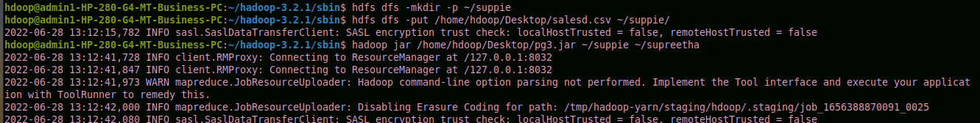

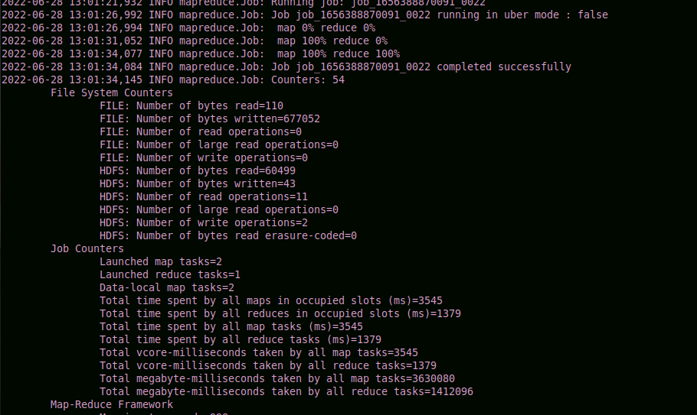

hdfs dfs -ls ~/supreetha
hdfs dfs -cat ~/supreetha/part-00000
