BIG DATA LAB

Supreetha G S
1NT19IS166
02/06/2022

Check hadoop version
$ hadoop version

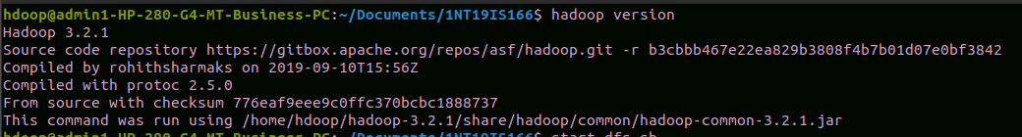
Start hadoop
$ start-dfs.sh

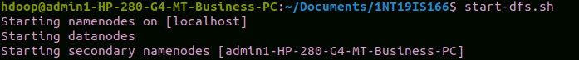

- Creating a directory
$ hdfs dfs -mkdir /supreetha_gs

- Listing all directories
$ hdfs dfs -ls /

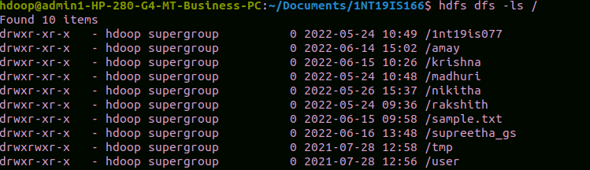

- Add two empty files into directory
$ hdfs dfs -touchz /supreetha_gs/file1.txt
$ hdfs dfs -touchz /supreetha_gs/file2.txt

- Listing all the files in the directory that was created
$ hdfs dfs -ls /supreetha_gs

- Moving file from local to hadoop using put command
$ hdfs dfs -mkdir /1nt19is166
$ hdfs dfs -put /home/hdoop/Desktop/1nt19is166_supreetha /1nt19is166

Checking file at destination
$ hdfs dfs -ls /1nt19is166

- Moving from hadoop to local
$ hadoop fs -get /1nt19is166/1nt19is166_supreetha /home/hdoop/Desktop

File moved to local
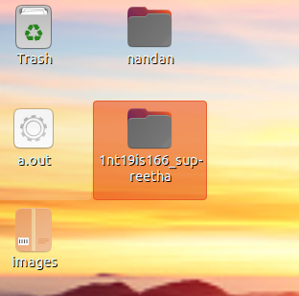
- Moving file within hadoop
$ hadoop fs -cp /supreetha_gs/file1.txt /1nt19is166

8. Displaying the size of files in directory
$ hadoop fs -du -h /supreetha_gs
$ hadoop fs -du -h /1nt19is166

Using stat command
$ hadoop fs -stat /supreetha_gs
$ hadoop fs -stat /1nt19is166

