1NT19IS166
SUPREETHA.G.S
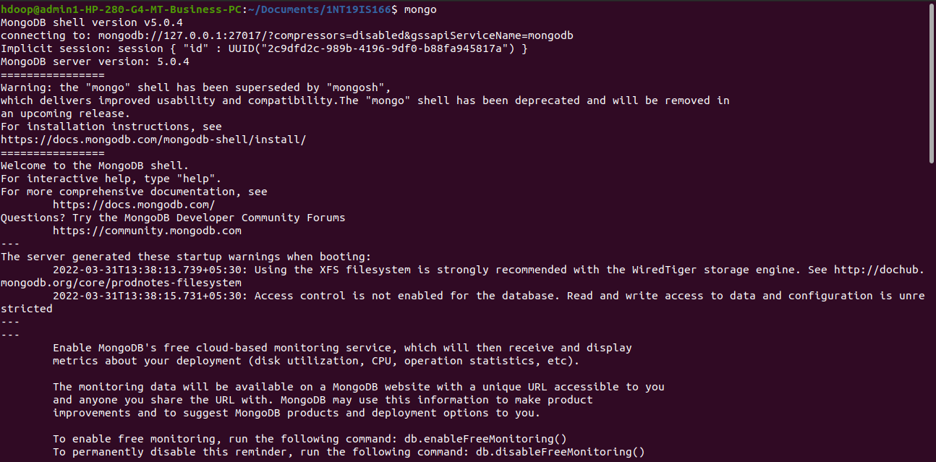
1. Command to enter into mongoDB in terminal
mongo

2. Create a database
use db_name
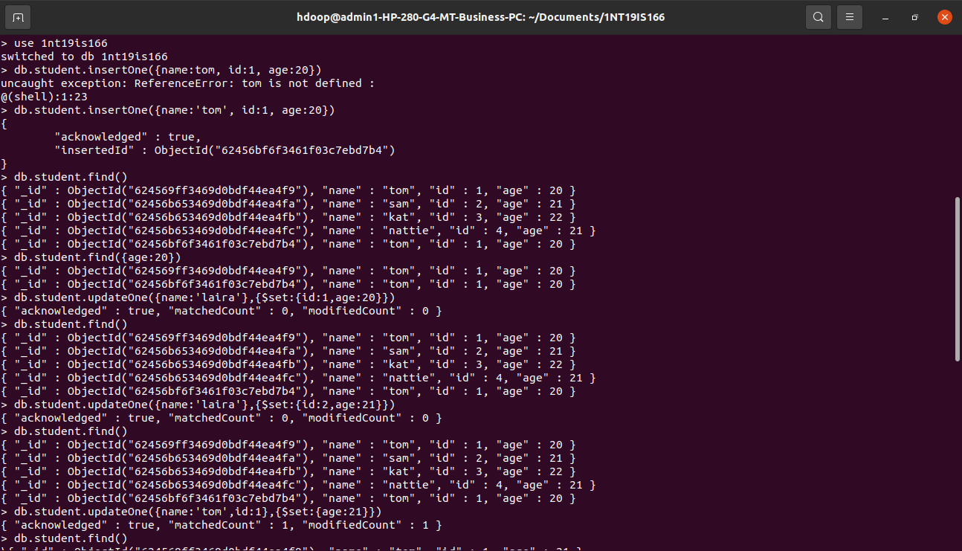
3.Insert one data
db.collection_name.insertOne()
4. Show databases
show dbs
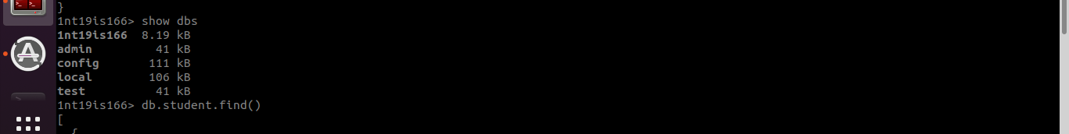
5. Show collections
show collections
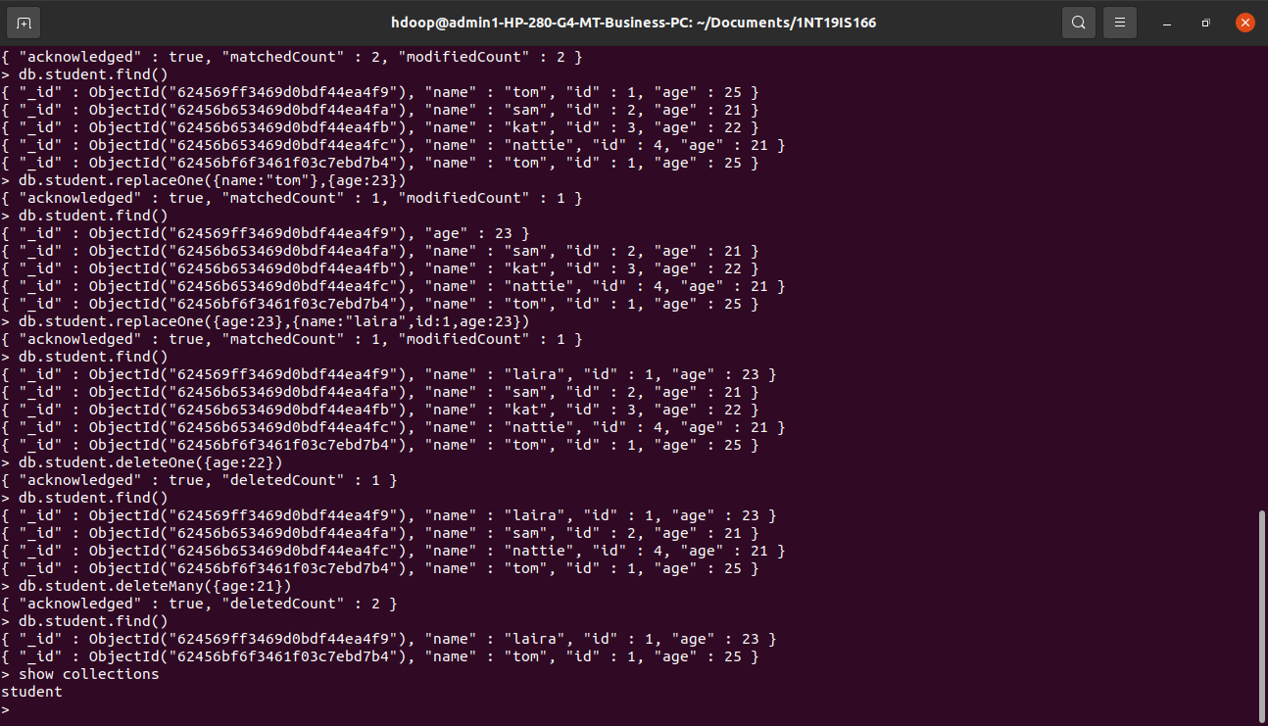

6. Insert many
db.student.insertMany([{name:'sam',id:2,age:21},{name:'kat',id:3,age:22},{name:'nattie',id:4,age:21}])
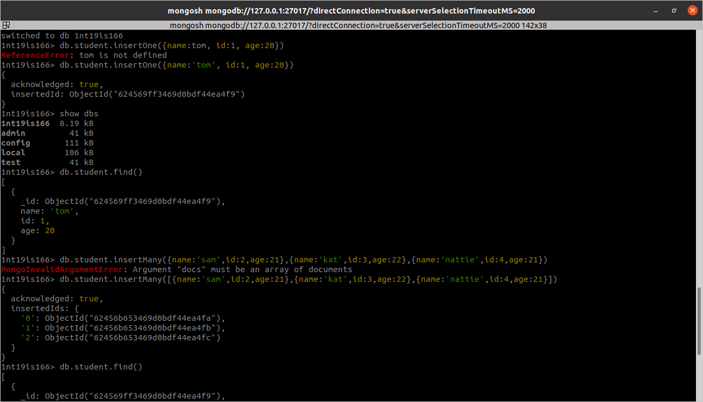
7. Display collection contents
db.collection_name.find()
7. Update One
db.student.updateOne({name:'tom',id:1},{$set:{age:21}})
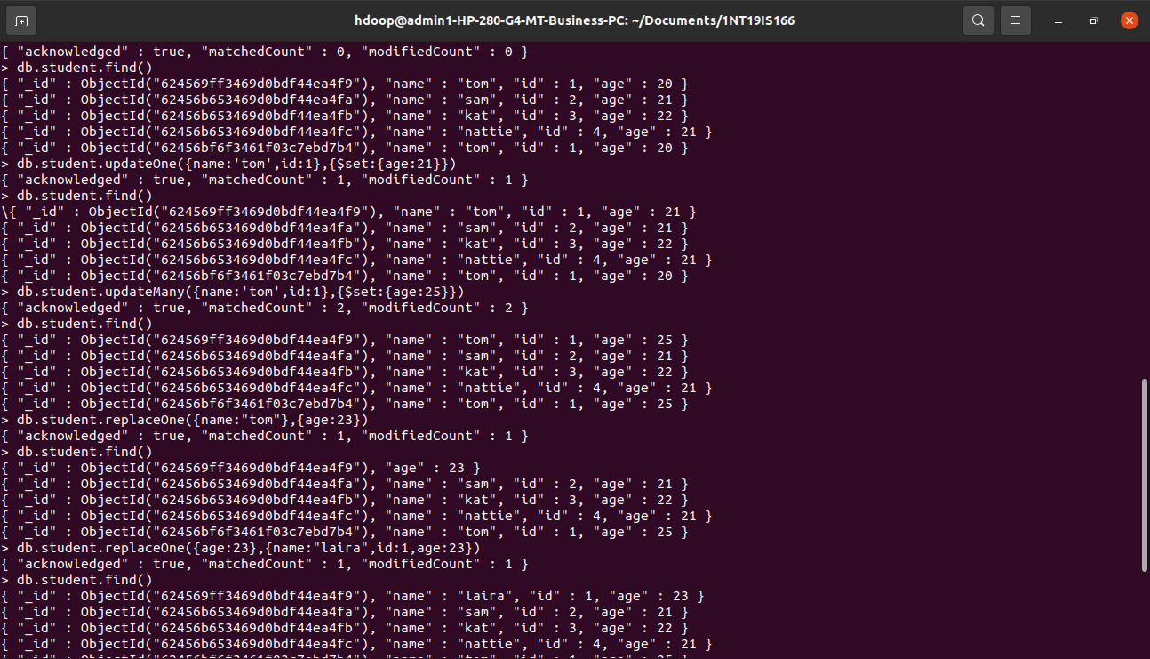
8. Update Many
db.student.updateMany({name:'tom',id:1},{$set:{age:25}})
9. Replace One
db.student.replaceOne({name:"tom"},{age:23})
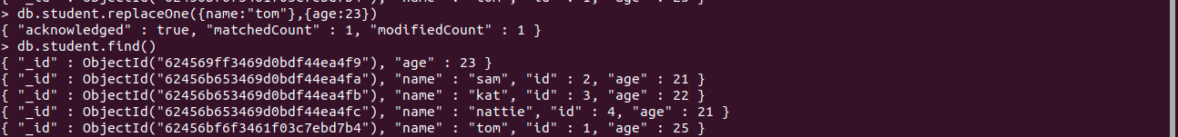

10. Delete One
db.student.deleteOne({age:22})
11.Delete Many
db.student.deleteMany({age:21})

