BIG DATA LAB
Name: Supreetha G S
USN: 1NT19IS166
Date:16.06.2022

Exercise-3: MapReduce Use the Hadoop framework to write a custom MapReduce program to perform word count operations on a custom data set.

Initially create a new project, package, and class in eclipse to run a java code.

To install jar files:
Right-click on the project (MapReduce)
Click on -> build a path -> add external archives -> Hadoop 3.2.1 -> share
In share
1. Click on common ->open hadoop-common-3.2.1.jar
2. Click on MapReduce -> open hadoop-mapreduce-client-core-3.2.1.jar

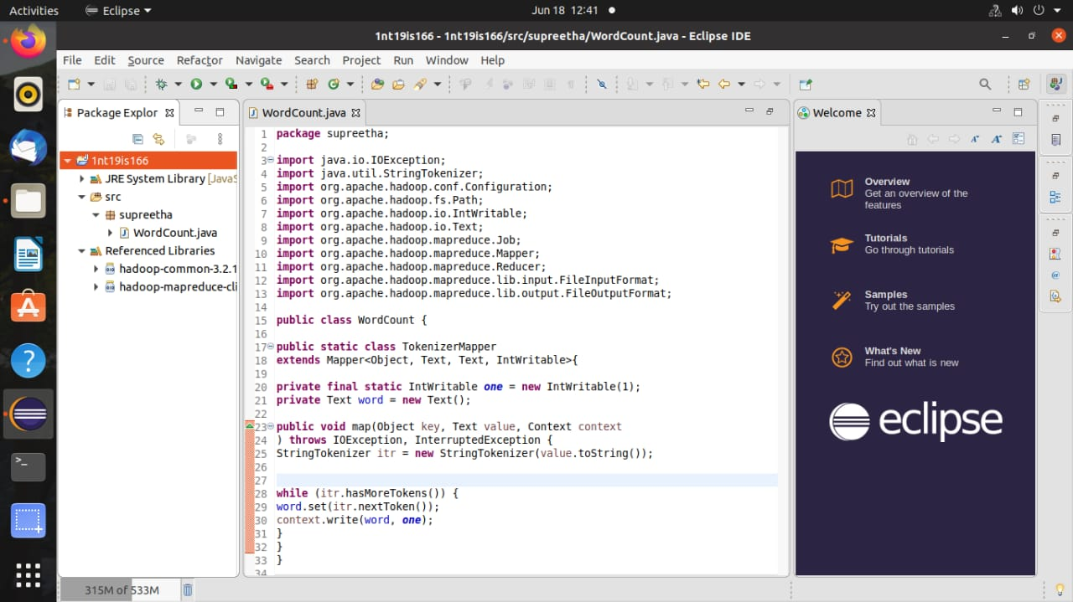
Right click on project -> export -> java -> jar file -> next Browse the address of the java file and save it in desktop/document/downloads and name it (supreetha.jar)

IN TERMINAL:
Run the commands:
cd $HADOOP_HOME
cd sbin
jps
start-all.sh

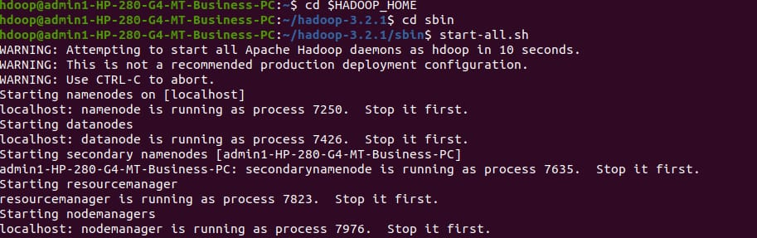

hdfs dfs -mkdir -p ~ /supreetha
hdfs dfs -appendToFile - ~/supreetha/file.txt
Create a file and add content to it. ->(ctrl D two times)

hadoop jar /home/hdoop/Desktop/supreetha.jar ~/supreetha ~/suppi

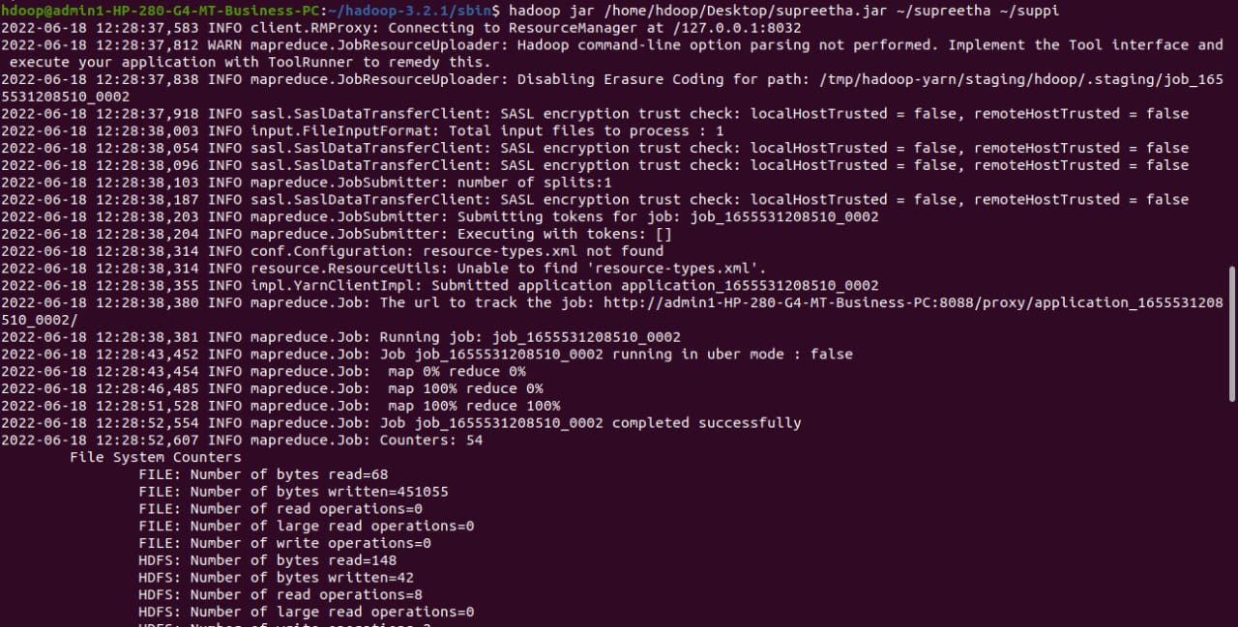

hdfs dfs -cat ~/out/part*

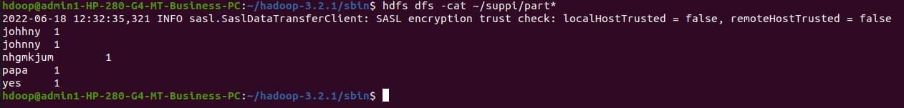

The word count of all the words in the file are 1.

