G. N. KHALSA COLLEGE
AUTONOMOUS (UNIVERSITY OF MUMBAI) MUMBAI-400019

DEPARTMENT OF COMPUTER SCIENCE
CERTIFICATE

Exam Seat No. __369__

CERTIFIED that the practicals, assignment duly signed, were performed by
Mr. ____Balmukund Shukla Roll No. _369_of M.Sc Part I/Part II class in the Computer Science Laboratory of G. N. Khalsa College, Mumbai during academic year 2026-2027.
He/She has completed the course of Laboratory assignments in Computer Science as contained in the course prescribed by the University of Mumbai

Sign. Of the Student Head of Dept.
Date Computer Science
Date

Professor-in-charge Sign of Examiner’s
- 1)
Date Date
- 2)
Date Date

Image Processing + Advanced Databases
INDEX

SR.  NO. | TITLE | DATE | PG.NO. | SIGNATURE
DIGITAL SIGNAL AND IMAGE PROCESSING
1 | - Generate and visualize sine, cosine, square, sawtooth signals  - Effect of sampling frequency on sinusoidal signal  - Add Gaussian noise; compute Mean, Variance, SNR  - Compare moving-average and frequency-domain  low-pass smoothing | 01-08-26 | 1-5
2 | - Read, display, analyze, modify, save image using OpenCV  - Intensity transformations: Negative, Logarithmic, Gamma | 08-08-26 | 6-8
3 | - Contrast stretching and global/adaptive thresholding  - Histogram equalization and histogram matching | 22-08-26 | 9-12
4 | - Remove salt-and-pepper noise using Mean,  Gaussian, Median filters  - Edge/detail enhancement using Laplacian and high-pass sharpening  - To calculate image gradients using Sobel operator and Laplacian | 29-08-26 | 13-18

ADVANCED DATABASE TECHNIQUES
1 | Demonstrate Object-Oriented Databases | 05-09-26 | 17-19
2 | Demonstrate a distributed database environment by dividing a given global database table into  - Horizontal fragments  - Vertical fragments | 12-09-26 | 20-31
3 | Perform the CRUD operations using  - MongoDB  - CouchDB | 19-09-26 | 32-44
4 | Perform the CRUD operations using  - Redis  - Apache Cassandra | 26-09-26 | 45-56

Practical No: 01

1A) Generate and visualize sine, cosine, square, sawtooth signals

Code:
import numpy as np
import matplotlib.pyplot as plt from scipy import signal
fs = 1000 # Sampling frequency (Hz)
t = np.arange(0, 1, 1/fs) # Time vector from 0 to 1 second f = 5 # Analog frequency (Hz)
# Generating the waves
sine = np.sin(2 * np.pi * f * t) cosine = np.cos(2 * np.pi * f * t)
square = signal.square(2 * np.pi * f * t) sawtooth = signal.sawtooth(2 * np.pi * f * t) # Plotting
plt.figure(figsize=(10, 7))
plt.subplot(4, 1, 1) plt.plot(t, sine) plt.title("Sine Wave") plt.ylabel("Amplitude") plt.grid()
plt.subplot(4, 1, 2) plt.plot(t, cosine) plt.title("Cosine Wave") plt.ylabel("Amplitude") plt.grid()
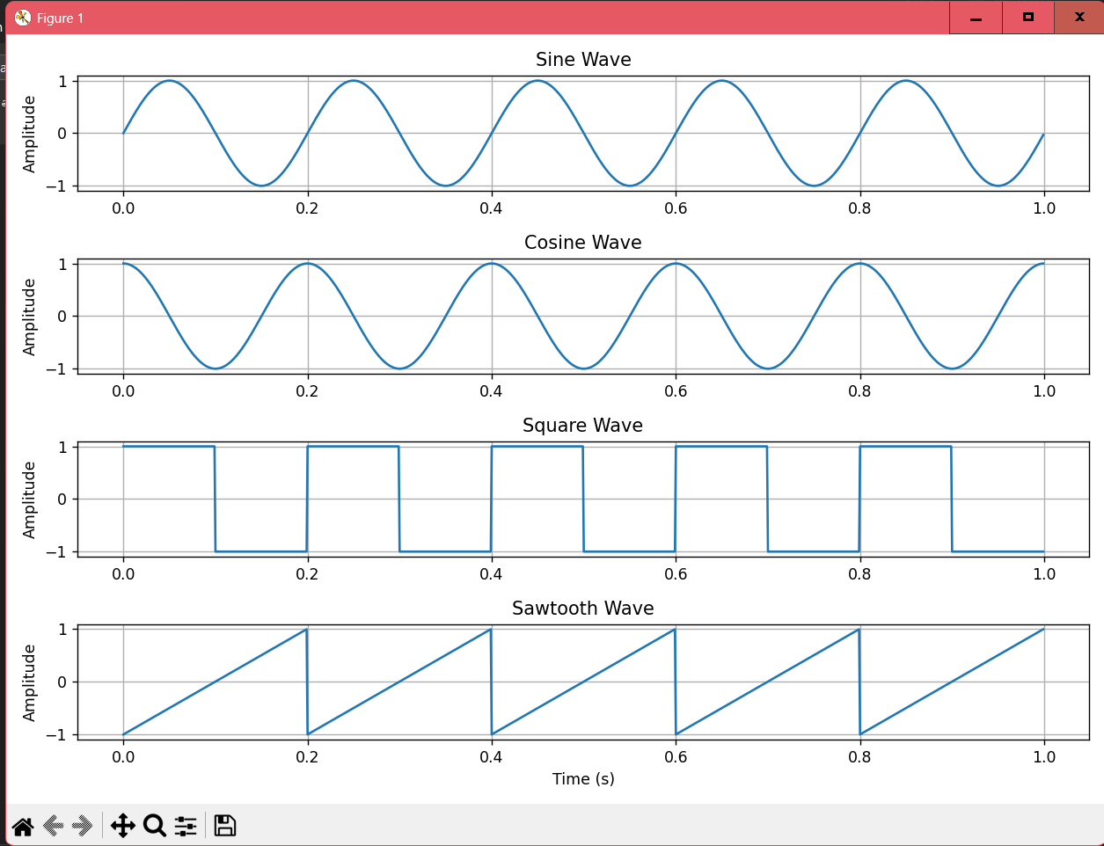
plt.subplot(4, 1, 3) plt.plot(t, square) plt.title("Square Wave") plt.ylabel("Amplitude") plt.grid()
plt.subplot(4, 1, 4) plt.plot(t, sawtooth) plt.title("Sawtooth Wave") plt.xlabel("Time (s)") plt.ylabel("Amplitude") plt.grid()
plt.tight_layout() plt.show()

Output:

1B) Effect of sampling frequency on sinusoidal signal

Code:
import numpy as np
import matplotlib.pyplot as plt
f = 10 # Analog signal frequency (Hz)
t_cont = np.linspace(0, 1, 2000) # Super high-res "continuous" time x_cont = np.sin(2*np.pi*f*t_cont) # The original perfect wave sampling_rates = [100, 20, 15] # Different sampling frequencies (Hz) plt.figure(figsize=(10, 7))
for i, fs in enumerate(sampling_rates, 1):
t = np.arange(0, 1, 1/fs) # Discrete time points x = np.sin(2*np.pi*f*t) # Sampled signal plt.subplot(3, 1, i)

plt.plot(t_cont, x_cont, label="Original") # Smooth line
plt.stem(t, x, linefmt="C1-", markerfmt="C1o", basefmt=" ", label=f"Sampled at {fs} Hz") plt.xlim(0, 0.4) # Zoom in to first 0.4 seconds
plt.grid() plt.legend()
plt.tight_layout() plt.show()

Output:
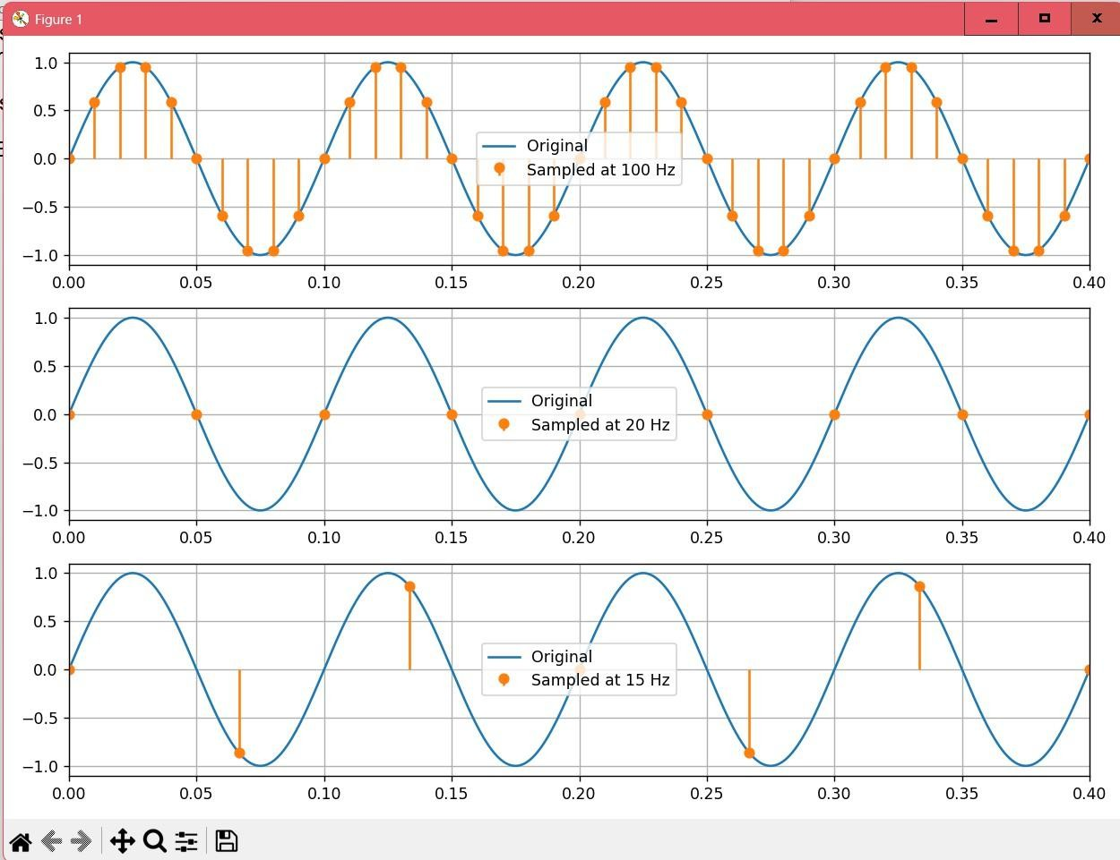

1C) Add Gaussian noise; compute Mean, Variance, SNR

Code:
import numpy as np
import matplotlib.pyplot as plt
np.random.seed(42) # Freezing the random generator so I get the same "random" results every time fs = 1000
t = np.arange(0, 1, 1/fs)
clean = np.sin(2*np.pi*10*t) # Pure 10 Hz signal
noise = np.random.normal(0, 0.3, len(t)) # Gaussian noise: mean=0, std=0.3 noisy = clean + noise # Corrupted signal
# Calculating SNR
signal_power = np.mean(clean**2) noise_power = np.mean(noise**2)
snr = 10 * np.log10(signal_power / noise_power) print("Mean of noise:", np.mean(noise)) print("Variance of noise:", np.var(noise)) print("SNR:", round(snr, 2), "dB") plt.figure(figsize=(10, 5))
plt.plot(t, clean, label="Clean Signal")
plt.plot(t, noisy, alpha=0.6, label="Noisy Signal") plt.xlim(0, 0.5)
plt.xlabel("Time (s)") plt.ylabel("Amplitude") plt.title("Effect of Gaussian Noise") plt.grid()
plt.legend() plt.show() Output:
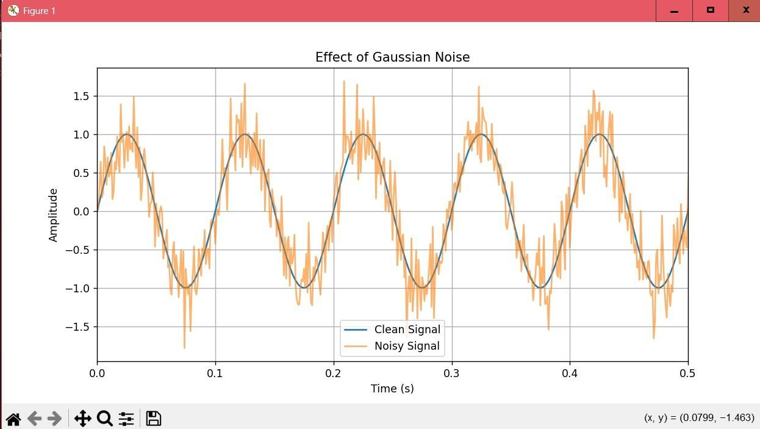
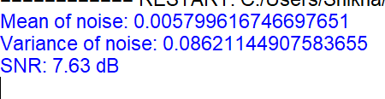

1D) Compare moving-average and frequency-domain low-pass smoothing

Code:
import numpy as np
import matplotlib.pyplot as plt fs = 500
t = np.arange(0, 2, 1/fs) np.random.seed(1)
# Creating a signal with a low frequency (5 Hz), a high frequency (60 Hz), and noise x = np.sin(2*np.pi*5*t) + 0.5*np.sin(2*np.pi*60*t)
x += 0.3*np.random.randn(len(t))
kernel = np.ones(11) / 11 # Smoothing window of size 11 smooth = np.convolve(x, kernel, mode="same")
# --- Frequency-domain low-pass filter ---X = np.fft.rfft(x)
freq = np.fft.rfftfreq(len(x), 1/fs)
cutoff = 20 # Cut out everything above 20 Hz X_filtered = X.copy()
X_filtered[freq > cutoff] = 0
filtered = np.fft.irfft(X_filtered, n=len(x)) # Plotting
plt.figure(figsize=(10, 7))
plt.subplot(3, 1, 1) plt.plot(t, x) plt.title("Noisy Signal") plt.grid()
plt.subplot(3, 1, 2) plt.plot(t, smooth)
plt.title("Moving Average Smoothing") plt.grid()
plt.subplot(3, 1, 3) plt.plot(t, filtered)
plt.title("Frequency-Domain Low-Pass Filtering") plt.xlabel("Time (s)")
plt.grid() plt.tight_layout() plt.show()

Output:

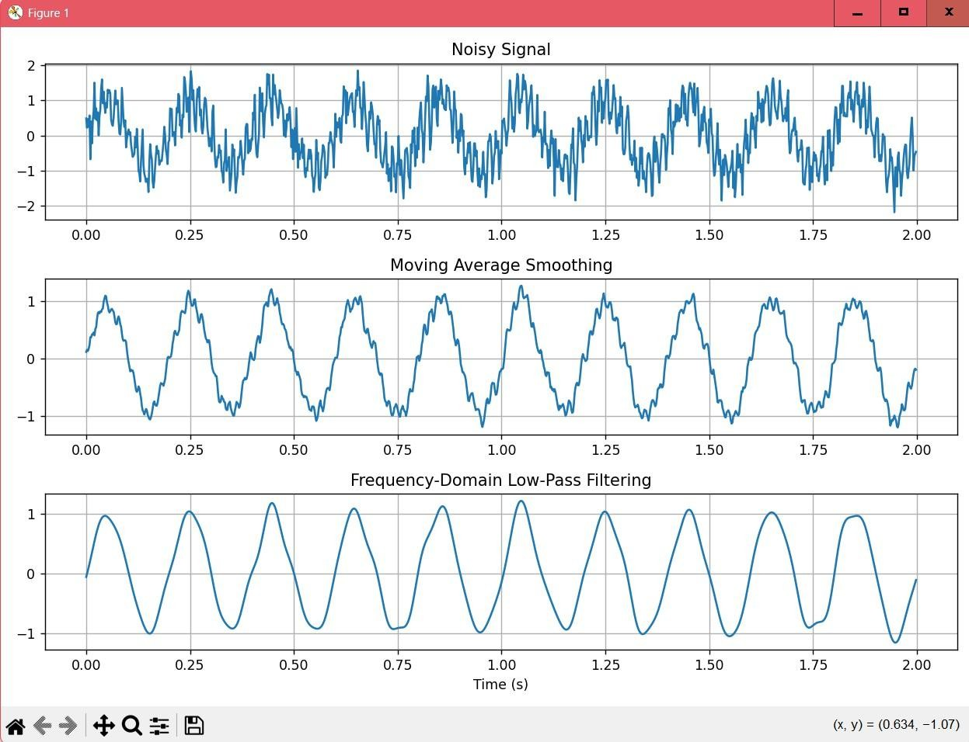

Practical No: 02

2A) Read, display, analyze, modify, save image using OpenCV
Code:
import cv2
import matplotlib.pyplot as plt # Read the image
img = cv2.imread("input.jpg") if img is None:
raise FileNotFoundError("Place an image named input.jpg in the same folder.") # Convert to grayscale
gray = cv2.cvtColor(img, cv2.COLOR_BGR2GRAY) # Print image properties
print("Image shape:", img.shape) print("Data type:", img.dtype)
print("Number of pixels:", img.shape[0] * img.shape[1]) # Modify one pixel (turn it red in BGR format) modified = img.copy()
modified[100, 100] = [0, 0, 255] # BGR: Blue=0, Green=0, Red=255 # Save the modified image
cv2.imwrite("output.png", modified) # Display the images side by side plt.figure(figsize=(10, 4))
plt.subplot(1, 2, 1)
plt.imshow(cv2.cvtColor(img, cv2.COLOR_BGR2RGB)) plt.title("Original")
plt.axis("off") plt.subplot(1, 2, 2)
plt.imshow(cv2.cvtColor(modified, cv2.COLOR_BGR2RGB)) plt.title("Modified")
plt.axis("off") plt.tight_layout() plt.show()

Output:
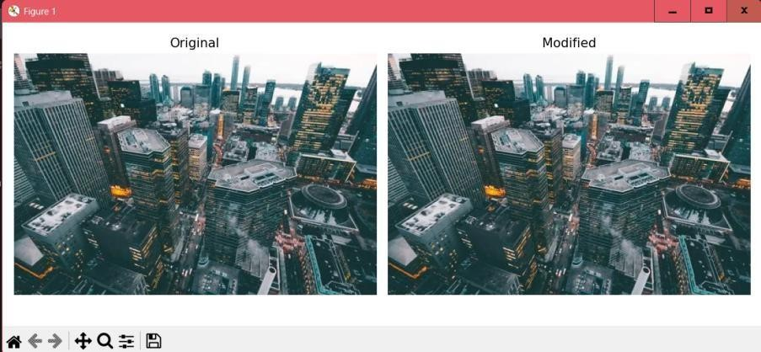

2B) Intensity transformations: Negative, Logarithmic, Gamma
Code:
import cv2
import numpy as np
import matplotlib.pyplot as plt

# Read image as grayscale
gray = cv2.imread("input.jpg", cv2.IMREAD_GRAYSCALE)

if gray is None:
raise FileNotFoundError("Place an image named input.jpg in the same folder.")

# --- 1. Negative Transformation ---negative = 255 - gray

# --- 2. Log Transformation ---
c = 255 / np.log1p(np.max(gray)) # Scaling constant so output is in 0-255 range log_img = c * np.log1p(gray) # log1p is log(1+x) to avoid log(0)
log_img = np.uint8(np.clip(log_img, 0, 255))

# --- 3. Power-Law (Gamma) Transformation ---gamma = 0.5
normalized = gray / 255.0 # Convert to range [0, 1] gamma_img = np.uint8(255 * (normalized ** gamma))

# Plotting the results plt.figure(figsize=(12, 7))

images = [gray, negative, log_img, gamma_img]
titles = ["Original", "Negative", "Log Transform", f"Gamma = {gamma}"]

for i, (image, title) in enumerate(zip(images, titles), 1): plt.subplot(2, 2, i)
plt.imshow(image, cmap="gray") plt.title(title)
plt.axis("off")

plt.tight_layout() plt.show()

Output:

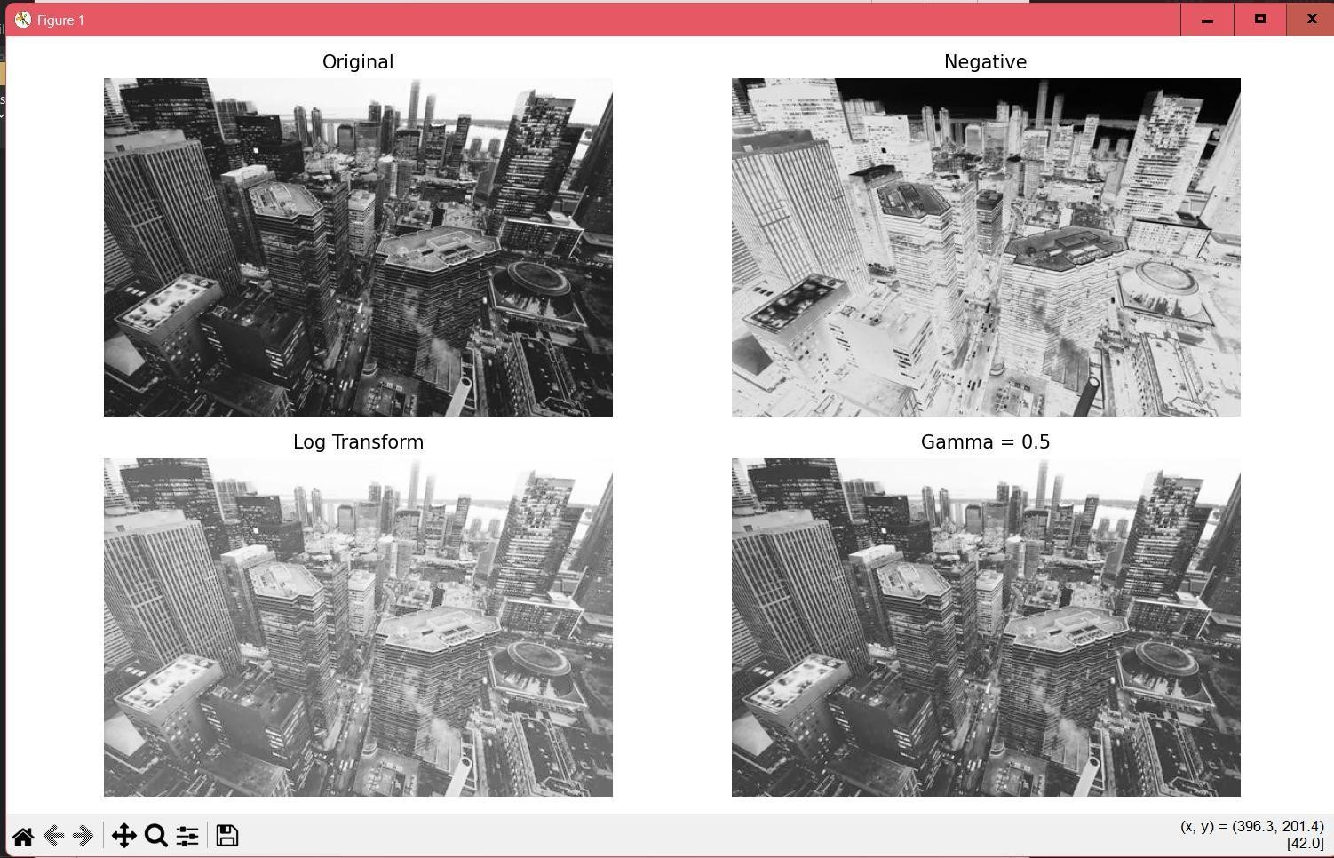

Practical No: 03

3A) Contrast stretching and global/adaptive thresholding
Code:
import cv2
import numpy as np
import matplotlib.pyplot as plt
gray = cv2.imread("input.jpg", cv2.IMREAD_GRAYSCALE)

if gray is None:
raise FileNotFoundError("Place an image named input.jpg in the same folder.") # Contrast Stretching
r_min, r_max = np.percentile(gray, (2, 98)) # Ignore extreme outliers stretched = (gray - r_min) * 255 / (r_max - r_min)
stretched = np.uint8(np.clip(stretched, 0, 255)) # Global Thresholding
_, binary = cv2.threshold(stretched, 127, 255, cv2.THRESH_BINARY) # Adaptive Thresholding
adaptive = cv2.adaptiveThreshold( stretched, 255,
cv2.ADAPTIVE_THRESH_GAUSSIAN_C, cv2.THRESH_BINARY, 11, 2
)
# Plotting plt.figure(figsize=(12, 7))

images = [gray, stretched, binary, adaptive]
titles = ["Original", "Contrast Stretched", "Global Threshold", "Adaptive Threshold"]

for i, (image, title) in enumerate(zip(images, titles), 1): plt.subplot(2, 2, i)
plt.imshow(image, cmap="gray") plt.title(title)
plt.axis("off")

plt.tight_layout() plt.show()

Output:

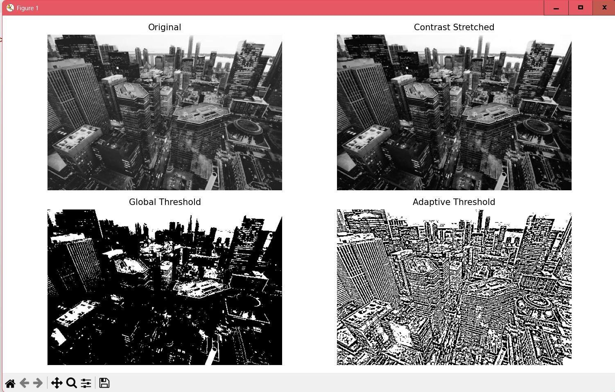

3B) Histogram equalization and histogram matching
Code:
import cv2
import numpy as np
import matplotlib.pyplot as plt
from skimage.exposure import match_histograms # Read source and reference images as grayscale
source = cv2.imread("input.jpg", cv2.IMREAD_GRAYSCALE) reference = cv2.imread("reference.jpg", cv2.IMREAD_GRAYSCALE) if source is None or reference is None:
raise FileNotFoundError("Place input.jpg and reference.jpg in the same folder.")

# Histogram Equalization
equalized = cv2.equalizeHist(source)

# Histogram Matching
matched = match_histograms(source, reference) matched = np.uint8(np.clip(matched, 0, 255))

# Plotting images and their histograms plt.figure(figsize=(12, 8))

# Row 1: Images plt.subplot(2, 3, 1)
plt.imshow(source, cmap="gray") plt.title("Source")
plt.axis("off") plt.subplot(2, 3, 2)
plt.imshow(equalized, cmap="gray") plt.title("Histogram Equalized") plt.axis("off")
plt.subplot(2, 3, 3) plt.imshow(reference, cmap="gray") plt.title("Reference")
plt.axis("off")
# Row 2: Histograms plt.subplot(2, 3, 4)
plt.hist(source.ravel(), 256, [0, 256])

plt.title("Source Histogram") plt.subplot(2, 3, 5)
plt.hist(equalized.ravel(), 256, [0, 256]) plt.title("Equalized Histogram") plt.subplot(2, 3, 6)
plt.hist(matched.ravel(), 256, [0, 256]) plt.title("Matched Histogram") plt.tight_layout()
plt.show()

Output:
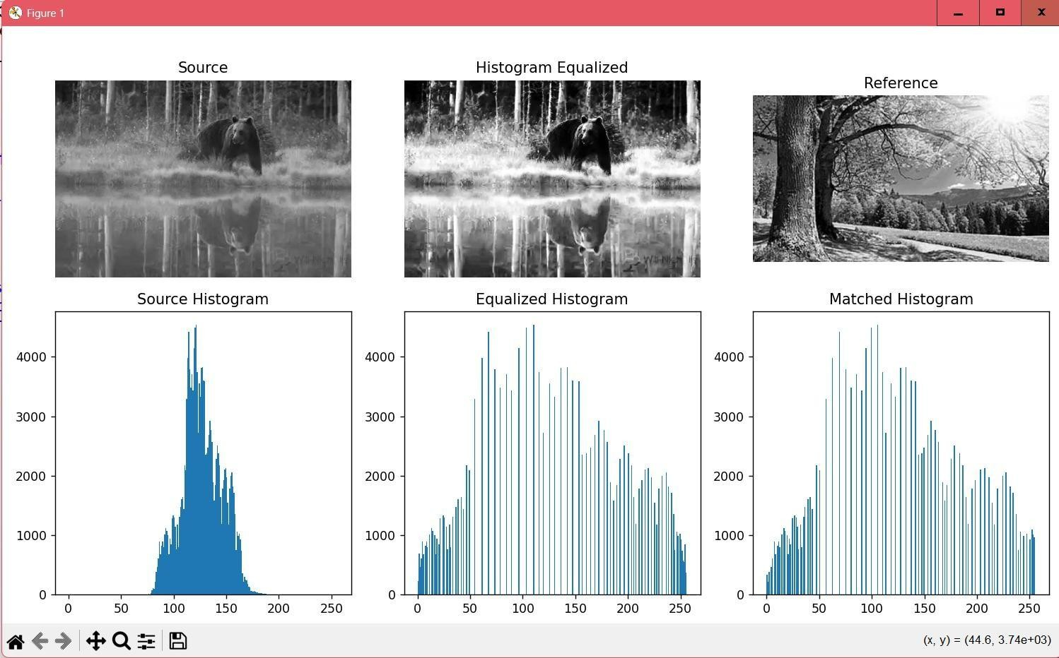

Practical No: 04

4A) Remove salt-and-pepper noise using Mean, Gaussian, Median filters
Code:
import cv2
import numpy as np
import matplotlib.pyplot as plt
img = cv2.imread("input.jpg", cv2.IMREAD_GRAYSCALE) if img is None:
raise FileNotFoundError("Place input.jpg in the same folder.")

# --- Adding Salt-and-Pepper Noise ---np.random.seed(42)
noisy = img.copy()

amount = 0.05 # 5% of pixels will be corrupted num_pixels = int(amount * img.size)

# Add "salt" (white pixels) coords = (
np.random.randint(0, img.shape[0], num_pixels), np.random.randint(0, img.shape[1], num_pixels)
)
noisy[coords] = 255

# Add "pepper" (black pixels) coords = (
np.random.randint(0, img.shape[0], num_pixels), np.random.randint(0, img.shape[1], num_pixels)
)
noisy[coords] = 0

# --- Applying Filters ---
mean_filter = cv2.blur(noisy, (5, 5)) # Linear: simple average gaussian = cv2.GaussianBlur(noisy, (5, 5), 0) # Linear: weighted average median = cv2.medianBlur(noisy, 5) # Non-linear: median value

# --- Plotting ---plt.figure(figsize=(12, 8))
images = [img, noisy, mean_filter, gaussian, median] titles = ["Original", "Noisy", "Mean Filter",
"Gaussian Filter", "Median Filter"]

for i, (image, title) in enumerate(zip(images, titles), 1):

plt.subplot(2, 3, i) plt.imshow(image, cmap="gray") plt.title(title)
plt.axis("off")

plt.tight_layout() plt.show()

Output:
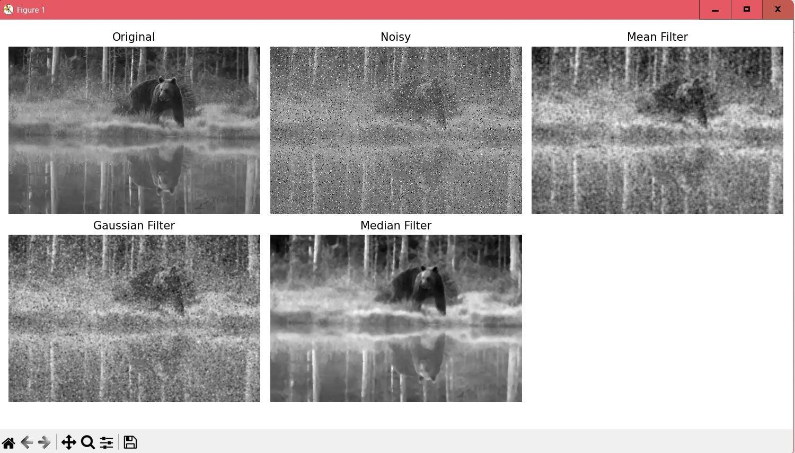

4B) Edge/detail enhancement using Laplacian and high-pass sharpening
Code:
import cv2
import numpy as np
import matplotlib.pyplot as plt
gray = cv2.imread("input.jpg", cv2.IMREAD_GRAYSCALE) if gray is None:
raise FileNotFoundError("Place input.jpg in the same folder.")

# --- Laplacian Edge Detection ---
lap = cv2.Laplacian(gray, cv2.CV_64F) lap_abs = cv2.convertScaleAbs(lap)

# --- Laplacian Sharpening ---
# Original + (Original - Blurred) = Original + Edges sharpened = cv2.addWeighted(gray, 1.5, lap_abs, -0.5, 0)

# --- High-Pass Filter (Original - Blurred) ---blur = cv2.GaussianBlur(gray, (5, 5), 0) high_pass = cv2.subtract(gray, blur)
high_pass_abs = cv2.convertScaleAbs(high_pass)

# --- Plotting ---plt.figure(figsize=(12, 8))

images = [gray, lap_abs, sharpened, high_pass_abs]
titles = ["Original", "Laplacian", "Sharpened", "High-Pass Details"]

for i, (image, title) in enumerate(zip(images, titles), 1): plt.subplot(2, 2, i)
plt.imshow(image, cmap="gray") plt.title(title)
plt.axis("off")

plt.tight_layout() plt.show()

Output:

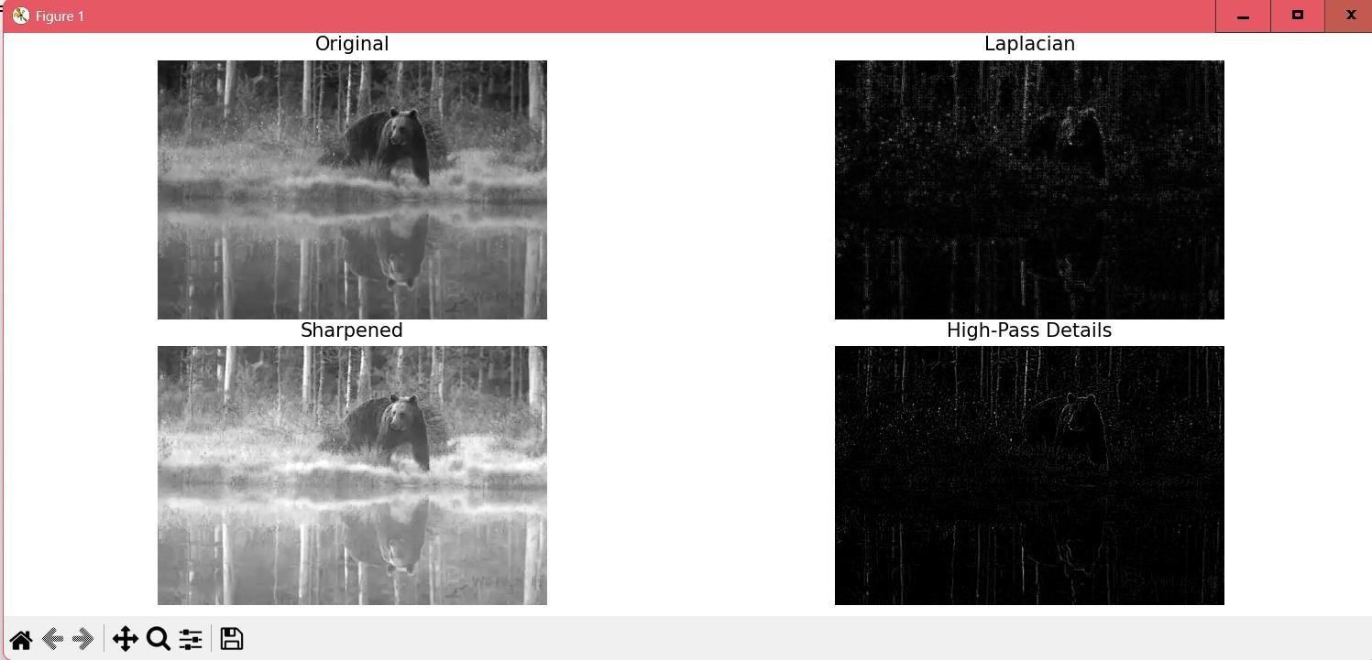

4C) To calculate image gradients using Sobel operator and Laplacian
Code:
import cv2
import numpy as np
import matplotlib.pyplot as plt
gray = cv2.imread("input.jpg", cv2.IMREAD_GRAYSCALE) if gray is None:
raise FileNotFoundError("Place input.jpg in the same folder.")

# --- Adding Gaussian Noise ---np.random.seed(10)
noise = np.random.normal(0, 25, gray.shape)
noisy = np.uint8(np.clip(gray.astype(float) + noise, 0, 255))

# --- Function to compute gradients and Laplacian ---def edge_results(image):
gx = cv2.Sobel(image, cv2.CV_64F, 1, 0, ksize=3) # Horizontal gradient gy = cv2.Sobel(image, cv2.CV_64F, 0, 1, ksize=3) # Vertical gradient magnitude = np.sqrt(gx**2 + gy**2) # Gradient magnitude lap = cv2.Laplacian(image, cv2.CV_64F) # Laplacian
return magnitude, np.abs(lap)

# --- Compute for clean and noisy images ---grad_clean, lap_clean = edge_results(gray) grad_noisy, lap_noisy = edge_results(noisy)

# --- Plotting ---plt.figure(figsize=(12, 8))

images = [gray, grad_clean, lap_clean, noisy, grad_noisy, lap_noisy] titles = [
"Original", "Gradient Magnitude", "Laplacian",
"Noisy Image", "Gradient of Noisy Image", "Laplacian of Noisy Image"
]

for i, (image, title) in enumerate(zip(images, titles),
1): plt.subplot(2, 3, i) plt.imshow(image, cmap="gray") plt.title(title)
plt.axis("off")

plt.tight_layout() plt.show()

Output:

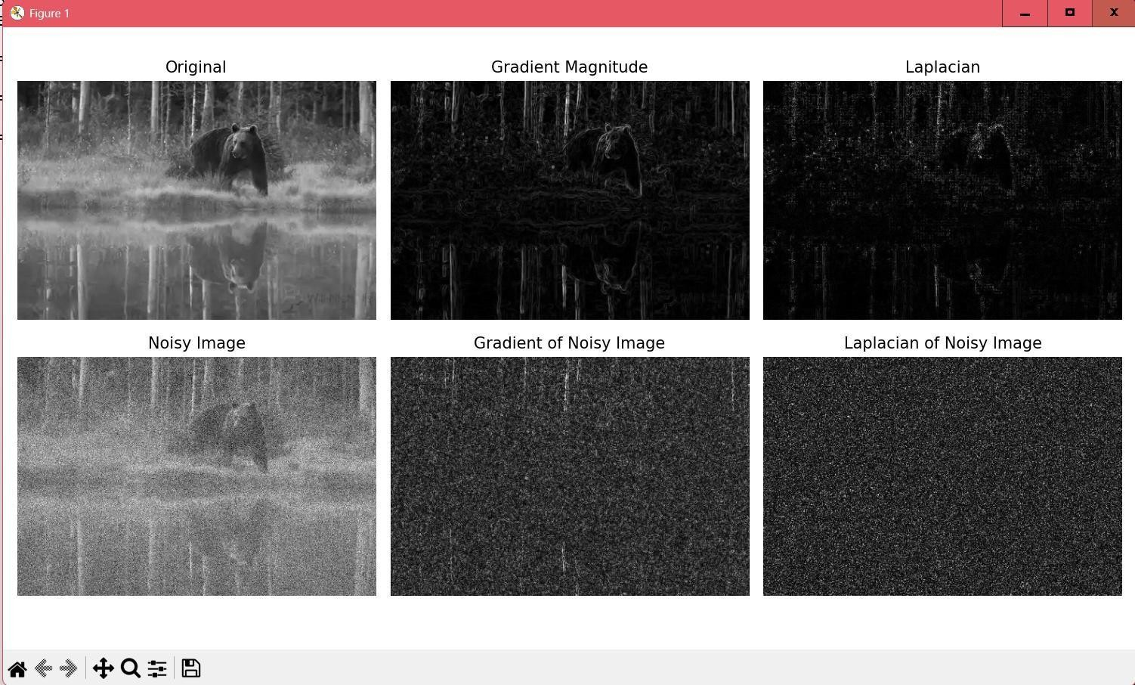

Practical No: 01

Aim: Demonstrate Object-Oriented Databases

Q. Create the following types using OODBMS:
- PersonType ( Per_id, Per_name, DOB)
- BankType (account_no, per_id, balance)

Queries
create or replace type persontype as object(personid number(3),person_name varchar2(20),dob date,member function age return number);
2 /
create or replace type banktype as object(account_no number(20),person ref persontype,balance number(20,2)); 2 /

Create the appropriate tables Insert 5 tuples and run the following queries:
create table person of persontype; create table banktable of banktype;
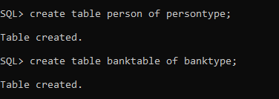

Insert values in the table
SQL> insert into person values(persontype(1,'sam','15-apr-2001')); SQL> insert into person values(persontype(1,'annie','14-apr-2012')); SQL> insert into person values(persontype(3,'marie','14-oct-2004')); SQL> insert into person values(persontype(4,'harry','24-oct-2005')); SQL> insert into person values(persontype(5,'sunny','14-jun-1993')); SQL> insert into person values(persontype(5,'sunny','14-jun-1993'));

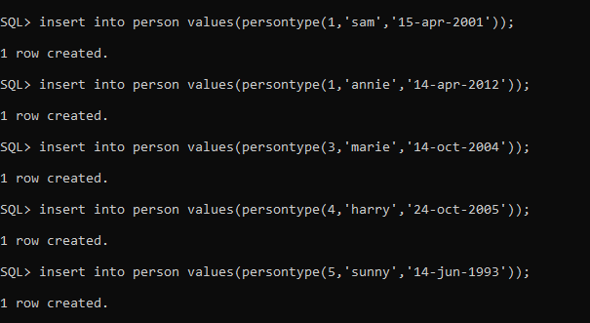

SQL> insert into banktable select 101,ref(p),100000 from person p where p.person_name = 'sam'; SQL> insert into banktable select 102,ref(p),20000 from person p where p.person_name = 'annie'; SQL> insert into banktable select 103,ref(p),30000 from person p where p.person_name = 'marie'; SQL> insert into banktable select 104,ref(p),40000 from person p where p.person_name = 'harry'; SQL> insert into banktable select 105,ref(p),50000 from person p where p.person_name = 'sunny';
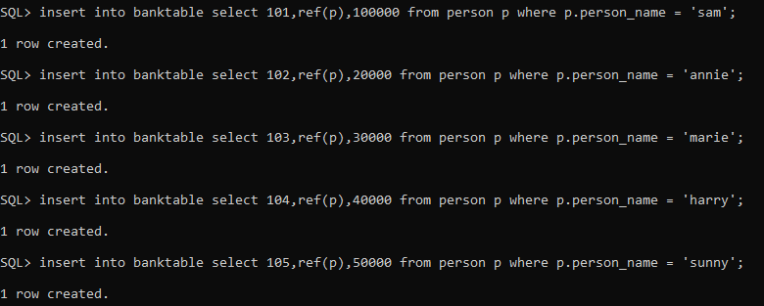
- Find name and age of a person

select p.person_name,p.age() "age" from person p;
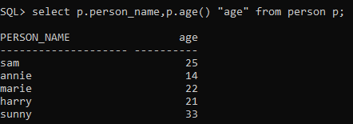

- Find all names with account number.

select p.person_name, b.account_no from banktable b ,person p where p.personid = b.person.personid;
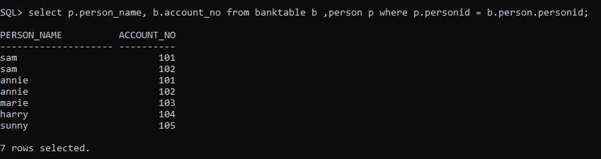

- Find the names with balance more than 12,000

select p.person_name,b.balance from banktable b ,person p where p.personid = b.person.personid and b.balance > 12000;
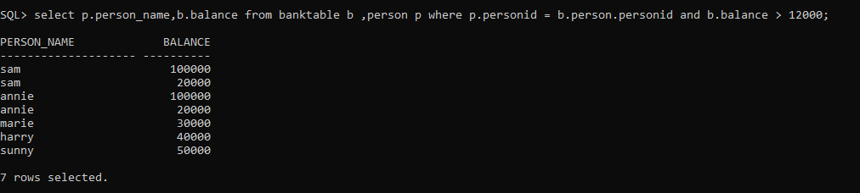

Practical No: 02
Aim: Demonstrate a distributed database environment by dividing a given global database table into
- Horizontal fragment
- Vertical fragments
- Horizontal Fragmentation
Step 1: Go to Browser and Download Oracle 26ai and in get started section -> Extract the zip file -> Run setup.exe (Set username and password – system/system -> Open SQL Plus
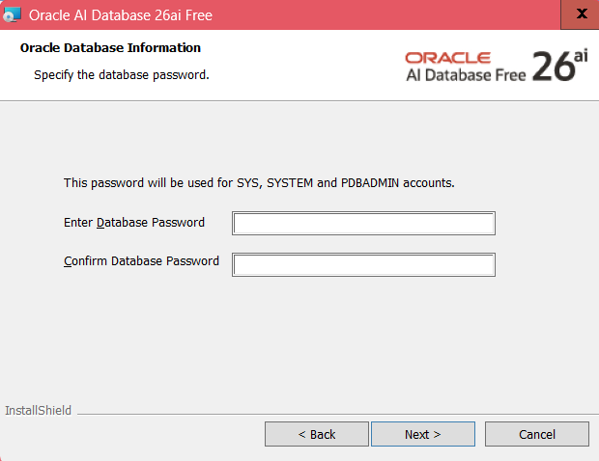
Step 2: Open command prompt and type sqlplus -v to check if SQL Plus is installed or not
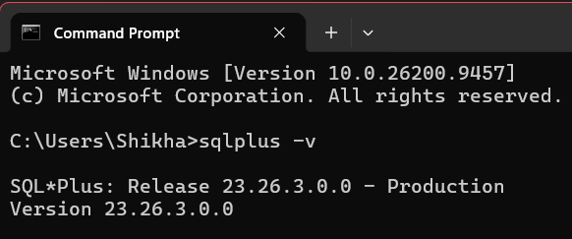
Step 3: Open SQL Plus and enter the username and password Step 4: Implement the following commands:

Connect as SYSTEM and create users
Connect as system CONNECT system@FREE Enter password: system

Allow creation of users without C## prefix in Oracle 12c+ ALTER SESSION SET "_ORACLE_SCRIPT" = true;
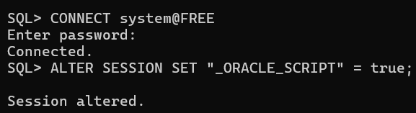

Create users
CREATE USER user1 IDENTIFIED BY u1; CREATE USER user2 IDENTIFIED BY u2; CREATE USER user3 IDENTIFIED BY u3;
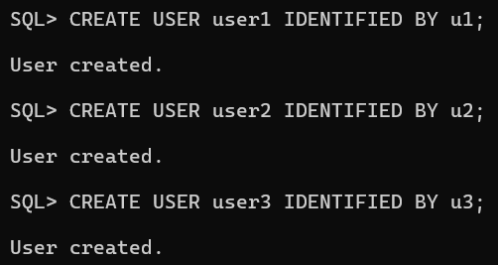

Grant privileges
GRANT CREATE SESSION, CREATE TABLE, CREATE SEQUENCE, CREATE VIEW, CREATE PROCEDURE, CONNECT, RESOURCE, CREATE DATABASE LINK, UNLIMITED TABLESPACE TO user1;

GRANT CREATE SESSION, CREATE TABLE, CREATE SEQUENCE, CREATE VIEW, CREATE PROCEDURE, CONNECT, RESOURCE, CREATE DATABASE LINK, UNLIMITED TABLESPACE TO user2;

GRANT CREATE SESSION, CREATE TABLE, CREATE SEQUENCE, CREATE VIEW, CREATE PROCEDURE, CONNECT, RESOURCE, CREATE DATABASE LINK, UNLIMITED TABLESPACE TO user3;
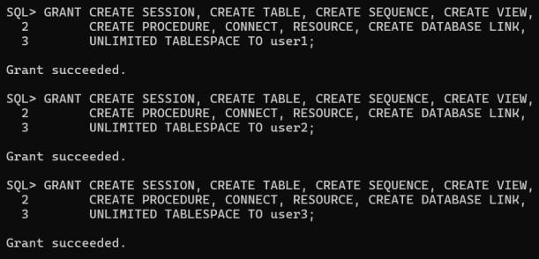

Create the global table Emp and insert records
Still connected as system CREATE TABLE emp (
eno NUMBER(3) PRIMARY KEY, ename VARCHAR2(20),
address VARCHAR2(30), email VARCHAR2(30), sal NUMBER(6)
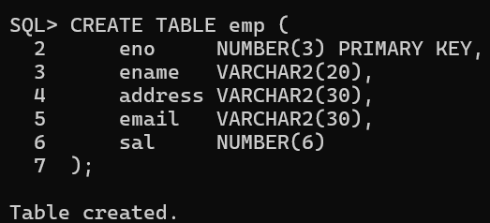
);

INSERT INTO emp VALUES (101, 'ram', 'dadar', 'ram@gmail.com', 10000); INSERT INTO emp VALUES (102, 'tom', 'cst', 'tom@gmail.com', 25000); INSERT INTO emp VALUES (103, 'sam', 'wadala', 'sam@gmail.com', 30000); INSERT INTO emp VALUES (104, 'sonu', 'wadala', 'sonu@gmail.com', 12000); INSERT INTO emp VALUES (105, 'monu', 'matunga', 'monu@gmail.com', 24000);
INSERT INTO emp VALUES (106, 'mona', 'sion', 'mona@gmail.com', 35000); INSERT INTO emp VALUES (107, 'sona', 'sion', 'sona@gmail.com', 40000); INSERT INTO emp VALUES (108, 'harry', 'kurla', 'harry@gmail.com', 30000); INSERT INTO emp VALUES (109, 'marry', 'kurla', 'marry@gmail.com', 60000); INSERT INTO emp VALUES (110, 'anni', 'kurla', 'anni@gmail.com', 10000);

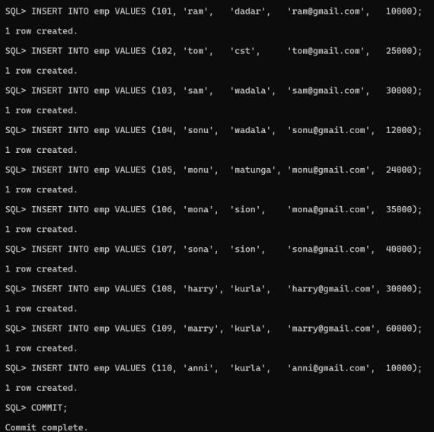
COMMIT;

Create fragment emp1 at USER1
Connect as user1 CONNECT user1@FREE
Password: u1

Create database link to global database (system schema)
CREATE DATABASE LINK l1
CONNECT TO system IDENTIFIED BY system USING 'FREE';
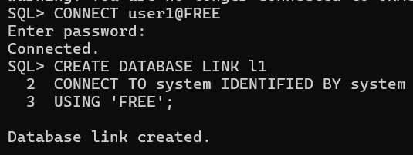

Create horizontal fragment emp1: salary <= 10000
CREATE TABLE emp1 AS
SELECT * FROM emp@l1 WHERE sal <= 10000;

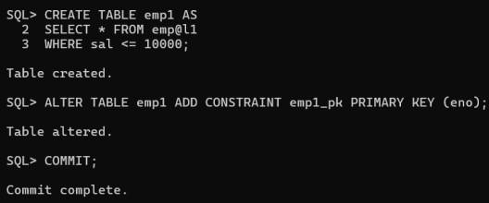
ALTER TABLE emp1 ADD CONSTRAINT emp1_pk PRIMARY KEY (eno); COMMIT;

Create fragment emp2 at USER2
Create horizontal fragment emp2: 10000 < salary <= 20000
CREATE TABLE emp2 AS
SELECT * FROM emp@l22
WHERE sal > 10000 AND sal <= 20000;

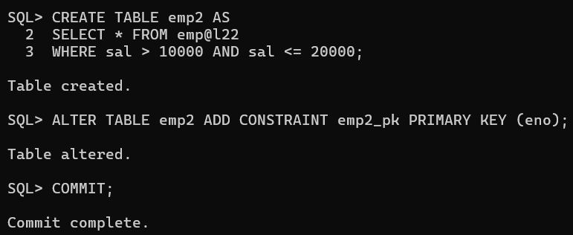
ALTER TABLE emp2 ADD CONSTRAINT emp2_pk PRIMARY KEY (eno); COMMIT;

Create database links in global site and consistency trigger
Connect back as system CONNECT system@FREE

Links from global site to fragment sites CREATE DATABASE LINK l1 CONNECT TO user1 IDENTIFIED BY u1 USING 'FREE';

CREATE DATABASE LINK l22 CONNECT TO user2 IDENTIFIED BY u2 USING 'FREE';
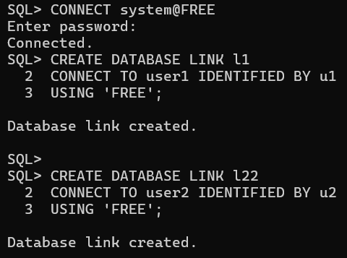
Trigger to route new inserts to correct fragment CREATE OR REPLACE TRIGGER trig_insert_emp

AFTER INSERT ON emp FOR EACH ROW BEGIN
IF :NEW.sal <= 10000 THEN INSERT INTO emp1@l1
VALUES (:NEW.eno, :NEW.ename, :NEW.address, :NEW.email, :NEW.sal);

ELSIF :NEW.sal > 10000 AND :NEW.sal <= 20000 THEN INSERT INTO emp2@l22
VALUES (:NEW.eno, :NEW.ename, :NEW.address, :NEW.email, :NEW.sal);

ELSE
NULL; END IF;
END;
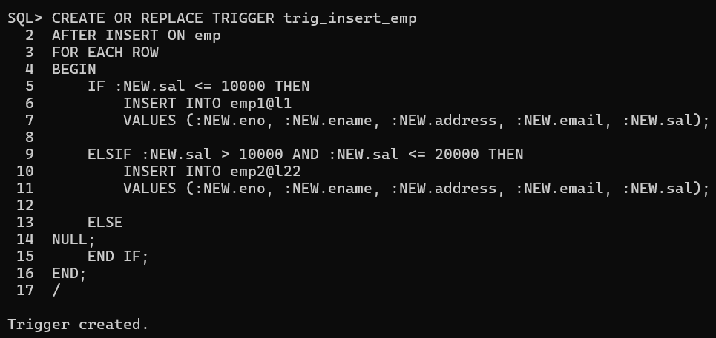
/

Test the trigger
Insert a new employee with salary 14500
INSERT INTO emp VALUES (111, 'ratan', 'bandra', 'ratan@gmail.com', 14500); COMMIT;

Check whether it appears in emp2 SELECT * FROM emp2@l22;
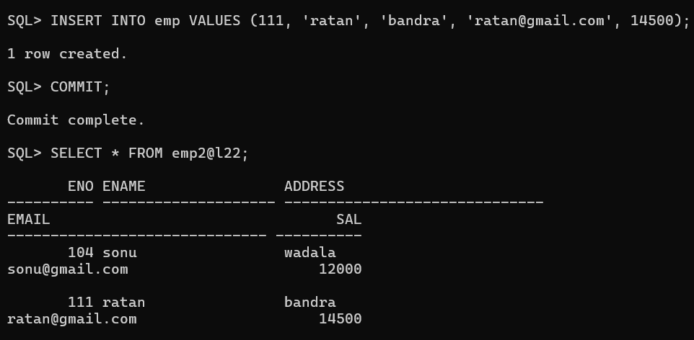

Fire the required queries from USER3
Connect as user3 CONNECT user3@FREE
Password: u3
Create database links
CREATE DATABASE LINK l0
CONNECT TO system IDENTIFIED BY system
USING 'FREE';

CREATE DATABASE LINK l1 CONNECT TO user1 IDENTIFIED BY u1 USING 'FREE';

CREATE DATABASE LINK l22 CONNECT TO user2 IDENTIFIED BY u2 USING 'FREE';
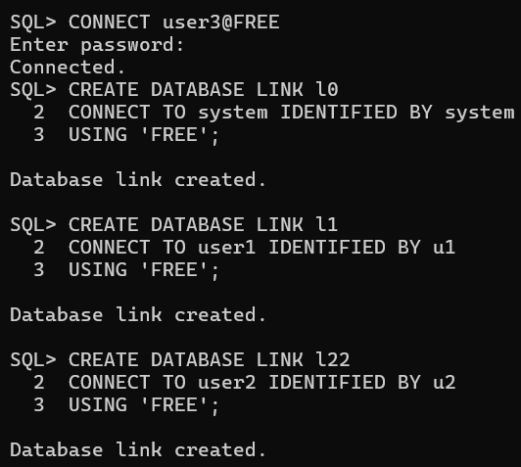

Find the salary of all employees
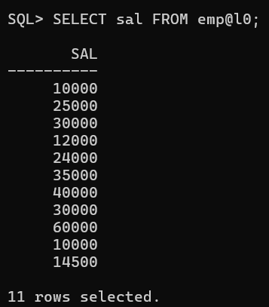
SELECT sal FROM emp@l0;
  - Find the Email of all employees where salary = 12,000
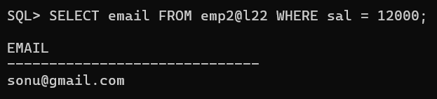
SELECT email FROM emp2@l22 WHERE sal = 12000;

Find the employee name and Email where employee number is known
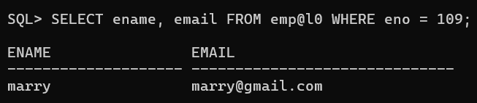
SELECT ename, email FROM emp@l0 WHERE eno = 109;
  - Find the employee name where salary > 20,000
SELECT ename FROM emp@l0 WHERE sal > 20000;

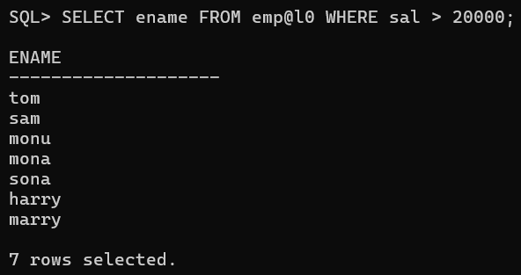

- Perform Vertical Fragmentation on a global conceptual schema Emp(Eno, Ename, Address, email, Salary) and insert 10 records. Divide Emp into vertical fragments Emp1(Eno, Ename, Address) and Emp2(Eno, Email, Salary) on two different nodes. Fire the following queries:
  - Find the salary of an employee where employee number is known.
  - Find the Email where the employee name is known.
  - Find the employee name and email where employee number is known.
  - Find the employee name whose salary is > 2000.

SIDE NOTE: Oracle Connection Error?
If you get ORA-12541 (No Listener) or a login failure:
- Command Prompt: Type lsnrctl status to check. If stopped, type lsnrctl start.
- Windows Services: Press Win + R → type services.msc → Enter. Start Oracle...TNSListener and OracleServiceFREE (or XE).
- College Username – system , Password - tycs

TAB 1 — SYSTEM (Global Database)
Log in to SQLPlus as SYSTEM.*

Step 1: Enable normal user creation
ALTER SESSION SET "_ORACLE_SCRIPT"=true;

Step 2: Create the users
(If user already exists then use the command - DROP USER user1 CASCADE;) CREATE USER user1 IDENTIFIED BY u1;
CREATE USER user2 IDENTIFIED BY u2; CREATE USER user3 IDENTIFIED BY u3;
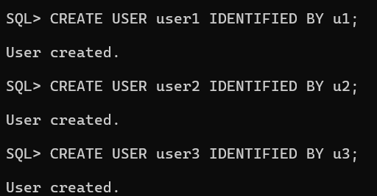

Step 3: Grant privileges to all users
GRANT CREATE SESSION, CREATE TABLE, CREATE SEQUENCE, CREATE VIEW, CREATE PROCEDURE, CONNECT, RESOURCE, CREATE DATABASE LINK, UNLIMITED TABLESPACE TO
user1;
GRANT CREATE SESSION, CREATE TABLE, CREATE SEQUENCE, CREATE VIEW, CREATE PROCEDURE, CONNECT, RESOURCE, CREATE DATABASE LINK, UNLIMITED TABLESPACE TO
user2;
GRANT CREATE SESSION, CREATE TABLE, CREATE SEQUENCE, CREATE VIEW, CREATE PROCEDURE, CONNECT, RESOURCE, CREATE DATABASE LINK, UNLIMITED TABLESPACE TO
user3;

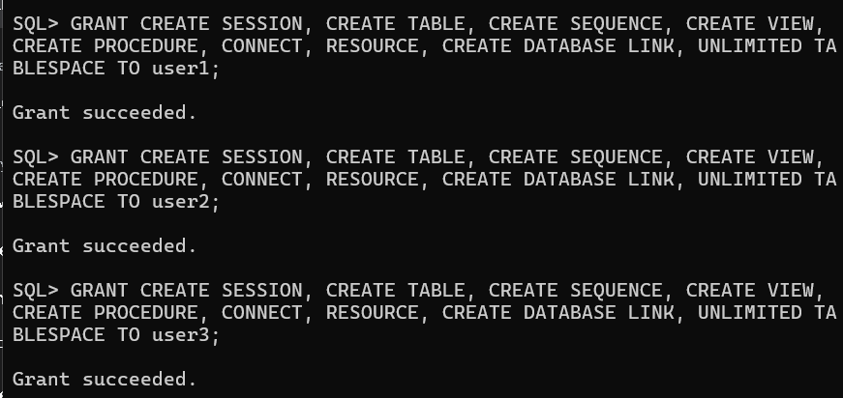

Step 4: Create the global conceptual schema table
CREATE TABLE emp(
eno NUMBER(3) PRIMARY KEY, ename VARCHAR2(20),
address VARCHAR2(30), email VARCHAR2(30), sal NUMBER(6)
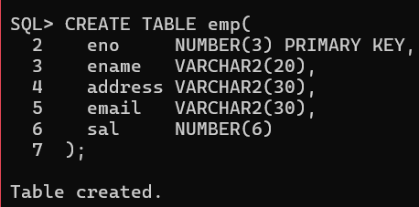
);

Step 5: Insert 10 records
INSERT INTO emp VALUES (101,'ram','dadar','ram@gmail.com',10000); INSERT INTO emp VALUES (102,'tom','cst','tom@gmail.com',25000); INSERT INTO emp VALUES (103,'sam','wadala','sam@gmail.com',30000); INSERT INTO emp VALUES (104,'sonu','wadala','sonu@gmail.com',12000); INSERT INTO emp VALUES (105,'monu','matunga','monu@gmail.com',24000); INSERT INTO emp VALUES (106,'mona','sion','mona@gmail.com',35000); INSERT INTO emp VALUES (107,'sona','sion','sona@gmail.com',40000); INSERT INTO emp VALUES (108,'harry','kurla','harry@gmail.com',30000); INSERT INTO emp VALUES (109,'marry','kurla','marry@gmail.com',60000); INSERT INTO emp VALUES (110,'anni','kurla','anni@gmail.com',10000);

Step 6: Commit and verify
COMMIT;
SELECT * FROM emp;

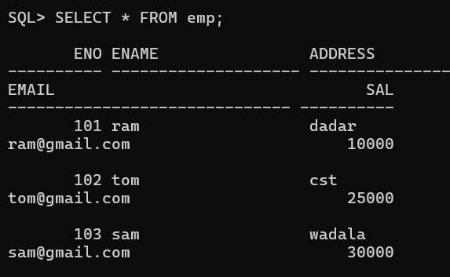

TAB 2 — USER1 (Fragment Emp1)
Open a brand new SQLPlus window. Type the following:
Connect as user1 (No 'USER' keyword!) CONNECT user1@FREE
Enter password: u1

Create database link to global schema
CREATE DATABASE LINK l1 CONNECT TO system IDENTIFIED BY tycs USING 'FREE';

Create the vertical fragment Emp1(Eno, Ename, Address)
CREATE TABLE e1 AS SELECT eno, ename, address FROM emp@l1;

Commit and verify COMMIT;
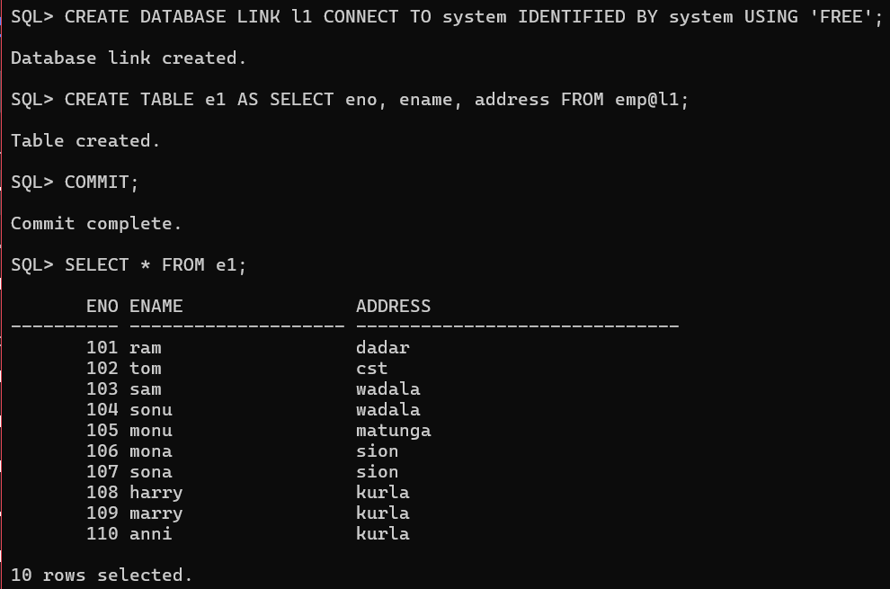
SELECT * FROM e1;

TAB 3 — USER2 (Fragment Emp2)
Open a third SQLPlus window. Type the following: Connect as user1 (No 'USER' keyword!) CONNECT user1@FREE
Enter password: u1

Create database link to global schema

CREATE DATABASE LINK l1 CONNECT TO system IDENTIFIED BY tycs USING 'FREE';

Create the vertical fragment Emp1(Eno, Ename, Address)
CREATE TABLE e1 AS SELECT eno, ename, address FROM emp@l1;

Commit and verify COMMIT;
SELECT * FROM e1;

TAB 3 — USER2 (Fragment Emp2)
Open a third SQLPlus window. Type the following:
Connect as user2 CONNECT user2@FREE
Enter password: u2

Create database link to global schema
CREATE DATABASE LINK l2 CONNECT TO system IDENTIFIED BY tycs USING 'FREE';

Create the vertical fragment Emp2(Eno, Email, Salary)
CREATE TABLE e2 AS SELECT eno, email, sal FROM emp@l2;
Commit and verify COMMIT;
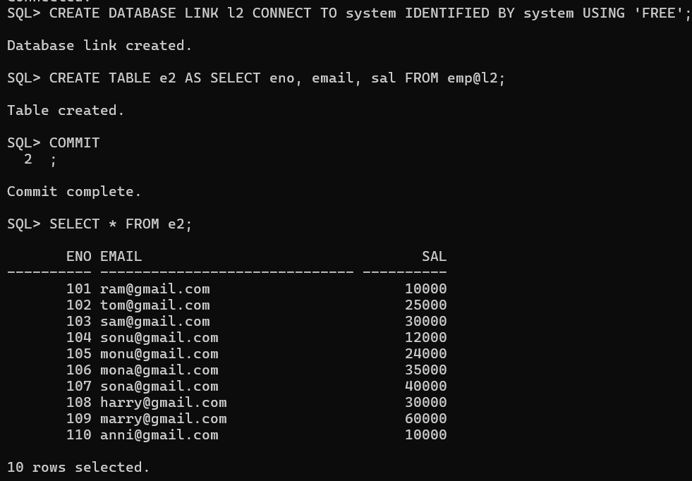
SELECT * FROM e2;

TAB 4 — USER3 (Queries on Fragments)
Open a fourth SQLPlus window. Type the following: Connect as user3
CONNECT user3@FREE
Enter password: u3

Create links to User1 and User2

CREATE DATABASE LINK l11 CONNECT TO user1 IDENTIFIED BY u1 USING 'FREE'; CREATE DATABASE LINK l22 CONNECT TO user2 IDENTIFIED BY u2 USING 'FREE';
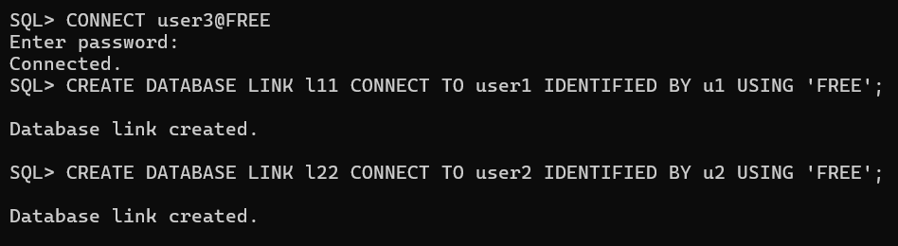

Query a) Find the salary of an employee where employee number is known.
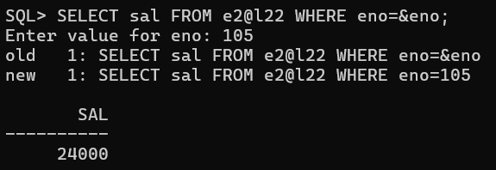
SELECT sal FROM e2@l22 WHERE eno=&eno;

Query b) Find the Email where the employee name is known.
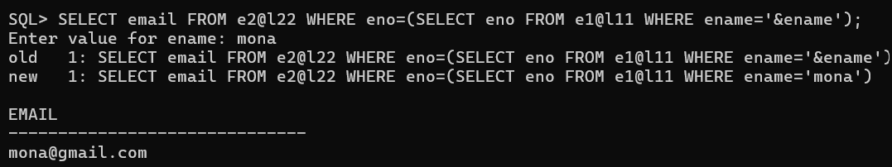
SELECT email FROM e2@l22 WHERE eno=(SELECT eno FROM e1@l11 WHERE ename='&ename');

Query c) Find the employee name and email where employee number is known.
SELECT e1.ename, e2.email FROM e1@l11 e1, e2@l22 e2
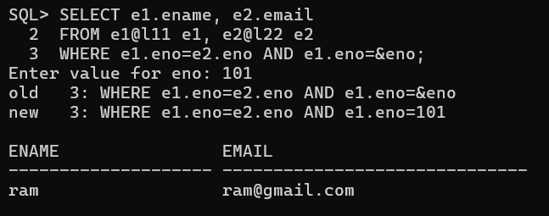
WHERE e1.eno=e2.eno AND e1.eno=&eno;
Query d) Find the employee name whose salary is > 2000.
SELECT ename FROM e1@l11 WHERE eno IN (SELECT eno FROM e2@l22 WHERE sal>2000);

Practical No: 03
Aim: Perform the CRUD operations using
- MongoDB
- CouchDB

MongoDB
Step 1: Download MongoDB Server, MongoDB Shell (mongosh) / Compass
Step 2: Open the terminal and type mongosh to start the connection (Error: Check Environment Variables) Step 3: Start with the implementation

Create Database and Collection
use CollegeDB db.createCollection("students")
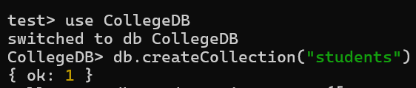

Insert at least 5 student documents
db.students.insertMany([
{_id: 1, name: "Rahul", age: 22, department: "Computer Science", semester: 2, city: "Mumbai", marks: 85, skills: ["Java", "MongoDB", "Python"]},
{_id: 2, name: "Priya", age: 21, department: "Computer Science", semester: 2, city: "Delhi", marks: 78, skills: ["C++", "MongoDB"]},
{_id: 3, name: "Amit", age: 23, department: "IT", semester: 4, city: "Pune", marks: 92, skills: ["Python", "SQL"]},
{_id: 4, name: "Sneha", age: 20, department: "AI", semester: 2, city: "Bangalore", marks: 88, skills: ["Python", "Machine Learning", "MongoDB"]},
{_id: 5, name: "Vikram", age: 24, department: "IT", semester: 6, city: "Chennai", marks: 35, skills: ["Java"]},
{_id: 6, name: "Ananya", age: 22, department: "AI", semester: 4, city: "Hyderabad", marks: 95, skills: ["Deep Learning", "MongoDB"]}
])

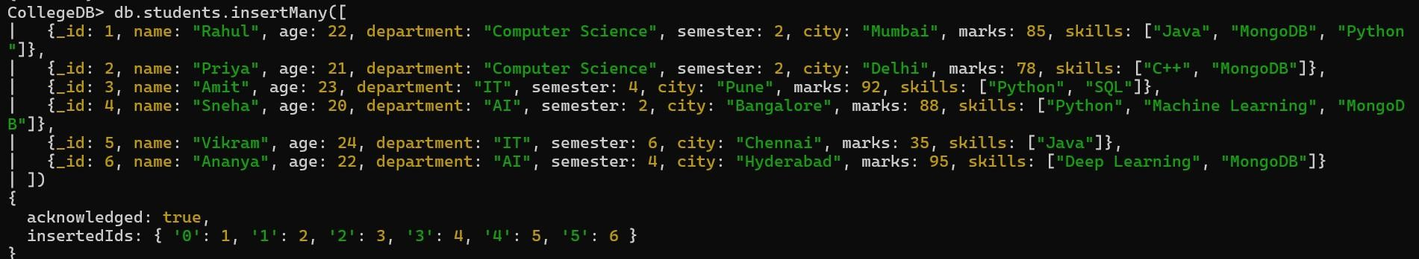

Display all students belonging to the Computer Science department.
db.students.find({ department: "Computer Science" })
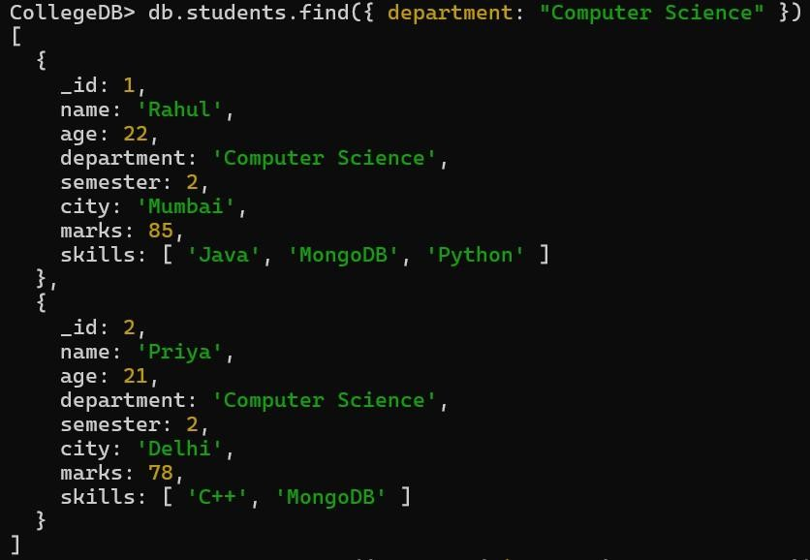

Find all students whose marks are greater than 80 and who belong to Semester 2
db.students.find({ marks: { $gt: 80 }, semester: 2 })
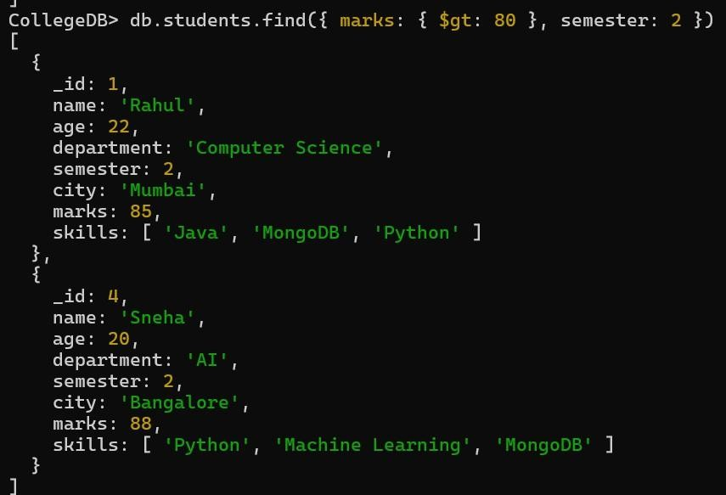

- Display only the name, department, and marks of all students without displaying the _id field

db.students.find({}, { _id: 0, name: 1, department: 1, marks: 1 })
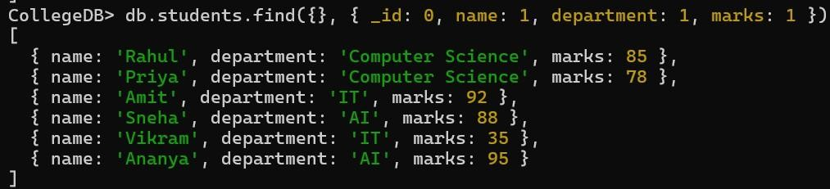

Display all students sorted by marks in descending order
db.students.find().sort({ marks: -1 })
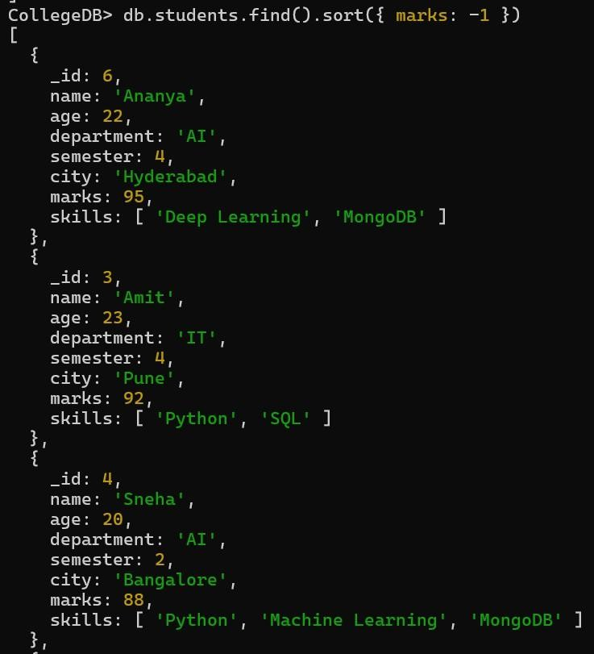

Find all students who have "MongoDB" as one of their skills
db.students.find({ skills: "MongoDB" })

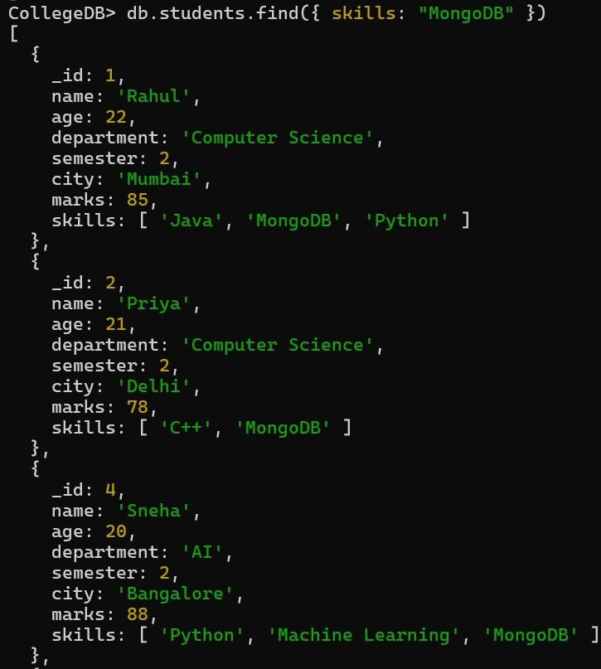

Increase all students' marks by 5
db.students.updateMany({}, { $inc: { marks: 5 } })
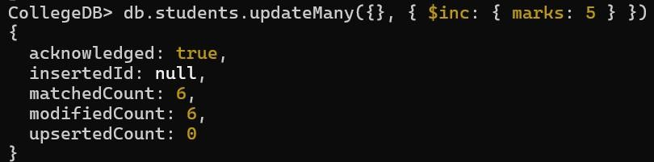

Delete all student records whose marks are less than 40
db.students.deleteMany({ marks: { $lt: 40 } })

Using the Aggregation Framework, calculate the average marks of students department-wise
db.students.aggregate([
{ $group: { _id: "$department", averageMarks: { $avg: "$marks" } } }
])

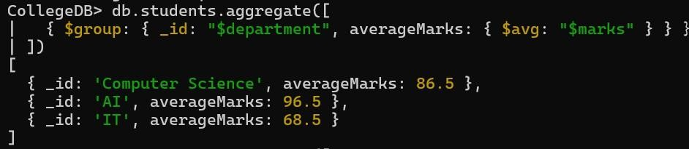

Write an aggregation query to display the number of students in each department
db.students.aggregate([
{ $group: { _id: "$department", totalStudents: { $sum: 1 } } }
])
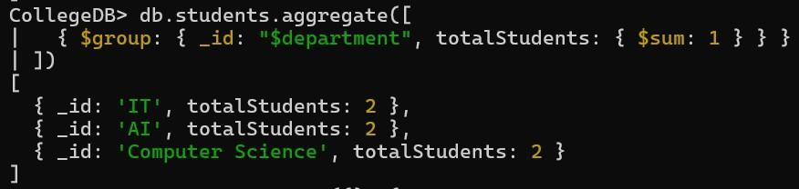

Find the top 3 highest-scoring students and display only their name, department, and marks
db.students.find({}, { _id: 0, name: 1, department: 1, marks: 1 }).sort({ marks: -1 }).limit(3)
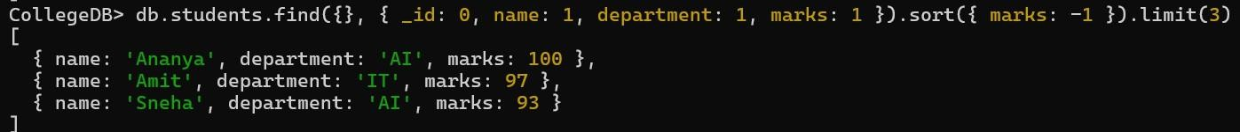

Indexing
Step 1: Open the terminal and type mongosh Step 2: Perform the following queries

Setup and Data Insertion
use CollegeDB db.students.insertMany([
{ _id: 1, name: "Rahul", department: "Computer Science", email: "rahul@gmail.com", marks: 85, semester: 2
},
{ _id: 2, name: "Priya", department: "Computer Science", email: "priya@gmail.com", marks: 78, semester: 2 },
{ _id: 3, name: "Amit", department: "IT", email: "amit@gmail.com", marks: 92, semester: 4 },
{ _id: 4, name: "Sneha", department: "AI", email: "sneha@gmail.com", marks: 88, semester: 2 },
{ _id: 5, name: "Vikram", department: "IT", email: "vikram@gmail.com", marks: 35, semester: 6 }
])

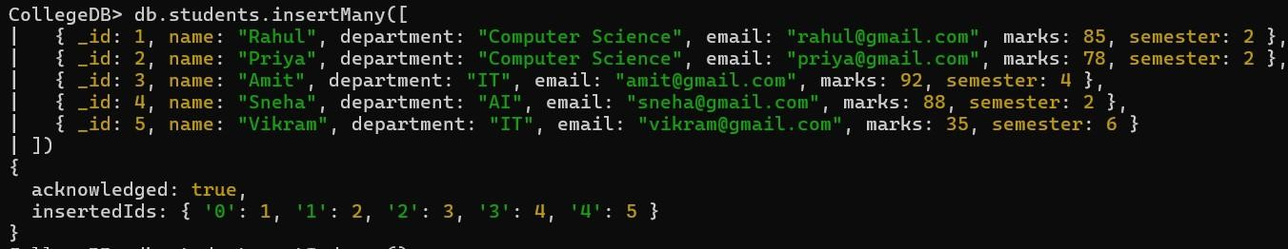

Check Indexes Before Creation
db.students.getIndexes()
Explanation: Lists all existing indexes on the collection. By default, MongoDB only creates an index on _id

Measure Performance BEFORE Indexing (Collection Scan)
db.students.find({ email: "rahul@gmail.com" }).explain("executionStats")
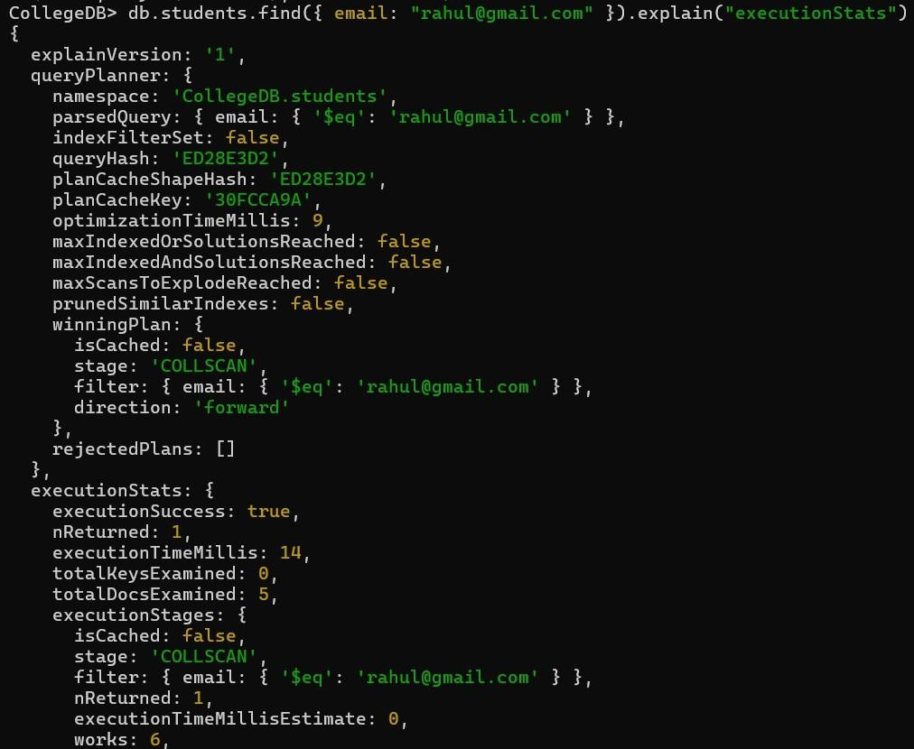

Explanation: Runs the query and provides detailed execution stats. Because there is no index on email, MongoDB must scan every single document to find a match.
Output (Key Metrics):
winningPlan.stage: "COLLSCAN" (Collection Scan) totalDocsExamined: 5 (Scanned all 5 documents) totalKeysExamined: 0 (No index keys used) executionTimeMillis: 8 (Takes time to scan)

Create an Index

db.students.createIndex({ "email": 1 })
Explanation: Creates a single-field ascending index on the email field to speed up future email searches.

Check Indexes After Creation
db.students.getIndexes()
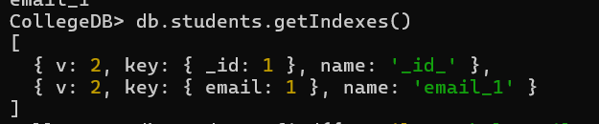

Measure Performance AFTER Indexing (Index Scan)
db.students.find({ email: "rahul@gmail.com" }).explain("executionStats")
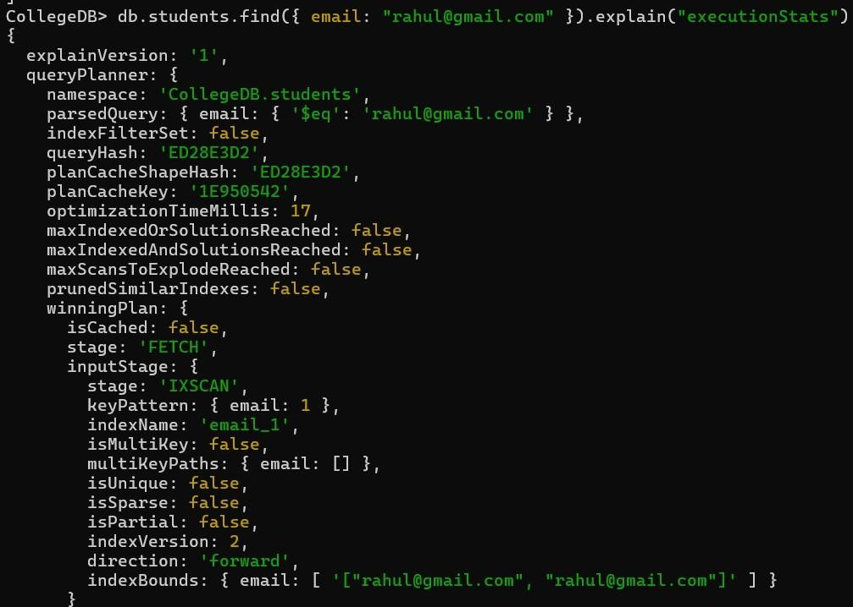

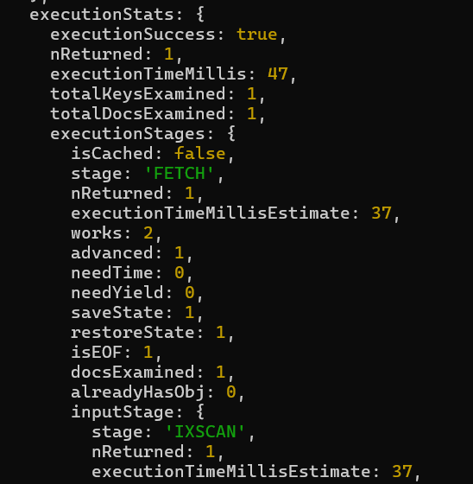
Explanation: Runs the exact same query again. MongoDB now uses the index to instantly locate the document, drastically reducing the amount of data it needs to read.
Output (Key Metrics):
winningPlan.stage: "FETCH" (Fetches the document) inputStage.stage: "IXSCAN" (Index Scan - fast) totalDocsExamined: 1 (Only 1 document scanned)
totalKeysExamined: 1 (Used 1 index key) executionTimeMillis: 0 (Instant execution)

Drop or Delete the Index
db.students.dropIndex({ "email": 1 })

Verify the Index has been Dropped
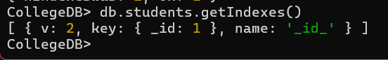
db.students.getIndexes()

2) CouchDB

Step 1) Downloaded the Windows .msi installer from the official Apache CouchDB website Run the installer set an Username - admin and Password - 123 and chose Single Node setup
After installation opened a web browser and go to the CouchDB welcome page http://localhost:5984

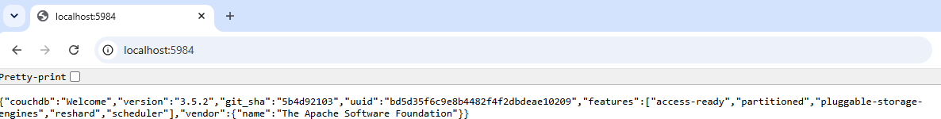

Opened the administration interface: http://localhost:5984/_utils

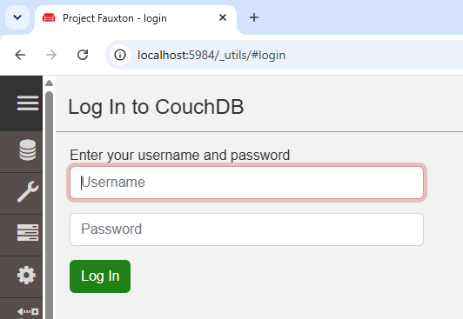

Step 2: Create Database
In the interface look at the top right corner Clicked the Create Database button
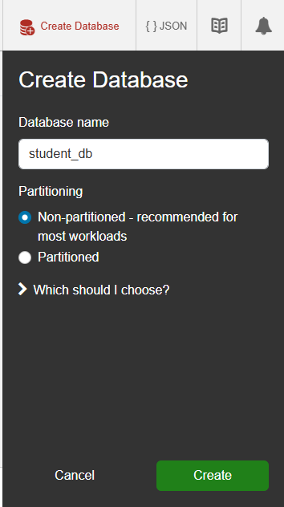
Typed the database name student_db and clicked Create

Step 3: Insert Data (Create Document)
Inside the student_db database, looked at the top right corner Clicked the Create Document button
In the JSON editor, replaced the default {} with the following data: json
{
"rollno": 1, "name": "sony",
"email"sony@gmail.com"
}
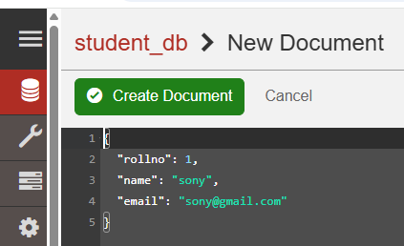

Clicked Create Document to save it
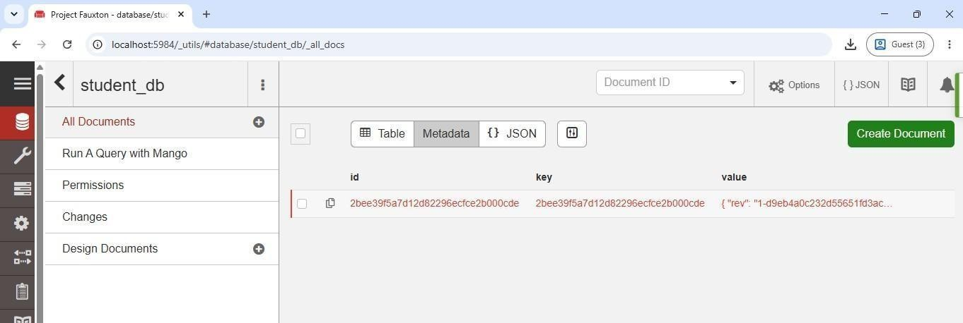

Step 4: View Data (Read)
Clicked on All Documents in the left sidebar
Switched the view to Table View (using the toggle option in the top middle part) to see the data in a structured format
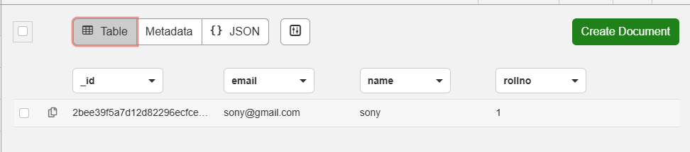

Step 5: Update Data (Update)
Clicked on the document to open it
Edited the JSON data. For example, changed "name": "sony" to "name": "snehal" Clicked the Save Changes button (located at the top left corner)
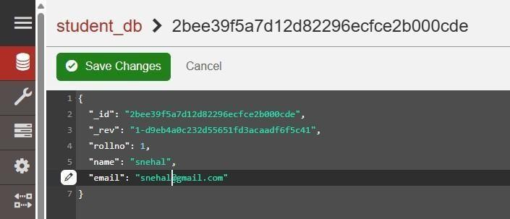

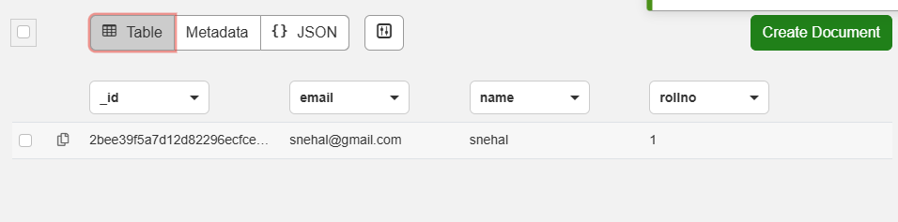

Step 6: Delete Data (Delete Document) Returned to Table View (All Documents)
Checked the checkbox on the left side of the row to be deleted Clicked the Delete icon (trash can) at the top
Confirmed the deletion on the prompt
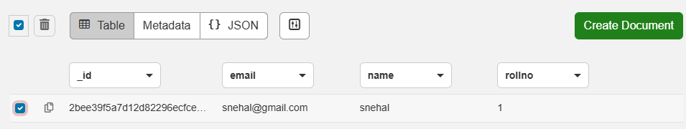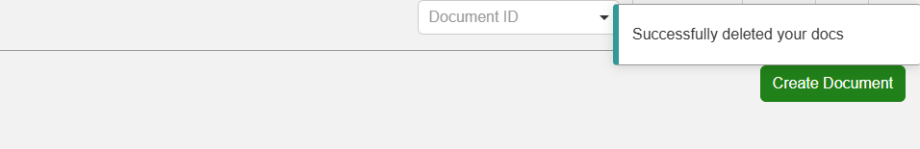

Step 7: Delete Database
Clicked the Database icon on the far left sidebar to return to the main database list Located student_db in the list
Clicked the Delete icon (trash can) next to the database name

In the confirmation prompt, typed student_db and clicked Delete
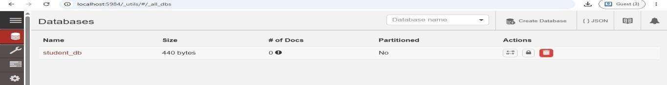

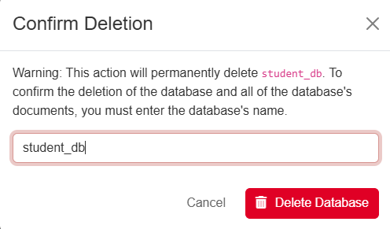
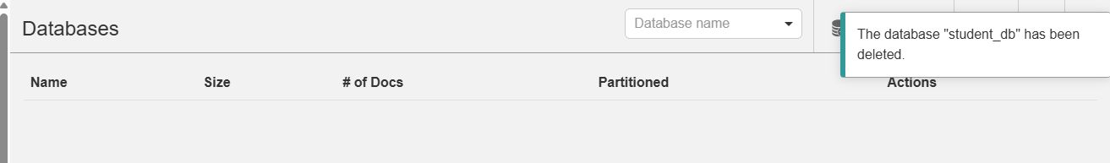

Practical No: 04
Aim: Perform the CRUD operations using
- Redis
- Apache Cassandra

Part A – Redis
Step 1: Installation and Starting the Server
- Downloaded and extracted the Redis zip file to a directory (e.g., `E:\redis`)
- Opened Command Prompt and navigated to the Redis directory
- Started the Redis Server by running redis-server.exe
- Opened a second Command Prompt window and started the Redis Client by running redis-cli.exe
- Tested the connection using the PING command Commands redis
ping
ping "hello world"
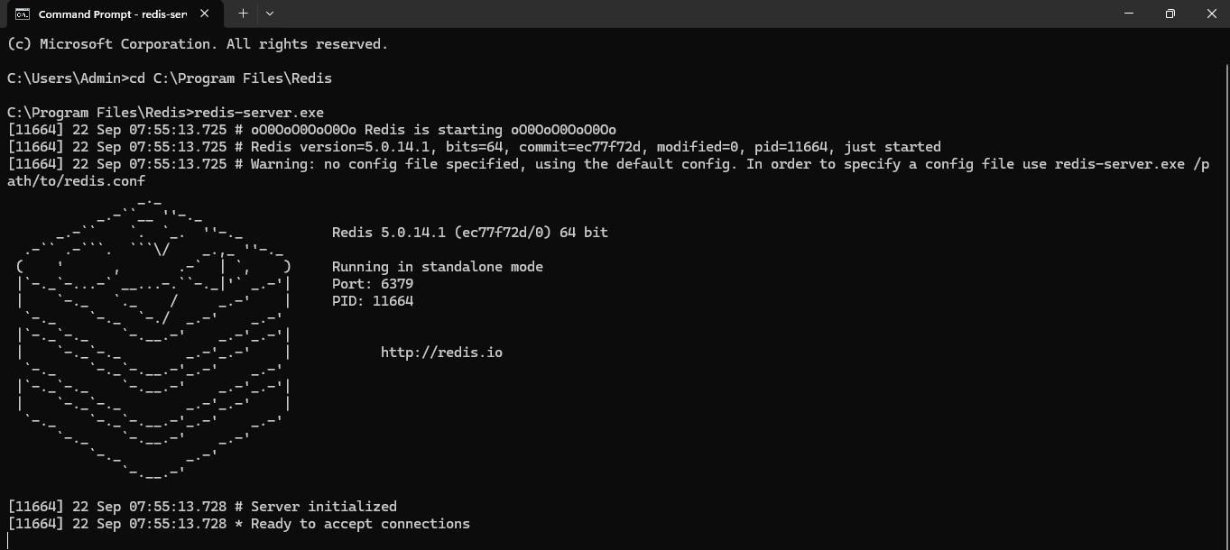
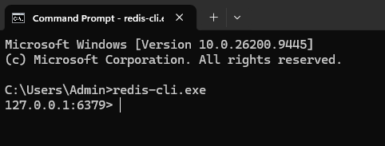

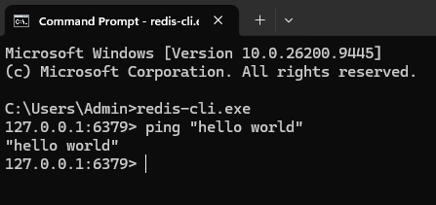

Step 2: Redis Strings (SET, GET, EXPIRE, APPEND, STRLEN)
Strings are the most basic data type in Redis we performed operations to add, view, and manipulate string values
Commands redis
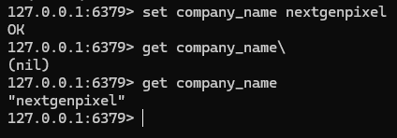
set company_name nextgenpixel get company_name
setex brand_name 10 pixel get brand_name get brand_name
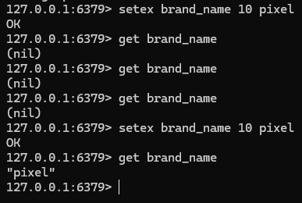

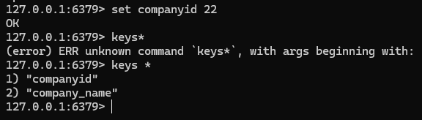
set company_id 22 keys *
del name keys *
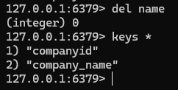
ttl head
expire head 10
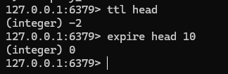

set phone_no 92959252952
expire phone_no 10 keys *
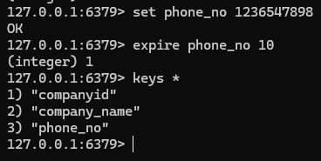

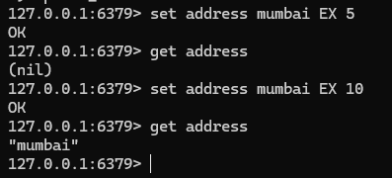
set address mumbai EX 5 get address
append company_name .co.in get company_name
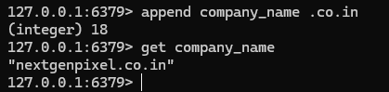
append company_name website get company_name
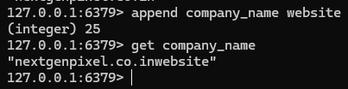
strlen company_name
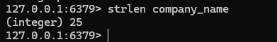
del companyid keys *
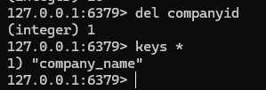
flushall keys *

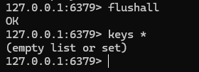

Step 3: Redis Lists (LPUSH, RPUSH, LRANGE, LPOP, RPOP, BLPOP)
Redis Lists are simply lists of strings, sorted by insertion order elements can be added to the head or the tail of the list
Commands redis
LPUSH company_name nextgenpixel LPUSH company_name adobe LPUSH company_name frolikpixel LRANGE company_name 0 10
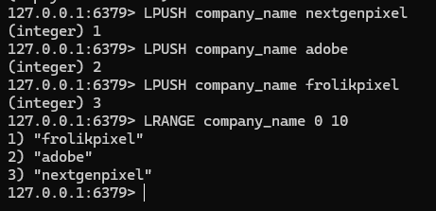
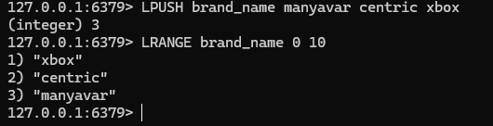
LPUSH brand_name manyavar centric xbox LRANGE brand_name 0 10
RPUSH brand_name web_engage LRANGE brand_name 0 10

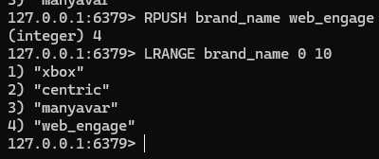
LINDEX brand_name 2
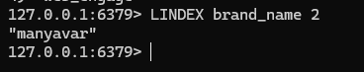
LSET brand_name 1 xbox360 LRANGE brand_name 0 10
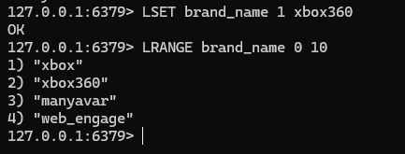
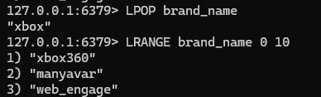
LPOP brand_name LRANGE brand_name 0 10
RPOP brand_name LRANGE brand_name 0 10
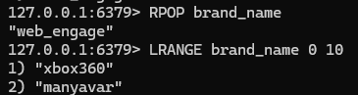
BLPOP brand_name 5
LRANGE brand_name 0 10

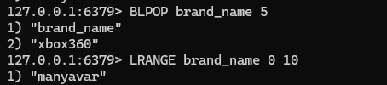
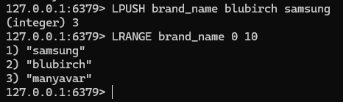
LPUSH brand_name blubirch samsung LRANGE brand_name 0 10

Step 4: Redis Sets (SADD, SMEMBERS, SCARD, SISMEMBER, SREM)
Redis Sets are an unordered collection of unique strings we performed operations to add, view, and remove members from sets
Commands redis
SADD company_name bluebirchentaix biretail zentaix SMEMBERS company_name
SCARD company_name
In Redis, a single key can only hold one type of data.
Earlier in the Lists section, you ran LPUSH company_name .This made the key company_name a List. Now you are trying to run SADD company_name , which is for Sets. Redis is saying: "I can't do Set operations on a List!"
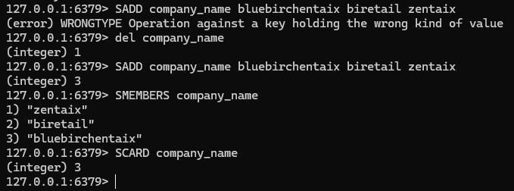

SADD brand_name posiflex SADD brand_name dinglix SADD brand_name spacex SADD brand_name valience
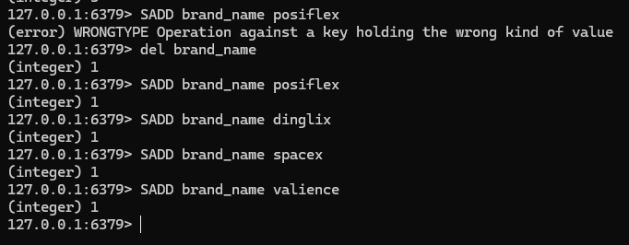
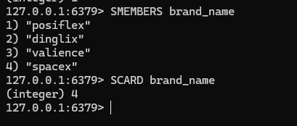
SMEMBERS brand_name SCARD brand_name

SISMEMBER brand_name spacex SREM brand_name spacex SMEMBERS brand_name
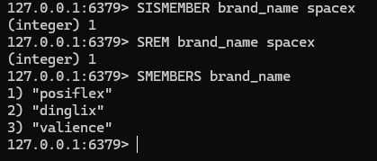
del brand_name SMEMBERS brand_name
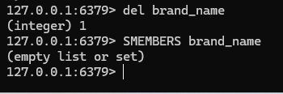

Part B – Apache Cassandra
Step 1) To start the Apache Cassandra -> Open Command Prompt window and launched the CQL shell: cmd
cqlsh
Showing the Cassandra server starting in one window and the `cqlsh` prompt connected in the second window

Step 2: Keyspace Operations
A keyspace is an object that holds column families (tables). It is similar to a database in RDBMS. CREATE KEYSPACE cscorner
WITH replication = {'class':'SimpleStrategy', 'replication_factor':3}; DESCRIBE cscorner;
USE cscorner;
ALTER KEYSPACE cscorner
WITH replication = {'class':'NetworkTopologyStrategy', 'replication_factor':1}; Showing the successful creation and description of the `cscorner` keyspace

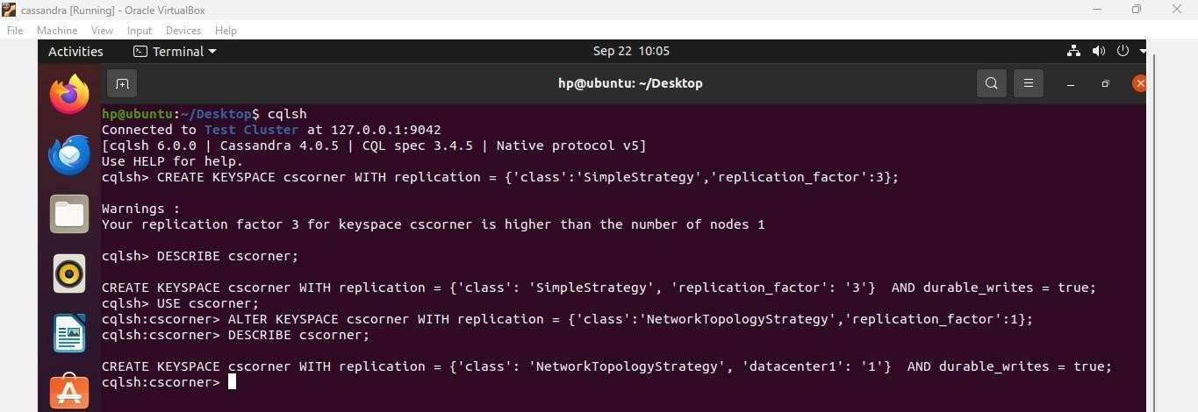

Step 3: Create Table and Insert Data (Create)
We created a table named `students` and inserted records into it.
CREATE TABLE students ( rollno int PRIMARY KEY, name text,age int); INSERT INTO students(rollno, name, age) VALUES (1, 'sunita', 18);
INSERT INTO students(rollno, name, age) VALUES (2, 'code with sunita', 20); SELECT * FROM students;

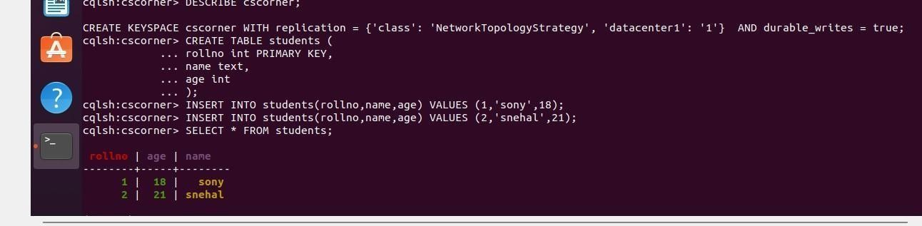

Step 4: Update Data (Update)
We updated the age of the student with `rollno = 1`. Commands UPDATE students SET age = 22 WHERE rollno = 1; SELECT * FROM students;
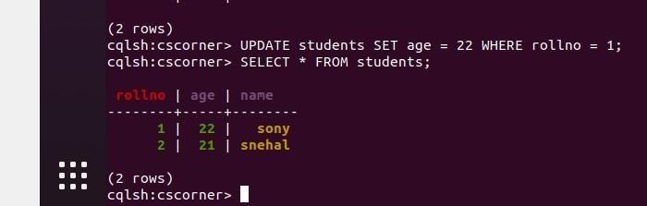

Step 5: Delete Data (Delete)
We deleted the student with `rollno = 2`. DELETE FROM students WHERE rollno = 2; SELECT * FROM students;
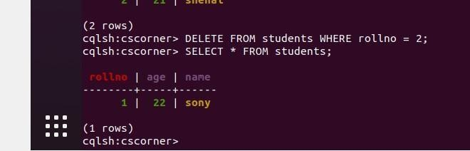

Step 6: Dropping Table and Keyspace
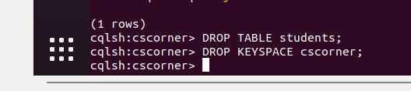
Finally, we cleaned up the environment by dropping the table and the keyspace. DROP TABLE studen

