|  |
| --- |
| MOBILE APPLICATIONS DEVELOPMENT LAB  CSLR-34 |

|  |  |
| --- | --- |
| 11/03/2021 | Experiment- 6 |

Submitted By: -

**Supria Basak**

**106118116**

**CSE**

QUESTION-1: DESIGN AN ANDROID APPLICATION USING ANDROID STUDIO WITH THE FOLLOWING SPECIFICATIONS.

Design an Android application using Android Studio with the following specifications.  
i) In an activity, include a title, 3 radio buttons (Mail, Notes,Video Capture) and a submit button. Selection of each radio button redirects to one activity.  
ii) In activity 1, have textviews and text boxes for the sender address, subject of the mail and body of the mail. Have a ‘Send’ button, upon clicking it should open the Gmail app with the contents using implicit intents.  
iii) In activity 2, have textviews and text boxes for the heading of the notes and message. Have a ‘Save notes’ button, upon clicking it should open the Notes app with the contents using implicit intents.  
iii) In activity 3, have a button which opens the camera app in video mode.

**EXPERIMENT NAME**: To create an application using Implicit & Explicit Intents.

**AIM:** To create an application using Implicit & Explicit Intents.

**DESCRIPTION OF APP:**

* The user needs to select an option from 3 different choices.
* On selecting an option and clicking submit button, they will be moved to corresponding activities using explicit intents.
* If chosen Send Gmail option, we get redirected to Gmail options. There after entering valid receiver's email and corresponding subject and content, if we click on submit, we will redirect to Gmail app with fields filled accordingly.
* If we choose Take Note option, we will be redirected to Note taker activity. In which after entering valid title and text ,upon clicking save we get redirect to Google keep notes app with corresponding fields filled.
* If we choose Video capture we will get redirected to Capture Video activity, upon clicking open camera button we will be redirected to camera with Video mode.

**DEVICE SPECIFICATION:**

**Device Name: -** Samsung S10  
**Android Version: - Android 11**  
**API Level: -** 30  
**Screen Size: -** 6 inch

**TECHNICAL CONCEPTS LEARNT:**

* **Intents :** To connect activities with activities or components.
* **Explicit Intent :** To link two activites
* **Implicit Intent :** To link our activity to activities of other apps or components
* **Toast:** To show a short time pop-up message
* **Intent.putExtra :** To pass parameters using intents
* **SetOnClickListener :** To define an action when a view is clicked
* **TextView :** View related to showing text
* **Button :** Viewto perform actions when clicked on them
* **RadioGroup :** To group department choices
* **RadioButton :** To show department choices

**SOURCE CODE:**

**MainActivity.java**

package com.example.lab_6;  
  
import androidx.appcompat.app.AppCompatActivity;  
  
import android.content.Intent;  
import android.os.Bundle;  
import android.view.View;  
import android.widget.Button;  
import android.widget.RadioButton;  
import android.widget.RadioGroup;  
import android.widget.TextView;  
import android.widget.Toast;  
  
public class MainActivity extends AppCompatActivity {  
 private TextView welcome;  
 private RadioButton sub1,sub2,sub3;  
 private Button submit,back;  
 private RadioGroup rg;  
 @Override  
 protected void onCreate(Bundle savedInstanceState) {  
 super.onCreate(savedInstanceState);  
 setContentView(R.layout.*activity_main*);  
 welcome = findViewById(R.id.*result*); rg = findViewById(R.id.*rg*);  
 sub1 = findViewById(R.id.*sub1*); sub2 = findViewById(R.id.*sub2*); sub3 = findViewById(R.id.*sub3*);  
  
 submit = findViewById(R.id.*submit*); submit.setOnClickListener(new View.OnClickListener() {  
 @Override  
 public void onClick(View v) {  
 if (rg.getCheckedRadioButtonId() == -1) {  
 Toast.*makeText*(getApplicationContext(), "Choose an option",  
 Toast.*LENGTH_LONG*).show();  
 return;  
 }  
  
 if (sub1.isChecked()) {  
 Toast.*makeText*(getApplicationContext(), "Welcome,Launching Mail activity", Toast.*LENGTH_LONG*).show();  
 Intent i=new Intent(getApplicationContext(),mail.class);  
 startActivity(i);  
 } else if (sub2.isChecked()) {  
 Toast.*makeText*(getApplicationContext(), "Welcome,Launching Note activity", Toast.*LENGTH_LONG*).show();  
 Intent i=new Intent(getApplicationContext(),Note.class); startActivity(i);  
 } else if (sub3.isChecked()) {  
 Object camera;  
 Toast.*makeText*(getApplicationContext(), "Welcome,Launching Camera activity", Toast.*LENGTH_LONG*).show();  
 Intent i=new  
 Intent(getApplicationContext(),camera_open.class);  
 startActivity(i);  
 }  
  
  
 }  
 });  
  
 }  
}

**Activity_main.xml**

<?xml version="1.0" encoding="utf-8"?>  
<LinearLayout xmlns:android="http://schemas.android.com/apk/res/android"  
 xmlns:app="http://schemas.android.com/apk/res-auto"  
 xmlns:tools="http://schemas.android.com/tools"  
 android:layout_width="match_parent"  
 android:layout_height="match_parent"  
 tools:context=".MainActivity">  
 android:orientation="vertical"  
 android:background="@color/design_default_color_secondary">  
  
 <LinearLayout  
 android:layout_width="match_parent"  
 android:layout_height="match_parent"  
 android:orientation="vertical"  
 android:layout_margin="20sp">  
  
 <TextView  
 android:id="@+id/result"  
 android:layout_width="wrap_content"  
 android:layout_height="wrap_content"  
 android:layout_gravity="center"  
 android:text="Explicit Intents"  
 android:textColor="#2C3CA5"  
 android:textSize="35sp"  
 android:textStyle="bold"  
 tools:text="Explicit Intents" />  
  
 <RadioGroup  
 android:id="@+id/rg"  
 android:layout_width="wrap_content"  
 android:layout_height="wrap_content"  
 app:layout_constraintTop_toBottomOf="@id/result"  
 android:layout_marginTop="50sp"  
 app:layout_constraintLeft_toLeftOf="parent"  
 android:layout_gravity="center">  
  
 <RadioButton  
 android:id="@+id/sub1"  
 android:layout_width="wrap_content"  
 android:layout_height="wrap_content"  
 android:layout_marginLeft="20sp"  
 android:layout_marginTop="50sp"  
 android:buttonTint="#ffff00"  
 android:text="Send Gmail"  
 android:textColor="@color/black"  
 android:textSize="30sp"  
 app:layout_constraintLeft_toLeftOf="parent"  
 app:layout_constraintTop_toBottomOf="@id/result" />  
  
 <RadioButton  
 android:id="@+id/sub2"  
 android:layout_width="wrap_content"  
 android:layout_height="wrap_content"  
 android:layout_marginLeft="20sp"  
 android:buttonTint="#ffff00"  
 android:text="Take Note"  
 android:textColor="@color/black"  
 android:textSize="30sp"  
 app:layout_constraintLeft_toLeftOf="parent"  
 app:layout_constraintTop_toBottomOf="@id/sub1" />  
  
 <RadioButton  
 android:id="@+id/sub3"  
 android:layout_width="wrap_content"  
 android:layout_height="wrap_content"  
 android:layout_marginLeft="20sp"  
 android:buttonTint="#ffff00"  
 android:text="Video Capture"  
 android:textColor="@color/black"  
 android:textSize="30sp"  
 app:layout_constraintLeft_toLeftOf="parent"  
 app:layout_constraintTop_toBottomOf="@id/sub2" />  
  
  
 </RadioGroup>  
  
 <Button  
 android:id="@+id/submit"  
 android:layout_width="wrap_content"  
 android:layout_height="wrap_content"  
 android:layout_marginTop="60sp"  
 android:textSize="20sp"  
 android:layout_gravity="center"  
 android:backgroundTint="#ffffe8"  
 android:textColor="#202020"  
 android:text="submit"/>  
  
 </LinearLayout>  
  
</LinearLayout>

**mail.java**

package com.example.lab_6;  
  
import androidx.appcompat.app.AppCompatActivity;  
  
import android.content.Intent;  
import android.net.Uri;  
import android.os.Bundle;  
import android.view.View; import android.widget.Button;  
import android.widget.EditText; import android.widget.Toast;  
  
  
public class mail extends AppCompatActivity {  
 EditText email,subject,content;  
 String email_ans,subject_ans,content_ans; Button submit;  
  
 @Override  
 protected void onCreate(Bundle savedInstanceState) {  
 super.onCreate(savedInstanceState);  
 setContentView(R.layout.*activity_mail*);  
 email = findViewById(R.id.*email_answer*);  
 subject = findViewById(R.id.*subject_answer*);  
 content = findViewById(R.id.*content_answer*);  
 submit = findViewById(R.id.*submit1*);  
  
 submit.setOnClickListener(new View.OnClickListener() { @Override  
 public void onClick(View v) {  
 email_ans = email.getText().toString();  
 subject_ans = subject.getText().toString();  
 content_ans = content.getText().toString();  
  
 if (email_ans.matches("")) {  
 Toast.*makeText*(mail.this, "Email Address cannot be empty", Toast.*LENGTH_SHORT*).show();  
 return;  
 }  
 if (!isEmailValid(email_ans)) {  
 Toast.*makeText*(mail.this, "Email Address is not valid", Toast.*LENGTH_SHORT*).show();  
 return;  
 }  
 send_email();  
  
 }  
 });  
 }  
 private void send_email(){  
  
 String[] recipients = email_ans.split(",");  
 Intent intent = new Intent(Intent.*ACTION_SEND*);  
 intent.putExtra(Intent.*EXTRA_EMAIL*, recipients);  
 intent.putExtra(Intent.*EXTRA_SUBJECT*, subject_ans);  
 intent.putExtra(Intent.*EXTRA_TEXT*, content_ans);  
 intent.setType("message/rfc822");  
 startActivity(Intent.*createChooser*(intent, "Choose an email client"));  
 }  
  
  
 public boolean isEmailValid(CharSequence email) {  
 return android.util.Patterns.*EMAIL_ADDRESS*.matcher(email).matches();  
  
  
 }  
}

**activity_mail.xml**

<?xml version="1.0" encoding="utf-8"?>  
<LinearLayout xmlns:android="http://schemas.android.com/apk/res/android"  
 xmlns:app="http://schemas.android.com/apk/res-auto"  
 xmlns:tools="http://schemas.android.com/tools"  
 android:layout_width="match_parent"  
 android:layout_height="match_parent"  
 android:orientation="vertical"  
 tools:context=".MainActivity"  
 android:background="#ffffe8">  
 <LinearLayout  
 android:layout_width="match_parent"  
 android:layout_height="match_parent"  
 android:orientation="vertical"  
 android:layout_margin="20sp">  
  
 <TextView  
 android:id="@+id/heading"  
 android:layout_width="wrap_content"  
 android:layout_height="wrap_content"  
 android:layout_gravity="center"  
 android:text="Gmail Details"  
 android:textColor="#2C3E9A"  
 android:textSize="26sp"  
 android:textStyle="bold"  
 tools:text="Your text comes here" />  
 <LinearLayout  
 android:layout_width="wrap_content"  
 android:layout_height="wrap_content"  
 android:orientation="horizontal"  
 android:layout_gravity="center"  
 android:layout_marginTop="30sp">  
  
 <TextView  
 android:id="@+id/roll"  
 android:layout_width="wrap_content"  
 android:layout_height="wrap_content"  
 android:layout_marginTop="20sp"  
 android:textSize="24sp"  
 android:text="Email: "  
 android:textColor="#000000"/>  
  
 <EditText  
 android:id="@+id/email_answer"  
 android:layout_width="300sp"  
 android:layout_height="wrap_content"  
 android:hint="Receiver's email Id"  
 android:layout_marginTop="18sp"  
 android:textSize="20sp"  
 android:textStyle="normal"  
 android:inputType="textEmailAddress"  
 />  
  
  
  
 </LinearLayout>  
  
  
 <LinearLayout  
 android:layout_width="wrap_content"  
 android:layout_height="wrap_content"  
 android:orientation="horizontal"  
 android:layout_gravity="center">  
  
 <TextView  
 android:id="@+id/subject"  
 android:layout_width="wrap_content"  
 android:layout_height="wrap_content"  
 android:layout_marginTop="20sp"  
 android:textSize="24sp"  
 android:text="Subject: "  
 android:textColor="#000000"/>  
  
 <EditText  
 android:id="@+id/subject_answer"  
 android:layout_width="300sp"  
 android:layout_height="wrap_content"  
 android:hint="Email Subject"  
 android:layout_marginTop="20sp"  
 android:textSize="20sp"  
 android:textStyle="normal"  
 android:inputType="text"  
 />  
  
  
  
 </LinearLayout>  
  
  
  
 <LinearLayout  
 android:layout_width="wrap_content"  
 android:layout_height="wrap_content"  
 android:orientation="horizontal"  
 android:layout_gravity="center">  
  
 <TextView  
 android:id="@+id/content"  
 android:layout_width="wrap_content"  
 android:layout_height="wrap_content"  
 android:layout_marginTop="20sp"  
  
 android:textSize="24sp"  
 android:text="Content: "  
 android:textColor="#000000"/>  
  
 <EditText  
 android:id="@+id/content_answer"  
 android:layout_width="300sp"  
 android:layout_height="wrap_content"  
 android:hint="Email Content"  
 android:layout_marginTop="20sp"  
 android:textSize="20sp"  
 android:textStyle="normal"  
 android:inputType="text"  
 />  
  
  
  
 </LinearLayout>  
  
 <Button  
 android:id="@+id/submit1"  
 android:layout_width="wrap_content"  
 android:layout_height="wrap_content"  
 android:layout_marginTop="30sp"  
 android:textSize="20sp"  
 android:layout_gravity="center"  
 android:backgroundTint="#ff8000"  
 android:textColor="#202020"  
 android:text="submit"/>  
  
 </LinearLayout>  
  
</LinearLayout>

**Note.java**

package com.example.lab_6;  
  
import androidx.appcompat.app.AppCompatActivity;  
  
import android.content.Intent;  
import android.os.Bundle;  
import android.view.View;  
import android.widget.Button;  
import android.widget.EditText;  
import android.widget.Toast;  
  
public class Note extends AppCompatActivity {  
  
 @Override  
 protected void onCreate(Bundle savedInstanceState) {  
 super.onCreate(savedInstanceState);  
 setContentView(R.layout.*activity_note*);  
 Button submit=findViewById(R.id.*submit2*);  
 EditText note=findViewById(R.id.*note_taker*);  
 EditText title=findViewById(R.id.*title_taker*);  
  
  
 submit.setOnClickListener(new View.OnClickListener() {  
 @Override  
 public void onClick(View v) {  
 String input_note=note.getText().toString();  
 String title_ans=title.getText().toString();  
 if(title_ans.matches("")){  
 Toast.*makeText*(Note.this, "Note Title is empty",  
 Toast.*LENGTH_SHORT*).show();  
 return;  
 }  
 if(input_note.matches("")){  
 Toast.*makeText*(Note.this, "Note is empty",  
 Toast.*LENGTH_SHORT*).show();  
 return;  
 }  
 Intent d=new Intent(Intent.*ACTION_SEND*);  
 d.setType("text/plain");  
 d.putExtra(Intent.*EXTRA_SUBJECT*,title_ans);  
 d.putExtra(Intent.*EXTRA_TEXT*,input_note);  
 startActivity(d);  
  
 }  
 });  
  
 }  
}

**activity_note.xml**

<?xml version="1.0" encoding="utf-8"?>  
<LinearLayout xmlns:android="http://schemas.android.com/apk/res/android"  
 xmlns:app="http://schemas.android.com/apk/res-auto"  
 xmlns:tools="http://schemas.android.com/tools"  
 android:layout_width="match_parent"  
 android:layout_height="match_parent"  
 android:background="#657DAC"  
 android:orientation="vertical"  
 tools:context=".Note">  
  
 <TextView  
 android:id="@+id/heading"  
 android:layout_width="wrap_content"  
 android:layout_height="wrap_content"  
 android:layout_gravity="center"  
 android:layout_marginTop="20sp"  
 android:text="Note taker"  
 android:textColor="#1D2461"  
 android:textSize="26sp"  
 android:textStyle="bold"  
 tools:text="Your text comes here" />  
  
 <LinearLayout  
 android:layout_width="wrap_content"  
 android:layout_height="wrap_content"  
 android:layout_gravity="center"  
 android:layout_marginTop="30sp"  
 android:orientation="horizontal">  
  
 <TextView  
 android:id="@+id/roll"  
 android:layout_width="wrap_content"  
 android:layout_height="wrap_content"  
 android:layout_marginTop="20sp"  
 android:text="Title: "  
 android:textColor="#000000"  
 android:textSize="24sp" />  
  
 <EditText  
 android:id="@+id/title_taker"  
 android:layout_width="300sp"  
 android:layout_height="wrap_content"  
 android:layout_marginTop="18sp"  
 android:hint="Enter title of note"  
 android:inputType="textEmailAddress"  
 android:textSize="20sp"  
 android:textStyle="normal" />  
 </LinearLayout>  
  
 <LinearLayout  
 android:layout_width="wrap_content"  
 android:layout_height="wrap_content"  
 android:layout_gravity="center"  
 android:orientation="horizontal">  
  
 <TextView  
 android:id="@+id/subject"  
 android:layout_width="wrap_content"  
 android:layout_height="wrap_content"  
 android:layout_marginTop="20sp"  
 android:text="Note: "  
 android:textColor="#000000"  
 android:textSize="24sp" />  
  
 <EditText  
 android:id="@+id/note_taker"  
 android:layout_width="300sp"  
 android:layout_height="wrap_content"  
 android:layout_marginTop="20sp"  
 android:hint="Enter Note Here"  
 android:inputType="text"  
 android:textSize="20sp"  
 android:textStyle="normal" />  
 </LinearLayout>  
  
 <Button  
 android:id="@+id/submit2"  
 android:layout_width="wrap_content"  
 android:layout_height="wrap_content"  
 android:layout_gravity="center"  
 android:layout_marginTop="30sp"  
 android:backgroundTint="#ff8000"  
 android:text="save"  
 android:textColor="#202020"  
 android:textSize="20sp" />  
  
</LinearLayout>

**Camera_open.java**

package com.example.lab_6;  
  
import androidx.appcompat.app.AppCompatActivity;  
  
import android.content.Intent;  
import android.os.Bundle;  
import android.provider.MediaStore;  
import android.view.View;  
import android.widget.Button;  
  
  
public class camera_open extends AppCompatActivity {  
  
 @Override  
 protected void onCreate(Bundle savedInstanceState) {  
 super.onCreate(savedInstanceState);  
 setContentView(R.layout.*activity_camera_open*);  
 Button open_cam=findViewById(R.id.*open_cam*);  
  
 open_cam.setOnClickListener(new View.OnClickListener() { @Override  
 public void onClick(View v) { Intent camera_intent = new  
 Intent(MediaStore.*INTENT_ACTION_VIDEO_CAMERA*);  
 startActivity(camera_intent);  
 }  
 });  
  
 }  
}

**activity_camera_open.xml**

<?xml version="1.0" encoding="utf-8"?>  
<RelativeLayout xmlns:android="http://schemas.android.com/apk/res/android"  
 xmlns:app="http://schemas.android.com/apk/res-auto"  
 xmlns:tools="http://schemas.android.com/tools"  
 android:layout_width="match_parent"  
 android:layout_height="match_parent"  
 tools:context=".camera_open">  
  
 <TextView  
 android:layout_width="wrap_content"  
 android:layout_height="wrap_content"  
 android:layout_centerHorizontal="true"  
 android:layout_marginTop="30sp"  
 android:text="Capture Video"  
 android:textColor="#3F51B5"  
 android:textSize="35sp"  
 android:textStyle="bold"  
 tools:text="Your text here" />  
  
  
 <Button  
 android:id="@+id/open_cam"  
 android:layout_width="wrap_content"  
 android:layout_height="wrap_content"  
 android:layout_marginTop="30sp"  
 android:textSize="20sp"  
 android:layout_centerInParent="true"  
 android:backgroundTint="#ff8000"  
 android:textColor="#202020"  
 android:text="Open Camera"/>  
  
  
</RelativeLayout>

**Screenshot:**

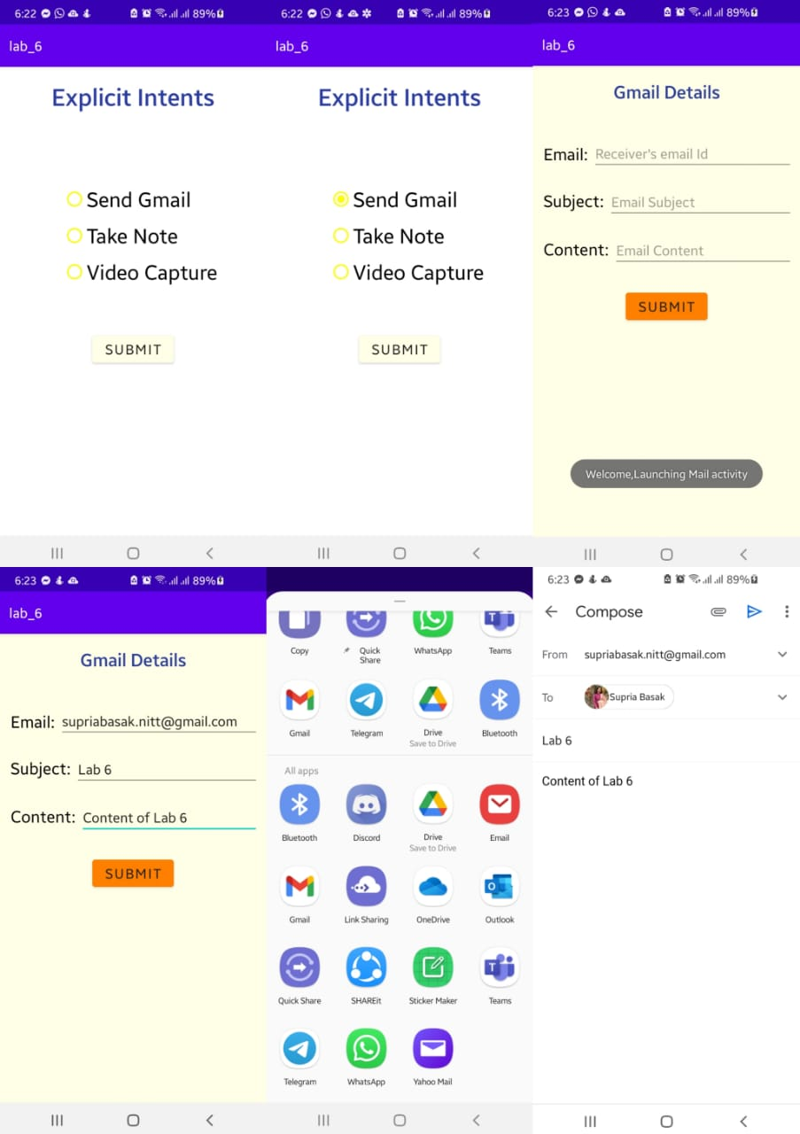

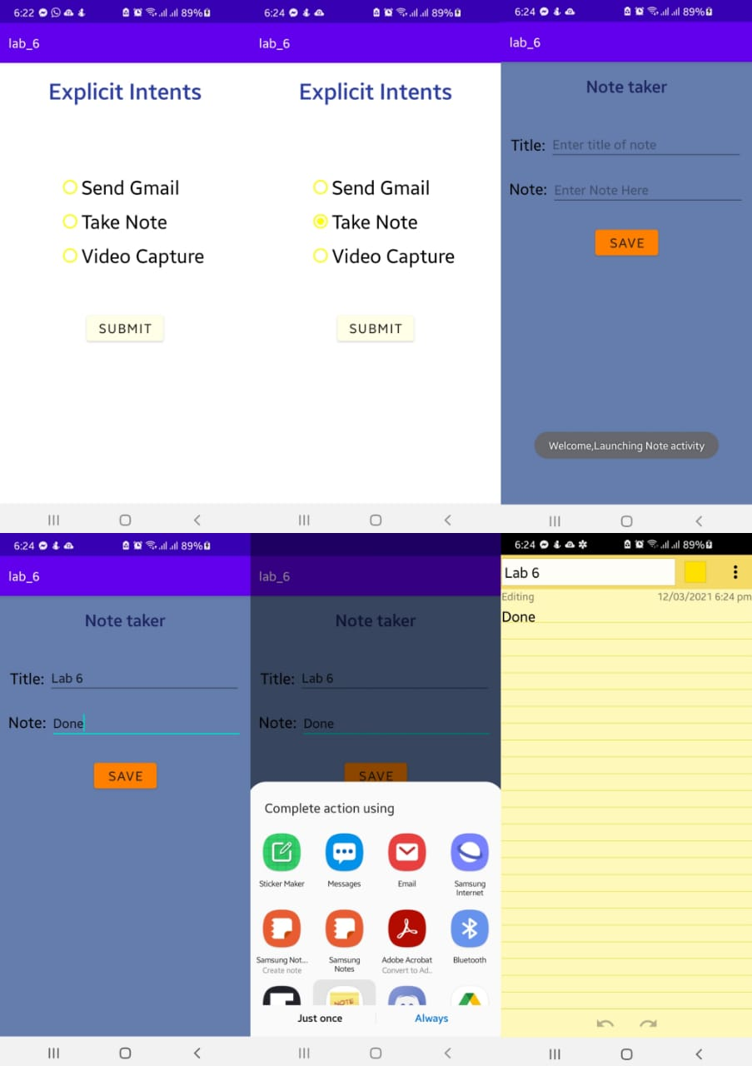

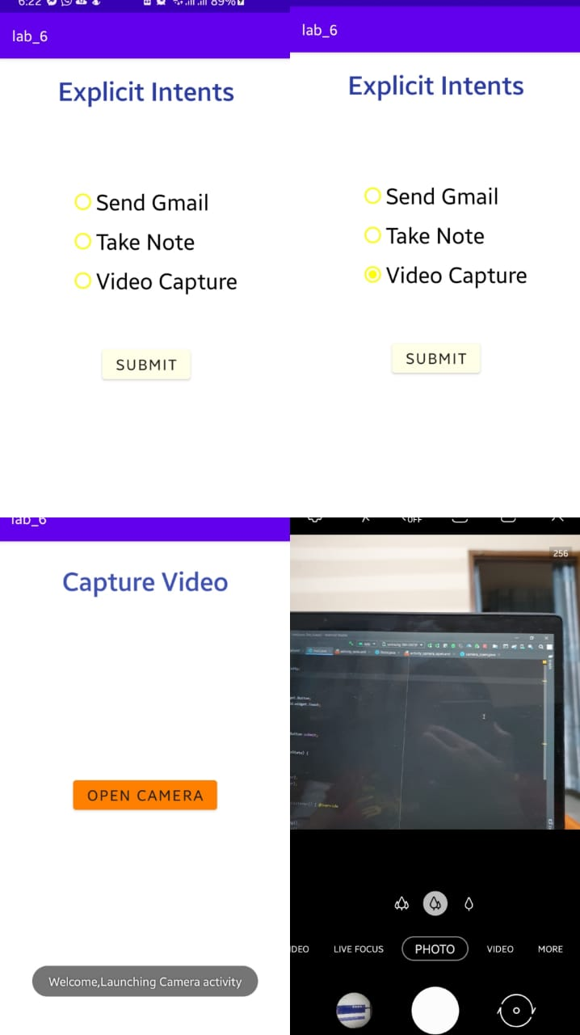

**Outcome:**

* Intent, Implicit Intent, Explicit Intent, Button views, Radio Group, Radio Button are used to build this application successfully.
* All specifications are successfully executed.
* I learned AVD manager functionality, Intent functionalities and implementing different options in the Palette