**Candy E-Commerce Sales Dashboard**

Objective: The owner of this store wants us to help them create a dashboard to track and analyze their online sales across India.

Step1: Create a Text Box to display the title of the dashboard.

Step2: Create a Stacked Column Chart to display the profit. For chart name: ‘Profit by Month’ - Use ‘Order Date-month’ of the X-axis (from the date hierarchy) and ‘Sum of Profit’ in the Y-Axis.

Step 3: Check the profit by sub-category. Create a stacked bar chart with name ‘Profit by sub-category’. Place ‘Sub-Category’ at Y-axis and ‘Sum of Profit’ at X-axis. This way the chat displays all the values, so we can consider the top 5 values.

Step 4: Check the product sales % as per Category. Let’s take a donut chart with ‘Category’ in the legend and ‘sum of quantity’ in the values.

For the label contents; go to format visual – Detail labels – Options – Label content- here select Category, % of total.

Step 5: Create another donut chart to check for the payment mode as per quantity. Use ‘payment mode’ at legend and ‘sum of quantity’ at values.

Step 6: Create a card visual representing the total amount of sales. Use ‘sum of amount’ in the fields section.

Step 7: Create a card visual representing the total quantity of sales. Use ‘sum of profit in the fields section.

Step 8: Create a card visual representing the total quantity of sales. Use ‘sum of quantity’ in the fields section.

Step 9: Create a card visual representing the average order value. To perform this task, go to the data view; select ‘details’ table, create a new column. Avg = [Amount] / [Quantity].

Step 10: Create a ‘stacked bar chart’ representing the top states from which the orders were placed. Drag state at the y-axis and ‘sum of amount’ at x-axis.

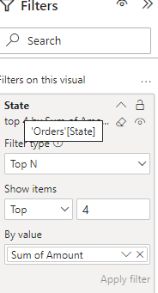

Step 11: Create another ‘stacked column chart’ displaying the customer who placed the highest orders. Drag ‘customer name’ at Y-axis and ‘sum of amount’ at x-axis.

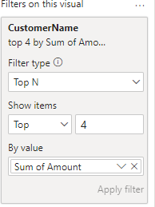

Step 12: Create a slicer to display quarter wise data with ‘quarter’ in the field.

Step 32: Create a slicer to display state wise data with ‘state’ in the field.