Industrial Internship Report on
Forecasting of Smart City Traffic Patterns
Domain: Data Science and Machine Learning
Prepared by
Student Name: Supriya Enjam
College Name: Swarna Bharathi Institute of Science and Technology
Internship Partner: upskill Campus & UniConverge Technologies Pvt Ltd (UCT)

Executive Summary
This report presents the work completed during the Industrial Internship organized by upskill Campus in collaboration with UniConverge Technologies Pvt Ltd (UCT). The assigned project was " Forecasting of Smart City Traffic Patterns", which focuses on predicting traffic patterns at multiple city junctions using Machine Learning techniques.
The objective of the project was to analyze historical traffic data, identify traffic patterns, and forecast future traffic volumes to assist government authorities in infrastructure planning and traffic management. The project involved data preprocessing, exploratory data analysis, feature engineering, machine learning model development, performance evaluation, and deployment through an interactive Streamlit dashboard.
A Random Forest Regressor model was implemented and enhanced with holiday-aware forecasting features. The final model achieved excellent prediction performance with an R² score of 0.969, demonstrating its effectiveness in forecasting traffic volume. This internship provided practical exposure to data science workflows, machine learning model development, and real-world problem-solving.

TABLE OF CONTENTS
1 Preface 3
2 Introduction 4
2.1 About UniConverge Technologies Pvt Ltd 4
2.2 About upskill Campus 8
2.3 Objective 9
2.4 Reference 9
2.5 Glossary 10
3 Problem Statement 11
4 Existing and Proposed solution 12
5 Proposed Design/ Model 13
5.1 High Level Diagram (if applicable) 13
5.2 Low Level Diagram (if applicable) 13
5.3 Interfaces (if applicable) 13
6 Performance Test 14
6.1 Test Plan/ Test Cases 14
6.2 Test Procedure 14
6.3 Performance Outcome 14
7 My learnings 15
8 Future work scope 16

Preface

The Industrial Internship program provided an opportunity to gain practical experience in solving real-world industry problems using modern technologies. During the internship, I worked on a Forecasting of Smart City Traffic Patterns project aimed at improving urban traffic management through data-driven decision making.
The project required understanding traffic patterns across multiple city junctions and building a predictive system capable of forecasting future traffic volumes. Throughout the internship, I learned data preprocessing, exploratory data analysis, feature engineering, machine learning model development, evaluation techniques, and dashboard deployment.
This internship significantly enhanced my technical and analytical skills while providing valuable exposure to industry-standard tools and methodologies.
I would like to express my sincere gratitude to upskill Campus, UniConverge Technologies Pvt Ltd (UCT), my mentors, and faculty members for their guidance and support throughout the internship.

Introduction

About UniConverge Technologies Pvt Ltd
UniConverge Technologies Pvt Ltd (UCT) is a technology company specializing in Digital Transformation, Industrial IoT, Cloud Computing, Machine Learning, and Smart City solutions. The company provides innovative technology solutions for industries and government organizations to improve efficiency, sustainability, and decision-making.
2.2 About upskill Campus
upskill Campus is a career development platform that offers internships, training programs, and industry-oriented learning opportunities. It helps students gain practical experience through real-world projects and mentorship from industry experts.
2.3 Objective of the Internship
The objectives of this internship were:
- To gain practical experience in Data Science and Machine Learning.
- To solve a real-world smart city problem.
- To understand the complete machine learning project lifecycle.
- To improve analytical, programming, and problem-solving skills.
- To develop a deployable predictive analytics solution.
2.4 References
1. Kaggle Smart City Traffic Patterns Dataset.
2. Python Documentation.
3. Scikit-Learn Documentation.
4. Pandas Documentation.
5. Streamlit Documentation.

2.5 Glossary
Term | Description
EDA | Exploratory Data Analysis
ML | Machine Learning
RF | Random Forest
MAE | Mean Absolute Error
RMSE | Root Mean Squared Error
R² | Coefficient of Determination

https://www.upskillcampus.com/

3. Problem Statement
The government aims to transform cities into smart cities by utilizing digital technologies to improve public services and infrastructure. One of the major challenges faced by urban areas is traffic congestion.
The objective of this project is to forecast traffic volume at four city junctions using historical traffic data. Understanding traffic patterns helps authorities:
- Predict traffic peaks.
- Optimize traffic signal timing.
- Improve road infrastructure planning.
- Reduce congestion.
- Enhance citizen mobility.
Traffic patterns vary significantly based on weekdays, weekends, holidays, and seasonal factors. Therefore, accurate forecasting is essential for effective traffic management.

4. Existing and Proposed Solution
Existing Solution
Traditional traffic management systems rely on historical observations and manual analysis. Such approaches often fail to accurately predict future traffic conditions.
Limitations
- Reactive rather than proactive management.
- Inability to forecast future traffic volumes.
- Limited consideration of temporal patterns.
- Poor scalability.
Proposed Solution
The proposed solution utilizes Machine Learning techniques to forecast traffic volumes using historical traffic data.
Key Features
- Automated traffic prediction.
- Holiday-aware forecasting.
- Traffic trend analysis.
- Interactive dashboard visualization.
- Support for infrastructure planning.

5. Proposed Design / Model
System Workflow
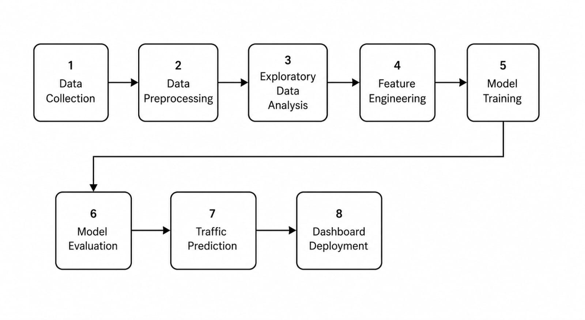
Feature Engineering
The following features were extracted from DateTime:
- Year
- Month
- Day
- Hour
- Day of Week
- Weekend Indicator
- Holiday Indicator
- Junction Number
Machine Learning Model
Random Forest Regressor
Random Forest was selected because:
- Handles non-linear relationships effectively.
- Works well with tabular datasets.
- Reduces overfitting.
- Provides feature importance analysis.

6. Performance Test
Test Plan
The dataset was divided into training and testing subsets. The Random Forest model was trained using engineered features and evaluated using standard regression metrics.
Test Procedure
1. Load and preprocess data.
2. Extract time-based features.
3. Add holiday indicators.
4. Split data into training and testing sets.
5. Train Random Forest model.
6. Evaluate model performance.
Performance Outcome
Metric | Value
MAE | 2.39
RMSE | 3.54
R² Score | 0.969

Interpretation
The model achieved excellent performance with an R² score of 96.9%, indicating that it accurately captures traffic patterns and provides reliable forecasts.

7. My Learnings
Throughout this internship, I gained practical experience in:
- Data Cleaning and Preprocessing
- Feature Engineering
- Exploratory Data Analysis
- Machine Learning Model Development
- Model Evaluation
- Random Forest Algorithm
- Holiday-Aware Forecasting
- Streamlit Dashboard Development
- Real-World Problem Solving
The project improved my understanding of the complete data science lifecycle and enhanced my technical confidence.

8. Outputs
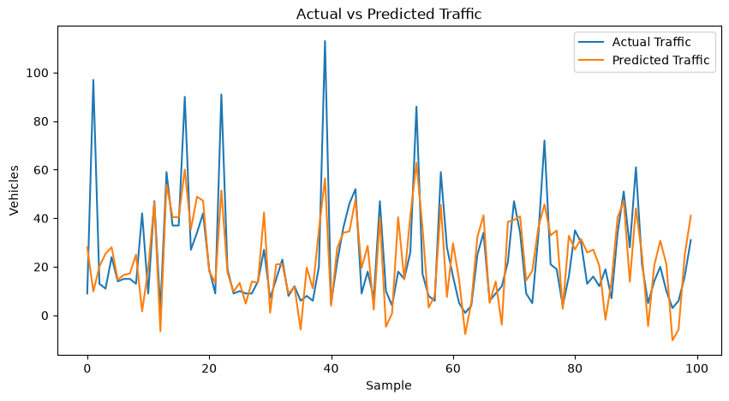
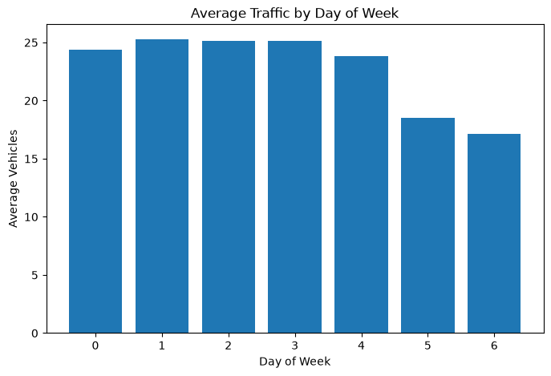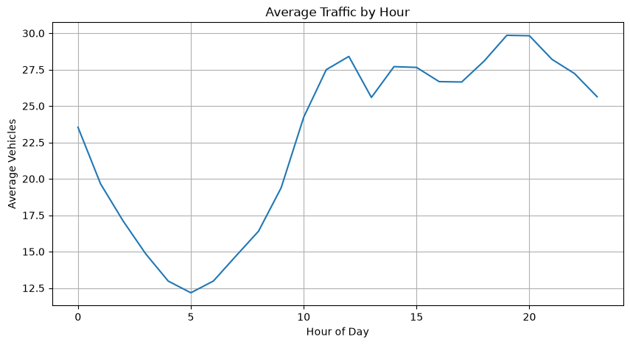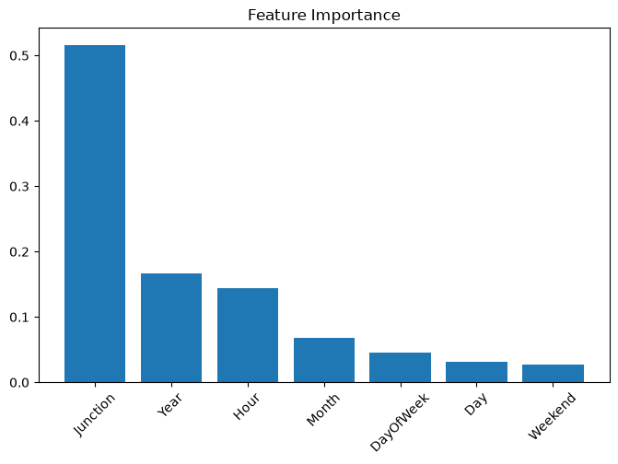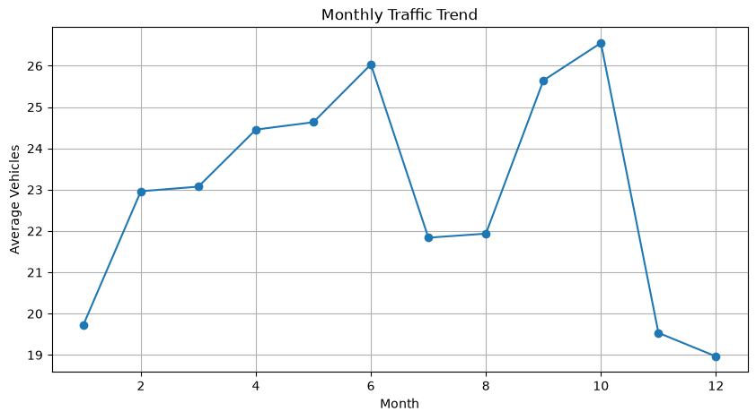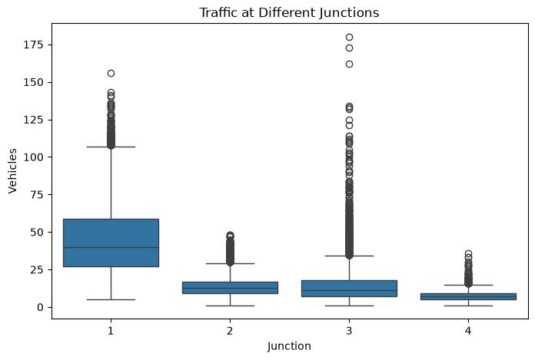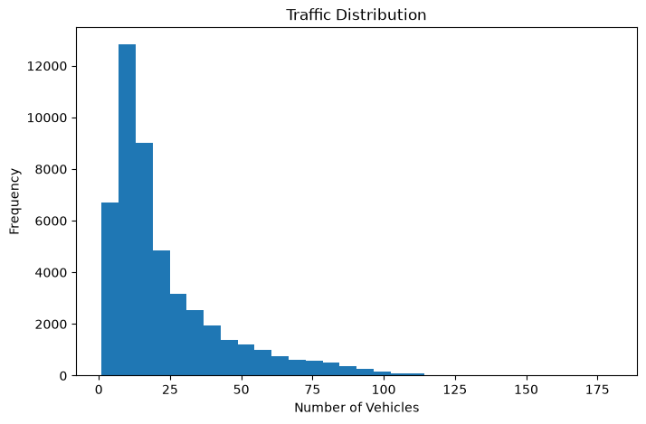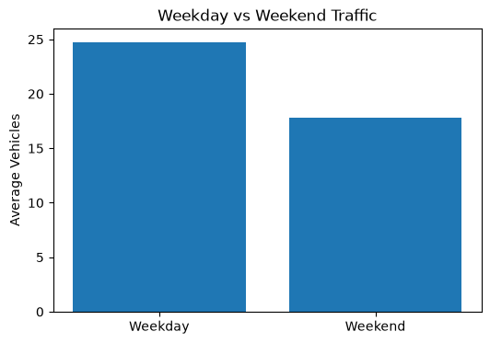
9. Future Work Scope
Several improvements can further enhance the project:
- Integration of Real-Time Traffic Data
- Weather-Based Traffic Forecasting
- Event-Based Traffic Prediction
- Deep Learning Models (LSTM)
- SARIMA Time Series Forecasting
- Cloud Deployment
- Mobile Application Integration
- Smart Route Recommendation System
These enhancements would make the system more suitable for large-scale smart city implementations.

Conclusion
The Smart City Traffic Forecasting project successfully demonstrated the application of Machine Learning in solving real-world urban traffic challenges. By leveraging historical traffic data, feature engineering, holiday information, and Random Forest Regression, an accurate forecasting model was developed.
The final solution achieved high prediction accuracy and was deployed through an interactive Streamlit dashboard, making it useful for city planners and decision-makers. This internship provided valuable industry exposure and strengthened my skills in Data Science, Machine Learning, and Software Development.

