|  |
| --- |
|  |
| Project-Associate |
| Skill Tracker |
|  |
|  |
|  |

Submitted By:

Konijeti. Supriya.

**Description of Project-Associates:**

**John Dempsey** works in an IT company. He is a new age HR Academic Manager. Few of his roles and responsibilities includes :

* Keeping track of skill of individual Full Stack Engineers
* To use the single page solution (**Skills Tracker**) to keep track of employee skills.

The proposed solution (**Skills Tracker**) will try to provide the above-mentioned features.

The **Skills Tracker** should be a Single Page Application (SPA). Using this internal portal **John Dempsey** will be able perform following operations:

* **Search Associate:** John will be able to search associate with following criteria :
  + Search by associate name
  + Search by associate ID
  + Search by Email ID
  + Search By Mobile Number
* **Add new Associate:** John will be able to add new associate and its respective Full Stack Development Skills.
* **Edit, Delete & View Associate:** The associate which is searched can be updated, deleted and viewed.
* **Search by either first Name or last Name:** John will be able to search associate by using either associate’s first name or last name.

**Microservice-Eureka:**

This project is implemented with Eureka-Server and it holds the information about the application.

**Microservice-ZuulProxyApiGateway:**

This project is implemented with Zuul Proxy Api-Gateway service.It also will register with Eureka server and automatically set up dynamic routing based on application that also registered with Eureka to provide access to our APIs through one singular point.

**Security:**

This project will also be configured with Spring Security in order to provide edge security across all out APIs.

RDS:

This project is implemented using RDS which is mySql database of AWS(Amazon Clod Services).

**Output:**

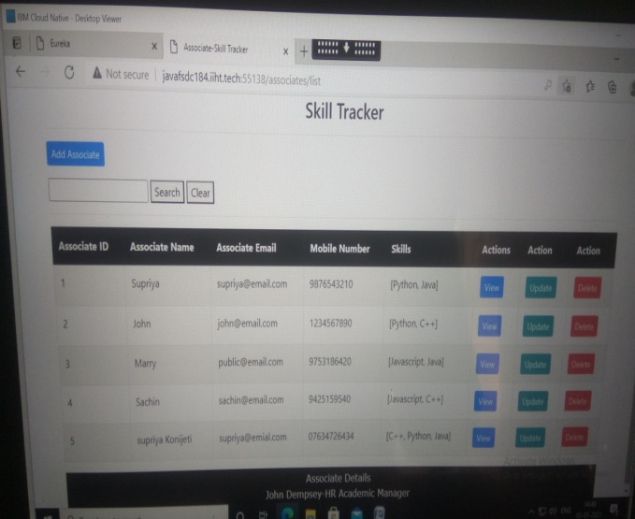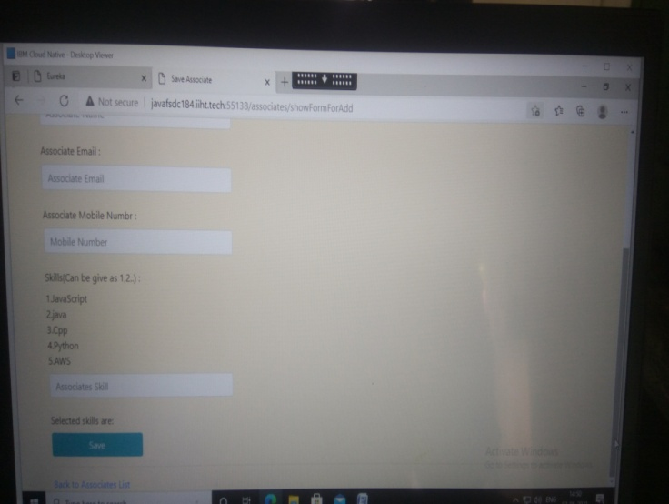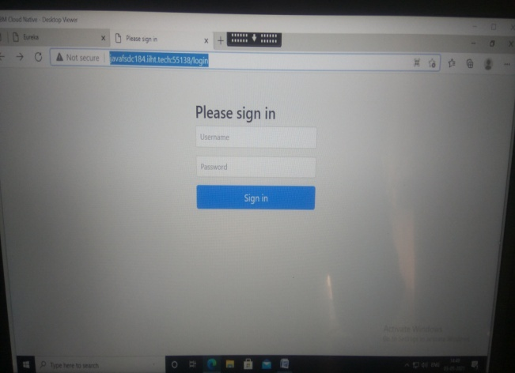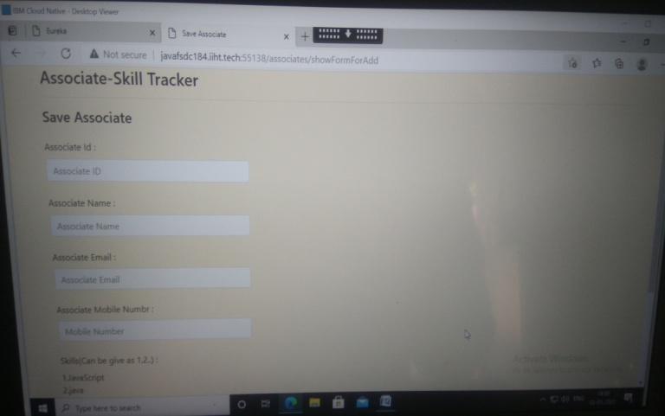

**Link of Source code:**

**https://drive.google.com/drive/folders/1Erbtmh5G89zperjpu_459446M_Wt5eW4?usp=sharing**

**Thank you…**