Project Requirement Document (PRD): Manufacturing OEE & Efficiency Dashboard
Project Name | Plant Operations & OEE Monitor
Domain | Manufacturing / Supply Chain
Primary Stakeholders | Plant Manager, Shift Supervisors, Process Engineers
Tools | Power BI (Recommended for DAX capability) or Tableau
Data Source | Kaggle ("Manufacturing Production" or "OEE Operations" datasets)

1. Executive Summary
Problem: The production facility lacks real-time visibility into line efficiency. The current reporting does not distinguish between downtime (Availability), slow cycles (Performance), or scrap (Quality), making it difficult to pinpoint the root cause of lost productivity.
Goal: Implement an OEE (Overall Equipment Effectiveness) dashboard to track the "Gold Standard" manufacturing metric. The tool must allow managers to visualize machine states via Gantt charts and identify the top reasons for product defects using Pareto analysis.

2. Project Objectives
- Metric Standardization: Calculate the weighted OEE score to benchmark shifts against one another.
- Downtime Visualization: Use a Gantt Chart to visualize exactly when and how long machines were down during a shift.
- Defect Reduction: Use Pareto Analysis (80/20 Rule) to identify the top rejection reasons that cause the majority of waste.
- Trend Analysis: Track OEE performance over the last 30 days to identify deteriorating assets.

3. Data Requirements
Source: Kaggle Manufacturing Dataset (Transactional).
Key Attributes (Columns) Required:
- Time: Date, Shift (Day/Night), StartTime, EndTime.
- Asset: MachineID, LineID.
- Status: State (Running, Idle, Down, Maintenance).
- Production Metrics: TargetOutput, ActualOutput, RejectedCount.
- Reasons: DowntimeReason (e.g., Motor Failure, No Material), RejectionReason (e.g., Dimensional Error, Scratch).

4. Functional Requirements (Formulas & Logic)

A. The OEE Calculation Engine
OEE is calculated by multiplying three factors. You must create measures for each:
- Availability % (Is the machine running?)
  - $Availability = \frac{\text{Actual Run Time}}{\text{Planned Production Time}}$
  - Logic: Planned Time minus Stop Time.
- Performance % (Is it running fast enough?)
  - $Performance = \frac{\text{Actual Output}}{\text{Target Output (at ideal speed)}}$
  - Note: If Target Output isn't in the dataset, use: $\frac{\text{Total Count}}{\text{Run Time} \times \text{Ideal Cycle Time}}$.
- Quality % (Is the product good?)
  - $Quality = \frac{\text{Good Count}}{\text{Total Count}}$
  - Where: $\text{Good Count} = \text{Actual Output} - \text{Rejected Count}$.
- OEE Score:
  - $OEE = Availability \times Performance \times Quality$

B. Visualization Strategy
- The "Machine Gantt" (Timeline):
  - Visual Type: Gantt Chart (or Stacked Bar with datetime axis).
  - Y-Axis: Machine Name.
  - X-Axis: Start Time / End Time.
  - Legend (Color): Status (Green=Running, Red=Down, Yellow=Idle).
  - Insight: Reveals micro-stops or long changeover times instantly.
- Defect Pareto Chart:
  - Visual Type: Line and Clustered Column Chart.
  - Bars: Count of Rejections (Descending).
  - Line: Cumulative % of Rejections.
  - Insight: "80% of our defects are caused by just 2 reasons: 'Misalignment' and 'Overheating'."
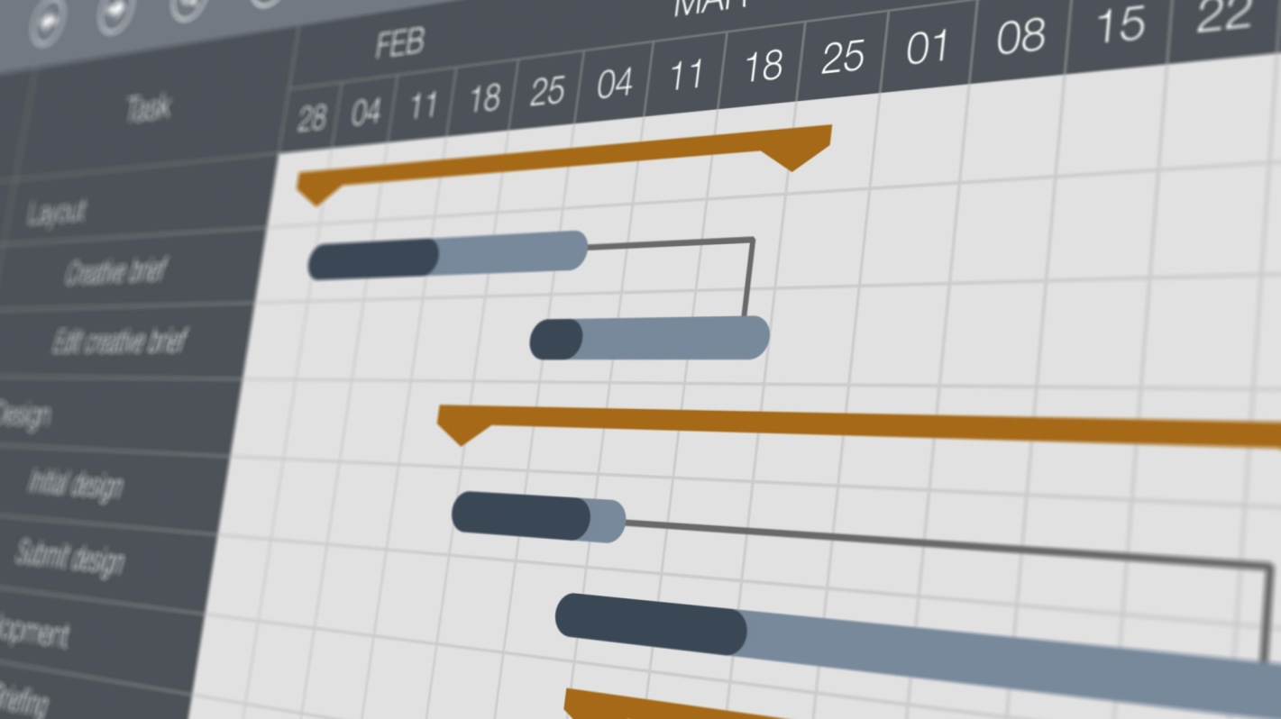
Shutterstock

5. Detailed Implementation Steps

Phase 1: Data Preparation (ETL)
Manufacturing data often comes in "Events" (Start/Stop rows).
- Duration Calculation:
  - Create a column Duration_Minutes:
DATEDIFF(minute, [StartTime], [EndTime])
- Categorization:
  - Ensure State is clearly mapped. If the raw data has codes (e.g., "State 01"), map them to text ("Running").
- Target Logic:
  - If the dataset lacks a TargetOutput column, you must define a standard. (e.g., "Machine A produces 60 units/hour").

Phase 2: Building the Dashboard
- Header:
  - Slicers: Date, Shift, Machine.
  - KPI Cards: OEE % (Color coded: <65% Red, >85% Green), Total Waste Cost.
- Availability Section:
  - Insert the Gantt Chart. This allows the manager to "replay" the shift.
- Quality Section:
  - Insert the Pareto Chart.
  - Add a "Rejection Rate" card alongside it.
- Performance Section:
  - Bar chart: Actual vs. Target Output by Hour.

Phase 3: The "Pareto" Logic (The Hard Part)
To build a proper Pareto chart in Power BI, you need a specific DAX pattern:
- Measure 1: Total Rejects.
- Measure 2: All Rejects (removes filters).
CALCULATE([Total Rejects], ALLSELECTED(Reason))
- Measure 3: Cumulative Rejects.
  - Sum of rejects for the current reason plus all reasons with a higher rank.
- Measure 4: Cumulative %.
[Cumulative Rejects] / [All Rejects]

6. Deliverables
- OEE Calculator Model: The .pbix file containing the 3-factor formulas.
- Shift Report: A printable PDF version of the dashboard for morning stand-up meetings.
- Data Dictionary: Explaining exactly how "Target Output" was defined/assumed.

Insights :
- Which machine delivers the highest OEE over time?
- Does scrap rate rise with humidity or temperature?
- Which shift (Day/Night/Swing) operates most efficiently?
- What is the cost per unit produced per product type?
- Compare Energy Consumption per output unit (kWh/Unit).
- Predict OEE using Regression (Production Time + Maintenance + Humidity).
- Find machines that meet output but fail quality expectations.
- Identify when maintenance ↓ defects vs when it does not.

