Weighing Machine Instruction Manual
e-YSIP 2017
Prerequisites:
- Plug a 9 volt or 12 volt DC adapter for power supply. Minimum current requirement is 1 Amps.
- Camera must be connected to the USB port present at the back of the Raspberry Pi located at the top right corner of the machine.
- Turn on the switch located at the back of the machine.
- Internet Connection (desired, but not mandatory).

Usage:

When the Machine is connected to the Internet:

- When you start the machine, it will take about 10 to 20 seconds for some message to be appear on LCD screen. In case of any problems, refer to the Troubleshooting section at the end of this manual.
- You will first see the following two screens, after which you can proceed.

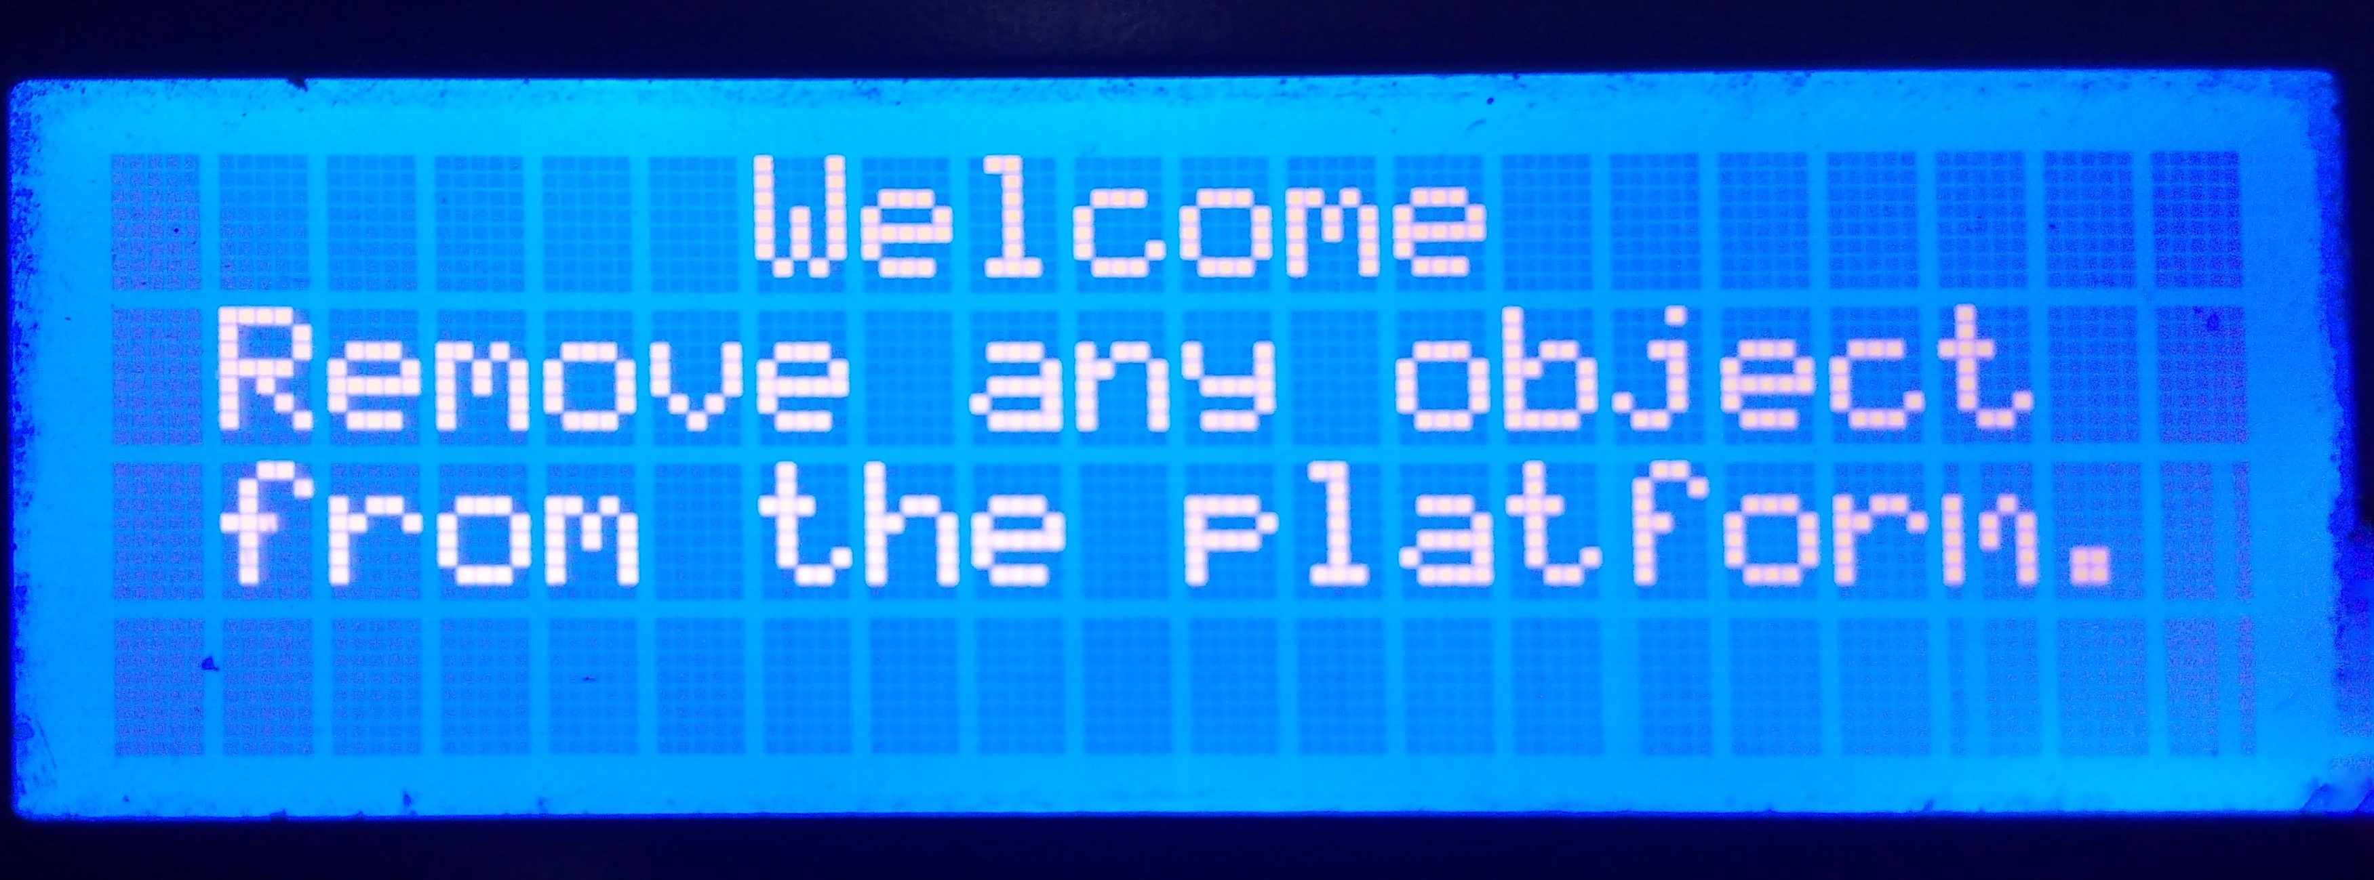

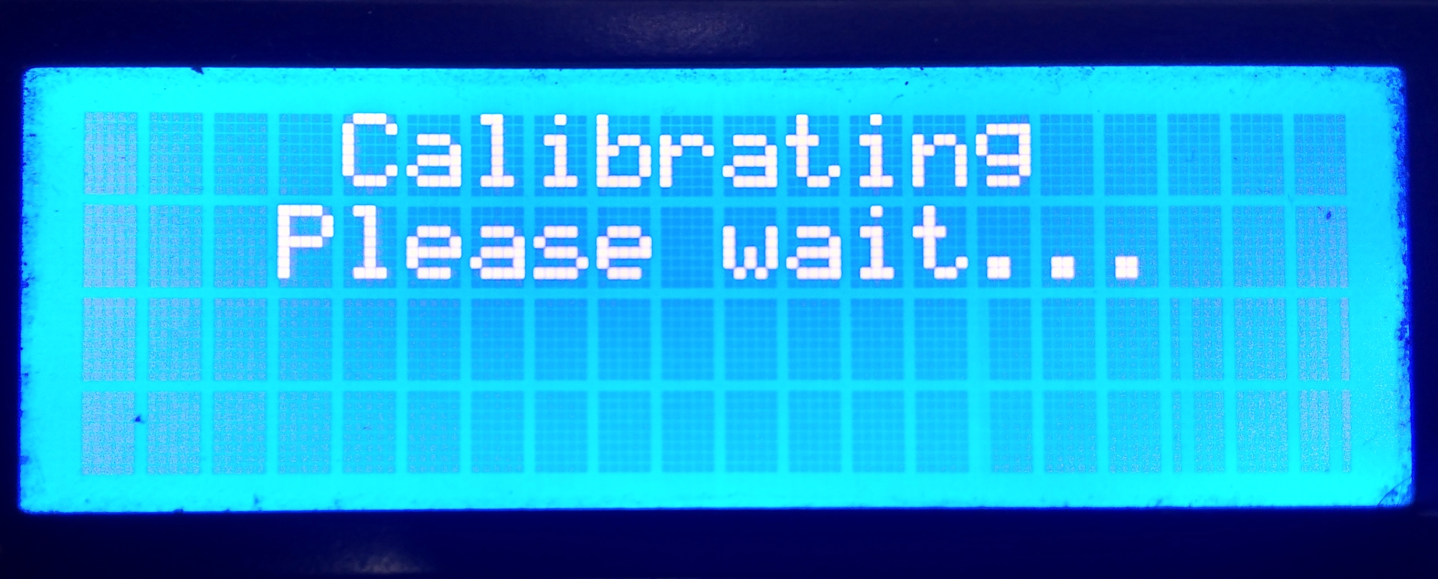

- When you see the following screen, you can begin using the machine as a weighing scale. The weight is displayed at the bottom.

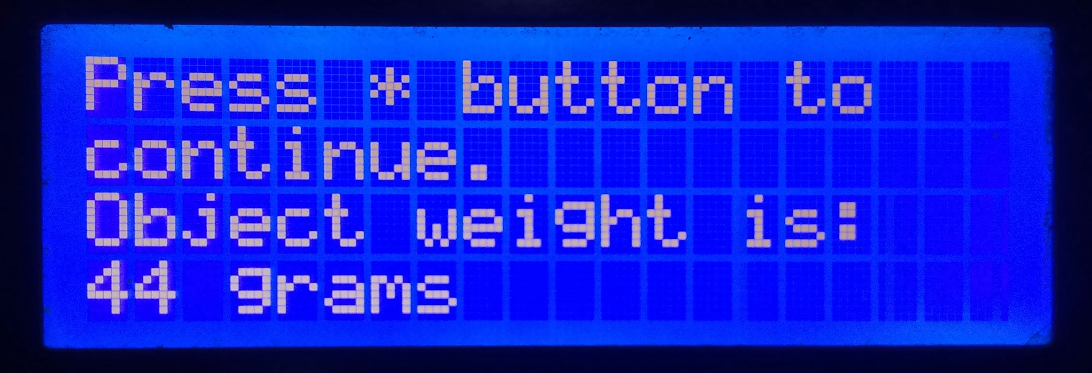

- This this your main screen. At this screen, press the:
- ‘A’ button to shut down the system.
- ‘B’ button to restart the Python script.
- ‘C’ button to restart the Raspberry Pi.
- ‘D’ button to tare weight.

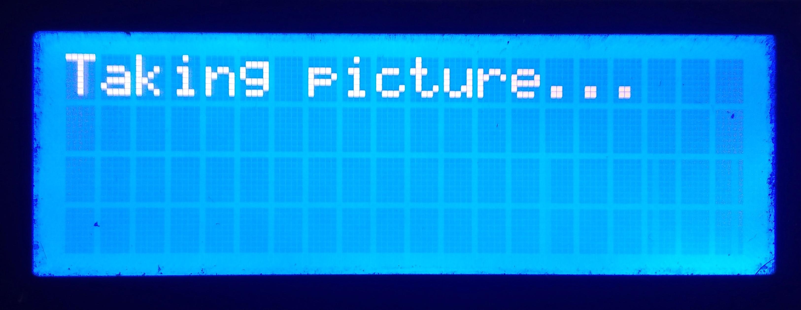

- After placing a crop on the weighing machine, if you want to log the vegetable into the system, press the ‘*’ button. This will take a picture and bring you to this screen.

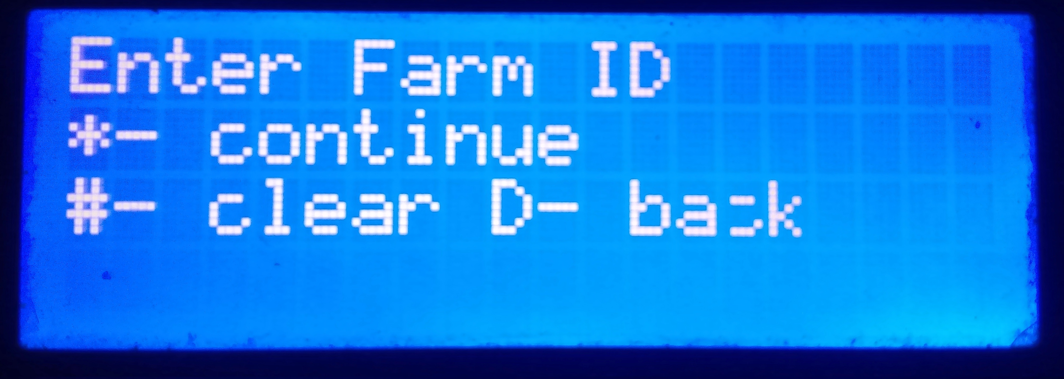

- At any input screen you can use ‘#’ as backspace and ‘D’ to go back to a previous step. Enter the Farm ID and press ‘*’ to continue.
- This will send an image to the server and use the Nostradamus module to predict the crop.

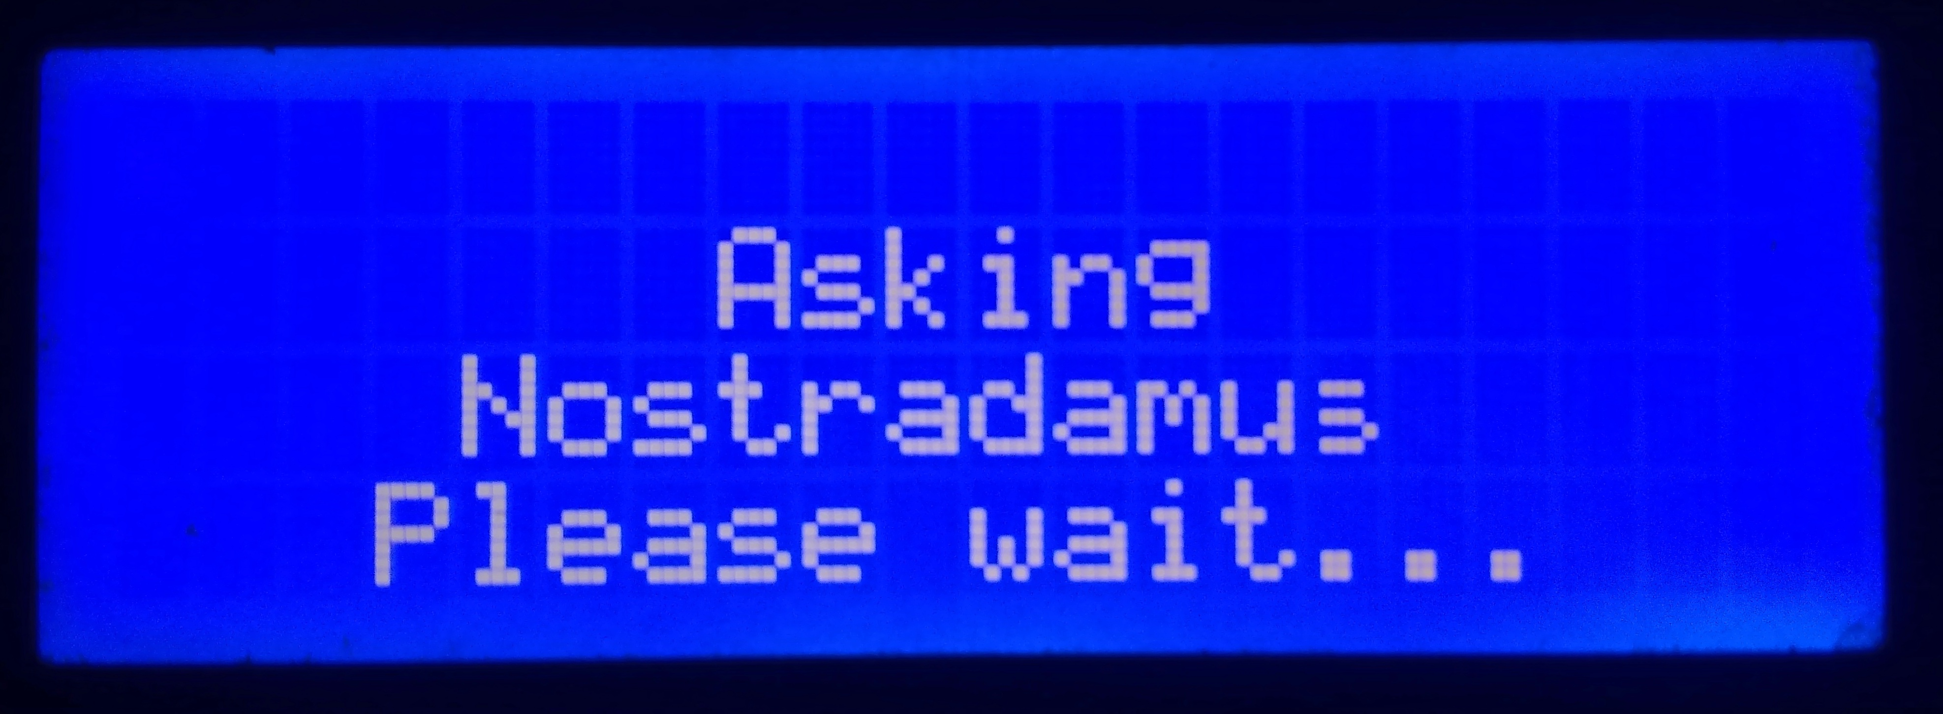

- After the prediction is done you will see the name of the crop identified.
- If the predicted crop is correct, you can simply press ‘*’ button to send the data to server and your crop will be logged into the system.

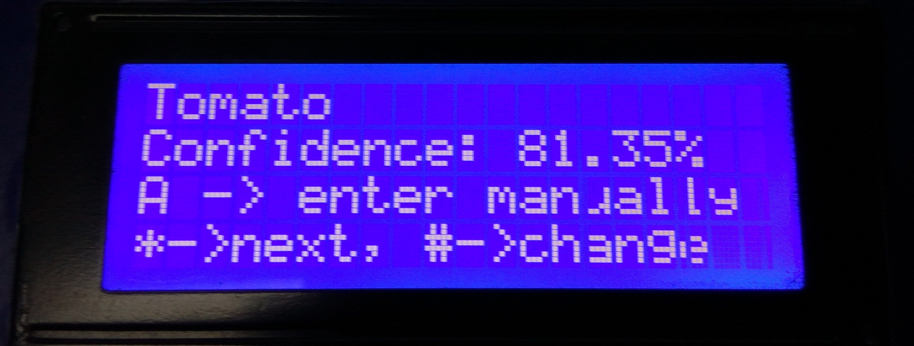

- If the data is incorrect, press the ‘#’ button to see a list of identified crops along with their percentages. They are sorted according to prediction confidence. Alternatively, go directly to step 12 if you want to enter the crop ID directly.

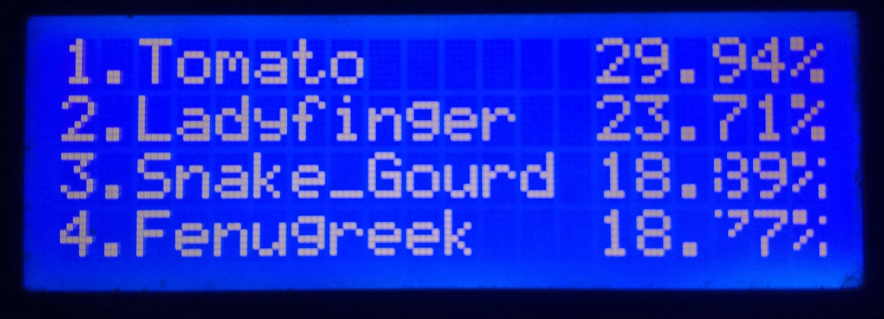

- Scroll through these crops using the ‘*’ and ‘#’ buttons to go forward and backward 1 page respectively. If your crop is not in the list, contact the system administrator to add your crop to the logging database.
- Press the numbers ‘1’, ’2’, ’3’ or ‘4’ depending upon which crop matches in the list.

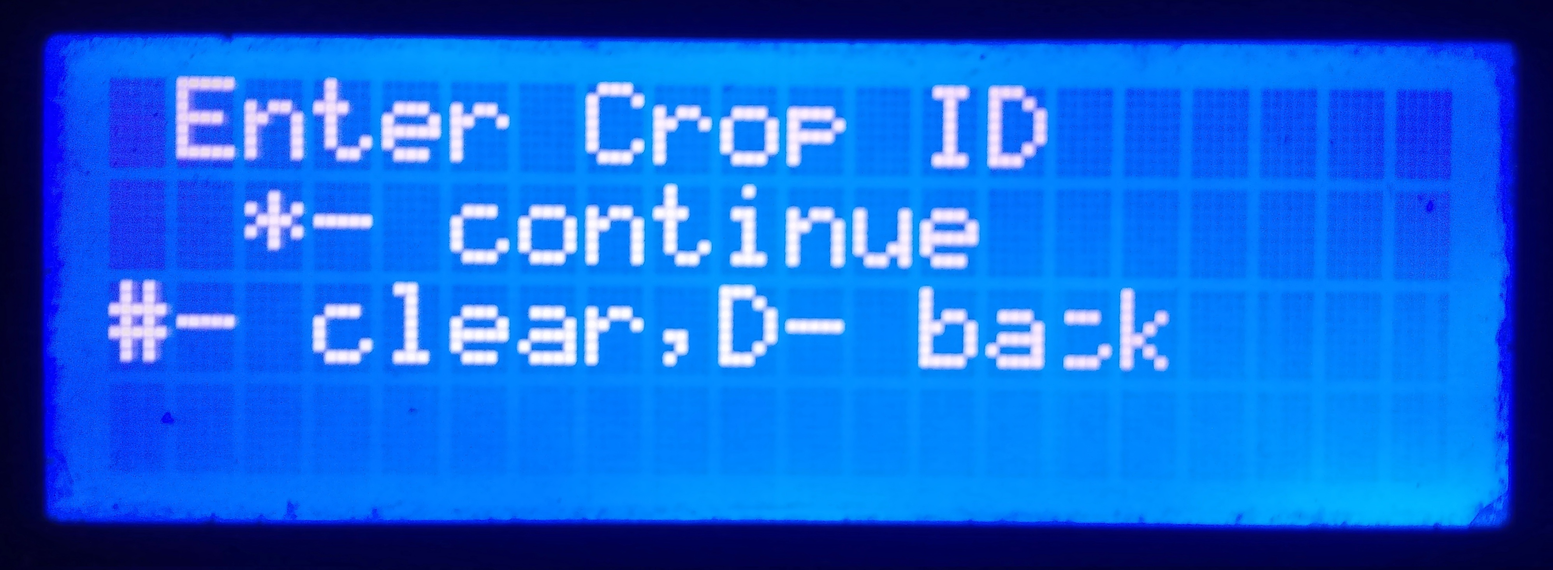

- If you already know the Crop ID of the crop and don’t wish to scroll through the list, press the ‘A’ button and directly enter the crop id.
- Once the data is sent, you are done! Repeat from step 1 if you want to add additional crops.

If the machine is not connected to the Internet:

- Even if the machine is not connected to the Internet, you can still use the machine as mentioned above.
- However, instead of sending the picture to the server to predict as in step 6 above, the picture will be stored locally and you directly get a list of crops out of which you can select the desired crop.
- You can also manually enter the Crop ID by pressing the ‘A’ key.
- Press ‘*’ to store data locally. This will send the data to the logging server the next time the machine is connected to the Internet.

Troubleshooting:
- If after you start the machine it does not display anything, then it might be because of some fault with the LCD. Open the front panel by removing two screws on top of front panel and check if the wires are connected properly.
- If the LCD still isn’t responding, try pressing the ‘A’ button on the keypad. The system should shut down and the LCD screen should be filled with white squares. If you don’t see these white squares then there is a pretty good chance the screen might be broken.
- If the system fails to send information to the server and always stores data locally even when connected to the Internet, then make sure you are connected to Internet and system's IP address is configured properly.
- If you see message ‘Camera not attached’ on LCD screen then attach the USB camera in the USB port which you can find at the back of the machine. If camera is attached and it still showing ‘Camera not attached’ then check camera connection or attach new camera.

