**REST - Country Web Service**

Write a REST service that returns India country details in the earlier created spring learn application.  
  
**URL**: /country  
**Controller**: com.cognizant.spring-learn.controller.CountryController  
**Method Annotation**: @RequestMapping  
**Method Name**: getCountryIndia()  
**Method Implementation**: Load India bean from spring xml configuration and return  
**Sample Request**: http://localhost:8083/country  
**Sample Response**:

{

"code": "IN",

"name": "India"

}  
  
My eclipse snap shot looks like below :

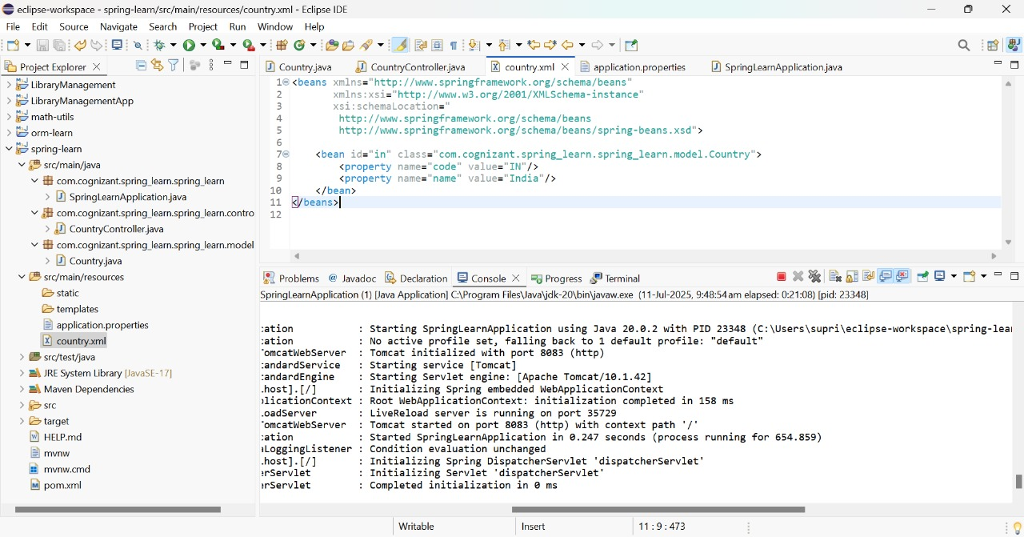

Output using the web browser is as follows :   
  
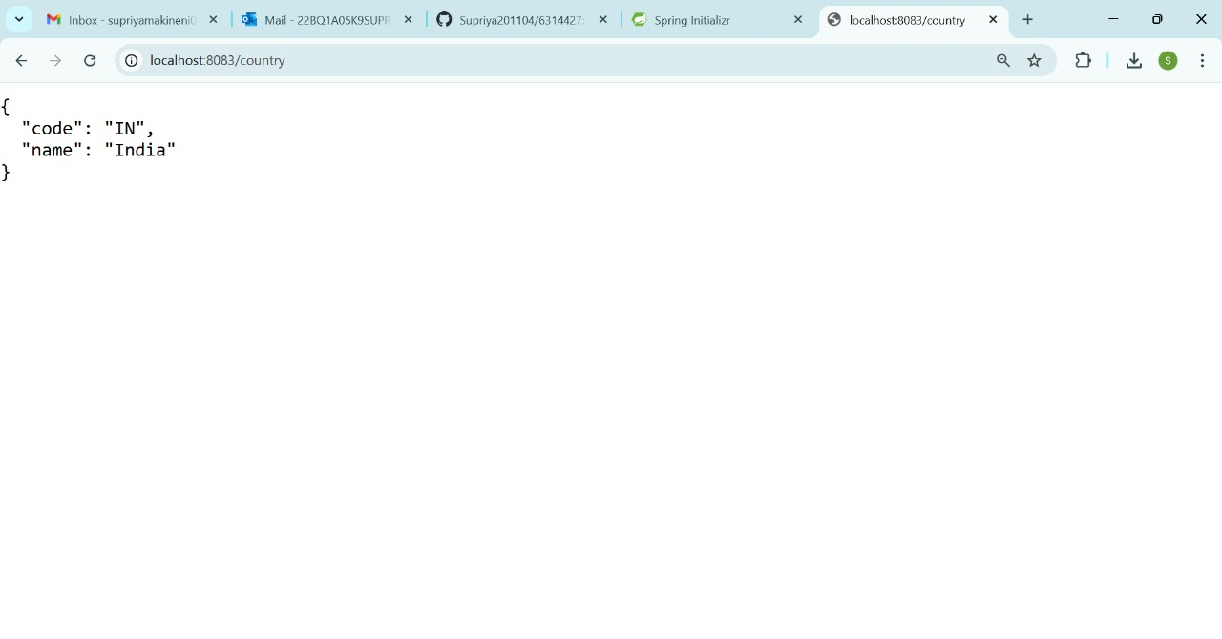  
  
Output using the Postman as follows :

