**Creating Microservices for account and loan**

**Procedure :**

In this hands on exercises, we will create two microservices for a bank. One microservice for handing accounts and one for handling loans.

**Account Microservice**

* Create folder with employee id in D: drive
* Create folder named 'microservices' in the new folder created in previous step. This folder will contain all the sample projects that we will create for learning microservices.
* Open https://start.spring.io/ in browser
* Enter form field values as specified below:
* Group: com.cognizant
* Artifact: account
* Select the following modules
* Developer Tools > Spring Boot DevTools
* Web > Spring Web
* Click generate and download the zip file
* Extract 'account' folder from the zip and place this folder in the 'microservices' folder created earlier
* Open command prompt in account folder and build using mvn clean package command
* Import this project in Eclipse and implement a controller method for getting account details based on account number. Refer specification below:
* Method: GET
* Endpoint: /accounts/{number}
* Sample Response. Just a dummy response without any backend connectivity.

**Sample output :**

{ number: "00987987973432", type: "savings", balance: 234343 }   
  
**Actual output :**   
 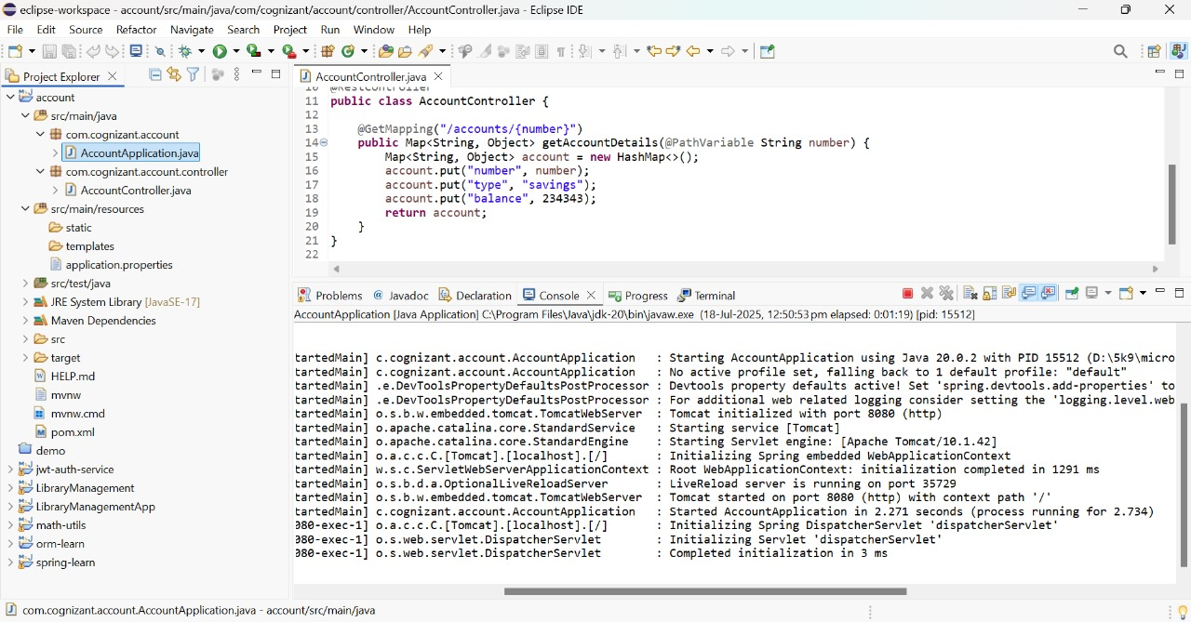  
  
  
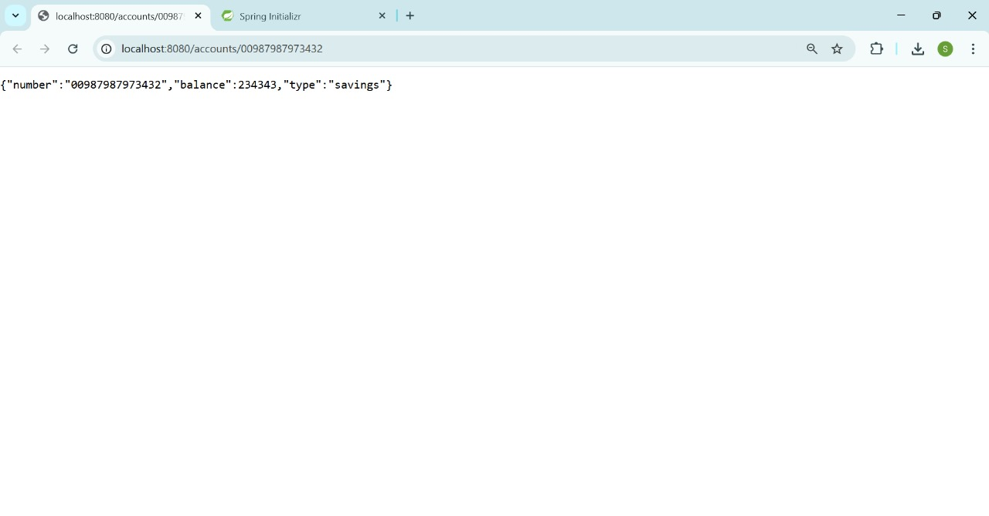  
  
  
**Procedure :**   
  
Loan Microservice

* Follow similar steps specified for Account Microservice and implement a service API to get loan account details
* Method: GET
* Endpoint: /loans/{number}
* Sample Response. Just a dummy response without any backend connectivity.

**Sample output :**

{ number: "H00987987972342", type: "car", loan: 400000, emi: 3258, tenure: 18 }  
  
**Actual output :**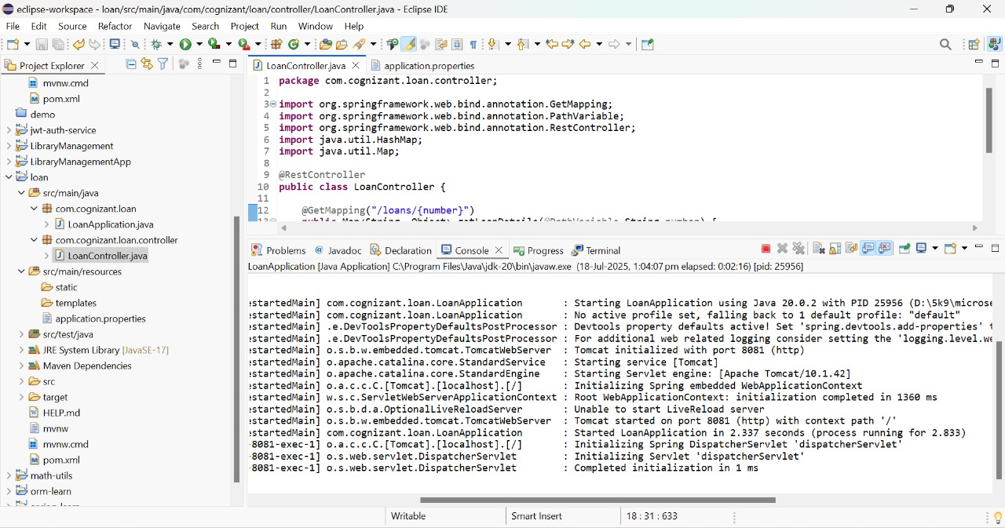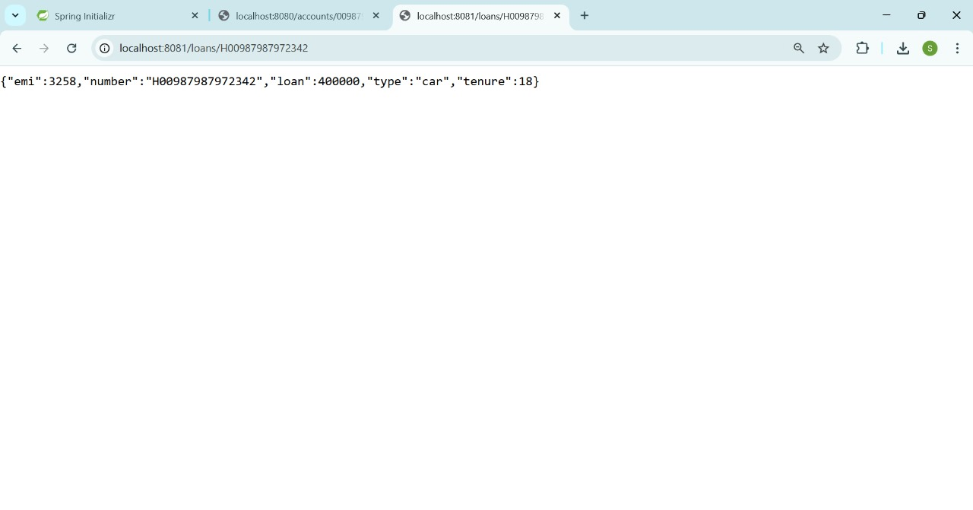

**And Finally :**

• Launching this application by having account service already running

• This launch will fail with error that the bind address is already in use

•The reason is that each one of the service is launched with default port number as 8080. Account service is already using this port and it is not available for loan service.

• Include "server.port" property with value 8081 and try launching the application

• Test the service with 8081 port

Now we have two microservices running on different ports.

**Output :**

When we run both the files at a time one runs on port 8080 and the other on port 8081 like the below :

