**React Task 4**

**Procedure :**

1.Create a new react application using create-react-app tool with the name as “blogapp”

2.Open the application using VS Code

3.Create a new file named as Post.js in src folder.

4.Create a new class based component named as **Posts** inside **Posts.js** file.

5.Initialize the component with a list of Post in state of the component using the constructor

6.Create a new method in component with the name as **loadPosts()** which will be responsible for using Fetch API and assign it to the component state created earlier. To get the posts use the url (<https://jsonplaceholder.typicode.com/posts>)

7.Implement the **componentDidMount()** hook to make calls to **loadPosts()** which will fetch the posts.

8.Implement the **render()** which will display the title and post of posts in html page using heading and paragraphs respectively.

9. Define a **componentDidCatch()** method which will be responsible for displaying any error happing in the component as alert messages.

10.Add the Posts component to App component.

11.Build and Run the application using *npm start* command.

**Procedure :**

**Post.js**

import React from 'react';

class Post extends React.Component {

  render() {

    return (

      <div className="post">

        <h2>{this.props.title}</h2>

        <p>{this.props.body}</p>

      </div>

    );

  }

}

export default Post;

**Posts.js :**

import React from 'react';

import Post from './Post';

class Posts extends React.Component {

  constructor(props) {

    super(props);

    this.state = {

      posts: [],

      hasError: false

    };

  }

  loadPosts = () => {

    fetch('https://jsonplaceholder.typicode.com/posts')

      .then(response => response.json())

      .then(data => this.setState({ posts: data }))

      .catch(error => {

        console.error("Error fetching posts:", error);

        this.setState({ hasError: true });

      });

  };

  componentDidMount() {

    this.loadPosts();

  }

  componentDidCatch(error, info) {

    alert("Something went wrong while loading posts.");

    console.error("Caught in componentDidCatch:", error, info);

  }

  render() {

    const { posts, hasError } = this.state;

    if (hasError) {

      return <h2 style={{ color: 'red' }}>Failed to load posts.</h2>;

    }

    return (

      <div>

        <h1>Blog Posts</h1>

        {posts.map(post => (

          <Post key={post.id} title={post.title} body={post.body} />

        ))}

      </div>

    );

  }

}

export default Posts;

**App.js :**

import React from 'react';

import './App.css';

import Posts from './Posts';

function App() {

  return (

    <div className="App">

      <Posts />

    </div>

  );

}

export default App;

In the link <https://jsonplaceholder.typicode.com/posts> it looks like :

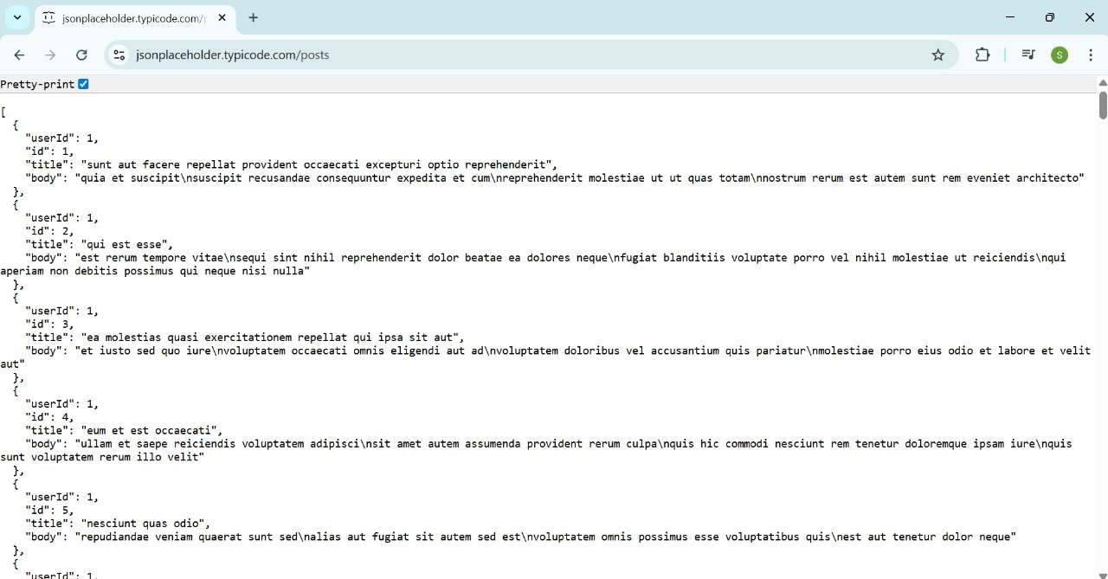

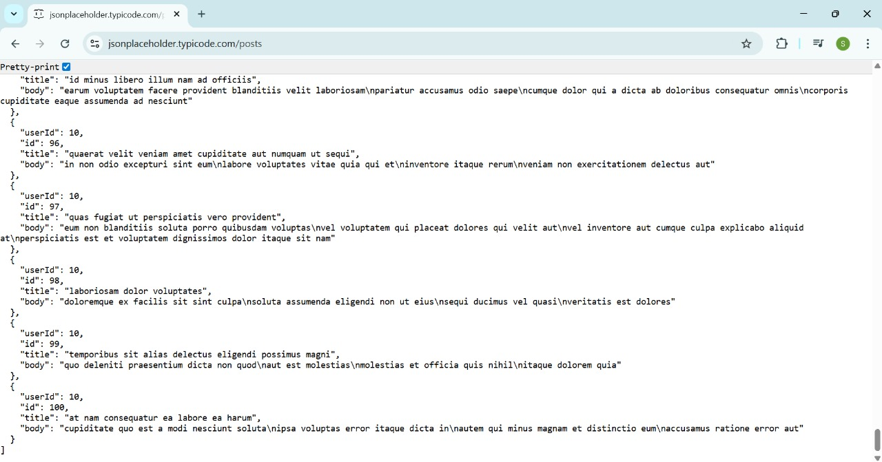

**Output :**

