**React Task 11**

**Aim :** Create a React Application “eventexamplesapp” to handle various events of the form elements in HTML.

**Procedure :**

1. Create “Increment” button to increase the value of the counter and “Decrement” button to decrease the value of the counter. The “Increase” button should invoke multiple methods.
   1. To increment the value
   2. Say Hello followed by a static message.
2. Create a button “Say Welcome” which invokes the function which takes “welcome” as an argument.
3. Create a button which invokes synthetic event “OnPress” which display “I was clicked”.
4. Create a “CurrencyConvertor” component which will convert the Indian Rupees to Euro when the Convert button is clicked.
5. Handle the Click event of the button to invoke the handleSubmit event and handle the conversion of the euro to rupees.

**App.js :**

import React, { useState } from "react";

import "./App.css";

function App() {

const [count, setCount] = useState(1);

const [amount, setAmount] = useState("");

const [currency, setCurrency] = useState("Euro");

const handleIncrement = () => {

incrementValue();

sayHello();

};

const incrementValue = () => {

setCount(count + 1);

};

const sayHello = () => {

alert("Hello! Member");

};

const handleDecrement = () => {

setCount(count - 1);

};

const sayWelcome = (message) => {

alert("welcome");

};

const handleClick = () => {

alert("I was clicked");

};

const handleAmountChange = (e) => {

setAmount(e.target.value);

};

const handleCurrencyChange = (e) => {

setCurrency(e.target.value);

};

const handleSubmit = (e) => {

e.preventDefault();

if (currency === "Euro") {

const converted = parseFloat(amount) * 100;

alert(`Converting to ${currency} Amount is ${converted}`);

}

};

return (

<div className="App" style={{ padding: 20 }}>

<h3>{count}</h3>

<button onClick={handleIncrement}>Increment</button>

<br />

<button onClick={handleDecrement}>Decrement</button>

<br />

<button onClick={sayWelcome}>welcome</button>

<br />

<button onClick={handleClick}>Click on me</button>

<h1 style={{ color: "green" }}>Currency Convertor!!!</h1>

<form onSubmit={handleSubmit}>

<label>

Amount:

<input

type="text"

value={amount}

onChange={handleAmountChange}

/>

</label>

<br />

<label>

Currency:

<input

type="text"

value={currency}

onChange={handleCurrencyChange}

/>

</label>

<br />

<button type="submit">Submit</button>

</form>

</div>

);

}

export default App;

**Output :**

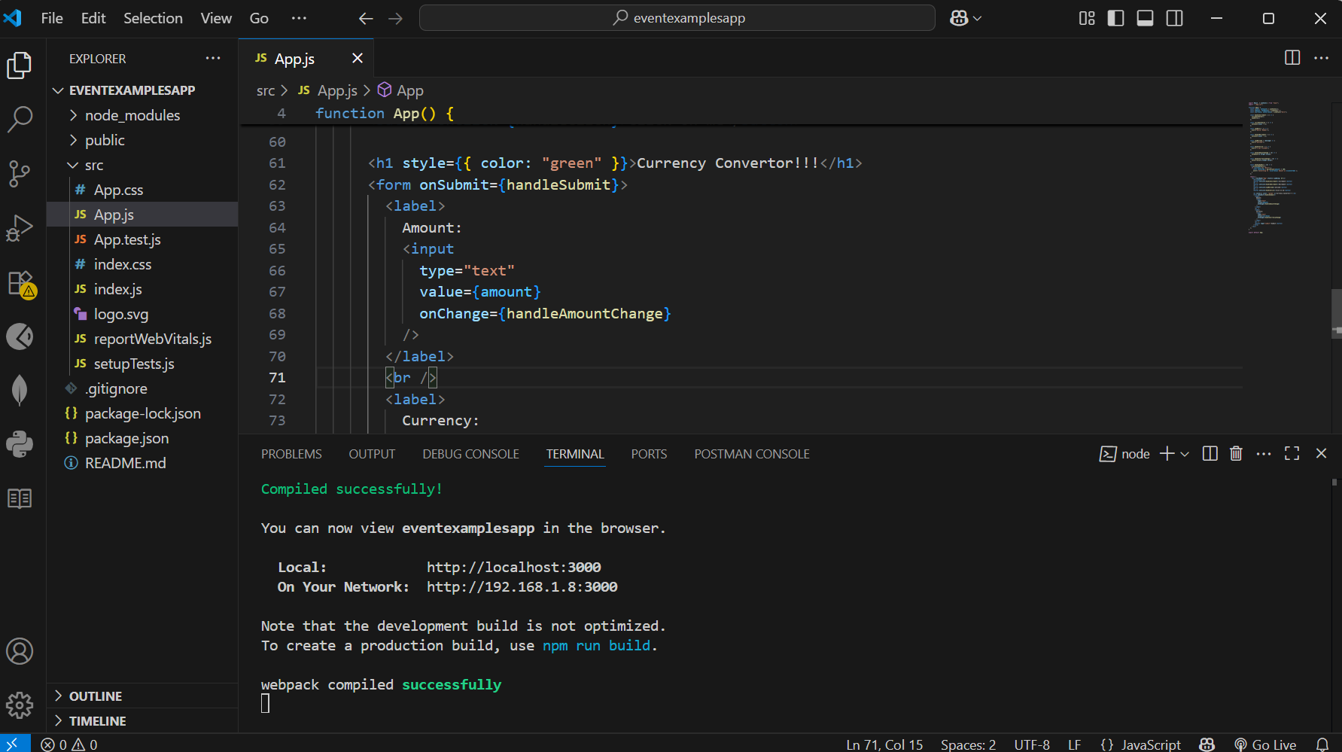

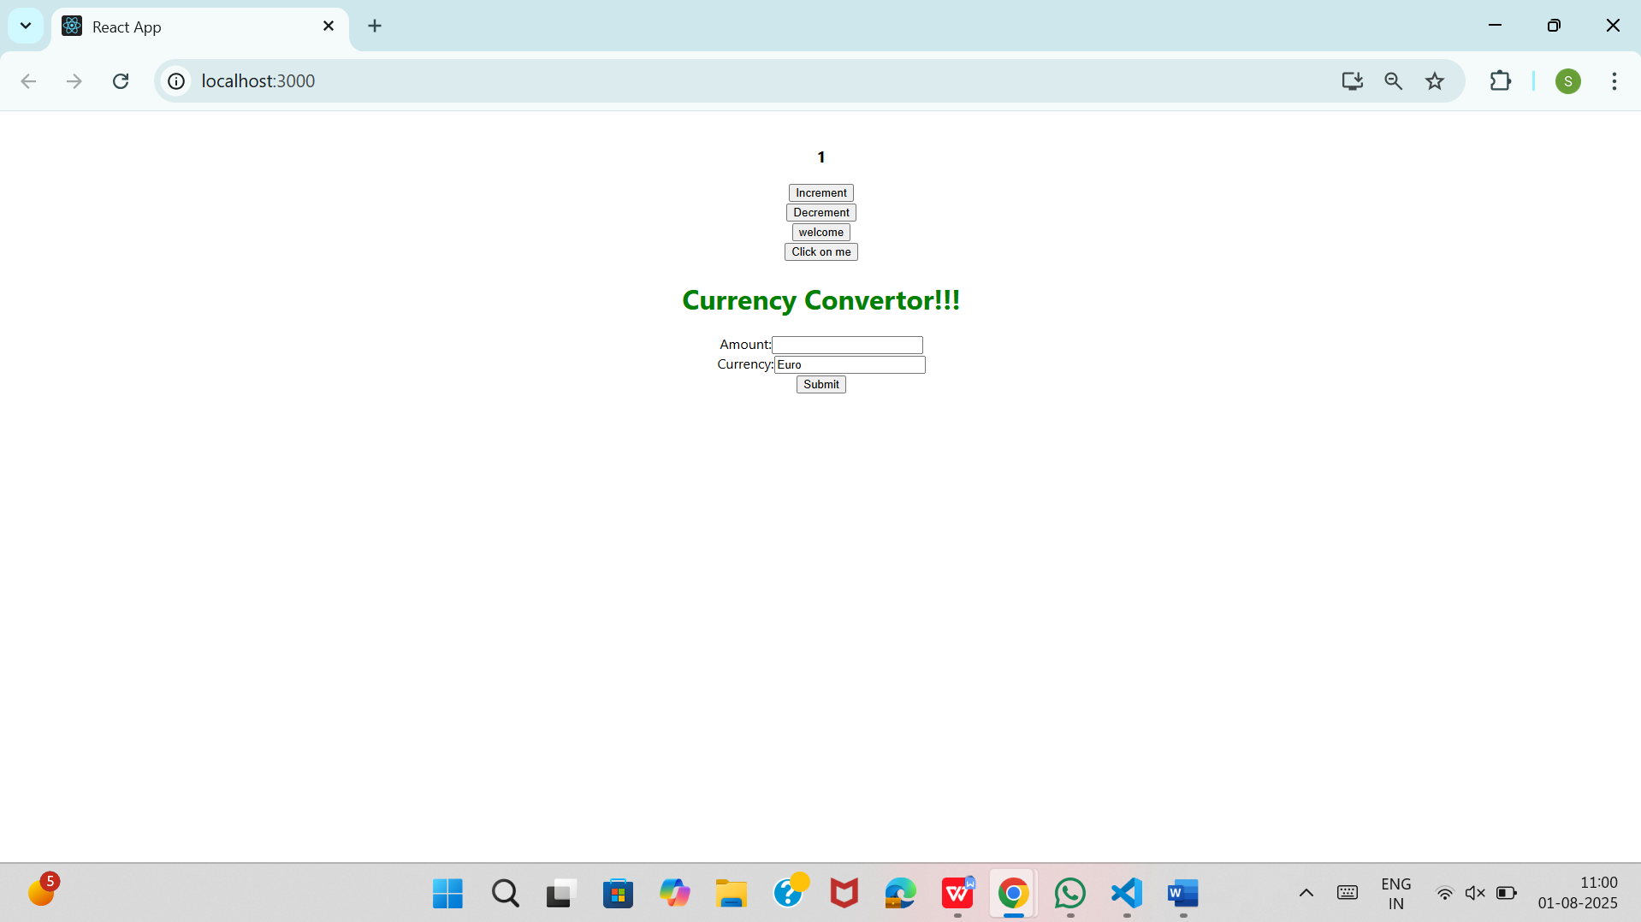

When I click on the increment button the output is :

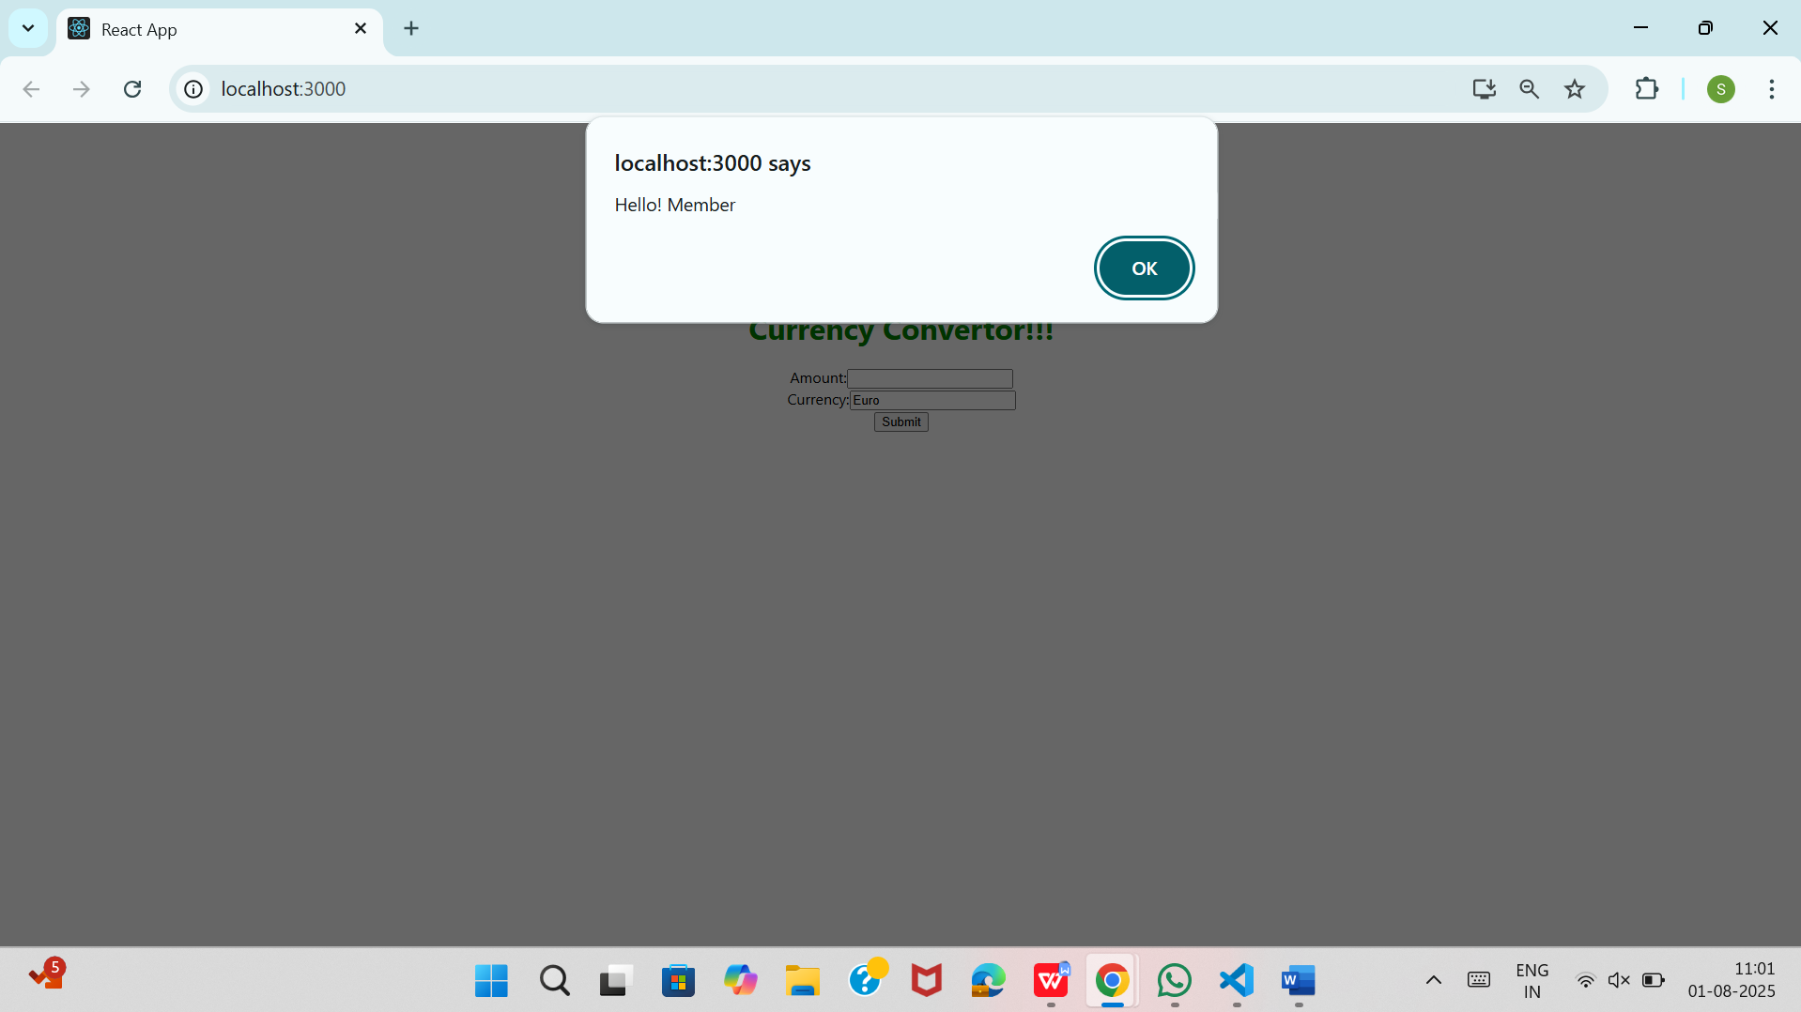

The value will be incremented from 1 to 2 .

When u click on the decrement button the value is then decremented as below :

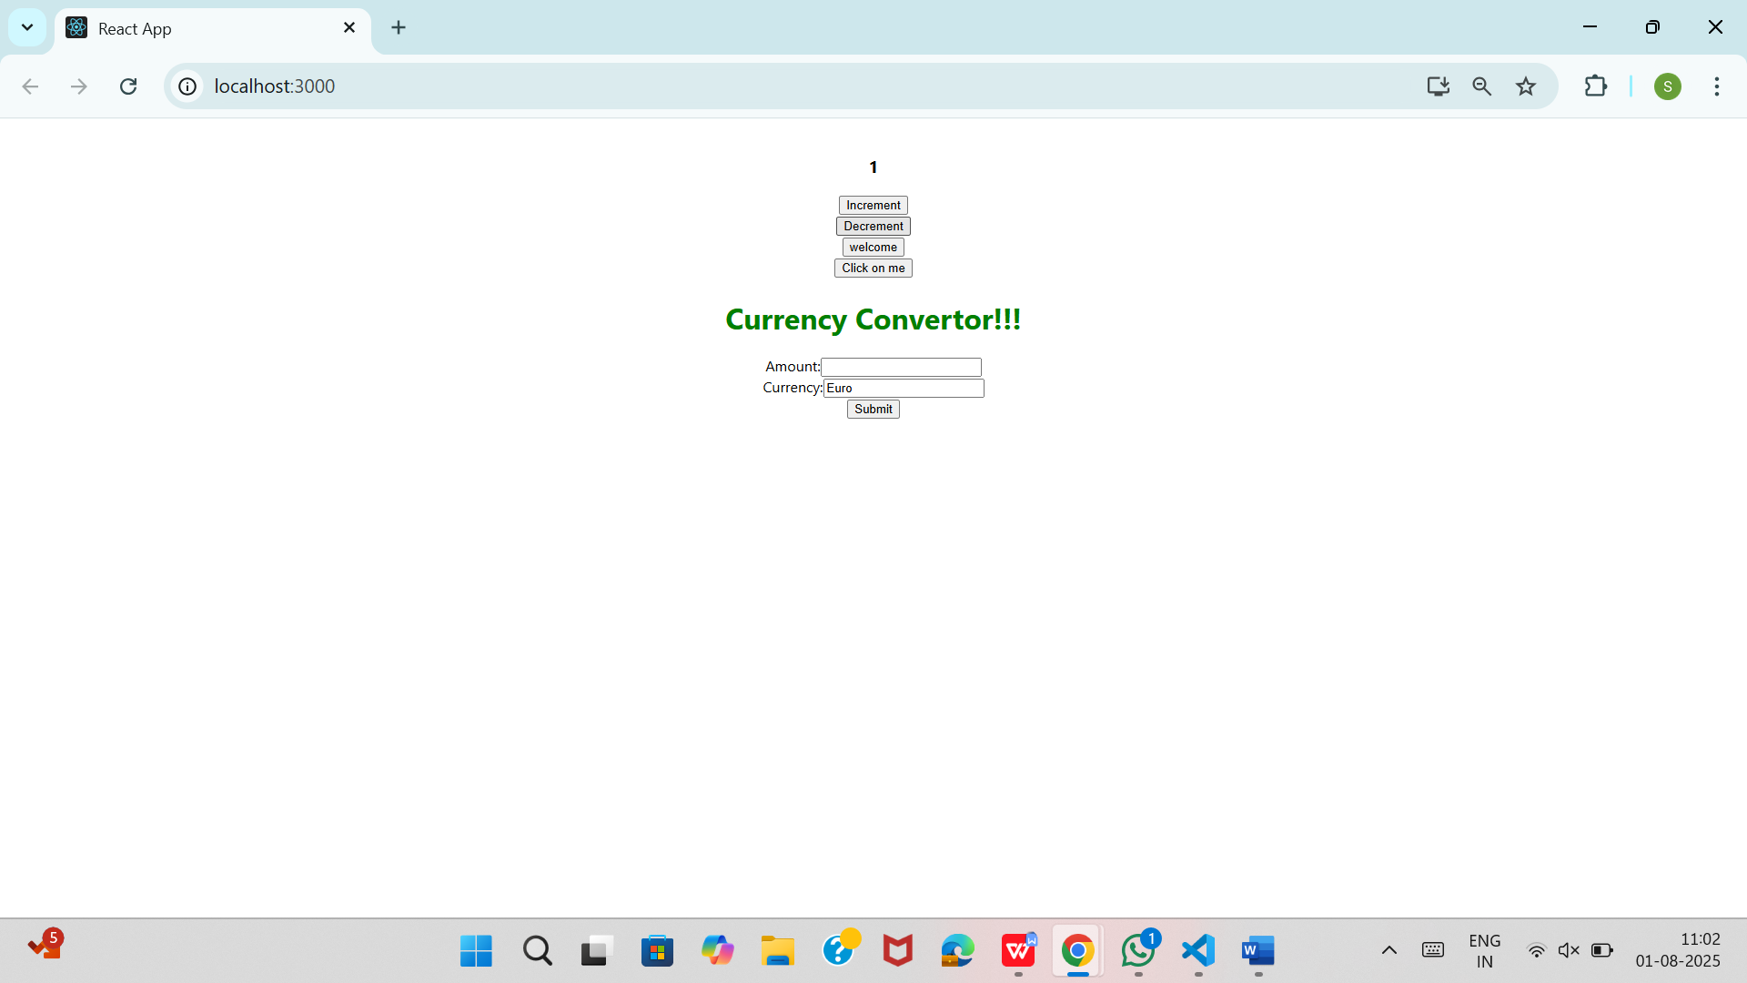

When I click on the welcome button the output is :

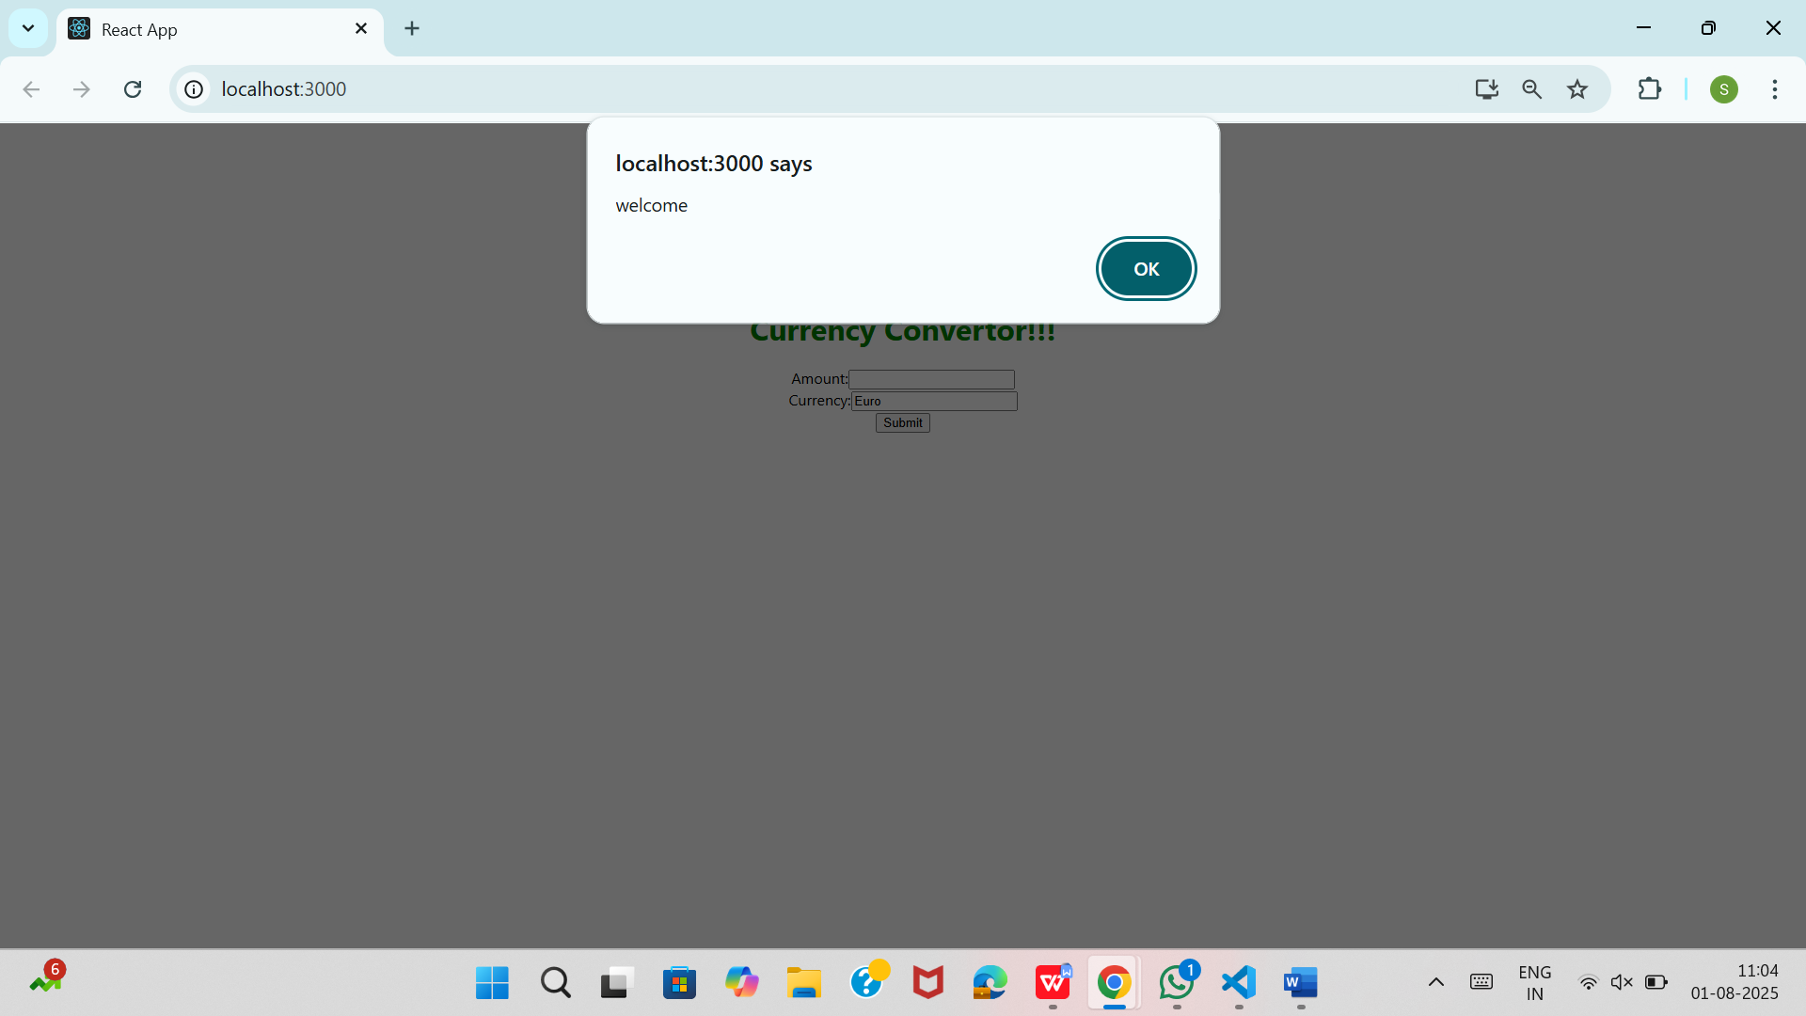

When I click on the click me button the output is :

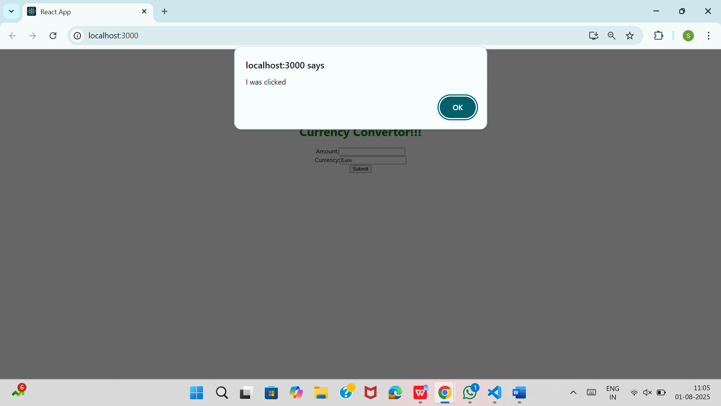

When I enter 10 in amount place and then click on submit button the output is :

