**React Task 12**

**Aim :** Create a React Application named “ticketbookingapp” where the guest user can browse the page where the flight details are displayed whereas the logged in user only can book tickets.

**Procedure :**

The Login and Logout buttons should accordingly display different pages. Once the user is logged in the User page should be displayed. When the user clicks on Logout, the Guest page should be displayed.

**Output :**

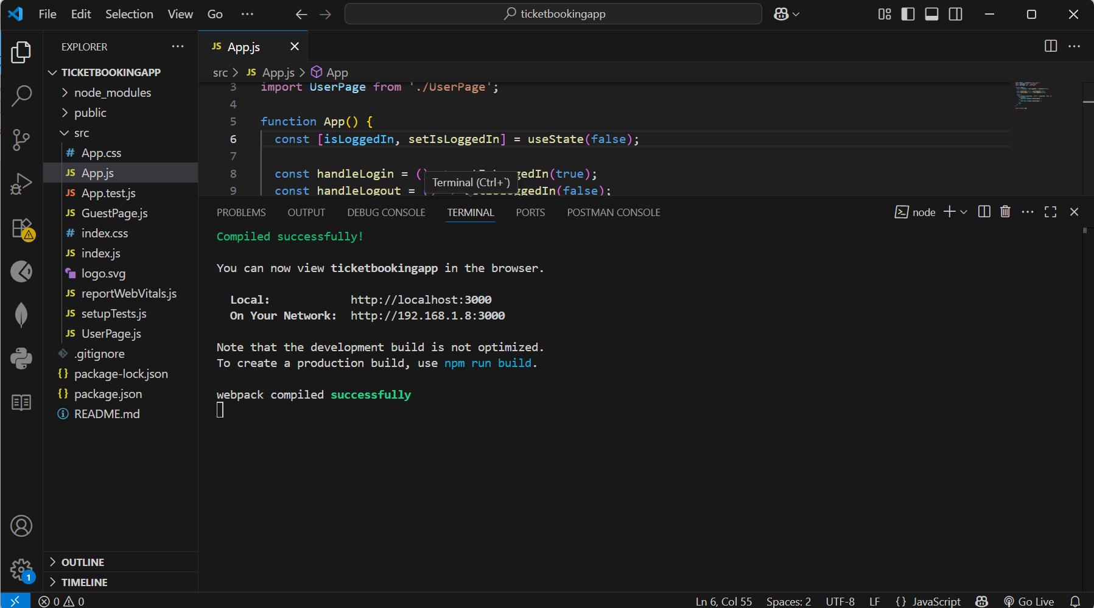

This page will be displayed as soon as we run the project in react :

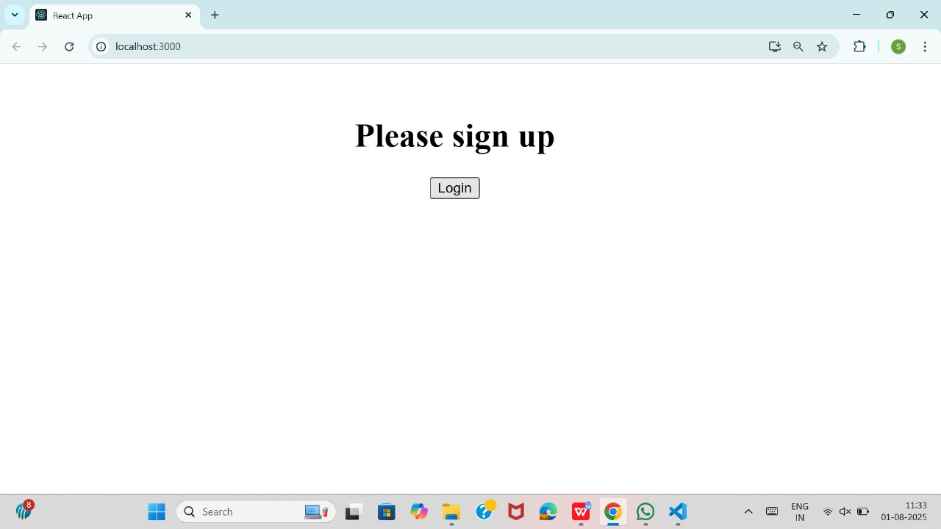

when we click on the login button :

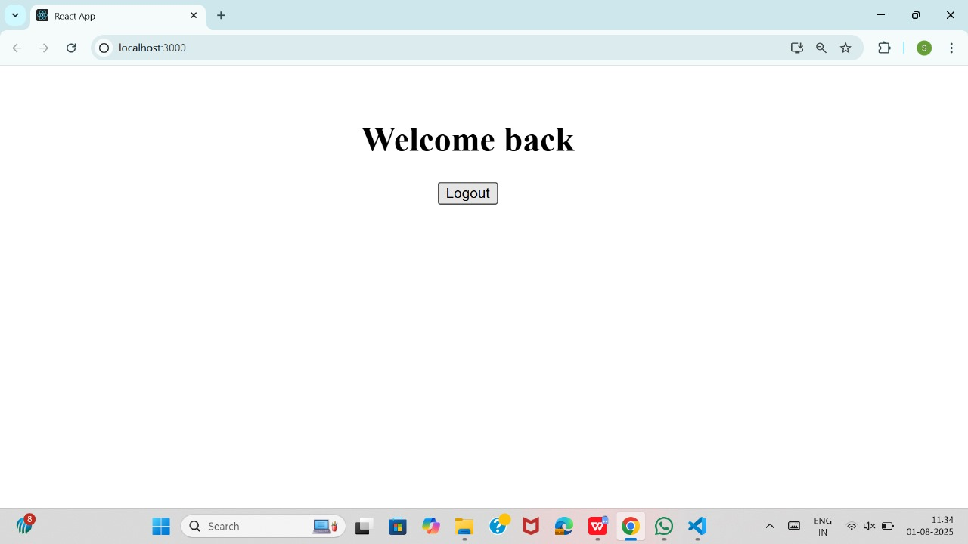

And when we click on the logout button here we come to first page as below :

