**Git-HOL Task 5**

**Aim :** Execute steps involving clean up and push back to remote Git.

**Procedure :**

1.Verify if master is in clean state.

2.List out all the available branches.

3.Pull the remote git repository to the master

4.Push the changes, which are pending from “Git-T03-HOL_002” to the remote repository.

5.Observe if the changes are reflected in the remote repository.

**Output :**

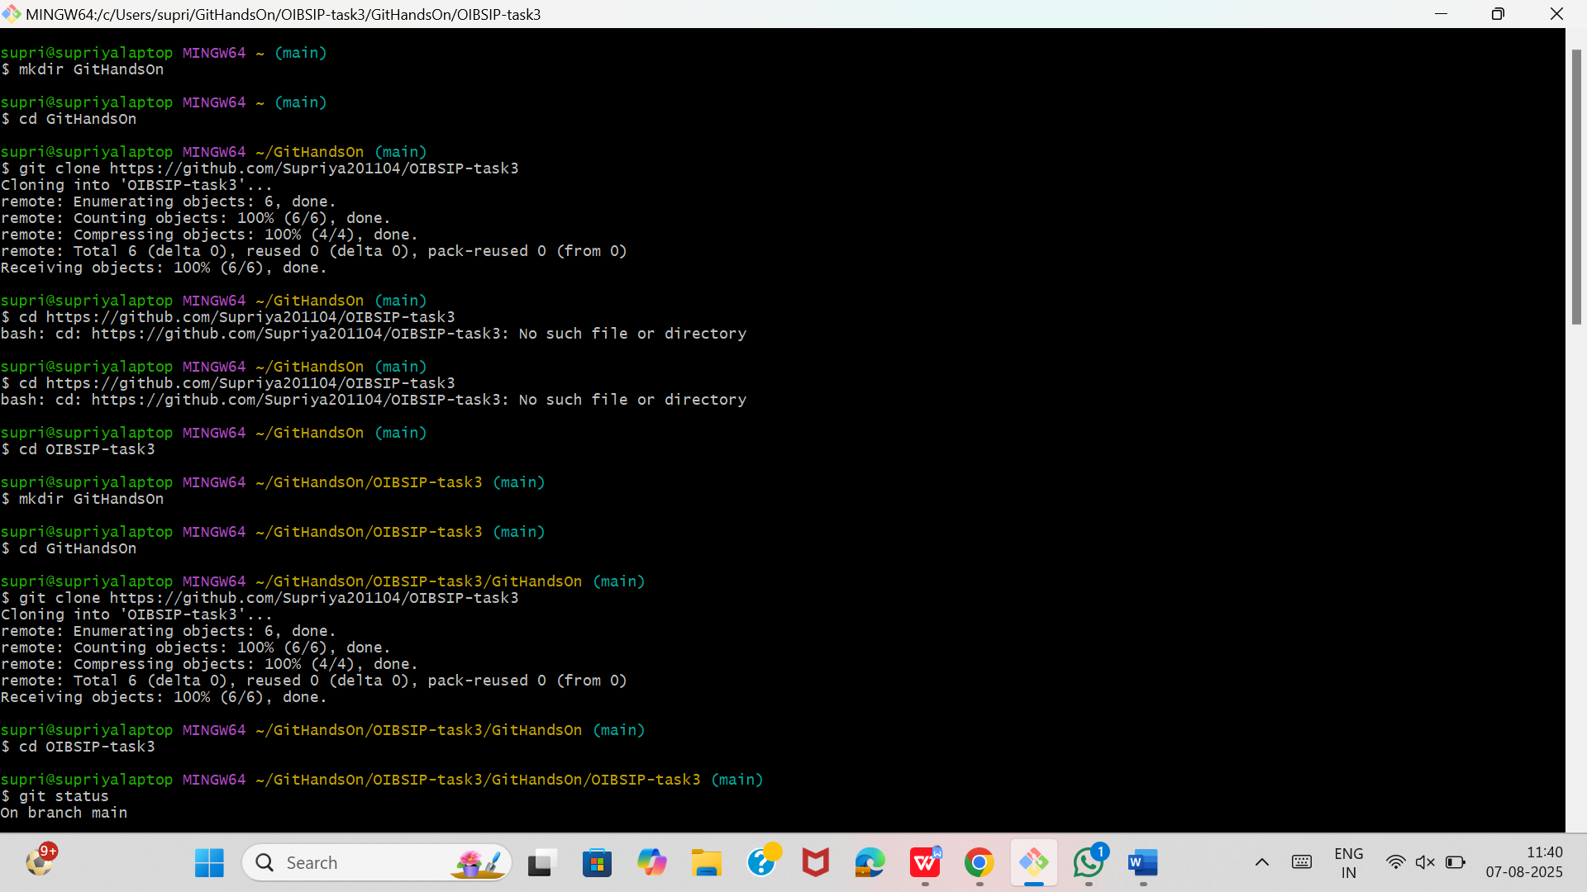

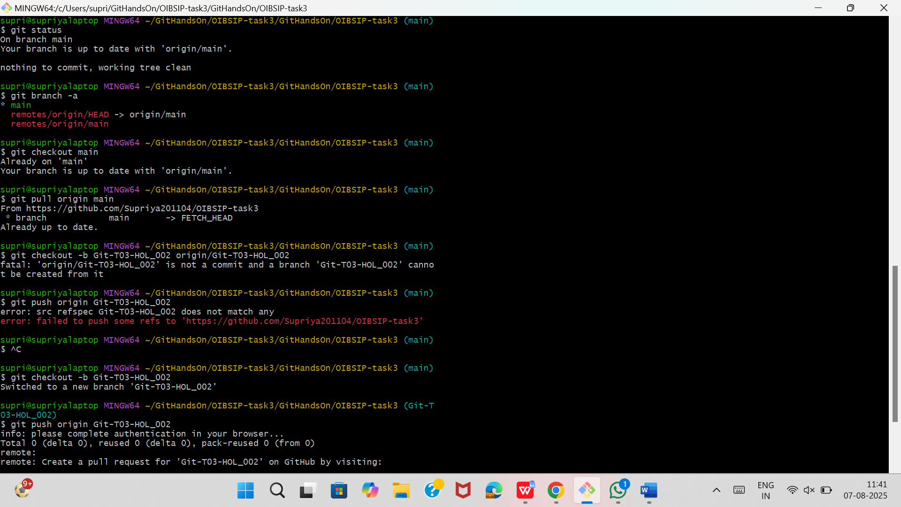

The repository that I used is :

https://github.com/Supriya201104/OIBSIP-task3

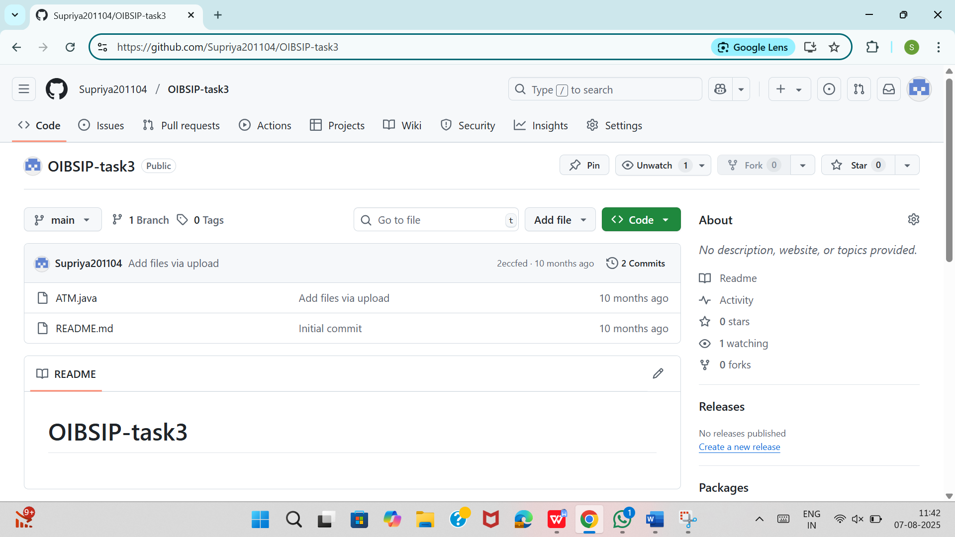

After pushing the pending changes from Git-T03-HOL_002 :

