INTEGRATION OF REAL-TIME CHESSBOARD AND CHESS PIECE DETECTION WITH ESP32-BASED INVERSE KINEMATICS CONTROL OF AUTONOMOUS ROBOTIC ARM FOR PLAYING CHESS

INTRODUCTION

Chess is one of the most popular board games played worldwide. It is set as the benchmark for human intelligence and decision-making skills. With the growing knowledge and studies in artificial intelligence, there has been a significant increase in the demand for autonomous robots which is capable of understanding the game environment and executing independent moves. It is the creation of the human mind that integrates real-time object detection and image processing with path planning and arm movement. To design a robotic arm that can play chess autonomously presents several challenges. This requires reliable integration of computer vision algorithms, inverse kinematics, and strong servo control. Though the work done in artificial intelligence has kept on improving in the past few decades, there are still miles to go. Conventional solutions are often built upon expensive robotic platforms and often rely on external computational devices. Even the accuracy of the computer vision models can be improved. The traditional servos utilizing PWM, having low torque and resolution, can also be worked on. To cater to these challenges, this paper proposes to design and implement an autonomous chess-playing robotic arm with improved accuracy of chess piece detection using YOLOv5, real-time chess board detection, and integrating it to an inverse kinematics-controlled ESP32 servo drive board, using Waveshare ST3215 servos, while maintaining portability.

METHODOLOGY

The standard SO100 robotic arm is 3-D printed to incorporate computer vision, with the end effector moving in response to input from the camera that's installed to take a clean picture of the board. To create a precise estimate of the source and destination squares for the piece to be placed, we must identify the different kinds of chess pieces and detect each of the 64 squares separately for the implementation. The controller receives the continuously updated visual data and uses inverse kinematics to determine the joint angles. As a result, the execution is accurate since the robotic arm can carry out “pick and place” tasks precisely.

A. IMAGE PROCESSING
Workflow
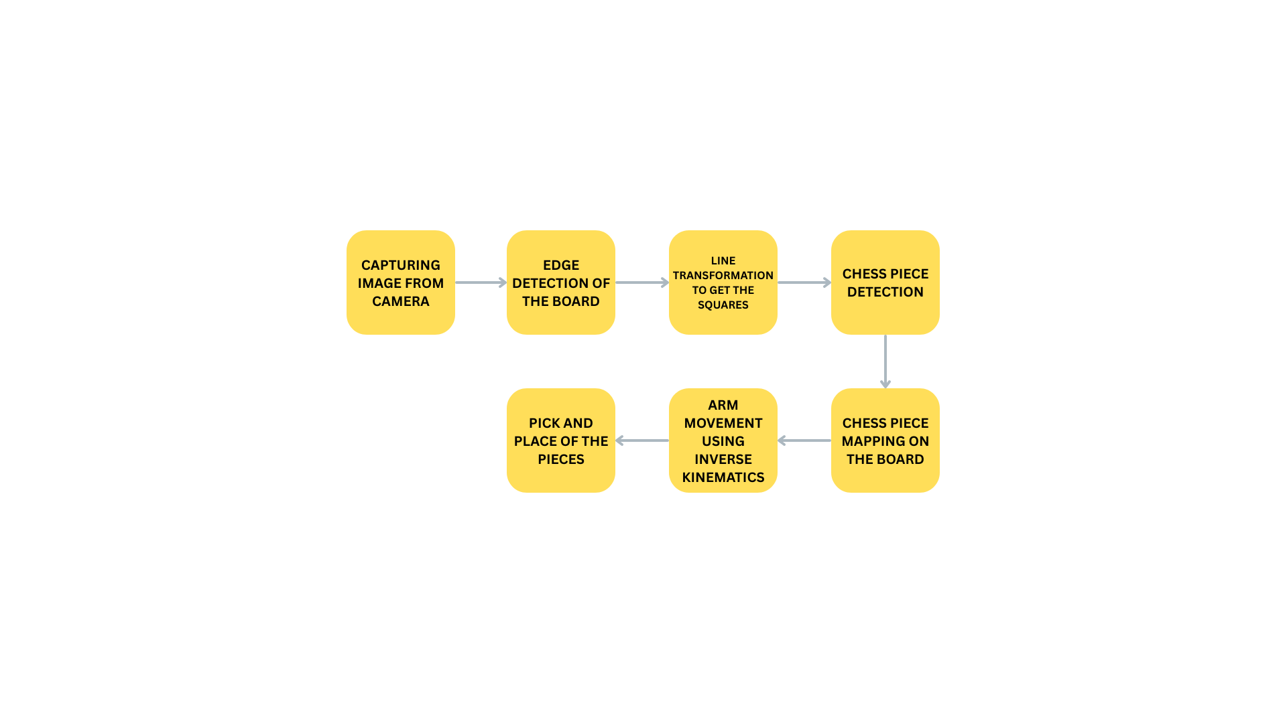

Accurate detection of the chessboard is required for error-free operation of the robotic arm. This is a computer vision problem where the structural features of the chessboard must be extracted from the image.
Preprocessing
Since the edge detection algorithm is noise sensitive, the Gaussian Blur filter is used so that the operation is smooth and the high-frequency noise is reduced while the information of the edge is preserved for further steps.
Edge Detection
Canny edge detection is used to extract edges from the preprocessed image. The gradient intensity is calculated at each pixel using the Sobel Operator:
$G_{x}=I×S_{x}$ , $G_{y}=I×S_{y}$ where ​$S_{x}$ and $S_{y}$are Sobel kernerls
Gradient magnitude A = $\sqrt{G_{x}^{2}}+G_{y}^{2}$
Gradient orientation $θ= \tan^{-1}\left(\frac{G_{y}}{G_{x}}\right)$
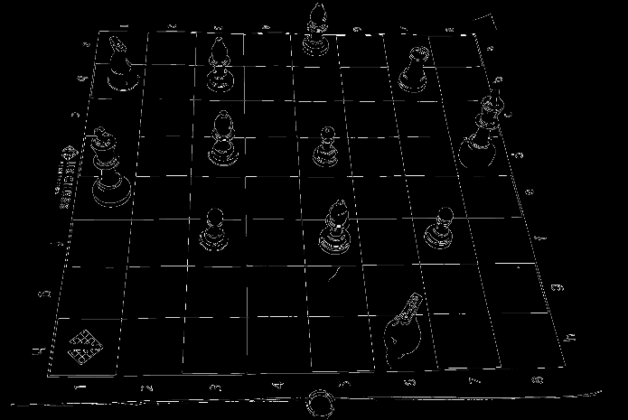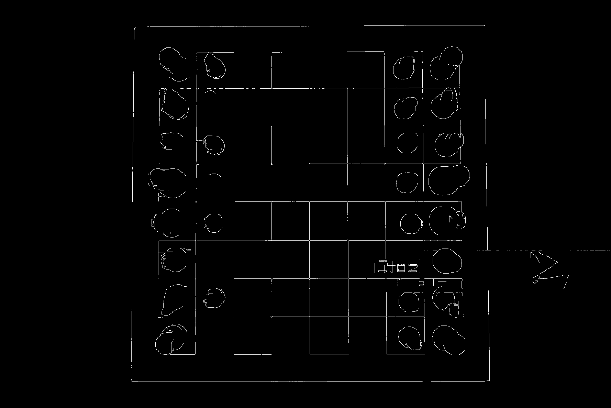
Fig – Edge detection using Canny edge detection algorithm

Line Detection
To identify the structure of the grid of the chessboard, a Hough Line Transform is applied to the image.
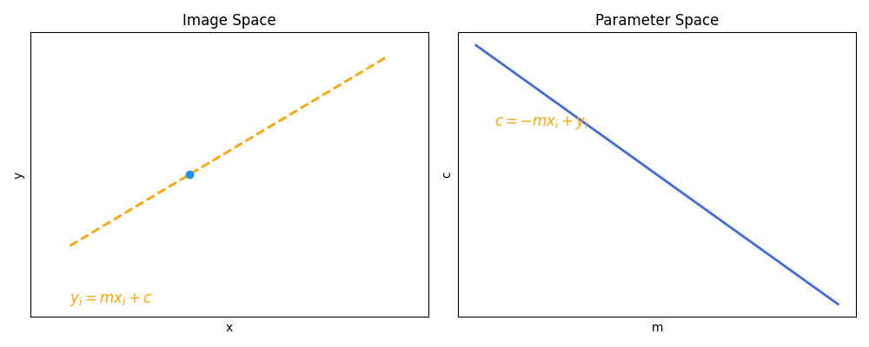
When we map the point (x,y) in parameter space (m,c), we get a line in the parameter space.
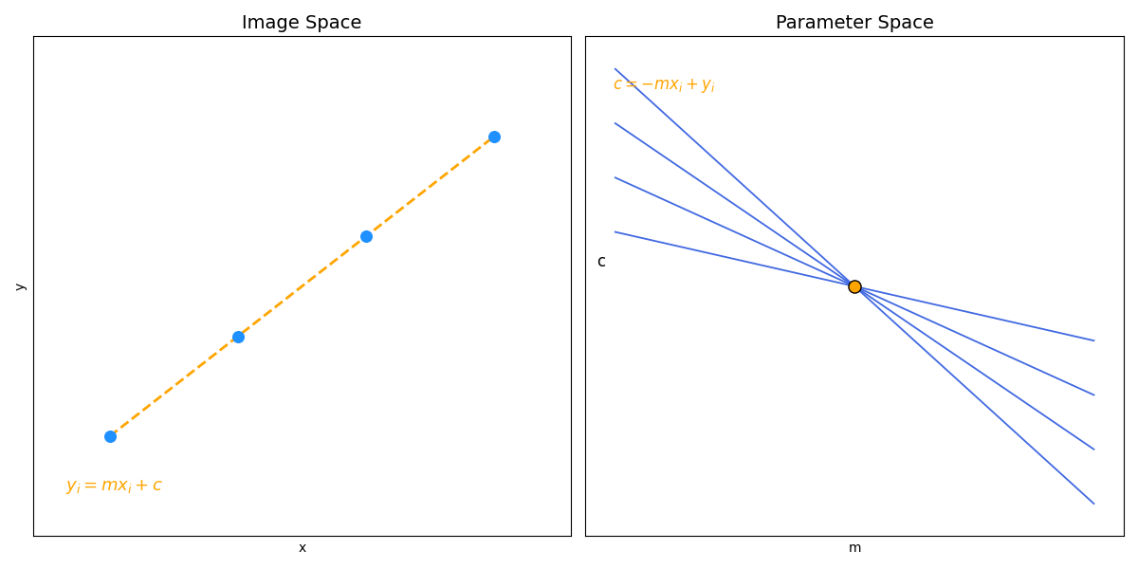
These are all the lines that pass through the point. A point in the image space corresponds to a line in the image space.
1 | 0 | 1 | 0 | 1
0 | 1 | 1 | 1 | 0
1 | 1 | 4 | 1 | 1
0 | 1 | 1 | 1 | 0
1 | 0 | 1 | 0 | 1
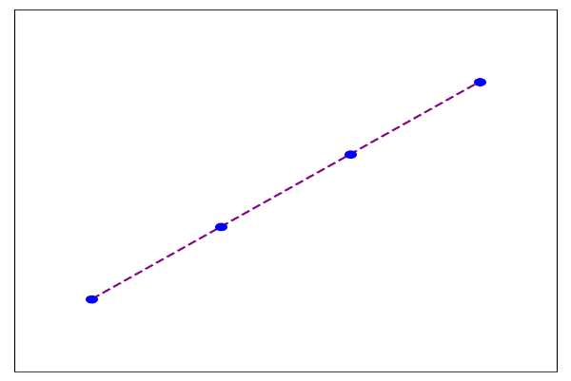
A(m,c)

We create an accumulator array, where all the cells are initially 0. For every point lying on the line, we increment the value by 1. (eg:- the above image has 4 points, hence the local maxima of the accumulator array comes out to be 4 ). The drawback is that the slope of the line is infinity, so we need a large accumulator.
This is solved by using the equation
$x\sin{θ}- y\cos{θ }+ρ =0$
where $θ$ lies between 0 and $π$ and the distance of $ρ$ is finite.

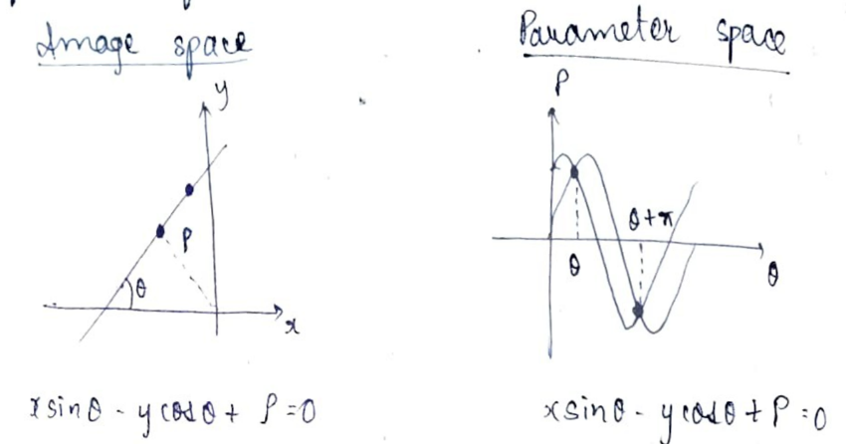
Points on the image space form a sinusoidal wave in the parameter space. The accumulator array is prepared with $(ρ, θ )$ parameter, and the value is incremented by 1 by plotting along the sinusoidal wave.
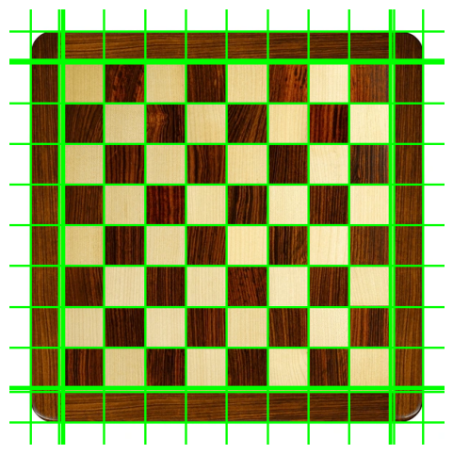
Fig:- Hough Line Transform Detection

B. CHESS PIECE DETECTION
Chess piece detection and identification of a particular type of piece on the board square is formulated as an object detection problem in computer vision. In a conventional computer vision approach, an image classification model assigns a single label to the given image. For chess, we need to crop each square individually and classify it as whether it contains a knight, a rook, or is the square empty. This pipeline is expensive in computational terms and is also prone to error, especially when multiple pieces are to be detected simultaneously. An object detection framework predicts both class labels and bounding box coordinates for all the objects present in the image. In this work, we are employing YOLOv5, a Convolutional Neural Network (CNN) based object detection framework that processes the entire chessboard in a single pass, hence reducing the inference time while maintaining high accuracy.

DATASET PREPARATION
We will be using the Roboflow Universal chess dataset, which provides us with an organized dataset for training. The dataset is augmented using grayscale conversion, rotation, flipping and scaling. This mitigates the problem of overfitting and helps in generalization. We will train the dataset using YOLOv5. We are not building the YOLOv5 model from scratch, but using a pre-built model, hence using the method of transfer learning. While training the dataset, bounding boxes are created around the chess pieces, which are stored in x_train. A vector of the box is then created and stored in y_train.
Y_train = ${\left[Pc,,Bx,By,Bw,Bh,C1,C2,…C n\right]}^{T}$
Pc – probability of the class
Bx, By – x and y coordinate of the centre of the box
Bw, Bh – height and width of the bounding box
C1, C2,…Cn – classes (eg- knight, pawn, king, queen, bishop, rook)
Then, x_train and y_train are passed through a Convolutional Neural Network, and the model learns to identify the images. During Inference ( Prediction ) – YOLOv5 predicts the bounding boxes automatically, and CNN extracts features like coordinates, class probability, etc. For multiple objects, the model uses a grid-based prediction system. For example, if we use a 4*4 grid, each grid will have its own vector, and each vector will have information regarding the probability, coordinate, and objectness score. Therefore,y_train will now have 16 such vectors, x_train and y_train will be passed through the CNN, and after training the model with a large number of images of the same object, it learns to recognize multiple chess pieces in a single frame.
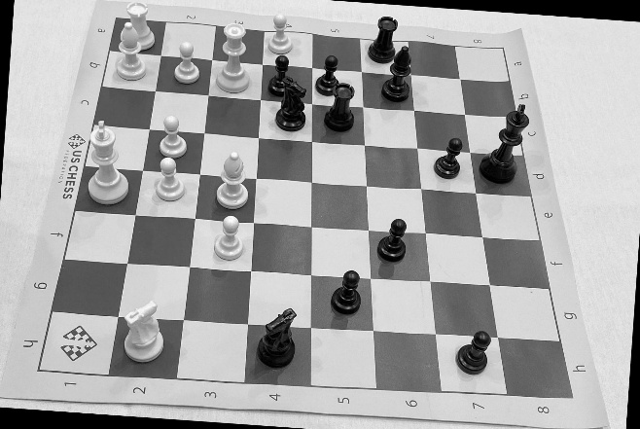
Fig – greyscale conversion and rotation(augmentation)

Architecture of YOLOv5

The architecture is divided into 3 components –
BACKBONE – CSPDarknet is used for feature extraction. It learns the hierarchy of edge, texture and object parts through convolution layers.
NECK – The SPPF (Spatial Pyramid Pooling – Fast) ensures that the chess pieces are detected at small, large and medium scales.
HEAD – Anchor boxes generates bounding box coordinates, objectness score and probability of the class. Multiple bounding boxes can be created around a single object, to overcome this issue, Non-Maximum Suppression (NMS) is used, i.e., it keeps the box with the highest detection probability while removing the rest.
Mathematically, the confidence score of the bounding box can be measured as –
Confidence_score = $P\left(object\right)×{IoU}_{predicted}^{truth}$
P(object) is the objectness probability and ${IoU}_{predicted}^{truth}$ is the intersection over union between the predicted and the ground-truth bounding box.
Implementation
YOLOv5 is implemented using the PyTorch deep learning framework. This model is trained on a large-scale dataset using transfer learning, i.e., we start from pre-trained weights and fine-tune on the chess dataset. Till YOLOv4, it used the Darknet repository, which was written in C, so it was not very user-friendly. Even though YOLOv5 is trained using PyTorch, it can be converted into various formats, such as ONNX, TensorRT, and CoreML, which enables deployment across various embedded devices.
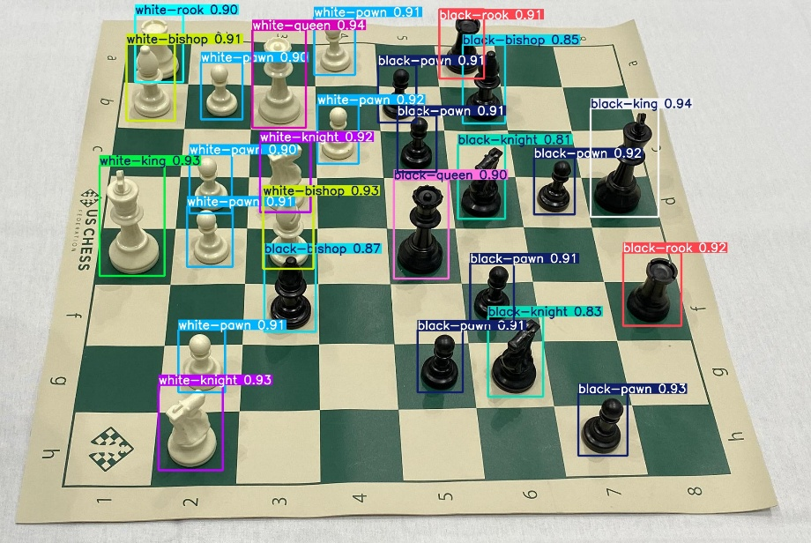
Fig – chess piece detection
C. ROBOTIC ARM CONTROL
A 5 DOF robotic arm is fabricated using 3D printed SO100 design which is driven by waveshare st3215 serial bus servo and waveshare esp32 servo driver board controls it. The conventional servos uses PWM signal for communication set through independent GPIO pins, whereas ST3215 uses a half-duplex RS485 bus for communication. This design allows the use of 235 servos to be daisy-chained on a single communication line, which helps to reduce the complexity that happens in wiring.
Simulation
Before deploying it on hardware, the inverse kinematics of the model is validated by using PyBullet physics simulator, which helps in trajectory planning, detecting forward and inverse kinematics, and detecting collision. Once validation is done, the angles are mapped to ticks and deployed on esp32 servo driver. When we work on simulating hardware, it ensures safety and reduces errors in physical terms.
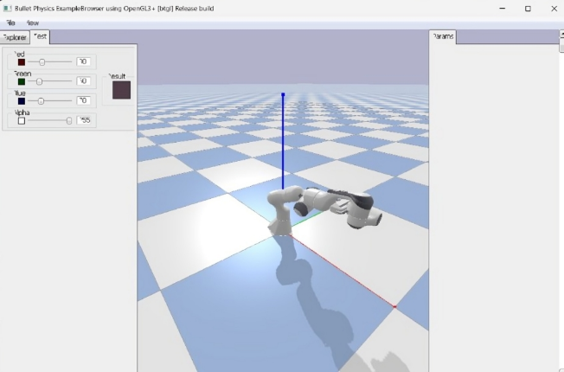
Fig – Simulation of inverse kinematics using PyBullet
ST3215 Servo Characterstics
It integrates 12-bit magnetic encoder and the angular-resolution is obtained by dividing full 360$°$ into 4096 ticks.
End_position = $\frac{θ}{360}×4096$ where $θ$ is the desired angle
6-12V external power supply is required for the servo to operate. It provides real-time feedback of power, load, speed, input voltage. This closed loop feedback system improves control of precision and reliability compared to open-loop PWM servos.
A standard servo control packet follows this protocol:
$[0×FF] [0×FF] [ID] [LENGTH] [CMD] [PARAMS] [CHECKSUM]$
Where $[0×FF] [0×FF]$ is the header and denotes the start of the packet, ID will identify the servo (1-253), length specifies the number of bytes, CMD is the command given, like read, write, move. Checksum adds all the bytes from ID to the last parameter and inverts it, to check whether the packets are received correctly or not.
CHECKSUM = $\sim ( \sum_{i=ID}^{last parameter}{ )}$
This protocol allows us to control multiple joints over a single UART bus, where RX, TX and Ground are connected to esp32 controller.
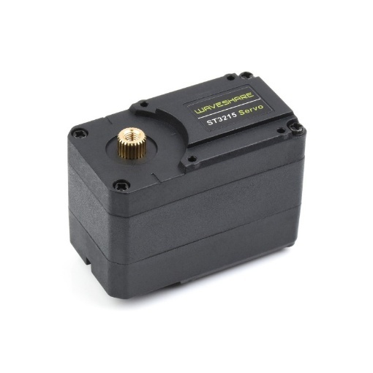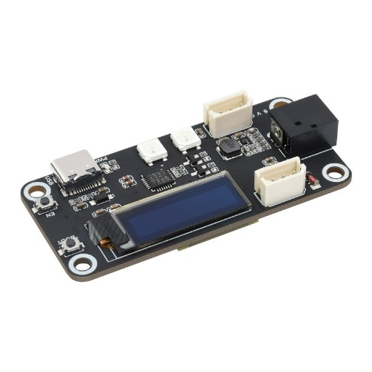
Fig:- ST3215 Servo Fig:- ESP32 Servo Drive Board
INVERSE KINEMATICS FOR MOVEMENT
For the movement of a chess piece from one square to another, the target Cartesian coordinate on the chess board is converted into a set of joint angles. This is achieved through inverse kinematics.
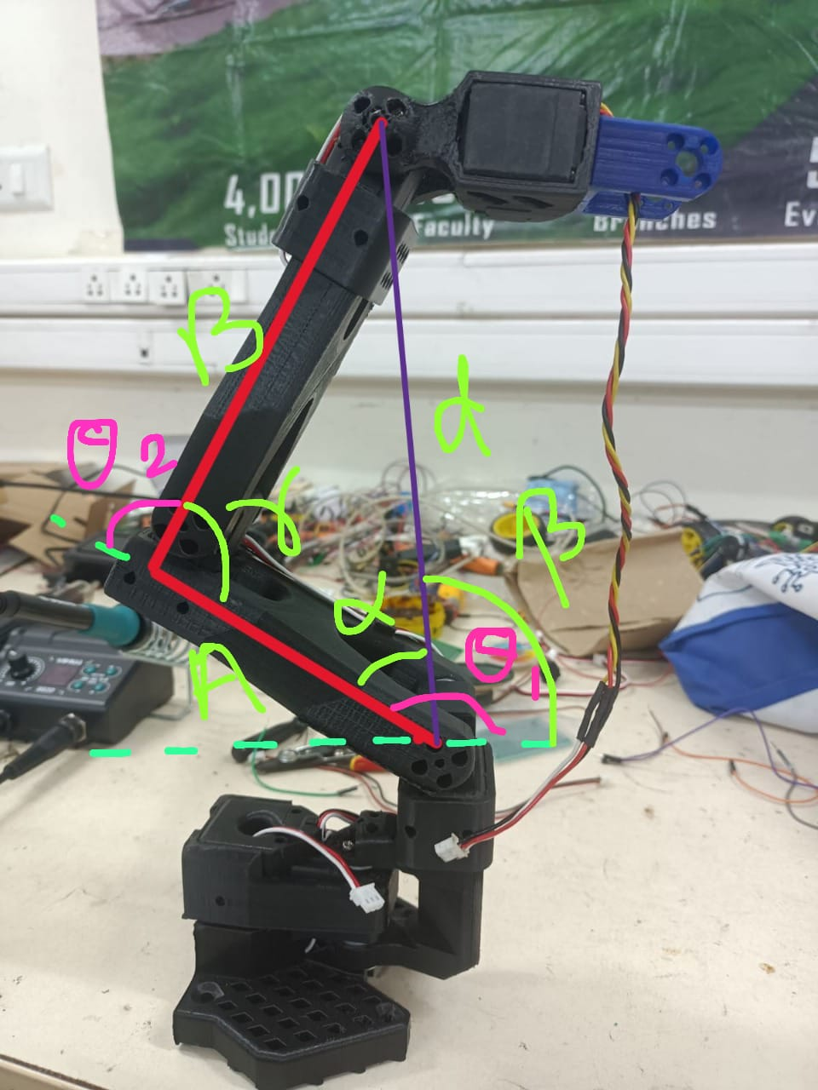
Fig – Inverse kinematics equations

A and B are the length of the arm segement
$d^{2}= A^{2}+B^{2}-2AB\cos{γ}$
$γ= \cos^{-1}\left[{(A}^{2}+B^{2}-x^{2}-y^{2})/2AB\right]$
$θ_{2}= π-γ$
$\cos{θ_{2}}= -\cos{γ}$
$θ_{2}= - \cos^{-1}\left[{(A}^{2}+B^{2}-x^{2}-y^{2})/2AB\right]$
$α=\tan^{-1}{((B\sin{θ_{2}})}/(A+B\cos{θ_{2}}))$
$β= \tan^{-1}{( \frac{y}{x} )}$
$θ_{1}= α+β$
$θ_{1}=$ $\tan^{-1}{((B\sin{θ_{2}})}/(A+B\cos{θ_{2}}))$ + $\tan^{-1}{( \frac{y}{x} )}$
Since we may encounter negative angles, eg:- if the arm reaches below the reference plane, the joint angle is normalized into [0$°,360°$] range using the modulus operator and then converted into ticks.

RESULT
A.CHESSBOARD DETECTION
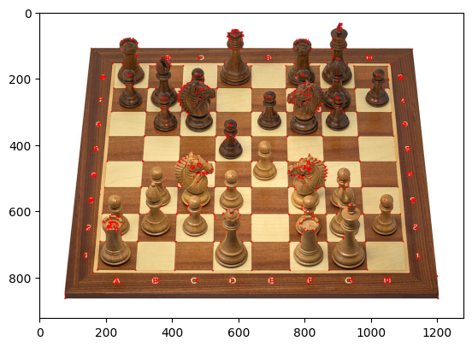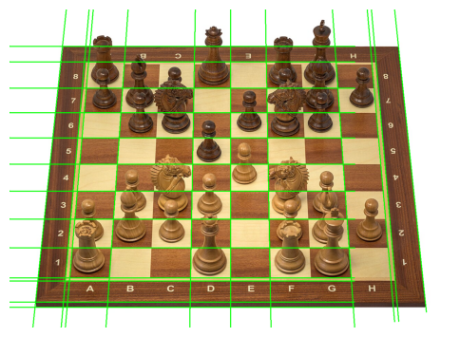
Fig – Shi Tomasi Corner Detection Fig – Hough Line Transform
To extract the structure of the chessboard, two classical computer vision techniques were evaluated: corner detection and Hough Line Transform
Shi-Tomasi Corner Detection
The algorithm identifies strong corners using eigenvalue analysis of gradient and covariance matrix. Although it detects multiple point of interest, it produces many false positives on the chess pieces leading to difficulty in precise segmentation of the board.
Hough Line Transform
The Hough method is mapping the edge points into the parameter space, where the points are converted into straight line. We see the horizontal and vertical lines superimposed on the chessboard ( with and without pieces ). This method extracts the grid structure even in presence of occluding pieces. Therefore, we are using this method for the localization and segmentation of the board.
B.CHESS PIECE DETECTION
The chess piece detection using YOLOV5 can classify the chess pieces on the board. The accuracy achieved based on the confusion matrix –
Black Bishop | 0.73
Black King | 0.93
Black Knight | 0.97
Black Pawn | 0.97
Black Queen | 0.91
Black Rook | 1.00
White Bishop | 1.00
White King | 1.00
White Knight | 1.00
White Pawn | 1.00
White Queen | 0.87
White Rook | 0.96
Recall is very high for most of the classes – close to 1 ( more than 0.95 )
In PR curve – both precision and recall are excellent
mAP@0.5 per class is about 0.99 and overall mAP@0.5 is 0.983
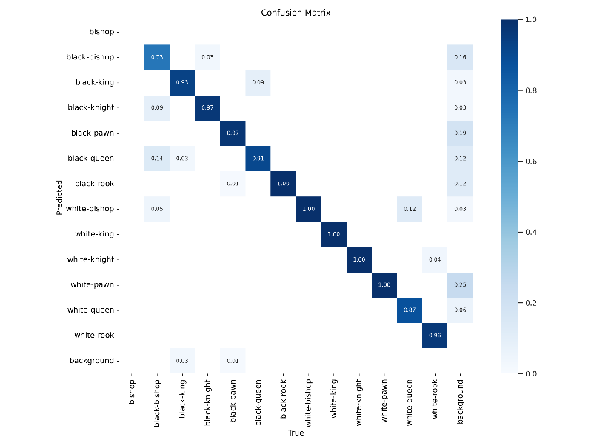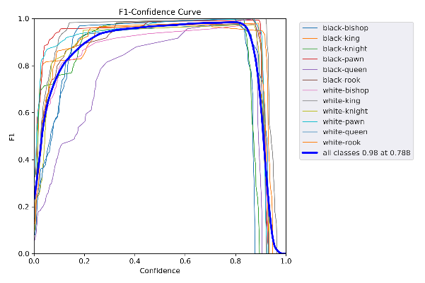
Classical 2-stage detector such as Faster R-CNN is accurate for general – purpose object detection ( mAP 87.65% ), but the inference speed is slow ( 17 FPS ) and the computational requirements are high, hence it is less-suited for real time application. Earlier YOLO models kept on increasing in accuracy and efficiency, while YOLOv4 achieved an mAP of 96.54% at about 34 FPS. However, these models show limitations, especially when working with dense and small objects, like the chess pieces.
Our YOLOv5 interpretation is achieving an mAP of 98.3%, where the class-wise precision has exceeded 95% across all chess-pieces.
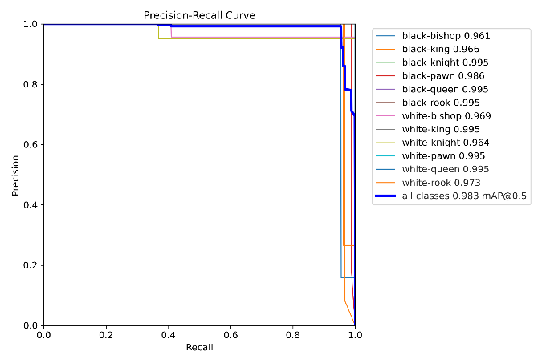

As seen in above cases, there should be a significant increase in the detection score with the improve in the version of YOLO, but our YOLOv5 implemented model achieves comparable mAP (98.3%) compared to YOLOv8(98.5%). YOLOv8 reports aggregate detection rate ( 89-94%), wherease YOLOv5 is providing class wise robustness, which is very essential for chess piece detection, where one misinterpreted chess piece can lead to erroneous move. The computational complexity of YOLOv5 is low, hence it can be deployed on embedded hardware platforms. Therefore, YOLOv5 is a more practical and reliable model for the application of chess-playing robotic arm.
C. HARDWARE CONTROL
To validate end-to-end system, the YOLOv5 model has to be integrated with the hardware control. We are using esp32 servo drive board controlled by five Waveshare ST3215 servo motors. The esp32 board uses UART based half-duplex RS485 for communication , where all the servos get connected through a single bus line, hence the wiring is simplified compared to the complex wiring of traditional PWM-based servos. The UART packet-based communication that we are using, reduces latency and improves the synchronization between multiple servos. The hardware validation demonstrates that the proposed system is not only effective in software based detection, but can also be deployed for real world robotic task.
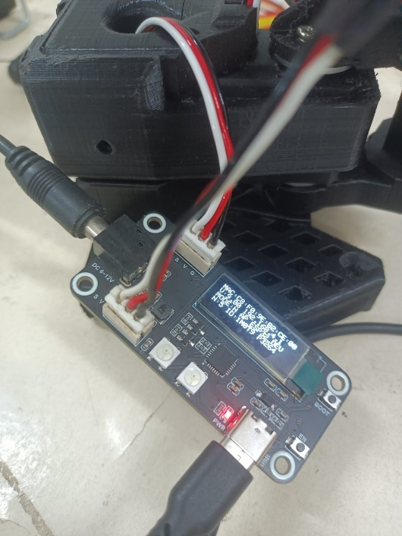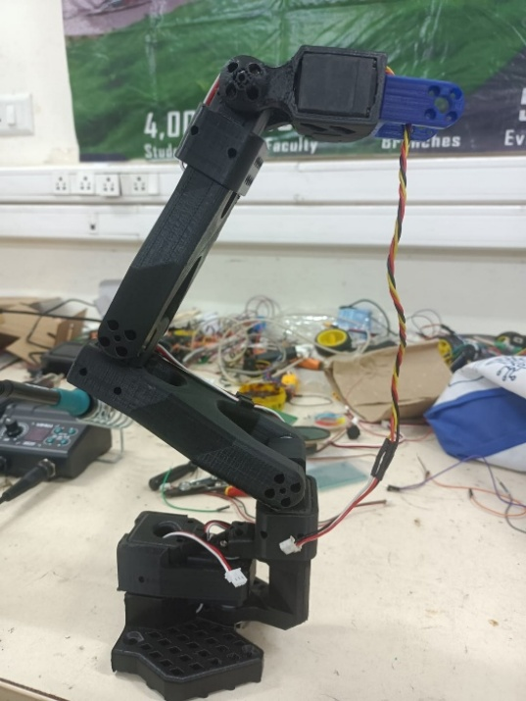
Fig – ESP32 Servo drive board connection Fig – 3D printed 5 DOF robotic arm

FEATURES | TRADITIONAL PWM SERVOS | ST3215+ ESP32 SERVO DRIVE BOARD(PROPOSED)
CONTROL SIGNAL | PWM (1 pin for each servo) | UART RS485 bus
MAXIMUM SERVOS SUPPORTED | Limited ( bounded by GPIO ) | Upto 253 on 1 bus line
 | 8–10 bit (0.35–0.7° step) | 12-bit (0.088° step, 4096 ticks for 360° rev)
  RESOLUTION
FEEDBACK | No feedback | Position, load, speed and voltage
WIRING | Complexity is high ( 1 wire/channel ) | Complexity is low ( 1 bus line for all the servos )
TORQUE AND STABILITY | Moderate | High

