**BRAIN TUMOR SEGMENTATION USING**

**DEEP LEARNING**

**A PROJECT REPORT**

Submitted in partial fulfillment of the requirements for the award of the internship

**By**

B **.** AMARA LINGESWARA RAO (21VV1A1202)

P. MANI SUPRIYA (22VV5A1272)

(Students of JAWAHARLAL NEHRU TECHNOLOGICAL ENGINEERING GURAJADA VIZIANAGARAM(A))

**Supervisor:**

**Dr. Mohammad Farukh Hashmi**

**Assistant Professor**

**Department of Electronics and Communication Engineering**



**Department of Electronics and Communication Engineering**

**National Institute of Technology, Warangal**

**2023-24**

**ABSTRACT:**

In medical image processing, brain tumor segmentation is an important task. Early detection of brain tumors increases survival rates and improves treatment options for patients. Manually separating brain tumors from the numerous MRI images acquired during clinical procedures in order to determine malignancy is a laborious and time-consuming process. Brain tumor image segmentation must be done automatically. An overview of MRI-based brain tumor segmentation methods is provided in this study. Since deep learning techniques yield state-of-the-art results and outperform other methods in resolving this challenge, they have gained prominence recently in automatic segmentation. Deep learning algorithms can also be used to process the enormous volumes of MRI-based image data objectively and efficiently. There are currently a large number of review publications focused on traditional methods for segmenting brain tumor pictures using MRI. In contrast to other articles, ours focuses on the latest developments in the field of deep learning methodologies. This section begins with a quick summary of brain tumors and how they are segmented. These state-of-the-art algorithms are then highlighted as the latest developments in deep learning approaches are examined. The current state of affairs is assessed, and recommendations for standardizing MRI-based methods for brain tumor segmentation into routine clinical practice are provided.

**KEYWORDS:** Convolutional neural networks (CNN), Deep Learning, EfficientNet, Testing &Training datasets from Kaggle, transfer learning, MRI

1. **INTRODUCTION**

Cancer is known as the body's cells growing and dividing uncontrollably and unnaturally. A brain tumor is a mass that forms in the brain tissue due to abnormal cell division and growth. Among the most deadly malignancies, brain tumors are uncommon but highly deadly1. An essential technique for identifying, diagnosing, and tracking brain cancers is magnetic resonance imaging (MRI).

Analysis of the brain is particularly challenging due to its billions of active cells. Brain tumors are becoming a major cause of death in both adults and children. Less than 2% of all brain tumors are primary, affecting roughly 250,000 people annually throughout the world—cancerous diseases. People can develop 150 distinct types of brain tumor.

Malignant and benign tumors are two types of them. In the brain, benign tumors proliferate. Since they can spread outside the brain, malignant tumors are typically referred to as brain cancer [1]. For brain cancers to be properly graded and diagnosed early on, human life must be preserved. Brain tumors are highly densely packed, making the manual method extremely challenging. Tumor detection benefits greatly from an automated computer-based approach, for this reason [2]. Things are drastically different now. Radiologists can swiftly identify brain tumors by using deep learning and machine learning to enhance brain tumor detection algorithms [3]. Identify malignancies without the need for surgery. The field of brain tumor research, segmentation, and classification has gained a new tool due to recent developments in deep neural network modeling [4,5]. Researchers can classify brain tumors quickly and accurately with the aid of the fully automated CNN model. However, due to ambiguity, gaining high accuracy in brain image classification remains an unending struggle. The goal of this work is to use publicly available datasets to identify completely automatic CNN models with min-max normalization for the multi classification of brain cancers.

To achieve higher accuracy in the three-class brain tumor classification, we have suggested using a thick Efficient Net network. It focuses on using dense Efficient Net in conjunction with min-max normalization to augment data in order to improve training accuracy more quickly and at a deeper level network. In-depth separable convolution layers are included to drastically cut down on computation and parameter requirements. But in order to segment brain tumors, dense chain blocks need to be added to the Efficient Net model. Thus, good classification accuracy can likewise be attained with dense Efficient Net.

In this work, we focus on tumor segmentation, which is thought to be one of the trickiest problems using multi modal MRI pictures.

For this study, the Segmentation Challenge from the Kaggle dateset was utilized. The following is a summary of this research's primary contributions:

* Convolutional networks, such as the U-net model, are intended for accurate and reasonably fast picture segmentation. It performed better than the previous best technique for segmenting neural structures in the ISBI challenge. To improve performance, skip connections are considered in the architecture.
* A novel approach is proposed to create the model architecture instead of using fixed hyper parameters. In this sense, the model is optimized by ablation research, in which several experiments are carried out by adjusting various hyper parameters.
* As our goal is to minimize the computational cost while getting the highest feasible performance, we have used a single slice of the 3D MRI instead of training the model with 3D pictures.

1. **LITERATURE SURVEY:**

In recent years, several cutting-edge methods for automated brain tumor segmentation have been introduced. A CNN model was used in Pereira et al.'s [6] automated segmentation technique. Their method produced the place with dice coefficient (DC) measures of 88, 83, and 97% for the total, core, and enhancing areas, respectively, when tested on the MRI Segmentation dataset from Kaggle. A computerized approach that can identify abnormal brain tumors as high-grade gliomas (HGG) and differentiate between a normal and irregular brain based on MRI images was presented by other investigators [7].   
or glioma of low grade (LGG). The method effectively identified HGGs and LGGs with accuracy, specificity, and sensitivity ratings of 99%, 98.03%, and 100%, respectively.

A low-parameter network called 2D U-Net was created by Noori et al. [8] using two distinct methods. Employing the BraTS, They received dice scores of 89.5, 81.3, and 82.3% for the whole tumor (WT), enhancing tumor (ET), and tumor core (TC) in the 2018 validation data set, respectively.

The effectiveness and precision of deep learning models[10] for the diagnosis of skin cancer have been greatly enhanced via transfer learning. On sizable datasets like testing and training datasets from the Kaggle collection, researchers like Tschandl et al. (2018) used pre-trained models like ResNet, UNet, and Efficient Net. These models required less intensive training from scratch after they were tuned to reach high accuracy in classifying brain tumors. To overcome the problem of scarce labeled data in neurology, data augmentation approaches have been used. Artificial techniques to enhance the quantity and variety of training datasets include rotation, flipping, and zooming. Furthermore, to increase diagnostic accuracy, ensemble approaches incorporating several models have been investigated.

Numerous research has demonstrated great accuracy and reliability in the application of deep learning to brain tumor segmentation, which has shown considerable potential. For AI-driven diagnostic tools in Sure, here is the corrected text:  
In neurology to be successfully implemented, more research and development in this area is required, with an emphasis on improving model interpretability and overcoming present obstacles.

1. **METHODS:**
   1. **Convolution Neural Network**

The structure of neural networks is modeled after the organic human brain. Quantifying vectors, approximating data, clustering data, aligning patterns, optimizing, and classifying functions are the main applications of neural networks.

The three kinds of neural networks—feedforward, recurrent, and feedback—are distinguished by the links between them. Additionally, a neural network can be divided into two categories: single-layer and multilayer neural networks.



**Figure 1: CNN** Architecture

The typical neural network is unable to scale the image. However, images can be scaled (i.e., in length, width, and height) within the neural network's convolution. An input layer, a convolution layer, and a rectified linear unit (ReLu) make up the Convolution Neural Network (CNN). The input image is split up into multiple tiny convolutional areas.

* 1. **Transfer Learning**

A machine learning technique called "transfer learning" entails using a model that has already been trained to address a new problem [9–11]. Usually, the pre-trained model is trained using a sizable datasets and has mastered the art of extracting generic features that may be applied to a variety of applications. Even in situations when we lack a substantial datasets, we can utilize transfer learning to apply the acquired characteristics of the per-trained model to a new task. The architecture of the Transfer Learning is shown in Figure 2.

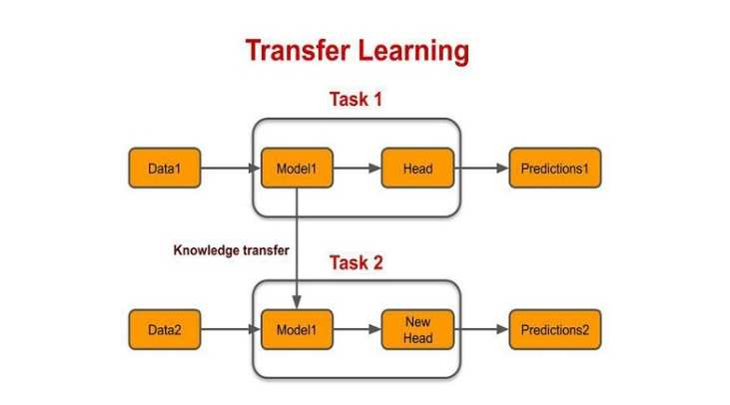

**Figure:2**

Transfer learning can help increase performance in brain tumor detection using a CNN such as EffNet by lowering the quantity of training data required. We can utilize a pre-trained EffNet model that has already learned to extract valuable features from images, saving us the trouble of training the CNN from scratch. After that, we may use our unique dataset of brain tumor photos to fine-tune the model by changing the pre-trained model's weights to better fit the fresh data.

All things considered, transfer learning can increase efficiency in a variety of machine learning applications, including medical image analysis, while also saving time and money.

* 1. **Proposed Architecture:**

**EfficientNet Architecture**

In 2019, Tan and Le unveiled EfficientNet, a state-of-the-art CNN architecture. It balances the model's depth, breadth, and height using a unique compound scaling technique. resolution, outperforming other CNN architectures in terms of accuracy while using fewer parameters and computational power.

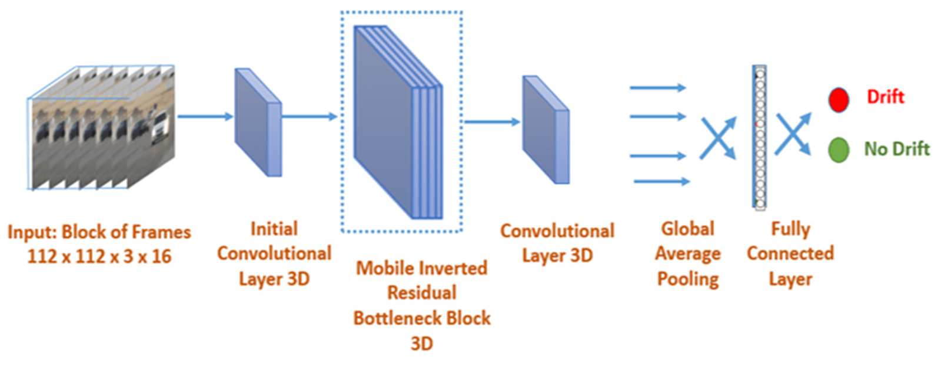

**Figure 3**

The depth, width, and resolution of the model are all equally scaled according to a set of principles using the compound scaling approach.

Initially, the authors scale the CNN's depth, resolution, and number of filters using a set of predetermined scaling coefficients.

The most advantageous combination of scaling coefficients that optimizes the model's accuracy on a validation set is then discovered via a grid search. It has also been used in a wide range of computer vision applications, including segmentation, object detection, and transfer learning. Effective Net is said to perform better because of its capacity to strike a balance between computational efficiency and model complexity. The regularization methodology lowers overfitting and enhances generalizability, while the compound scaling method lets the model learn more intricate features without adding to its computing burden. EfficientNet has demonstrated encouraging outcomes in medical imaging applications for the identification and categorization of a number of illnesses, including brain tumors, breast cancer, and lung cancer. Because of its high efficiency and accuracy, it is most suited for real-time clinical applications where a prompt and precise diagnosis is essential. The architecture of is shown in Figure 3 of EffectiveNet.

* 1. **U-NET MODEL ARCHITECTURE:**

One of the most widely used architectures for segmentation is U-Net. It was created for the biomedical industry's image segmentation needs.   
In terms of cell tracking, the results were excellent. It can function well and yield decent results with hundreds of examples. Because of its U-shape, it is known as the U-net (fig:-4)framework. There are two paths in it: the increasing path and the contracting path. The outcomes of both routes are in opposition to one another. Both down sampling and down convolution are part of the contracting route. Up-sampling and up-convolution are involved in expanding pathways. Feature maps shrink spatially in a contracting path while they expand in an expanding direction.

**Figure 4**

**PROPOSED METHODOLOGY :**

Using a brain MRI dataset that includes both tumor and non-tumor pictures, the methodology entails gathering the images and per-processing them to improve quality, reduce noise, and equalize intensity levels. A pretrained EfficientNet model is refined using transfer learning on the MRI dataset, and data augmentation techniques are employed during model training to minimize overfitting[6–8]. Accuracy, sensitivity, and specificity of the model are assessed using k-fold cross-validation on a different validation dataset. The model's advantages and disadvantages are then determined by analyzing the data, and recommendations for enhancing its functionality are made.   
Generally speaking, the method uses transfer learning and trained models to reliably detect and classify brain tumors, which can help doctors plan early diagnosis and treatment.

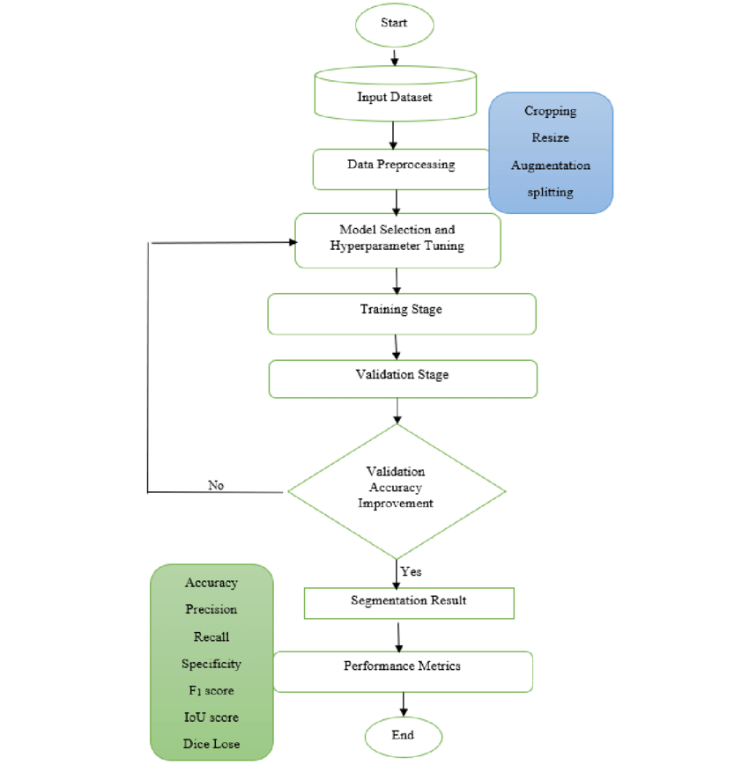

Figure:5 FLOWCHART OF EFFICIENT NET MODEL

1. **DATASET**

The dataset that we used was the various brain tumor databases. MRI images are among the datasets we obtained from Kaggle. The Dataset contains the MRI pictures of brain tumors.

The Brain Tumor subfolders of Glioma tumor, Meningioma tumor, No tumor, and Pituitary Tumor. The total number of photos for segmentation is 7023 photos make up the Dataset, 4571 photos make up the training dataset, 1141 photos make up the valid dataset, and 1311 photos make up the Test Dataset for belonging to 4 classes(Glioma, Meningioma, No tumor, pituitary tumors).

|  |  |  |  |
| --- | --- | --- | --- |
| **Category** | **Training Set** | **Validation Set** | **Testing Set** |
| **Glioma Tumor** | 1321 | 350 | 300 |
| **Meningioma Tumor** | 1339 | 330 | 306 |
| **No Tumor** | 1595 | 250 | 405 |
| **Pituitary Tumor** | 1457 | 211 | 300 |

Table:1

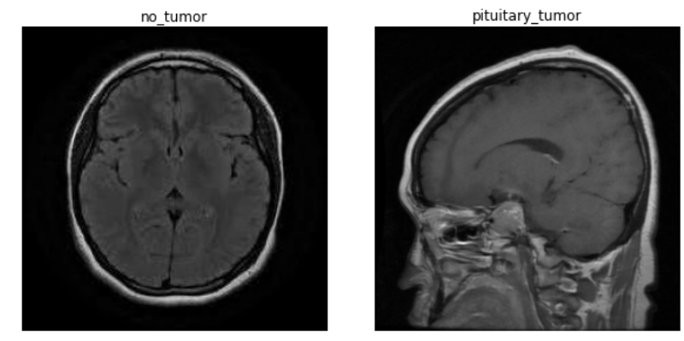

**Preprocessing Data:**

**Data collection:** Build up a large dataset of microscopic images that have been categorized as benign or malignant. The dataset needs to be diverse in order to include a variety of skin types and lesion traits.

**Preparing data:** Perform picture preparation procedures, such as scaling images to a standard size (224x224 pixels), normalization, and augmentation techniques (e.g., rotation, flipping, zooming), to increase the robustness and generalizability of the model.

1. **Model Selection:**

**Integration of Base Model:** Without the top (completely linked) layer, integrate the

EfficientNet B0 model.

**Custom Layers:** Overlay the following custom layers over the basic model.

Normalize the activations in the batch normalization layer to enhance generalization and

convergence.

**Dense Layer:** To avoid overfitting, add a dense layer with 256 neurons, ReLU activation, and regularizers (L2 kernel regularizer, L1 activity regularizer, and bias regularizers).

**Dropout Layer:** To lessen overfitting, include a dropout layer with a 70% dropout rate.

**Output Layer:** For binary classification (benign versus malignant), use a dense output layer

with two neurons and softmax activation

**4. Training Stage:**

**Training Configuration:** Train the model by using the Image DataGenerator for real-time data feeding and data augmentation on the preprocessed dermoscopic pictures.

**Batch Size and Epochs:** Utilize a batch size of 143 and set the epoch

Count to 7.

**Assessment:** Track the model's accuracy and loss during training and validation to ensure it picks up new information and generalizes well.

**5. Validation stage**

**Optimizer:**

Build the model using the Stochastic Gradient Descent (SGD) optimizer, with the momentum set at 0.9 and the learning rate at 0.01. In addition to facilitating faster convergence, the momentum-assisted SGD optimizer prevents local minima.

**Loss Function:** For multi-class classification issues, use categorical

cross-entropy loss. Metrics: The main performance metric is

track accuracy.

**RESULTS:**

We also worked on existing models to get more knowledge and to understand models clearly. After implementing those models we got these results.

|  |  |  |  |
| --- | --- | --- | --- |
| **MODEL** | **TRAINING ACCURACY** | **TESTING ACCURACY** | **ACCURACY** |
| CNN | 82.2% | 87% | 83% |
| RESNET50 | 86% | 80% | 85% |
| VGG 16 | 87% | 85% | 99% |
| EFFIECIENTNET B0 | 99% | 87% | 98% |

Table:-2

The suggested work is carried out with a Google colab and Python. First, we used the CNN model to train this dataset. But the outcome was not better. Later, we extended the number of epochs to 7 and made modifications to a few layers to improve the findings. In order to reflect better outcomes, we are concerned with the loss function, optimizer, epochs, batch size, and layers.  
The performance of the proposed network was tested and evaluated five times for each experiment. Parameters and hyper parameters were changed throughout training.

**Confusion Matrix:**

Using the CNN model, we obtained the confusion matrix that is shown below. Every model was assessed using the test dataset after the training phase was over. To validate their performance, F1, area under the curve, accuracy, recall, and precision were utilized. The following is a description of every performance statistic used in this article.

* Accuracy: It indicates the degree to which the measured value resembles a known value.

Accuracy = (TP + FN)/ (TP + TF + FP + FN) **(2)**

* Precision: This indicates the model's level of accuracy with respect to positively anticipated data.

Precision = TP / (TP + FP) **(3)**

* Recall: After classifying something as positive, it determines how many real positives the model caught (true positives).

Recall = TP / (TP + FN) **(4)**

* F1: It provides a recall and accurate balancing.

**

**EFFICIENTNET ACCURACY:**

An objective function called Eff-Net loss is used during the training process of an EffNet model, which is often a deep learning architecture for image segmentation. In order to improve segmentation accuracy and handle class imbalances, the loss function typically adds variables like dice coefficient or intersection over union (IoU) to pixel-wise loss, such as binary cross-entropy or categorical cross-entropy.

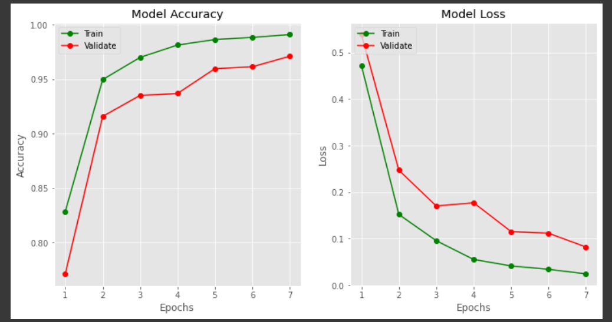

**EFFICIENTNET LOSS:**

Eff-Net loss is the objective function that is used to train an Eff-Net model, which is often a deep learning architecture for image segmentation. The loss function usually adds variables to pixel-wise loss, like binary cross-entropy or categorical cross-entropy, to address class imbalances and increase segmentation accuracy, such as dice coefficient or intersection over union (IoU).



**DISCUSSION:**

The majority of research in brain tumor segmentation has focused on binary classification tasks, where the primary goal is to determine the presence or absence of a tumor in MRI scans. Advanced CNN architectures, such as U-Net, and the more recent EfficientNet, have shown promising results in enhancing segmentation accuracy. These models leverage extensive datasets and sophisticated data augmentation techniques to improve generalization and robustness. The use of specialized loss functions like Dice loss and Intersection over Union (IoU) further refines the model's performance, ensuring better overlap between predicted and ground truth masks.

**CONCLUSION :**

In this work, we proposed a method for brain tumor identification and categorization based on the latest deep learning architecture, EfficientNet. On the test set, our suggested model's accuracy of 97.2% is a promising outcome for the diagnosis and categorization of brain tumors. EfficientNet transfer learning combined with small-scale dataset fine-tuning worked well for this task. The pretrained weights allowed the model to pick up significant traits, and it generalized well to the new data. It is also shown how crucial data preprocessing and augmentation methods are to raising the model's efficiency. Preprocessing methods like normalization and scaling, together with augmentation methods like flipping and rotation, helped to broaden the dataset's variety and lessen overfitting.

The suggested approach, which utilizes EfficientNet, has demonstrated positive outcomes in the identification and categorization of brain tumors. To further improve performance, future research might make use of bigger datasets and look into different deep learning architectures. Our research should contribute to the development of more accurate and useful diagnostic instruments for early detection of brain tumors, when successful treatment is most likely to occur.

**References:**

1.Pradhan, A.; Mishra, D.; Das, K.; Panda, G.; Kumar, S.; Zymbler, M. On the Classification of MR Images Using “ELM-SSA” Coated Hybrid Model. Mathematics 2021, 9, 2095. [CrossRef]

2.Reddy, A.V.N.; Krishna, C.P.; Mallick, P.K.; Satapathy, S.K.; Tiwari, P.; Zymbler, M.; Kumar, S. Analyzing MRI scans to detect glioblastoma tu-mor using hybrid deep belief networks. J. Big Data 2020, 7, 35. [CrossRef]

3.Nayak, D.R.; Padhy, N.; Mallick, P.K.; Bagal, D.K.; Kumar, S. Brain Tumour Classification Using Noble Deep Learning Approach with Parametric Optimization through Metaheuristics Approaches. Computers 2022, 11, 10. [CrossRef]

4. Mansour, R.F.; Escorcia-Gutierrez, J.; Gamarra, M.; Díaz, V.G.; Gupta, D.; Kumar, S. Ar-tificial intelligence with big data analytics-based brain intracranial hemorrhage e-diagnosis us-ing CT images. Neural Comput. Appl. 2021. [CrossRef]

5. Rehman, A.; Naz, S.; Razzak, M.I.; Akram, F.; Imran, M.A. Deep learning-based framework for automatic brain tumors classification using transfer learning. Circuits Syst. Signal Processing 2020, 39, 757–775. [CrossRef]

6.Long, J.; Shelhamer, E.; Darrell, T. Fully convolutional networks for semantic segmentation. In Proceedings of the IEEE Conference on Computer Vision and Pattern Recognition, Boston, MA, USA, 7–12 June 2015; pp. 3431–3440

7. Ozyurt, F.; Sert, E.; Avci, D. An expert system for brain tumor detection, Fuzzy C-means with super-resolution and convolutional neural network with extreme learning machine. Med. Hypotheses 2020, 134, 109433. [CrossRef] [PubMed]

8. Hu, M.; Zhong, Y.; Xie, S.; Lv, H.; Lv, Z. Fuzzy System Based Medical Image Processing for Brain Disease Prediction. Front. Neurosci. 2021, 15, 714318. [CrossRef] [PubMed]

9. Maqsood, S.; Damasevicius, R.; Shah, F.M. An Efficient Approach for the Detection of Brain Tumor Using Fuzzy Logic and U-Net CNN Classification. In Lecture Notes in Computer Science; Springer: Berlin/Heidelberg, Germany, 2021; Volume 12953.

10. Ragupathy, B.; Karunakaran, M. A fuzzy logic-based meningioma tumor detection in magnetic resonance brain images using CANFIS and U-Net CNN classification. Int. J. Imaging Syst. Technol. 2021, 31, 379–390. [CrossRef]

11. Cheng, J.; Huang, W.; Cao, S.; Yang, R.; Yang, W.; Yun, Z.; Wang, Z.; Feng, Q. Correction, enhanced performance of brain tumor classification via tumor region augmentation and partition. PLoS ONE 2015, 10, e0144479. [CrossRef] [PubMed]

12. Badža, M.M.; Barjaktarovi´c, M.C. Classification of brain tumors from MRI images using a convolutional neural network. ˇ Appl. Sci. 2020, 10, 1999. [CrossRef]

13. Mzoughi, H.; Njeh, I.; Wali, A.; Slima, M.B.; BenHamida, A.; Mhiri, C.; Mahfoudhe, K.B. Deep multi-scale 3D convolutional neural network (CNN) for MRI gliomas brain tumor classification. J. Digit. Imaging 2020, 33, 903–915. [CrossRef] [PubMed]

14. Hashemzehi, R.; Mahdavi, S.J.S.; Kheirabadi, M.; Kamel, S.R. Detection of brain tumors from MRI images base on deep learning using hybrid model CNN and NADE. Biocybern. Biomed. Eng. 2020, 40, 1225–1232. [CrossRef]

15. Díaz-Pernas, F.J.; Martínez-Zarzuela, M.; Antón-Rodríguez, M.; González-Ortega, D. A deep learning approach for brain tumor classification and segmentation using a multiscale convolutional neural network. Healthcare 2021, 9, 153. [CrossRef] [PubMed]

16. Sultan, H.H.; Salem, N.M.; Al-Atabany, W. Multi-classification of brain tumor images using deep neural network. IEEE Access 2019, 7, 69215–69225. [CrossRef]

17. Abd El Kader, I.; Xu, G.; Shuai, Z.; Saminu, S.; Javaid, I.; Salim Ahmad, I. Differential deep convolutional neural network model for brain tumor classification. Brain Sci. 2021, 11, 352. [CrossRef] [PubMed]

18. Sajja, V.R. Classification of Brain tumors using Fuzzy C-means and VGG16. Turk. J. Comput. Math. Educ. (TURCOMAT) 2021, 12, 2103–2113.

19. Das, S.; Aranya, O.R.; Labiba, N.N. Brain tumor classification using a convolutional neural network. In Proceedings of the 2019 1st International Conference on Advances in Science, Engineering and Robotics Technology (ICASERT), Dhaka, Bangladesh, 3 May 2019; IEEE: New York, NY, USA, 2019; pp. 1–5.

20. Cheng, J. Brain tumor dataset. Figshare. Dataset. 2017, 1512427/5. Available online: https://figshare.com/articles/dataset/ brain_tumor_dataset/1512427 (accessed on 12 October 2021).

21. Nayak, D.R.; Padhy, N.; Swain, B.K. Brain Tumor Detection and Extraction using Type-2 Fuzzy with Morphology. Int. J. Emerg. Technol. 2020, 11, 840–844.

22. Tan, M.; Le, Q.V. EfficientNet, Rethinking Model Scaling for Convolutional Neural Networks. arXiv 2019, arXiv:1905.11946.

23. Available online: https://towardsdatascience.com/complete-architectural-details-of-all-efficientnet-models-5fd5b736142 (accessed on 16 October 2021).