***INSERTION, UPDATION, DELETION, SEARCH & PRINTING REPORT***

***Create the table structure of student***

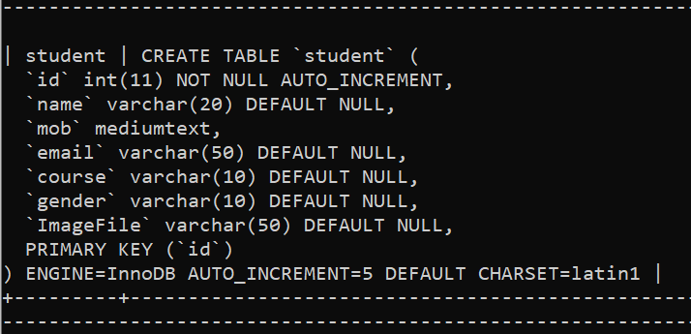

**\*) Design the VB Form**

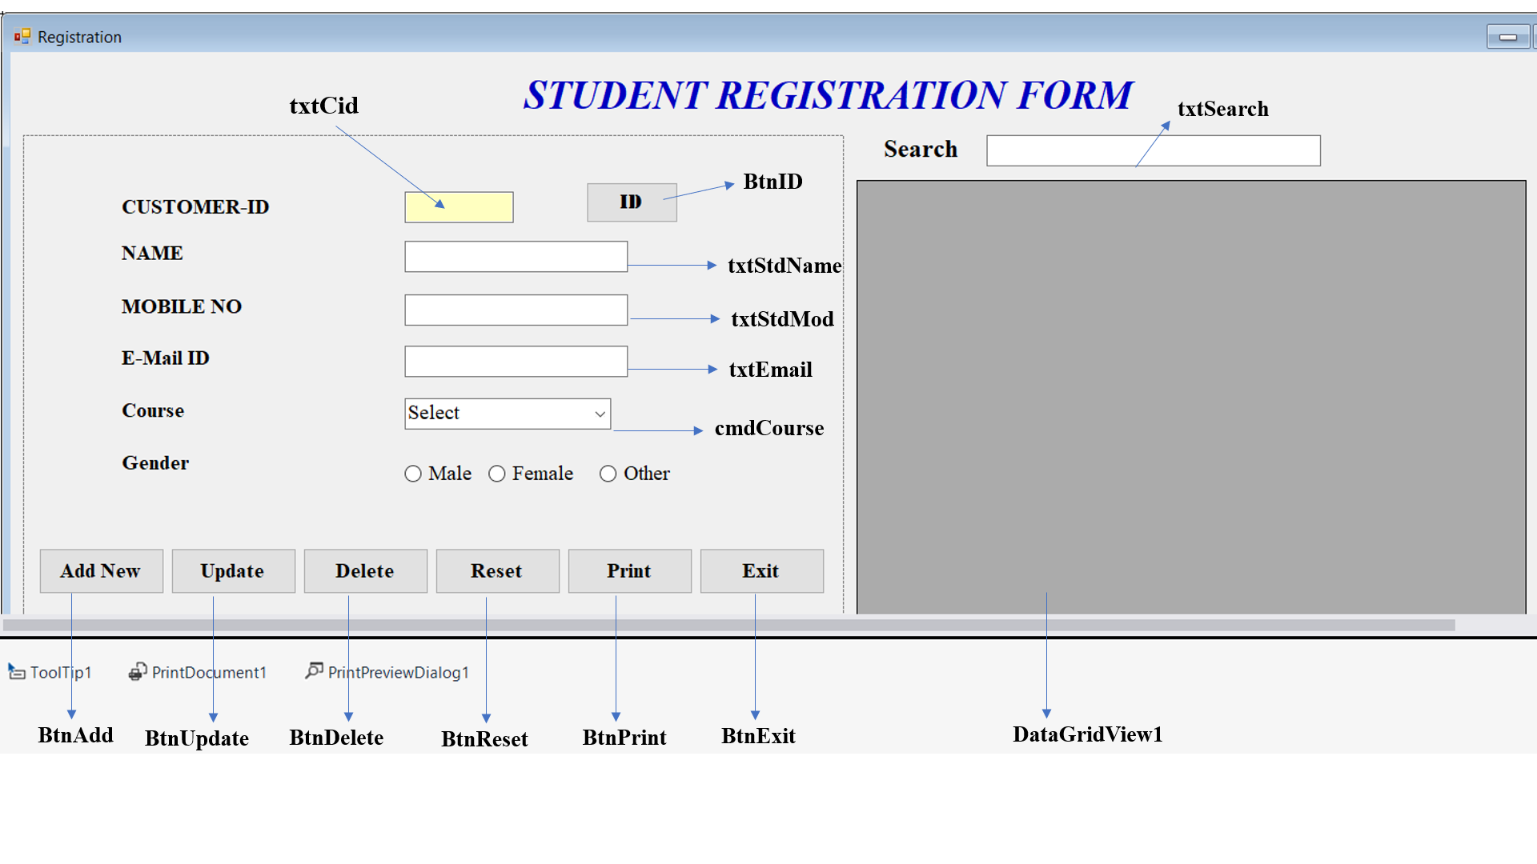

1. Design the form and give the appropriate name
2. From the toolbox drag and drop Tooltip, PrintDocument1, PrintPriviewDialog1
3. Add database connection and connect to the database.

* Give ur required tooltip by clicking on button/ textboxes🡪 In Properties 🡪(Under Tooltip on Tooltip1) -- Click on to Generate ID

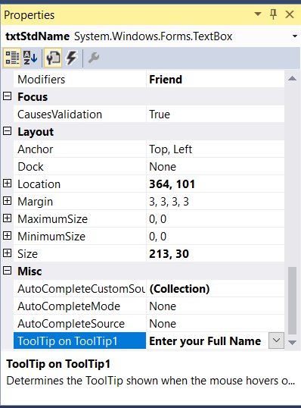

**Give tooltip for all control…!!**

Imports MySql.Data.MySqlClient

Imports Microsoft.VisualBasic.ApplicationServices

Imports Microsoft.Win32

Public Class Registration

Dim sqlConn As New MySqlConnection

Dim sqlCmd As New MySqlCommand

Dim sqlRd As MySqlDataReader

Dim table As New DataTable()

Private bitmap As Bitmap

Protected Sub updateTable()

Dim table1 As New DataTable()

Dim connection As New MySqlConnection("datasource=localhost;port=3308;username=root;password=root")

Dim adapter As New MySqlDataAdapter("select * from vbproject.student", connection)

adapter.Fill(table)

adapter.Fill(table1)

DataGridView1.DataSource = table

DataGridView1.DataSource = table1

End Sub

Private Sub Registration_Load(sender As Object, e As EventArgs) Handles MyBase.Load

con_open()

updateTable()

End Sub

Private Sub BtnId_Click(sender As Object, e As EventArgs) Handles BtnId.Click

Dim temp As Integer

temp = 0

'TextBox1.Enabled = True

rec_open("select id from Student order by id desc limit 1")

If Not rs.EOF Then

temp = rs(0).Value + 1

txtCid.Text = temp

Else

txtCid.Text = 1

End If

End Sub

Private Sub BtnAdd_Click(sender As Object, e As EventArgs) Handles BtnAdd.Click

Dim gender As String

If RadioButton1.Checked = True Then

gender = RadioButton1.Text

ElseIf RadioButton2.Checked = True Then

gender = RadioButton2.Text

Else

gender = RadioButton3.Text

End If

If txtStdName.Text = "" Or txtEmail.Text = "" Or txtStdMod.Text = "" Or cmdCourse.Text = "" Then

MsgBox("Mandatory Fields!! Please fill it", vbOKOnly, "Form Registration")

Exit Sub

Else

rec_open("insert into student values(null,'" & txtStdName.Text & "','" & txtStdMod.Text & "','" & txtEmail.Text & "','" & cmdCourse.Text & "','" & gender & "')")

MsgBox("Data Inserted Successfully!!", vbOKOnly, "Status Update")

updateTable()

End If

End Sub

Private Sub BtnExit_Click(sender As Object, e As EventArgs) Handles BtnExit.Click

Dim iExit As DialogResult

iExit = MessageBox.Show("Confirm, If you want to Exit from the Application?", "MySQL Connector", MessageBoxButtons.YesNo, MessageBoxIcon.Question)

If DialogResult.Yes Then

Application.Exit()

End If

End Sub

Private Sub DataGridView1_CellClick(sender As Object, e As DataGridViewCellEventArgs) Handles DataGridView1.CellClick

Dim gender As String

Try

If e.RowIndex >= 0 Then

Dim row As DataGridViewRow

row = Me.DataGridView1.Rows(e.RowIndex)

'GlobalVariables.SelectedlineItemRowNo = e.RowIndex ' Or row

'MsgBox("GlobalVariables.SelectedlineItemRowNo is ---> " & GlobalVariables.SelectedlineItemRowNo)

txtCid.Text = row.Cells("id").Value.ToString()

txtStdName.Text = row.Cells("name").Value.ToString()

txtStdMod.Text = row.Cells("mob").Value.ToString()

txtEmail.Text = row.Cells("email").Value.ToString()

cmdCourse.Text = row.Cells("course").Value.ToString()

gender = row.Cells("gender").Value.ToString()

If gender = "Male" Then

RadioButton1.Checked = True

ElseIf gender = "Female" Then

RadioButton2.Checked = True

Else

RadioButton3.Checked = True

End If

'textboxTst.Text = row.Cells("Description").Value.ToString

End If

Catch ex As Exception

MsgBox(ex.Message)

End Try

End Sub

Private Sub BtnUpdate_Click(sender As Object, e As EventArgs) Handles BtnUpdate.Click

Dim gender As String

If RadioButton1.Checked = True Then

gender = RadioButton1.Text

ElseIf RadioButton2.Checked = True Then

gender = RadioButton2.Text

Else

gender = RadioButton3.Text

End If

If txtStdName.Text = "" Or txtEmail.Text = "" Or txtStdMod.Text = "" Or cmdCourse.Text = "" Then

MsgBox("Select A Row from Gridview and then Click on Update !! ", vbOKOnly, "Form Registration")

Exit Sub

Else

rec_open("update student set name='" & txtStdName.Text & "',mob='" & txtStdMod.Text & "',email='" & txtEmail.Text & "',course='" & cmdCourse.Text & "',gender='" & gender & "' where id= " & txtCid.Text & "")

MsgBox("Data Updated Successfully!!", vbOKOnly, "Status Update")

updateTable()

End If

End Sub

Private Sub BtnDelete_Click(sender As Object, e As EventArgs) Handles BtnDelete.Click

If txtStdName.Text = "" Or txtEmail.Text = "" Or txtStdMod.Text = "" Or cmdCourse.Text = "" Then

MsgBox("Select A Row from Gridview and then Click on Delete !! ", vbOKOnly, "Form Registration")

Exit Sub

Else

rec_open("delete from student where id= " & txtCid.Text & "")

MsgBox("Data Deleted Successfully!!", vbOKOnly, "Status Update")

updateTable()

End If

End Sub

Private Sub BtnReset_Click(sender As Object, e As EventArgs) Handles BtnReset.Click

txtCid.Text = ""

txtStdName.Text = ""

txtStdMod.Text = ""

txtEmail.Text = ""

cmdCourse.Text = "Select"

RadioButton1.Checked = False

RadioButton2.Checked = False

RadioButton3.Checked = False

End Sub

Private Sub BtnPrint_Click(sender As Object, e As EventArgs) Handles BtnPrint.Click

Dim height As Integer = DataGridView1.Height

DataGridView1.Height = DataGridView1.RowCount * DataGridView1.RowTemplate.Height

bitmap = New Bitmap(Me.DataGridView1.Height, Me.DataGridView1.Width)

DataGridView1.DrawToBitmap(bitmap, New Rectangle(0, 0, Me.DataGridView1.Height, Me.DataGridView1.Width))

PrintPreviewDialog1.Document = PrintDocument1

PrintPreviewDialog1.PrintPreviewControl.Zoom = 1

PrintPreviewDialog1.ShowDialog()

DataGridView1.Height = height

End Sub

Private Sub PrintDocument1_PrintPage(sender As Object, e As Printing.PrintPageEventArgs) Handles PrintDocument1.PrintPage

e.Graphics.DrawImage(bitmap, 0, 0)

Dim recP As RectangleF = e.PageSettings.PrintableArea

If Me.DataGridView1.Height - recP.Height > 0 Then e.HasMorePages = True

End Sub

Private Sub txtSearch_KeyPress(sender As Object, e As KeyPressEventArgs) Handles txtSearch.KeyPress

Try

If Asc(e.KeyChar) = 13 Then

Dim dv As DataView

dv = table.DefaultView

dv.RowFilter = String.Format("name like '%{0}%'", txtSearch.Text)

DataGridView1.DataSource = table

End If

Catch ex As Exception

MessageBox.Show(ex.Message)

End Try

End Sub

End Class

