**Name: Supriya kapse**

**Roll No- 38**

**Practical No. 2 implement Client Server communication model using UDP**

**Question No. 1 find if number is Even or Odd**

**Client Program:**

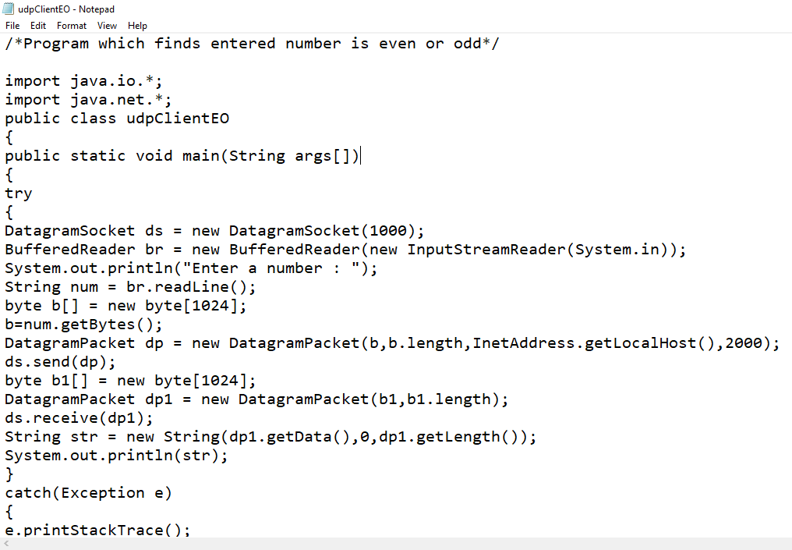 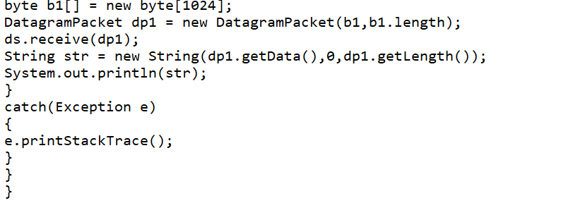

**Code :-**

/*Program which finds entered number is even or odd*/

import java.io.*;

import java.net.*;

public class udpClientEO

{

public static void main(String args[])

{

try

{

DatagramSocket ds = new DatagramSocket(1000);

BufferedReader br = new BufferedReader(new InputStreamReader(System.in));

System.out.println("Enter a number : ");

String num = br.readLine();

byte b[] = new byte[1024];

b=num.getBytes();

DatagramPacket dp = new DatagramPacket(b,b.length,InetAddress.getLocalHost(),2000);

ds.send(dp);

byte b1[] = new byte[1024];

DatagramPacket dp1 = new DatagramPacket(b1,b1.length);

ds.receive(dp1);

String str = new String(dp1.getData(),0,dp1.getLength());

System.out.println(str);

}

catch(Exception e)

{

e.printStackTrace();

}

}

}

**Server Program:**

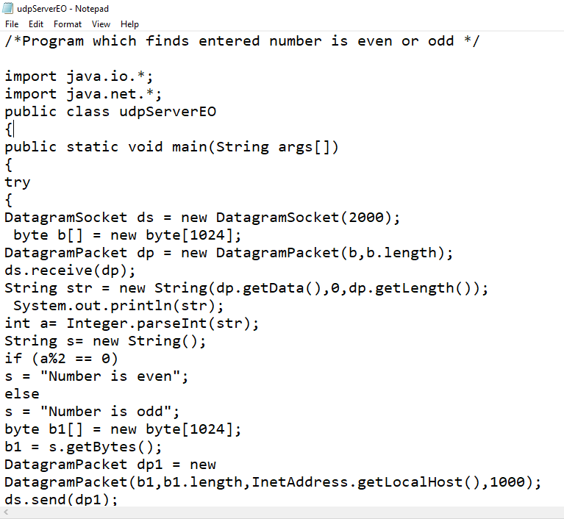 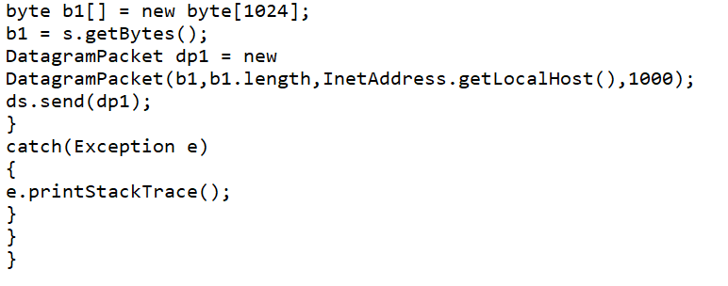

**Code :-**

/*Program which finds entered number is even or odd */

import java.io.*;

import java.net.*;

public class udpServerEO

{

public static void main(String args[])

{

try

{

DatagramSocket ds = new DatagramSocket(2000);

byte b[] = new byte[1024];

DatagramPacket dp = new DatagramPacket(b,b.length);

ds.receive(dp);

String str = new String(dp.getData(),0,dp.getLength());

System.out.println(str);

int a= Integer.parseInt(str);

String s= new String();

if (a%2 == 0)

s = "Number is even";

else

s = "Number is odd";

byte b1[] = new byte[1024];

b1 = s.getBytes();

DatagramPacket dp1 = new

DatagramPacket(b1,b1.length,InetAddress.getLocalHost(),1000);

ds.send(dp1);

}

catch(Exception e)

{

e.printStackTrace();

}

}

}

**Output**

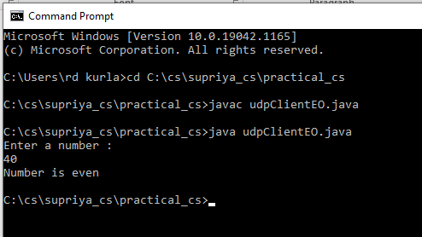

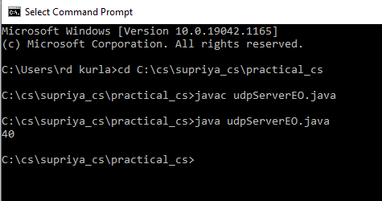

**Question 2. Simple Calculator add, sub, mul and div**

**Client Program:**

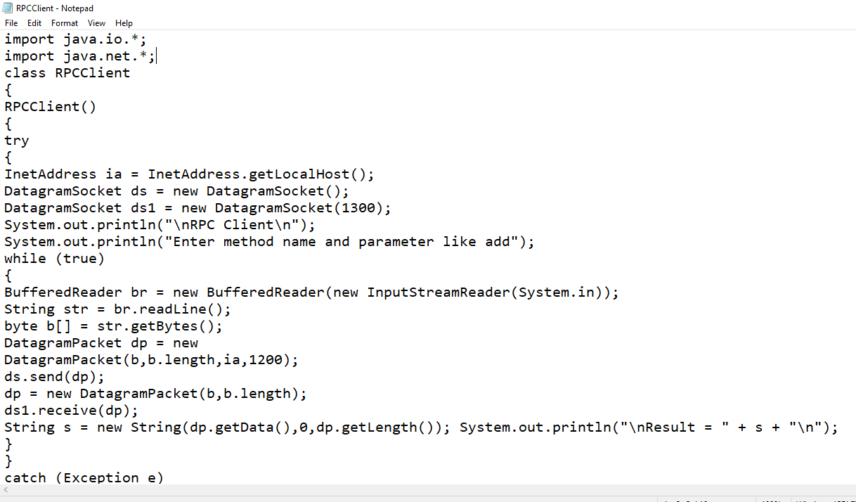 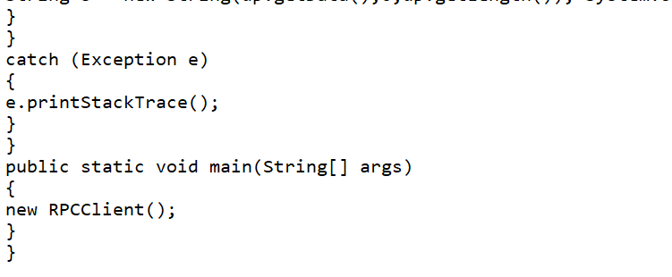

**Code :-**

import java.io.*;

import java.net.*;

class RPCClient

{

RPCClient()

{

try

{

InetAddress ia = InetAddress.getLocalHost();

DatagramSocket ds = new DatagramSocket();

DatagramSocket ds1 = new DatagramSocket(1300);

System.out.println("\nRPC Client\n");

System.out.println("Enter method name and parameter like add");

while (true)

{

BufferedReader br = new BufferedReader(new InputStreamReader(System.in));

String str = br.readLine();

byte b[] = str.getBytes();

DatagramPacket dp = new

DatagramPacket(b,b.length,ia,1200);

ds.send(dp);

dp = new DatagramPacket(b,b.length);

ds1.receive(dp);

String s = new String(dp.getData(),0,dp.getLength()); System.out.println("\nResult = " + s + "\n");

}

}

catch (Exception e)

{

e.printStackTrace();

}

}

public static void main(String[] args)

{

new RPCClient();

}

}

**Server Program:**

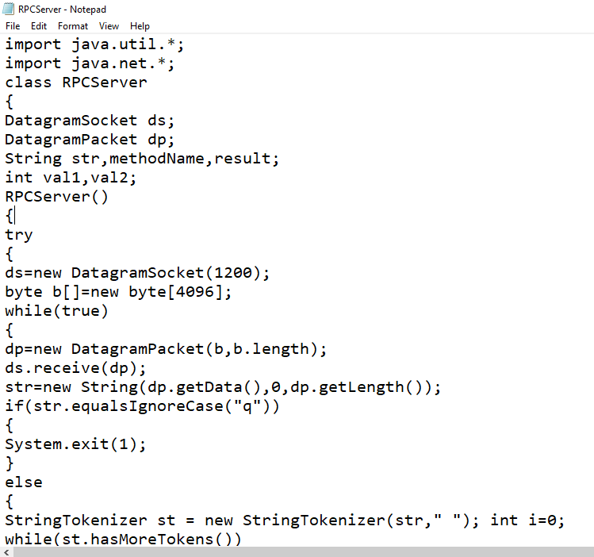 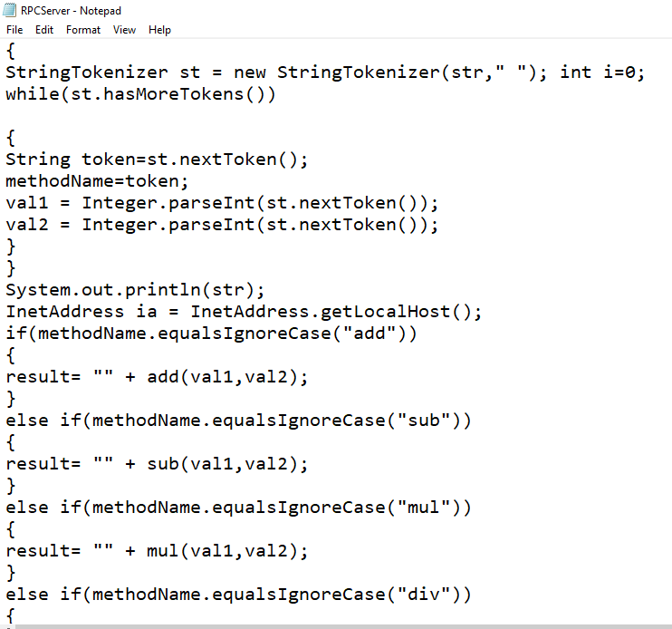 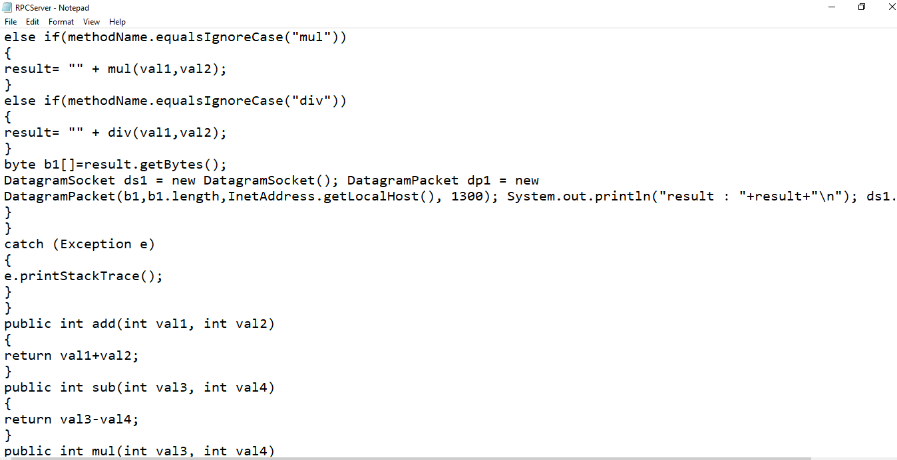 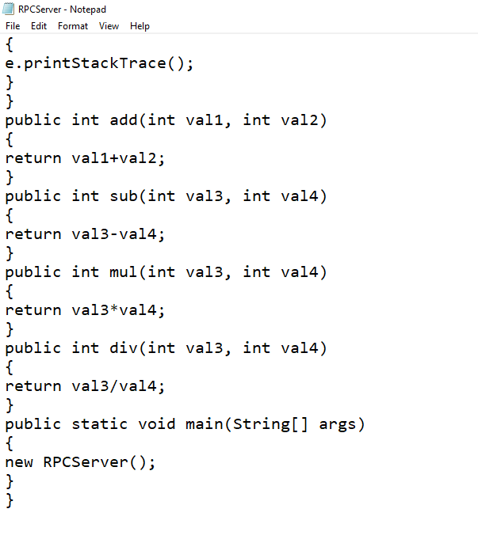

**Code :-**

import java.util.*;

import java.net.*;

class RPCServer

{

DatagramSocket ds;

DatagramPacket dp;

String str,methodName,result;

int val1,val2;

RPCServer()

{

try

{

ds=new DatagramSocket(1200);

byte b[]=new byte[4096];

while(true)

{

dp=new DatagramPacket(b,b.length);

ds.receive(dp);

str=new String(dp.getData(),0,dp.getLength());

if(str.equalsIgnoreCase("q"))

{

System.exit(1);

}

else

{

StringTokenizer st = new StringTokenizer(str," "); int i=0;

while(st.hasMoreTokens())

{

String token=st.nextToken();

methodName=token;

val1 = Integer.parseInt(st.nextToken());

val2 = Integer.parseInt(st.nextToken());

}

}

System.out.println(str);

InetAddress ia = InetAddress.getLocalHost();

if(methodName.equalsIgnoreCase("add"))

{

result= "" + add(val1,val2);

}

else if(methodName.equalsIgnoreCase("sub"))

{

result= "" + sub(val1,val2);

}

else if(methodName.equalsIgnoreCase("mul"))

{

result= "" + mul(val1,val2);

}

else if(methodName.equalsIgnoreCase("div"))

{

result= "" + div(val1,val2);

}

byte b1[]=result.getBytes();

DatagramSocket ds1 = new DatagramSocket(); DatagramPacket dp1 = new

DatagramPacket(b1,b1.length,InetAddress.getLocalHost(), 1300); System.out.println("result : "+result+"\n"); ds1.send(dp1);

}

}

catch (Exception e)

{

e.printStackTrace();

}

}

public int add(int val1, int val2)

{

return val1+val2;

}

public int sub(int val3, int val4)

{

return val3-val4;

}

public int mul(int val3, int val4)

{

return val3*val4;

}

public int div(int val3, int val4)

{

return val3/val4;

}

public static void main(String[] args)

{

new RPCServer();

}

}

**Output:-**

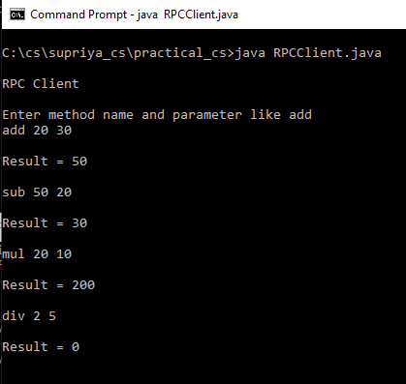

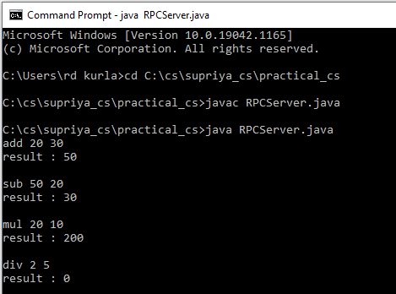

**Question No. 3 find Factorial of given number**

**Client Program:**

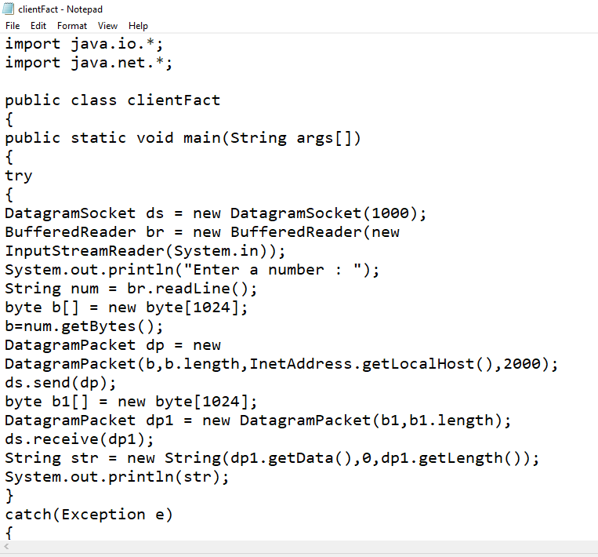 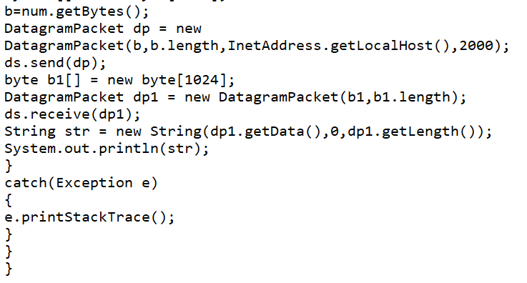

**Code :-**

import java.io.*;

import java.net.*;

public class clientFact

{

public static void main(String args[])

{

try

{

DatagramSocket ds = new DatagramSocket(1000);

BufferedReader br = new BufferedReader(new

InputStreamReader(System.in));

System.out.println("Enter a number : ");

String num = br.readLine();

byte b[] = new byte[1024];

b=num.getBytes();

DatagramPacket dp = new

DatagramPacket(b,b.length,InetAddress.getLocalHost(),2000);

ds.send(dp);

byte b1[] = new byte[1024];

DatagramPacket dp1 = new DatagramPacket(b1,b1.length);

ds.receive(dp1);

String str = new String(dp1.getData(),0,dp1.getLength());

System.out.println(str);

}

catch(Exception e)

{

e.printStackTrace();

}

}

}

**Server Program:**

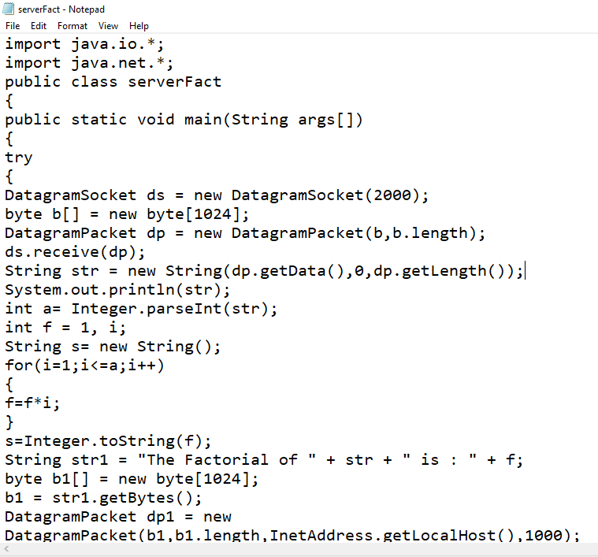 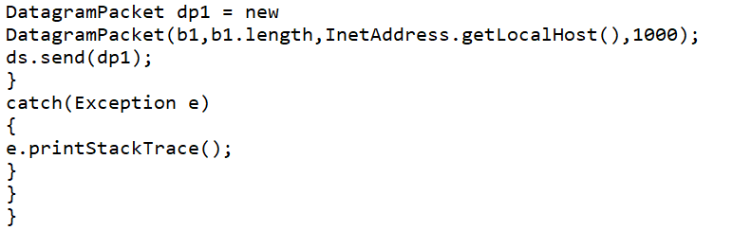

**Code:-**

import java.io.*;

import java.net.*;

public class serverFact

{

public static void main(String args[])

{

try

{

DatagramSocket ds = new DatagramSocket(2000);

byte b[] = new byte[1024];

DatagramPacket dp = new DatagramPacket(b,b.length);

ds.receive(dp);

String str = new String(dp.getData(),0,dp.getLength());

System.out.println(str);

int a= Integer.parseInt(str);

int f = 1, i;

String s= new String();

for(i=1;i<=a;i++)

{

f=f*i;

}

s=Integer.toString(f);

String str1 = "The Factorial of " + str + " is : " + f;

byte b1[] = new byte[1024];

b1 = str1.getBytes();

DatagramPacket dp1 = new

DatagramPacket(b1,b1.length,InetAddress.getLocalHost(),1000);

ds.send(dp1);

}

catch(Exception e)

{

e.printStackTrace();

}

}

}

**Output :-**

