AZURE LAB TASK:

**TASK 1**

1. Research and list any five benefits of cloud computing over traditional on-premises infrastructure.

🡪 **BANKING:**

**Disaster Recovery:**

Cloud platforms can provide us backup options ensuring data integrity and facilitating fast recovery in case of unexpected event or disaster.

But when it comes to traditional on-premises infrastructure we might lost our data if any unexpected event or disaster occurs.

**Scalability:**

Cloud infrastructure enables banks to expand their services globally, enabling a seamless experience for customers.

But in traditional on-premises we don’t have that feature. For example, we have a fixed number of resources and to expand our resources it will cost a lot.

**Fault Tolerance:**

If anyone is using a banking application which has traditional on-premises infrastructure, if any power cut happens or networking issue happens while so many people are using the application, then the application might crash. While making any transaction, it might stuck and data may not be updated in people’s bank accounts.

But in case of Cloud computing, it provides us the ability to handle faults like power, networking or hardware failure. So, if any fault occurs the application will still run, and data will still be updated in customer accounts.

**High Availability:**

Banking application need to be highly available for seamless experience.

But in traditional infrastructure, sometimes it is difficult to maintain the availability due to various factors like power cut, networking etc.

**Agility:**

Cloud services provide flexibility to quickly adapt to changing market condition or regulatory requirements, allowing banks to deploy and update applications faster than traditional methods.

2. Describe the CapEx and OpEx models of financing IT infrastructure, providing examples of when each model might be preferred.

🡪 **Capital Expenditure (CapEx)**: Involves upfront spending on physical assets or long-term investments, typically considered as capital assets.

CapEx is preferred when the organization is making long term investment in assets.

**Operational Expenditure (OpEx)**: Involves ongoing, day to day expenses requires to run a business.

OpEx is beneficial when flexibility and scalability are crucial. OpEx is preferable with predictable and manageable ongoing cost.

**TASK 2**

1. Create a brief reporting differentiating between public, private, and hybrid clouds. Include diagram that represent each cloud model.

🡪

|  |  |  |
| --- | --- | --- |
| **PUBLIC CLOUDS** | **PRIVATE CLOUDS** | **HYBRID CLOUDS** |
| In public cloud resources are shared among multiple user or tenants. | Private cloud are dedicated to a single organization. | Hybrid cloud integrates both public and private cloud environments. |
| Services and infrastructure are accessible over the internet to the general public | Services and infrastructure are accessible to only authorized users. | Services and Infrastructures are accessible based on user. |
| Public clouds offer high scalability, allowing the users to quicky scale resources up or down based on demand. | Private cloud can be more limited than public clouds, as resources are dedicated to single organization. | Organization can leverage the scalability and cost efficiency of public clouds for certain workloads, while keeping sensitive or critical workloads in a private cloud for enhanced control. |
| Example: AWS , Microsoft Azure | Example: VMware cloud Foundation, IBM Cloud Private | Example: A company might use a public cloud for web based customer service applications while keeping sensitive customer data in private. |

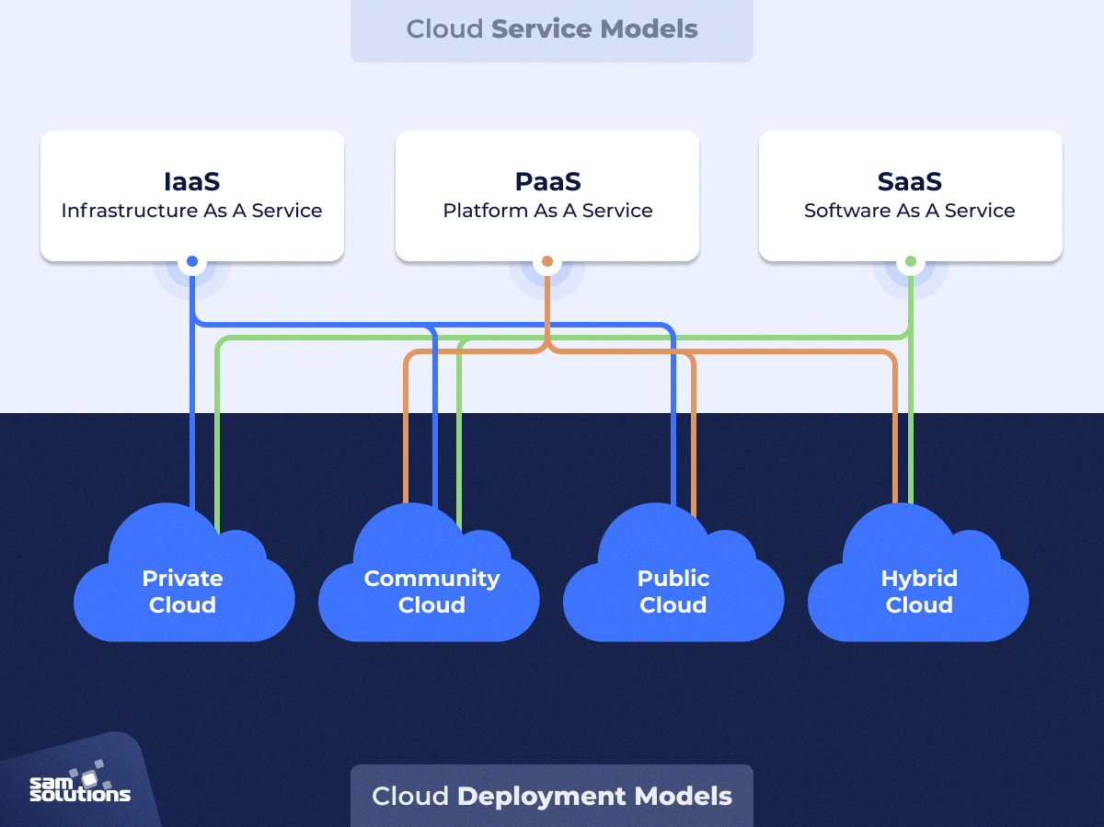

1. For each cloud model, list one real world application or scenario where that model would be the most appropriate choice.

🡪 Public Cloud: AWS , Microsoft Azure

Private Cloud: VMware cloud Foundation, IBM Cloud Private

Hybrid Cloud: A company might use a public cloud for web based customer service applications while keeping sensitive customer data in private.