AZURE CLI

1. Login to azure cli

1. Create a resource group.

1. Create a virtual machine in newly created resource group.

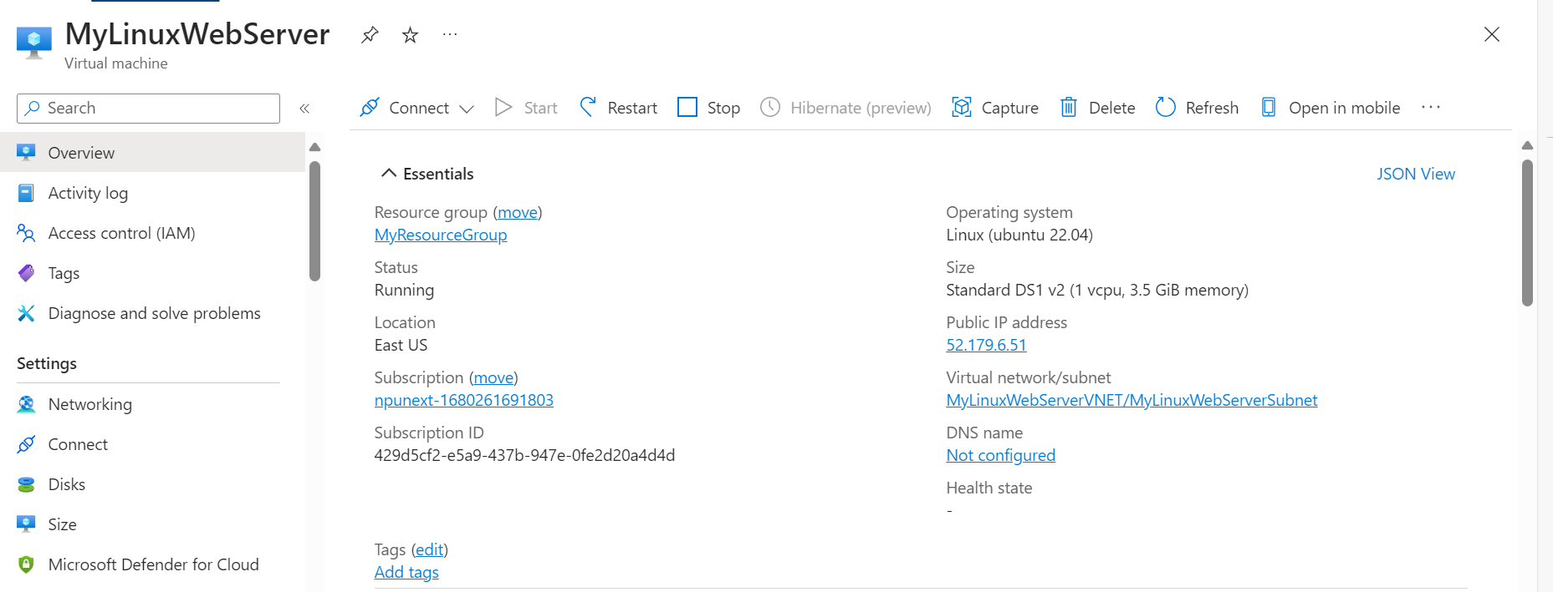

1. Access the command line of VM that is created.

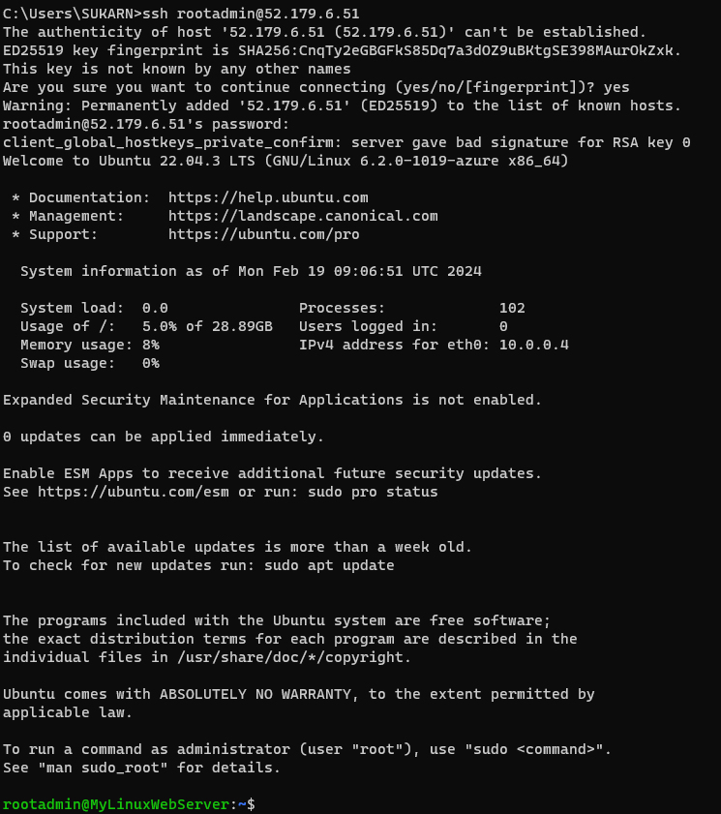

1. Update the software so that the latest package is installed in future.

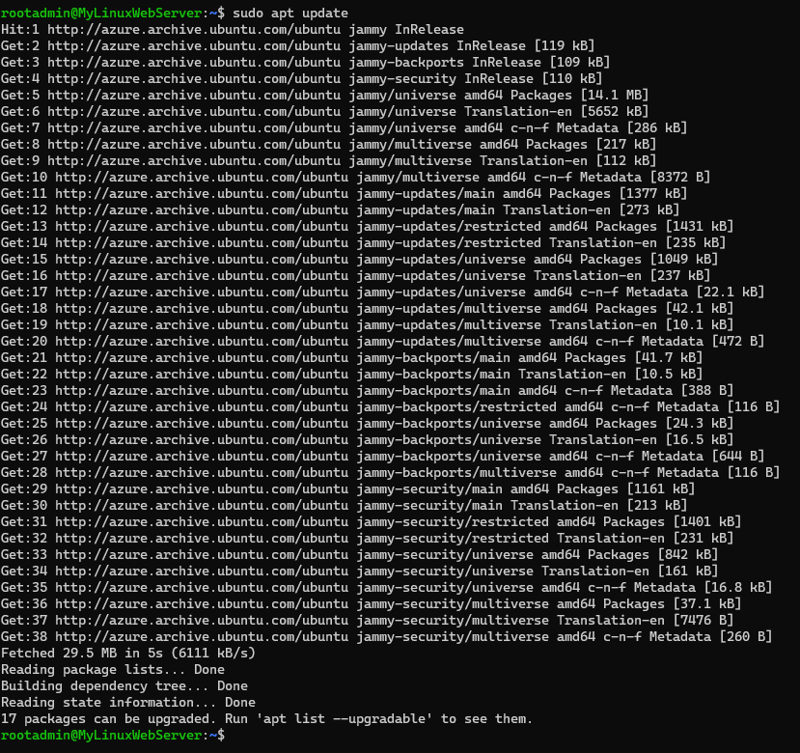

1. Install nginx.

1. Verify if the default html page is working.

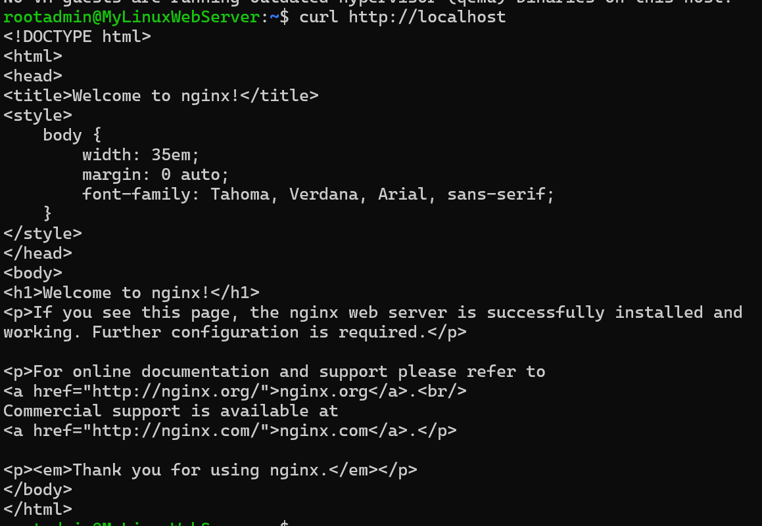

1. Add inbound security rule to the MyLinuxServerNSG having port 80 and priority of 100.

1. Give access to Read, Write and Execute to the files to HTML and CSS files in the VM.



1. Create a HTML, CSS project on your local machine that needs to be hosted on the newly created VM.

