**PokemonGo**

Agenda :

* Project Description
* Technology and Tools
* Problem Statement
* Solution
* Challenges
* Screenshot
* Improvements and Ideas.

Project Description:

PokemonGo is a responsive web application built on SAPUI5 front-end technology that Fetches, Displays and allows the user to modify Pokemon (Cartoon Character) details that are available in Pokedex Rest Api.

Technology & Tools:

**Languages** : SAPUI5, V1.84, Javascript, Jquery, Ajax.

**Platform** : Responsive Web Application (compatible in Mobile Screens), Windows.

**API** : Pokedex (Rest-API)

**Development Tool :** Visual Studio Code

**Unit Testing :** Qunit testing

Solution:

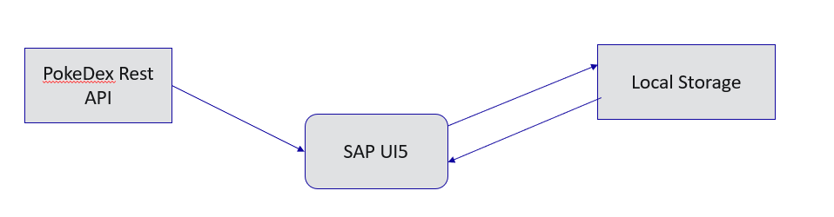

1. Used Master-Detail Worklist floorplan for displaying and storing Pokemon details.
2. Connected to PokeDex API using Jquery Ajax function call.
3. Stored data to local storage using Jquery SAP local storage.
4. Unit tested using Qunit.

Recording:

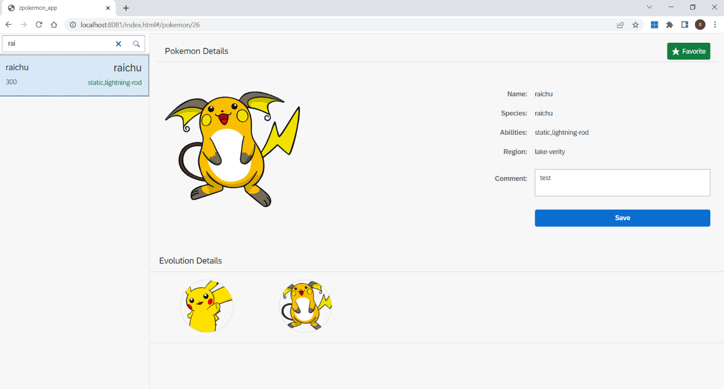

Improvements and Ideas:

* Lazy loading or pagination for master list to avoid performance issues
* Better UI design
* Error handling
* Test cases for all scenarios