Task 1

1. Customization in dynamics 365 sales is done by using following steps,

For adding new fields to the entity, go to the powerapps website <https://make.powerapps.com/>.

Sign-in -> Solution - > default solution -> entities -> lead.

In leads there are various sections, go to the fields -> click on new field -> provide the display name-> Name -> field requirement -> searchable(yes/No) -> data type -> field type -> default value if required.

Save.

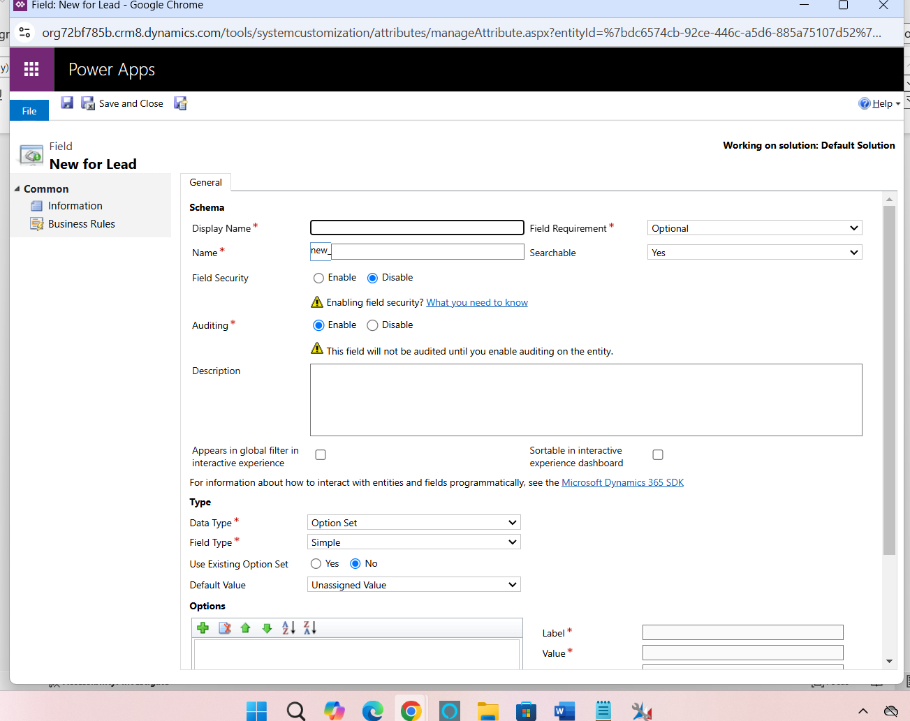

Once we created the field we need to add the field in the required form, for this go to the forms section and drag the field into the form as there is drag and drop option is available.

Save and close.

Publish, and to validate the field is showing in the form or not, we need to check and test and for scalable and maintainable field, we should use proper name to address the particular companyfield etc, and using the correct data type.

For the form scripts:

Select the particular form and the lead entity for which we want to add the script logic.

Go to the insert tab and we can add the form script by creating the web resource, writing the name display name, and the visibility then writing the javascript function code and provide.js as the type of the file and upload the js file and add the file by clicking on the form properties, we can use the events such as onload, onsave and publish and test.

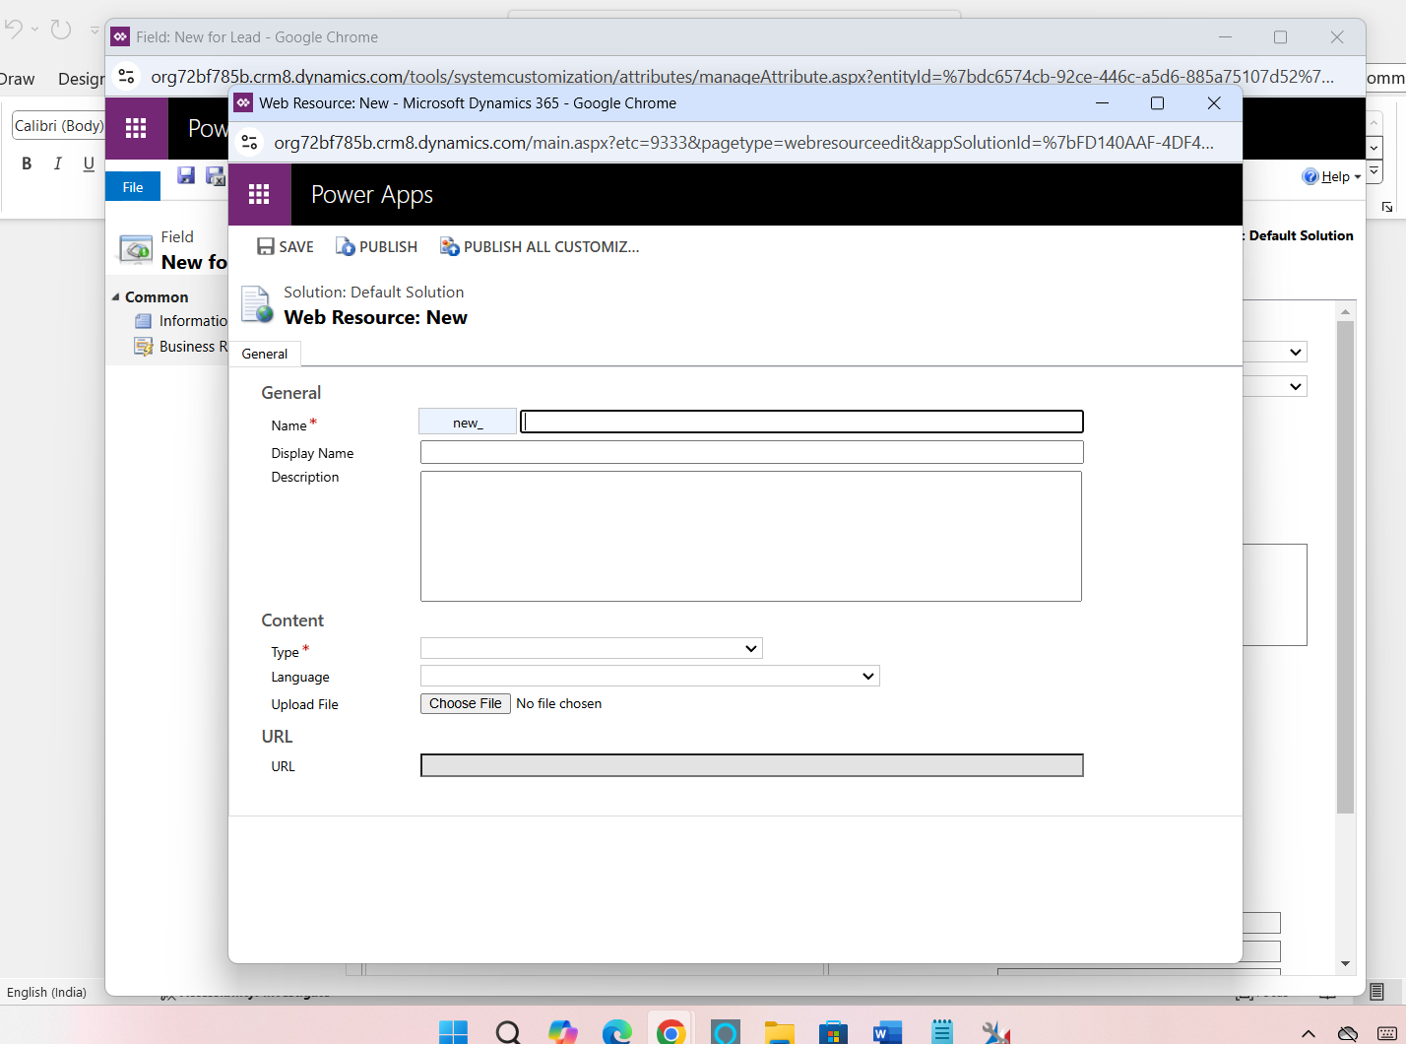

For scalable and maintainable script, we can ensure the error handling in proper way.

Customizing the ribbon

To customize the ribbon, we need the xrmtool box tool to install the ribbon workbench is as below,

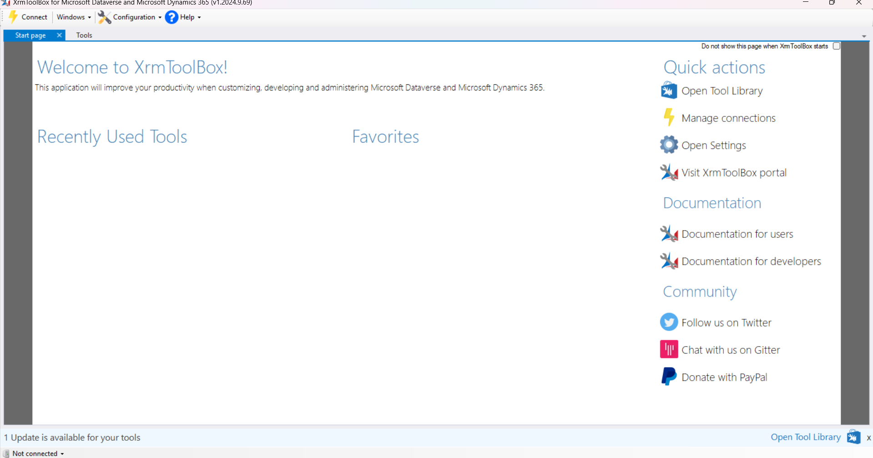

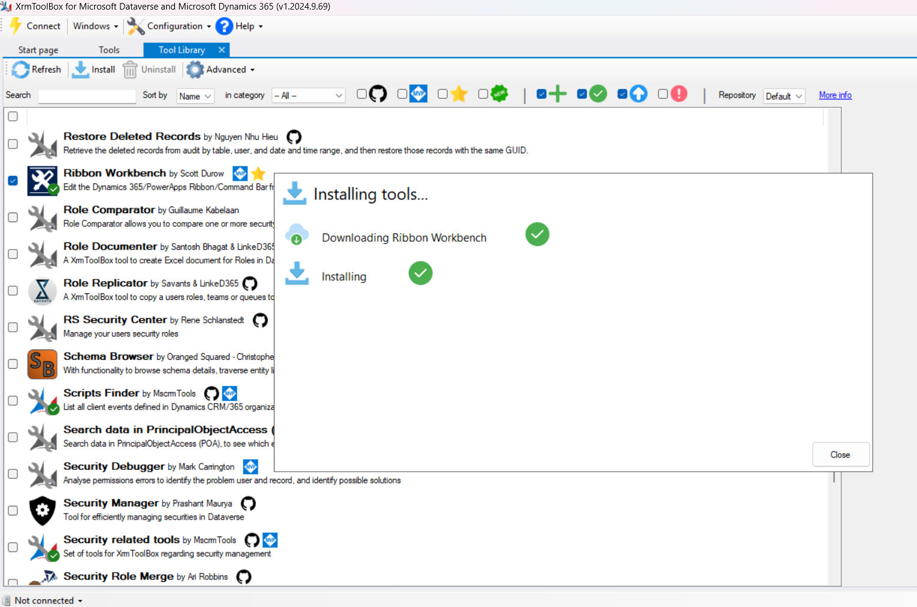

And connect to the d365 environment, is as below,

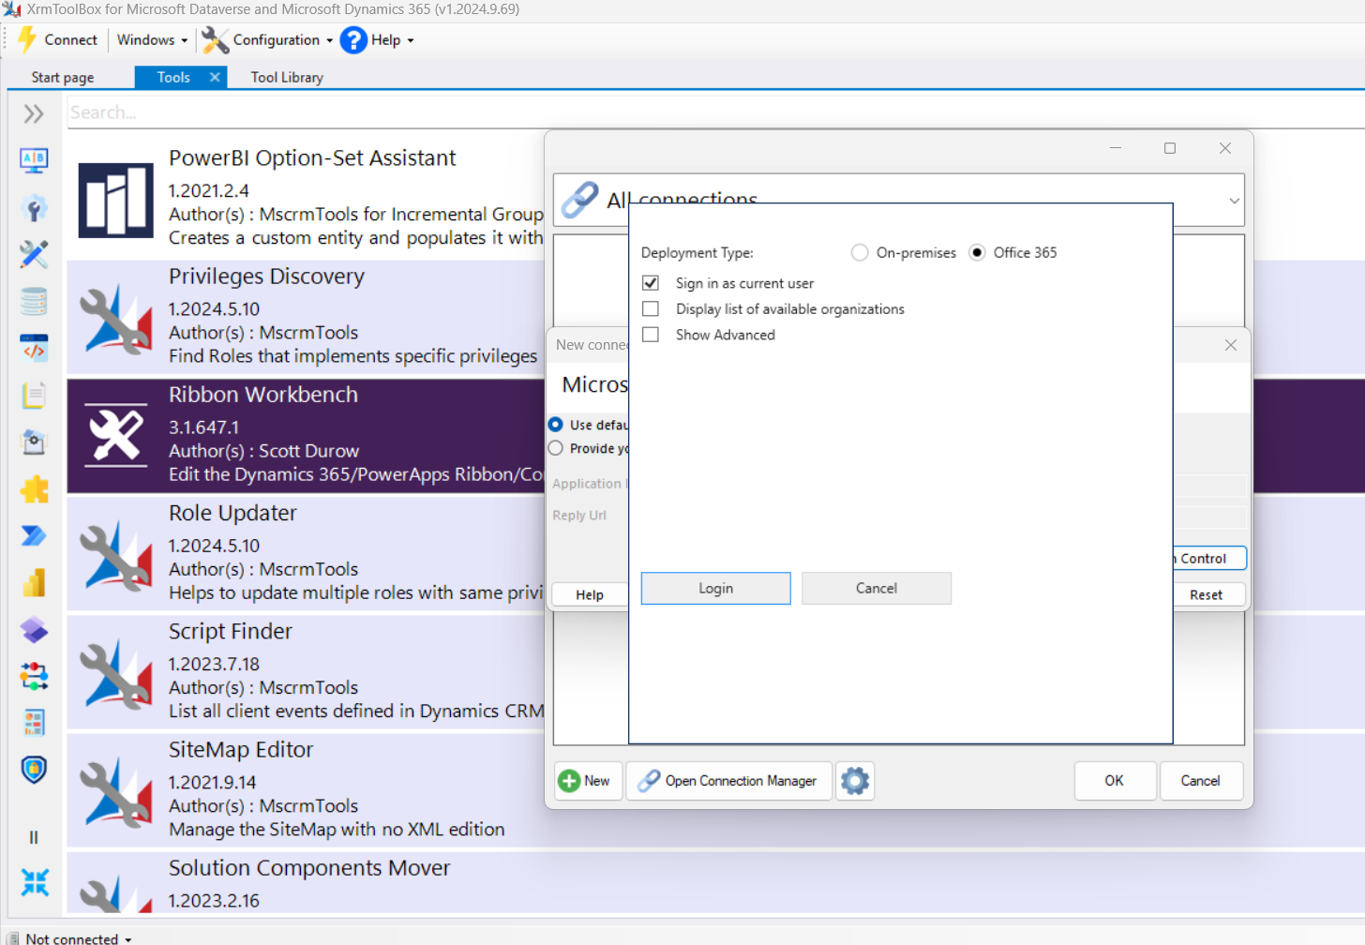

For this I have connected through Oauth which required to connect with an azure AD application by providing the client ID and client secret,

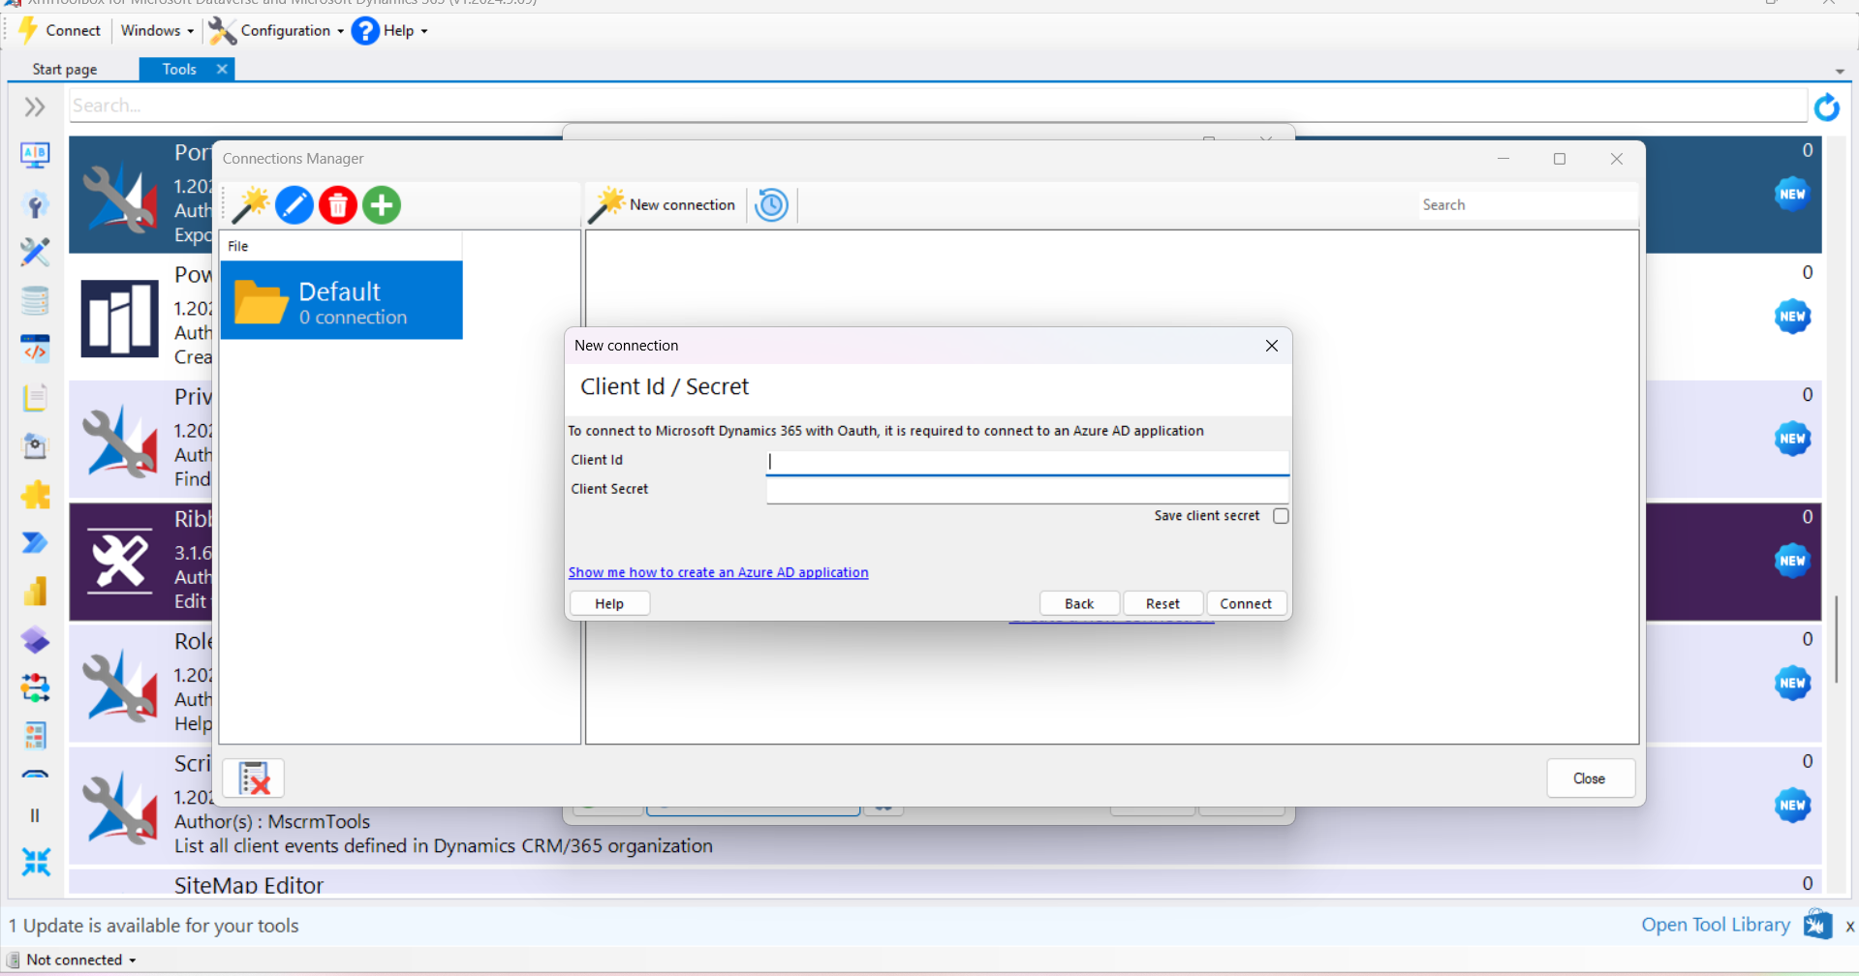

Once connected, open the ribbon workbench and select the lead entity, here we can add new button by selecting ribbon and we can provide the action to be taken by that button like as we write submit, save, create update etc and we need to show proper display rules and naming for the button for the effective process and then we can publish the buttons.

For the business rules, we need to create the new business rule in the provided section for the lead entity and we can make the necessary actions and conditions for the button like showing the field or hiding the field, and then activate the rule

2. Advanced techniques for automating the lead qualification to opportunity process, including the use of power automate, custom workflows and plugins,

When we use power automate for the lead qualification process, we can trigger the flow once any action has been performed on that particular record, like in our case, it would be the product ratings, deal sizes etc.

We can check the qualification criteria as well, as for the particular region the leads has been qualified or exceeded likewise.

For the custom workflow we can use the same techniques like triggering the workflow and the lead qualification such as above, creating the opportunity if the condition matched with the criteria of that particular lead, and assigning the opportunity ad updating the lead record.

With the help of plugins which are way more flexible than workflows as these are servier side customizer, we can register the plugins via XRM toolbox like we did above, writing the plugin logic, like opportunity creating and assigning the ownership and update it, and select it should run sync or async way.

When handling the complex business logic in this process in the condition that the opportunity will be owned by the retail which another business unit with distinct access, we can use above methods as well like plugins and security roles for accssing the rights to the opportunity.

3.

Strategies should be implemented to ensure the marketing dept retains read access to the lead when it is referred to another subsiedary where there is no sharing of data, for these scenario we can setup the security roles, visibility control, record sharing rules, field level security, team and the team owner in which the access is being shared with the team.

Also, we can provide them the read-only access with the help of maual sharing.

We can create the view for the marketing team that show only the leads that are referred to them, also we can create the dashboards as well for showing the metrics for the leads and opportunities.

For the visibility, we can provide the shared access with the team, either we can use manual or automatic sharing for that matter.

4. strategy to migrate existing leads to the cloud while maintaining all the relationships is carried out with the help of proper planning, which can be done by few steps, mapping the document, maintaining the parent child relationship, we need to check for the security roles and user permissions as well, we can perform the pilot migration as well, before going for the actual migration to ensure everthing is at place.

We need to extract the data from the on-premise with the help of sql based export, reviewing the relationships and the datatypes formats and then perform the actual migration process with the help of power query -> import the leads and check for the security roles, also we need to perform unit tesing as well.

5. Migration of the email messages towards the cloud, is actually the same process would be use like mentioned above, we need to check for the setup and the data should be mapped on the cloud as it is, we can use the dmf tool.

We need to check for the proper format for the email as well, such as excel or .csv.

We need to configure for the server side synchronization and we need to maintain the attachment relationships as well as the email body.

Post migration, we need to check for the server side sync process whether it is working properly or not.

6.

We can use the tools for integrating on-premise api’s with cloud sustem, like azure logic apps, azure data factry, power automate,

For the monitoring, we can create the dashboard in the power Bi, error handling, data validation and quality checks. Performance monitoring.

7.

Migrating the teams shared data to the cloud can be achieve with the help of scribe and dmf tool which are commonly used, steps would be the etl the data,

Creating the similar teams on the cloud and maintaining the security roles

8. for the personal views and dashboards migration to the cloud, configuration migration tool, powershell and web api we can use by exporting the views and dashboards, modify the data and importing the data.

After migration, we need to reconfigure the user permissions to make sure whether it is properly performed or not.