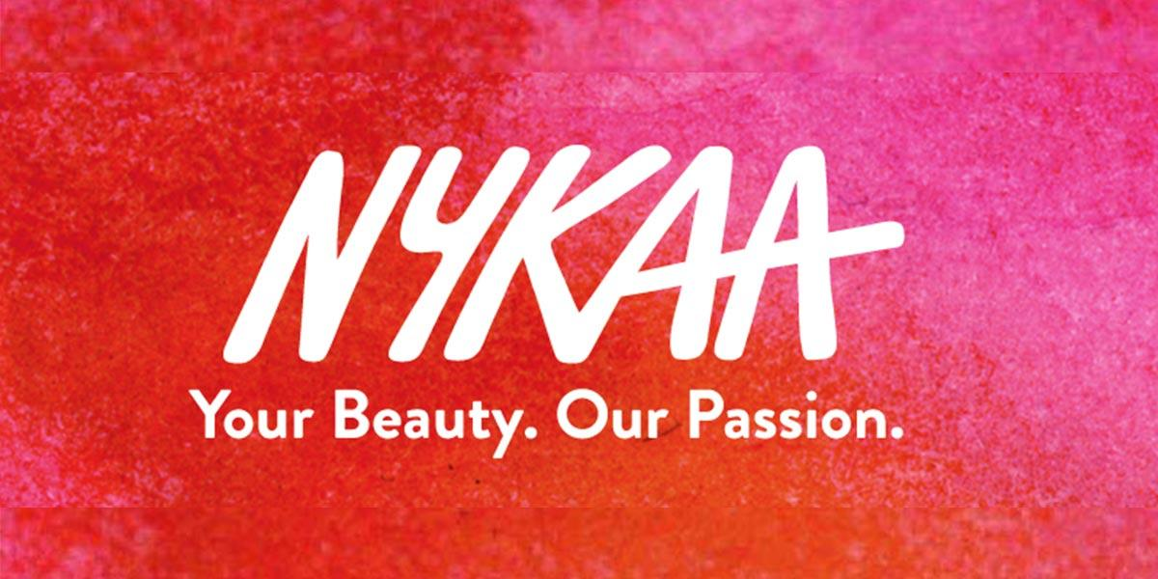

# 

# 

# 

**Product Dissection for Nykaa**

**Company Overview**

Nykaa is an Indian e-commerce company headquartered in Mumbai. It sells beauty, wellness and fashion products through its website, mobile app, and over 100 physical stores. Nykaa was founded in 2012 by Falguni Nayar, a former investment banker who quit her job to pursue her entrepreneurial dream. The company has grown rapidly since its inception and is now valued at over US$13 billion.

### Product Dissection and Real-World Problems Solved by Nykaa:

**Product Dissection**

Nykaa's product offerings can be broadly categorized into three main segments:

**Beauty**: This is Nykaa's core segment and includes a wide range of makeup, skincare, haircare, fragrances, and personal care products. The company offers a curated selection of over 2,000 brands, from mass-market to luxury.

**Wellness**: This segment includes products that promote physical and mental well-being, such as supplements, herbal remedies, and aromatherapy products. Nykaa also offers a range of wellness services, such as yoga and meditation classes.

**Fashion**: This segment includes a selection of apparel, footwear, and accessories from Indian and international brands. Nykaa's fashion offerings are curated to complement its beauty products, creating a holistic shopping experience for women.

**Real-World Problems Solved by Nykaa**

Nykaa addresses several real-world problems faced by women in India:

**Access to Quality Beauty Products:** Nykaa provides women with access to a wide range of high-quality beauty products from both Indian and international brands. This was previously difficult for women in India, as many international brands were not readily available.

**Product Discovery and Recommendations:** Nykaa's website and mobile app offer a personalized shopping experience, with product recommendations based on a user's skin type, preferences, and purchase history. This helps women discover new products and make informed purchasing decisions.

**Authenticity and Counterfeit Products:** The Indian beauty market is plagued by counterfeit products. Nykaa sources its products directly from brands and suppliers, ensuring that all products are authentic.

**In-Store Beauty Expertise:** Nykaa's physical stores offer personalized beauty consultations from trained beauty experts. This helps women find the right products for their skin type and needs.

**Convenience and Access:** Nykaa's omni channel business model makes it convenient for women to shop for beauty products. They can shop online, in-store, or through the Nykaa mobile app.

**Content and Education:** Nykaa provides a wealth of content and education on its website and mobile app, covering topics such as beauty trends, skincare tips, and makeup tutorials. This helps women make informed decisions about their beauty routines.

**Localization and Understanding Indian Skin Tones:** Nykaa understands the unique needs of Indian women, and its product selection and content are tailored to suit Indian skin tones and preferences.

**Empowering Women:** Nykaa is a female-led company that empowers women through its products, services, and content. The company has a strong focus on promoting self-love and acceptance.

**Supporting Indian Brands:** Nykaa showcases a wide range of Indian beauty brands, providing them with a platform to reach a wider audience. This helps to promote Indian entrepreneurship and creativity in the beauty industry.

**Sustainable Practices:** Nykaa is committed to sustainability and has implemented several initiatives to reduce its environmental impact. The company uses eco-friendly packaging materials, sources products from sustainable sources, and promotes recycling.

**Conclusion:**

Overall, Nykaa has made a significant impact on the Indian beauty industry by providing women with access to high-quality products, personalized recommendations, and expert advice. The company has also played a role in empowering women and promoting sustainable practices.

### Top Features of Nykaa:

**1. Wide Range of Products :** Nykaa offers a wide range of beauty and wellness products, including makeup, skincare, haircare, fragrances, and personal care items. The company has over 2,000 brands in its portfolio, from mass-market to luxury. This means that Nykaa has something for everyone, regardless of their budget or preferences.

**2. Personalized Recommendations:** Nykaa's website and mobile app offer a personalized shopping experience. Users can create a profile that includes their skin type, hair type, and makeup preferences. Nykaa then uses this information to recommend products that are right for each individual. This is a great feature for people who are new to makeup or who are looking for new products to try.

**3. Expert Advice:** Nykaa offers a variety of expert advice resources to help customers make informed decisions about their beauty routines. The company has a team of beauty experts who are available to answer questions and provide advice. Nykaa also has a blog with articles on a wide range of beauty topics, from skincare tips to makeup tutorials.

**4. Physical Stores:** In addition to its online store, Nykaa also has a growing number of physical stores across India. These stores offer a curated selection of products, as well as personalized beauty consultations from trained beauty experts. This is a great option for people who want to try on products before they buy them or who want to get expert advice.

**5. Omnichannel Experience:** Nykaa offers an omnichannel experience, which means that customers can shop seamlessly across its online and offline channels. Users can create a profile that is synced across all channels, and they can also check product availability and place orders online or in-store. This makes it easy for customers to shop whenever and however they want.

**6. Mobile App:** Nykaa has a user-friendly mobile app that makes it easy to shop for beauty products on the go. The app has all the same features as the website, plus it allows users to scan barcodes to get product information, track orders, and receive exclusive offers.

**7. Payment Options:** Nykaa offers a variety of payment options, including cash on delivery, credit and debit cards, net banking, and mobile wallets. This makes it easy for customers to pay for their orders, regardless of their preferred payment method.

**8. Returns and Exchanges:** Nykaa has a hassle-free returns and exchanges policy. Customers can return or exchange products within 15 days of purchase, no questions asked. This gives customers peace of mind when shopping online.

**9. Loyalty Program:** Nykaa has a loyalty program that rewards customers for their purchases. Customers can earn points for every purchase they make, and these points can be redeemed for discounts on future purchases. The loyalty program also gives members access to exclusive offers and events.

**10. Social Media Presence:** Nykaa is active on social media and has a large following on platforms like Instagram, Facebook, and Twitter. The company uses social media to connect with its customers, share beauty tips, and promote its products.

### 

### 

### 

### Schema Description:

The schema for Nykaa involves multiple entities that represent different aspects of the platform. These entities include Users, Order, Product,and more. Each entity has specific attributes that describe its properties and relationships with other entities.

**User Entity:** Represents a registered user on the Nykaa platform.

Attributes:

* UserID (Primary Key): A unique identifier for each user.
* Name: The user's full name.
* Email: The user's email address.
* Phone_Number: The user's phone number.
* Address: The user's shipping address.
* Registration_Date: The date when the user joined Nykaa.

**Product** **Entity**: Represents a product offered on the Nykaa platform.

Attributes:

* ProductID (Primary Key): A unique identifier for each product.
* Product_Name: The name of the product.
* Brand: The brand of the product.
* Category: The category of the product (e.g., makeup, skincare, haircare).
* Description: A detailed description of the product.
* Price: The price of the product.
* Image_URL: The URL of the product's image.
* Stock_Quantity: The current quantity of the product in stock.

**Order** **Entity**: Represents a purchase made on the Nykaa platform.

Attributes:

* OrderID (Primary Key): A unique identifier for each order.
* UserID (Foreign Key referencing User Entity): The user who placed the order.
* Order_Date: The date when the order was placed.
* Order_Status: The current status of the order (e.g., pending, processing, shipped, delivered).
* Shipping_Address: The shipping address for the order.
* Payment_Method: The payment method used for the order.
* Order_Total: The total amount of the order.

**Order_Item** **Entity**: Represents an item within an order.

Attributes:

* OrderItemID (Primary Key): A unique identifier for each order item.
* OrderID (Foreign Key referencing Order Entity): The order to which the item belongs.
* ProductID (Foreign Key referencing Product Entity): The product associated with the item.
* Quantity: The number of units of the product ordered.
* Item_Price: The price of the item.

**Review** **Entity**: Represents a user's review of a product.

Attributes:

* ReviewID (Primary Key): A unique identifier for each review.
* UserID (Foreign Key referencing User Entity): The user who wrote the review.
* ProductID (Foreign Key referencing Product Entity): The product being reviewed.
* Review_Date: The date when the review was written.
* Rating: The user's rating of the product (out of 5 stars).
* Review_Text: The user's written review of the product.

**Wishlist** **Entity** : Represents a user's wishlist of products.

Attributes:

* WishlistID (Primary Key): A unique identifier for each wishlist.
* UserID (Foreign Key referencing User Entity): The user who owns the wishlist.
* ProductID (Foreign Key referencing Product Entity): The product that is added to the wishlist.
* Date_Added: The date when the product was added to the wishlist.

**Relationships**:

**One-to-many:**

* A user can place multiple orders, but an order belongs to one user.
* An order can have multiple order items, but an order item belongs to one order.
* A product can have multiple reviews, but a review belongs to one product.

**Many-to-many:**

* A user can have multiple products in their wishlist, and a product can be in multiple users' wishlists.

**ER Diagram:**

Let's construct an ER (Entity-Relationship) diagram that illustrates the relationships and attributes of the entities within the Nykaa schema. This ER diagram will serve as a visual representation, highlighting the key components of Nykaa’s data structure. By using this diagram, you'll gain a better understanding of the complex interactions and connections that define the platform's operations.

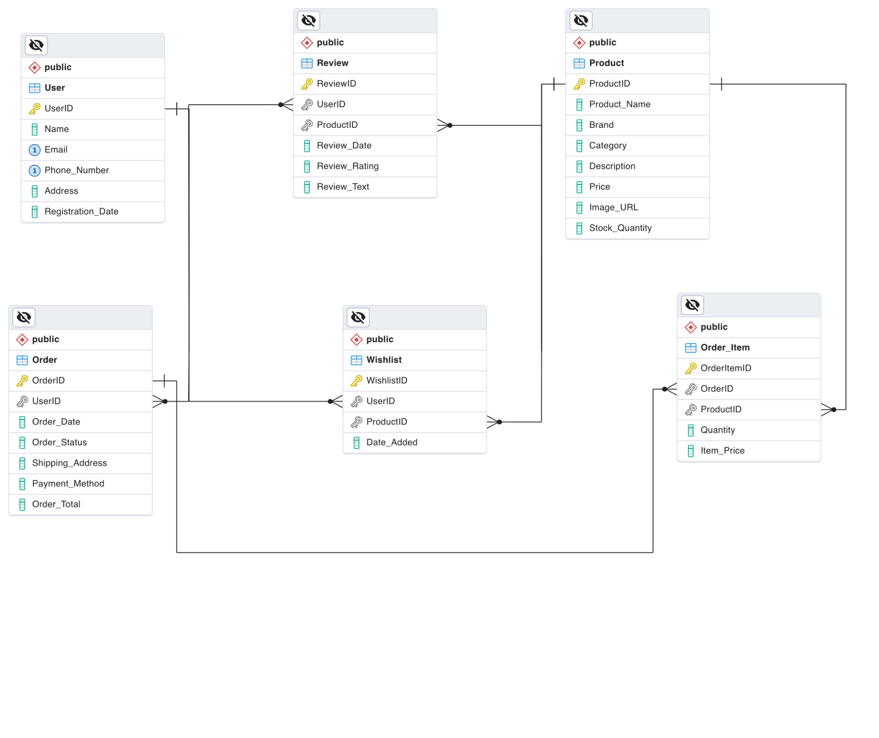

Nykaa has achieved remarkable success in the Indian beauty and wellness market by leveraging its strengths in product curation, personalized recommendations, omnichannel presence, and strong brand positioning. The company's focus on customer satisfaction, digital marketing expertise, strategic acquisitions, and emphasis on customer experience has further contributed to its growth. Nykaa's success serves as an inspiration for e-commerce businesses, demonstrating the importance of a customer-centric approach, targeted marketing strategies, and a focus on quality and innovation.