TASK 2 – CALCULATOR WEBSITE
Intern Name: Supriya Penki
Internship: Alfido Tech Internship
Task: Task 2 – Calculator Website

1. Introduction
This project is a Calculator Website developed as part of Task 2 of the Alfido Tech Internship. The application performs basic arithmetic operations through a simple, responsive, and user-friendly interface.
The calculator is designed to provide accurate calculations while offering a clean layout that works smoothly across different devices.

2. Objectives
- Develop a functional web-based calculator.
- Implement basic arithmetic operations.
- Improve JavaScript programming skills.
- Create a responsive and interactive user interface.
- Deploy the project using GitHub Pages.

3. Technologies Used
- HTML5
- CSS3
- JavaScript

4. Features of the Calculator Website
- Responsive design.
- Clean and modern user interface.
- Addition, subtraction, multiplication, and division operations.
- Decimal number support.
- Clear (AC) button to reset calculations.
- Delete (DEL) button to remove the last entered character.
- Real-time display updates.

5. Implementation
The calculator was built using HTML for the layout, CSS for styling, and JavaScript for handling user input and performing calculations.
HTML Structure
https://github.com/SupriyaPenki/calculator-project/blob/main/index.html
CSS
https://github.com/SupriyaPenki/calculator-project/blob/main/style.css
JavaScript
https://github.com/SupriyaPenki/calculator-project/blob/main/script.js

6. Screenshots
- Calculator Home Screen
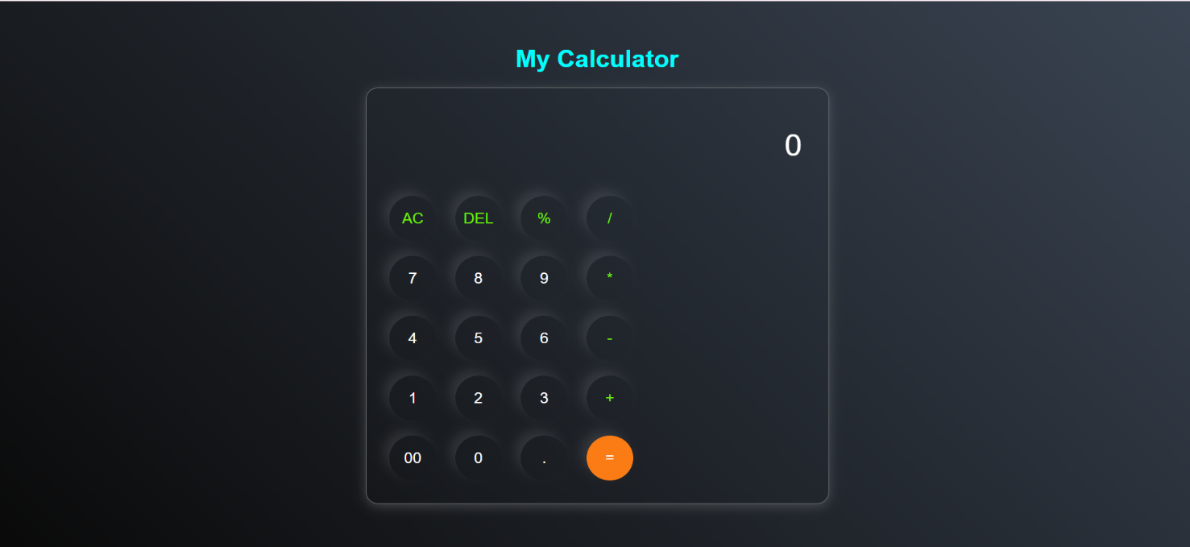

7. Project Links
GitHub Repository
https://github.com/SupriyaPenki/calculator-project
Hosted Link (Live Demo)
https://supriyapenki.github.io/calculator-project/

8. Learning Outcomes
Through this project, I gained practical experience in:
- Building interactive web applications.
- Using JavaScript for arithmetic operations.
- Handling user inputs and button events.
- Designing responsive layouts with CSS.
- Managing projects using Git and GitHub.
- Deploying projects using GitHub Pages.

10. Conclusion
The Calculator Website project strengthened my understanding of HTML, CSS, and JavaScript by allowing me to build a fully functional web application. It enhanced my front-end development skills, improved my logical thinking, and provided hands-on experience in developing and deploying responsive web projects.

