

Data Technician

Name:
Course Date:
Table of contents
Day 1: Task 1 2
Day 2: Task 1 2
Day 2: Task 2 3
Day 3: Task 1 4
Day 3: Task 2 5
Dataset: 6
Step 1: Create a Pivot Table 6
Step 2: Use the SWITCH Function 6
Submission: 6
Day 3: Task 3 7
Course Notes 8
Additional Information 8

Day 1: Task 1

Please complete the below boxes on commons laws and regulations that must be followed when working with customers data, use the below bulleted list to support your answers.

- What is it
- Why is it important
- Provide a real-world example of how you can follow it
- How does it impact working with data
- What could happen if you breached it

Data Protection Act
GDPR
Freedom of Information Act
Computer Misuse Act

Day 2: Task 1

Please research and complete the following tasks within the retail-sales_dataset.xlsx document, paste a print screen into the provided boxes below:

- In the sheet ‘retail_sales_dataset’ add all available data between columns A – H into a ‘table’
- Using the ‘filter’ function, filter ‘Age’ to ‘largest to smallest’
- Using the ‘SUM’ function, show me the commission total in cell ‘P10’
- Using the ‘AVERAGE’ function, show me the average commission in cell ‘P11’

Print screen 1
 |  | Male | 63 | Senior | Electronics | 2
Print screen 3 |  | Female | 63 | Senior | Electronics | 2
Print screen 4 |  | Male | 63 | Senior | Electronics | 3

Day 2: Task 2

Please research and complete the following tasks within the retail-sales_dataset.xlsx document in Task 2 worksheet, paste print screens into the provided box below:

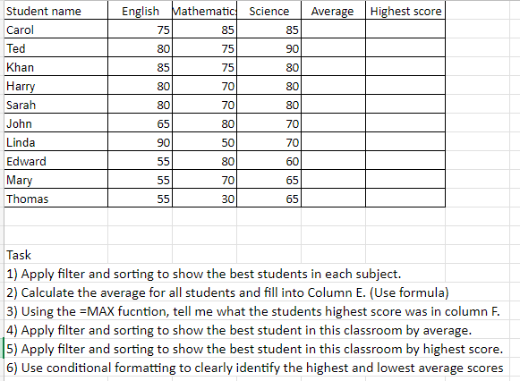

Print screen 1

Day 3: Task 1

Please download the dataset ‘Day_3_Task_1_Bike_Sales_Pivot_Lab.xlsx’ from here.

The lab instructions can be found here. Do not worry if you do not complete the lab, just working with data and playing with the pivot table will be good experience.

Please paste your final pivot table below and complete the reflection questions:

Print screen 1
In which markets do Germany have customers? | Age group 35-64
What country has sales in all markets? | Australia
What are the most profitable markets by country, age group, and gender? | Australia,Female and two age groups Young Adults and Adults
Any other findings? | 1.USA has very less demand and only adults are purchasing.  2.Purchases from youth are pertaining only to Australia,France and few parts of UK.  3.Most customers are from Age group 35-64 from  4.Bikes are more popular among female than male.

Day 3: Task 2

The dataset below tracks the sales performance of different products in various counties in England. Please paste the dataset into a blank Excel workbook. Your task is to:
- Create a Pivot Table to summarise the data by county and product.
- Use the SWITCH function to categorise products based on their sales volume.

Dataset:
County | Product | Sales Volume
Yorkshire | Laptops | 500
Yorkshire | Smartphones | 200
Cornwall | Laptops | 700
Cornwall | Printers | 400
Lancashire | Smartphones | 150
Lancashire | Laptops | 600
Essex | Printers | 800
Essex | Smartphones | 300
Durham | Laptops | 250
Durham | Printers | 300
Greater Manchester | Smartphones | 600
Greater Manchester | Laptops | 400

Step 1: Create a Pivot Table
- Select the dataset (columns A to C).
- Insert a Pivot Table to summarise the data by County in the rows and Products in the columns. Use Sales Volume as the value to be summarised.

Step 2: Use the SWITCH Function
In a new column next to your data, use the SWITCH function to categorise products based on Sales Volume as follows:
  - For sales greater than 600: "High"
  - For sales between 300 and 600: "Medium"
  - For sales less than 300: "Low"

SWITCH Function Example:
=SWITCH(TRUE, C2 > 600, "High", C2 >= 300, "Medium", "Low")
- Apply this formula to each row, and check if the products are categorised correctly.

Submission:
- A completed Pivot Table summarising sales by county and product.
- A new column in the dataset categorising products by sales volume using the SWITCH function.
  - Please paste your completed work below

Print screen 1

Day 3: Task 3

Please download the dataset ‘Day_3_Task_3_Bike_Sales_Visualisations_Lab.xlsx’ from here.

The lab instructions can be found here. Do not worry if you do not complete the lab, just working with data and playing with the charts will be good experience.

Please paste your results below:

Print screen 1

Course Notes

It is recommended to take notes from the course, use the space below to do so, or use the revision guide shared with the class:

Additional Information

We have included a range of additional links to further resources and information that you may find useful, these can be found within your revision guide.

END OF WORKBOOK

Please check through your work thoroughly before submitting and update the table of contents if required.

Please send your completed work booklet to your trainer by submitting in MS Teams Assignment page.

