TASK2:

SHELL SCRIPTING:

File Search:

Write a command to find all files with the extension .txt in the /home directory and its subdirectories

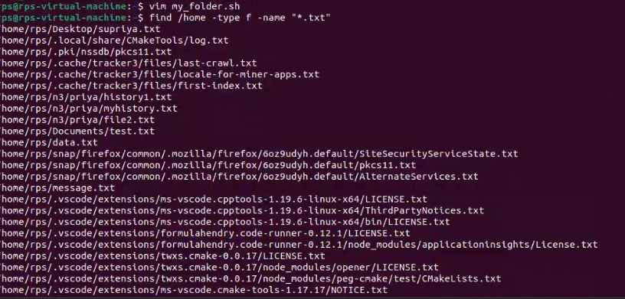

File Permissions:

Write a command to change the permissions of all files in the /var/log directory to 644.

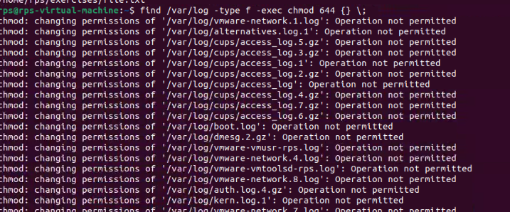

Disk Usage:

Write a command to display the disk usage of all directories in the /home directory in a human-readable format.



Process Management:

Write a command to list all running processes that contain the name "apache" in their command line.



Text Processing:

Write a command to count the number of lines in a file named error.log.



Network Configuration:

Write a command to display the IP address of all network interfaces on the system.

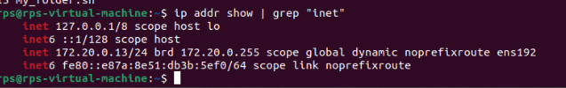

Package Management:

Write a command to install a package named htop using the package manager.



User Management:

Write a command to add a new user named developer to the system.



File Compression:

Write a command to compress a directory named backup into a .tar.gz file



System Monitoring:

Write a command to display real-time system resource usage, including CPU, memory, and disk I/O.

